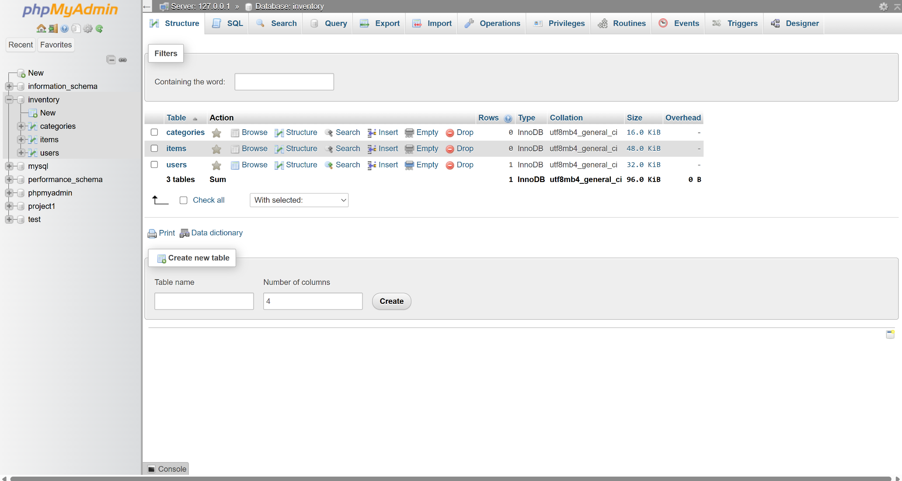

{

"error": "Use POST"

}

