

GUJARAT TECHNOLOGICAL UNIVERSITY Chandkheda, Ahmedabad
Affiliated
C. K. Pithawala College of Engineering and Technology, Surat
A
CIPAT Report
On
Bus Pass Application
Prepared as a part of the requirements for the subject of
Mobile Application Development (3170726)
B. E. IV, Semester – VII
(Computer Engineering)
Submitted by:
Sr. No. | Name of Student | Enrolment No
1. | Hani Patel | 220090107119
2. | Kevin Patel | 220090107127
3. | Krishna Patel | 220090107133

Prof. Chaitali Sheth
(Subject Co-Ordinator)

Dr. Vishruti V Desai
HOD

Abstract

The Bus Pass Application is an Android-based system designed to simplify and digitize the process of bus pass issuance, management, and verification for passengers. Traditionally, obtaining and renewing bus passes requires physical visits and manual verification, leading to inconvenience and delays. This application aims to overcome those challenges by providing a seamless, user-friendly mobile platform.
Users can register, log in, and apply for bus passes directly from their smartphones. The app integrates with Firebase for secure authentication and data storage, ensuring real-time synchronization and reliability. Through the application, users can view their pass status, edit proile , delete account and receive notifications about updates or renewals, and access route maps for convenience.
The system’s modular design — comprising activities like Login, Registration, Map, Status, and Notifications — ensures scalability and maintainability. By digitalizing the bus pass process, this project reduces paperwork, minimizes human error, and promotes an efficient, eco-friendly approach to public transportation management.

Table Of Contents

Abstract 1
Table Of Contents 2
1. Introduction: 3
2. Project Summary: 3
3. Architecture and Activity Life Cycle with reference to any activity. 3
4. Activity Page 5
4.1 LoginActivity 5
4.2 MainActivity 5
4.3 MapActivity 6
4.4 NotificationsActivity 6
4.5 RegistrationActivity 7
4.6 StatusActivity 7
4.7 ProfileActivity 8
5. Code(XML) 8
6. Code(Kotlin) 24
7. Output Screenshot: 46
8. APK steps of the application: 50

Introduction:

The Bus Pass Application is a mobile-based system developed to simplify the process of applying for and managing bus passes. Instead of standing in long queues or filling out paper forms, users can easily register, log in, and apply for their bus passes through an Android app. The application also allows users to check their pass status, view bus routes, and receive important notifications. By using cloud-based services like Firebase, the system ensures secure data handling and real-time updates. This project provides a modern, convenient, and eco-friendly solution for public transportation management.

Project Summary:
- Project Title: Bus Pass Application
- Technology Used: Android Studio (Kotlin), XML, Firebase Firestore, Google Cloud Console
- Development Tools: Android Studio Ladybug 2024.2.1 Patch 1
- Database: Firebase Firestore (Cloud-based)
- Operating System: Android (minSdk 24)
- Language Used: Kotlin, XML
- Purpose: The main purpose of the Bus Pass Application is to simplify and digitize the process of applying for, renewing, and managing bus passes, thereby reducing manual work and enhancing convenience for users.

Architecture and Activity Life Cycle with reference to any activity.
- Architecture:
The Bus Pass Application is built using the standard Android application architecture, which promotes a separation of concerns between the user interface (UI) and the application logic.
- UI Layer (Layout & Drawable Files): The visual structure of each screen is defined in XML files (e.g., activity_main.xml). These files contain the blueprints for all the UI elements. The app's visual identity is further enhanced through drawable resources, such as
layered_bus_background.xml which provides a custom image background, and card_background.xml which styles the E-Pass. The overall color scheme is managed centrally in colors.xml and applied via themes.xml.
- Logic Layer (Activity/Kotlin Files): Each screen is controlled by a corresponding Kotlin Activity class (e.g., MainActivity.kt). This class is responsible for inflating the XML layout, finding UI elements, handling user interactions (like button clicks), and communicating with backend services like Firebase Authentication and Firestore.

- Activity:
An Activity represents a single screen with which a user can interact. The lifecycle is the series of states it goes through from creation to destruction. Understanding this is crucial for managing app resources and ensuring a smooth user experience.
- The key lifecycle states, with reference to our MainActivity, are:
- onCreate(): Called once when MainActivity is created (e.g., after login). It performs one-time setups: setting the layout, initializing the toolbar and buttons, and setting up onClickListeners.
- onStart(): Called just after onCreate(), making the Activity visible.
- onResume(): The Activity comes to the foreground and is ready for user interaction.
- onPause(): Called when the user navigates away (e.g., opening RegistrationActivity). The Activity is partially visible but not in focus.
- onStop(): Called when the Activity is no longer visible (e.g., RegistrationActivity completely covers it).
- onDestroy(): The final state, called when the Activity is destroyed (e.g., after clicking "Sign Out" and calling finish().

Activity Page

4.1 LoginActivity
The LoginActivity is the entry point and security gateway of the application. As the designated LAUNCHER activity in the AndroidManifest.xml, it is the very first screen presented to the user. The user interface is clean and straightforward, featuring input fields for an email and a password. It provides two primary actions: "Login" for existing users and "Sign Up" for new users.
The corresponding Kotlin file, LoginActivity.kt, manages all authentication logic by interfacing directly with the Firebase Authentication service. When the user clicks "Sign Up," the createUserWithEmailAndPassword method is called to create a new user account securely. When "Login" is clicked, the signInWithEmailAndPassword method is used to verify the user's credentials. If authentication is successful, the app navigates the user to the MainActivity and closes the login screen so the user cannot return to it by pressing the back button. If a user is already logged in from a previous session, the code checks this state in the onCreate method and by passes the login screen entirely, sending them directly to the main app hub. This ensures a seamless experience for returning users.
so, displays a system notification.

4.2 MainActivity
The MainActivity serves as the central dashboard or "hub" of the application, providing the main navigation point after a user successfully logs in. The UI is designed for clarity and ease of use, featuring a prominent toolbar at the top with the application's title and a notification icon. The main body of the screen contains large, clearly labeled buttons that direct the user to the core features: "Register for New Bus Pass," "Check Pass Status," and "View Bus Route." A "Sign Out" button is also available for the user to securely end their session.
The logic in MainActivity.kt orchestrates the app's primary functions. It sets up the toolbar and inflates the options menu to display the notification icon. onClickListeners are attached to each button to launch their respective Activities (RegistrationActivity, StatusActivity, MapActivity, NotificationsActivity). A key feature of this activity is its notification logic. In the onCreate method, it calls a function that checks the user's pass status in the Firestore database. If the status has been updated to "approved" or "rejected" and a notification has not yet been sent, it triggers a system notification in the status bar and saves a record of this notification to the database for later viewing.

4.3 MapActivity
The MapActivity is designed to fulfill the course outcome related to maps and location services. This screen provides a visual representation of various bus routes within a specified area. The user interface consists of a full-screen interactive Google Map. Users can pan, zoom in/out using pinch gestures, and use the on-screen zoom controls to explore the map freely.
The MapActivity.kt code is responsible for initializing the map and drawing the routes. When the map is ready (onMapReady callback), the code adds markers for the start and end points of three distinct, pre-defined bus routes. It then draws a Polyline (a colored line) for each route, using different colors (blue, red, green) to make them easily distinguishable. To ensure a good user experience, the code calculates the geographical bounds required to show all three routes simultaneously and animates the camera to that position, providing a comprehensive overview of the available routes as soon as the map loads.

4.4 NotificationsActivity
The NotificationsActivity serves as a persistent inbox or history log for the user. Its purpose is to provide a dedicated screen where users can view all past status update notifications they have received regarding their bus pass application. The UI is simple, featuring a title and a scrollable list area. If no notifications are available, a "No notifications yet" message is displayed to inform the user.
The logic in NotificationsActivity.kt is focused on data retrieval and dynamic UI generation. When the screen is created, it queries a specific "notifications" subcollection in the Firestore database, which is unique to the currently logged-in user. It retrieves all notification documents, ordered with the newest first. For each notification message found, it dynamically creates a new TextView element in the code and adds it to the LinearLayout container, effectively building a list of all historical notifications for the user to review.

4.5 RegistrationActivity
The RegistrationActivity is the primary data entry screen of the application. This is where users formally apply for a new bus pass by providing their personal details. The user interface is a comprehensive form containing various input fields (EditText) for information such as Full Name, Age, DOB, Blood Group, Contact Number, Emergency Contact, and Address. It also includes a RadioGroup for selecting Gender and a Spinner (dropdown) for choosing the pass validity period.
The RegistrationActivity.kt file manages the form's functionality. It initializes all UI elements and populates the validity Spinner with options. The core logic resides in the onClickListener for the "Submit Application" button. When clicked, it retrieves the text from all EditText fields and the selections from the RadioGroup and Spinner. After performing a simple validation to ensure key fields are not empty, it packages all the data into a HashMap. This map is then saved as a new document in the "pass_applications" collection in the Firestore database, using the user's unique Firebase ID as the document ID. This ensures each user has a single, up-to-date application record.

4.6 StatusActivity
The StatusActivity is a dynamic screen that provides the user with real-time feedback on their bus pass application. The UI can display one of two states. The first is a "pending" state, which shows a simple text message indicating the current status (e.g., "Submitted" or "Rejected"). The second is an "approved" state, which reveals a visually rich E-Pass designed to look like an interactive card with a yellow background and border. This card displays all the user's key details and a machine-readable QR code.
The logic in StatusActivity.kt is responsible for fetching the user's application data from Firestore and deciding which UI state to display. When the activity starts, it retrieves the user's document from the "pass_applications" collection. Based on the value of the "status" field in the document, it makes either the pending_layout or the approved_layout visible. If the status is "approved," the code proceeds to populate all the TextViews on the E-Pass card with the corresponding data from the document. Finally, it uses the zxing library to generate a unique QR code bitmap from the user's Pass ID and displays it in the ImageView on the card.

4.7 ProfileActivity
The ProfileActivity empowers users to manage their personal information. The UI presents a form pre-populated with the user's current data fetched from Firestore. Users can edit their details and click "Update Profile" to save the changes. The ProfileActivity.kt code handles both loading the data and writing the updated information back to the same Firestore document. This screen also includes a critical "Delete Account" feature. When confirmed via a dialog, the code executes a two-step deletion process: it first removes all the user's data from Firestore (both their pass application and any saved notifications) and then deletes the user from Firebase Authentication, ensuring the account is completely and permanently removed.

Code(XML)

- Activity_main.xml:

<androidx.constraintlayout.widget.ConstraintLayout xmlns:android="http://schemas.android.com/apk/res/android"
xmlns:app="http://schemas.android.com/apk/res-auto"
xmlns:tools="http://schemas.android.com/tools"
android:layout_width="match_parent"
android:layout_height="match_parent"
tools:context=".MainActivity"
android:background="@drawable/layered_bus_background">

<androidx.appcompat.widget.Toolbar
android:id="@+id/toolbar"
android:layout_width="match_parent"
android:layout_height="?attr/actionBarSize"
android:background="@color/app_yellow_primary"
app:title="Bus Pass Portal"
app:titleTextColor="@color/app_text_on_yellow"
app:layout_constraintTop_toTopOf="parent"
app:layout_constraintStart_toStartOf="parent"
app:layout_constraintEnd_toEndOf="parent" />

<Button
android:id="@+id/register_pass_button"
android:layout_width="0dp"
android:layout_height="wrap_content"
android:text="Register for New Bus Pass"
android:backgroundTint="@color/app_yellow_primary"
android:textColor="@color/app_text_on_yellow"
android:layout_marginTop="32dp"
android:layout_marginStart="16dp"
android:layout_marginEnd="16dp"
app:layout_constraintTop_toBottomOf="@id/toolbar"
app:layout_constraintStart_toStartOf="parent"
app:layout_constraintEnd_toEndOf="parent" />

<Button
android:id="@+id/check_status_button"
android:layout_width="0dp"
android:layout_height="wrap_content"
android:text="Check Pass Status"
android:backgroundTint="@color/app_yellow_primary"
android:textColor="@color/app_text_on_yellow"
android:layout_marginTop="16dp"
android:layout_marginStart="16dp"
android:layout_marginEnd="16dp"
app:layout_constraintTop_toBottomOf="@id/register_pass_button"
app:layout_constraintStart_toStartOf="parent"
app:layout_constraintEnd_toEndOf="parent" />

<Button
android:id="@+id/view_profile_button"
android:layout_width="0dp"
android:layout_height="wrap_content"
android:text="View / Edit Profile"
android:backgroundTint="@color/app_yellow_primary"
android:textColor="@color/app_text_on_yellow"
android:layout_marginTop="16dp"
android:layout_marginStart="16dp"
android:layout_marginEnd="16dp"
app:layout_constraintTop_toBottomOf="@id/check_status_button"
app:layout_constraintStart_toStartOf="parent"
app:layout_constraintEnd_toEndOf="parent" />

<Button
android:id="@+id/view_map_button"
android:layout_width="0dp"
android:layout_height="wrap_content"
style="@style/Widget.MaterialComponents.Button.OutlinedButton"
android:text="View Bus Route"
android:layout_marginTop="16dp"
android:layout_marginStart="16dp"
android:layout_marginEnd="16dp"
app:layout_constraintTop_toBottomOf="@id/view_profile_button"
app:layout_constraintStart_toStartOf="parent"
app:layout_constraintEnd_toEndOf="parent" />

<Button
android:id="@+id/sign_out_button"
android:layout_width="wrap_content"
android:layout_height="wrap_content"
android:text="Sign Out"
app:layout_constraintBottom_toBottomOf="parent"
app:layout_constraintEnd_toEndOf="parent"
android:layout_marginBottom="16dp"
android:layout_marginEnd="16dp"/>

</androidx.constraintlayout.widget.ConstraintLayout>

- Activity_login.xml:

<androidx.constraintlayout.widget.ConstraintLayout xmlns:android="http://schemas.android.com/apk/res/android"
xmlns:app="http://schemas.android.com/apk/res-auto"
xmlns:tools="http://schemas.android.com/tools"
android:layout_width="match_parent"
android:layout_height="match_parent"
android:background="@drawable/layered_bus_background"
android:padding="16dp"
tools:context=".LoginActivity">

<TextView
android:id="@+id/title_text_view"
android:layout_width="wrap_content"
android:layout_height="wrap_content"
android:text="Bus Pass Portal"
android:textSize="32sp"
android:textStyle="bold"
app:layout_constraintTop_toTopOf="parent"
app:layout_constraintStart_toStartOf="parent"
app:layout_constraintEnd_toEndOf="parent"
android:layout_marginTop="64dp"/>

<EditText
android:id="@+id/email_edit_text"
android:layout_width="0dp"
android:layout_height="wrap_content"
android:hint="Email"
android:inputType="textEmailAddress"
app:layout_constraintTop_toBottomOf="@id/title_text_view"
app:layout_constraintStart_toStartOf="parent"
app:layout_constraintEnd_toEndOf="parent"
android:layout_marginTop="48dp"/>

<EditText
android:id="@+id/password_edit_text"
android:layout_width="0dp"
android:layout_height="wrap_content"
android:hint="Password"
android:inputType="textPassword"
app:layout_constraintTop_toBottomOf="@id/email_edit_text"
app:layout_constraintStart_toStartOf="parent"
app:layout_constraintEnd_toEndOf="parent"
android:layout_marginTop="16dp"/>

<Button
android:id="@+id/login_button"
android:layout_width="0dp"
android:layout_height="wrap_content"
android:text="Login"
android:backgroundTint="@color/app_yellow_primary"
android:textColor="@color/app_text_on_yellow"
app:layout_constraintTop_toBottomOf="@id/password_edit_text"
app:layout_constraintStart_toStartOf="parent"
app:layout_constraintEnd_toEndOf="parent"
android:layout_marginTop="24dp"/>

<Button
android:id="@+id/signup_button"
style="@style/Widget.MaterialComponents.Button.TextButton"
android:layout_width="wrap_content"
android:layout_height="wrap_content"
android:text="Don't have an account? Sign Up"
app:layout_constraintTop_toBottomOf="@id/login_button"
app:layout_constraintStart_toStartOf="parent"
app:layout_constraintEnd_toEndOf="parent"
android:layout_marginTop="8dp"/>

</androidx.constraintlayout.widget.ConstraintLayout>

- Activity_map.xml:

<fragment xmlns:android="http://schemas.android.com/apk/res/android"
xmlns:tools="http://schemas.android.com/tools"
android:id="@+id/map"
android:name="com.google.android.gms.maps.SupportMapFragment"
android:layout_width="match_parent"
android:layout_height="match_parent"
tools:context=".MapActivity" />

- Activity_notifications.xml:

<androidx.constraintlayout.widget.ConstraintLayout xmlns:android="http://schemas.android.com/apk/res/android"
xmlns:app="http://schemas.android.com/apk/res-auto"
xmlns:tools="http://schemas.android.com/tools"
android:layout_width="match_parent"
android:layout_height="match_parent"
tools:context=".NotificationsActivity">

<TextView
android:id="@+id/notifications_title"
android:layout_width="wrap_content"
android:layout_height="wrap_content"
android:text="Notifications"
android:textSize="24sp"
android:textStyle="bold"
app:layout_constraintTop_toTopOf="parent"
app:layout_constraintStart_toStartOf="parent"
android:layout_marginTop="16dp"
android:layout_marginStart="16dp"/>

<ScrollView
android:layout_width="0dp"
android:layout_height="0dp"
app:layout_constraintTop_toBottomOf="@id/notifications_title"
app:layout_constraintBottom_toBottomOf="parent"
app:layout_constraintStart_toStartOf="parent"
app:layout_constraintEnd_toEndOf="parent"
android:layout_marginTop="16dp">

<LinearLayout
android:id="@+id/notifications_container"
android:layout_width="match_parent"
android:layout_height="wrap_content"
android:orientation="vertical"
android:padding="16dp" />
</ScrollView>

<TextView
android:id="@+id/no_notifications_text"
android:layout_width="wrap_content"
android:layout_height="wrap_content"
android:text="No notifications yet."
android:textSize="18sp"
android:visibility="gone"
app:layout_constraintTop_toTopOf="parent"
app:layout_constraintBottom_toBottomOf="parent"
app:layout_constraintStart_toStartOf="parent"
app:layout_constraintEnd_toEndOf="parent"/>

</androidx.constraintlayout.widget.ConstraintLayout>

- Activity_profile.xml

<ScrollView xmlns:android="http://schemas.android.com/apk/res/android"
xmlns:app="http://schemas.android.com/apk/res-auto"
xmlns:tools="http://schemas.android.com/tools"
android:layout_width="match_parent"
android:layout_height="match_parent"
tools:context=".ProfileActivity">

<androidx.constraintlayout.widget.ConstraintLayout
android:layout_width="match_parent"
android:layout_height="wrap_content"
android:padding="16dp">

<TextView
android:id="@+id/profile_title"
android:layout_width="wrap_content"
android:layout_height="wrap_content"
android:text="Your Profile"
android:textSize="24sp"
android:textStyle="bold"
app:layout_constraintTop_toTopOf="parent"
app:layout_constraintStart_toStartOf="parent" />

<TextView
android:id="@+id/profile_subtitle"
android:layout_width="0dp"
android:layout_height="wrap_content"
android:text="You can view and update your information here."
app:layout_constraintTop_toBottomOf="@id/profile_title"
app:layout_constraintStart_toStartOf="parent"
app:layout_constraintEnd_toEndOf="parent"
android:layout_marginTop="4dp"/>

<EditText
android:id="@+id/profile_name_edit_text"
android:layout_width="0dp"
android:layout_height="wrap_content"
android:hint="Full Name"
android:inputType="textPersonName"
app:layout_constraintTop_toBottomOf="@id/profile_subtitle"
app:layout_constraintStart_toStartOf="parent"
app:layout_constraintEnd_toEndOf="parent"
android:layout_marginTop="24dp"/>

<EditText
android:id="@+id/profile_age_edit_text"
android:layout_width="0dp"
android:layout_height="wrap_content"
android:hint="Age"
android:inputType="number"
app:layout_constraintTop_toBottomOf="@id/profile_name_edit_text"
app:layout_constraintStart_toStartOf="parent"
app:layout_constraintEnd_toEndOf="parent"
android:layout_marginTop="8dp"/>

<EditText
android:id="@+id/profile_contact_number_edit_text"
android:layout_width="0dp"
android:layout_height="wrap_content"
android:hint="Contact Number"
android:inputType="phone"
app:layout_constraintTop_toBottomOf="@id/profile_age_edit_text"
app:layout_constraintStart_toStartOf="parent"
app:layout_constraintEnd_toEndOf="parent"
android:layout_marginTop="8dp"/>

<EditText
android:id="@+id/profile_address_edit_text"
android:layout_width="0dp"
android:layout_height="wrap_content"
android:hint="Address"
android:inputType="textPostalAddress"
app:layout_constraintTop_toBottomOf="@id/profile_contact_number_edit_text"
app:layout_constraintStart_toStartOf="parent"
app:layout_constraintEnd_toEndOf="parent"
android:layout_marginTop="8dp"/>

<Button
android:id="@+id/update_profile_button"
android:layout_width="0dp"
android:layout_height="wrap_content"
android:text="Update Profile"
app:layout_constraintTop_toBottomOf="@id/profile_address_edit_text"
app:layout_constraintStart_toStartOf="parent"
app:layout_constraintEnd_toEndOf="parent"
android:layout_marginTop="24dp"/>

<Button
android:id="@+id/delete_account_button"
style="@style/Widget.MaterialComponents.Button.TextButton"
android:textColor="@android:color/holo_red_dark"
android:layout_width="wrap_content"
android:layout_height="wrap_content"
android:text="Delete Account"
app:layout_constraintTop_toBottomOf="@id/update_profile_button"
app:layout_constraintEnd_toEndOf="parent"
android:layout_marginTop="16dp"/>

</androidx.constraintlayout.widget.ConstraintLayout>

</ScrollView>
- Activity_registration.xml:

<ScrollView xmlns:android="http://schemas.android.com/apk/res/android"
xmlns:app="http://schemas.android.com/apk/res-auto"
xmlns:tools="http://schemas.android.com/tools"
android:layout_width="match_parent"
android:layout_height="match_parent"
tools:context=".RegistrationActivity">

<androidx.constraintlayout.widget.ConstraintLayout
android:layout_width="match_parent"
android:layout_height="wrap_content"
android:padding="16dp">

<TextView
android:id="@+id/form_title"
android:layout_width="wrap_content"
android:layout_height="wrap_content"
android:text="New Pass Registration"
android:textSize="24sp"
android:textStyle="bold"
app:layout_constraintTop_toTopOf="parent"
app:layout_constraintStart_toStartOf="parent" />

<EditText
android:id="@+id/name_edit_text"
android:layout_width="0dp"
android:layout_height="wrap_content"
android:hint="Full Name"
android:inputType="textPersonName"
app:layout_constraintTop_toBottomOf="@id/form_title"
app:layout_constraintStart_toStartOf="parent"
app:layout_constraintEnd_toEndOf="parent"
android:layout_marginTop="16dp"/>

<EditText
android:id="@+id/age_edit_text"
android:layout_width="0dp"
android:layout_height="wrap_content"
android:hint="Age"
android:inputType="number"
app:layout_constraintTop_toBottomOf="@id/name_edit_text"
app:layout_constraintStart_toStartOf="parent"
app:layout_constraintEnd_toEndOf="parent"
android:layout_marginTop="8dp"/>

<EditText
android:id="@+id/dob_edit_text"
android:layout_width="0dp"
android:layout_height="wrap_content"
android:hint="Date of Birth (DD/MM/YYYY)"
android:inputType="date"
app:layout_constraintTop_toBottomOf="@id/age_edit_text"
app:layout_constraintStart_toStartOf="parent"
app:layout_constraintEnd_toEndOf="parent"
android:layout_marginTop="8dp"/>

<!-- NEW: Gender Radio Group -->
<TextView
android:id="@+id/gender_label"
android:layout_width="wrap_content"
android:layout_height="wrap_content"
android:text="Gender:"
android:textSize="16sp"
app:layout_constraintTop_toBottomOf="@id/dob_edit_text"
app:layout_constraintStart_toStartOf="parent"
android:layout_marginTop="16dp"/>

<RadioGroup
android:id="@+id/gender_radio_group"
android:layout_width="0dp"
android:layout_height="wrap_content"
android:orientation="horizontal"
app:layout_constraintTop_toBottomOf="@id/gender_label"
app:layout_constraintStart_toStartOf="parent"
app:layout_constraintEnd_toEndOf="parent">

<RadioButton
android:id="@+id/male_radio_button"
android:layout_width="wrap_content"
android:layout_height="wrap_content"
android:text="Male" />

<RadioButton
android:id="@+id/female_radio_button"
android:layout_width="wrap_content"
android:layout_height="wrap_content"
android:text="Female"
android:layout_marginStart="16dp"/>
</RadioGroup>

<EditText
android:id="@+id/blood_group_edit_text"
android:layout_width="0dp"
android:layout_height="wrap_content"
android:hint="Blood Group"
android:inputType="text"
app:layout_constraintTop_toBottomOf="@id/gender_radio_group"
app:layout_constraintStart_toStartOf="parent"
app:layout_constraintEnd_toEndOf="parent"
android:layout_marginTop="8dp"/>

<EditText
android:id="@+id/contact_number_edit_text"
android:layout_width="0dp"
android:layout_height="wrap_content"
android:hint="Contact Number"
android:inputType="phone"
app:layout_constraintTop_toBottomOf="@id/blood_group_edit_text"
app:layout_constraintStart_toStartOf="parent"
app:layout_constraintEnd_toEndOf="parent"
android:layout_marginTop="8dp"/>

<!-- NEW: Emergency Contact Field -->
<EditText
android:id="@+id/emergency_contact_edit_text"
android:layout_width="0dp"
android:layout_height="wrap_content"
android:hint="Emergency Contact Number"
android:inputType="phone"
app:layout_constraintTop_toBottomOf="@id/contact_number_edit_text"
app:layout_constraintStart_toStartOf="parent"
app:layout_constraintEnd_toEndOf="parent"
android:layout_marginTop="8dp"/>

<!-- NEW: Address Field -->
<EditText
android:id="@+id/address_edit_text"
android:layout_width="0dp"
android:layout_height="wrap_content"
android:hint="Address"
android:inputType="textPostalAddress"
app:layout_constraintTop_toBottomOf="@id/emergency_contact_edit_text"
app:layout_constraintStart_toStartOf="parent"
app:layout_constraintEnd_toEndOf="parent"
android:layout_marginTop="8dp"/>

<Spinner
android:id="@+id/validity_spinner"
android:layout_width="0dp"
android:layout_height="wrap_content"
app:layout_constraintTop_toBottomOf="@id/address_edit_text"
app:layout_constraintStart_toStartOf="parent"
app:layout_constraintEnd_toEndOf="parent"
android:layout_marginTop="8dp"/>

<Button
android:id="@+id/submit_button"
android:layout_width="0dp"
android:layout_height="wrap_content"
android:text="Submit Application"
app:layout_constraintTop_toBottomOf="@id/validity_spinner"
app:layout_constraintStart_toStartOf="parent"
app:layout_constraintEnd_toEndOf="parent"
android:layout_marginTop="16dp"/>

</androidx.constraintlayout.widget.ConstraintLayout>

</ScrollView>

- Activity_status.xml:

<androidx.constraintlayout.widget.ConstraintLayout xmlns:android="http://schemas.android.com/apk/res/android"
xmlns:app="http://schemas.android.com/apk/res-auto"
xmlns:tools="http://schemas.android.com/tools"
android:layout_width="match_parent"
android:layout_height="match_parent"
android:padding="16dp"
tools:context=".StatusActivity">

<ProgressBar
android:id="@+id/loading_indicator"
android:layout_width="wrap_content"
android:layout_height="wrap_content"
app:layout_constraintTop_toTopOf="parent"
app:layout_constraintBottom_toBottomOf="parent"
app:layout_constraintStart_toStartOf="parent"
app:layout_constraintEnd_toEndOf="parent"
android:visibility="gone" />

<LinearLayout
android:id="@+id/pending_layout"
android:layout_width="0dp"
android:layout_height="wrap_content"
android:gravity="center"
android:orientation="vertical"
app:layout_constraintBottom_toBottomOf="parent"
app:layout_constraintEnd_toEndOf="parent"
app:layout_constraintStart_toStartOf="parent"
app:layout_constraintTop_toTopOf="parent">

<TextView
android:id="@+id/status_text_view"
android:layout_width="wrap_content"
android:layout_height="wrap_content"
android:text="Checking status..."
android:textAlignment="center"
android:textSize="20sp" />

</LinearLayout>

<ScrollView
android:id="@+id/approved_layout"
android:layout_width="match_parent"
android:layout_height="0dp"
android:visibility="gone"
app:layout_constraintBottom_toBottomOf="parent"
app:layout_constraintTop_toTopOf="parent"
tools:visibility="visible">

<LinearLayout
android:layout_width="match_parent"
android:layout_height="wrap_content"
android:background="@drawable/card_background"
android:gravity="center_horizontal"
android:orientation="vertical"
android:padding="24dp">

<TextView
android:layout_width="wrap_content"
android:layout_height="wrap_content"
android:layout_marginBottom="16dp"
android:text="STUDENT E-PASS"
android:textSize="22sp"
android:textStyle="bold" />

<ImageView
android:id="@+id/pass_user_photo"
android:layout_width="100dp"
android:layout_height="100dp"
android:layout_marginBottom="16dp"
android:scaleType="centerCrop"
tools:src="@tools:sample/avatars" />

<TextView
android:id="@+id/pass_name"
android:layout_width="wrap_content"
android:layout_height="wrap_content"
android:textSize="20sp"
android:textStyle="bold"
tools:text="Hani Patel" />

<TextView
android:id="@+id/pass_id"
android:layout_width="wrap_content"
android:layout_height="wrap_content"
android:textSize="16sp"
tools:text="Pass ID: BUS12345678" />

<TextView
android:id="@+id/pass_validity"
android:layout_width="wrap_content"
android:layout_height="wrap_content"
android:textSize="16sp"
tools:text="Validity: 3 Months" />

<TextView
android:id="@+id/pass_age"
android:layout_width="wrap_content"
android:layout_height="wrap_content"
android:textSize="16sp"
tools:text="Age: 25" />

<TextView
android:id="@+id/pass_dob"
android:layout_width="wrap_content"
android:layout_height="wrap_content"
android:textSize="16sp"
tools:text="DOB: 01/01/2000" />

<TextView
android:id="@+id/pass_gender"
android:layout_width="wrap_content"
android:layout_height="wrap_content"
android:textSize="16sp"
tools:text="Gender: Male" />

<TextView
android:id="@+id/pass_blood_group"
android:layout_width="wrap_content"
android:layout_height="wrap_content"
android:textSize="16sp"
tools:text="Blood Group: O+" />

<TextView
android:id="@+id/pass_contact"
android:layout_width="wrap_content"
android:layout_height="wrap_content"
android:textSize="16sp"
tools:text="Contact: 1234567890" />

<TextView
android:id="@+id/pass_emergency_contact"
android:layout_width="wrap_content"
android:layout_height="wrap_content"
android:textSize="16sp"
tools:text="Emergency: 0987654321" />

<TextView
android:id="@+id/pass_address"
android:layout_width="wrap_content"
android:layout_height="wrap_content"
android:layout_marginBottom="16dp"
android:textSize="16sp"
tools:text="Address: 123, Main St, Surat" />

<ImageView
android:id="@+id/pass_qr_code"
android:layout_width="150dp"
android:layout_height="150dp"
android:scaleType="fitCenter" />

</LinearLayout>
</ScrollView>

</androidx.constraintlayout.widget.ConstraintLayout>

Code(Kotlin)

- MainActivity.kt:
package com.example.buspassapplication
import android.app.NotificationChannel
import android.app.NotificationManager
import android.content.Context
import android.content.Intent
import android.os.Build
import android.os.Bundle
import android.view.Menu
import android.view.MenuItem
import android.widget.Button
import androidx.appcompat.app.AppCompatActivity
import androidx.appcompat.widget.Toolbar
import androidx.core.app.NotificationCompat
import com.google.firebase.auth.FirebaseAuth
import com.google.firebase.firestore.FirebaseFirestore

class MainActivity : AppCompatActivity() {

private lateinit var auth: FirebaseAuth
private lateinit var db: FirebaseFirestore
private val CHANNEL_ID = "bus_pass_status_channel"

override fun onCreate(savedInstanceState: Bundle?) {
super.onCreate(savedInstanceState)
setContentView(R.layout.activity_main)

// --- NEW: Setup the Toolbar ---
val toolbar: Toolbar = findViewById(R.id.toolbar)
setSupportActionBar(toolbar)

createNotificationChannel()

auth = FirebaseAuth.getInstance()
db = FirebaseFirestore.getInstance()

// Find the remaining buttons
val registerButton: Button = findViewById(R.id.register_pass_button)
val statusButton: Button = findViewById(R.id.check_status_button)
val mapButton: Button = findViewById(R.id.view_map_button)
val signOutButton: Button = findViewById(R.id.sign_out_button)

registerButton.setOnClickListener {
startActivity(Intent(this, RegistrationActivity::class.java))
}

statusButton.setOnClickListener {
startActivity(Intent(this, StatusActivity::class.java))
}

mapButton.setOnClickListener {
startActivity(Intent(this, MapActivity::class.java))
}

signOutButton.setOnClickListener {
auth.signOut()
val intent = Intent(this, LoginActivity::class.java)
intent.flags = Intent.FLAG_ACTIVITY_NEW_TASK or Intent.FLAG_ACTIVITY_CLEAR_TASK
startActivity(intent)
finish()
}

checkPassStatusForNotification()
}

// --- NEW: Inflate the menu to show the icon ---
override fun onCreateOptionsMenu(menu: Menu?): Boolean {
menuInflater.inflate(R.menu.main_menu, menu)
return true
}

// --- NEW: Handle clicks on the menu icon ---
override fun onOptionsItemSelected(item: MenuItem): Boolean {
return when (item.itemId) {
R.id.action_notifications -> {
// Open the NotificationsActivity when the icon is clicked
startActivity(Intent(this, NotificationsActivity::class.java))
true
}
else -> super.onOptionsItemSelected(item)
}
}

private fun checkPassStatusForNotification() {
val currentUser = auth.currentUser ?: return

db.collection("pass_applications").document(currentUser.uid)
.get()
.addOnSuccessListener { document ->
if (document != null && document.exists()) {
val status = document.getString("status")
val notificationSent = document.getBoolean("notification_sent") ?: false
if ((status == "approved" || status == "rejected") && !notificationSent) {
val message = "Your bus pass application has been $status."
showStatusNotification(message)
saveNotificationToFirestore(message)
document.reference.update("notification_sent", true)
}
}
}
}

private fun saveNotificationToFirestore(message: String) {
val currentUser = auth.currentUser ?: return
val notification = hashMapOf(
"message" to message,
"timestamp" to System.currentTimeMillis()
)
db.collection("users").document(currentUser.uid).collection("notifications")
.add(notification)
}

private fun createNotificationChannel() {
if (Build.VERSION.SDK_INT >= Build.VERSION_CODES.O) {
val name = "Bus Pass Status"
val descriptionText = "Notifications for bus pass application status updates"
val importance = NotificationManager.IMPORTANCE_DEFAULT
val channel = NotificationChannel(CHANNEL_ID, name, importance).apply {
description = descriptionText
}
val notificationManager: NotificationManager =
getSystemService(Context.NOTIFICATION_SERVICE) as NotificationManager
notificationManager.createNotificationChannel(channel)
}
}

private fun showStatusNotification(message: String) {
val builder = NotificationCompat.Builder(this, CHANNEL_ID)
.setSmallIcon(R.drawable.ic_notification)
.setContentTitle("Bus Pass Status Update")
.setContentText(message)
.setPriority(NotificationCompat.PRIORITY_DEFAULT)
.setAutoCancel(true)

val notificationManager = getSystemService(Context.NOTIFICATION_SERVICE) as NotificationManager
notificationManager.notify(0, builder.build())
}
}

- LoginActivity.kt

package com.example.buspassapplication

import android.content.Intent
import android.os.Bundle
import android.widget.Button
import android.widget.EditText
import android.widget.Toast
import androidx.appcompat.app.AppCompatActivity
import com.google.firebase.auth.FirebaseAuth

class LoginActivity : AppCompatActivity() {

private lateinit var auth: FirebaseAuth

override fun onCreate(savedInstanceState: Bundle?) {
super.onCreate(savedInstanceState)
setContentView(R.layout.activity_login)

auth = FirebaseAuth.getInstance()

// Check if a user is already logged in from a previous session
if (auth.currentUser != null) {
// If yes, skip the login screen and go directly to the MainActivity
startActivity(Intent(this, MainActivity::class.java))
finish() // Close the login activity so the user can't go back to it
}

val emailEditText: EditText = findViewById(R.id.email_edit_text)
val passwordEditText: EditText = findViewById(R.id.password_edit_text)
val loginButton: Button = findViewById(R.id.login_button)
val signupButton: Button = findViewById(R.id.signup_button)

loginButton.setOnClickListener {
val email = emailEditText.text.toString().trim()
val password = passwordEditText.text.toString().trim()

if (email.isEmpty() || password.isEmpty()) {
Toast.makeText(this, "Please fill in all fields", Toast.LENGTH_SHORT).show()
return@setOnClickListener
}

auth.signInWithEmailAndPassword(email, password)
.addOnCompleteListener(this) { task ->
if (task.isSuccessful) {
// Sign in success, navigate to the main activity
Toast.makeText(this, "Login Successful.", Toast.LENGTH_SHORT).show()
startActivity(Intent(this, MainActivity::class.java))
finish()
} else {
// If sign in fails, display a message to the user.
Toast.makeText(this, "Authentication failed. Please check your credentials.", Toast.LENGTH_LONG).show()
}
}
}

signupButton.setOnClickListener {
val email = emailEditText.text.toString().trim()
val password = passwordEditText.text.toString().trim()

if (email.isEmpty() || password.isEmpty()) {
Toast.makeText(this, "Please fill in all fields to sign up", Toast.LENGTH_SHORT).show()
return@setOnClickListener
}

auth.createUserWithEmailAndPassword(email, password)
.addOnCompleteListener(this) { task ->
if (task.isSuccessful) {
// Sign up success
Toast.makeText(this, "Sign up successful! You can now log in.", Toast.LENGTH_LONG).show()
} else {
// If sign up fails, display a message to the user.
Toast.makeText(this, "Sign up failed: ${task.exception?.message}", Toast.LENGTH_LONG).show()
}
}
}
}
}

- MapActivity.kt:

package com.example.buspassapplication

import android.graphics.Color
import android.os.Bundle
import androidx.appcompat.app.AppCompatActivity
import com.google.android.gms.maps.CameraUpdateFactory
import com.google.android.gms.maps.GoogleMap
import com.google.android.gms.maps.OnMapReadyCallback
import com.google.android.gms.maps.SupportMapFragment
import com.google.android.gms.maps.model.LatLng
import com.google.android.gms.maps.model.LatLngBounds
import com.google.android.gms.maps.model.MarkerOptions
import com.google.android.gms.maps.model.PolylineOptions

class MapActivity : AppCompatActivity(), OnMapReadyCallback {

private lateinit var mMap: GoogleMap

override fun onCreate(savedInstanceState: Bundle?) {
super.onCreate(savedInstanceState)
setContentView(R.layout.activity_map)

// Obtain the SupportMapFragment and get notified when the map is ready to be used.
val mapFragment = supportFragmentManager
.findFragmentById(R.id.map) as SupportMapFragment
mapFragment.getMapAsync(this)
}

/**
* This callback is triggered when the map is ready to be used.
*/
override fun onMapReady(googleMap: GoogleMap) {
mMap = googleMap

// --- NEW: Enable user controls for zooming ---
mMap.uiSettings.isZoomControlsEnabled = true
mMap.uiSettings.isZoomGesturesEnabled = true

// --- NEW: Define multiple routes ---

// Route 1 (Blue)
val startPoint1 = LatLng(21.1702, 72.8311) // Surat Station
val endPoint1 = LatLng(21.2418, 72.8885) // Sarthana Jakatnaka
mMap.addMarker(MarkerOptions().position(startPoint1).title("Route 1 Start"))
mMap.addMarker(MarkerOptions().position(endPoint1).title("Route 1 End"))
val routePolyline1 = PolylineOptions()
.add(startPoint1)
.add(LatLng(21.2050, 72.8590)) // Intermediate stop
.add(endPoint1)
.width(10f)
.color(Color.BLUE)
mMap.addPolyline(routePolyline1)
// Route 2 (Red)
val startPoint2 = LatLng(21.1959, 72.7821) // Adajan
val endPoint2 = LatLng(21.1593, 72.8159) // Vesu
mMap.addMarker(MarkerOptions().position(startPoint2).title("Route 2 Start"))
mMap.addMarker(MarkerOptions().position(endPoint2).title("Route 2 End"))
val routePolyline2 = PolylineOptions()
.add(startPoint2)
.add(LatLng(21.1717, 72.7877)) // Intermediate stop
.add(endPoint2)
.width(10f)
.color(Color.RED)
mMap.addPolyline(routePolyline2)

// Route 3 (Green)
val startPoint3 = LatLng(21.2267, 72.8340) // Katargam
val endPoint3 = LatLng(21.1449, 72.7820) // Dumas Beach
mMap.addMarker(MarkerOptions().position(startPoint3).title("Route 3 Start"))
mMap.addMarker(MarkerOptions().position(endPoint3).title("Route 3 End"))
val routePolyline3 = PolylineOptions()
.add(startPoint3)
.add(LatLng(21.1895, 72.8088)) // Intermediate stop
.add(endPoint3)
.width(10f)
.color(Color.GREEN)
mMap.addPolyline(routePolyline3)

// --- NEW: Move the camera to show ALL routes at once ---
val boundsBuilder = LatLngBounds.Builder()
boundsBuilder.include(startPoint1)
boundsBuilder.include(endPoint1)
boundsBuilder.include(startPoint2)
boundsBuilder.include(endPoint2)
boundsBuilder.include(startPoint3)
boundsBuilder.include(endPoint3)
val bounds = boundsBuilder.build()
val padding = 150 // Padding in pixels from the edge of the screen
val cameraUpdate = CameraUpdateFactory.newLatLngBounds(bounds, padding)

// Use post to ensure the map has laid out before moving the camera
mMap.setOnMapLoadedCallback {
mMap.animateCamera(cameraUpdate)
}
}
}

- NotificationsActivity.kt:

package com.example.buspassapplication

import android.os.Bundle
import android.view.View
import android.widget.LinearLayout
import android.widget.TextView
import android.widget.Toast
import androidx.appcompat.app.AppCompatActivity
import com.google.firebase.auth.FirebaseAuth
import com.google.firebase.firestore.FirebaseFirestore
import com.google.firebase.firestore.Query

class NotificationsActivity : AppCompatActivity() {

private lateinit var auth: FirebaseAuth
private lateinit var db: FirebaseFirestore
private lateinit var notificationsContainer: LinearLayout
private lateinit var noNotificationsTextView: TextView

override fun onCreate(savedInstanceState: Bundle?) {
super.onCreate(savedInstanceState)
setContentView(R.layout.activity_notifications)

auth = FirebaseAuth.getInstance()
db = FirebaseFirestore.getInstance()

notificationsContainer = findViewById(R.id.notifications_container)
noNotificationsTextView = findViewById(R.id.no_notifications_text)

fetchNotifications()
}

private fun fetchNotifications() {
val currentUser = auth.currentUser
if (currentUser == null) {
noNotificationsTextView.visibility = View.VISIBLE
noNotificationsTextView.text = "You must be logged in to see notifications."
return
}

// We will store notifications in a subcollection under the user's document
db.collection("users").document(currentUser.uid).collection("notifications")
.orderBy("timestamp", Query.Direction.DESCENDING) // Show newest first
.get()
.addOnSuccessListener { documents ->
if (documents.isEmpty) {
noNotificationsTextView.visibility = View.VISIBLE
} else {
noNotificationsTextView.visibility = View.GONE
// Clear any old views before adding new ones
notificationsContainer.removeAllViews()
for (document in documents) {
val message = document.getString("message")
if (message != null) {
addNotificationView(message)
}
}
}
}
.addOnFailureListener { e ->
noNotificationsTextView.visibility = View.VISIBLE
noNotificationsTextView.text = "Failed to load notifications."
Toast.makeText(this, "Error: ${e.message}", Toast.LENGTH_SHORT).show()
}
}

/**
* Dynamically creates a TextView for a notification message and adds it to the container.
*/
private fun addNotificationView(message: String) {
val notificationTextView = TextView(this).apply {
text = message
textSize = 16f
setPadding(8, 16, 8, 16)
}
notificationsContainer.addView(notificationTextView)
}
}

- ProfileActivity.kt:

package com.example.buspassapplication

import android.content.Intent
import android.os.Bundle
import android.widget.Button
import android.widget.EditText
import android.widget.Toast
import androidx.appcompat.app.AlertDialog
import androidx.appcompat.app.AppCompatActivity
import com.google.firebase.auth.FirebaseAuth
import com.google.firebase.firestore.FirebaseFirestore
import com.google.firebase.firestore.ktx.toObject

class ProfileActivity : AppCompatActivity() {

private lateinit var auth: FirebaseAuth
private lateinit var db: FirebaseFirestore

// Declare UI elements
private lateinit var nameEditText: EditText
private lateinit var ageEditText: EditText
private lateinit var contactNumberEditText: EditText
private lateinit var addressEditText: EditText
private lateinit var updateProfileButton: Button
private lateinit var deleteAccountButton: Button

override fun onCreate(savedInstanceState: Bundle?) {
super.onCreate(savedInstanceState)
setContentView(R.layout.activity_profile)

auth = FirebaseAuth.getInstance()
db = FirebaseFirestore.getInstance()

// Initialize UI elements from the layout
nameEditText = findViewById(R.id.profile_name_edit_text)
ageEditText = findViewById(R.id.profile_age_edit_text)
contactNumberEditText = findViewById(R.id.profile_contact_number_edit_text)
addressEditText = findViewById(R.id.profile_address_edit_text)
updateProfileButton = findViewById(R.id.update_profile_button)
deleteAccountButton = findViewById(R.id.delete_account_button)

loadUserProfile()

updateProfileButton.setOnClickListener {
updateUserProfile()
}

deleteAccountButton.setOnClickListener {
showDeleteConfirmationDialog()
}
}

/**
* Fetches the user's current data from Firestore and populates the EditText fields.
*/
private fun loadUserProfile() {
val currentUser = auth.currentUser
if (currentUser == null) {
Toast.makeText(this, "User not logged in.", Toast.LENGTH_SHORT).show()
return
}

db.collection("pass_applications").document(currentUser.uid)
.get()
.addOnSuccessListener { document ->
if (document != null && document.exists()) {
// Populate the fields with existing data
nameEditText.setText(document.getString("name"))
ageEditText.setText(document.getString("age"))
contactNumberEditText.setText(document.getString("contactNumber"))
addressEditText.setText(document.getString("address"))
} else {
Toast.makeText(this, "No profile data found. Please register first.", Toast.LENGTH_LONG).show()
}
}
.addOnFailureListener { e ->
Toast.makeText(this, "Failed to load profile: ${e.message}", Toast.LENGTH_LONG).show()
}
}

/**
* Updates the user's data in Firestore with the new values from the EditText fields.
*/
private fun updateUserProfile() {
val currentUser = auth.currentUser ?: return

val updatedData = mapOf(
"name" to nameEditText.text.toString(),
"age" to ageEditText.text.toString(),
"contactNumber" to contactNumberEditText.text.toString(),
"address" to addressEditText.text.toString()
)

db.collection("pass_applications").document(currentUser.uid)
.update(updatedData)
.addOnSuccessListener {
Toast.makeText(this, "Profile updated successfully!", Toast.LENGTH_SHORT).show()
finish() // Close the profile activity and go back
}
.addOnFailureListener { e ->
Toast.makeText(this, "Update failed: ${e.message}", Toast.LENGTH_LONG).show()
}
}

/**
* Shows a confirmation dialog before deleting the user account.
*/
private fun showDeleteConfirmationDialog() {
AlertDialog.Builder(this)
.setTitle("Delete Account")
.setMessage("Are you sure you want to permanently delete your account? This action cannot be undone.")
.setPositiveButton("Delete") { _, _ ->
deleteUserAccount()
}
.setNegativeButton("Cancel", null)
.show()
}

/**
* Deletes all user data from Firestore and then deletes the user from Firebase Authentication.
*/
private fun deleteUserAccount() {
val user = auth.currentUser ?: return

// Step 1: Delete Firestore documents
val passAppDoc = db.collection("pass_applications").document(user.uid)
val userNotificationsDoc = db.collection("users").document(user.uid)

passAppDoc.delete()
.addOnSuccessListener {
// After deleting pass application, delete notifications
userNotificationsDoc.collection("notifications").get().addOnSuccessListener { querySnapshot ->
for (document in querySnapshot.documents) {
document.reference.delete()
}
userNotificationsDoc.delete() // Delete the user document itself
}

// Step 2: Delete the user from Firebase Authentication
user.delete()
.addOnCompleteListener { task ->
if (task.isSuccessful) {
Toast.makeText(this, "Account deleted successfully.", Toast.LENGTH_LONG).show()
// Navigate back to the Login screen
val intent = Intent(this, LoginActivity::class.java)
intent.flags = Intent.FLAG_ACTIVITY_NEW_TASK or Intent.FLAG_ACTIVITY_CLEAR_TASK
startActivity(intent)
finish()
} else {
Toast.makeText(this, "Failed to delete account: ${task.exception?.message}", Toast.LENGTH_LONG).show()
}
}
}
.addOnFailureListener { e ->
Toast.makeText(this, "Failed to delete profile data: ${e.message}", Toast.LENGTH_LONG).show()
}
}
}

- RegistrationActivity.kt:

package com.example.buspassapplication

import android.os.Bundle
import android.widget.*
import androidx.appcompat.app.AppCompatActivity
import com.google.firebase.auth.FirebaseAuth
import com.google.firebase.firestore.FirebaseFirestore

class RegistrationActivity : AppCompatActivity() {

private lateinit var auth: FirebaseAuth
private lateinit var db: FirebaseFirestore

override fun onCreate(savedInstanceState: Bundle?) {
super.onCreate(savedInstanceState)
setContentView(R.layout.activity_registration)

auth = FirebaseAuth.getInstance()
db = FirebaseFirestore.getInstance()

// Initialize all the UI elements from the layout
val nameEditText: EditText = findViewById(R.id.name_edit_text)
val ageEditText: EditText = findViewById(R.id.age_edit_text)
val dobEditText: EditText = findViewById(R.id.dob_edit_text)
val genderRadioGroup: RadioGroup = findViewById(R.id.gender_radio_group)
val bloodGroupEditText: EditText = findViewById(R.id.blood_group_edit_text)
val contactNumberEditText: EditText = findViewById(R.id.contact_number_edit_text)
val emergencyContactEditText: EditText = findViewById(R.id.emergency_contact_edit_text)
val addressEditText: EditText = findViewById(R.id.address_edit_text)
val validitySpinner: Spinner = findViewById(R.id.validity_spinner)
val submitButton: Button = findViewById(R.id.submit_button)

// Setup the spinner with options from arrays.xml
ArrayAdapter.createFromResource(
this,
R.array.validity_options,
android.R.layout.simple_spinner_item
).also { adapter ->
adapter.setDropDownViewResource(android.R.layout.simple_spinner_dropdown_item)
validitySpinner.adapter = adapter
}

submitButton.setOnClickListener {
val currentUser = auth.currentUser
if (currentUser == null) {
// This should not happen if the user is logged in, but it's a good safety check
Toast.makeText(this, "You must be logged in to register.", Toast.LENGTH_SHORT).show()
return@setOnClickListener
}

// Get selected gender from the RadioGroup
val selectedGenderId = genderRadioGroup.checkedRadioButtonId
if (selectedGenderId == -1) {
Toast.makeText(this, "Please select a gender.", Toast.LENGTH_SHORT).show()
return@setOnClickListener
}
val selectedRadioButton: RadioButton = findViewById(selectedGenderId)
val gender = selectedRadioButton.text.toString()

// Get all the data from the form
val name = nameEditText.text.toString()
val age = ageEditText.text.toString()
val dob = dobEditText.text.toString()
val bloodGroup = bloodGroupEditText.text.toString()
val contactNumber = contactNumberEditText.text.toString()
val emergencyContact = emergencyContactEditText.text.toString()
val address = addressEditText.text.toString()
val validity = validitySpinner.selectedItem.toString()

// Simple validation
if (name.isEmpty() || age.isEmpty() || dob.isEmpty() || contactNumber.isEmpty() || emergencyContact.isEmpty() || address.isEmpty()) {
Toast.makeText(this, "Please fill all the fields.", Toast.LENGTH_SHORT).show()
return@setOnClickListener
}

// Create a data map to upload to Firestore, including all new fields
val passApplication = hashMapOf(
"userId" to currentUser.uid,
"name" to name,
"age" to age,
"dateOfBirth" to dob,
"gender" to gender,
"bloodGroup" to bloodGroup,
"contactNumber" to contactNumber,
"emergencyContact" to emergencyContact,
"address" to address,
"passValidity" to validity,
"status" to "submitted", // Initial status is always "submitted"
"passId" to "pending",
"timestamp" to System.currentTimeMillis(),
"notification_sent" to false // Always initialize the flag to false
)

// Save the data to Firestore.
db.collection("pass_applications").document(currentUser.uid)
.set(passApplication)
.addOnSuccessListener {
Toast.makeText(this, "Application submitted successfully!", Toast.LENGTH_LONG).show()
finish() // Close the registration activity and go back to the main screen
}
.addOnFailureListener { e ->
Toast.makeText(this, "Error: ${e.message}", Toast.LENGTH_LONG).show()
}
}
}
}

- StatusActivity.kt

package com.example.buspassapplication

import android.graphics.Bitmap
import android.os.Bundle
import android.view.View
import android.widget.*
import androidx.appcompat.app.AppCompatActivity
import com.bumptech.glide.Glide
import com.google.firebase.auth.FirebaseAuth
import com.google.firebase.firestore.FirebaseFirestore
import com.google.zxing.BarcodeFormat
import com.journeyapps.barcodescanner.BarcodeEncoder

class StatusActivity : AppCompatActivity() {

private lateinit var auth: FirebaseAuth
private lateinit var db: FirebaseFirestore

// Declare all UI elements
private lateinit var statusTextView: TextView
private lateinit var loadingIndicator: ProgressBar
private lateinit var pendingLayout: LinearLayout
private lateinit var approvedLayout: ScrollView

// E-Pass UI elements
private lateinit var passUserPhotoImageView: ImageView
private lateinit var passNameTextView: TextView
private lateinit var passIdTextView: TextView
private lateinit var passValidityTextView: TextView
private lateinit var passAgeTextView: TextView
private lateinit var passDobTextView: TextView
private lateinit var passGenderTextView: TextView
private lateinit var passBloodGroupTextView: TextView
private lateinit var passContactTextView: TextView
private lateinit var passEmergencyContactTextView: TextView
private lateinit var passAddressTextView: TextView
private lateinit var passQrCodeImageView: ImageView

override fun onCreate(savedInstanceState: Bundle?) {
super.onCreate(savedInstanceState)
setContentView(R.layout.activity_status)

auth = FirebaseAuth.getInstance()
db = FirebaseFirestore.getInstance()

// Initialize UI elements
statusTextView = findViewById(R.id.status_text_view)
loadingIndicator = findViewById(R.id.loading_indicator)
pendingLayout = findViewById(R.id.pending_layout)
approvedLayout = findViewById(R.id.approved_layout)

// Initialize E-Pass UI elements, including all new fields
passUserPhotoImageView = findViewById(R.id.pass_user_photo)
passNameTextView = findViewById(R.id.pass_name)
passIdTextView = findViewById(R.id.pass_id)
passValidityTextView = findViewById(R.id.pass_validity)
passAgeTextView = findViewById(R.id.pass_age)
passDobTextView = findViewById(R.id.pass_dob)
passGenderTextView = findViewById(R.id.pass_gender)
passBloodGroupTextView = findViewById(R.id.pass_blood_group)
passContactTextView = findViewById(R.id.pass_contact)
passEmergencyContactTextView = findViewById(R.id.pass_emergency_contact)
passAddressTextView = findViewById(R.id.pass_address)
passQrCodeImageView = findViewById(R.id.pass_qr_code)

fetchApplicationStatus()
}

private fun fetchApplicationStatus() {
loadingIndicator.visibility = View.VISIBLE
pendingLayout.visibility = View.GONE
approvedLayout.visibility = View.GONE

val currentUser = auth.currentUser
if (currentUser == null) {
Toast.makeText(this, "You need to be logged in.", Toast.LENGTH_SHORT).show()
loadingIndicator.visibility = View.GONE
pendingLayout.visibility = View.VISIBLE
statusTextView.text = "Error: Not logged in."
return
}

// Fetch the application document using the current user's ID
db.collection("pass_applications").document(currentUser.uid)
.get()
.addOnSuccessListener { document ->
loadingIndicator.visibility = View.GONE
if (document != null && document.exists()) {
val status = document.getString("status") ?: "Unknown"

if (status == "approved") {
approvedLayout.visibility = View.VISIBLE
pendingLayout.visibility = View.GONE
displayEpass(document.data)
} else {
approvedLayout.visibility = View.GONE
pendingLayout.visibility = View.VISIBLE
statusTextView.text = "Your application status is: ${status.replaceFirstChar { it.uppercase() }}"
}
} else {
approvedLayout.visibility = View.GONE
pendingLayout.visibility = View.VISIBLE
statusTextView.text = "No application found. Please submit one first."
}
}
.addOnFailureListener { e ->
loadingIndicator.visibility = View.GONE
pendingLayout.visibility = View.VISIBLE
statusTextView.text = "Error fetching status."
Toast.makeText(this, "Failed to load data: ${e.message}", Toast.LENGTH_LONG).show()
}
}

private fun displayEpass(data: Map<String, Any>?) {
if (data == null) return

// To use the user photo, you'll need to add photo upload to the registration form
// and save the URL to Firestore, just like we did in the very first version.
// val photoUrl = data["photoUrl"].toString()
// Glide.with(this).load(photoUrl).into(passUserPhotoImageView)

// Set text for all fields, including the new ones
passNameTextView.text = "${data["name"]}"
passIdTextView.text = "Pass ID: ${data["passId"]}"
passValidityTextView.text = "Validity: ${data["passValidity"]}"
passAgeTextView.text = "Age: ${data["age"]}"
passDobTextView.text = "DOB: ${data["dateOfBirth"]}"
passGenderTextView.text = "Gender: ${data["gender"]}"
passBloodGroupTextView.text = "Blood Group: ${data["bloodGroup"]}"
passContactTextView.text = "Contact: ${data["contactNumber"]}"
passEmergencyContactTextView.text = "Emergency: ${data["emergencyContact"]}"
passAddressTextView.text = "Address: ${data["address"]}"

// Generate and display QR code from the passId
val passId = data["passId"].toString()
if (passId.isNotEmpty() && passId != "pending") {
try {
val barcodeEncoder = BarcodeEncoder()
val bitmap: Bitmap = barcodeEncoder.encodeBitmap(passId, BarcodeFormat.QR_CODE, 400, 400)
passQrCodeImageView.setImageBitmap(bitmap)
} catch (e: Exception) {
e.printStackTrace()
}
}
}
}

Output Screenshot:

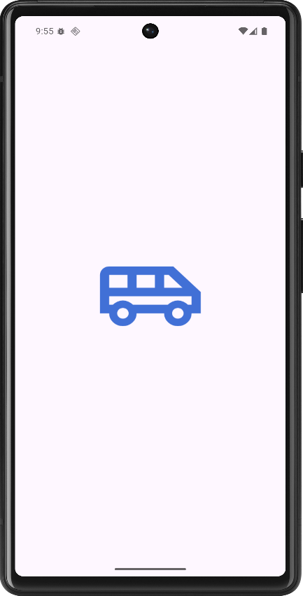
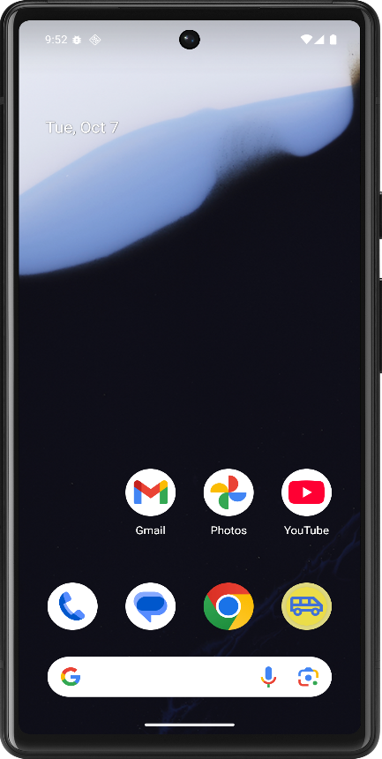

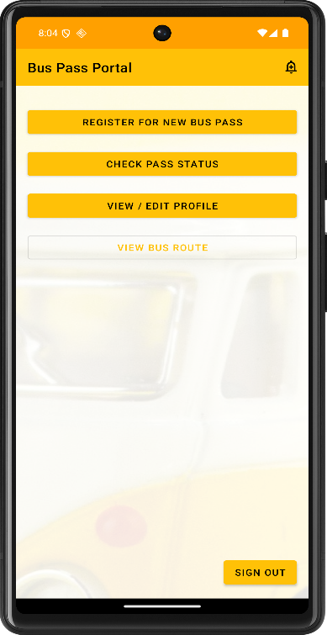
Figure 7.1 Application Figure 7.2 App Loading Interface
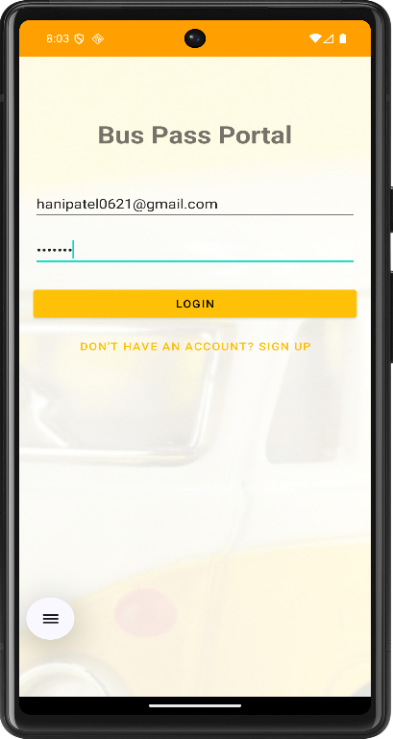

Figure 7.3 Login Interface Figure 7.4 Home Screen
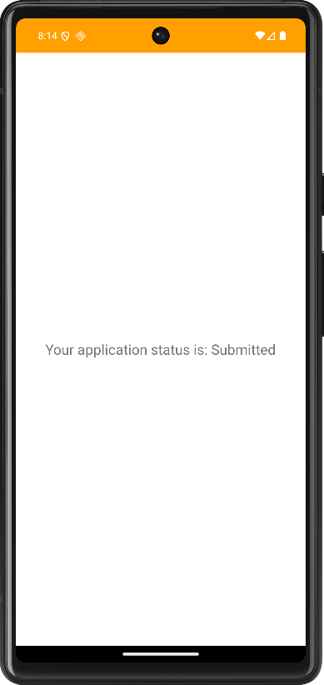
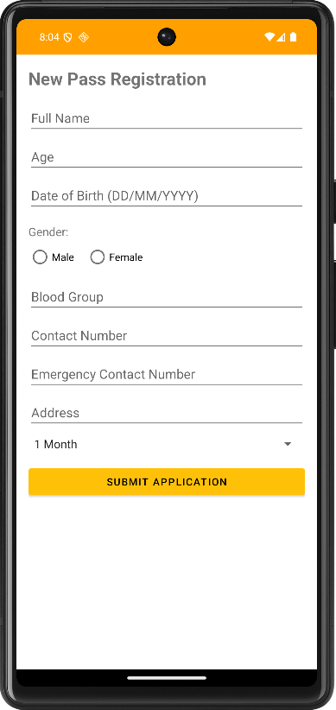

Figure 7.5 Registration Form Figure 7.6 Pass Status After Submitting Form
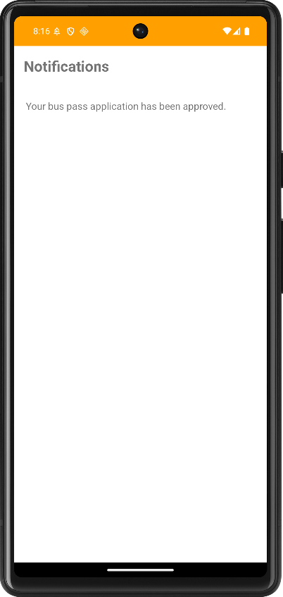
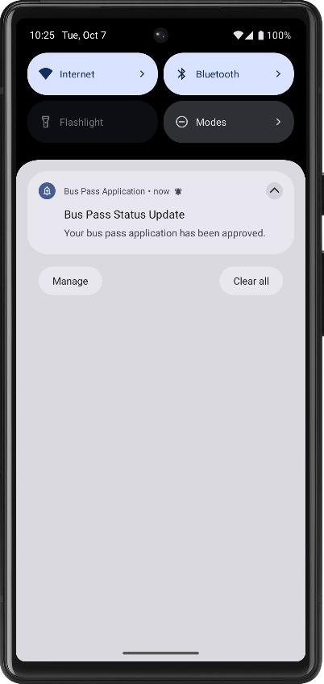

Figure 7.7 Notification Interface Figure 7.8 Notification Drawer
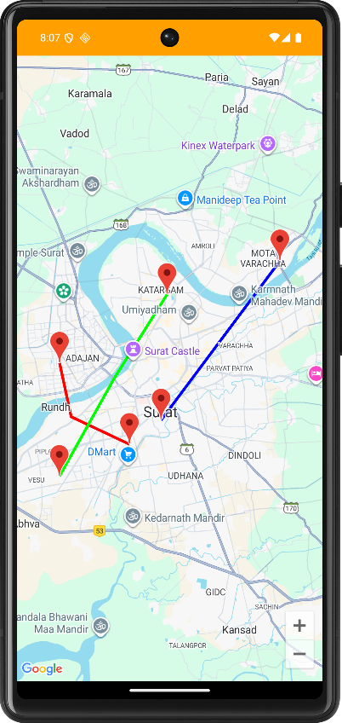
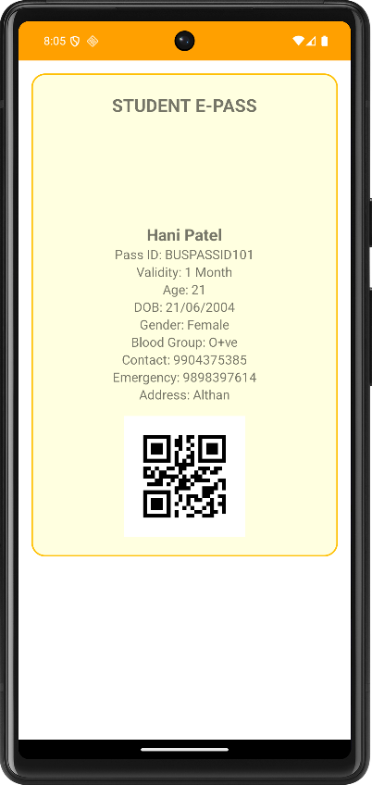

Figure 7.9 E-Pass With QR Code After Form Approval Figure 7.10 Google Map to View Bus Routes

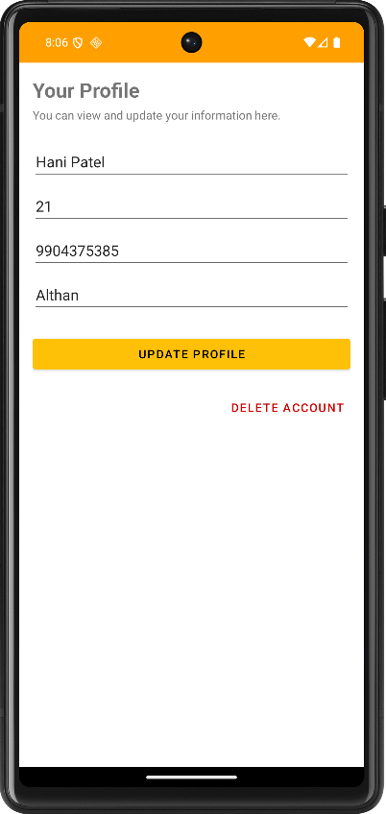

Figure 7.11 Edit/View/ Delete Profile Interface
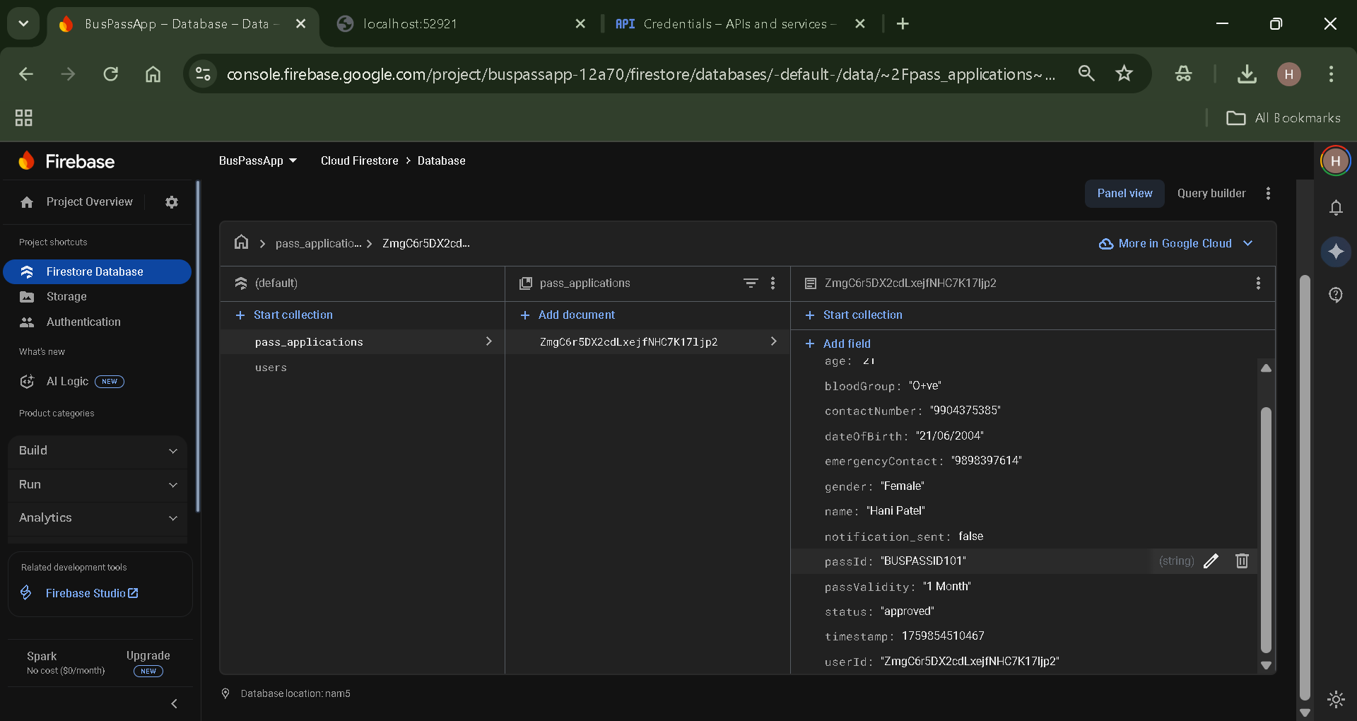
Figure 7.12 Firebase Datastore
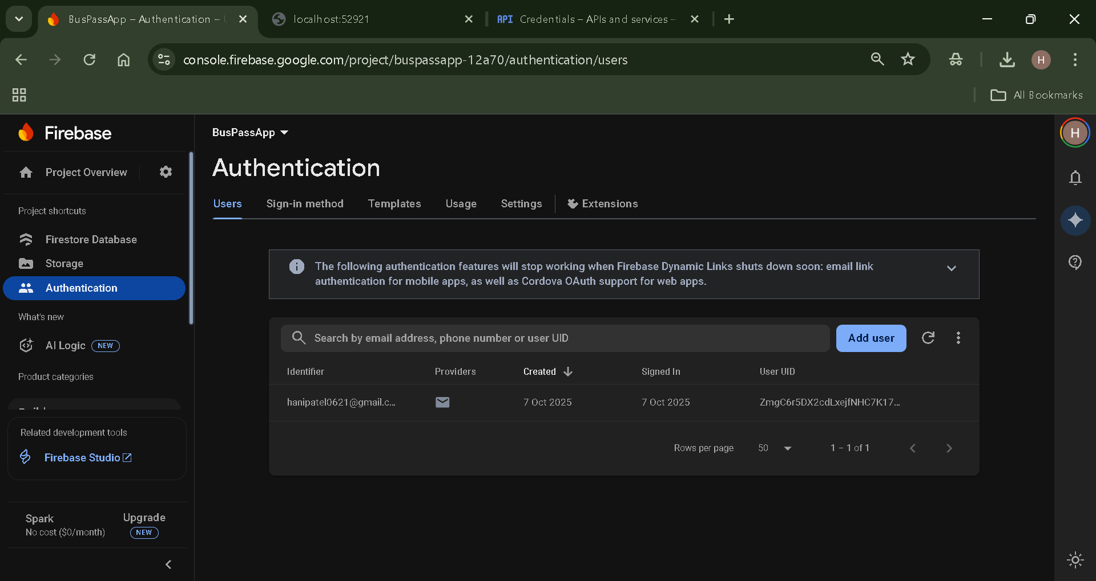

7.13 Firebase Authentication

APK steps of the application:

To distribute or submit the application, it must be packaged into an APK (Android Package Kit) file. This process involves digitally signing the app to verify its authenticity.
- In the top menu bar of Android Studio, click Build > Generate Signed Bundle / APK....
- A dialog will appear. Select APK and click Next.
- The "Generate Signed APK" window will open. In the "Key store path" section, click Create new.
- The "New Key Store" window will appear. Filled this to create a digital signature.
- Key store path: Click the folder icon and choose a location on computer to save your key file. Given a file name like bus_pass_key.jks.
- Password: Create and confirm a secure password for key store.
- Key alias: Given key an alias, like buspassapp.
- Password: Create and confirm a password for the key itself.
- Validity: Leave this at the default 25 years.
- Certificate: Filled name field.
- Click OK.
- It will be returned to the "Generate Signed APK" window. The paths and passwords just created will be filled in. Click Next.
- On the final screen, choose the Build Variant. For a final version, select release.
- Click Finish.
Android Studio will now build the signed APK. This may take a minute. When it's finished, a small pop-up will appear in the bottom-right corner with a link to "locate" the file. Clicking this will open the folder on computer containing the app-release.apk file.

