

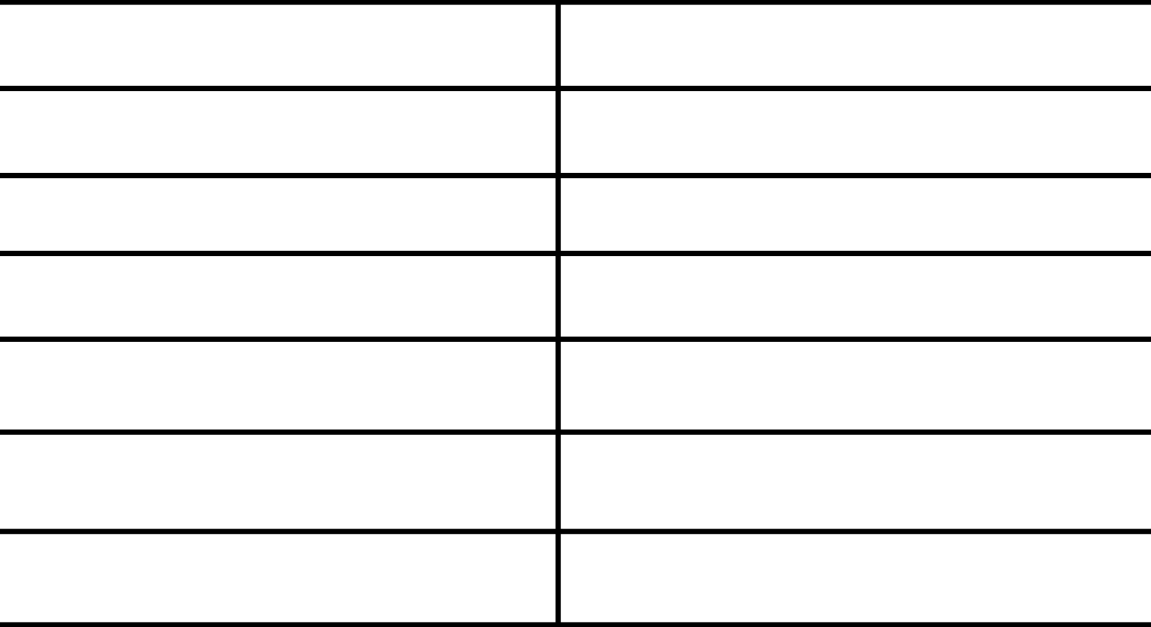

20191700729

20191700165

20191700728

20191700730

20191700732

20191700740

20191700742

Contact us via

[hady20191700728@cis.asu.edu.eg](mailto:hady20191700728@cis.asu.edu.eg)

ھﺎدى ﻋﺎطﻒ ﺳﯿﺪ ﻣﺤﻤﺪ

ھﯿﺜﻢ ﻣﺤﻤﻮد اﻟﺴﯿﺪ ﻣﺤﻤﻮد

ھﺎﻧﻰ ﻣﺤﻤﺪ ﺳﯿﺪ اﺣﻤﺪ

وﺳﯿﻢ ﻋﺒﺪه ﻓﺘﺤﻰ ﻋﺒﺪه

ھﺎدى اﺣﻤﺪ ﻋﺒﺪ اﻟﺴﻼم

ھﺎدى اﻳﮭﺎب رﺟﺎء اﺣﻤﺪ

اﻳﻪ ﻣﺤﻤﺪ ﻋﺒﺪاﻟﻌﺰﻳﺰ اﺑﺮاھﯿﻢ

Team Members

Team ID – 37

TA – Radwa Mostafa

**Note: Please kindly run all the statements starting from the first line till the last insert statement including “commit;”. After that, run the procedures one by one.**

drop SEQUENCE seqHistoryId;

drop table medicines cascade constraints;

drop table users cascade constraints;

drop table login cascade constraints;

drop table cart cascade constraints;

drop table userHistory cascade constraints;

drop table History cascade constraints;

CREATE SEQUENCE seqHistoryId

MINVALUE 1

START WITH 1

INCREMENT BY 1;

create table Medicines(

medId number primary key ,

medName varchar(50) not null,

desciption varchar(50) not null,

medPrice number not null,

medAmount number not null,

medCategory varchar(50) not null,

medCatId number not null

);

create table users(

userId number primary key,

gender varchar(50) not null,

userName varchar(50) not null,

userAge number not NULL,

userPassword varchar(50) not null);

create table login(

userId number not null,

gender varchar(50) not null,

userName varchar(50) not null,

userAge number not NULL,

userPassword varchar(50) not null);

create table cart(

cartUserId number references users (userId),

cartMedId number references Medicines (medId) on delete cascade,

amount number not null,

constraint PK_D primary key (cartUserId, cartMedId)

);

create table userHistory(

historyID number PRIMARY KEY ,

userId number references users (userId) on delete cascade,

total number not null,

timeP varchar(50) not null

);

create table History(

historyId number references userHistory (historyId),

medId number references medicines (medId) on delete cascade,

amount number not null);

commit;

insert into medicines values(1,'Panadol','For treating moderate and severe migraines',19.5,200,'Medicines',1);

insert into medicines values(2,'Abimol Extra','Analgesic and Antipyretic | 20 tab',9,150,'Medicines',1);

insert into medicines values(3,'Hero Milk','400gm Lactose-free Infant',124,120,'Medicines',1);

insert into medicines values(4,'Kenacomb','Cream | 30gm',24.5,90,'Medicines',1);

insert into medicines values(5,'Bronchicum','Anti Cough | 100ml',35,170,'Medicines',1);

insert into medicines values(6,'Cetal','Antiviral | 20caps',15,180,'Medicines',1);

insert into medicines values(7,'Otrivin','Nasal Drops for Adult | 15ml',10,190,'Medicines',1);

insert into medicines values(8,'Zyrtec','Treating Allergies | 10mg | 20 Tabs',39.75,145,'Medicines',1);

insert into medicines values(9,'Closeup','Toothpaste Menthol Fresh - 120ml',28,300,'Oral Care',7);

insert into medicines values(10,'Visine','Original Eye Drops | 15ml',13.5,210,'Medicines',1);

insert into medicines values(11,'Molfix','7 Diapers Small Pack | Size 5',25,160,'Baby Care',2);

insert into medicines values(12,'Milo','Baby Cream | 150gm',75,100,'Baby Care',2);

insert into medicines values(13,'Rexona','Motion sense Deodorant',10,155,'Women Care',3);

insert into medicines values(14,'Bobana','Shower Gel Madness | 500ml',25,85,'Women Care',3);

insert into medicines values(15,'Johnsons','Gold Shampoo | 100ml',19,115,'Baby Care',2);

insert into medicines values(16,'Axe Excite','Deodorant Body Spray - 150ml',58,135,'Men Care',4);

insert into medicines values(17,'Nivea','Dry Impact Deodorant Spray | 150ml',50,165,'Men Care',4);

insert into medicines values(18,'Gillette','Men’s Disposable Razors - 5 Pack',38,142,'Men Care',4);

insert into medicines values(19,'Seropipe','spray 200 ml',150,60,'Hair Care',5);

insert into medicines values(20,'Garnier','Color Naturals Crème Hair Color',55,85,'Hair Care',5);

insert into medicines values(21,'Beurer','Weight Scale Glass Electronic | 180kg',799,100,'Med. Supplies',9);

insert into medicines values(22,'Syringe','3 ml',2,300,'Med. Supplies',9);

insert into medicines values(23,'Lifebuoy','Total 10 Soap | 125gm',9,250,'Protection 101',10);

insert into medicines values(24,'Wipes','Dettol | Fresh Skin Wipes | 10s',19,220,'Protection 101',10);

insert into medicines values(25,'Hand Gel','Secure Hand Gel | 75ml',20,215,'Protection 101',10);

insert into medicines values(26,'Arthenia','Skin Cream | 20gm',85,140,'Skin Care',6);

insert into medicines values(27,'Oral B 123','Toothbrush',18,135,'Oral Care',7);

insert into medicines values(28,'Areej','Peppermint Cream | 200gm',150,50,'Organic Prods.',8);

insert into medicines values(29,'Sensodyne','Action Nitro Toothpaste - 75ml',34,155,'Oral Care',7);

insert into medicines values(30,'Fucidin','15 gm Cream',23,95,'Medicines',1);

insert into medicines values(31,'C-retard','Vitamin C | 500mg | 10 Capsules',16,105,'Medicines',1);

insert into medicines values(32,'Antinal','Treating Diarrhea | 24 Caps',21,205,'Medicines',1);

insert into medicines values(33,'Glycerin','Infants | 5 Supps',5.3,198,'Medicines',1);

insert into medicines values(34,'Physiomer','Strong Jet Nasal Spray | 210ml',110,75,'Medicines',1);

insert into medicines values(35,'Eva','Skin Care | 100 ml',20,115,'Women Care',3);

insert into medicines values(36,'OGX','Brazilian Keratin Conditioner | 385ml',250,185,'Hair Care',5);

insert into medicines values(37,'Infinity','Care Sunscreen Mist SPF 50+ | 200ml',175,60,'Skin Care',6);

insert into medicines values(38,'Beesline','Whitening and Lifting Facial Foam | 150ml',210,100,'Skin Care',6);

insert into medicines values(39,'Oil House','Coffee Oil 30 Ml',120,155,'Organic Prods.',8);

insert into medicines values(40,'Bless','Argan Oil | 50ml',185,177,'Organic Prods.',8);

insert into users values(1, 'Male','Hadi', 20 ,'hadi' );

insert into users values(2, 'Male','Haytham', 22 ,'h123' );

insert into users values(3, 'Male','Hani', 21 ,'456' );

insert into users values(4, 'Female','Aya', 23 ,'908' );

insert into users values(5, 'Not Say','Alberto', 30 ,'alb12');

insert into cart values(1,9,3);

insert into cart values(2,5,4);

insert into cart values(5,6,7);

insert into cart values(3,4,5);

insert into cart values(4,2,8);

insert into userhistory values(1,1,208.6875,'5/6/2022 12:52:13 AM');

insert into userhistory values(2,2,208.6875,'5/6/2022 12:52:13 AM');

insert into userhistory values(3,3,208.6875,'5/6/2022 12:52:13 AM');

insert into userhistory values(4,4,208.6875,'5/6/2022 12:52:13 AM');

insert into userhistory values(5,5,208.6875,'5/6/2022 12:52:13 AM');

Commit;

create or replace procedure GetMed2(MedicineID out NUMBER, mName in VARCHAR2,MedicinePrice out NUMBER, MedicineAmount out NUMBER, MedicineCat out number )

as

begin

SELECT meds.medid ,meds.medprice, meds.medamount ,meds.medcatid

INTO medicineid ,MedicinePrice, MedicineAmount ,MedicineCat

from medicines meds

where upper(meds.medname) like upper(mname);

end GetMed2;

create or replace procedure GetAllMeds(MID OUT sys_refcursor)

AS

begin

OPEN mid for

SELECT * from medicines;

end GetAllMeds;

create or replace

procedure GetMedCategory(cat in VARCHAR2, allprop out sys_refcursor)

as

begin

open allprop for

select *

from medicines

where medcategory = cat;

end GetMedCategory;