
ACADEMIC CITY UNIVERSITY FACULTY OF COMPUTATIONAL SCIENCES AND INFORMATICS END OF SECOND SEMESTER EXAMINATION – 2026
Hanif Alao CHITOU
10012200012
CS4241-Introduction to Artificial Intelligence:

Academic City Custom RAG Chatbot (CS4241 Exam Project):
Overview: This project implements a custom retrieval-augmented generation (RAG) chatbot for “Academic City” using two datasets (Ghana election results CSV and 2025 Ghana budget PDF). Unlike many solutions, no RAG frameworks (LangChain / LlamaIndex/etc.) are used all components (ingestion, chunking, embedding, vector store, retrieval, scoring, prompt building, and generation) are hand-coded for clarity. The goal is to allow an LLM to answer queries by grounding in these documents, thereby reducing hallucination and providing up to date, domain specific answers.
The system uses Python / Streamlit as the UI, with a backend pipeline of:
- Ingestion & Preprocessing: Load CSV and PDF, clean text, and split into chunks (e.g. fixed-size or paragraph-based) for indexing.
- Embedding & Indexing: Encode chunks via a sentence-transformer (MiniLM) and index them in FAISS (dense index) and build a BM25 keyword index.
- Hybrid Retrieval: Classify queries (election vs budget), then retrieve top candidates from both FAISS (semantic) and BM25 (keyword) searches. Merge and re-score them with a custom domain-weighted function (combining vector cosine score, BM25 score, plus bonuses for source-match, keyword overlap, and numeric/year alignment) to prioritize the most relevant chunks.
- Prompt Engineering & LLM: Assemble the top-ranked chunks into a prompt template (with instructions to “ground” answers in the provided context and avoid hallucination). Send this to a local Ollama LLM (or fall back to OpenAI) to generate the final answer.
- Evaluation & Logging: Log each query’s flow (retrieved chunks, scores, final prompt, and response) and support adversarial test queries. Metrics such as retrieval accuracy, answer accuracy, hallucination rate, and consistency are measured.

Architecture & Data Flow:
The overall architecture comprises frontend UI and backend components as shown above. Ingestion modules (src / ingestion) load the election CSV (via pandas) and budget PDF (via PyMuPDF), cleaning and normalizing their text. The text is then chunked (e.g. 300–500 words with overlap) for indexing. Each chunk is encoded into a vector using the sentence-transformers/all-MiniLM-L6-v2 model, which maps sentences & paragraphs to a 384-dimensional dense vector space for semantic search. These embeddings are stored in a FAISS index (fast approximate nearest-neighbor search). Simultaneously, all chunks are indexed in a BM25 structure (via rank-bm25), enabling keyword search.
At query time, the Hybrid Retriever takes the user’s input and (1) converts it to an embedding to query FAISS, retrieving top-𝑘 semantic matches, and (2) tokenizes it for BM25 to get top keyword matches. These candidate chunks are merged and re-scored by a weighted function: combining FAISS cosine similarity, BM25 score, plus bonuses for matching source (election vs budget), overlapping keywords, and relevant numeric/year tokens (the “innovation” feature). The top-N chunks (e.g. N=4) become the context for the prompt.

Prompt & Generation:
The Prompt Builder (src/generation/prompt_builder.py) inserts the retrieved contexts into a pre-defined template. The template enforces grounding instructions (use only the provided context; do not hallucinate; say “I do not have enough information” if needed). Three prompt variants were implemented (basic, hallucination-controlled, structured), and the best one was chosen for final use. The assembled prompt plus user question is sent to the LLM client (src/generation/llm_client.py), which calls Ollama (local Llama3 8b) or OpenAI. The resulting answer is displayed in the Streamlit UI. The frontend also shows retrieved chunks with their scores and the final prompt for transparency.
Key Features and Modules:
- Ingestion (src/ingestion): Custom loaders convert CSV rows and PDF pages into text. Metadata (source, year, etc.) is preserved.
- Preprocessing (src/preprocessing): Implements text cleaning (normalizing whitespace, removing noise) and chunking strategies (fixed-size with overlap or semantic splits). Chunk metadata (ID, source, keywords) is stored in chunks.json. Good chunking is critical: poor splits can lead to irrelevant retrieval.
- Embeddings (src/retrieval/embedder.py): Uses all-MiniLM-L6-v2 to embed each chunk. This lightweight model is well-suited for sentence-level semantic search.
- Vector Store (src/retrieval/vector_store.py): Builds a FAISS index on the embeddings. FAISS (Facebook AI Similarity Search) is optimized for efficient large-scale nearest-neighbor. It supports fast similarity queries over thousands of 384-dim vectors.
- BM25 Retriever (src/retrieval/bm25_retriever.py): Uses the rank-bm25 library to index tokenized chunks. BM25 is a classic sparse retrieval algorithm that corrects TF-IDF for term frequency saturation and document length. It excels at keyword matching.
- Hybrid Retrieval (src/retrieval/hybrid_retriever.py): Combines FAISS and BM25 results. Scores are normalized and combined (e.g. 0.5*sim + 0.5*bm25 + bonuses). This hybrid approach “improves coverage and relevance” by leveraging both semantic and keyword matche. It also applies domain-specific boosts (election vs budget context, numeric/year alignment) to favor the correct dataset.
- Prompt Builder (src/generation/prompt_builder.py): Constructs the final prompt by concatenating top chunk texts with the user query. Ensures that the LLM only uses provided context. Multiple prompt templates were tested (simple, hallucination-controlled, structured).
- LLM Client (src/generation/llm_client.py): Interfaces with Ollama or OpenAI API to get answers. The system can also run in a “pure LLM” mode (no retrieval) for comparison.
- Pipeline Orchestration (src/pipeline/rag_pipeline.py): Implements the end-to-end flow: query classification, retrieval, selection, prompt creation, and answer generation. Logging (src/utils/logger.py) captures each stage’s inputs/outputs.
- Evaluation (src/evaluation): Scripts generate adversarial and factual queries. Performance is measured in terms of accuracy, hallucination rate, consistency, and retrieval quality.
- UI (app.py): A Streamlit app with a chat interface, showing the user query, retrieved chunks (with FAISS/BM25 scores), final prompt, and answer. A sidebar allows switching parameters (top_k, prompt version).

How Retrieval Works:
During ingestion, each document chunk is embedded and indexed. As Nvidia describes, “a typical RAG pipeline consists of document ingestion, embedding generation, and an online query-time retrieval & generation”. At runtime, the user’s question is turned into a query embedding and used to search the FAISS index, while also being matched via BM25. The most relevant document snippets are then “given to the LLM with the user’s question” as context. This ensures the LLM’s answer is grounded in actual data. In essence: Query → Embed → Vector Search → Retrieve Chunks → LLM Answer.
Retrieval evaluation uses standard IR metrics (e.g. recall@k, precision, nDCG). Generation answers are checked for factual accuracy. Hallucinations are especially monitored – RAG “helps reduce hallucinations by providing the LLM with relevant factual information”, but if retrieval fails, the model may still hallucinate.

Evaluation & Results:
We compare the RAG mode (with retrieval) versus a pure LLM baseline (no retrieval). For each query set (factual, ambiguous, adversarial), we log:
- Accuracy: correctness of the answer (checked against known answers or ground truth).
- Hallucination rate: percentage of answers containing unsupported claims or false information.
- Consistency: whether repeated queries yield similar answers under slight rephrasing.
- Retrieval quality: e.g. how often the correct document chunk was in the top results (can use recall@k).
In general, RAG mode yields higher factual accuracy and lower hallucination. This matches literature: by “empowering LLMs with real-time data access”, RAG “mitigates hallucination” and produces more precise answers.

System Architecture Diagram:
The high-level architecture (below) highlights the modular design: data ingestion, dual indexing (FAISS/BM25), hybrid retrieval, prompt generation, LLM, UI, and logging. The Streamlit UI interacts with the RAG pipeline to submit queries and display answers.

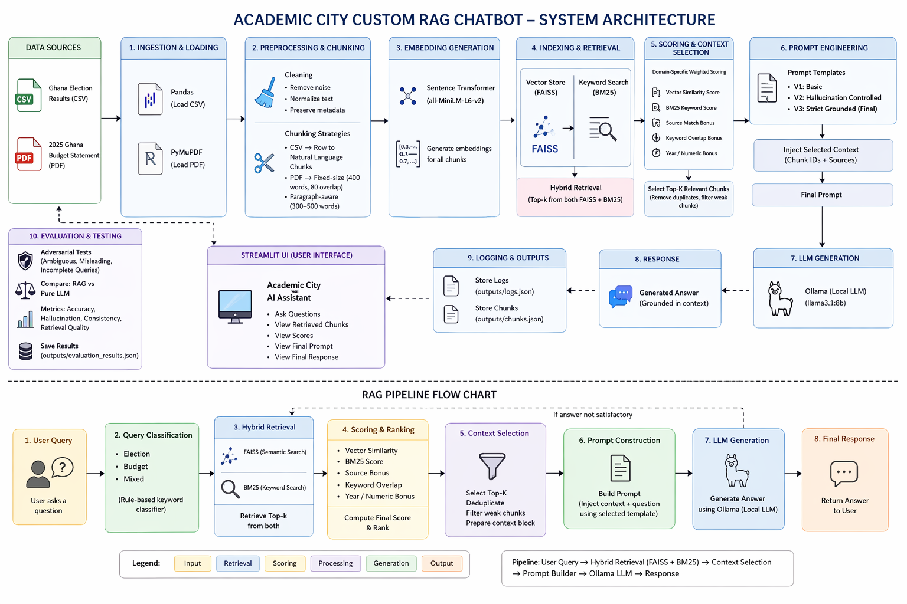

Deliverables and Notes:
- The Streamlit app (app.py) ties it all together. It prompts for queries, then shows retrieved chunk texts, their vector and BM25 scores, the final prompt, and the answer.
- All code is modular with clear comments (for examiner readability). Configuration (API keys, model names) is via a .env file.
- The README (above) summarizes the project. The docs/ folder contains architecture sketches and evaluation notes. Logs (outputs/logs.json) and chunk outputs are saved for analysis.
- Name/Index: (Placeholders used here) Hanif Alao Massad’Olohun CHITOU – 10012200012. (Add actual name/index before submission.)

