Software Requirements
Specification

A Mobile Application for Facility Management

Team
UNI•FLOW

Tutorial Details
3 | Moamen Attia

Members
Hania Mohsen | 13007287 (Lead)
Nadine Mohsen| 13007288
Nada Ehab| 13002151
Maryam Nasser | 13004116
Chantal Victor | 13007378
Saif Eldeen Shoman | 13006530
Salma Momtaz | 13004419

- Introduction
This document describes the Software Requirements Specification (SRS) for the Facility Management Mobile Application at the German International University (GIU).
The purpose of this system is to provide an easy and efficient way for members of the GIU community to report infrastructure, maintenance, cleanliness, and sustainability issues on campus. Campuses are important assets for any university. They affect students’ comfort, productivity, and overall experience. They also create first impressions for new students and visitors.
Even with regular maintenance, issues such as broken doors, flickering lights, overflowing trash cans, or open windows while the AC is running can still occur. Therefore, there needs to be a clear and organized way for community members to report these problems.
The mobile application will allow users to submit a ticket by taking a photo, writing a short description, and selecting the location of the issue. The Facility Management team will be able to view these tickets, assign workers, and update their status. This helps ensure faster response times and better communication between all parties.
This document is intended for developers, instructors, project stakeholders, and team members involved in building and evaluating the system. It explains what the system should do and defines its requirements.

1.1 Product Vision & Scope
The vision of the Facility Management Mobile Application is to create a centralized and easy-to-use platform that improves how maintenance issues are reported and handled at GIU.
The main goal of the system is to make it simple for community members to report problems they notice on campus and to ensure that these problems are handled quickly and efficiently. By involving students and staff in reporting issues, the system also encourages a sense of responsibility and ownership toward the university environment.
The application will support three main user roles: community members, workers, and the facility manager. Each role will have specific permissions within the system (RBAC). Community members can submit tickets and track their status. Workers can view the tickets assigned to them and update their status after handling the issue. The facility manager, who is also the admin, is responsible for viewing all submitted tickets, assigning workers to them, updating ticket statuses, and managing users within the system.
The scope of the project includes:
- Creating and submitting maintenance tickets with a photo, description, and location.
- Viewing and tracking ticket status.
- Assigning tickets to workers.
- Sending notifications when tickets are created, assigned, or resolved.
The system does not include financial management, payroll systems, or other unrelated university services.

1.2 Definitions and Acronyms
Below are important terms and abbreviations used in this document:
- SRS (Software Requirements Specification): A document that describes the system’s features, requirements, and constraints.
- GIU (German International University): The university for which the system is being developed.
- Ticket: A digital record created in the system to report a maintenance or infrastructure issue.
- RBAC (Role-Based Access Control): A system where users are given permissions based on their role.
- API (Application Programming Interface): A set of rules that allows the mobile application to communicate with the backend system.
- UI (User Interface): The visual part of the application that users interact with.

User Stories and Functional Requirements:

  - User stories:

Community Member User Stories:
US-CM-01:
As a Community Member, I want to create an account, so that I can access the system.
US-CM-02:
As a community member, I want to log in using my email and password, so that I can securely access the system.

US-CM-03:
As a community member, I want to receive a verification email to confirm my university email address before full access, so that only valid users can use the system.

US-CM-04:
As a community member, I want to create a new maintenance ticket when I notice an issue, so that it can be addressed by the facility team.

US-CM-05:
As a community member, I want to take or upload photos of the issue, so that the maintenance team can understand the problem better.

US-CM-06:
As a community member, I want to select or enter the location of the issue, so that the maintenance team knows exactly where to go.

US-CM-07:
As a community member, I want to add additional details about the issue, so that the maintenance team has all the necessary information

US-CM-08:
As a Community Member, I should be able to view my submitted issues so that I can track their status.
US-CM-09:
As a community member, I want to track the status of my submitted tickets (Pending, In Progress, Resolved), so that I know when the issue is being handled.

US-CM-10:
As a community member, I want to receive push notifications only when the ticket status changes to resolved, so that I am informed when the problem has been fixed.

Community Member Functional Requirements

FR-CM-01: Account Creation
The system shall allow community members to create an account by providing required information such as name, email and password.
FR-CM-02: User Authentication
The system shall allow community members to log in using a valid email and password.
FR-CM-03: Log Out
The system shall allow community members to log out of the application securely.
FR-CM-04: Email Verification – Community Member
The system shall send a verification email to community member users (Students, Professors, TAs) to confirm that their university email address is valid before allowing full access to the system.
FR-CM-05: View My Tickets
The system shall allow users to view his submitted tickets.
FR-CM-06: Search & Filter
The system shall allow users to filter tickets by category, status, or location.
FR-CM-07: Create Ticket
The system shall allow logged-in users to create a new maintenance ticket.
FR-CM-08: Upload Photo
The system shall allow users to take or upload photos of the issue.
FR-CM-09: Specify Location
The system shall allow users to select or enter the issue location.
FR-CM-10: Add Description and Category
The system shall allow users to add additional details and category of the issue.
FR-CM-11: Track Status
The system shall allow users to track the status of submitted tickets.
Possible statuses include:
- Pending
- In Progress
- Resolved

FR-CM-12: Notifications
The system shall send push notifications to users only when the ticket status changes to resolved.

Facility Manager User Stories:

US-FM-01:
As a Facility Manager, I want to be able to create an account so that I can log in to the facility management system.
US-FM-02:
As a Facility Manager, I want to log in using my email and password, so that I can securely access the facility management system.
US-FM-03:
As a Facility Manager, I want to log out of the system, so that my account remains secure on shared devices.
US-FM-04:
As a Facility Manager, I want to view and filter all submitted tickets by status, category, location, and priority, so that I can quickly identify critical issues and manage them efficiently.
US-FM-05:
As a Facility Manager, I want to assign newly submitted tickets to available workers based on both the issue type and the priority level, so that high-priority maintenance problems are addressed promptly and resources are allocated efficiently.
US-FM-06:
As a Facility Manager, I should be able to update an issue’s status so that the system reflects the current state of the issue.

US-FM-07:
As a Facility Manager, I want to view reports on worker performance and ticket resolution times, so that I can evaluate efficiency and improve service quality.

US-FM-08:
As a Facility Manager, I should be able to close an issue after it is resolved so that the system reflects that the issue is completed.

Facility Manager Functional Requirements:
FR-FM-01: Account Creation
The system shall allow a Facility Manager to create an account.
FR-FM-02: User Authentication
The system shall allow the facility manager to log in using a valid email and password.

FR-FM-02: Logout
The system shall allow the facility manager to log out of the application securely.

FR-FM-03: Manual Worker Verification
The system shall allow the facility manager to manually verify and approve worker accounts before granting them access to the system.

FR-FM-04: View All Tickets
The system shall allow the facility manager to view all submitted tickets across the campus.
Included Use Case: Filter Tickets — the facility manager can filter tickets by status, category, location, or priority level.
Included Use Case: Review Proof Photos — the facility manager can review uploaded proof photos before marking tickets as resolved.

FR-FM-05: Set Priority – Manual & AI Support
The system shall allow the facility manager to manually set or modify the priority level of tickets based on status, category, location and priority level.
The system shall also include an AI-based model that suggests a priority level based on keywords detected in the ticket description.

FR-FM-06: Assign Ticket to Worker
The system shall allow the facility manager to assign submitted or unassigned tickets to verified workers based on issue category and priority level.

FR-FM-07: Update Issue Status
The system shall allow a Facility Manager to update the status of an issue.

FR-FM-08: Close Issue
The system shall allow a Facility Manager to close an issue once it has been resolved.

Worker User Stories:

US-W-01:
As a Worker, I want to be able to create an account so that I can log in to the application.
US-W-02:
As a worker, I want to log in using my email and password only after verification by the facility manager, so that I can securely access the system and start handling assigned tickets.
US-W-03:
As a worker, I want to log out of the system, so that my account remains secure on shared devices.
US-W-04:
As a worker, I want to receive notifications whenever a new ticket is assigned to me, so that I can respond promptly to maintenance requests.
US-W-05:
As a worker, I want to view a list of tickets assigned to me, so that I can see my workload and plan my tasks efficiently.
US-W-06:
As a worker, I want to view detailed information for each assigned ticket—including location, photos, description, category, and priority level—so that I fully understand the issue before starting work.
US-W-07:
As a worker, I want to accept or acknowledge tickets assigned to me, so that the system and facility manager know I am responsible for handling them.
US-W-08:
As a worker, I want to update a ticket’s status from “Assigned” to “In Progress”.
US-W-09:
As a worker, I want to add comments to a ticket, so that I can provide updates or communicate progress to the facility manager.
US-W-09:
As a worker, I want to upload before-and-after photos to the ticket as proof of completion, so that the facility manager can verify my work and update ticket status.
US-W-10:
As a worker, I want to view my previously handled and completed tickets, so that I can track my work history and review past tasks if needed.

Worker Functional Requirements:

FR-W-01: Account Creation
The system shall allow a Worker to create an account.
FR-W-02: User Authentication
The system shall allow workers to log in using their email and password only after manual verification by the facility manager.
FR-W-03: Logout
The system shall allow workers to log out of the application securely.
FR-W-04: Receive Ticket Notifications
The system shall notify workers when a new ticket is assigned to them by the facility manager.
FR-W-05: View Assigned Tickets
The system shall allow workers to view a list of tickets assigned to them.
FR-W-06: View Ticket Details
The system shall allow workers to view detailed ticket information including location, photo, description, category, and priority level.
FR-W-07: Accept Ticket
The system shall allow workers to accept or acknowledge assigned tickets.
FR-W-08: Comment on Ticket
The system shall allow workers to add comments to tickets for communication and updates.
FR-W-09: Update Ticket Status to In Progress
The system shall allow a Worker to mark an assigned issue as In Progress.
FR-W-10: Upload Proof Photos to Ticket
The system shall allow workers to upload before and after photos as proof of completion within the ticket.
FR-W-11: View Ticket History
The system shall allow workers to view their previously handled and completed tickets.

System Admin User Stories

US-SA-01:
As a System Admin, I want to log in so that I can access the application.

US-SA-02:
As a System Admin, I want to log out so that my data remains secure on shared devices.

US-SA-03:
As a System Admin, I want to activate or deactivate any account so that I can ensure all users follow the system rules.

US-SA-04
As a System Admin, I want to view all registered users so that I can manage the system users.

System Admin Functional Requirements
FR-SA-01: Admin Authentication
The system shall allow a System Admin to log in.
FR-SA-02: Logout
The system shall allow a System Admin to log out.
FR-SA-03: Account Management
The system shall allow a System Admin to activate or deactivate user accounts.
FR-SA-04: View Registered Users
The system shall allow a System Admin to view all registered users in the system

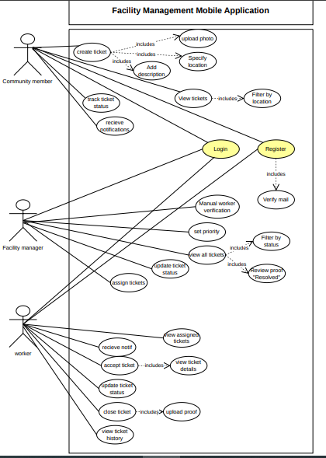
  - UML Use-case Diagram

3. Non-functional Requirements:
Details the performance, usability, security, and other constraints of the system.

- Response Time: Page load times under three seconds
- Concurrent Users: Support for at least 500 simultaneous users
- API Security: Rate limiting and input validation
- Backup & Recovery: Automated daily backups with disaster recovery plan
- Usability: Intuitive UI such that tickets for issues can be submitted in under one minute.
- Reliability: Must handle image uploads robustly, even on unstable network connections.

4. Constrains:
Design Constraints:
The system design must follow GIU’s official branding guidelines (colors, logo usage, and UI standards) to ensure consistency with university platforms. The application must implement Role-Based Access Control (RBAC) to strictly separate permissions between community members, workers, and the facility manager. The UI must remain simple and intuitive to allow ticket submission in under one minute, which limits complex navigation or advanced design features as it may take additional time for the user to complete the task. In addition, the design must ensure compatibility with common smartphone screen sizes and operating systems (Android and iOS), restricting the use of features or layouts that are not supported across different devices and ensuring consistent performance and usability.

Development Constraints:
The system must be developed to ensure fast response times, meaning that screens, ticket submissions, and status updates should load quickly without noticeable delays. This requires efficient backend processing, optimized database queries, and proper handling of image uploads to prevent system lag. The application must also integrate with GIU’s existing IT infrastructure and follow its security and network policies, which limits architectural and technology choices. Additionally, the backend must be structured to handle multiple users performing actions simultaneously without affecting overall system performance.
Implementation Constraints:
The system must be implemented on GIU-approved servers or cloud platforms, limiting hosting choices. Also, Storage space for images and ticket data is restricted so large or uncompressed files cannot be used, requiring careful handling and optimization of uploaded images. All updates and maintenance must be performed with minimal downtime, restricting features that need long interruptions.

5. Entity Relation Diagram
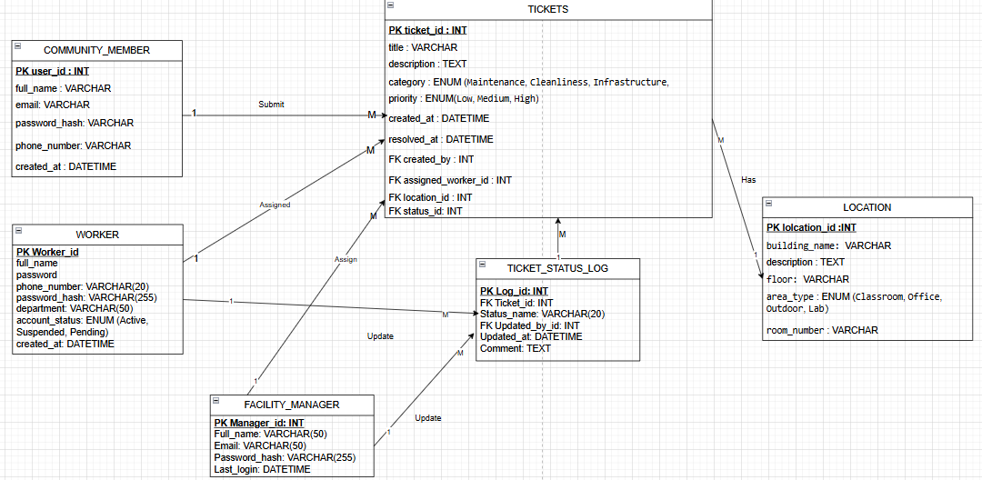
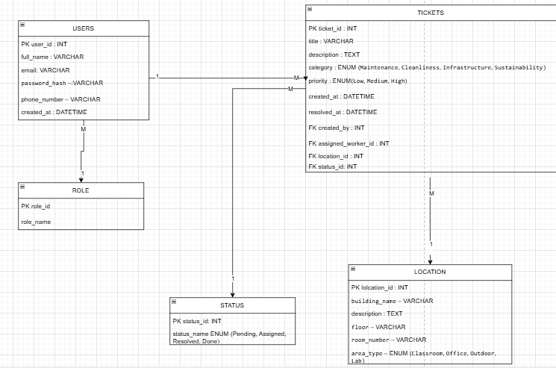

6. Technology Stack
- Response Time: Page load times under three seconds
- Concurrent Users: Support for at least 500 simultaneous users
- API Security: Rate limiting and input validation
- Backup & Recovery: Automated daily backups with disaster recovery plan

7. Future Scope of the Project
Future versions of the system may include the following additional enhancements:
- QR Code Reporting: Place QR codes in campus buildings that allow users to instantly report an issue in that specific location without manually entering it.
- Live Ticket Status Timeline: Add a visual progress timeline (Submitted → Assigned → In Progress → Resolved → Done) for better transparency.
- Multi-Language Support: Provide Arabic and English language options to improve accessibility for all users.
- Push Notifications for All Status Changes: Allow users to customize which ticket updates they want to receive notifications for.
- Analytics Heatmap: Display a campus map highlighting locations with the highest number of reported issues.

