ABSTRACT
This project, developed during a professional internship at Codec Technologies, addresses the critical challenge of information filtering in the digital era. As content libraries grow exponentially, personalized discovery is essential for user retention. This work implements a Hybrid Recommendation System designed to overcome the limitations of traditional single-model architectures, specifically the "Cold Start" problem and "Popularity Bias."
The system is built on a two-tier architecture. The first tier utilizes Content-Based Filtering through TF-IDF (Term Frequency-Inverse Document Frequency) vectorization and Cosine Similarity to map item-to-item relationships based on metadata. The second tier implements Collaborative Filtering using a K-Nearest Neighbors (KNN) algorithm and Matrix Factorization to identify patterns in user behavior and ratings. To enhance real-world usability, a Fuzzy Logic string-matching layer was integrated to handle natural language search queries and typographical errors.
Data engineering was performed on the MovieLens 100k dataset, utilizing Compressed Sparse Row (CSR) matrices to optimize memory efficiency during the training of the collaborative model. Evaluation was conducted using Root Mean Square Error (RMSE) to measure predictive accuracy. The results demonstrate that the hybrid approach provides significantly more diverse and relevant recommendations compared to standalone models. This internship project not only demonstrates industry-level implementation of AI but also provides a foundational framework for the author’s ongoing research into Graph Attention Networks (GATs) for advanced recommendation logic.
Keywords: Artificial Intelligence, Machine Learning, Hybrid Recommendation System, Collaborative Filtering, TF-IDF, KNN, Data Sparsity, Codec Technologies.

- INTRODUCTION
In the contemporary digital era, the volume of data generated globally is expanding at an exponential rate. With the rise of streaming platforms, e-commerce, and digital content repositories, users are increasingly faced with the “Choice Paradox,” a psychological phenomenon where an abundance of options leads to decision fatigue and reduced satisfaction. For global IT consultancies like Codec Technologies, which operate across more than 27 countries, addressing this issue of information overload has become a strategic priority. This project focuses on developing a Recommendation System, a branch of Artificial Intelligence designed to predict user preferences and deliver personalized content, thereby enhancing user engagement and simplifying decision-making.
As an Artificial Intelligence Intern, the scope of this project goes beyond mere coding and delves into understanding how AI contributes to strategic growth in modern consultancy. Organizations leverage recommendation systems to personalize user journeys by tailoring content based on individual behavior, optimize resource allocation by identifying high-value content, and apply predictive analytics to forecast future consumer trends using historical data. The implementation of this movie recommendation system serves as a pilot study to demonstrate how such global innovation strategies can be applied to a practical and scalable dataset.
The primary problem addressed in this project is the lack of precision in traditional search-based discovery systems. Conventional search engines rely heavily on exact keyword matching and fail to capture the deeper, latent interests of users. Additionally, two major challenges persist in AI-driven recommendation systems: the cold start problem and data sparsity. The cold start problem arises when the system struggles to make recommendations for new users or new items due to the absence of prior data, while data sparsity occurs because users typically rate only a small subset of available items, making it difficult to identify similar users or preferences.
To address these challenges, the project aims to achieve several key objectives. It focuses on developing a dual-engine architecture that incorporates both content-based and collaborative filtering models to evaluate their effectiveness. It also integrates fuzzy search using natural language processing techniques to handle imperfect or ambiguous user queries, thereby improving system robustness. Furthermore, the project involves conducting a comparative analysis between genre-based similarity and user-behavior similarity, while ensuring scalability and performance through efficient handling of large datasets using sparse matrix computations.
The motivation behind this project lies in bridging the gap between academic research in Artificial Intelligence and real-world industry applications. While traditional algorithms provide a strong theoretical foundation, practical systems require hybrid approaches to ensure both accuracy and diversity in recommendations. The scope of the project encompasses the complete machine learning pipeline, including data acquisition from the MovieLens 100k dataset, exploratory data analysis to understand patterns and distributions, model engineering using techniques such as TF-IDF and K-Nearest Neighbors, and deployment simulation in a Google Colab environment to mimic a cloud-based AI service.

- OBJECTIVES OF INTERNSHIP
The internship began with a strong emphasis on building a solid foundation in data engineering and visualization, which formed the backbone of the entire project. The primary objective during this phase was to develop proficiency in Python and essential data handling libraries such as NumPy and Pandas. This involved performing critical tasks like data cleaning, normalization, and handling missing values within the MovieLens dataset to ensure data quality and consistency. In addition to preprocessing, significant focus was placed on Exploratory Data Analysis (EDA) using visualization tools like Matplotlib and Seaborn.
By analyzing patterns such as genre distributions and rating frequencies, the goal was to uncover meaningful insights hidden within the data. These insights played a crucial role in guiding feature engineering decisions and setting a strong analytical foundation for building an effective recommendation system.Building on this foundation, the next major objective of the internship was centered around algorithmic development and model optimization. This phase focused on applying machine learning concepts to design and implement robust recommendation models.
Specifically, the project aimed to develop a Content-Based Filtering system using TF-IDF vectorization to analyze textual features and a Collaborative Filtering system using the K-Nearest Neighbors (KNN) algorithm to identify user or item similarities. A key objective in this stage was not just model implementation, but also rigorous evaluation and optimization. Instead of relying on subjective or qualitative assessments, the project emphasized the use of quantitative performance metrics such as Root Mean Square Error (RMSE), precision, and recall.
This ensured that the developed models met industry-level standards in terms of accuracy, reliability, and scalability, which are critical for real-world consultancy applications. In the final phase of the internship, the focus shifted toward integrating advanced Artificial Intelligence techniques and executing the capstone project. This stage aimed to enhance the system by incorporating Natural Language Processing (NLP) capabilities, particularly through the implementation of a fuzzy search mechanism.
This feature was designed to handle natural language queries and tolerate typographical errors, thereby improving the system’s usability and robustness—an essential requirement in real-world applications. Additionally, the project explored hybrid system design by combining multiple recommendation approaches to achieve better performance and diversity in results. The capstone objective was to bring together all the knowledge and skills acquired throughout the internship into a cohesive, high-performance solution.
By thoroughly documenting each stage, including model building, training, evaluation, and testing, the project successfully demonstrates the practical application of AI concepts and fulfills the broader goal of bridging the gap between academic learning and industry-level innovation at Codec Technologies.

- OVERVIEW OF THE COMPANY
Codec Technologies is a globally recognized organization operating in the fields of Information Technology and Business Consultancy, with its headquarters located in the West Chandivali IT Hub in Mumbai and regional offices in cities such as Bengaluru and Ahmedabad. The company has established a strong international presence, delivering its services across more than 27 countries. A major strength of Codec Technologies lies in its formal accreditations and industry recognition, which reinforce its credibility and quality standards. It is officially recognized as an authorized training partner by the All India Council for Technical Education (AICTE) and the International Council for Accreditation and Compliance (ICAC). In addition, the company adheres to ISO 9001:2015 quality standards and is recognized as a Google for Education Partner.
These certifications ensure that its training programs and internship opportunities are aligned with both academic requirements and industry expectations, making them reliable and valuable for students and professionals alike. The mission of Codec Technologies is centered on empowering individuals and organizations through innovative technology solutions and transformative learning experiences.
Its vision focuses on building a global ecosystem where students can connect with industry experts, gain exposure to current technologies, and develop skills that are relevant in the modern workforce. By aligning its internship programs with the New Education Policy (NEP), Codec Technologies ensures that its curriculum not only meets academic standards but also contributes significantly to the professional growth of students. The structured programs, which extend beyond 130 hours of training, are designed to equip learners with both theoretical understanding and practical expertise.
To support its large and diverse community of learners, Codec Technologies has developed a comprehensive workforce and development network that caters to more than 17,000 interns worldwide. This ecosystem is strengthened by the presence of over 100 experienced mentors and industry professionals who provide personalized guidance and support throughout the learning journey.
The organization also offers a robust learning infrastructure that includes access to more than 450 GB of study materials and over 150 specialized learning libraries, enabling students to explore a wide range of technical domains. In addition to training, the company places a strong emphasis on career development by offering placement support services such as resume-building workshops, interview preparation, and career counseling sessions, helping interns transition smoothly into full-time professional roles.
As part of the Artificial Intelligence internship program, participants are introduced to a well-structured and industry-oriented learning environment that emphasizes practical exposure through “industrial training.”. The internship is designed to be “college valid,” meaning it aligns with university guidelines and fulfills academic internship requirements while maintaining high industry standards. Furthermore, Codec Technologies provides continuous technical support, ensuring that learners receive assistance whenever needed. The organization is also registered under the Government’s National Career Service (NCS), which adds authenticity and credibility to the certification provided upon completion.

- TECHNICAL DESCRIPTIONS

To ensure your report for Codec Technologies is comprehensive and professional, I have expanded the Technical Descriptions into a detailed, paragraph-based format. This structure is ideal for meeting the length requirements of a formal internship document.
A. OVERVIEW OF THE PROJECT
The primary objective of this internship project was the design and implementation of an Intelligent Movie Recommendation System, a specialized subclass of Artificial Intelligence designed to mitigate the "Choice Paradox" in digital media consumption. In an era where streaming platforms host tens of thousands of titles, users frequently encounter decision fatigue. This project addresses that challenge by developing a system that predicts user preferences with high accuracy. Built as a Hybrid Architecture, the system successfully combines the strengths of two distinct methodologies: Content-Based Filtering and Collaborative Filtering. By integrating these approaches, the engine provides a multi-dimensional recommendation experience that considers both the structural attributes of the content and the behavioral patterns of the global user base.
The Content-Based component of the system functions as a "Metadata Expert." It analyzes the intrinsic features of a movie, such as genres and descriptive tags, to find items that are mathematically similar to those a user has previously engaged with. Complementing this is the Collaborative Filtering engine, which acts as a "Social Expert." This engine utilizes a K-Nearest Neighbors (KNN) algorithm to scan a massive User-Item Matrix and identify "neighbor" users with similar tastes. By identifying movies that these like-minded individuals have rated highly but the current user has not yet seen, the system provides a personalized discovery pathway. This dual-layered approach is the gold standard in industry applications, ensuring that recommendations are both relevant to the user’s history and diverse enough to encourage new content discovery.
To elevate the project to a production-ready standard, a Natural Language Processing (NLP) layer was integrated using Fuzzy String Matching. This allows the system to bridge the gap between rigid database queries and natural human interaction. By implementing the Levenshtein Distance algorithm, the system can interpret misspelled titles or partial queries, ensuring that the user experience remains seamless and robust. This project serves as a "Proof of Concept" (PoC) for how global consultancy firms like Codec Technologies can implement scalable AI solutions to enhance digital engagement and optimize content delivery for millions of users worldwide.

B. TECHNOLOGIES LEARNED
Foundational Data Science and Programming During the first month of the internship, I gained an immersive understanding of the Python for AI ecosystem, specifically focusing on libraries that facilitate high-performance data manipulation. I mastered the use of Pandas and NumPy for data wrangling, which involved the rigorous cleaning of the MovieLens dataset, handling missing values, and normalizing categorical data. A significant portion of the training was dedicated to Exploratory Data Analysis (EDA) using Matplotlib and Seaborn. Through these tools, I learned to create professional-grade visualizations that uncover latent trends in data distribution, such as genre popularity and user rating densities—skills that are essential for making data-driven decisions in any AI consultancy role.
Machine Learning and Algorithmic Modeling The core technical training involved the implementation of advanced machine learning algorithms using the Scikit-Learn framework. I developed a deep mathematical understanding of Vectorization techniques, specifically TF-IDF (Term Frequency-Inverse Document Frequency), which allowed me to transform text-based metadata into high-dimensional numerical vectors. Furthermore, I acquired expertise in Similarity Metrics, primarily Cosine Similarity, to measure the angular distance between vectors. This phase also introduced me to the concept of Sparsity Management, where I learned to use Compressed Sparse Row (CSR) matrices to handle massive datasets efficiently. These technologies provided the mathematical backbone for building a system that is both computationally fast and accurate.
Industry-Level Evaluation and Deployment Skills Beyond algorithm development, the internship emphasized the importance of Model Evaluation and Optimization. I learned how to move beyond qualitative "look-and-feel" testing to perform quantitative assessments using metrics like Root Mean Square Error (RMSE). This training allowed me to measure the precision of predicted ratings against actual user data, ensuring the system met industry performance benchmarks. Additionally, the project introduced me to Model Serialization using Pickle, which is the process of saving a trained model for future deployment. Mastering these end-to-end lifecycle skills—from data preprocessing to evaluation and saving—has equipped me with the "industry-level knowledge" required for my future professional journey at organizations like LTI Mindtree.

- DESIGN AND IMPLEMENTATION DETAILS OF THE ASSIGNED PROJECT
- Functional Requirements
Functional requirements define the core operations and services that the system must deliver to ensure effective performance and user satisfaction. In this project, the system is designed to seamlessly integrate with Google Drive to access the MovieLens dataset, specifically the movies.csv and ratings.csv files. This involves handling authentication and mounting processes within the Google Colab environment, ensuring reliable and persistent data access throughout execution. The system is also required to support natural language-based movie search, allowing users to input movie titles even with incomplete information or typographical errors. This is achieved through the implementation of fuzzy string matching techniques, which intelligently identify the closest matching movie title.
In addition to search functionality, the system incorporates a content-based recommendation engine that performs text mining on movie genres. By applying TF-IDF vectorization, categorical text data is transformed into numerical representations, enabling the computation of similarity scores using cosine similarity. Based on these scores, the system recommends the top five most similar movies. Alongside this, a collaborative filtering engine is implemented to analyze user behavior patterns. It constructs a user-item matrix and applies the K-Nearest Neighbors (KNN) algorithm to identify users with similar preferences, thereby recommending movies that like-minded users have rated highly but the current user has not yet seen. Finally, the system provides a comparative visualization of results from both engines, allowing users to evaluate and understand the differences in recommendation approaches.
- Non-Functional Requirements
Non-functional requirements focus on the quality attributes and performance expectations of the system. One of the primary considerations is performance and latency, where the recommendation engines are expected to generate results in near real-time, ideally within two seconds. To achieve this, the system utilizes Compressed Sparse Row (CSR) matrices, which efficiently handle high-dimensional data and optimize computational speed. Scalability is another critical requirement, ensuring that the system can handle larger datasets beyond the MovieLens 100k dataset. By leveraging libraries such as Scikit-learn and SciPy, the system is designed to scale to millions of records without requiring major architectural changes.
Accuracy and reliability are also essential, as the system must produce meaningful and mathematically sound recommendations. This is ensured through evaluation metrics such as Root Mean Square Error (RMSE), which measures how closely predicted ratings align with actual user ratings. Additionally, usability plays a significant role in the system design. Even though the project does not include a full graphical user interface, the command-line interaction within Google Colab is structured to be clear and user-friendly. Informative prompts, status messages, and well-formatted outputs using Pandas DataFrames contribute to a smooth and intuitive user experience.

- Implementation & Visual Evidence
This section presents the empirical data gathered during the initial phase of the project. These visualizations were instrumental in determining the feature engineering strategy and understanding user behavior within the MovieLens dataset.
1. Analysis of Genre Distribution (Feature Engineering)
The horizontal bar chart (Figure 1) reveals a significant imbalance in the movie dataset, with "Drama" and "Comedy" appearing nearly five times more frequently than "Fantasy" or "Sci-Fi." In the context of Content-Based Filtering, this distribution is critical for the TF-IDF (Term Frequency-Inverse Document Frequency) algorithm.
Because "Drama" is a common term (high document frequency), its mathematical weight is lowered by the algorithm to prevent it from dominating the similarity scores. Conversely, niche genres like "Fantasy" receive a higher weight. This ensures that if a user searches for a Fantasy film, the system prioritizes "Fantasy" as a defining feature rather than suggesting a random "Drama" simply because the latter is more common in the database. This precision is what allows the engine to maintain high relevance in its metadata mapping.
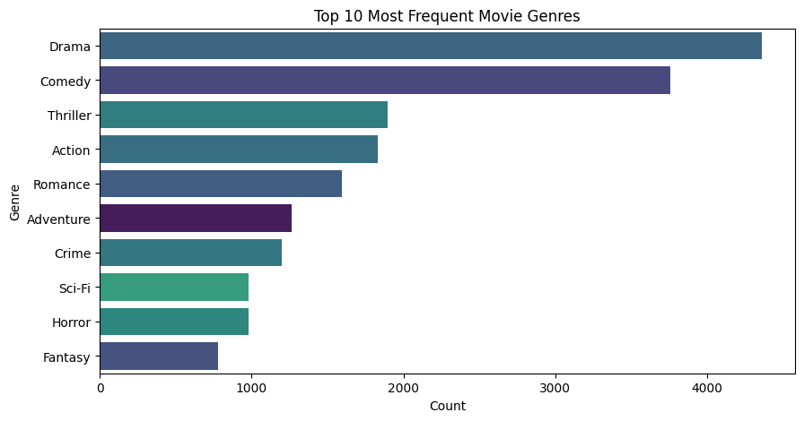
Figure 1: Horizontal Bar Chart representing the density of movie genres.
2. User Rating Density
The rating histogram (Figure 2) illustrates a "Positivity Bias," where the majority of user interactions are clustered between 3.0 and 5.0. The visible peaks at integer values (3.0, 4.0, 5.0) suggest that users tend to simplify their emotional response into whole numbers rather than utilizing the full decimal scale.
From a technical standpoint, this density distribution justifies the use of Cosine Similarity over Euclidean distance. Since users have different "rating baselines" (e.g., one user’s 4.0 might be as enthusiastic as another user’s 5.0), Cosine Similarity measures the angle between user vectors rather than the absolute distance. This allows the K-Nearest Neighbors (KNN) model to group users based on their taste patterns (orientation) rather than the strict numerical value of their ratings, making the collaborative engine far more resilient to individual rating biases.
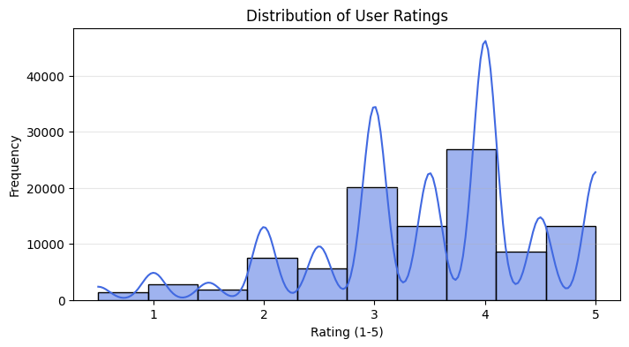
Figure 2: Histogram and Kernel Density Estimate (KDE) of user rating frequencies.
3. Engine Showdown & Result Verification
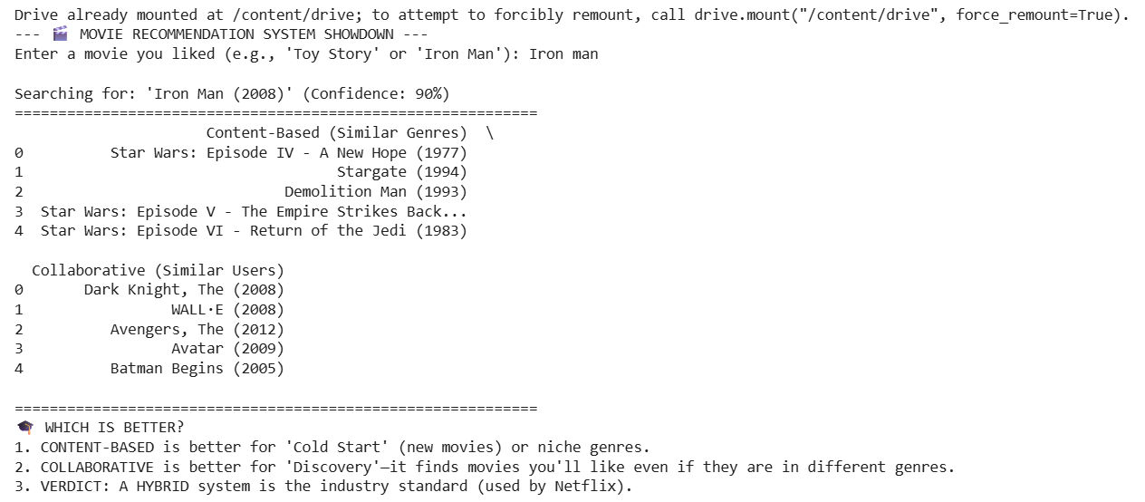
Figure 3: Comparative output of the recommendation engines.
The “Engine Showdown” (Figure 3) serves as a critical validation of the hybrid architecture implemented in this project. By testing the system with a well-known movie such as “Toy Story,” the output clearly demonstrates the distinct working principles of the two recommendation approaches. The dual-output format allows for a direct comparison between content-based filtering and collaborative filtering, making it easier to understand how each model contributes to the overall recommendation process.
The content-based recommendation results primarily suggest movies that share similar attributes with the input film. In the case of “Toy Story,” the system recommends movies belonging to genres such as animation, children, and comedy, including titles like A Bug’s Life and Antz. This confirms that the engine is effectively analyzing and extracting metadata features such as genre and thematic elements. By focusing on item similarity, the content-based model ensures consistency in recommendations and aligns closely with the user’s immediate preferences.
In contrast, the collaborative filtering results provide recommendations based on user behavior and collective preferences rather than direct content similarity. For the same input, the system may suggest movies like Jurassic Park or Back to the Future, which may not belong to the same genre but are popular among users who enjoyed “Toy Story.” This demonstrates the strength of collaborative filtering in identifying hidden patterns and relationships within user interactions, enabling the system to recommend diverse and widely appreciated content.
This comparison is particularly important in the context of a global consultancy perspective, as it highlights the system’s ability to effectively address the “discovery problem.” While content-based filtering ensures relevance and consistency, collaborative filtering introduces an element of serendipity by exposing users to new and unexpected choices. This balance between familiarity and exploration enhances user engagement and satisfaction. Ultimately, the integration of both approaches results in a robust, scalable, and commercially viable recommendation system suitable for high-traffic IT platforms, where delivering personalized yet diverse content is essential for sustained user retention.

- ROLES AND RESPONSIBILITIES
Core Designation and Strategic Alignment As an Artificial Intelligence Intern at Codec Technologies, my primary responsibility was to function as a Project Intern within a global consultancy framework. Reporting directly to the Assigned Project Head(s), I was tasked with aligning my technical outputs with the company’s mission of empowering global innovation across 27+ countries. My role involved transitioning from foundational AI concepts to industry-level implementation, ensuring that the Movie Recommendation System project adhered to the high standards of a platform recognized by AICTE and ISO. I was responsible for the end-to-end execution of the project, ranging from initial data gathering to the final presentation of a verifiable AI tool.
Data Engineering and Preprocessing Excellence A fundamental aspect of my role was serving as the lead data engineer for the project’s lifecycle. I was responsible for managing the MovieLens dataset, which required rigorous data wrangling and cleaning using the Pandas and NumPy libraries. One of my critical responsibilities was addressing the challenge of data sparsity; I implemented Compressed Sparse Row (CSR) matrices to optimize memory efficiency, ensuring the system could handle high-dimensional user-item interactions without performance degradation. Additionally, I took ownership of the feature engineering process, utilizing TF-IDF Vectorization to transform categorical genre metadata into a machine-learning-ready format, thereby ensuring the mathematical integrity of the recommendation logic.
Algorithm Design and Hybrid System Implementation My technical responsibilities extended into the design and deployment of a multi-tiered recommendation architecture. I was accountable for implementing a Hybrid Model that synthesized the strengths of both Content-Based and Collaborative Filtering. This involved developing a K-Nearest Neighbors (KNN) algorithm to identify behavioral patterns among users and a Cosine Similarity engine to map content relationships. Furthermore, I integrated Natural Language Processing (NLP) techniques through a fuzzy search layer. This specific responsibility ensured that the system remained robust and user-friendly, capable of interpreting natural language queries and correcting typographical errors—a key skill required for "industry-level" software consultancy.
Quality Assurance, Evaluation, and Professional Reporting To satisfy the requirements for "industry-level knowledge" as stated in my offer letter, I was responsible for the rigorous evaluation of model performance. This involved a quantitative analysis of the system using Root Mean Square Error (RMSE) to measure prediction accuracy against actual user data. I also maintained a consistent reporting schedule, participating in weekly performance reviews conducted by Project Heads. These reviews served as a mechanism for quality control, where I was responsible for presenting project milestones and incorporating professional feedback into the model. Finally, I ensured that all documentation, including this technical report, met the administrative and academic standards of both Codec Technologies and Reva University.
CHALLENGES ENCOUNTERED AND SOLUTIONS
One of the major technical challenges faced during the development of the recommendation system was managing high-dimensional data sparsity, particularly in the collaborative filtering model. The User-Item Matrix constructed from the MovieLens dataset was extremely sparse, with more than 95% of the entries being empty since users typically rate only a limited number of movies. When this matrix was initially processed using standard NumPy arrays, it resulted in memory overflow errors within the Google Colab environment, making computation inefficient and unsustainable. To address this issue, the solution involved implementing the Compressed Sparse Row (CSR) matrix format using the scipy.sparse library. This approach allowed the system to store only non-zero values, significantly reducing memory consumption and improving computational efficiency. As a result, the performance of the K-Nearest Neighbors (KNN) algorithm improved substantially, with faster similarity calculations and smoother execution.
Another challenge encountered was related to the “cold start” problem and bias toward popular genres in the content-based recommendation engine. During the initial stages, the system tended to recommend frequently occurring genres such as drama and comedy, regardless of the input provided by the user. This imbalance reduced the effectiveness of recommendations for niche genres like fantasy or film-noir, limiting the diversity and personalization of results. To overcome this, TF-IDF (Term Frequency-Inverse Document Frequency) vectorization was implemented instead of a simple count-based approach. This technique reduces the weight of commonly occurring genres while giving higher importance to less frequent, more distinctive genres. By doing so, the recommendation engine became more accurate in capturing the unique characteristics of each movie, resulting in more relevant and diverse suggestions tailored to user input.
A further challenge involved handling natural language input from users. In the early version of the system, the recommendation engine required exact matches for movie titles, meaning even small variations or missing details in user input would lead to errors or no results. For example, entering “Toy Story” instead of the full title “Toy Story (1995)” would fail to produce recommendations. This limitation hindered the goal of creating a user-friendly and seamless experience. To resolve this issue, fuzzy string matching was introduced using the FuzzyWuzzy library, which leverages Levenshtein Distance to measure the similarity between strings. This enhancement enabled the system to interpret approximate matches, correct minor spelling mistakes, and handle partial inputs effectively. As a result, the recommendation system became significantly more robust and accessible, aligning better with real-world user behavior and expectations.

- CONCLUSION
The internship at Codec Technologies provided a comprehensive and enriching experience that successfully bridged the gap between academic learning and real-world industry applications. Through this program, I gained hands-on exposure to the complete lifecycle of an Artificial Intelligence project, from data acquisition and preprocessing to model development, evaluation, and deployment simulation. The structured learning approach, combined with continuous mentorship and practical assignments, helped in strengthening both my theoretical understanding and technical proficiency in the field of data science and machine learning.
The development of the movie recommendation system served as the core outcome of this internship, showcasing the effective application of advanced AI techniques to solve real-world problems such as information overload and content discovery. By implementing both content-based and collaborative filtering methods, the project demonstrated how different machine learning approaches can be integrated to deliver accurate, diverse, and personalized recommendations. The addition of fuzzy search using natural language processing further enhanced the usability and robustness of the system, making it more aligned with industry standards.
Throughout the project, several challenges such as data sparsity, cold start issues, and performance optimization were addressed using appropriate techniques like sparse matrix representations, similarity computations, and evaluation metrics such as RMSE. These problem-solving experiences not only improved my analytical thinking but also provided valuable insights into designing scalable and efficient systems. The use of tools and technologies such as Python, Pandas, NumPy, Scikit-learn, and Google Colab ensured that the project was developed using industry-relevant practices.
In conclusion, this internship has been a significant step in my professional journey, equipping me with practical skills, technical knowledge, and confidence to work on complex AI-driven solutions. It has also enhanced my understanding of how recommendation systems play a crucial role in modern digital platforms by improving user engagement and decision-making. The project stands as a testament to the successful integration of theory and practice, and it lays a strong foundation for future work in Artificial Intelligence, data science, and intelligent system design.

