**Outputs / results**

1. **Home page** 
   1. The home page of the project where there is two options first for the students and others is for admin

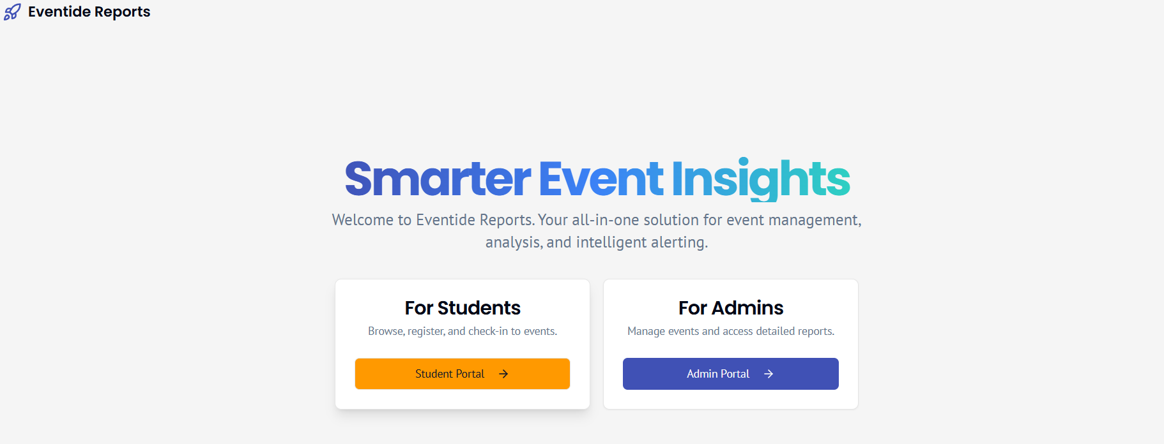

**Fig 1.1. the homepage**

1. **For Admins**
   1. **This page allows the admins to login**

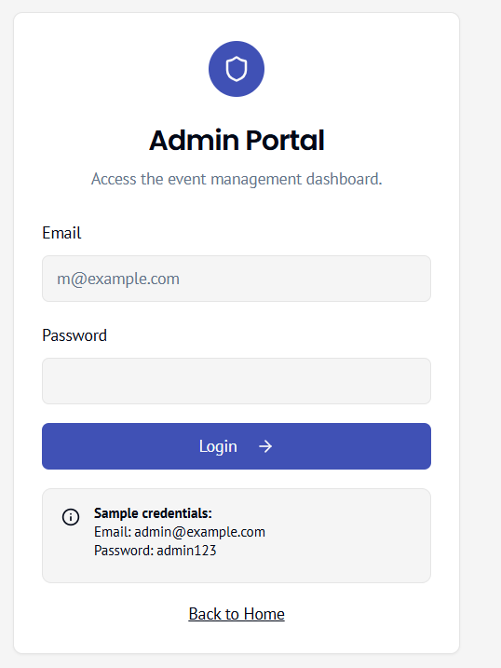

**Fig 2.2. the login page for admin**

**2.2 sample admin login page**

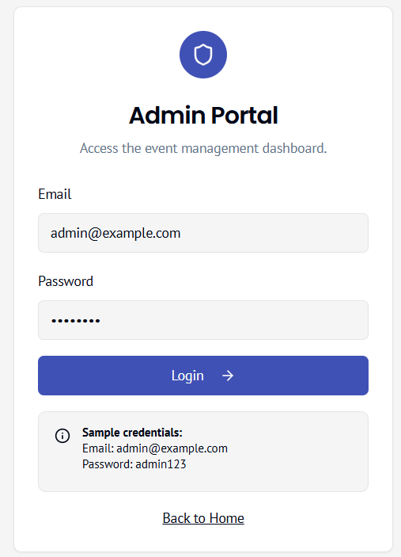

**Fig 2.2. sample admin login**

* 1. **Admin page after admin logins**

As soon as the admin login he can see the below page, where there is two buttons (Dashboard, create event).

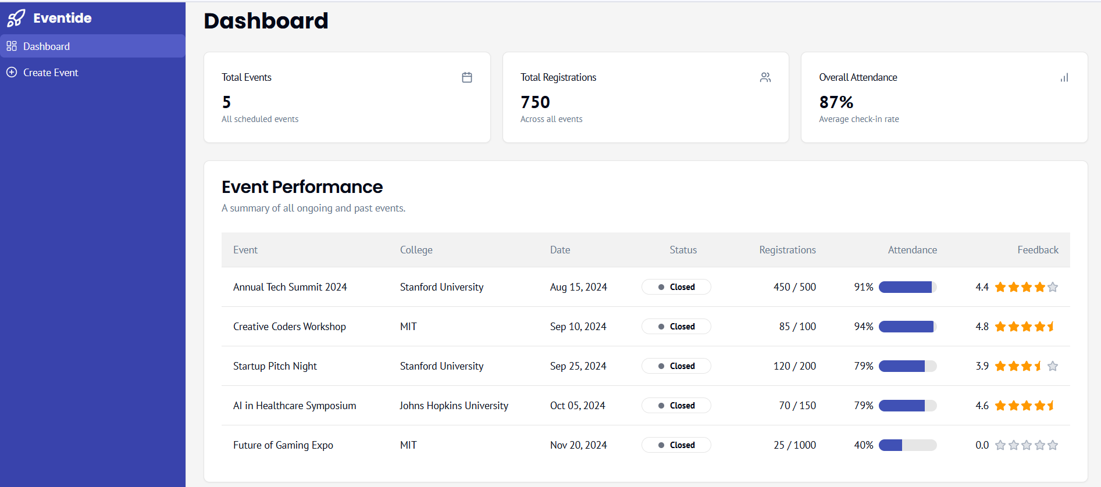

**Fig 2.3 admin after admin login**

**2.4 dashboard in admin login**



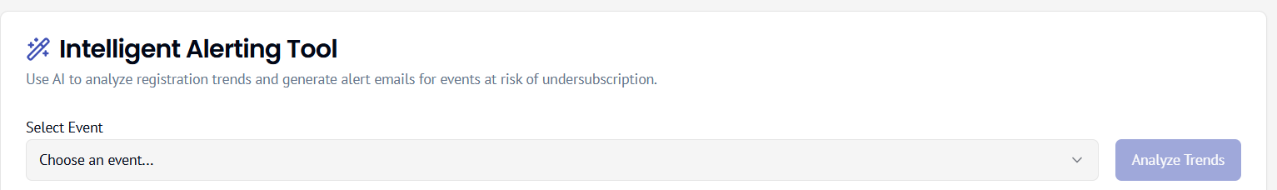

**Fig 2.4 dashboard along with intelligence alerting tool**

**2.5 Intelligence alerting tool**

When the admin selects the event name, he can analyze the risk of that event

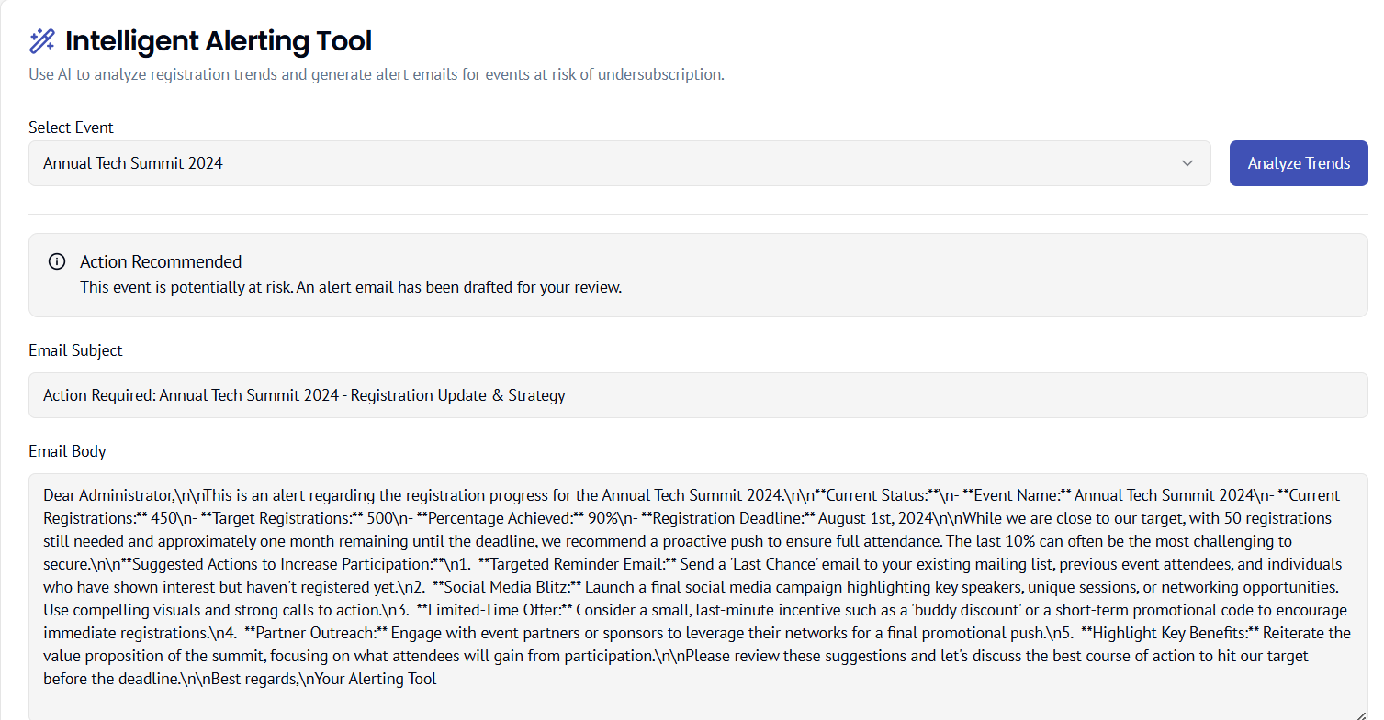

Fig 2.5 Intelligence alerting tool screenshot

**2.6 we have another feature in admin login that is create event feature**

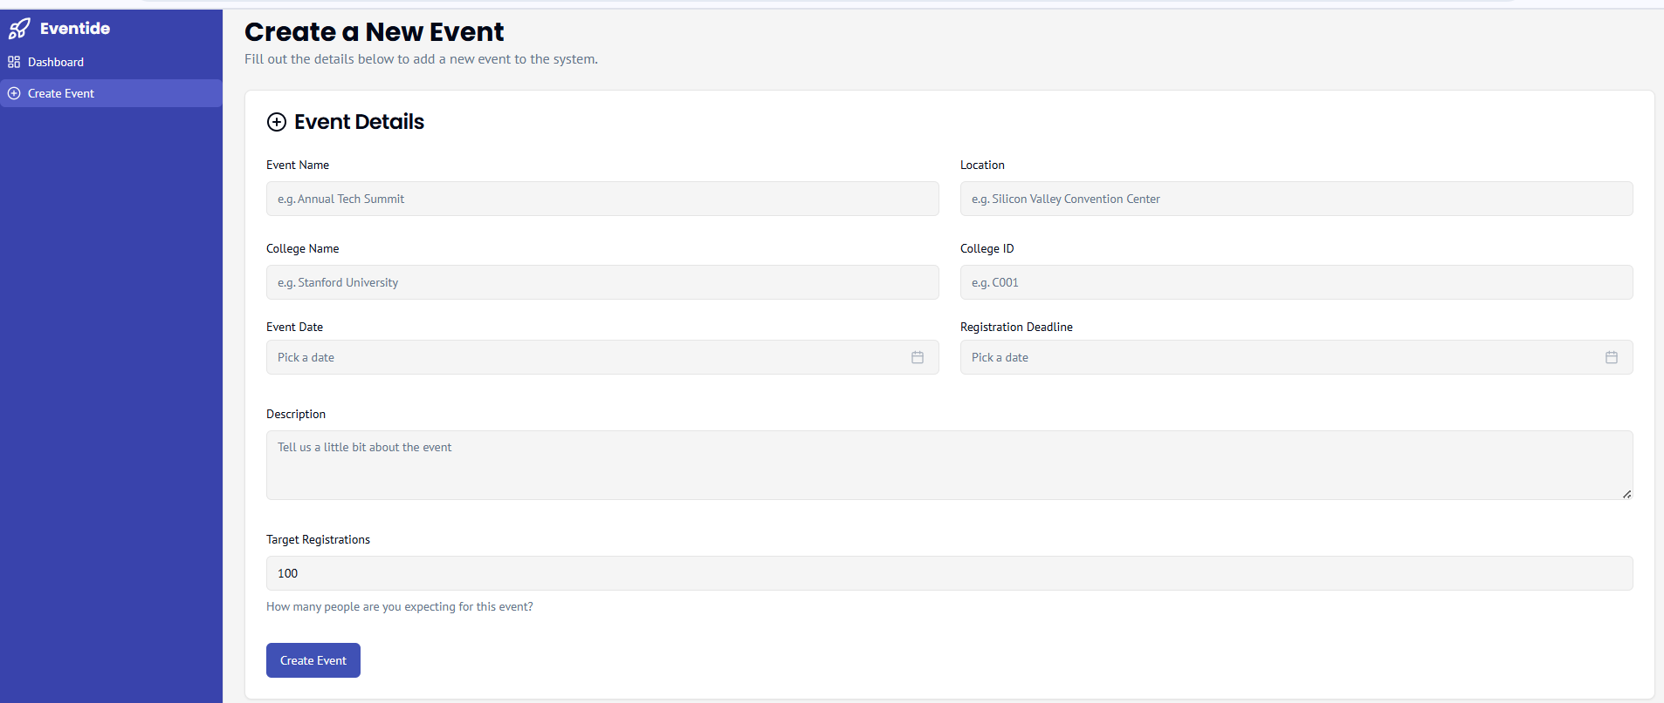

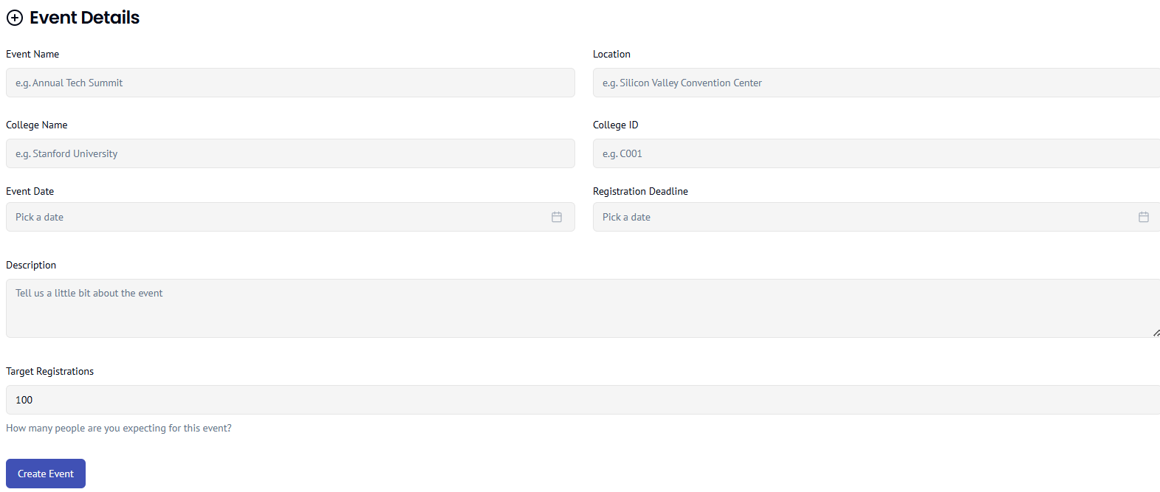

Fig 2.6 create event page where admins can create the event based on providing the required fields

**3. For Student**

**3.1 Student login page**

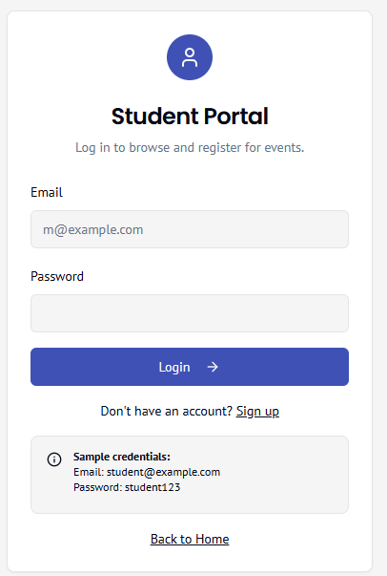

Fig 3.1 there is the option for students to login with email and password

**3.2 Sample student login page**

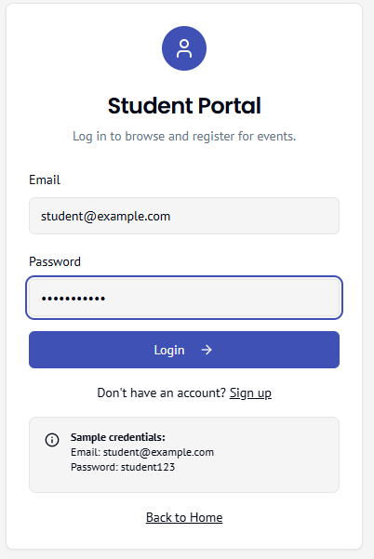

Fig 3.2 sample student login page

**3.3 Student page after student login**

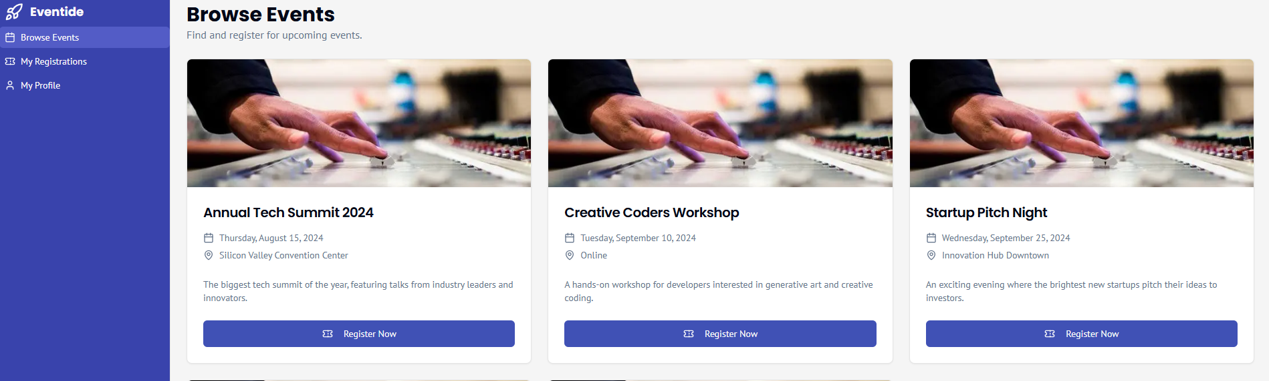

Fig 3.3 student page with three options (Browse events, my registrations, my profile)

**3.4 Browse event page**

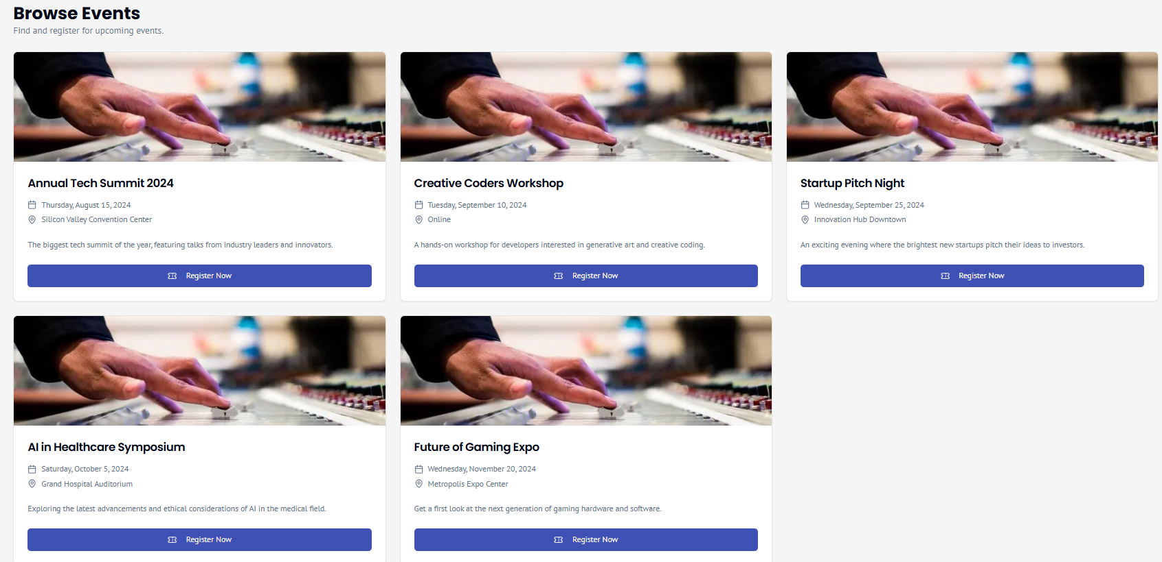

Fig 3.4 Browse event where all the new events added by the admins will be viable for the students

**3.5 My registration page**

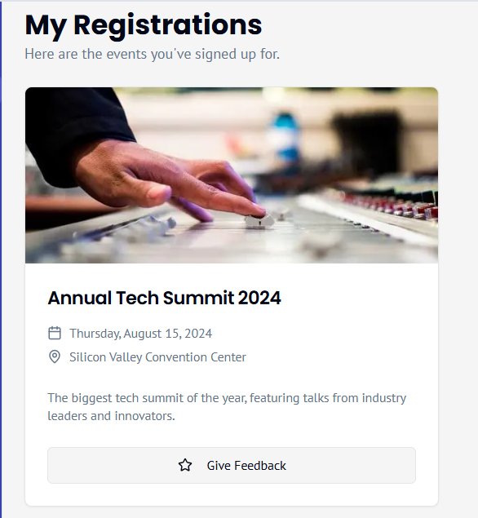

Fig 3.5 my registration page that shows all the events to which the student has registered and there is a feedback page

3.6 **Feedback page**

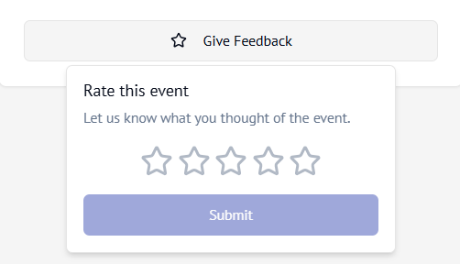

Fig 3.6 **Feedback page**

**3.7 My profile page** 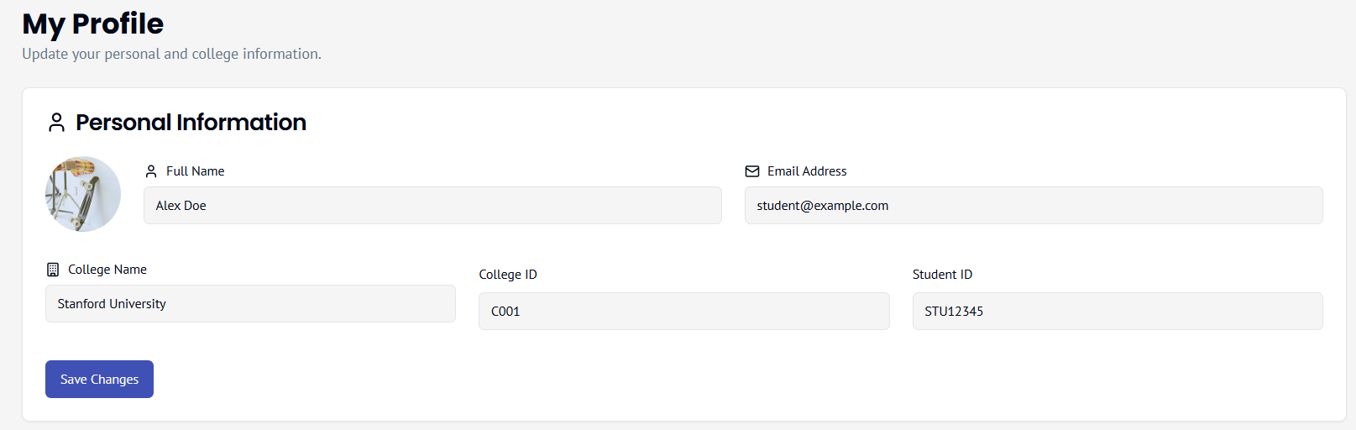

Fig 3.7 this shows a page where students can edit their profile