**Lớp:** SE1851

**Họ tên:** Lương Ngọc Thùy Dương

**MSSV:** SE171916

**DBI202**

Giving a database schema:

- Sailors(sid: integer, sname: string, rating: integer, age: real)

- Boats(bid:integer , bname: string, color: string)

- Reserves(sid: integer, bid: integer , day: date )

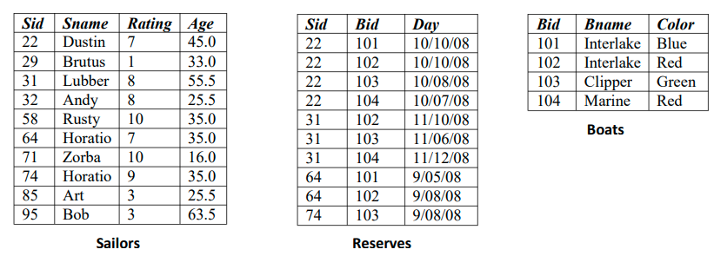

1. **Find the names of sailors who have reserved boat 103**

$π_{Sname}(σ_{Bid= 103}\left(Sailors⋈ Reserves\right))$

|  |
| --- |
| **Sname** |
| Dustin |
| Lubber |
| Horatio |

1. **Find the names of sailors who have reserved a red boat**

$$π_{Sname}(σ_{Color=^{'}red^{'}}\left(Sailors⋈ Reserves⋈Boats\right))$$

|  |
| --- |
| **Sname** |
| Dustin |
| Lubber |
| Horatio |

1. **Find the colors of boats reserved by Lubber.**

$$π_{Color}(σ_{Sname=^{'}Lubber^{'}}\left(Sailors⋈ Reserves⋈Boats\right))$$

|  |
| --- |
| **Color** |
| Red |
| Green |

1. **Find the names of sailors who have reserved at least one boat. $π_{Sname}(Sailors⋈ Reserves)$**

|  |
| --- |
| **Sname** |
| Dustin |
| Lubber |
| Horatio |

1. **Find the names of sailors who have reserved a red or a green boat**

$$π_{Sname}(σ_{Color=^{'}red^{'}OR Color=^{'}green^{'}}\left(Sailors⋈ Reserves⋈Boats\right))$$

|  |
| --- |
| **Sname** |
| Dustin |
| Lubber |
| Horatio |

1. **Find the names of sailors who have reserved a red and a green boat**

$$π_{Sname, Color}(Sailors⋈ Reserves⋈Boats)÷π_{Color}(σ_{Color=^{'}red^{'}OR Color=^{'}green^{'}}\left(Boats\right))$$

|  |
| --- |
| **Sname** |
| Dustin |
| Lubber |

1. **Find the sids of sailors with age over 20 who have not reserved a red boat**

$$π_{Sid}(σ_{Age>20 AND Color ≠{}_{}^{'}red^{'}}\left(Sailors⋈ Reserves⋈Boats\right))$$

|  |
| --- |
| **Sid** |
| 29 |
| 32 |
| 58 |
| 85 |
| 95 |

1. **Find the names of sailors who have reserved all boats**

$$π_{Sname} (Sailors⋈\left(Reserves÷π_{Bid}\left(Boats\right)\right))$$

|  |
| --- |
| **Sname** |
| Dustin |

1. **Find the names of sailors who have reserved all boats called Interlake**

$π_{Sname}$ ($Sailors⋈ Reserves ÷ π_{Bid}(σ_{Bname=^{'}Interlake^{'}}\left(Boats\right)))$

|  |
| --- |
| **Sname** |
| Dustin |
| Lubber |
| Horatio |

1. **Find the names of sailors who have reserved at least two boats**

$$π_{Sname}(σ_{count\left(bid\right)≥2}\left(π_{Sid, Bid}\left(Reserves\right)GROUP BY sid\right))$$

|  |
| --- |
| **Sname** |
| Dustin |
| Lubber |