**BÁO CÁO WORKSHOP02**

**Tổng quát**

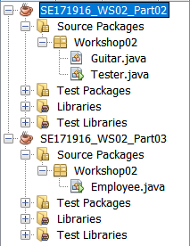

**Part 1: Find classes and use UML to draw class structure [2 points]**

|  |
| --- |
| Guitar |
| - serialNumber: String  - price: int  - builder: String  - model: String  - backWood: String  - topWood: String |
| + Guitar()  + Guitar(String serialNumber, int price, String builder, String model, String backWood, String topWood)  + getSerialNumber(): String  + getPrice(): int  + getBuilder(): String  + getModel (): String  + getBackWood (): String  + getTopWood (): String  + createSound(): void |

|  |
| --- |
| Inventory |
| - The list(array) of guitars |
| + addANewGuitar(): void  + searchTheGuitarBySerialNumber(): void |

**Part 2: Implement the Guitar [3 points].**

- create a new file named “**Guitar.java”**

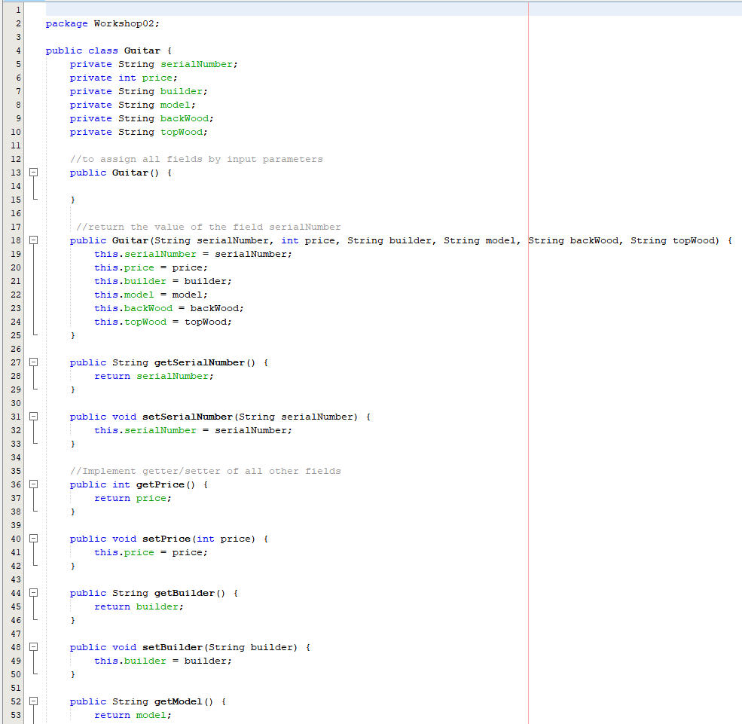

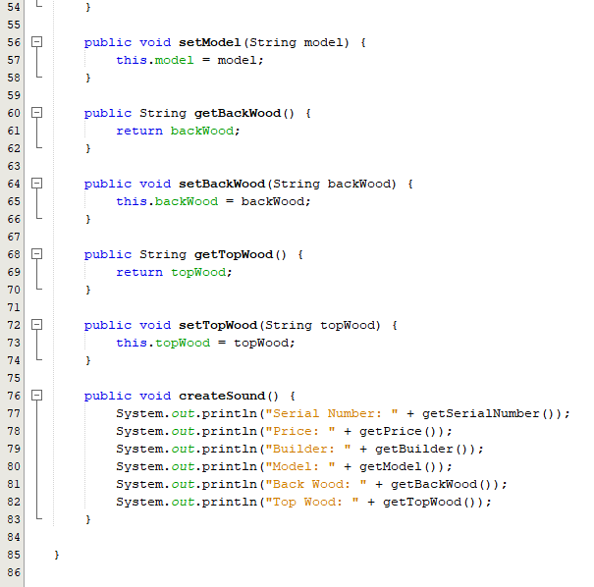

create a new file named “**Tester.java**

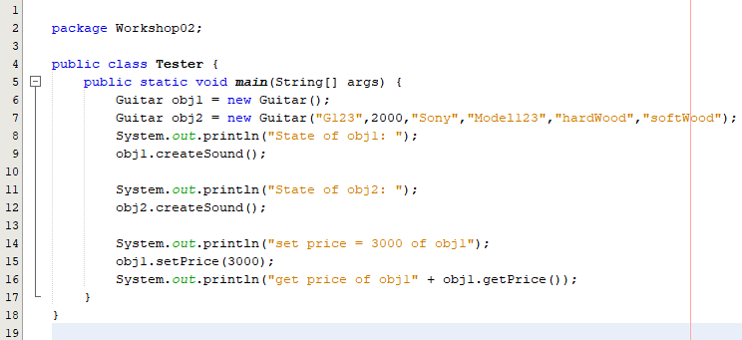

**Output**:

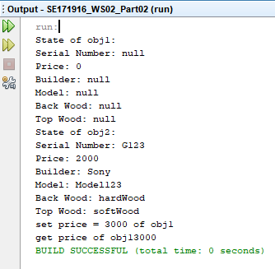

**Part 3: Implement Employee management program** **[5 point]**

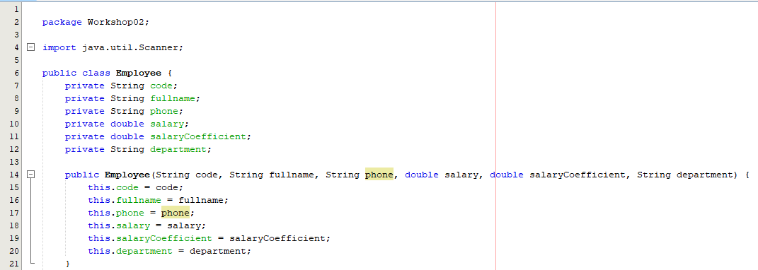

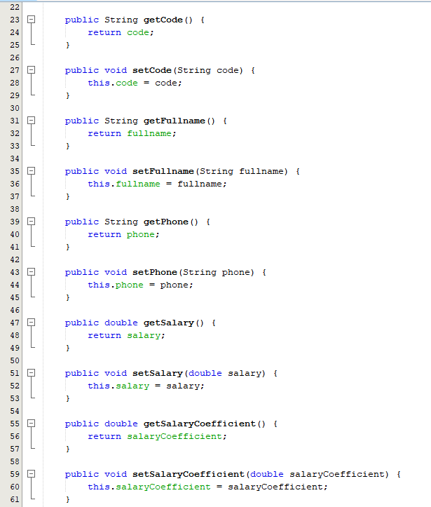

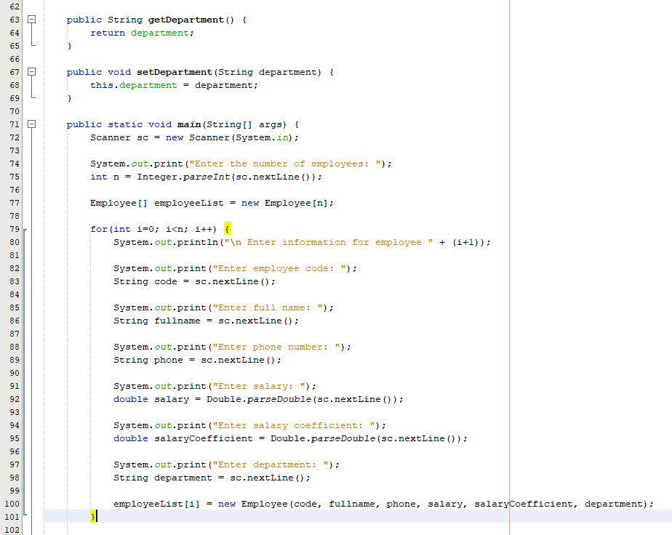

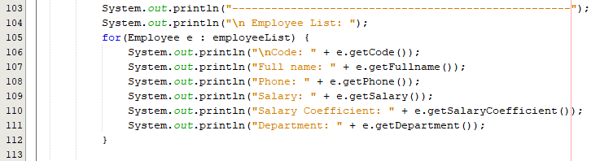

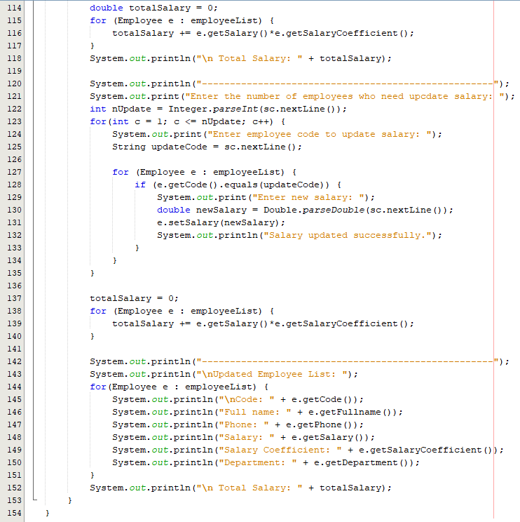

**Output:**

