Workshop #1: Foundations of Java language

**Learning Outcomes:**

Upon successful completion of this workshop, you will have demonstrated the abilities to:

* Practice basic Java language syntax and semantics to write Java programs.
* Use concepts such as variables, conditional and iterative execution methods.
* Compile and run a program.
* Describe to your instructor what you have learned in completing this workshop.

**Requirements:**

**Part1: [3 points]**

Write a Java program that will accept a matrix of integers then this matrix will be printed out and sum of values and average of values are printed also.

The user interface may be:

Enter number of rows: 2

Enter number of columns: 3

Enter the matrix

m[0][0]=1

m[0][1]=2

m[0][2]=3

m[1][0]=4

m[1][1]=5

m[1][2]=6

Matrix inputted:

1 2 3

4 5 6

Sum: 21

Average: 3.5

Hint: Use System.out.format("%3d", n);

**Step by step workshop instructions:**

* Initializing NetBeans and create a new project named “workshop1”

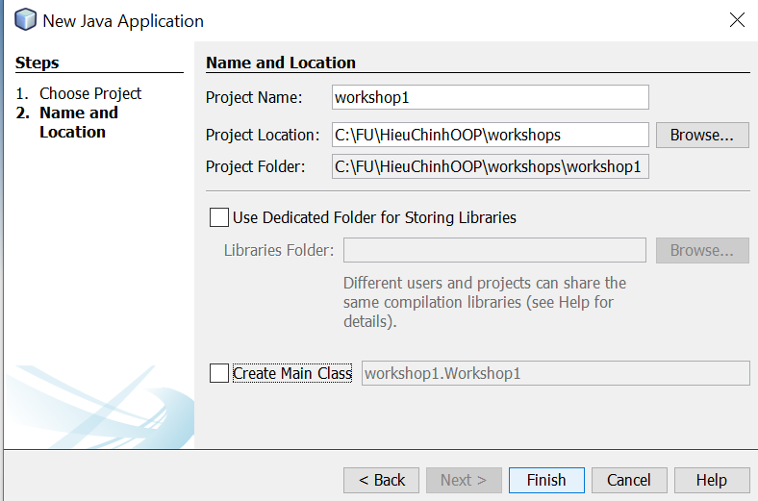

* Create a class named “part1.java”

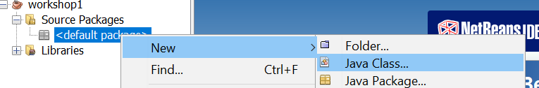

* In the class “Part1.java”, you type:

**Task 1:** input the matrix

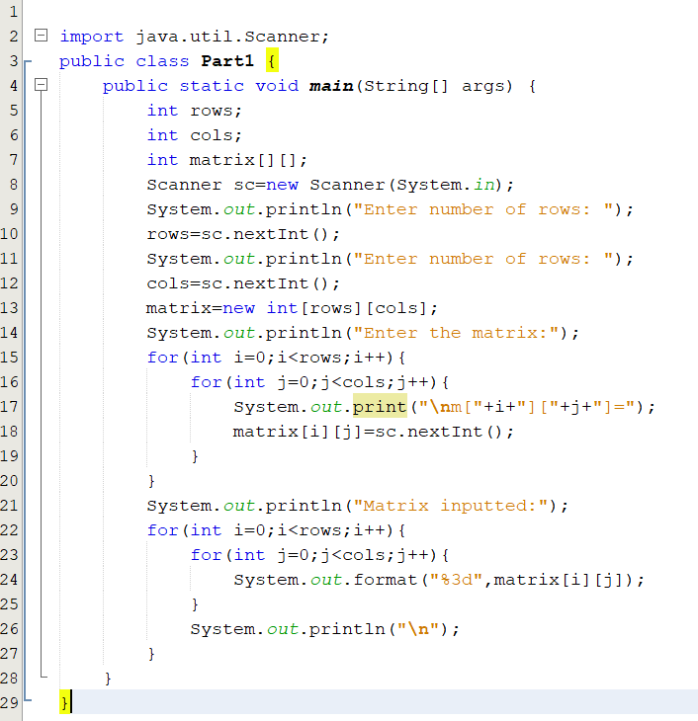

* To run the code, click the right mouse and choose “run file”

**Task 2:** get sum of values

* You will add the code to “Part1.java”

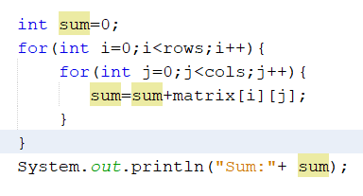

**Task 3:** get average of values

- You will add the code “System.out.println("Average:" +(float)sum/(rows*cols));” to “Part1.java”

**Review criteria**

Upon completion of the workshop, your submission will be reviewed based on the following criteria:

* Input the matrix successfully [1 point]
* Get sum [1 point]
* Get average [1 point]

**Part 2: [3 points]**

Write a Java program that will accept two float numbers and an operator (+-*/) then the program will print out the result of the specified expression that bases on the inputted operator.

The user interface may be:

Input the number 1: 4  
Input the number 2: 5  
Input the operator: +  
the result of 4+5=9

**Step by step workshop instructions:**

* In the project above, you create a new class named “Part2.java” and add the code:

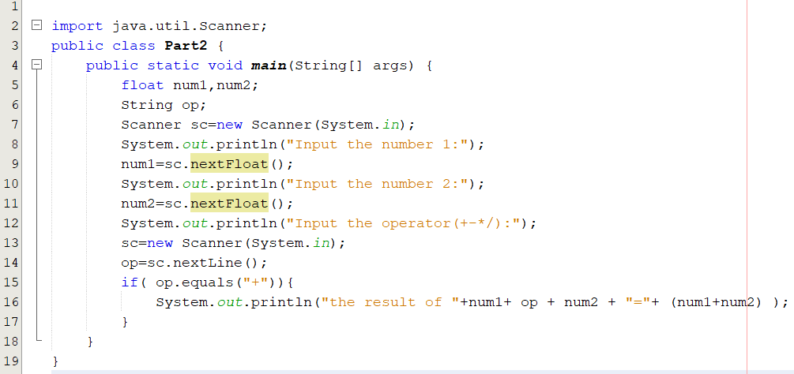

* You must add your code to get the result when user inputs another operator

**Part 3 [4 points]**

Write a Java program that will accept the list of student name, convert all names to uppercase and then the program will print out the list of student name.

**Step by step workshop instructions:**

* you create a new class named “Part3.java” and add the code:

