Nama : Hanifah Putri Trisnawati
Nim : 2200018217

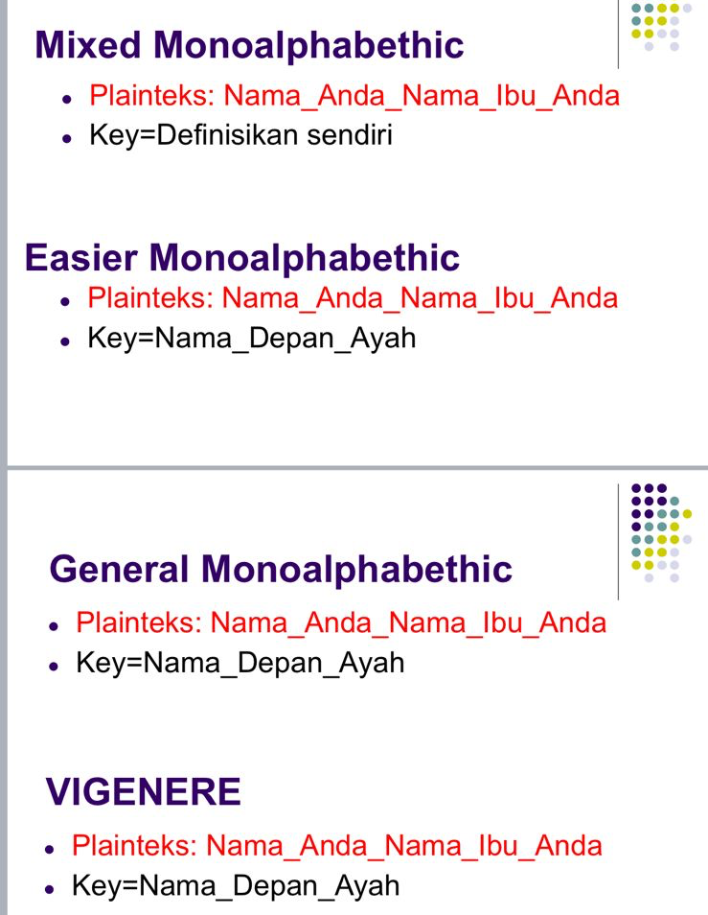

- Mixed Monoalphabethic
Planteks : Nama_Anda_Nama_Ibu_Anda
Key : Definisikan sendiri ( KRIPTO )
cipher alphabet :
K R I P T O A B C D E F G H J L M N Q S U V W X Y Z

Tabel Pemetaan
A | K
B | R
C | I
D | P
E | T
F | O
G | A
H | B
I | C
J | D
K | E
L | F
M | G
N | H
O | J
P | L
Q | M
R | N
S | Q
T | S
U | U
V | V
W | W
Q | X
Y | Y
Z | Z

Plainteks Soal
Nama_Anda_Nama_Ibu_Anda
- N → H
- A → K
- M → G
- A → K

- A → K
- N → H
- D → P
- A → K

- N → H
- A → K
- M → G
- A → K

- I → C
- B → R
- U → U

- A → K
- N → H
- D → P
- A → K
Hasil Cipherteks
HKGK_KHPK_HKGK_CRU_KHPK

- Eaiser Monoalphabethic
Planteks : Nama_Anda_Nama_Ibu_Anda
Key : Nama_Depan_Ayah

Enkripsi per Huruf
Plain | Key | (P+K) mod 26 | Cipher

N(13) | N(13) | 13 + 13 = 26 | A
A(0) | A(0) | 0 + 0 = 0 | A
M(12) | M(12) | 24 | Y
A(0) | A(0) | 0 | A
A(0) | D(3) | 3 | D
N(13) | E(4) | 17 | R
D(3) | P(15) | 18 | S
A(0) | A(0) | 0 | A
N(13) | N(13) | 26 → 0 | A
A(0) | A(0) | 0 | A
M(12) | Y(24) | 36 mod 26 = 10 | K
A(0) | A(0) | 0 | A
I(8) | H(7) | 15 | P
B(1) | N(13) | 14 | O
U(20) | A(0) | 20 | U
A(0) | M(12) | 12 | M
N(13) | A(0) | 13 | N
D(3) | D(3) | 6 | G
A(0) | E(4) | 4 | E

Gabungkan Hasil Cipherteks
AAYA_ADRSAAKAPOUMNGE

- General Monoalphabethic
Plainteks : Nama_Anda_Nama_Ibu_Anda
Key : Nama_Depan_Ayah

- Buat substitution alphabet dari kunci : N A M D E P Y H
- Lalu tambahkan huruf-huruf alfabet lain yang belum muncul, dalam urutan A–Z :
N A M D E P Y H B C F G I J K L O Q R S T U V W X Z
- Buat table subtitusi
Normal Alphabet | Cipher Alphabet
A | N
B | A
C | M
D | D
E | E
F | P
G | Y
H | H
I | B
J | C
K | F
L | G
M | I
N | J
O | K
P | L
Q | O
R | Q
S | R
T | S
U | T
V | U
W | V
X | W
Y | X
Z | X

Enkripsi plainteks
Plainteks:
N A M A _ A N D A _ N A M A _ I B U _ A N D A
Hasil Akhir
Cipherteks : JNIN_JDNJ_NIN_BAT_NJDN

- Vignere
Plainteks : Nama_Anda_Nama_Ibu_Anda
Key : Nama_Depan_Ayah
- Plainteks : N A M A A N D A N A M A I B U A N D A
- Kunci (ulang hingga sama panjang): N A M A D E P A N A Y A H N A M A D E P A N A
Huruf | Nilai
A | 0
B | 1
D | 3
E | 4
H | 7
I | 8
M | 12
N | 13
P | 15
U | 20
Y | 24

Enkripsi
Ci = (Pi + Ki) mod 26
P | K | (P+K) mod 26 | Cipher
N(13) | N(13) | 26→0 | A
A(0) | N(13) | 0 | A
M(12) | M(12) | 24 | Y
A(0) | A(0) | 0 | A
A(0) | D(3) | 3 | D
N(13) | E(4) | 17 | R
D(3) | P(15) | 18 | S
A(0) | A(0) | 0 | A
N(13) | N(13) | 0 | A
A(0) | A(0) | 0 | A
M(12) | Y(24) | 36→10 | K
A(0) | A(0) | 0 | A
I(8) | H(7) | 15 | P
B(1) | N(13) | 14 | O
U(20) | A(0) | 20 | U
NA(0) | M(12) | 12 | M
N(13) | A(0) | 13 | N
D(3) | D(3) | 6 | G
A(0) | E(4) | 4 | E

HASIL CIPHER
AAYA_ADRS_AAK_APOU_MNGE

