STORE MANAGEMENT SYSTEM

Submitted By

Rakibul Ahasan Papon || 17183103022

Sk.Abu Hanif || 17183103043

Shakil Khan || 17183103028

Abul Foyez || 16172103241



DEPARTMENT OF COMPUTER SCIENCE AND ENGINEERING

BANGLADESH UNIVERSITY OF BUSINESS AND TECHNOLOGY

SUMMER 2020

**DECLARATION**

**Project Title:** Stores Management System

I do hereby declare that, this project is an original work and was done under the supervision of **Farha Akhter Munmun, Lecturer , Department of CSE, Bangladesh University of Business And Technology, Mirpur - 2, Dhaka.**

Submitted To:



**Farha Akhter Munmun**

Lecturer

Bangladesh University of Business And Technology

Dhaka

Bangladesh

ACKNOWLEDGEMENT

First I express my heartiest thanks and gratefulness to almighty Allah for His divine blessing makes it possible to complete this project successfully.

I would like to thank my entire course mates in **Bangladesh University of Business And Technology**, who took part in this discussion while completing the course work.

Finally, I must acknowledge with due respect the constant support and patients of my parents.

**TABLE OF CONTENTS**

**CHAPTER 1: INTRODUCTION (9 –11)**

Introduction 10

1.1 Review current system business operation 10

1.2 Motivation 10

1.3 Goal of our Project 10

1.4 Objectives  **11**

**CHAPTER 2: BACKGROUND STUDY (12– 17)**

2.1 What is Departmental Store Management System 13

2.2 Reasons Why You Need DSMS Software (13–14)

2.2.1 Quick and Accurate Sales 13

2.2.2 Inventory Control 14

2.2.3 Know Your Customers 14

2.2.4 Save Time! 14

2.3 Benefits of Using a DSM System (14 -15)

2.3.1 Inventory 14

2.3.2 Purchasing 15

2.3.3 Departmental Store Management System 15

2.4 DSM Features 15

2.4.1 Explain DSM Features 15

**CHAPTER 3: SOFTWARE REQUIREMENT ANALYSIS (18 –21)**

3.1 SRS Assumption Dependencies 19

3.2 Functional Requirement 20

3.3 Interface Requirement (20– 21)

3.3.1 User Interfaces 20

3.3.2 Hardware Interfaces 20

3.3.3 Software Interfaces 21

**CHAPTER 4: SYSTEM DESIGN (21 – 44)**

4.1 UML Design 22

4.2 Use Case (22 – 24)

4.2.1: Use case diagram of DSM (User Part) 22

4.2.2: Use case diagram of DSM (Product Part) 23

4.2.3: Use case diagram of DSM (Customer Part) 24

4.3 ERD (Entity Relationship Diagram) 25

4.4 Web page Design (26 – 44)

4.6.1 Login Page 27

4.6.2 Home/Dashboard page 28

4.6.3 Items 29

4.6.4 Product List page 30

4.6.5 Add Product page 31

4.6.6 Revenue Page 32

4.6.7 Customers Details Page 33

4.6.8 Vendor Details Page 34

4.6.9 Stock List Page 35

4.6.10 Sales Page 36

4.6.11 After Sales completion Terminal to Print Invoice Page 37

4.6.12 Report Page 49

4.6.13 Account Details Page 40

4.6.14 Configuration Page 44

**CHAPTER 5 : CONCLUSION AND FUTURE WORKS (44-45)**

**REFERENCES 46**

**Chapter 01**

**CHAPTER 1**

**INTRODUCTION**

DSMS stands for Departmental Store Management System. This is a rather broad definition that can include merchandising aids, displays and the methods used to enable transactions. In our case, we're talking about the hardware and software that runs both the front counter and back office operations of a business.

A Departmental Store Management System (DSMS) is an application that executes a collection of protocols to coordinate the actions of multiple processes on a network, such that all components cooperate together to perform a single or small set of related tasks. This system is good when one has an established Shop and wants his/her stores to blinked.

One of its advantages is the ability to connect remote use with remote resources in an open (where each component is continually open to interaction with other components) and scalable (the system can easily be altered to accommodate changes in the number of users, resources and computing) way, and can also be larger and more powerful given the combined capabilities of the Departmental Store Management System. Components compared to that of the Departmental Store Management System.

**1.1 Motivation**

Departmental Store Management System (DSMS), commonly found in retail establishments and known as DSM, often feature a complex arrangement of hardware, software and network connections. DSM systems rely on predictable operation, and any number of problems can appear when hardware, software or users do not perform as expected. So this perspective things Motivates me to kind of software in real time business.

**1.2 Goal of our Project**

**Web Based or Mobile DSM:** Our works on Mobile, Tab and PC system you can use one or more than one Platform. It works both online and offline.

**DSM Works Offline:** DSM works online but when the internet is down then you can continue your selling. DSM will automatically resynchronize with other terminals & up-to-date back-up.

**Mobile Friendly:** You can operate and see details of the shop on your mobile phone.

**Inventory Control:** See stock on hand, get notification when stock is low.

**Customer History:** Keep all your customer information in one place. It keeps customer purchase history.

**Multi-Outlet:** You can open a new outlet using the same database.

**1.3 Objectives**

Departmental Store Management (DSM) system provides businesses with the ability to computerize, systematize and correlate retail information. Where cash registers, including complex register systems, have limited information collection capacity, DSM systems can gather, store and return detailed reports on inventory trends and customer information. Additionally, DSM systems more easily integrate with numerous sales and ordering systems.

**Chapter 02**

**CHAPTER 2**

**BACKGROUND STUDY**

DSMS stands for **D**epartmental **S**tore **M**anagement System. This is a system that is used throughout the restaurant and retail industry. This computerized system allows business owners to track sales, cash flow, food inventory and can help simplify your bookkeeping enormously.

**2.1 What is the Departmental store management system (DSMS)?**

**DSMS** is an abbreviation for **Departmental Store Management System**. The term is applicable to a retail shop or store, the checkout/cashier counter in the store, or a location where such transactions can occur in this type of environment. It can also apply to the actual **Departmental Store Management (DSM) System Hardware & Software** including but not limited to: electronic cash register systems, touch-screen display, barcode scanners, receipt printers, scales and pole displays. Departmental store management systems are utilized in many different industries, ranging from restaurants, hotels & hospitality businesses, nail/beauty salons, casinos, stadiums, and let's not forget - the retail environments. In the most basic sense, if something can be exchanged for monetary value - a Departmental Store Management System can be used.

**2.2 Reasons Why You Need DSM Software**

In the retail business, a good Departmental Store Management System is one of your biggest assets. If it works as advertised, it’ll be a lot like having your own team of experts working behind the scenes, making sure everything’s moving along quickly and efficiently. To remain on top in today’s highly competitive retail landscape, you need a DSM system to help you run your business the right way here’s why.

**2.2.1 Quick and Accurate Sales**

It all comes down to sales. If you aren’t making sales you aren’t going to stay in business. Sales are the core of your business and how you handle this process is essential to your success. A DSM system makes sure that everything runs smoothly on every transaction.

**2.2.2 Inventory Control**

If sales are number one, good inventory control is a close second. Without good inventory control you miss out on sales, overstock unwanted products, and lose out on high profit margins. A DSM system will keep an accurate count of every product in your store. It allows you to see what items are selling, what’s sitting on the shelf, and what you need to order.

**2.2.3 Know Your Customers**

Sales and inventory might be one and two, but everyone knows the customer is always right. Without real people coming in you won’t have sales and there will be no need to stock any inventory. A Departmental store management system should give you the ability to track all of your customers so you can see which customers are big spenders, who is waiting for a special order, and who has a layaway on that product tucked away in the back room.

**2.2.4 Save Time!**

T**here’s one thing that we could all use a little more of: Time!**There’s one thing that we could all use a little more of: Time! Possibly the thing you’ll love the most about a Departmental store management system is the time it will save you.

**2.3 Benefits of Using a DSM System**

The right Departmental store management system will give you control over many different areas of your business operations increasing efficiency and profitability. A Departmental store management system will streamline business operations, including inventory and vendor management along with streamlining Departmental store management system processes. The following overview, categorized by area of operation, highlights some of the typical benefits of using a Departmental store management system.

**2.3.1 Inventory :**

A Departmental store management system allows you to categorize your inventory by a number of fields for easy lookup and sorting of your merchandise. A typical inventory hierarchy would include Store, Dept., Class, Subclass, Item Description, Size, and Color. Most systems also offer extended inventory descriptions to track additional information such as alternate lookup and additional product descriptions. You can quickly search and sort your inventory to track quantity on hand and restock levels for each item in your inventory. In addition you can typically track suppliers, substitutes, aliases, and parent relationships.

**2.3.2 Purchasing :**

A Departmental store management system will help you replenish items efficiently and negotiate lower vendor costs. You can quickly generate purchase orders and add items on the fly. Purchase orders can be created for standard items as well as matrix items (size and color). Purchase orders can be tracked by order date, receive date and cancel date so you can take the appropriate action on your open orders. You will be able view what is on order and backorder at all times and print aging reports for open orders.

**2.4 DSM Features :**

Here Departmental store management system features are:

* Log In Admin person
* Add New Sales person
* Delete sales person
* Add New Items
* Search Items
* Update Items(Edit/Delete)
* Add new Invoices
* Search Invoices
* Update Invoices(Edit/Delete)
* Add new Revenues
* Search Revenues
* Update Revenues(Edit/Delete)
* Add new Customers
* Search Customers
* Update Customers(Edit/Delete)
* Buy Product
* Pay Bill
* Add new Bill
* Search Bill
* Update Bill(Edit/Delete)
* Add new Payments
* Search Payments
* Update Payments
* Add new Vendors
* Search Vendors
* Update Vendors
* Customer Details
* Sales Details
* Payment Details
* Print sales reports
* Products Inventory
* Print Invoices
* Print Bills
* Add Product
* Search Products
* Edit Product
* Update Product
* Delete Product

**2.4.1 Explain DSM Features :**

* **Log in Sales person :** The DSM software is able to login to the sales person.
* **Add New Salesperson :** It will add a new User for Sales product. The sales person contains those fields which are Company Name, First Name, Last Name,Roles,Gender Phone Number, Email, Password and Verify Password.
* **Items Details :** Item Name,Tax,Date of Product,Expire date,Sales price,Purchase price,Category etc
* **Bills Details :** Vendor, Name,Bill Date,Bill Number,Quantity,Price,Tax,Total etc
* **Customers/Vendors Details :**Email,Name,Phone,Website,Address etc
* **Invoices Details :** Customer,Name,Invoices date,Invoices Number,Quantity,Price etc
* **Payments Details :** Date,Vendor,Amount,Payable,Category etc
* **Revenue Details :** Date,Customer,Amount,Receivable etc
* **Delete Sales person :**You can delete sales people.
* **Pay Bill :** Customer will pay bill for the product
* **Customer Details :** Customer name, customer address.
* **Sales Details :** Amount, vat, total amount
* **Payment details :** Cash and change.
* **Print Sales Reports :** Seller will print sales reports.
* **Product Inventory :** There are many products in this inventory.
* **Print Product Inventory :** Print product inventory list.
* **Add Product :** Sales person added new item of product. The product contains those fields which are Item Code, Item Description, Price, Discount and Tax.
* **Search Product :** Search the product from the stock which is available on not.
* **Edit Product :** The system has product item edit where the edit fields are Item Code, Item Description, Price, Discount and Tax.
* **Update Product :** The system has product item Update where update fields are Item Code, Item Description, Price, Discount and Tax.
* **Delete Product :** The system has product item delete where delete fields are Delete Product Information.

**Chapter 03**

**3.1 SRS Scopes:**

In recording the purchases made by customers, the following information are stored:

(1) A unique transaction number assigned to every transaction,

(2) The name of the customer

(3) The name of the waiter

(4) The items purchased and their prices

(5) The date and time of the transaction

(6) Discounts applied to the transaction (if any)

(7) The total price of all the items bought or ordered after applying the discounts (if any).

For the database of items, the system will only store information about the items offered in the lounge. Data regarding the number of stock for each item is not covered since an inventory system is no longer in our scope. The following information are stored for each item in the database:

(1) The unique product identification number

(2) The product name

(3) Item type

(4) Category

(5) The price the item was bought and

(6) The selling price. The item type is either Food or Drinks. The category may be any one of the following: appetizer, chef’s special, noodles, starters, sandwich, sizzler, seafood, for Food itemtype; Cocktail, beer, liquor, shooters, on-the rocks, beverages, fruit shakes, for Drinks item-type.

**3.2 Functional Requirement:**

**Functional requirements are-**

* **Login**
* Simple two step login system

Admin Login

* **Administrator Dashboard**
* Admin can control whole system easily
* Admin can add/delete sales person, Edit, update, delete, generate etc
* Admin show payment option**.**
* **Items Role**
* Add Items
* Search Items
* Show Items
* **Sales Role:**

* Invoices
* Revenues
* Customers

* **Purchases Role:**

* Bills
* Payments
* Vendors
* **Banking**

* **Reports**
* **Setting**

**3.3 Interface Requirement:**

3.3.1 User Interfaces

* Login Screen
* Registration Screen
* Profile Screen
* Dashboard Screen
* Items Screen
* Sales Screen
* Purchase Screen

3.3.2Hardware Interfaces

* Server Configuration: Minimum 2GB Hard Disk
* P-III processor or equivalent
* Ram 512 MB
* Windows with Apache preloaded
* Client Configuration

3.3.3 Software Interfaces

* Operating system = windows 10
* Language = C#
* Database = MYSQL

**Chapter 04**

**SYSTEM DESIGN**

**4.1. Data Flow Diagrams:**

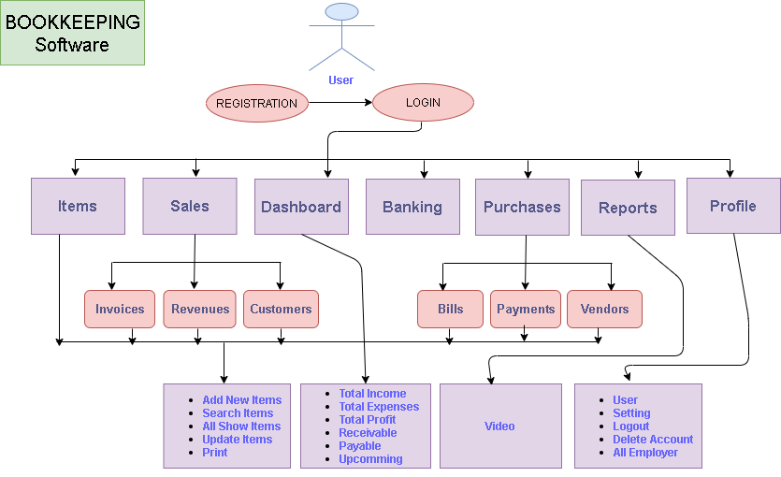

Fig 4.1.1: Use case diagram of DSM (Main Part)

**4.1.1: Use case diagram of DSM (User Part)**

This is the diagram representing whole admin panel access. Admin is login after all acerbate as like admin panel show, admin accessible menu add product, authorization etc.

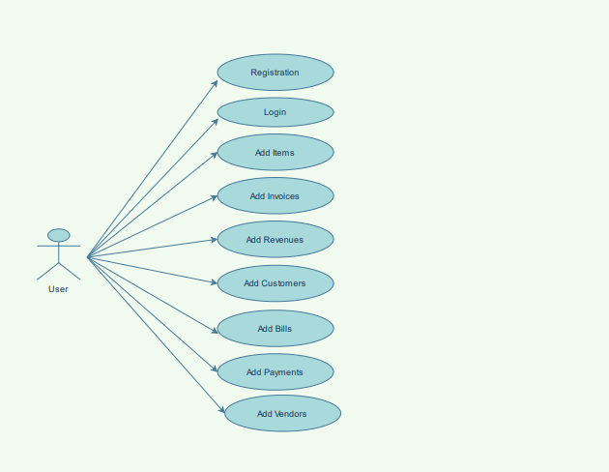

Fig 4.1.2: Use case diagram of DSM (User Part)

**4.1.2: Use case diagram of DSM (Product Part)**

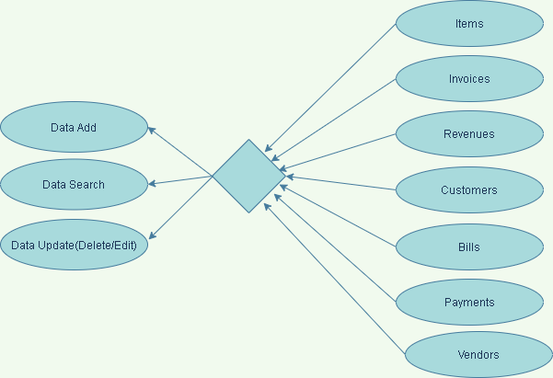

**Fig 4.1.3: Use case diagram of DSM (Product Part)**

4.1.3 ERD (Entity Relationship Diagram)

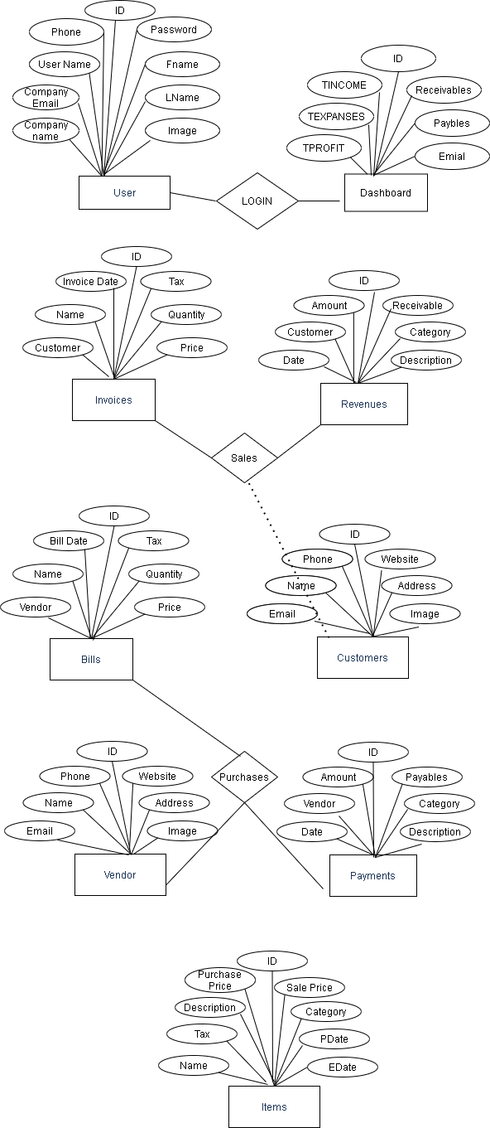

Fig 4.1.4 : E-R diagram of a DSM System

**SYSTEM IMPLEMENTATION**

**4.2. Screens & Reports:**

Web page Design

**4.2.0 Cover Page :**

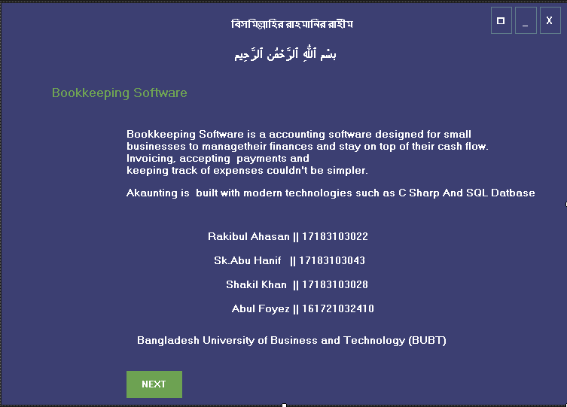

**4.2.1 Registration Page :** This is our DSM system **Registration** page. Admin or sales person used their **Registration** this system.

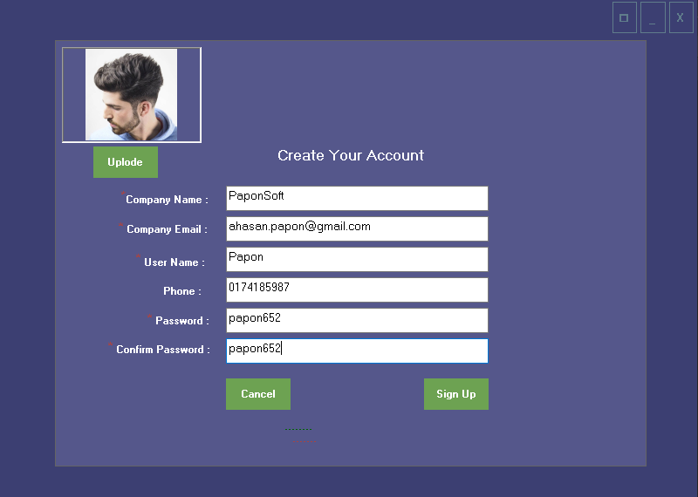

Fig 4.2.1 : **Registration**  page of DSMS Software

**4.2.2 Login Page :** This is our DSM system **login** page. Admin or sales person used their Email and password to login this system.

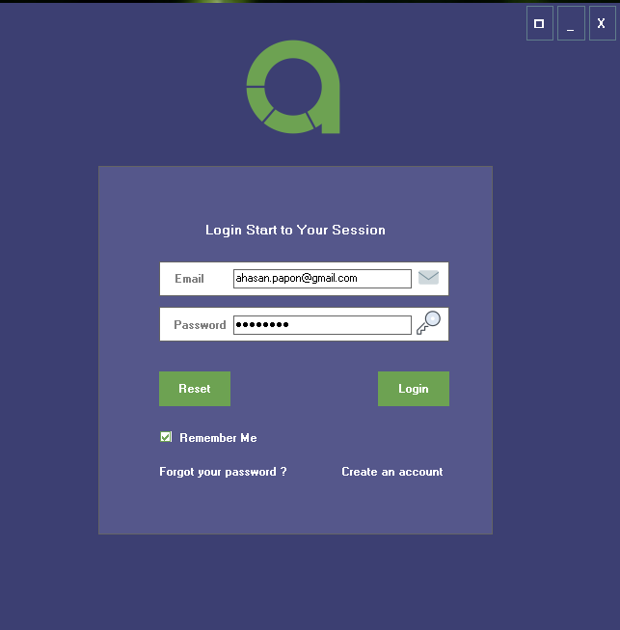

Fig 4.2.2 : **Login** page of DSMS Software

**4.2.3 Home page/Dashboard:** It’s our DSM software home page/Dashboard.

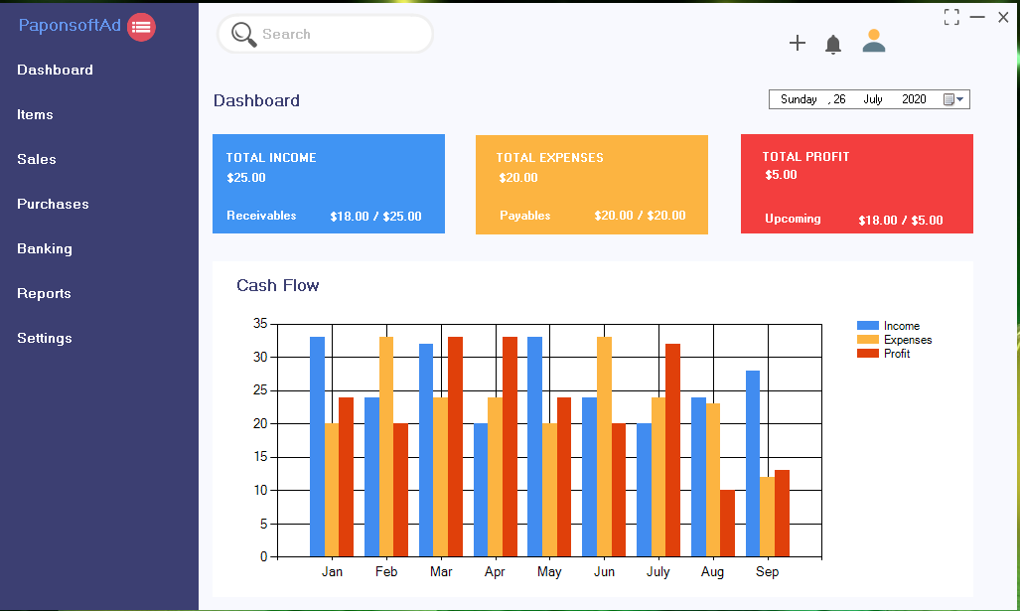

Fig 4.2.3 : Home page/Dashboard of DSM Software

**4.2.4 Adding Items Brands page:** In this chapter we describe the using process of the software(Show,Search And Add New Items).

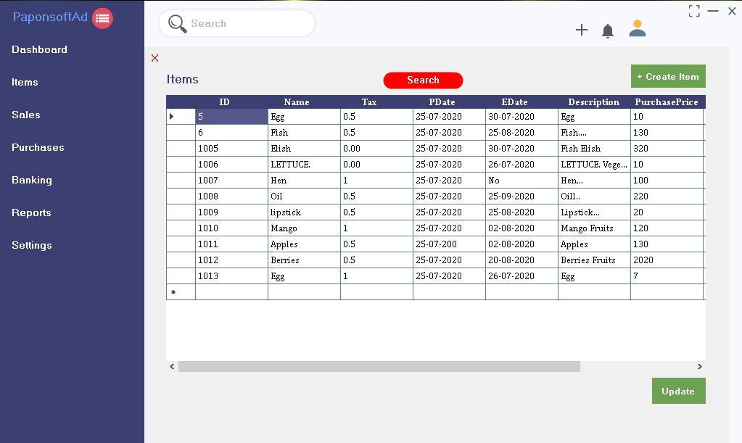

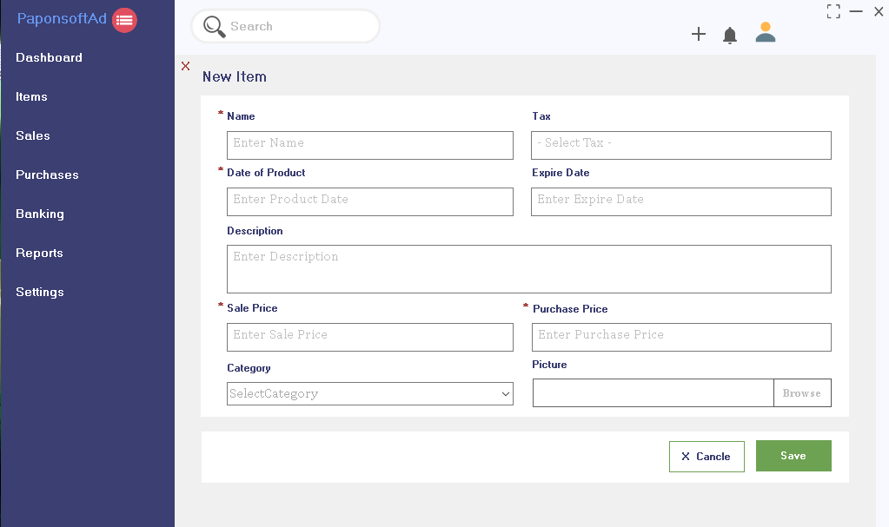

Fig 4.2.4 : Items of DSM Software

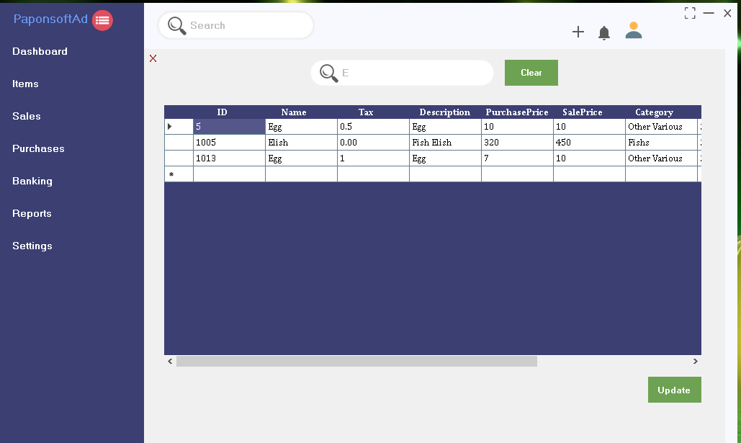

**4.2.5 Adding Invoices Brands page**: In this chapter we describe the using process of the software(Show,Search And Add New Items).

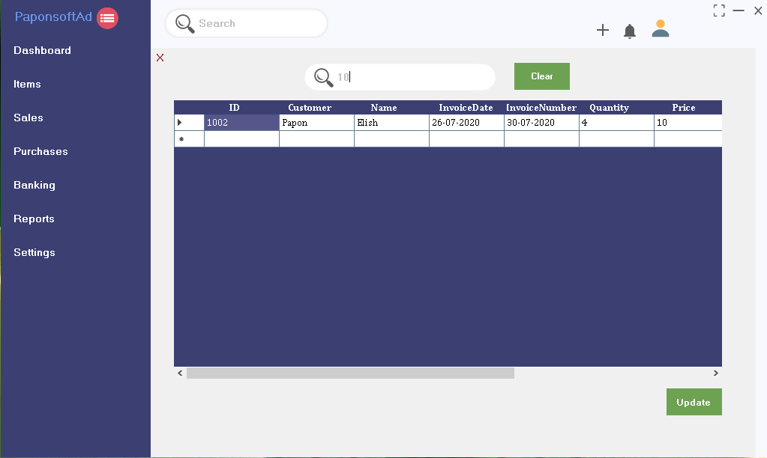

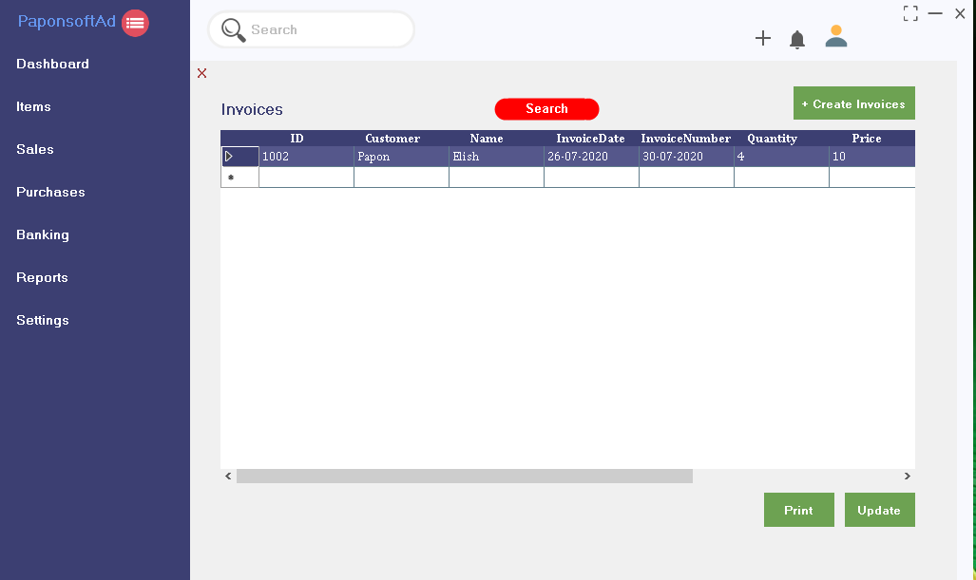

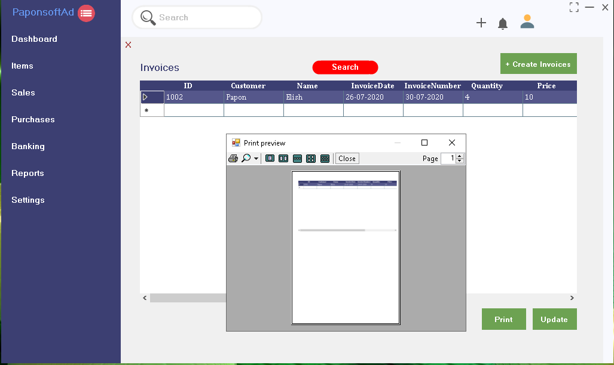

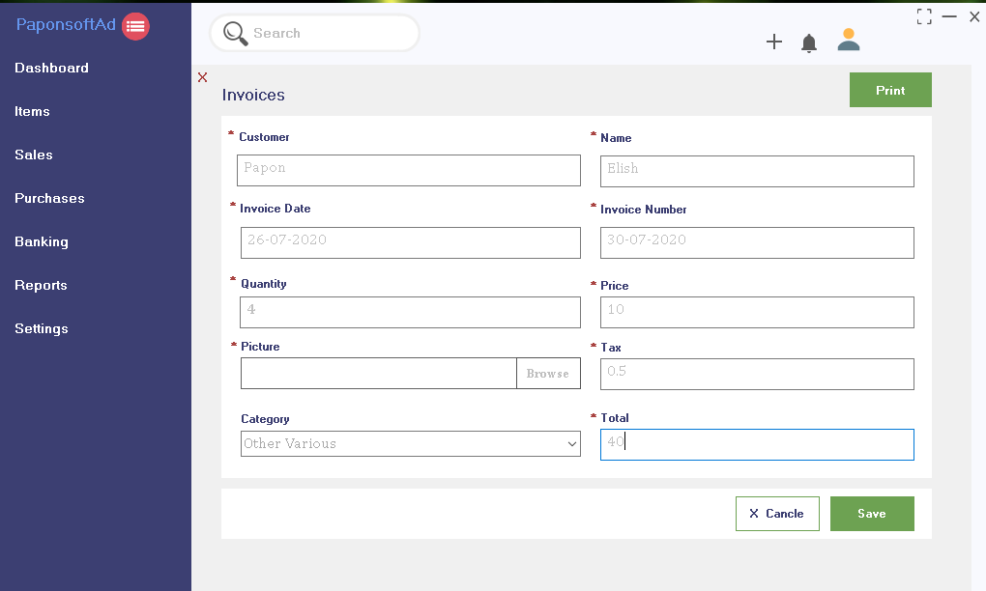

Fig 4.2.5 : Invoicess of DSM Software

**4.2.6 Adding Revenues Brands page:** In this chapter we describe the using process of the software(Show,Search And Add New Items).

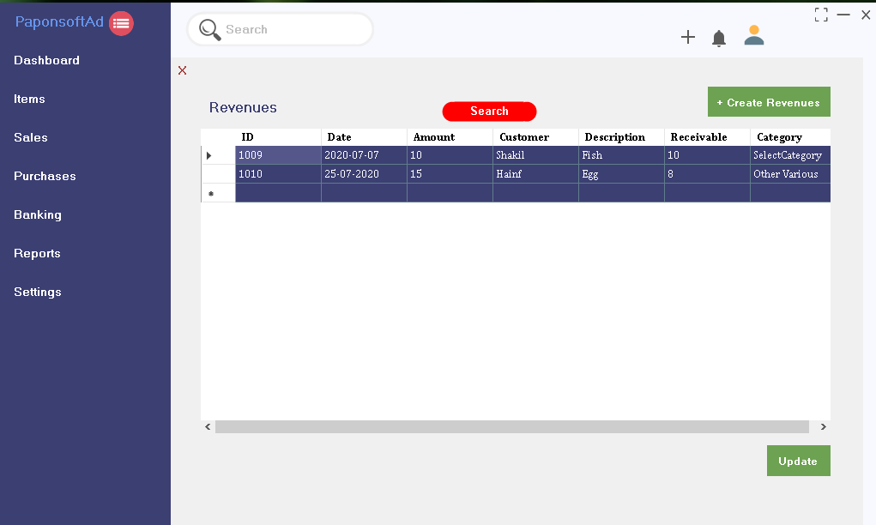

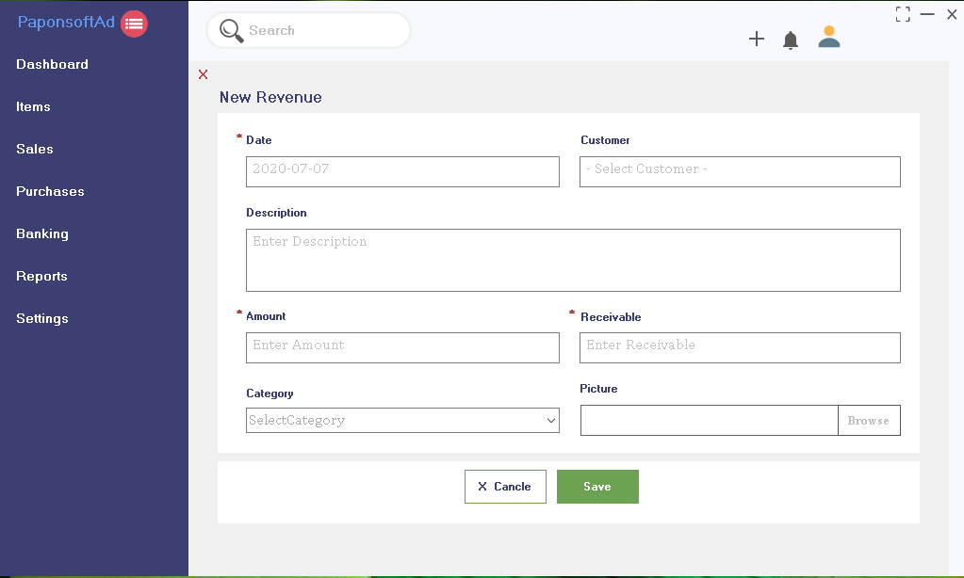

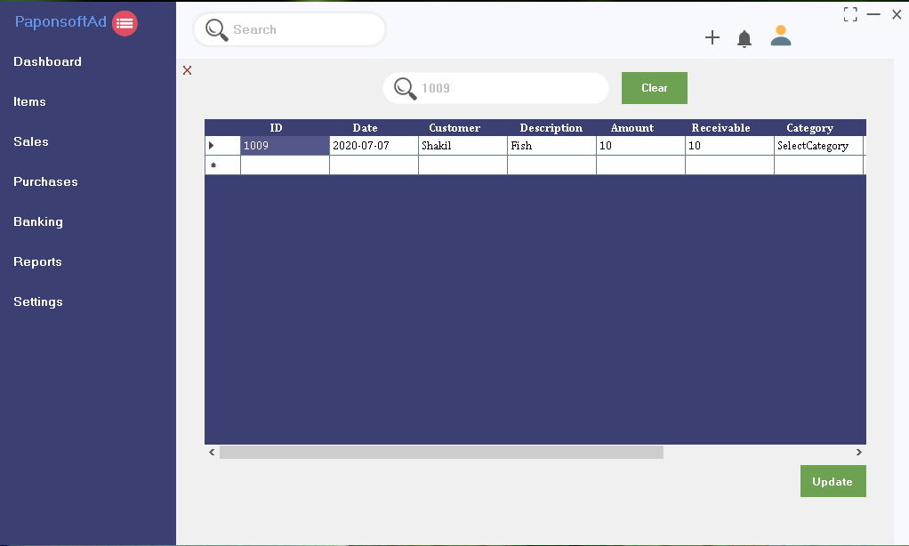

Fig 4.2.6 : Revenues of DSM Software

**4.2.7 Adding Customers Brands page:** In this chapter we describe the using process of the software(Show,Search And Add New Items).

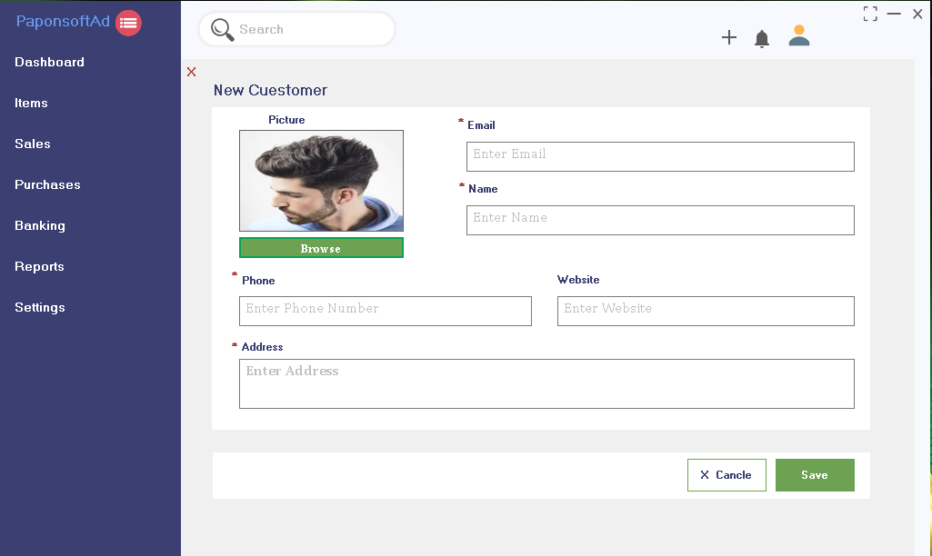

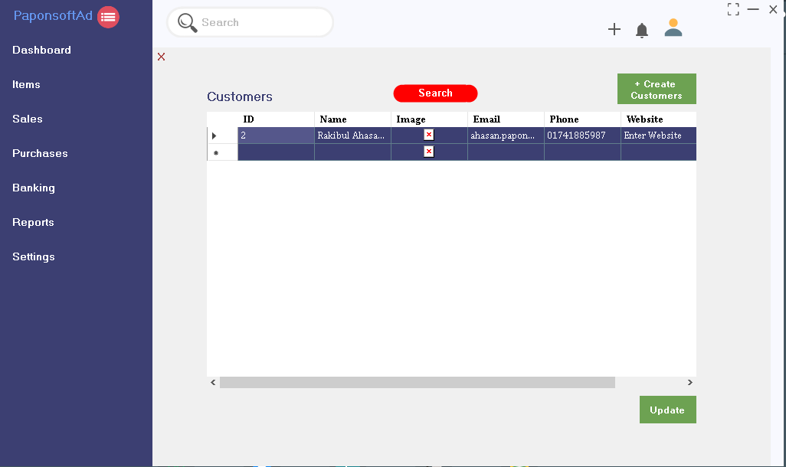

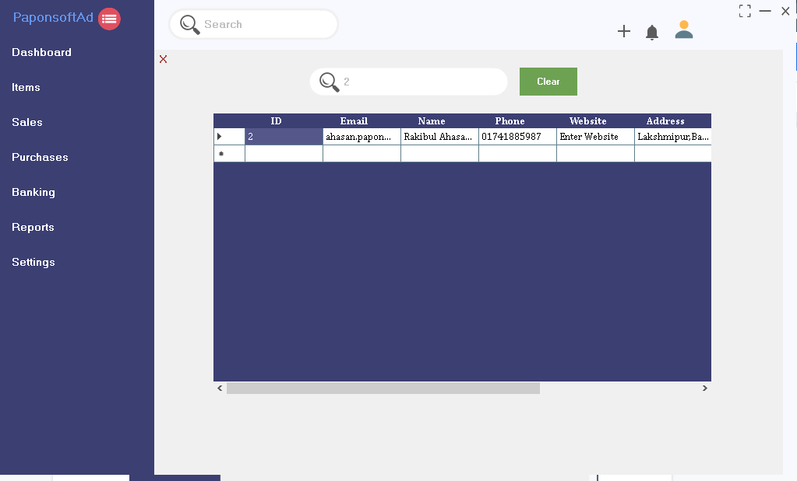

Fig 4.2.7 : Customers of DSM Software

**Database Design**

**4.2.8 : User Table**

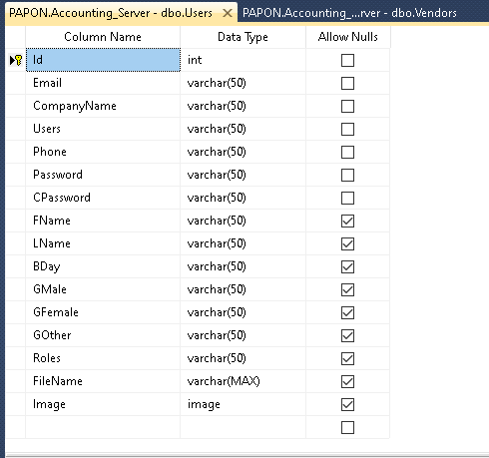

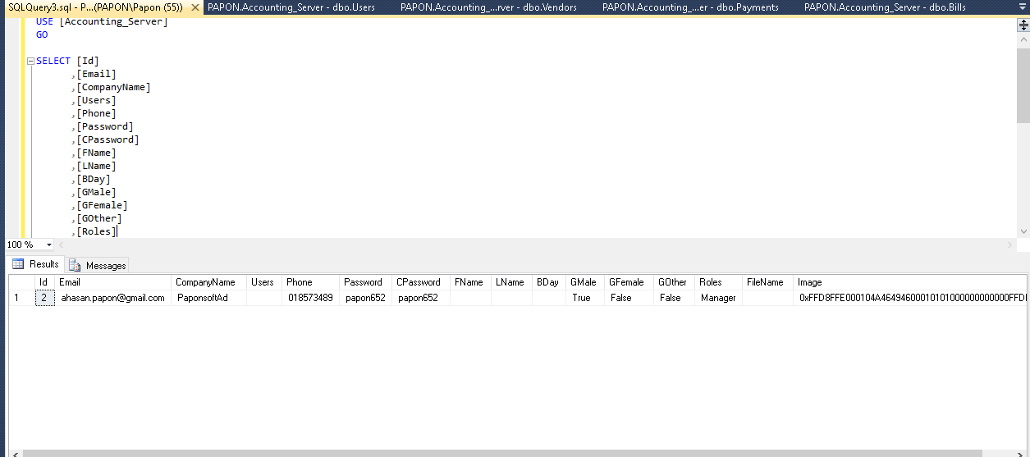

**4.2.9 : DAshboard Table**

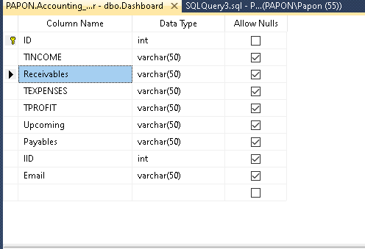

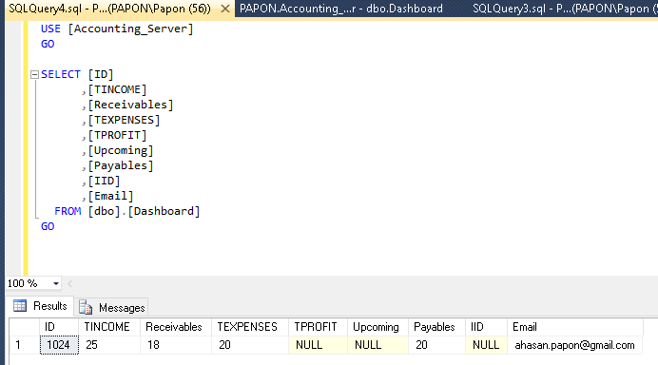

**4.2.10 : Items Table**

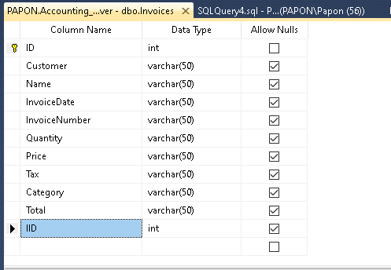

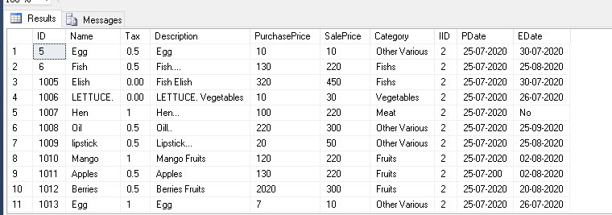

**4.2.11 : Revenues Table**

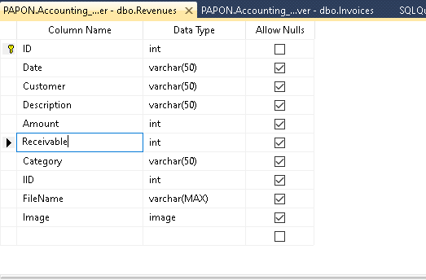

**4.2.12 : Customers Table**

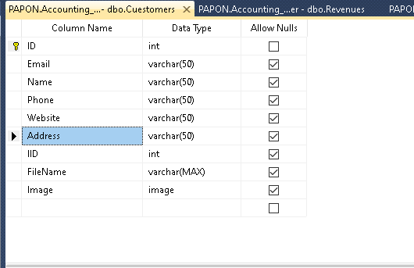

**4.2.13 : Bills Table**

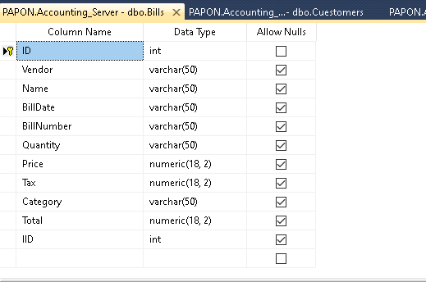

**4.2.14 : Payments Table**

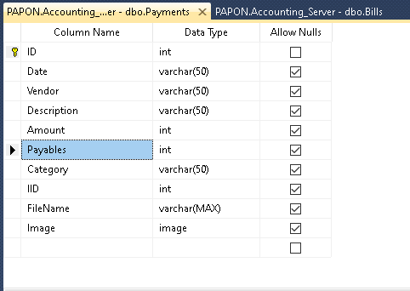

**4.2.15 : Vendors Table**

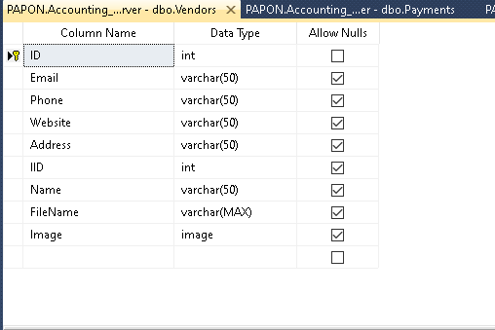

**4.2.6 : Query (Insert,Select And Update)**

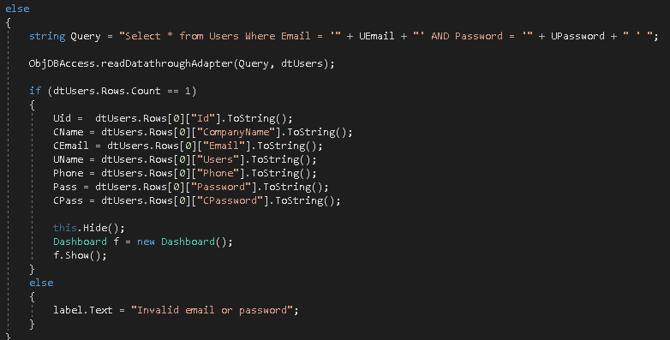

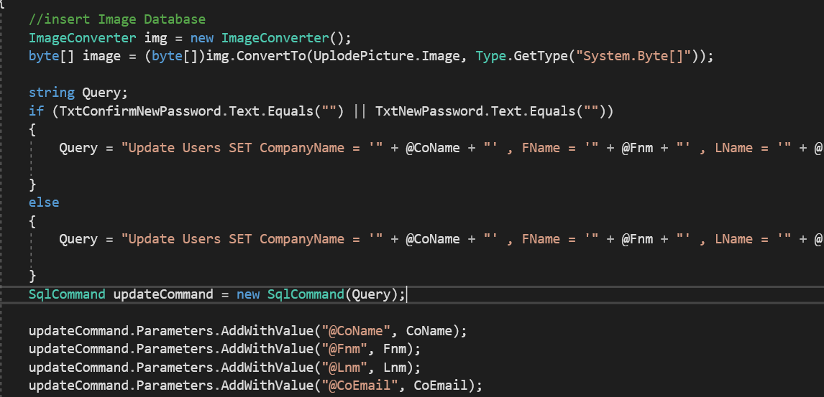

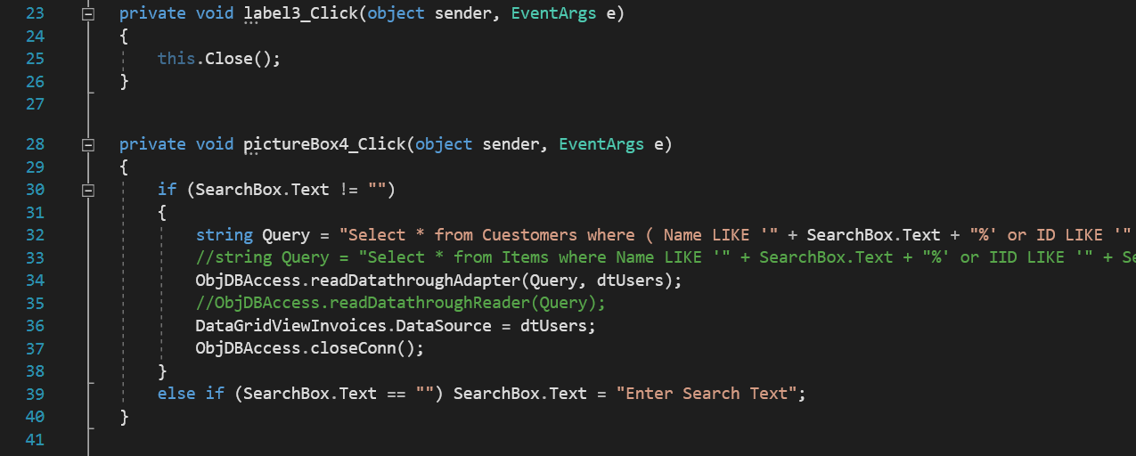

Chapter 05

CHAPTER 6

**CONCLUSION AND FUTURE WORKS**

Now words any mini shopping mall don’t have an online DSM software. We have to work it to have online based DMS software for a Mini Shop. So that, their transaction process and payment report should be clear. In our country we find many shopping mall, they are used desktop base DSM software and fact many problems .So, we made an online base DSM system software to improve that system and also developed our country.

I have done proper in this project are compliantly logical business model and it's really sequential effective project. This project functionality, usability each and every point structural.

While point of sale systems are an integral part of today’s commercial workplace, the details and options available for purchase can be mind-boggling to the novice shopper. It is vital to narrow down the numerous selections available in order to find which DSM system will best suit a particular user. Shopping on Agora allows the option of narrowing selections to find the necessary options, in addition to allowing shoppers to buy from sellers worldwide.

REFERENCES

[1] Ian Somerville, “project planning”, Software Engineering Pearson Education, Update 8th Edition, 1989-1992.

[2] http://en.wikipedia.org/wiki/Point_of_sale

[3] <https://www.geeksforgeeks.org/>

[4] <https://www.w3schools.com/>

--- End---