**DEPARTMENTAL STORE MANAGEMENT SYSTEM**

***Submitted By***

**SHAHREAR AMIR RAJIB**

ID# 2013-3-96-004

***Supervised By***

**Dr. Md. Nawab Yousuf Ali**

Associate Professor

Department of Computer Science and Engineering

East West University

**This Report Presented in Partial Fulfillment of the Requirements for the Degree of Master of Science in Computer Science and Engineering. East West University, Dhaka, Bangladesh**



**DEPARTMENT OF COMPUTER SCIENCE AND ENGINEERING EAST WEST UNIVERSITY**

**SPRING 2017**

I

**ABSTRACT**

This project develops a Departmental Store Management System (DSMS) is commonly found today at most retail store registers. Store merchandise, identified by a price code is checked out by a cashier who then accepts payment for the item(s). A DSMS is either read by a bar code scanner or manually entered by the cashier. At the completion of a sale, a receipt is created for the customer and sales information is collected for the generation of reports at a later time. A DSM system should help you alleviate the daily chores of your business. A DSM system should not interfere or make it harder for you to run your business. It should run parallel to your business operation. A perfect DSM system should run your business for you, but not in a literal sense where it takes total control. You want one comprehensive package for your entire business, either small or large. And it should scale as much as your business grows. The system also provides for processing the return of purchased items and reimbursement to the customer. While many DSM Systems support multiple terminals that are networked together and interface with external systems (such as inventory control) the primary goal of this system is to develop a self-contained sales terminal application that supports the purchase and return of store merchandise.



II

**DECLARATION**

I do hereby declare that, this project is an original work and was done under the

supervision of **Dr. Md. Nawab Yousuf Ali, Associate Professor, Department of CSE, East** **West University, Afatbnagar, Dhaka**. I also declare that neither this project nor any part ofthis project has been submitted elsewhere for award of any degree or diploma or for any other purposes except for publication. The materials that are obtained from other sources are duly acknowledge in this project.

**Submitted by:**

**Shahrear Amir Rajib**

ID# 2013-3-96-004

Department of CSE

East West University

Aftabnagar, Dhaka,

Bangladesh



III

**Latter of Acceptance**

This Project titled **“Departmental Store Management System (DSMS)**”, submitted by *Shahrear Amir Rajib (ID: 2013-3-96-004)* to the Department of Computer Science andEngineering, East West University, Aftabnagar, Dhaka has been accepted as satisfactory for the partial fulfillment of the requirements for the degree of Master of Science in Computer Science and Engineering and approved as to its style and contents.

**Supervised by:**

**Dr. Md. Nawab Yousuf Ali**

**Associate Professor**

Department of Computer Science & Engineering (CSE)

East West University

Aftabnagar, Dhaka,

Bangladesh



IV

**BOARD OF EXAMINERS**

**Dr. Md. Nawab Yousuf Ali** **Supervisor**

**Associate Professor**

Department of Computer Science and Engineering

East West University

Aftabnagar, Dhaka

Bangladesh

**Dr. Ahmed Wasif Reza** **Chairperson**

**Associate Professor and Chairperson (acting)**

Department of Computer Science and Engineering

East West University

Aftabnagar, Dhaka

Bangladesh



V

**ACKNOWLEDGEMENT**

First I express my heartiest thanks and gratefulness to almighty Allah for His divine blessing makes it possible to complete this project successfully.

I fell grateful to and wish my profound our indebtedness to **Dr. Md. Nawab Yousuf** **Ali , Associate Professor, Department of CSE East West University**, **Aftabnagar, Dhaka**.Deep Knowledge and keen interest of our supervisor in the field of wireless network influenced us to carry out this project. His endless patience, scholarly guidance, continual encouragement, constant and energetic supervision, constructive criticism, valuable advice, reading many inferior draft and correcting them at all stage have made it possible to complete this project.

I would like to express my heartiest gratitude to **Dr. Md. Nawab Yousuf Ali, Associate** **Professor, Department of CSE East West University**, **Aftabnagar , Dhaka** for his kind helpto finish the project and also to other faculty member and the staff of Computer Engineering department of East West University

I would like to thank my entire course mates in East West University, who took part in this discuss while completing the course work.

Finally, I must acknowledge with due respect the constant support and patients of my parents.



VI

|  |  |  |  |
| --- | --- | --- | --- |
|  |  | **TABLE OF CONTENTS** |  |
| Abstract | |  | II |
| Declaration | |  | III |
| Latter of Acceptance | | | IV |
| Board of Examiners | | | V |
| Acknowledgement | | | VI |
| **CHAPTER 1: INTRODUCTION** | | | **(1–4)** |
| Introduction | |  | 2 |
| 1.1 | Review current system business operation | | 2 |
| 1.2 | Motivation | | 2 |
| 1.3 | Goal of our Project | | 3 |
| 1.4 | Problem Analysis and Methodology | | 4 |
| 1.5 | Objectives | | 4 |
| **CHAPTER 2: BACKGROUND STUDY** | | | **(5 – 12)** |
| 2.1 | What is Departmental Store Management System | | 6 |
| 2.2 Reasons Why You Need DSMS Software | | | (6–8) |
|  | 2.2.1 Quick and Accurate Sales | | 7 |
|  | 2.2.2 | Inventory Control | 7 |
|  | 2.2.3 | Know Your Customers | 7 |
|  | 2.2.4 | Make Decisions Based On Data | 7 |
|  | 2.2.5 | Save Time! | 8 |
|  | 2.2.6 | Bonus: Vendor Integration for Smooth Ordering! | 8 |
| 2.3 | Benefits of Using a DSM System | | (8–9) |



VII

|  |  |  |  |
| --- | --- | --- | --- |
| 2.3.1 | Inventory | | 8 |
| 2.3.2 | Purchasing | | 9 |
| 2.3.3 | Departmental Store Management System | | 9 |
| 2.3.4 | Customer Relationship Management (CRM) | | 9 |
| 2.3.5 | Reports and Analysis | | 9 |
| 2.4 DSM Features | |  | 10 |
| 2.4.1 | Explain DSM Features | | (11 – 12) |
| **CHAPTER 3: SOFTWARE REQUIRMENT ANALYSIS** | | | **(13 – 24)** |
| 3.1 Requirement Analysis | | | 14 |
| 3.2 Software Requirement Specification | | | (14 – 18) |
| 3.2.1 | SRS Scopes | | 15 |
| 3.2.2 | SRS Assumption Dependencies | | 15 |
| 3.2.3 | Functional Requirement | | 16 |
| 3.2.4 | Non Functional Requirement | | 17 |
|  | 3.2.4.1 | Reliability | 17 |
|  | 3.2.4.2 | Availability | 17 |
|  | 3.2.4.3 | Security | 17 |
|  | 3.2.4.4 | Maintainability | 18 |
|  | 3.2.4.5 | Portability | 18 |
|  | 3.2.4.6 | Usability | 18 |
| 3.3 Interface Requirement | | | (19 – 20) |
| 3.3.1 | User Interfaces | | 19 |
| 3.3.2 | Hardware Interfaces | | 19 |
| 3.3.3 | Software Interfaces | | 19 |
| 3.3.4 | Communications Interfaces | | 19 |
| 3.4 SRS Specification | | | 20 |
| 3.5 Analysis | |  | 22 |



VIII

|  |  |  |
| --- | --- | --- |
| **CHAPTER 4: SYSTEM DESIGN** | | **(25 – 43)** |
| 4.1 UML Design | | 26 |
| 4.2 Use Case |  | (26 – 29) |
| 4.2.1: Use case diagram of DSM (Admin Part) | | 27 |
| 4.2.2: Use case diagram of DSM (Sales Person Part) | | 28 |
| 4.2.3: Use case diagram of DSM (Customer Part) | | 29 |
| 4.3 ERD (Entity Relationship Diagram) | | (30 – 31) |
| 4.4 DFD (Data Flow Diagram) | | (31 – 33) |
| 4.4.1: Context Diagram of DSM | | 31 |
| 4.4.2: Level 1 DFD | | 32 |
| 4.4.3: DFD Level 2 | | 32 |
| 4.4.4: DFD Level 3 | | 33 |
| 4.5 State Transaction Diagram | | 34 |
| 4.6 Web page Design | | (35 – 43) |
| 4.6.1 | Login Page | 35 |
| 4.6.2 | Home page | 36 |
| 4.6.3 | Adding Product Brands page | 36 |
| 4.6.4 | Product List page | 37 |
| 4.6.5 | Add Product page | 37 |
| 4.6.6 | Categorize List Page | 38 |
| 4.6.7 | Supplier Details Page | 38 |
| 4.6.8 | Customer Details Page | 39 |
| 4.6.9 | Stock List Page | 39 |
| 4.6.10 Sales Page | | 40 |
| 4.6.11 After Sales completion Terminal to Print Invoice Page | | 41 |
| 4.6.12 Report Page | | 42 |
| 4.6.13 Account Details Page | | 42 |
| 4.6.14 Configuration Page | | 43 |



IX

|  |  |
| --- | --- |
| 4.7 Gantt Chart | 43 |

|  |  |  |
| --- | --- | --- |
| **CHAPTER 5 : DEVELOPMENT AND IMPLEMENTATION** | | **(44 – 47)** |
| 5.1 | Project Overview | 45 |
| 5.2 | Departmental Store Management System (DSMS) Terminal | 46 |
| 5.3 | DSM System and the related risks and controls | 46 |
| 5.4 | Project Deliverables | 46 |
| 5.5 | Resource Allocation | 47 |
| **CHAPTER 6 : CONCLUSION AND FUTURE WORKS** | | **(48 – 49)** |

|  |  |
| --- | --- |
| **REFERENCES** | **50** |



X

**LIST OF FIGURES**

|  |  |
| --- | --- |
| **FIGURES** | **Page No.** |
| Fig 4.2.1: Use Case of DSMS (Admin part) | 27 |
| Fig 4.2.2: Use Case of DSMS (Sales Person part | 28 |
| Fig 4.2.3: Use Case of DSMS (Customer part) | 29 |
| Fig 4.3: ER Diagram of DSMS | 30 |
| Fig 4.4.1: Context Diagram of DSMS | 31 |
| Fig 4.4.2: DFD Level 1 of DSMS | 32 |
| Fig 4.4.3: DFD Level 2 of DSMS | 32 |
| Fig 4.4.4: DFD Level 3 of DSMS | 33 |
| Fig 4.5: State Transaction Diagram of DSMS | 40 |

**LIST OF TABLES**

|  |  |
| --- | --- |
| **TABLES** | **Page No.** |
| Table 3.4: SRS Specification Chart | 17-19 |
| Table 3.5: Analytical level of requirement | 20-21 |



XI

**Chapter 01**



1 | P a g e

**CHAPTER 1**

**INTRODUCTION**

DSMS stands for **D**epartmental **S**tore **M**anagement **S**ystem. This is a rather broad definition that can include merchandising aids, displays and the methods used to enable transactions. In our case, we're talking about the hardware and software that runs both the front counter and back office operations of a business.

A **D**epartmental **S**tore **M**anagement **S**ystem (DSMS) is an application that executes a collection of protocols to co-ordinate the actions of multiple processes on a network, such that all components cooperate together to perform a single or small set of related tasks. This system is good when one is has an established Shop and wants his/her stores to blinked.

One of its advantages is the ability to connect remote use with remote resources in an open (where each component is continually open to interaction with other components) and scalable (the system can easily be altered to accommodate changes in the number of users, resources and computing) way, and can also be larger and more powerful given the combined capabilities of the Departmental Store Management System. Components compared to that of Departmental Store Management System.

**1.1 Review of current system business operation**

Inventory software programs now on the market let you track usage, monitor changes in unit Costs, calculate when you need to reorder, and analyze inventory levels on an item-by-item basis. You can even control inventory right at the cash register with Departmental Store Management System (DSM) software systems. DSM software records each sale when it happens, so your inventory records are always up-to-date. Better still, you get much more information about the sale than you could gather with a manual system. By running reports based on this information, you can make better decisions about ordering and merchandising. I can analyze sales data, figure out how well all the items on our shelves sell, and adjust purchasing levels accordingly. I can maintain a sales history to help adjust our buying decisions for seasonal purchasing trends. I can improve pricing accuracy by integrating bar-code scanners and credit card authorization ability with the DSM system.

**1.2 Motivation**

Departmental Store Management System (DSMS), commonly found in retail establishments and known as DSM, often feature a complex arrangement of hardware, software and network connections. DSM systems rely on predictable operation, and any number of problems can appear when hardware, software or users do not perform as expected. So this perspective things Motivates me to kind of software in real time business.



2 | P a g e

**1.3 Goal of our Project**

Web Based or Mobile DSM: Our works on Mobile, Tab and PC system you can use one or more than one Platform. It works in both online and offline.

**DSM Works Offline**: DSM works online but when internet down than you can continue yourselling. DSM will automatically resynchronize with other terminals & up-to-date back-up.

**Online Store:** Open an Online Store and quickly get your product online with just one click. Noneed to be web expert.

**Mobile Friendly:** You can operate and see details of shop in your mobile phone.

**Domain and Hosting**: Bring your own domain to ensure to match your Shop.

**Inventory Control:** See stock on hand, get notification when stock is low.

**Customer History:** Keep all your customer information in one place. It keeps customerpurchase history.

**Customizable Reporting:** Build your own reports and quick see the store. Reports likeinventory, sells, end of day. You can even see the reports from mobile phone.

**Add-Ons:** You can integrate multiple data in one database it’s synchronize automatically**.**

**Multi-Outlet:** You can open new outlet using same database. You can add more than one userjust a click.

**DSM System is perfect for retail stores, just like yours**

* Fashion boutiques
* Home & Lifestyle
* Health & Beauty
* Sports & Outdoors
* Food & Drink
* Coffee Shops
* Computer Shops
* Bike Shops
* And Many More....



3 | P a g e

**1.4 Problem Analysis and Methodology** User’s view of the problem

The user’s problem is that his branches and their associated systems function Independently thus creating difficulties in keeping track of any changes made to the local Databases. Therefore a system is needed that will be able to make changes Instantaneously in a synchronized manner. This will mean that a distributed application should be introduced which will be needed to send objects from one application to another by summoning a single application program of object methods located in Another program. In so doing, it will be easy to monitor the progress of the company and employees.

Methodology

In this chapter the requirement where analyzed from the developer’s point of view. I was using Asail Methodology. I had begun the analysis by looking at the possible challenges that will be encountered and Alternative solutions that could be implemented. System implementation will be carried out Using Bootstrap, CSS 3, Jquery, Ajax, PHP 7, MySQL, and framework: Codeigniter 3, which are the open source applications.

**1.5 Objectives**

Departmental Store Management (DSM) system provides businesses with the ability to computerize, systematize and correlate retail information. Where cash registers, including complex register systems, have limited information collection capacity, DSM systems can gather, store and return detailed reports on inventory trends and customer information. Additionally, DSM systems more easily integrate with numerous sales and ordering systems, including mail or online ordering systems used in conjunction with in-person sales.



4 | P a g e

**Chapter 02**



5 | P a g e

**CHAPTER 2**

**BACKGROUND STUDY**

DSMS stands for **D**epartmental **S**tore **M**anagement **S**ystem. This is a system that is used throughout the restaurant and retail industry. This computerized system allows business owners to track sales, cash flow, food inventory and can help simplify your bookkeeping enormously.

**2.1 What is Departmental store management system (DSMS)?**

**DSMS** is an abbreviation for **Departmental Store Management System**. The term isapplicable to a retail shop or store, the checkout/cashier counter in the store, or a location where such transactions can occur in this type of environment. It can also apply to the actual **Departmental Store Management (DSM) System Hardware & Software** including but notlimited to: electronic cash register systems, touch-screen display, barcode scanners, receipt printers, scales and pole displays. Departmental store management system are utilized in many different industries, ranging from restaurants, hotels & hospitality businesses, nail/beauty salons, casinos, stadiums, and let's not forget - the retail environments. In the most basic sense, if something can be exchanged for monetary value - a Departmental Store Management System can be used.

**2.2 Reasons Why You Need DSM Software**

In the retail business, a good Departmental Store Management System is one of your biggest assets. If it works as advertised, it’ll be a lot like having your own team of experts working behind the scenes, making sure everything’s moving along quickly and efficiently. To remain on top in today’s highly competitive retail landscape, you need a DSM system to help you run your business the right way here’s why.



6 | P a g e

**2.2.1 Quick and Accurate Sales**

It all comes down to sales. If you aren’t making sales you aren’t going to stay in business. Sales are the core of your business and how you handle this process is essential to your success. A DSM system makes sure that everything runs smoothly on every transaction.

**2.2.2 Inventory Control**

If sales are number one, good inventory control is a close second. Without good inventory control you miss out on sales, overstock unwanted product, and lose out on high profit margins. A DSM system will keep an accurate count of every product in your store. It allows you to see what items are selling, what’s sitting on the shelf, and what you need to order.

**2.2.3 Know Your Customers**

Sales and inventory might be one and two, but everyone knows the customer is always right. Without real people coming in you won’t have sales and there will be no need to stock any inventory. A Departmental store management system should give you the ability to track all of your customers so you can see which customers are big spenders, who is waiting for a special order, and who has a layaway on that product tucked away in the back room.

**2.2.4 Make Decisions Based On Data**

If you’re not making day to day business decisions based on facts and data you are gambling with your money and time! To make the right decisions you need reliable data. Once you have done the work to setup a Departmental store management system and get all your inventory in you can start to reap the rewards. Your system should provide reports on sales and inventory that will help you make purchasing decisions



7 | P a g e

**2.2.5 Save Time!**

**There’s one thing that we could all use a little more of: Time!** Possibly the thingyou’ll love the most about a Departmental store management system is the time it will save you. With integrated barcode readers, label printers, receipt printers you’ll cut your manual labor dramatically.

**2.2.6 Bonus: Vendor Integration for Smooth Ordering!**

**New Departmental store management system offer integration with your vendors/suppliers.** This can save you time when you create purchase orders by:checking in-stock status for items on your order, automatically submitting the order to your vendor, downloading your invoices to help check in your order when it arrives.

**2.3 Benefits of Using a DSM System**

The right Departmental store management system will give you control over many different areas of your business operations increasing efficiency and profitability. A Departmental store management system will streamline business operations, including inventory and vendor management along with streamlining Departmental store management system processes. The following overview, categorized by area of operation, highlights some of the typical benefits of using a Departmental store management system.

**2.3.1 Inventory :** A Departmental store management system allows you to categorizeyour inventory by a number of fields for easy lookup and sorting of your merchandise. A typical inventory hierarchy would include Store, Dept., Class, Subclass, Item Description, Size, and Color. Most systems also offer extended inventory descriptions to track additional information such as alternate lookup and additional product descriptions. You can quickly search and sort your inventory to track quantity on hand and restock levels for each item in your inventory. In addition you can typically track suppliers, substitutes, aliases, and parent relationships.



8 | P a g e

**2.3.2 Purchasing :** A Departmental store management system will help you replenishitems efficiently and negotiate lower vendor costs. You can quickly generate purchase orders and add items on the fly. Purchase orders can be created for standard items as well as matrix items (size and color). Purchase orders can be tracked by order date, receive date and cancel date so you can take the appropriate action on your open orders. You will be able view what is on order and backorder at all times and print aging reports for open orders.

**2.3.3 Departmental Store Management System :** Allows you to reduce pricingerrors and speed up checkouts. A Departmental store management system enables cashiers to process transactions and serve customers efficiently, and allows managers to maintain tight control. Some of the benefits of using a system include the ability to automatically look up and sell items based on pre-set sales, quantity discount, and preferred price levels. In addition at the Departmental store management you can check availability of items on the fly and be able to support multiple tender transactions, including cash, check and credit card.

2.3.4 ***Customer*** **Relationship** ***Management (CRM)*** **:** keep a complete profile of every customer who has shopped in your store. Customer information typically includes demographics, preferences and purchase history. Using CRM features will allow you to target market and send promotions to customer based on purchasing history or other specific customer preferences.

2.3.5 ***Reports*** **and** ***Analysis*** **:** a Departmental store management system will allow you to preview, search and print daily sales reports and journals by register, batch, and receipt number.

You will be able to identify sales trends by item, style, department, and vendor. Review top performer reports for cashier, sales person, and customers. Most systems will also allow you to export reports directly into Excel, XML, CSV or your E-mail application.



9 | P a g e

2.4 **DSM Features :**

Here Departmental store management system features are**:**

* Log In Admin/Sales person
* Add New Salesperson
* Delete sales person
* Buy Product
* Pay Bill
* Sales register
* Sales summary
* Discount for Cash
* Customer Details
* Sales Details
* Payment Details
* Print sales reports
* Delivery Receipt
* Products Inventory
* Print Products Inventory
* Add Product
* Search Products
* Edit Product
* Update Product
* Delete Product
* Generate Barcode
* Print Barcode Labels
* Barcode Scanner
* Refunds Products
* Refunds and sales Transactions
* Refunds and sales Transactions Reports
* Daily/Weekly/Monthly/ Yearly Reports
* Print Daily/Weekly/Monthly/ Yearly Reports



10 | P a g e

**2.4.1 Explain DSM Features :**

**Log in Admin/Sales person :** The DSM software is able to login to both admin and salesperson.

* **Add New Salesperson :** It will add new User for Sales product. The sales personcontains those fields which are First Name, Last Name, Phone Number, Email, Additional Info, Password and Verify Password.
* **Delete Salesperson :** admin can be delete sales person.
* **Buy Product :** Customer can buy product in this Agora cosmetic and supermarket.
* **Pay Bill :** Customer will pay bill for the product
* **Sales Register :** Sales person must be registered in order to sell products.
* **Sales Summary :** Customer details, sales details and payment details.
* **Discounts for Cash :** Get some discount for customer products.
* **Customer Details :** Customer name, customer address.
* **Sales Details :** Amount, vat, total amount.
* **Auto Product VAT:** Customer will payautovat for a product.
* **Payment details :** Cash and change.
* **Print Sales Reports :** Seller will print sales reports.
* **Delivery Receipts :** Seller will provide the customer delivery receipts.
* **Product Inventory :** There are many products in this inventory.
* **Print Product Inventory :** Print product inventory list.
* **Add Product :** Sales person added new item of product. The product contains thosefields which are Item Code, Item Description, Price, Discount and Tax.



11 | P a g e

* **Search Product :** Search the product from the stock which are available on not.
* **Edit Product :** The system have product item edit where edit field are Item Code, ItemDescription, Price, Discount and Tax.
* **Update Product :** The system have product item Update where update field are ItemCode, Item Description, Price, Discount and Tax.
* **Delete Product :** The system have product item delete where delete field are DeleteProduct Information.
* **Generate Barcode :** Create Barcode of product. The Barcode will have those fieldswhich are Number of Code, Data, Output and Print.
* **Print Barcode Labels :** Print Random Barcode Labels.
* **Barcode Scanner :** Barcode must be scanned for integrity of product. One BarcodeReader.
* **Refunds Products :** It store the product which are returned into stock and update fundswhere the field must displays that are Quantity, Item, Description, Unit Value, Discount, Tax and Line Total Tk.
* **Refunds and sales Transactions :** Aftertransaction where some information are Salesperson, Payment Method and Amount.

modify the refund and sales it will be contained those are Date, Transaction,

* **Refund and Sales Transactions Report :** It will transact the refund and sales product

.the report will have those field which are Date, Transaction Ref, Salesperson, Payment Methods and Amount.

* **Daily/Weekly/Monthly/Yearly Reports :** Delivery date report. The report will havethose fields which are Transaction and Stock Report.
* **Print Daily/Weekly/Monthly/Yearly Reports :** Print Daily/Weekly/Monthly/Yearlyproducts sell reports.



12 | P a g e

**Chapter 03**



13 | P a g e

**CHAPTER 3**

**SOFTWARE REQUIREMENT ANALYSIS**

A software requirement is a field within software engineering that deals with establishing the needs of stakeholders that are to be solved by software. The IEEE Standard Glossary of Software Engineering Terminology defines requirements.

**3.1 Requirement Analysis:**

The Departmental Store Management System Requirements provides high-level of functional requirements.

The functions of the DSM system are discussed below.

Admin can directly login this system but the sales person used to register to login this system

Admin

Sales Person

Admin can do all activities in this system and the seal person, who sells product, Inventory product, seals reports create etc.

**3.2 Software Requirement Specification:**

Elements of the DSM Supplementary Specification:

Documentation (user, installation, administration) and help licensing and other legal concerns

Packaging

Standards (technical, safety, quality)

Physical environment concerns (for example, heat or vibration)

Operational concerns (for example, how do errors get handled, or how often should backups be done?)

Application-specific domain rules information in domains of interest (for example, what is the entire cycle of credit payment handling?)



14 | P a g e

**3.2.1 SRS Scopes:**

In recording the purchases made by customers, the following information are stored:

1. A unique transaction number assigned to every transaction,
2. The name of the customer
3. The name of the waiter
4. The items purchased and their prices
5. The date and time of the transaction
6. Discounts applied to the transaction (if any)
   1. The total price of all the items bought or ordered after applying the discounts (if any).

For the database of items, the system will only store information about the items offered in the lounge. Data regarding the number of stock for each item is not covered since an inventory system is no longer in our scope. The following information are stored for each item in the database:

* 1. The unique product identification number
  2. The product name
  3. Item type

1. Category
2. The price the item was bought and
3. The selling price. The item type is either *Food* or *Drinks.* The category may be any one of the followings: appetizer, chef’s special, noodles, starters, sandwich, sizzler, seafood, for Food item-type; Cocktail, beer, liquor, shooters, on-the rocks, beverages, fruit shakes, for Drinks item-type.

**3.2.2 SRS Assumption Dependencies:**

Requirements analysis is usually the first phase of large-scale software development project. It is undertaken after a feasibility study has been performed to define the precise costs and benefits of a software system. The purpose of this phase is to identify and document the exact requirements for the system. The customer, the developer, a marketing organization or any combination of the three may perform such study. In cases where the requirements are not clear e.g., for a system that is never been defined, more interaction is required between the user and the developer. The requirements at this stage are in end-user terms.



15 | P a g e

**3.2.3 Functional Requirement:**

In Software engineering and systems engineering, a functional requirement defines a function of a system or its component. A function is described as a set of inputs, the behavior, and outputs. Functional requirements may be calculations, technical details, data manipulation and processing and other specific functionality that define what a system is supposed to accomplish. Behavioral requirements describing all the cases where the system uses the functional requirements are captured in use cases. Functional requirements are supported by non-functional requirements, which impose constraints on the design or implementation.

Functional requirements are-

Login

* 1. Simple two step login system
     + Admin Login
     + Sales person Login

Administrator Dashboard

* 1. Admin can control whole system easily

1. Admin can add/delete sales person, Edit, update, delete, generate barcode etc.
   1. Admin show payment option. Sales person Role:
   2. Sell Products
   3. Stock Products
   4. Delivery Receipt
   5. Payment Process
   6. Accept Refunds Products Payment process
   7. Only Cash Payments
2. Paid Vat
   1. Get Discounts Barcode
   2. Generate Barcode



16 | P a g e

* 1. Print Barcode Level
  2. Barcode Scanner

Refunds Process

* 1. Accept Refund Products
  2. Cash back

Reports Module

* 1. View Sales Reports
  2. View Transaction Reports o View Refunds Reports

o Daily/Weekly/Monthly/Yearly Reports Database

**3.2.4 Non Functional Requirement:**

In systems engineering and requirements engineering, a non-functional requirement is a requirement that specifies criteria that can be used to judge the operation of a system, rather than specific behaviors. They are contrasted with functional requirements that define specific behavior or functions. The plan for implementing functional requirements is detailed in the system design. The plan for implementing non-functional requirements is detailed in the system architecture, because they are usually Architecturally Significant Requirements.

**3.2.4.1** **Reliability**

The following requirements describe the expected reliability of the Operational Interface

* The Operational Interface shall have a Mean Time Between Failures of no less than 17 days

**3.2.4.2** **Availability**

The following requirements indicate the expected availability of the Operational Interface.

* The system shall be available 99.5% of the time

**3.2.4.3 Security**

The software system needs a robust security mechanism in place so that unauthorized users are not allowed access to Departmental store management system. All users of the system



17 | P a g e

must be uniquely identified. This could be done by using a user name and associated password scheme that would authenticate and authorize the user access to the system and, if applicable, grant the user access to restricted or controlled Departmental store management system. If a user cannot be identified, he/she will be given “anonymous” access with read-only capabilities. In order to monitor all past access to the system, all attempts to access the system must be logged.

* All users of the system shall login using some form of unique identification (e.g., username and password)
* All login attempts shall be done so in a secure manner (e.g., encrypted passwords)
* Each user shall either be trusted or not trusted.

**3.2.4.4** **Maintainability**

The following requirements increase the maintainability of the Operational Interface software.

* All source code and development related documents shall be controlled under a version control system
* All source code shall adhere to an agreed upon and well-defined set of coding standards for each development language used.
* A standard naming convention for classes, variables and packages shall be agreed upon and adhered to.

**3.2.4.5 Portability**

* Hardware
* Operating Systems

Since the software must run on several popular hardware platforms and the goal is to achieve a

Reasonable level of platform independence.

The system shall be compatible with the Microsoft Windows Operating System (Vista, Windows 7/8/10, XP or greater).

**3.2.4.6 Usability**

The system’s user interface intuitive, easy to use and provide an overall positive user experience.



18 | P a g e

**3.3 Interface Requirement:**

In computing, an interface is a shared boundary across which two separate components of a computer system exchange information. The exchange can be between software, computer hardware, peripheral devices, humans and combinations of these. Some computer hardware devices, such as a touchscreen, can both send and receive data through the interface, while others such as a mouse or microphone may only provide an interface to send data to a given system.

3.3.1 User Interfaces

Login Screen Home Screen

Product Inventory Details Add Products Page

Refunds Product Page

3.3.2 Hardware Interfaces

Server Configuration: Minimum 2GB Hard Disk P-III processor or equivalent

Ram 512 MB

Windows with Apache preloaded. Client Configuration

3.3.3 Software Interfaces

Operating system = WindowsXP/2000/vista/widows 7 Language = PHP

Database = MYSQL

3.3.4 Communications Interfaces

Communications interfaces can be provided through e-mail, web browser, network server communications protocols, electronic forms, and so on. For this we can use communication



19 | P a g e

standards such as FTP or HTTP to provide security using encryption algorithms and synchronization mechanisms.

**3.4 SRS Specification**

A software requirements specification describes the essential behavior of a software. Content of the SRS Specification is given in Table 3.4

**Table 3.4: SRS Specification**

|  |  |  |  |
| --- | --- | --- | --- |
| **No** | **Requirement Name** | **Requirement Classified** |  |
|  |  |  |  |
| 1. | **Login** | **F1** |  |
|  |  |  |  |
| 2. | Admin Login | F1.1 |  |
|  |  |  |
|  |  |  |  |
| 3. | Sales Person Login | F1.2 |  |
|  |  |  |
|  |  |  |  |
| 4. | **Administration Dashboard** | **F2** |  |
|  |  |  |  |
| 5. | Add Sales Person | F2.1 |  |
|  |  |  |
|  |  |  |  |
| 6. | Delete Sales Person | F2.2 |  |
|  |  |  |
|  |  |  |  |
| 7. | Edit Product | F2.3 |  |
|  |  |  |
|  |  |  |  |
| 8. | Update Product | F2.4 |  |
|  |  |  |
|  |  |  |  |
| 9. | Delete Product | F2.5 |  |
|  |  |  |
|  |  |  |  |
| 10. | Products Inventory | F2.6 |  |
|  |  |  |  |
| 11. | Add Products | F2.7 |  |
|  |  |  |  |
| 12. | Auto Products Vat | F2.8 |  |
|  |  |  |  |
| 13. | Generate Barcode | F2.9 |  |
|  |  |  |  |
| 14. | Print Barcode Level | F2.10 |  |
|  |  |  |  |
| 15. | Daily/weekly/monthly/yearly Products Reports | F2.11 |  |
|  |  |  |  |



20 | P a g e

|  |  |  |  |  |
| --- | --- | --- | --- | --- |
| 16. | | **Sales Person Role** | **F3** |  |
|  |  |  |  |  |
| 17. | | Sell Products | F3.1 |  |
|  |  |  |  |  |
| 18. | | Stock Products | F3.2 |  |
|  |  |  |  |  |
| 19. | | Payment Process | F3.3 |  |
|  |  |  |  |  |
| 20. | | Refunds Products | F3.4 |  |
|  |  |  |  |  |
| 21. | | **Payment Process** | **F4** |  |
|  |  |  |  |  |
| 22. | | Cash Payment | F4.1 |  |
|  |  |  |  |  |
| 23. | | Paid Vat | F4.2 |  |
|  |  |  |  |  |
| 24. | | Get Discount | F4.3 |  |
|  |  |  |  |  |
| 25. | | **Barcode** | **F5** |  |
|  |  |  |  |  |
| 26. | | Generate Barcode | F5.1 |  |
|  |  |  |  |  |
| 27. | | Barcode Scanner | F5.2 |  |
|  |  |  |  |  |
| 28. | | **Refunds Process** | **F6** |  |
|  |  |  |  |  |
| 29. | | Accept Refunds Products | F6.1 |  |
|  |  |  |  |  |
| 30. | | Cash Back | F6.2 |  |
|  |  |  |  |  |
| 31. | | **Reports Module** | **F7** |  |
|  |  |  |  |  |
| 32. | | Sales Reports | F7.1 |  |
|  |  |  |  |  |
| 33. | | Transection Reports | F7.2 |  |
|  |  |  |  |  |
| 34. | | Refunds Reports | F7.3 |  |
|  |  |  |  |  |
| 35. | | Daily/weekly/monthly/yearly Products Reports | F7.4 |  |
|  |  |  |  |  |
| 36. | | **Buy Products** | **NF1** |  |
|  |  |  |  |  |
| 37. | | **Pay Bill** | **NF2** |  |
|  |  |  |  |  |
|  |  |  |  |  |

21 | P a g e

|  |  |  |
| --- | --- | --- |
| 38. | **Delivery Receipts** | **NF3** |
|  |  |  |
| 39. | **Print Sales Reports** | **NF4** |
|  |  |  |
| 40. | **Reliability** | **NF5** |
|  |  |  |
| 41. | **Availability** | **NF6** |
|  |  |  |
| 42. | **Security** | **NF7** |
|  |  |  |
| 43. | **Maintainability** | **NF8** |
|  |  |  |
| 44. | **Usability** | **NF9** |
|  |  |  |
| 45. | **Portability** | **NF10** |
|  |  |  |
| 46. | **Database** | **F8** |
|  |  |  |

**3.5 Analysis**

The analysis phase defines the requirements of the system, independent of how these requirements will be accomplished. This phase defines the problem that the customer is trying to solve. The deliverable result at the end of this phase is a requirement document. Ideally, this document states in a clear and precise fashion what is to be built. This analysis represents the ``what'' phase. The requirement document tries to capture the requirements from the customer's perspective by defining goals and interactions at a level removed from the implementation details.

Priority Check List: Priority check list have 3 levels.

Level 1- Must be perform Level 2- Mid-level perform Level 3- Not required



22 | P a g e

**Content of the requirement is given in Table 3.5**

**Table 3.5: Analytical level of requirement**

|  |  |  |  |  |
| --- | --- | --- | --- | --- |
| **No.** | **Requirements** | **Functional/Non-** | **Priority** | **Description** |
|  |  | **Functional** |  |  |
|  |  |  |  |  |
| **1** | Login | Functional | 1 | Must be perform |
|  |  |  |  |  |
| **2** | Add Seals Person | Functional | 1 | Must be perform |
|  |  |  |  |  |
| **3** | Add Products | Functional | 1 | Must be perform |
|  |  |  |  |  |
| **4** | Products Inventory | Functional | 1 | Must be perform |
|  |  |  |  |  |
| **5** | Edit/Update/Delete Products | Functional | 1 | Must be perform |
|  |  |  |  |  |
| **6** | Generate Barcode | Functional | 1 | Must be perform |
|  |  |  |  |  |
| **7** | Products Vat | Functional | 2 | Mid-level features |
|  |  |  |  |  |
| **8** | Discount | Functional | 2 | Mid-level features |
|  |  |  |  |  |
| **9** | Products Transaction Reports | Functional | 1 | Must be perform |
|  |  |  |  |  |
| **10** | Products Sales Reports | Functional | 1 | Must be perform |
|  |  |  |  |  |
| **11** | Payment Process | Functional | 1 | Must be perform |
|  |  |  |  |  |
| **12** | Barcode Scanner | Functional | 1 | Must be perform |
|  |  |  |  |  |
| **13** | Refunds Products | Functional | 1 | Must be perform |
|  |  |  |  |  |



23 | P a g e

|  |  |  |  |  |
| --- | --- | --- | --- | --- |
| **14** | Buy Products | Non-Functional | 2 | Mid-level features |
|  |  |  |  |  |
| **15** | Pay bill | Non-Functional | 1 | Must be perform |
|  |  |  |  |  |
| **16** | Delivery Receipts | Non-Functional | 1 | Must be perform |
|  |  |  |  |  |
| **17** | Reliability | Non-Functional | 1 | Must be perform |
|  |  |  |  |  |
| **18** | Availability | Non-Functional | 1 | Must be perform |
|  |  |  |  |  |
| **19** | Security | Non-Functional | 1 | Must be perform |
|  |  |  |  |  |
| **20** | Maintainability | Non-Functional | 1 | Must be perform |
|  |  |  |  |  |
| **21** | Database | Functional | 1 | Must be perform |
|  |  |  |  |  |



24 | P a g e

**Chapter 04**



25 | P a g e

**CHAPTER 4**

**SYSTEM DESIGN**

Before developing a system we have to design our system like how Use case of our system. Data Flow Diagram (DFD) provides a view of how the system or business flows that able to increase the efficiency and effectiveness to achieve system objectives. For native user we have Use Case Diagram thus they could easily understand about our system. How would be the database of our table? Entity Relationship Diagram (ERD) will tell us about our database. We can know our system structure when we will design it and that is State transaction diagram showing entities that interact with this system and the last one Gantt charts it’s illustrate the start and finish dates of the terminal elements and summary elements of a project.

**4.1 UML Design:**

The Unified Modeling Language (UML) is a general-purpose, developmental, modeling language in the field of software engineering that is intended to provide a standard way to visualize the design of a system .UML was originally motivated by the desire to standardize the disparate notational systems and approaches to software design developed by Grady Brooch. Since then it has been periodically revised to cover the latest revision of UML.

**4.2 Use Case:**

UML Use Case Diagrams can be used to describe the functionality of a system in a horizontal way. That is, rather than merely representing the details of individual features of your system, UCDs can be used to show all of its available functionality. It is important to note, though, that UCDs are fundamentally different from sequence diagrams or flow charts because they do not make any attempt to represent the order or number of times that the systems actions and sub-actions should be executed.



26 | P a g e

**4.2.1: Use case diagram of DSM (Admin Part)**

This is the diagram represent whole admin panel access. Admin is login after all acerbate as like admin panel show, admin accessible menu add product, authorization etc.

**Fig 4.2.1 : Use case diagram of DSM (Admin Part)**

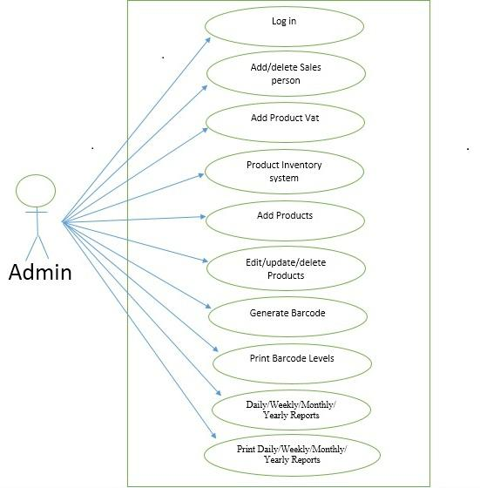

27 | P a g e

**4.2.2 : Use case diagram of DSM (Sales Person Part)**

This diagram I was show that total sales panel. Sales panel accessibility, sale control access as like sale product, product discount with customer etc.

**Fig 4.2.2 : Use case diagram of DSM (Sales Person Part)**

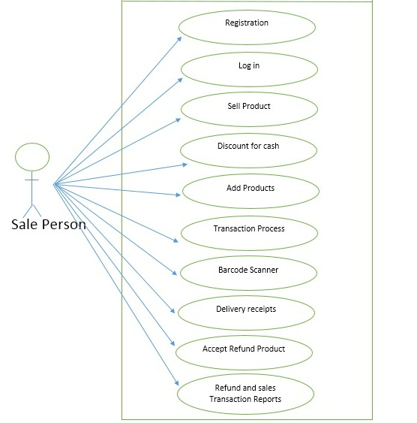

28 | P a g e

**4.2.3: Use case diagram of DSM (Customer Part)**

This diagram I was show that all customer accessibility and this system customer facilities.

**Fig 4.2.3: Use case diagram of DSM (Customer Part)**

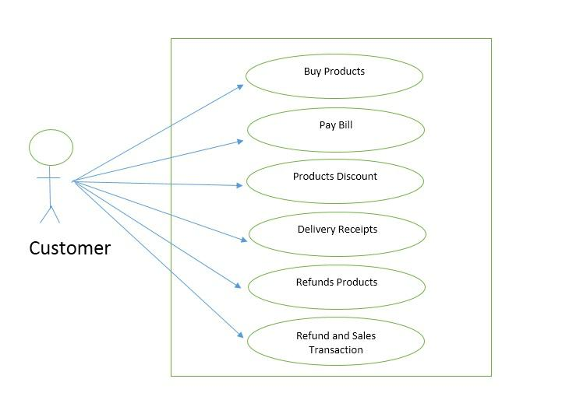

29 | P a g e

4.3 **ERD (Entity Relationship Diagram)**

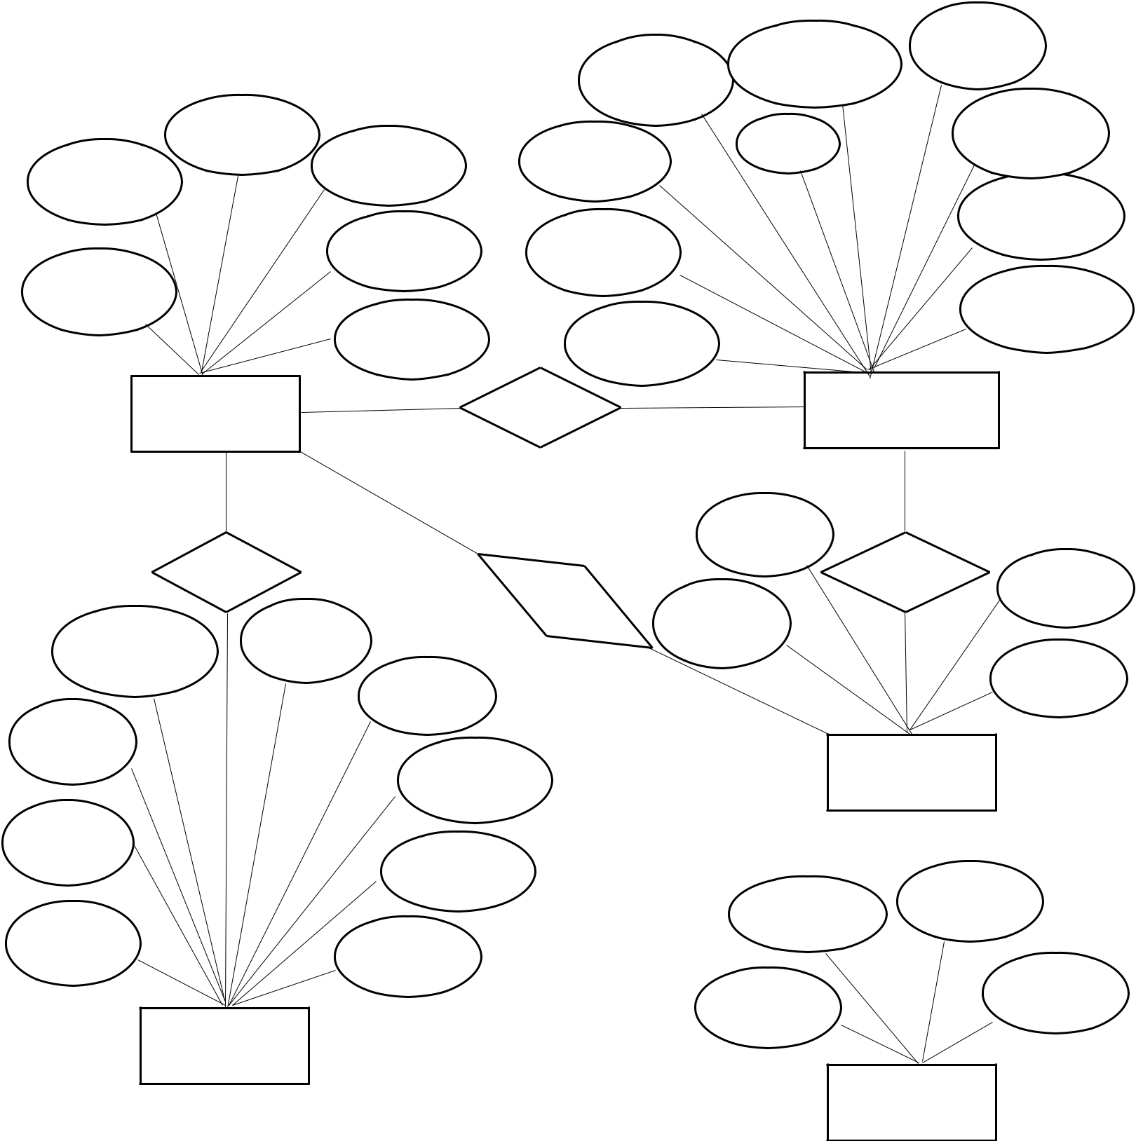

|  |  |  |  |
| --- | --- | --- | --- |
|  | Product | Discount |  |
| Quantity |  |  |
| Price |  |  |
|  |  |  |

|  |  |  |  |  |  |
| --- | --- | --- | --- | --- | --- |
|  | Date |  | Unit | Product |  |
| Invoice ID | Name | Product | name |  |
| code |  |  |  |
|  |  |  |  |
|  |  |  |  | Product |  |
|  | Address | Invoice |  | description |  |
|  |  |  |  |
| Customer |  |  |  | Product |  |
| ID |  |  |  |  |
|  |  |  | Amount |  |
|  | Amount | Product ID |  |  |
|  |  |  |  |

Customer Sell

Buy

|  |  |  |
| --- | --- | --- |
| Description | Unit |  |
|  |  |
|  | Cost |  |
| Name |  |  |
|  | Price |  |
| Product |  |  |
| Code | Quantity |  |
|  |  |
| Product | Sold |  |
| Id |  |

Sales Product

Product

Name

Accept Quantity

Refund

ID

Amount

Refunds

Product

Username Password

Product

ID

Position

User

**Fig 4.3 : E-R diagram of a DSM System**



30 | P a g e

Entity-relationship (ER) diagram, a graphical representation of entities and their relationships to each other, typically used in computing in regard to the organization of data within databases or Information systems. An entity is a piece of data-an object or concept about which data is stored.

**4.4 DFD (Data Flow Diagram):**

We usually begin withdrawing a context diagram, a simple representation of the whole system. To elaborate further from that, we drill down to a level 1 diagram with additional information about the major functions of the system. This could continue to evolve to become a level 2 diagram when further analysis is required. Progression to level 3, 4 and so on is possible but anything beyond level 3 is not very common. Please bear in mind that the level of detail asked for depends on your process change plan.

Context diagram (Level 0 DFD) :

**Fig 4.4.1 : Context Diagram of DSM**

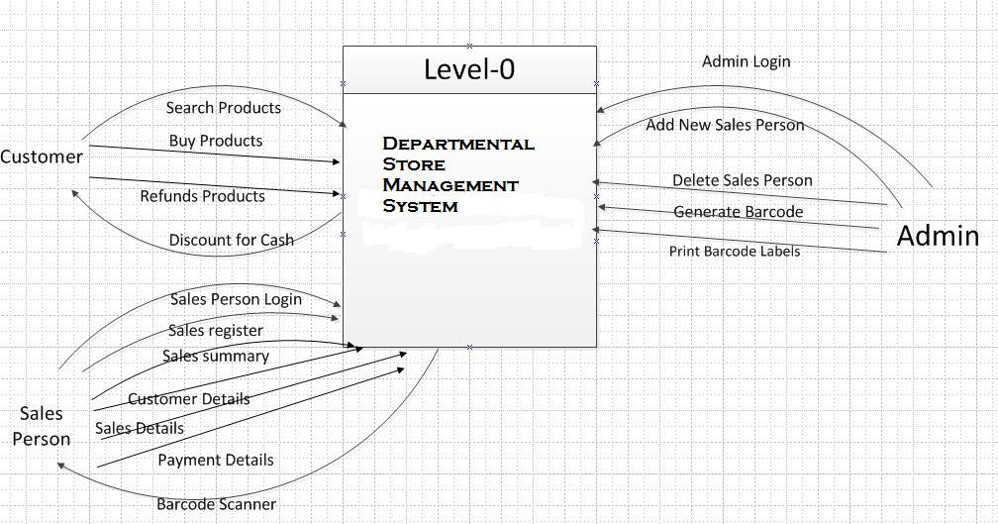

31 | P a g e

Level 1 DFD :

**Fig 4.4.2 : DFD Level 1 of UCAS**

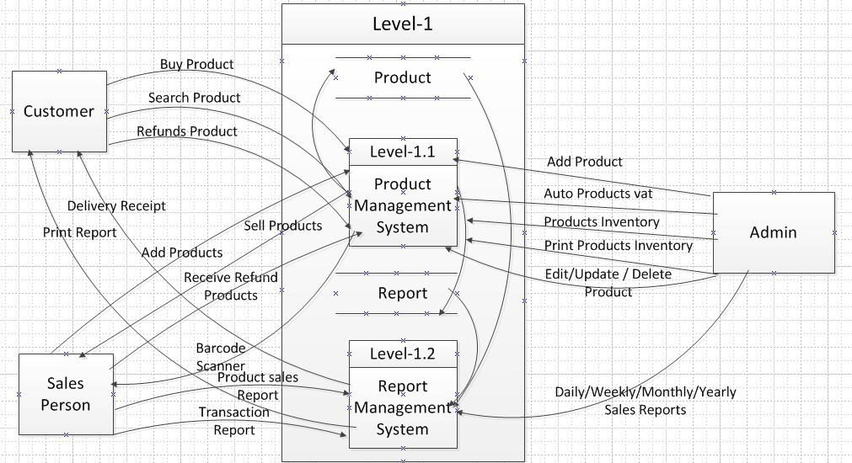

Level 2- DFD :

**Fig 4.4.3 : DFD Level 2 of DSMS**

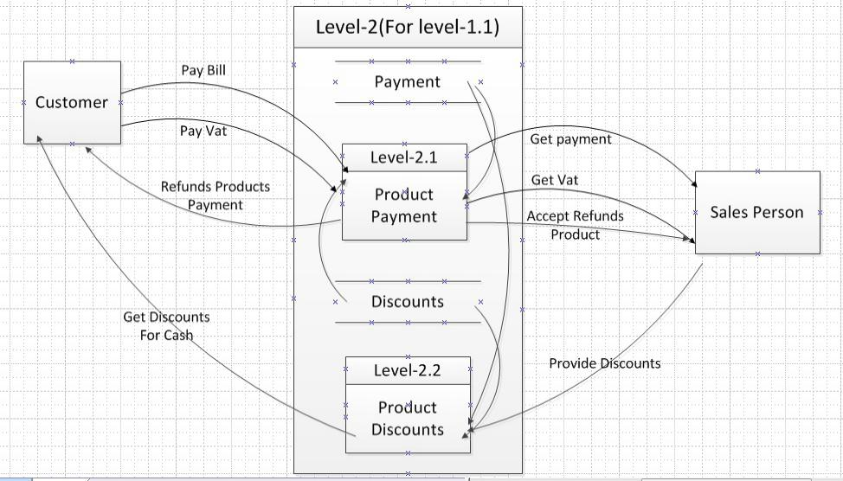

32 | P a g e

Level 3- DFD :

**Fig 4.4.4: DFD Level 3 of DSMS**

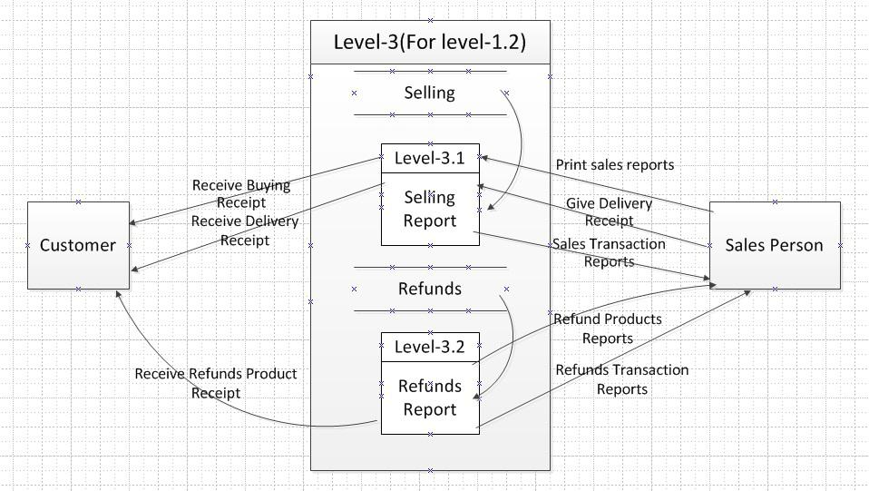

In this DFD, we showed the diagram up to level 2. In the first level, we break the mother process “Shop Management System” in two parts as, “Product Management” and “Report Management” Again another mother process “Product Management” is break by two parts as “Product Payment” and “Product Discount” Then the mother process “Report Management” is break by two parts as “Selling Report” and “Refunds Report”.



33 | P a g e

**4.5 State Transaction Diagram:** A state diagram is a type of diagram used in computerscience and related fields to describe the behavior of systems. State diagrams require that the system described is composed of a finite number of states; sometimes, this is indeed the case, while at other times this is a reasonable abstraction. Many forms of state diagrams exist, which differ slightly and have different semantics. Following Fig 4.5 shows the paths.

**Fig 4.5: State Transaction Diagram of a DSM System**

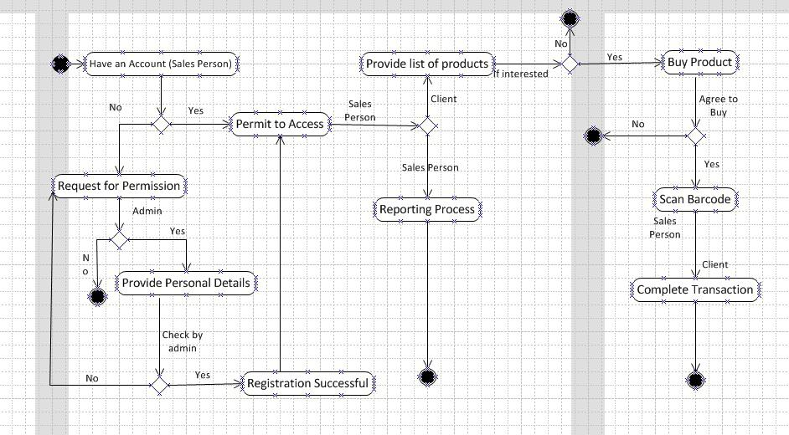

34 | P a g e

**4.6 Web page Design**

Web design encompasses many different skills and disciplines in the production and maintenance of websites. The different areas of web design include web graphic design; interface design; authoring, including standardized code and proprietary software; user experience design; and search engine optimization. Often many individuals will work in teams covering different aspects of the design process, although some designers will cover them all. The term web design is normally used to describe the design process relating to the front-end design of a website including writing mark up. Web design partially overlaps web engineering in the broader scope of web development. Web designers are expected to have an awareness of usability and if their role involves creating markup then they are also expected to be up to date with web accessibility guidelines.

**4.6.1 Login Page :** This is our DSM system login page**.** Admin and sales person used their username and password to login this system.

**Fig 4.6.1 : Login page of DSMS Software**

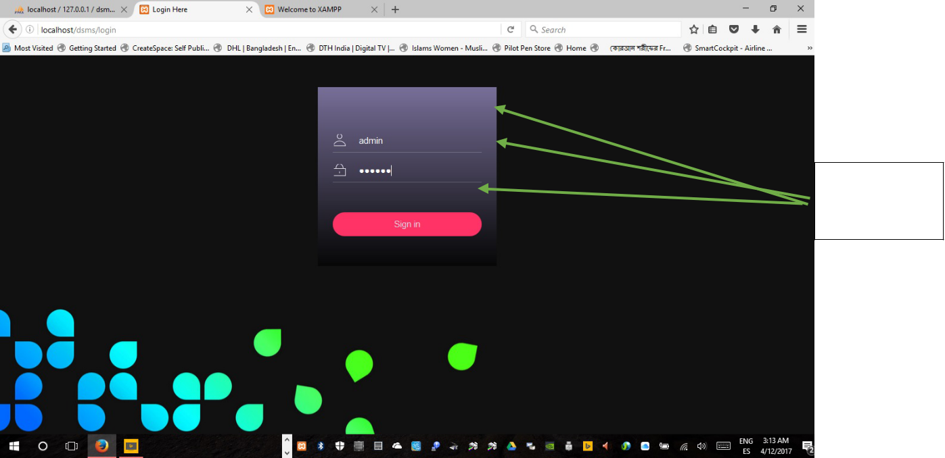

Admin/sales person



35 | P a g e

**4.6.2 Home page:** It’s our DSM software home page.

**Fig 4.6.2 : Home page of DSM Software**

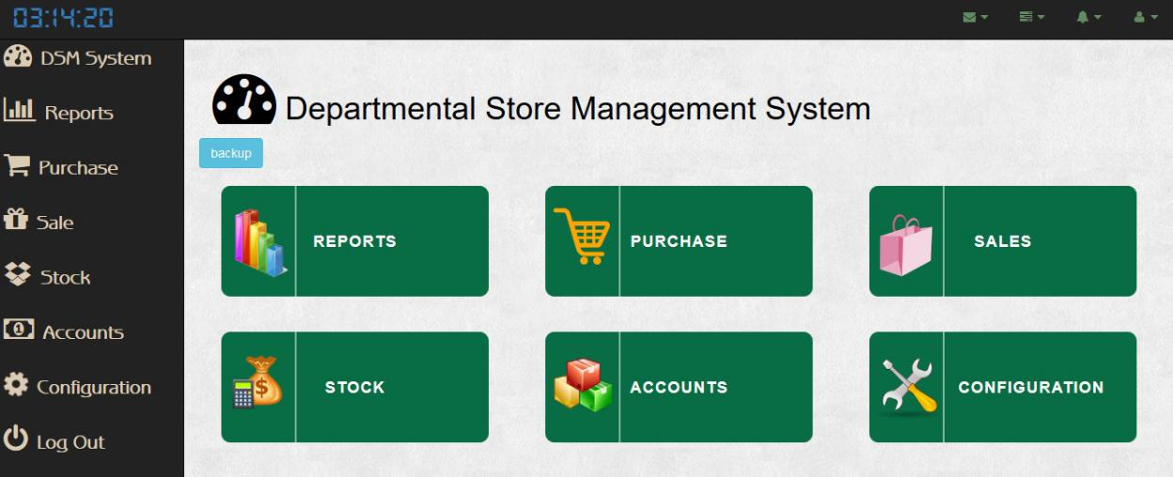

**4.6.3 Adding Product Brands page:** In this chapter we describe the using process of thesoftware.

**Fig: 03 (Adding Product Brands )**

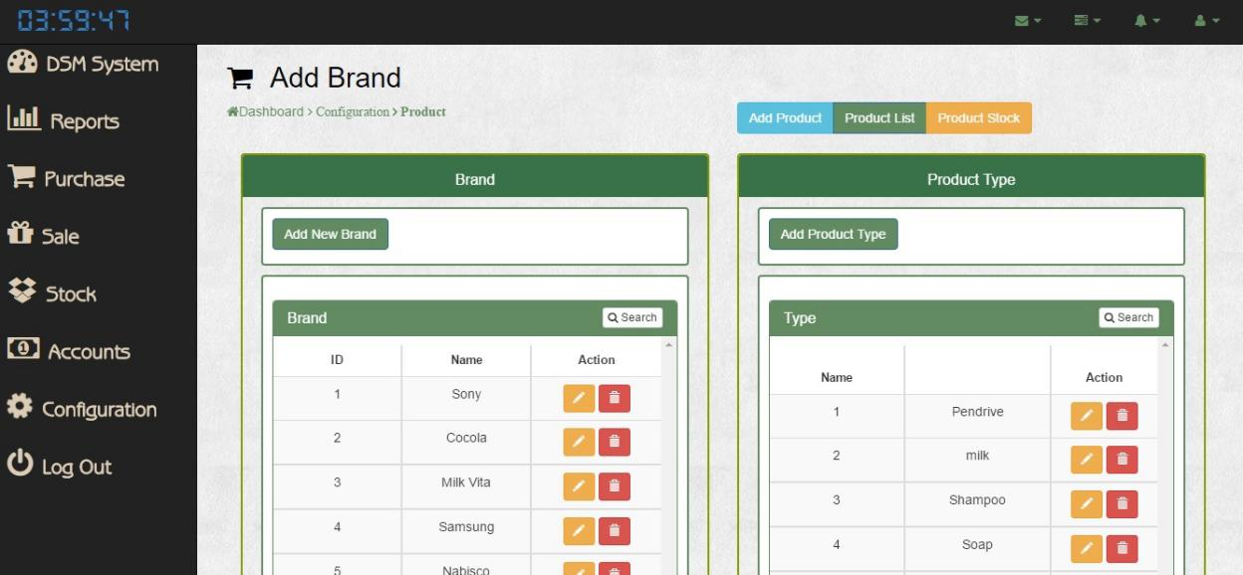

36 | P a g e

**4.6.4 Product List page:**This is a system product list page.We are add all product then the addadall product show this product list page.

**Fig : 04 (Adding Product using Name, Purchase & Sales Prices, Brands, VAT% & Discount% (if applicable)**

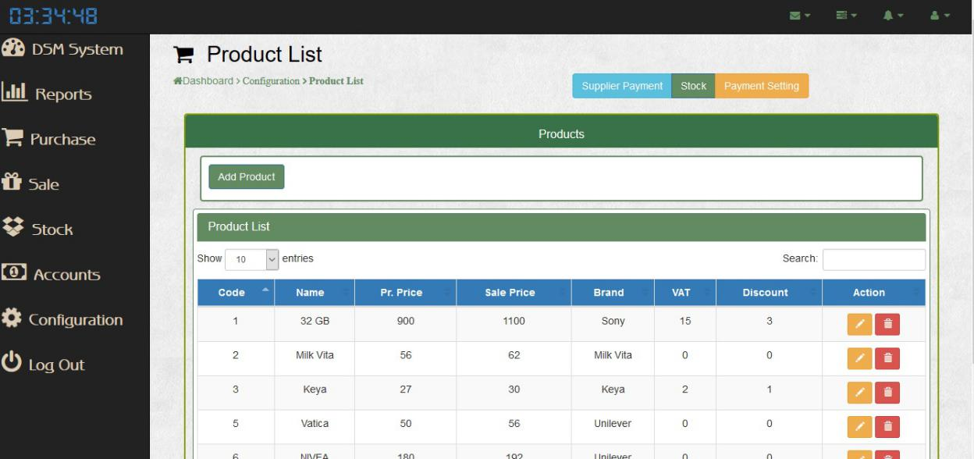

**4.6.5 Add Product page** This is a add product page this page we are starting business productadd.

**Fig : 05 (Adding Product including Purchas Ref. & Product Details Info.)**

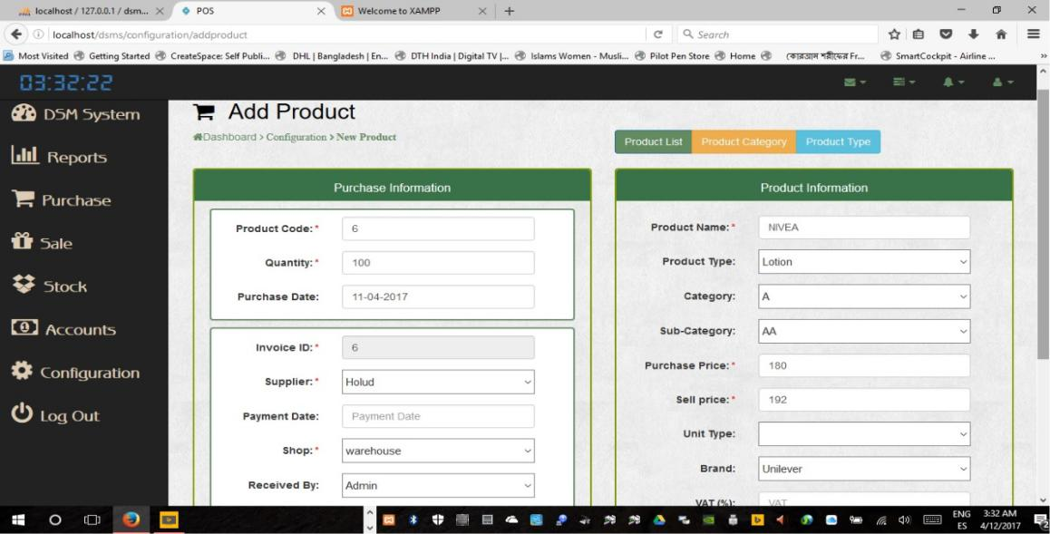

37 | P a g e

**4.6.6 Categorize List Page:** This is a add product catagoris and sub-catagoris page this page weare starting business product catagories and sub- catagoris.

**Fig: 06 (Adding Product in Categorize & Sub-Categorize List)**

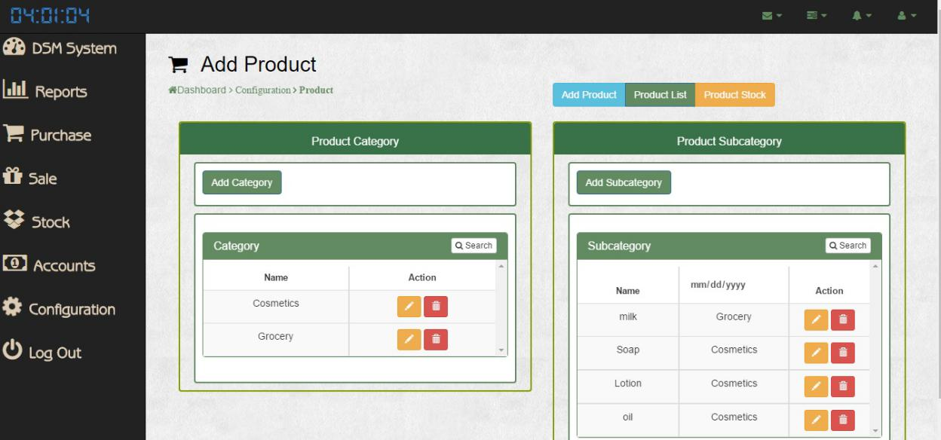

**4.6.7 Supplier Details Page:** This page we are making business suppler. We are add all supplerlist and start the business.

**Fig: 07 (Product Supplier Details)**

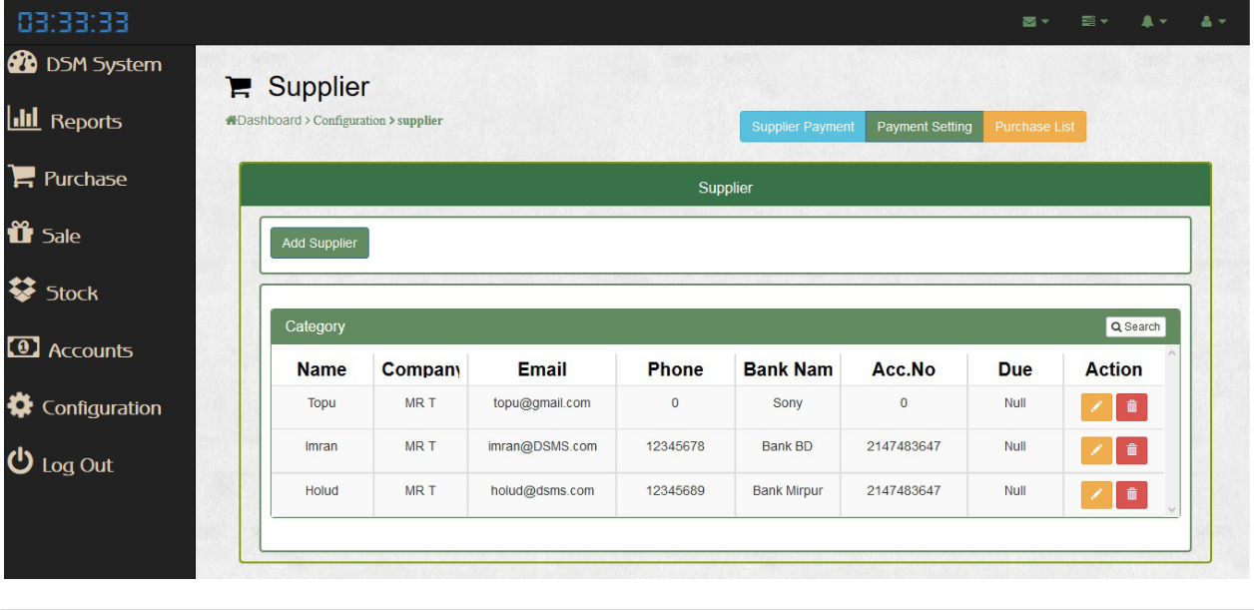

38 | P a g e

**4.6.8 Customer Details Page:** This page is add coustomer list and track the business coustomar.This purpose any time view and check all type of coustomer,

**Fig : 08 ( Customer Details for Future Ref. )**

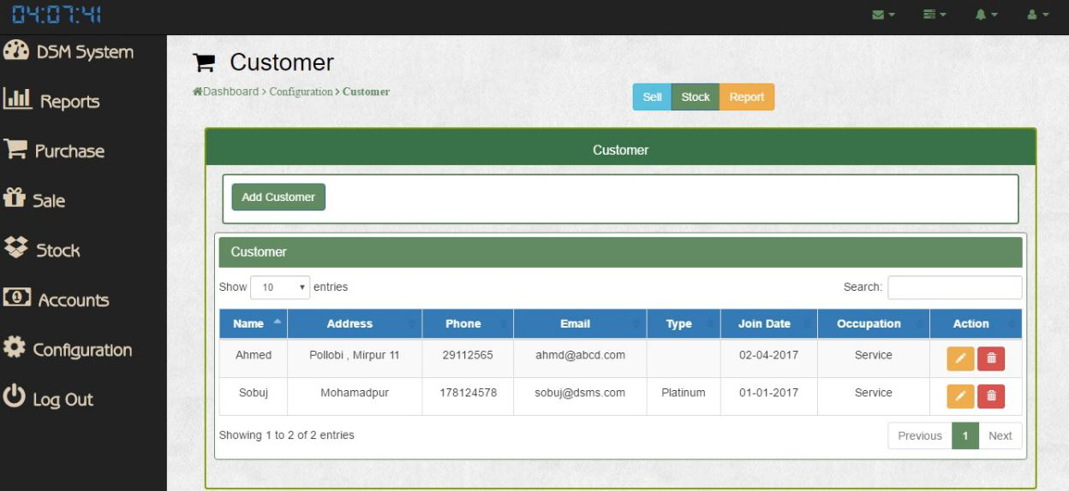

**4.6.9 Stock List Page:** This is the stock list page. we are starting the business so start allstocking our business product.

**Fig : 09 (Stock List of the product)**

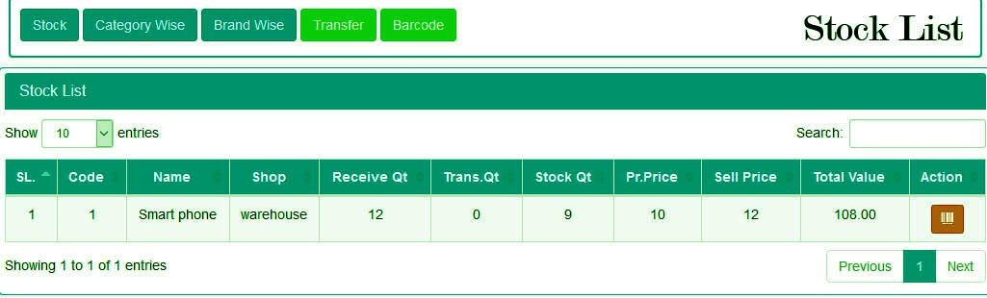

39 | P a g e

**4.6.10 Sales Register Page:** This is the sales page. This page using all sales man continuoussales our stocking product.

**Fig : 10 ( Sales Register Terminal Screen)**

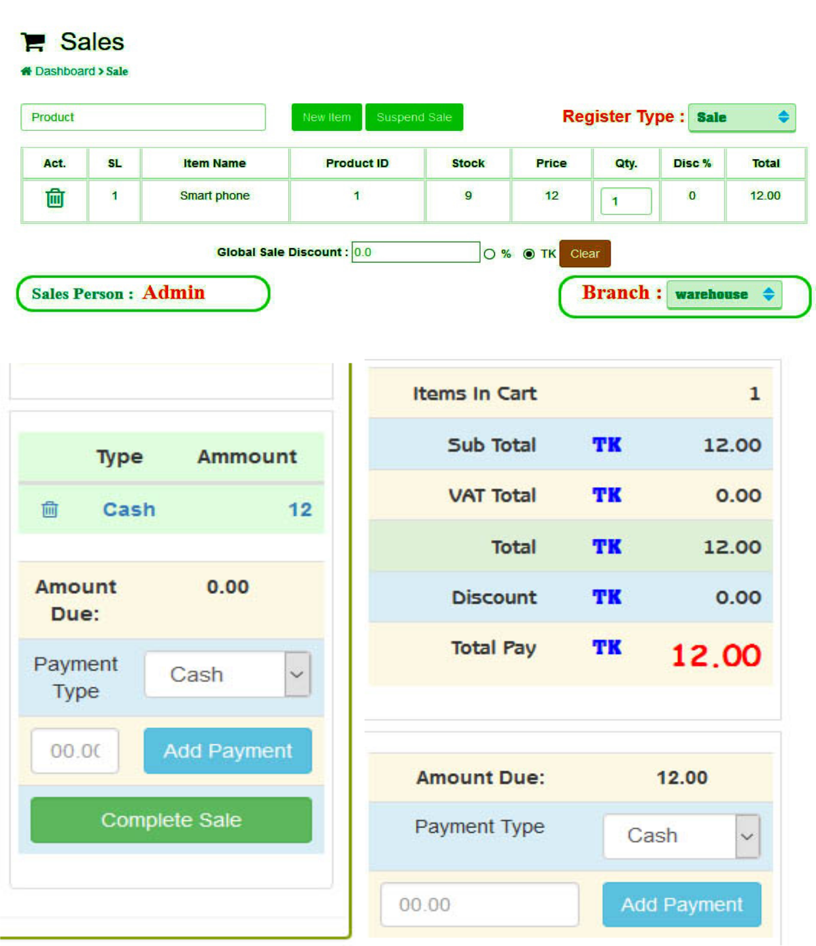

40 | P a g e

Runing sales views.select arious types of product and staring sales.

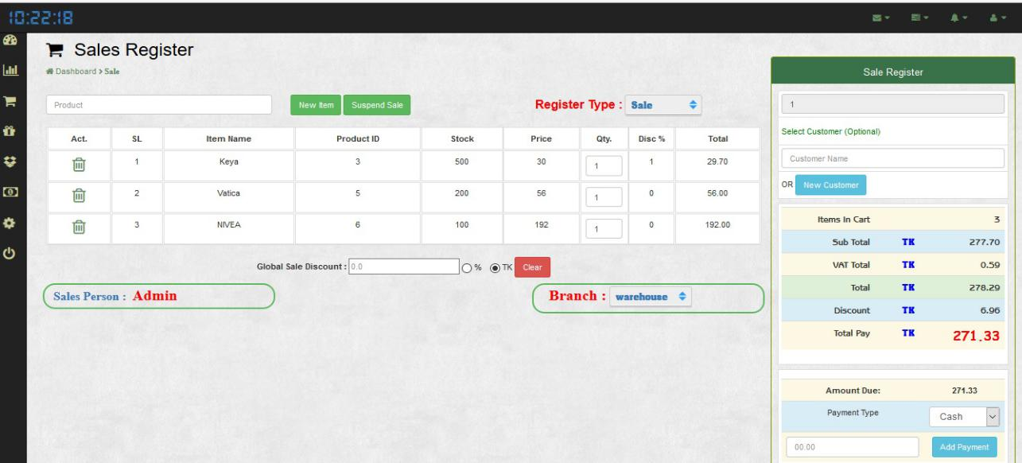

**4.6.11 After Sales completion Terminal to Print Invoice Page:** After sale complete thenautomatically request the invoice print

**Fig: 11 (After Sales completion Terminal to Print Invoice)**

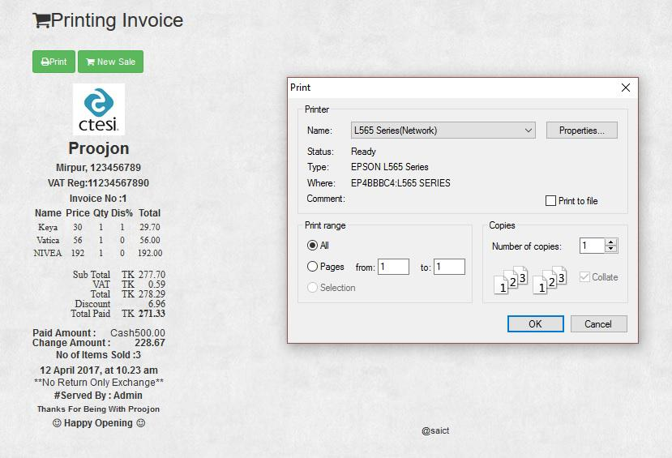

41 | P a g e

**4.6.12 Sales Register Page:** This is the report page. We are staring the business so naturally wewant to view all types of report so this are the report searching module.

**Fig : 12 ( Report Generation Screen based on Warehouse )**

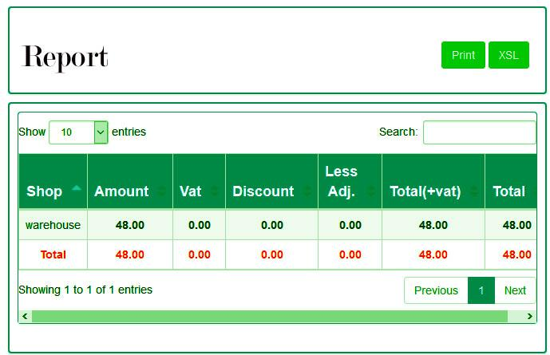

**4.6.13 Account Details Page:** This is the accounts page. This page using all type of accounttrrranjection identify and calculate the business loss or profit.

**Fig: 13 (Account Details for Purchas & Sells)**

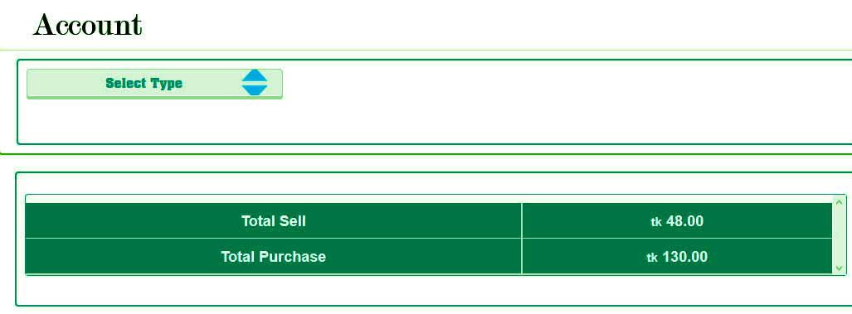

42 | P a g e

**4.6.14 Configuration Page:** This is a configaration page. This page is system all set up processand compilitely workrable system activities control and management for our business system.

**Fig : 14 ( Configuration Terminal to customize Product, Supplier & Companies)**

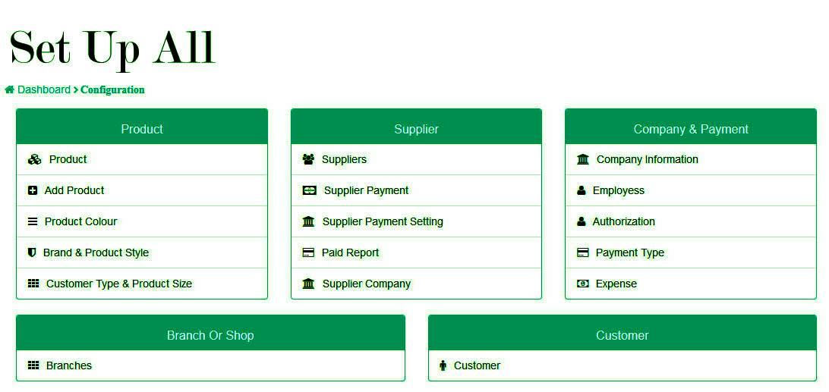

**4.7 Gantt Chart**

Gantt charts illustrate the start and finish dates of the terminal elements and summary elements of a project. Terminal elements and summary elements comprise the work breakdown structure of the project. Modern Gantt charts also show the dependency (i.e., precedence network) relationships between activities. Gantt charts can be used to show current schedule status using percent-complete shadings and a vertical "TODAY" line as shown here.

**Fig 4.7: Gantt chart of a DSM system**

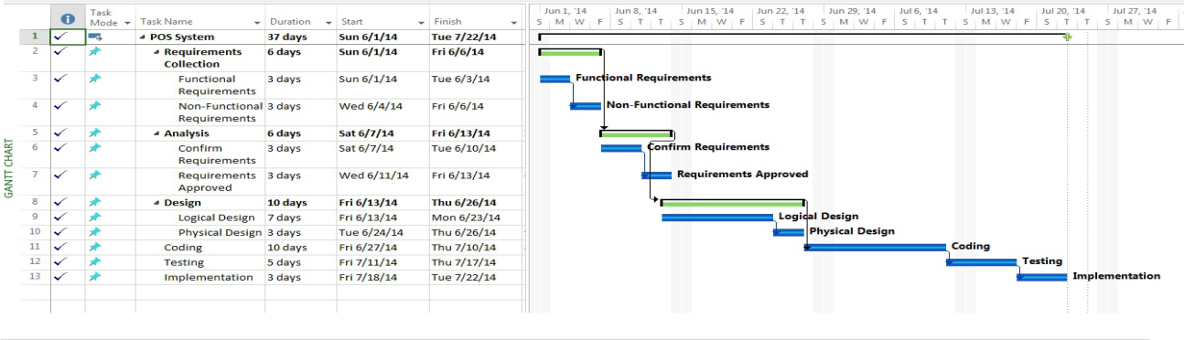

43 | P a g e

**Chapter 05**



44 | P a g e

**CHAPTER 5**

**DEVELOPMENT AND IMPLEMENTATION**

Software development is the process of computer programming, documenting, testing, and bug fixing involved in creating and maintaining applications and frameworks resulting in a software product. Software development is a process of writing and maintaining the source code, but in a broader sense, it includes all that is involved between the conception of the desired software through to the final manifestation of the software, sometimes in a planned and structured process. Implementation is the realization of an application, or execution of a plan, idea, model, design, specification, standard, algorithm, or policy.

**5.1 Project Overview**

Departmental store management system created for Departmental store has following stages

Admin/Sales person login

Add products, Sell products, Refund products Auto discount, Product vat

Barcode generate , Barcode scanner

**Admin/Salesperson Login:** The DSM software is able to login to both admin and sales person.Admin who used to login to. Admin to manage the whole DSM system and seals persons sells the products.

**Add products/ Sell products/Refund products:** Sales person add product, sells product andaccept refund products also.

**Auto discount, Product vat:** Customer must pay VAT % to buy products and get discounts onsome products.

**Barcode generate, Barcode scanner:** Admin generates barcode and salesperson scan productbarcodes.



45 | P a g e

**5.2 Departmental Store Management System (DSMS) Terminal**

A Departmental store management (DSM) system terminal is a computerized replacement for a cash register. Much more complex than the cash registers of even just a few years ago, the DSM system can include the ability to record and track customer orders, process credit and debit cards, connect to other systems in a network, and manage inventory. Generally, a DSM terminal has as its core a personal computer, which is provided with application-specific programs and I/O devices for the particular environment in which it will serve. A DSM system for a restaurant, for example, is likely to have all menu items stored in a database that can be queried for information in a number of ways. DSM terminals are used in most industries that have a Departmental store management system such as a service desk, including restaurants, lodging, entertainment, and museums.

**5.3 Departmental Store Management (DSM) System and the related risks and controls:**

Many retail operations use Departmental store management (DSM) system to capture all relevant sales data at the Departmental store management: the cash register. You have seen DSM Systems on your shopping visits to grocery or department stores. As you checked out, the bar codes are scanned on the items you purchased, prices were determined by the accessing of inventory and price list data, sales revenue was recorded, and inventory values were updated. All of these processes occur in real time, and the store can provide to its managers or home office daily summaries of sales by cash register or by product. Many companies adopt DSM Systems because they enhance customer satisfaction by enabling automated system in an organized way.

**5.4 Project Deliverables:**

Project deliverables are the outputs from a project that normally provide beneficial change. Deliverables can be process improvements, new or improved products and services, service quality improvements, image and reputation artifacts, risk reduction benefits, increases to the flexibility or effectiveness of staff, or policy compliances. Deliverables can be for both



46 | P a g e

within the business and external Customers, such as an internal improvement necessary to make cost savings to allow the Customer products to be delivered on time and within budget.

**5.5 Resource Allocation :**

In software planning, resource allocation is a plan for using available resources, for example human resources, especially in the near term, to achieve goals for the future. It is the process of allocating resources among the various projects or business units.

The plan has two parts, firstly, there is the basic allocation decision and secondly there are contingency mechanisms. The basic allocation decision is the choice of which items to fund in the plan, and what level of funding it should receive, and which to leave unfunded: the resources are allocated to some items, not to others.



47 | P a g e

**Chapter 06**



48 | P a g e

**CHAPTER 6**

**CONCLUSION AND FUTURE WORKS**

Now words any mini shopping mall don’t have an online DSM software. We have to work it to have online based DMS software for a Mini Shop. So that, their transaction process and payment report should be clear. In our country we find many shopping mall, they are used desktop base DSM software and fact many problems .So, we made an online base DSM system software to improve that system and also developed our country.

I have done proper in this project are compliantly logical business model and it's really sequential effective project. This project functionality, usability each and every point structural.

While point of sale systems are an integral part of today’s commercial workplace, the details and options available for purchase can be mind-boggling to the novice shopper. It is vital to narrow down the numerous selections available in order to find which DSM system will best suit a particular user. Shopping on Agora allows the option of narrowing selections to find the necessary options, in addition to allowing shoppers to buy from sellers worldwide.



49 | P a g e

**REFERENCES**

* 1. Ian Somerville, “project planning”, Software Engineering Pearson Education, Update 8th Edition, 1989-1992.

1. Ian Somerville, ”Software Implementation and Testing”, Software Engineering,

Update 6th Edition, 1995-1997.

1. PhP and MySql (Version: 5) Witten By: Md. Mijanur Rahman
2. http://www.shopify.com/pos (Last Access : 03/02/2017)
3. http://en.wikipedia.org/wiki/Point_of_sale (Last Access : 11/02/2017)

[6]http://www.academia.edu/6967044/Software_Requirements_Specification_for_Point_Of_Co mmunication_Sale_System (Last Access : 22/02/2017)

1. http://www.pos.com/pos (Last Access : 15/02/2017)
2. http://www.phpreferencebook.com (Last Access : 25/02/2017)



50 | P a g e