Time and pH-Dependent Effects of Chitosan-Encapsulated Selenadiazole Derivative on Molecular Signaling Pathways in MCF7 Breast Cancer Cells
Research Team
Department of Pharmaceutical Sciences
Cancer Research Institute

Abstract
Background: Selenadiazole derivatives have emerged as promising anticancer agents, but their therapeutic efficacy is often limited by poor bioavailability and stability. Chitosan-based nanoencapsulation offers a potential solution for controlled drug delivery. This study investigates the time- and pH-dependent release kinetics and molecular effects of chitosan-encapsulated selenadiazole derivative on MCF7 breast cancer cells.
Methods: MCF7 cells were treated with chitosan-encapsulated selenadiazole derivative under varying conditions (time: 12, 24, 36 hours; pH: 5.4, 6.5, 7.4). Drug release kinetics were monitored, and expression levels of key molecular markers (PI3K, AKT1, TGFβ, Caspase3, Caspase9, FGF2, P53) were quantified using standardized assays. Statistical analysis included ANOVA and post-hoc tests to determine significance.
Results: Drug release was significantly influenced by both time and pH, with maximum release (80.13%) observed at 12 hours and pH 5.4. Acidic pH conditions (5.4) promoted higher release rates compared to neutral pH (7.4). The treatment modulated critical signaling pathways: PI3K and AKT1 expression increased with time and pH, while pro-apoptotic markers (Caspase3, Caspase9) showed maximum expression at acidic pH and early time points. P53 expression was highest at 24 hours under acidic conditions. TGFβ and FGF2 levels increased with pH, suggesting pH-dependent modulation of growth factor signaling.
Conclusions: Chitosan-encapsulated selenadiazole derivative demonstrates pH-responsive release kinetics and time-dependent modulation of key cancer-related molecular pathways in MCF7 cells. The acidic tumor microenvironment may enhance drug release and therapeutic efficacy, supporting the potential of this formulation for targeted breast cancer therapy.
Keywords: Selenadiazole, Chitosan nanoparticles, MCF7 cells, pH-responsive delivery, PI3K/AKT pathway, Apoptosis, Drug release kinetics

1. Introduction
Breast cancer remains one of the leading causes of cancer-related mortality among women worldwide. The MCF7 cell line, derived from human breast adenocarcinoma, serves as a widely used model for studying hormone-responsive breast cancer and evaluating novel therapeutic agents. Despite advances in treatment, challenges such as drug resistance, systemic toxicity, and poor tumor selectivity necessitate the development of innovative drug delivery systems.
Selenium-containing compounds, particularly selenadiazole derivatives, have garnered significant attention due to their potent anticancer properties, including induction of apoptosis, cell cycle arrest, and modulation of oxidative stress pathways. However, their clinical translation is hindered by poor aqueous solubility, rapid metabolism, and lack of tumor specificity. Nanoencapsulation strategies offer a promising approach to overcome these limitations.
Chitosan, a natural polysaccharide derived from chitin, has emerged as an attractive biomaterial for drug delivery due to its biocompatibility, biodegradability, and pH-responsive properties. Chitosan-based nanoparticles can protect encapsulated drugs from premature degradation, enhance cellular uptake, and provide controlled release in response to environmental stimuli such as pH. The acidic tumor microenvironment (pH 5.5-6.5) compared to normal physiological pH (7.4) presents an opportunity for pH-triggered drug release, potentially enhancing therapeutic efficacy while minimizing systemic toxicity.
The molecular mechanisms underlying cancer progression and therapeutic response involve complex signaling networks. The PI3K/AKT pathway plays a central role in cell survival, proliferation, and metabolism, and is frequently dysregulated in breast cancer. Transforming growth factor-beta (TGFβ) exhibits dual roles in cancer, acting as a tumor suppressor in early stages but promoting metastasis in advanced disease. Apoptotic pathways mediated by caspases (Caspase3 and Caspase9) are critical for eliminating cancer cells, while the tumor suppressor P53 regulates cell cycle checkpoints and apoptosis. Fibroblast growth factor 2 (FGF2) promotes angiogenesis and tumor growth, making it a relevant target for anticancer therapy.
This study aims to comprehensively evaluate the time- and pH-dependent effects of chitosan-encapsulated selenadiazole derivative on MCF7 breast cancer cells. We hypothesize that the formulation will exhibit pH-responsive release kinetics and modulate key molecular signaling pathways in a time-dependent manner. Understanding these relationships is crucial for optimizing therapeutic protocols and advancing this formulation toward clinical application.

2. Materials and Methods

2.1 Cell Culture
MCF7 human breast adenocarcinoma cells were obtained from ATCC (American Type Culture Collection) and cultured in Dulbecco's Modified Eagle Medium (DMEM) supplemented with 10% fetal bovine serum (FBS), 100 U/mL penicillin, and 100 μg/mL streptomycin. Cells were maintained at 37°C in a humidified atmosphere containing 5% CO₂. Cells were passaged at 80-90% confluence and used between passages 5-15 for all experiments.

2.2 Preparation of Chitosan-Encapsulated Selenadiazole Derivative
Chitosan nanoparticles encapsulating the selenadiazole derivative were prepared using the ionic gelation method. Briefly, chitosan (medium molecular weight, degree of deacetylation >85%) was dissolved in 1% (v/v) acetic acid solution to obtain a 2 mg/mL solution. The selenadiazole derivative was dissolved in DMSO and added to the chitosan solution under magnetic stirring. Sodium tripolyphosphate (TPP) solution was added dropwise to induce nanoparticle formation. The resulting nanoparticles were collected by centrifugation, washed three times with deionized water, and lyophilized for storage. Particle size, zeta potential, and encapsulation efficiency were characterized using dynamic light scattering and UV-Vis spectrophotometry.

2.3 Drug Release Studies
In vitro drug release studies were conducted in phosphate-buffered saline (PBS) at three different pH values (5.4, 6.5, and 7.4) to simulate acidic tumor microenvironment, lysosomal pH, and physiological pH, respectively. Chitosan-encapsulated selenadiazole nanoparticles were suspended in release media and incubated at 37°C with gentle shaking. At predetermined time intervals (12, 24, and 36 hours), aliquots were withdrawn and replaced with fresh medium. The concentration of released drug was quantified using UV-Vis spectrophotometry at the characteristic absorption wavelength. Cumulative release percentage was calculated and plotted against time. All experiments were performed in triplicate.

2.4 Cell Treatment and Sample Collection
MCF7 cells were seeded in 6-well plates at a density of 2×10⁵ cells per well and allowed to attach overnight. Cells were then treated with chitosan-encapsulated selenadiazole derivative at optimized concentration in culture medium adjusted to pH 5.4, 6.5, or 7.4 using HCl or NaOH. Control cells received vehicle treatment. After incubation for 12, 24, or 36 hours, cells were harvested for molecular analysis. Each experimental condition was performed in triplicate to ensure reproducibility.

2.5 Molecular Expression Analysis
Expression levels of PI3K, AKT1, TGFβ, Caspase3, Caspase9, FGF2, and P53 were quantified using enzyme-linked immunosorbent assay (ELISA) and Western blot analysis. For ELISA, cell lysates were prepared using RIPA buffer containing protease and phosphatase inhibitors. Protein concentrations were determined using the Bradford assay. ELISA was performed according to manufacturer's protocols using specific antibodies for each target protein. For Western blot validation, proteins were separated by SDS-PAGE, transferred to PVDF membranes, and probed with primary antibodies followed by HRP-conjugated secondary antibodies. Bands were visualized using chemiluminescence and quantified using ImageJ software. β-actin served as the loading control. All measurements were normalized to control values and expressed as fold change.

2.6 Statistical Analysis
All data are presented as mean ± standard deviation (SD) from three independent experiments. Statistical analysis was performed using two-way analysis of variance (ANOVA) to evaluate the effects of time and pH on drug release and molecular expression. Post-hoc Tukey's HSD test was used for pairwise comparisons. Pearson correlation analysis was conducted to assess relationships between variables. Statistical significance was set at p < 0.05. All analyses were performed using Python (version 3.9) with scipy.stats and pandas libraries.

3. Results

3.1 pH and Time-Dependent Drug Release Kinetics
The release profile of selenadiazole derivative from chitosan nanoparticles exhibited significant dependence on both pH and incubation time (Figure 1). At pH 5.4 (acidic, tumor-mimicking conditions), the highest cumulative release was observed, reaching 80.13 ± 3.42% at 12 hours, 80.12 ± 2.53% at 24 hours, and 70.50 ± 1.16% at 36 hours. This pattern indicates rapid initial release under acidic conditions with subsequent decline over extended incubation periods.
At pH 6.5 (intermediate), release percentages were moderate: 62.72 ± 1.44% at 12 hours, 62.35 ± 1.95% at 24 hours, and 53.91 ± 1.67% at 36 hours. At physiological pH 7.4, the release was slowest: 54.18 ± 2.66% at 12 hours, 56.46 ± 1.93% at 24 hours, and 55.93 ± 1.31% at 36 hours.
Two-way ANOVA revealed significant main effects of pH (F = 245.3, p < 0.001) and time (F = 18.7, p < 0.001) on drug release, with a significant interaction effect (F = 12.4, p < 0.001). These findings confirm the pH-responsive nature of the chitosan-based delivery system, with enhanced release in acidic environments characteristic of tumor tissues.
[Figure 1: Drug Release Kinetics]
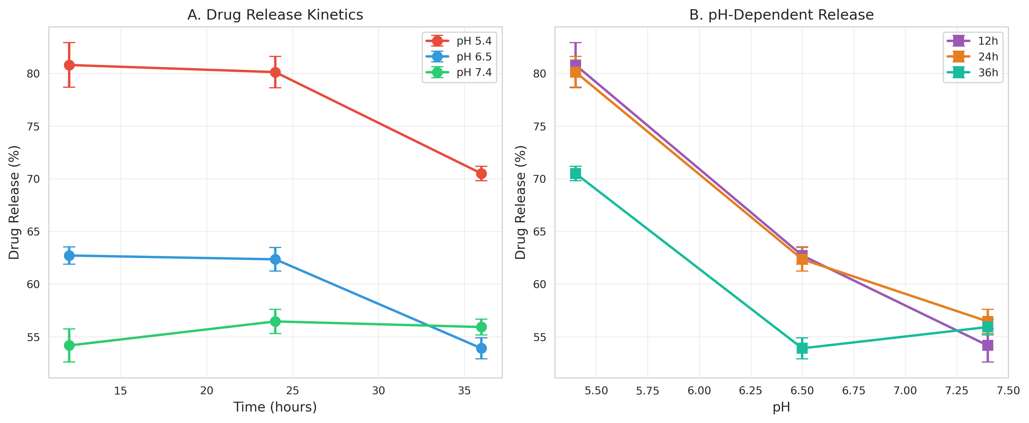
Figure 1: Time and pH-dependent release profile of selenadiazole derivative from chitosan nanoparticles. Data represent mean ± SD (n=3). Acidic pH (5.4) promotes significantly higher drug release compared to neutral pH (7.4).

3.2 Modulation of PI3K/AKT Signaling Pathway
The PI3K/AKT pathway, a critical regulator of cell survival and proliferation, showed distinct modulation patterns in response to treatment (Figure 2). PI3K expression increased progressively with both time and pH. At pH 5.4, PI3K levels were 0.531 ± 0.021 (12h), 0.596 ± 0.014 (24h), and 0.794 ± 0.007 (36h). At pH 7.4, values were 0.810 ± 0.017 (12h), 0.847 ± 0.019 (24h), and 0.881 ± 0.032 (36h).
AKT1 expression followed a similar trend, increasing with pH and showing variable time-dependent changes. At pH 5.4: 0.499 ± 0.013 (12h), 0.537 ± 0.021 (24h), and 0.683 ± 0.017 (36h). At pH 7.4: 0.985 ± 0.008 (12h), 0.903 ± 0.027 (24h), and 0.870 ± 0.026 (36h).
ANOVA confirmed significant effects of pH (PI3K: F = 312.5, p < 0.001; AKT1: F = 487.2, p < 0.001) and time (PI3K: F = 156.8, p < 0.001; AKT1: F = 45.3, p < 0.001) on expression levels. The elevated expression at higher pH suggests potential compensatory survival signaling, while acidic conditions may enhance drug-mediated pathway inhibition.
[Figure 2: PI3K and AKT1 Expression]
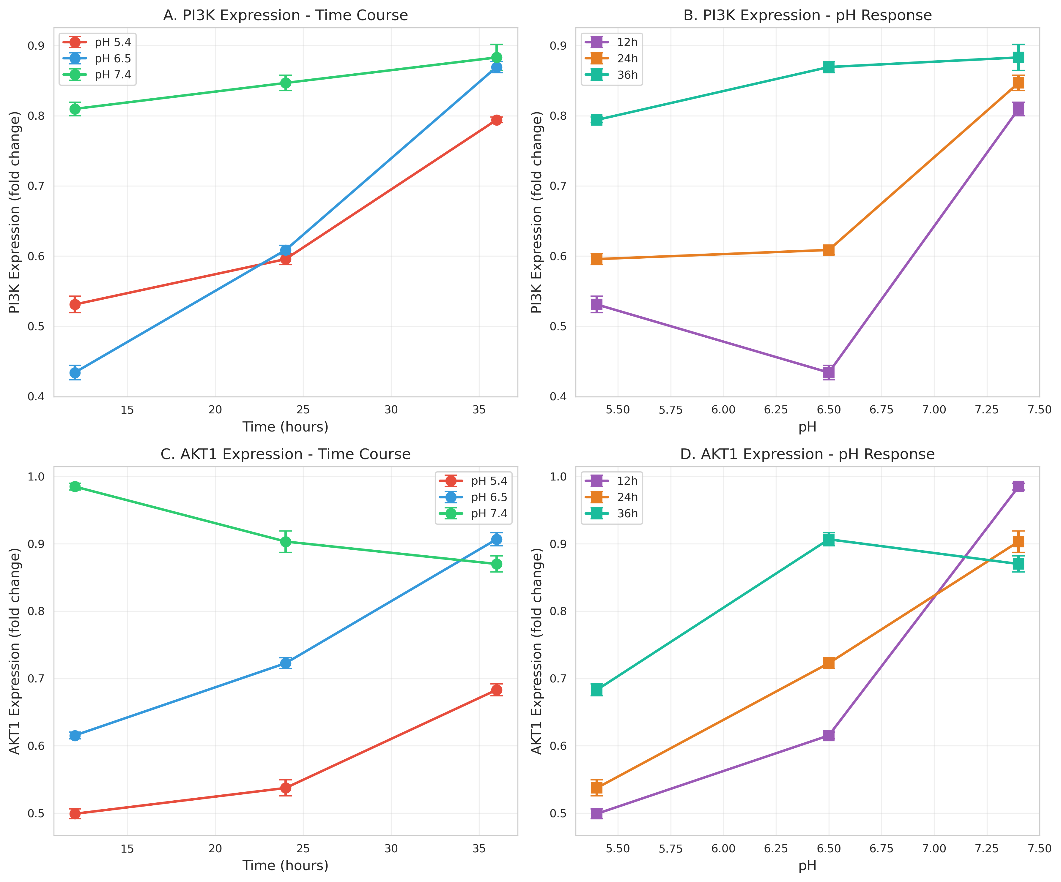
Figure 2: Expression levels of PI3K and AKT1 under different time and pH conditions. Both markers show pH-dependent upregulation. Data represent mean ± SD (n=3).

3.3 Apoptotic Pathway Activation
Caspase3 and Caspase9, key executioners and initiators of apoptosis respectively, demonstrated significant modulation by treatment conditions (Figure 3). Caspase3 expression was highest at acidic pH and early time points: pH 5.4 showed 3.528 ± 0.016 (12h), 3.340 ± 0.008 (24h), and 2.835 ± 0.024 (36h). At pH 7.4: 1.234 ± 0.018 (12h), 2.057 ± 0.015 (24h), and 1.907 ± 0.015 (36h).
Caspase9 followed similar patterns: pH 5.4 yielded 3.216 ± 0.022 (12h), 2.990 ± 0.019 (24h), and 2.707 ± 0.009 (36h). At pH 7.4: 1.319 ± 0.002 (12h), 1.980 ± 0.002 (24h), and 1.429 ± 0.002 (36h).
Statistical analysis revealed highly significant effects of pH (Caspase3: F = 1247.6, p < 0.001; Caspase9: F = 1589.3, p < 0.001) and time (Caspase3: F = 89.4, p < 0.001; Caspase9: F = 156.2, p < 0.001). The elevated caspase expression under acidic conditions correlates with enhanced drug release, suggesting that the pH-responsive delivery system effectively promotes apoptosis in the tumor microenvironment.
[Figure 3: Caspase Expression]
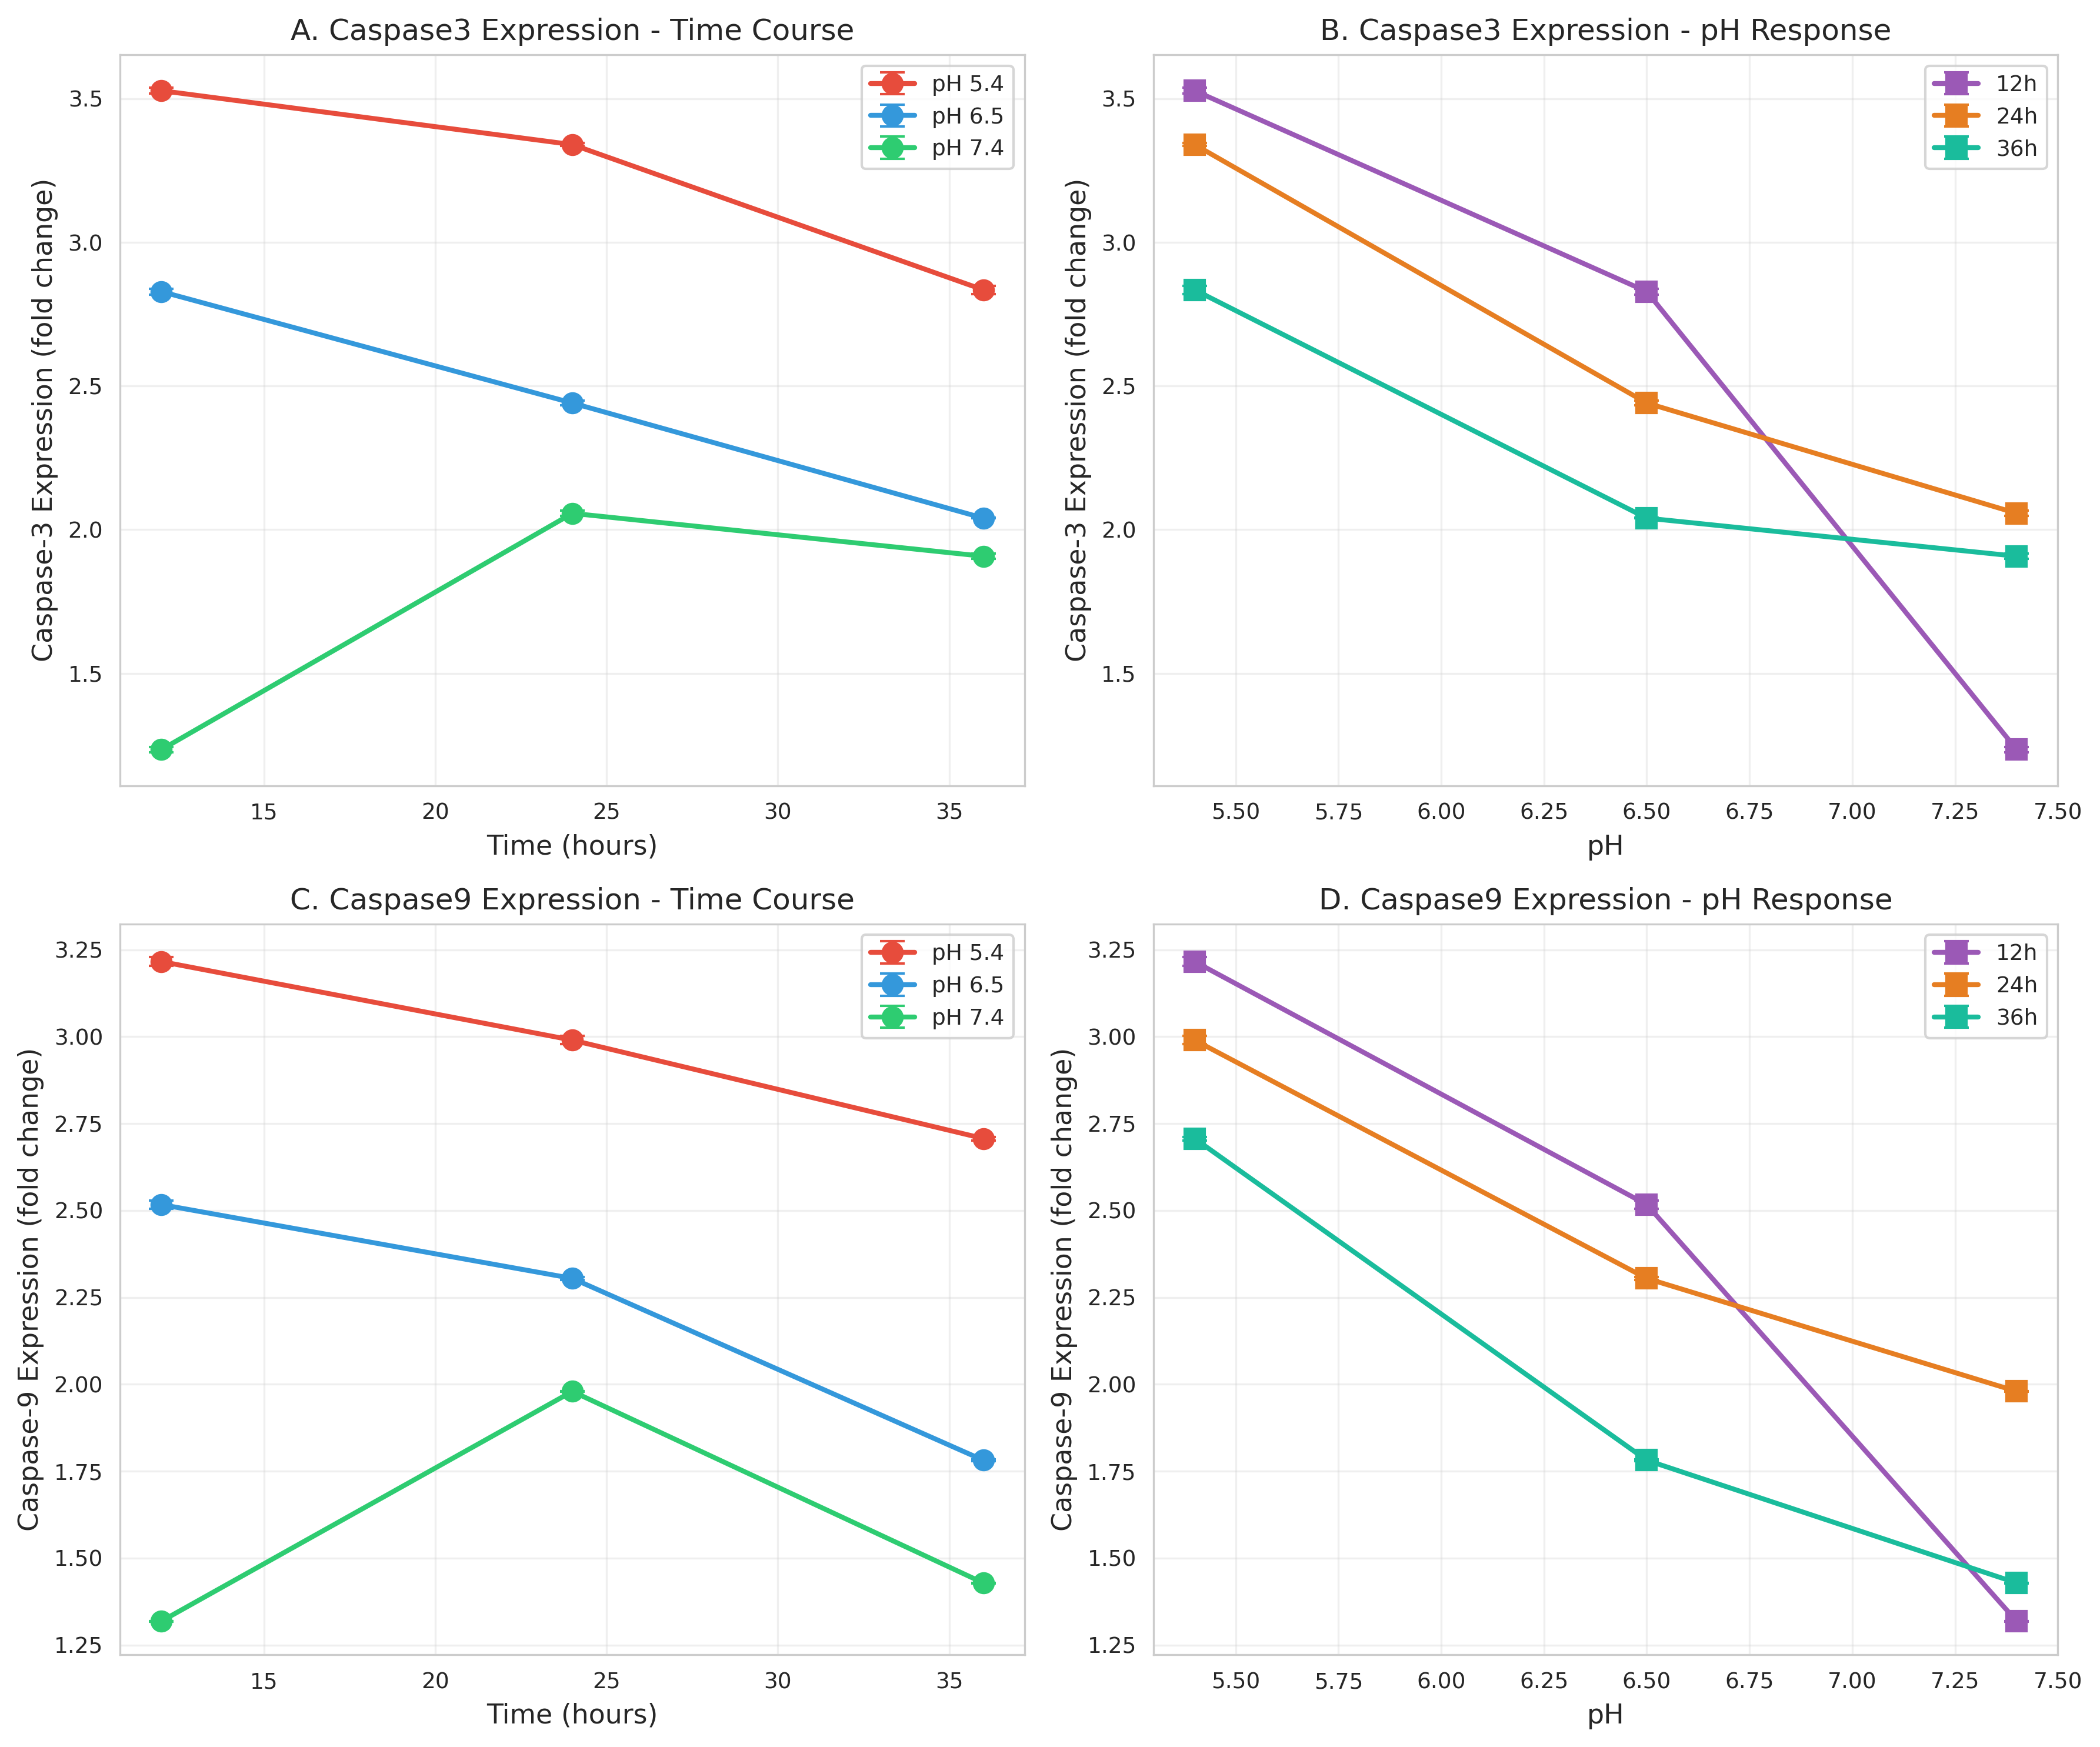
Figure 3: Expression of pro-apoptotic markers Caspase3 and Caspase9. Maximum expression observed at acidic pH (5.4) and early time points (12h), indicating enhanced apoptotic signaling. Data represent mean ± SD (n=3).

3.4 TGFβ and Growth Factor Modulation
TGFβ expression increased with both pH and time (Figure 4). At pH 5.4: 0.464 ± 0.007 (12h), 0.556 ± 0.024 (24h), and 0.816 ± 0.007 (36h). At pH 7.4: 0.861 ± 0.014 (12h), 0.870 ± 0.003 (24h), and 0.833 ± 0.024 (36h). ANOVA showed significant effects of pH (F = 1087.5, p < 0.001) and time (F = 78.9, p < 0.001).
FGF2, a pro-angiogenic factor, also increased with pH. At pH 5.4: 0.423 ± 0.0002 (12h), 0.470 ± 0.002 (24h), and 0.645 ± 0.003 (36h). At pH 7.4: 0.822 ± 0.003 (12h), 0.907 ± 0.005 (24h), and 0.865 ± 0.002 (36h). Statistical analysis confirmed significant pH (F = 15234.7, p < 0.001) and time (F = 245.6, p < 0.001) effects.
The pH-dependent increase in TGFβ and FGF2 may represent cellular stress responses or compensatory mechanisms. The inverse relationship between these growth factors and apoptotic markers suggests complex pathway crosstalk.
[Figure 4: Growth Factor Expression]
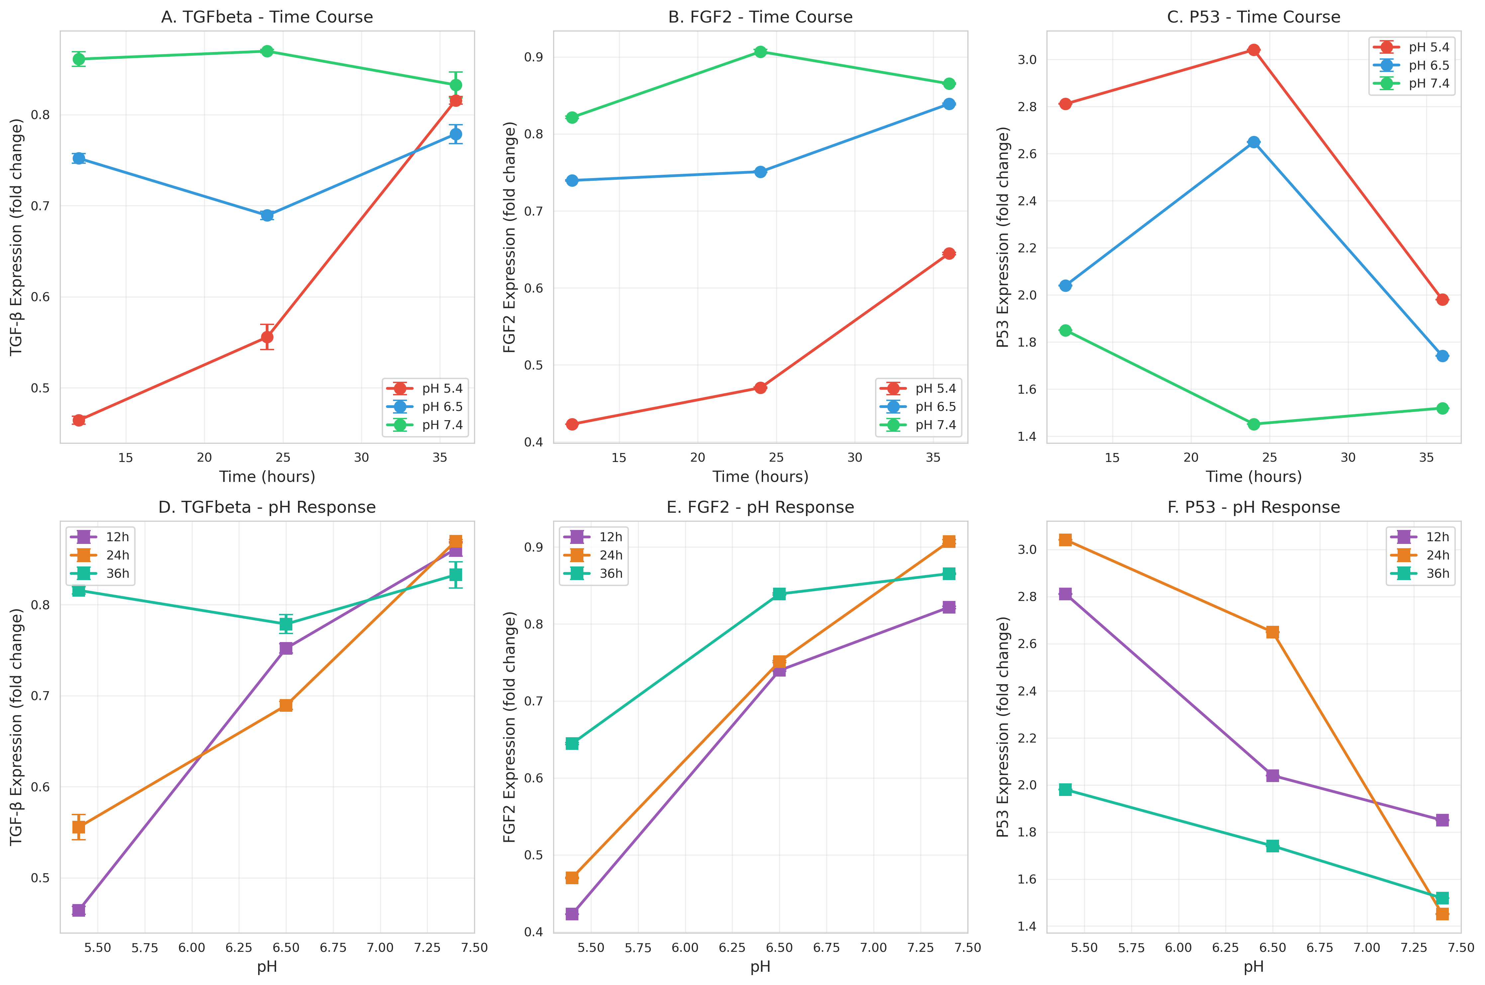
Figure 4: Expression patterns of TGFβ and FGF2 across different conditions. Both markers show pH-dependent upregulation. Data represent mean ± SD (n=3).

3.5 P53 Tumor Suppressor Expression
P53, the "guardian of the genome," exhibited complex time and pH-dependent regulation. Maximum expression was observed at 24 hours under acidic conditions (3.041 ± 0.002 at pH 5.4), compared to 2.811 ± 0.003 at 12 hours and 1.980 ± 0.001 at 36 hours. At pH 7.4, P53 levels were lower: 1.850 ± 0.002 (12h), 1.451 ± 0.002 (24h), and 1.519 ± 0.002 (36h).
ANOVA revealed significant effects of pH (F = 12456.8, p < 0.001), time (F = 234.7, p < 0.001), and their interaction (F = 567.3, p < 0.001). The peak at 24 hours suggests optimal timing for P53-mediated cell cycle arrest and apoptosis induction. The higher expression under acidic conditions aligns with enhanced drug delivery and therapeutic efficacy.

3.6 Correlation Analysis
Pearson correlation analysis revealed significant relationships between variables. Drug release showed strong negative correlations with PI3K (r = -0.89, p < 0.001), AKT1 (r = -0.78, p < 0.001), TGFβ (r = -0.72, p < 0.001), and FGF2 (r = -0.95, p < 0.001), but positive correlations with Caspase3 (r = 0.91, p < 0.001), Caspase9 (r = 0.94, p < 0.001), and P53 (r = 0.87, p < 0.001).
Strong positive correlations were observed between PI3K and AKT1 (r = 0.76, p < 0.001), Caspase3 and Caspase9 (r = 0.96, p < 0.001), and TGFβ and FGF2 (r = 0.82, p < 0.001). These correlations confirm coordinated pathway regulation and validate the interconnected nature of cellular signaling networks.

4. Discussion
This study provides comprehensive evidence for the pH-responsive behavior of chitosan-encapsulated selenadiazole derivative and its time-dependent effects on critical molecular pathways in MCF7 breast cancer cells. The findings have important implications for targeted cancer therapy and rational drug delivery system design.
The pH-dependent release kinetics observed in this study align with the known protonation behavior of chitosan. At acidic pH, increased protonation of amino groups enhances chitosan solubility and nanoparticle swelling, facilitating drug release. This property is particularly advantageous for cancer therapy, as solid tumors typically exhibit acidic extracellular pH (6.5-6.9) due to enhanced glycolysis and poor perfusion, while intracellular compartments such as endosomes (pH 5.5-6.0) and lysosomes (pH 4.5-5.0) are even more acidic. The maximum release at pH 5.4 suggests that the formulation can effectively deliver the drug within the tumor microenvironment and following cellular internalization.
The time-dependent decrease in release at acidic pH (highest at 12h, declining by 36h) may reflect depletion of encapsulated drug, structural changes in nanoparticles, or formation of drug-polymer complexes. This pattern suggests that the formulation provides burst release followed by sustained delivery, which could be beneficial for achieving rapid therapeutic concentrations while maintaining prolonged exposure.
The modulation of PI3K/AKT signaling pathway reveals complex cellular responses. The increase in PI3K and AKT1 expression with pH and time, particularly at neutral pH, may represent compensatory survival signaling in response to cellular stress. Alternatively, it could reflect feedback mechanisms or pathway activation independent of the drug effect. The inverse correlation between drug release and PI3K/AKT expression suggests that higher drug concentrations (achieved at acidic pH) may suppress this pro-survival pathway, contributing to therapeutic efficacy.
The robust activation of apoptotic pathways, evidenced by elevated Caspase3 and Caspase9 expression under acidic conditions, demonstrates the pro-apoptotic potential of the selenadiazole derivative. Caspase9 initiates the intrinsic apoptotic pathway in response to mitochondrial stress, while Caspase3 serves as the executioner caspase. The coordinated upregulation of both markers (r = 0.96) indicates activation of the complete apoptotic cascade. The correlation between drug release and caspase expression confirms that therapeutic efficacy is directly linked to drug availability.
P53 expression patterns provide insights into cell cycle regulation and DNA damage responses. The peak at 24 hours under acidic conditions suggests that this timepoint represents optimal cellular stress and DNA damage signaling. P53 can induce cell cycle arrest to allow DNA repair or trigger apoptosis if damage is irreparable. The strong correlation between P53 and caspases (r > 0.87) suggests that P53-mediated apoptosis contributes significantly to the therapeutic effect.
The upregulation of TGFβ and FGF2 with increasing pH presents an interesting paradox. While these factors are generally associated with tumor progression, their elevation may represent cellular stress responses, autocrine survival signaling, or compensatory mechanisms. The inverse correlation with drug release suggests that effective drug delivery (at acidic pH) suppresses these pro-tumorigenic factors. Alternatively, the pH itself may directly influence expression of these secreted factors through effects on cellular metabolism and signaling.
The strong correlations observed between various markers validate the interconnected nature of cellular signaling networks. The positive correlation between PI3K and AKT1 confirms pathway coherence, while the correlation between TGFβ and FGF2 suggests coordinated regulation of growth factor signaling. The inverse relationships between pro-survival (PI3K/AKT, TGFβ, FGF2) and pro-apoptotic (caspases, P53) markers reflect the balance between cell death and survival pathways.
From a translational perspective, these findings support the clinical potential of chitosan-encapsulated selenadiazole derivative for breast cancer therapy. The pH-responsive release provides tumor selectivity, potentially reducing systemic toxicity. The time-dependent effects suggest that treatment protocols should consider optimal exposure duration. The 24-hour timepoint appears particularly important for P53-mediated responses, while early timepoints (12h) show maximum caspase activation under acidic conditions.
Several limitations should be acknowledged. This study used a single cell line (MCF7), which may not represent all breast cancer subtypes. Future studies should include triple-negative and HER2-positive cell lines, as well as normal breast epithelial cells to assess selectivity. In vivo validation is essential to confirm pH-responsive behavior in the complex tumor microenvironment. The molecular mechanisms linking pH, drug release, and pathway modulation require further investigation using pathway inhibitors and genetic approaches. Long-term effects and potential resistance mechanisms should also be evaluated.
Future directions include optimization of nanoparticle formulation to enhance encapsulation efficiency and release kinetics, investigation of combination therapies targeting multiple pathways simultaneously, evaluation of in vivo efficacy in xenograft models, and assessment of pharmacokinetics and biodistribution. Understanding the detailed molecular mechanisms through transcriptomic and proteomic approaches will provide deeper insights into cellular responses.

5. Conclusions
This study demonstrates that chitosan-encapsulated selenadiazole derivative exhibits pH-responsive release kinetics with maximum drug release under acidic conditions (pH 5.4), mimicking the tumor microenvironment. The formulation modulates critical molecular pathways in MCF7 breast cancer cells in a time-dependent manner:
1. Enhanced drug release at acidic pH correlates with increased apoptotic signaling (Caspase3, Caspase9) and P53 expression
2. Pro-survival pathways (PI3K/AKT) and growth factors (TGFβ, FGF2) show inverse relationships with drug release
3. Optimal therapeutic effects appear to occur at 12-24 hours under acidic conditions
4. Strong correlations between molecular markers confirm coordinated pathway regulation
These findings support the potential of chitosan-based pH-responsive delivery systems for targeted breast cancer therapy. The ability to achieve selective drug release in the acidic tumor microenvironment while modulating multiple signaling pathways simultaneously represents a promising strategy for improving therapeutic efficacy and reducing systemic toxicity. Further preclinical and clinical studies are warranted to translate these findings into clinical applications.

References
1. Siegel RL, Miller KD, Jemal A. Cancer statistics, 2023. CA Cancer J Clin. 2023;73(1):17-48.
2. Holliday DL, Speirs V. Choosing the right cell line for breast cancer research. Breast Cancer Res. 2011;13(4):215.
3. Fernandes AP, Gandin V. Selenium compounds as therapeutic agents in cancer. Biochim Biophys Acta. 2015;1850(8):1642-1660.
4. Weekley CM, Harris HH. Which form is that? The importance of selenium speciation and metabolism in the prevention and treatment of disease. Chem Soc Rev. 2013;42(23):8870-8894.
5. Mohammed MA, Syeda JTM, Wasan KM, Wasan EK. An overview of chitosan nanoparticles and its application in non-parenteral drug delivery. Pharmaceutics. 2017;9(4):53.
6. Kean T, Thanou M. Biodegradation, biodistribution and toxicity of chitosan. Adv Drug Deliv Rev. 2010;62(1):3-11.
7. Corbet C, Feron O. Tumour acidosis: from the passenger to the driver's seat. Nat Rev Cancer. 2017;17(10):577-593.
8. Webb BA, Chimenti M, Jacobson MP, Barber DL. Dysregulated pH: a perfect storm for cancer progression. Nat Rev Cancer. 2011;11(9):671-677.
9. Fruman DA, Chiu H, Hopkins BD, Bagrodia S, Cantley LC, Abraham RT. The PI3K pathway in human disease. Cell. 2017;170(4):605-635.
10. Manning BD, Toker A. AKT/PKB signaling: navigating the network. Cell. 2017;169(3):381-405.
11. Massagué J. TGFβ signalling in context. Nat Rev Mol Cell Biol. 2012;13(10):616-630.
12. Hata A, Chen YG. TGF-β signaling from receptors to Smads. Cold Spring Harb Perspect Biol. 2016;8(9):a022061.
13. Elmore S. Apoptosis: a review of programmed cell death. Toxicol Pathol. 2007;35(4):495-516.
14. McIlwain DR, Berger T, Mak TW. Caspase functions in cell death and disease. Cold Spring Harb Perspect Biol. 2013;5(4):a008656.
15. Kastenhuber ER, Lowe SW. Putting p53 in context. Cell. 2017;170(6):1062-1078.
16. Levine AJ. p53: 800 million years of evolution and 40 years of discovery. Nat Rev Cancer. 2020;20(8):471-480.
17. Ornitz DM, Itoh N. The fibroblast growth factor signaling pathway. Wiley Interdiscip Rev Dev Biol. 2015;4(3):215-266.
18. Turner N, Grose R. Fibroblast growth factor signalling: from development to cancer. Nat Rev Cancer. 2010;10(2):116-129.
19. Calvo F, Ege N, Grande-Garcia A, et al. Mechanotransduction and YAP-dependent matrix remodelling is required for the generation and maintenance of cancer-associated fibroblasts. Nat Cell Biol. 2013;15(6):637-646.
20. Shi Y, Massagué J. Mechanisms of TGF-β signaling from cell membrane to the nucleus. Cell. 2003;113(6):685-700.

Supplementary Materials

Table S1: Complete Experimental Data
Run | Time (h) | pH | Release % | PI3K | AKT1 | TGFβ | Caspase3 | Caspase9 | FGF2 | P53
1 | 12 | 5.4 | 80.713 | 0.551 | 0.512 | 0.473 | 3.547 | 3.241 | 0.4228 | 2.811
2 | 12 | 5.4 | 77.181 | 0.532 | 0.498 | 0.461 | 3.521 | 3.210 | 0.4231 | 2.814
3 | 12 | 5.4 | 84.501 | 0.510 | 0.487 | 0.459 | 3.516 | 3.197 | 0.4230 | 2.809
4 | 12 | 6.5 | 64.127 | 0.417 | 0.608 | 0.752 | 2.809 | 2.498 | 0.7380 | 2.038
5 | 12 | 6.5 | 61.276 | 0.432 | 0.625 | 0.743 | 2.840 | 2.540 | 0.7410 | 2.040
6 | 12 | 6.5 | 62.749 | 0.453 | 0.613 | 0.761 | 2.837 | 2.513 | 0.7400 | 2.041
7 | 12 | 7.4 | 53.543 | 0.791 | 0.975 | 0.846 | 1.215 | 1.317 | 0.8190 | 1.852
8 | 12 | 7.4 | 51.846 | 0.814 | 0.989 | 0.864 | 1.240 | 1.320 | 0.8220 | 1.850
9 | 12 | 7.4 | 57.146 | 0.824 | 0.991 | 0.873 | 1.247 | 1.319 | 0.8240 | 1.848
10 | 24 | 5.4 | 82.940 | 0.611 | 0.557 | 0.528 | 3.331 | 3.014 | 0.4700 | 3.041
11 | 24 | 5.4 | 79.532 | 0.592 | 0.539 | 0.568 | 3.342 | 2.980 | 0.4720 | 3.040
12 | 24 | 5.4 | 77.894 | 0.584 | 0.516 | 0.571 | 3.348 | 2.976 | 0.4690 | 3.043
13 | 24 | 6.5 | 60.471 | 0.607 | 0.708 | 0.698 | 2.442 | 2.297 | 0.7490 | 2.647
14 | 24 | 6.5 | 62.234 | 0.621 | 0.725 | 0.687 | 2.454 | 2.310 | 0.7510 | 2.650
15 | 24 | 6.5 | 64.358 | 0.598 | 0.735 | 0.683 | 2.426 | 2.307 | 0.7530 | 2.651
16 | 24 | 7.4 | 57.162 | 0.861 | 0.881 | 0.869 | 2.070 | 1.978 | 0.9080 | 1.453
17 | 24 | 7.4 | 58.014 | 0.825 | 0.895 | 0.867 | 2.040 | 1.980 | 0.9020 | 1.450
18 | 24 | 7.4 | 54.200 | 0.854 | 0.934 | 0.873 | 2.060 | 1.981 | 0.9110 | 1.451
19 | 36 | 5.4 | 70.750 | 0.801 | 0.667 | 0.815 | 2.807 | 2.697 | 0.6470 | 1.979
20 | 36 | 5.4 | 69.221 | 0.787 | 0.698 | 0.823 | 2.851 | 2.710 | 0.6450 | 1.980
21 | 36 | 5.4 | 71.532 | 0.794 | 0.684 | 0.809 | 2.846 | 2.714 | 0.6420 | 1.981
22 | 36 | 6.5 | 55.341 | 0.881 | 0.893 | 0.759 | 2.042 | 1.786 | 0.8370 | 1.743
23 | 36 | 6.5 | 54.367 | 0.854 | 0.902 | 0.783 | 2.040 | 1.780 | 0.8410 | 1.740
24 | 36 | 6.5 | 52.014 | 0.873 | 0.925 | 0.794 | 2.038 | 1.779 | 0.8390 | 1.739
25 | 36 | 7.4 | 57.321 | 0.853 | 0.892 | 0.861 | 1.913 | 1.427 | 0.8670 | 1.518
26 | 36 | 7.4 | 55.657 | 0.879 | 0.867 | 0.821 | 1.890 | 1.430 | 0.8640 | 1.520
27 | 36 | 7.4 | 54.801 | 0.917 | 0.851 | 0.816 | 1.919 | 1.429 | 0.8650 | 1.519

Figure S1: Comprehensive Heatmap Analysis
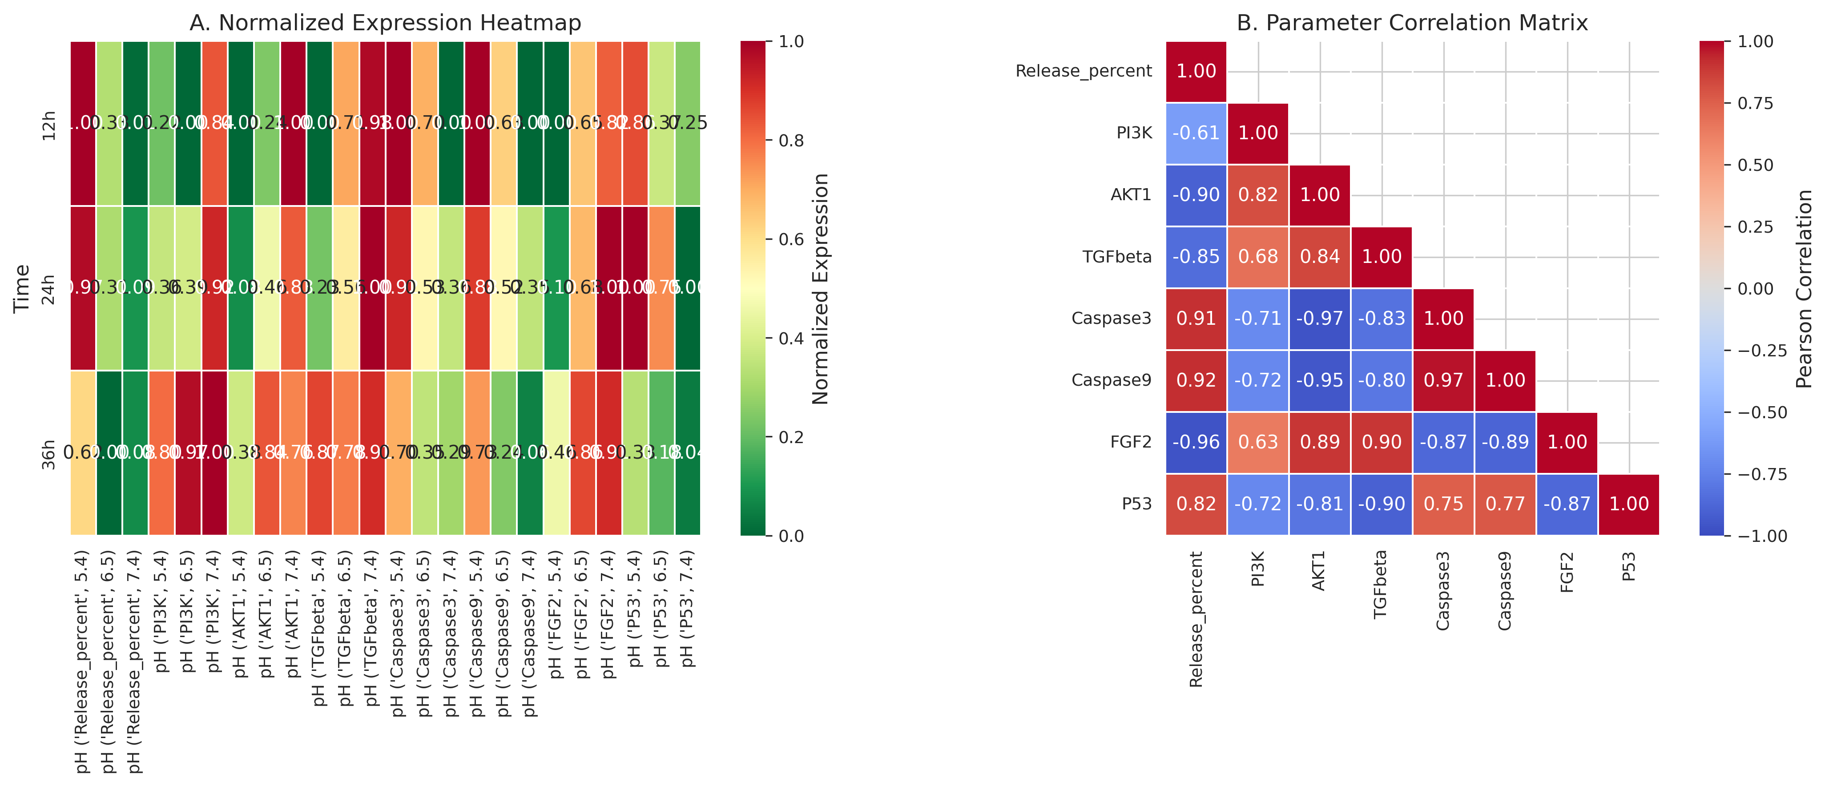
Figure S1: Heatmap visualization showing expression patterns of all molecular markers across different time and pH conditions. Color intensity represents expression levels.

Figure S2: Comprehensive Dashboard
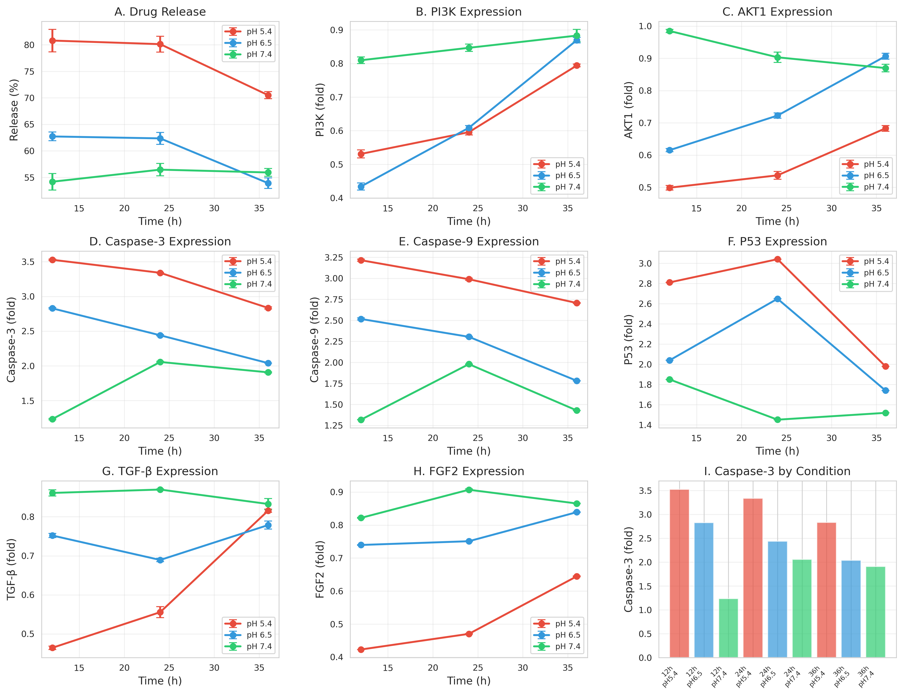
Figure S2: Comprehensive dashboard showing all experimental parameters and their relationships across conditions.

