**Lab Activity 04: Heroku**

**Student Name:** Hanikumar Lad

**Student ID:** 100918861

**Subject:** AI in Enterprise Systems

**Date:** 12th March 2025

**Here, I am predicting the “Species” of the fish using a Random Forest Classifier**

**Step1: Create a Machine Learning model and save it with the extension “.pkl”**

**Load dataset:**

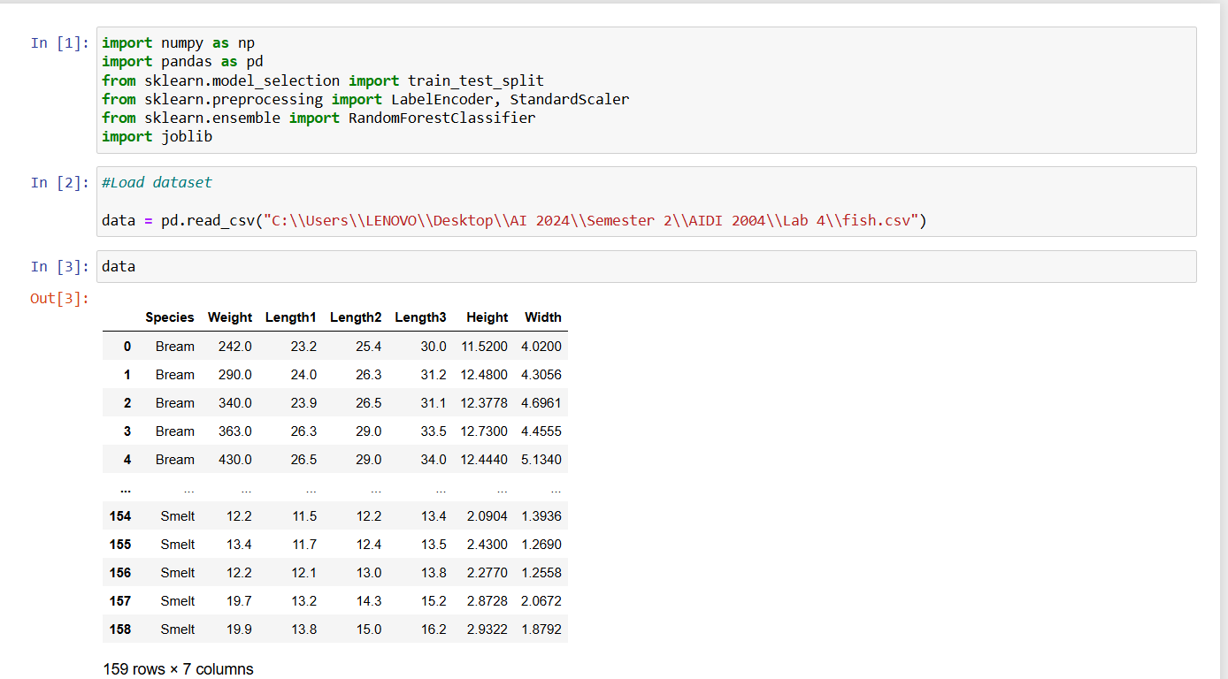

**Model training:**

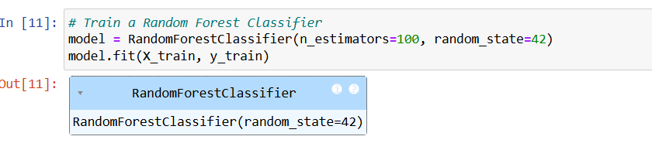

**Save .pkl file:**

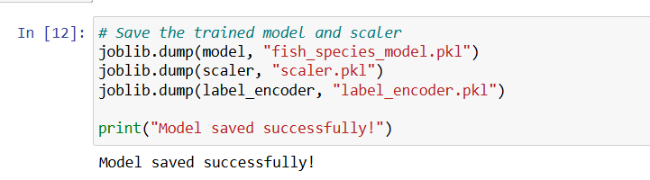

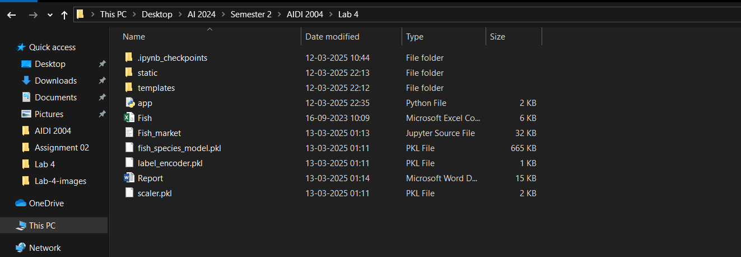

**Step2: Create HTML and CSS files for User Interface**

**Save HTML and CSS files in templates and Static folders respectively**

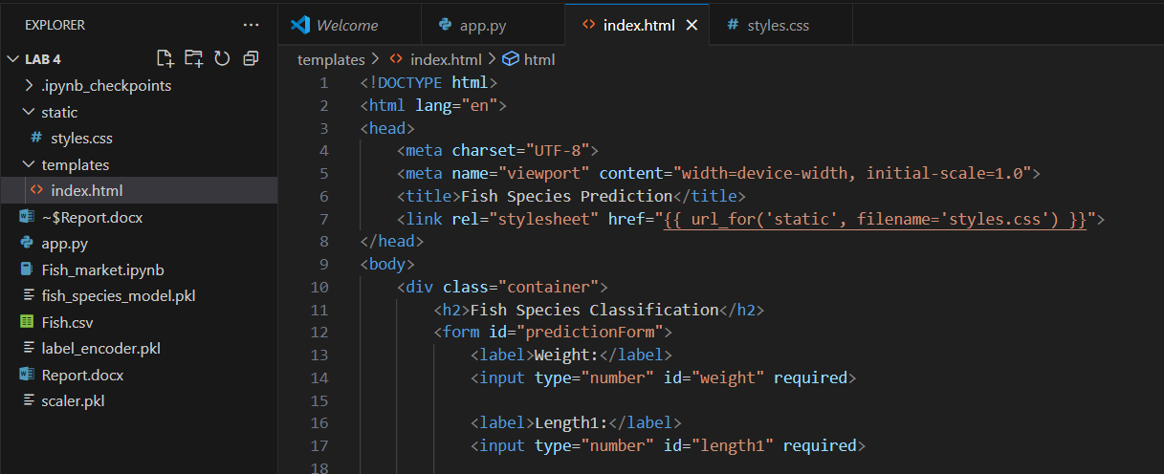

**Create app.py and run**

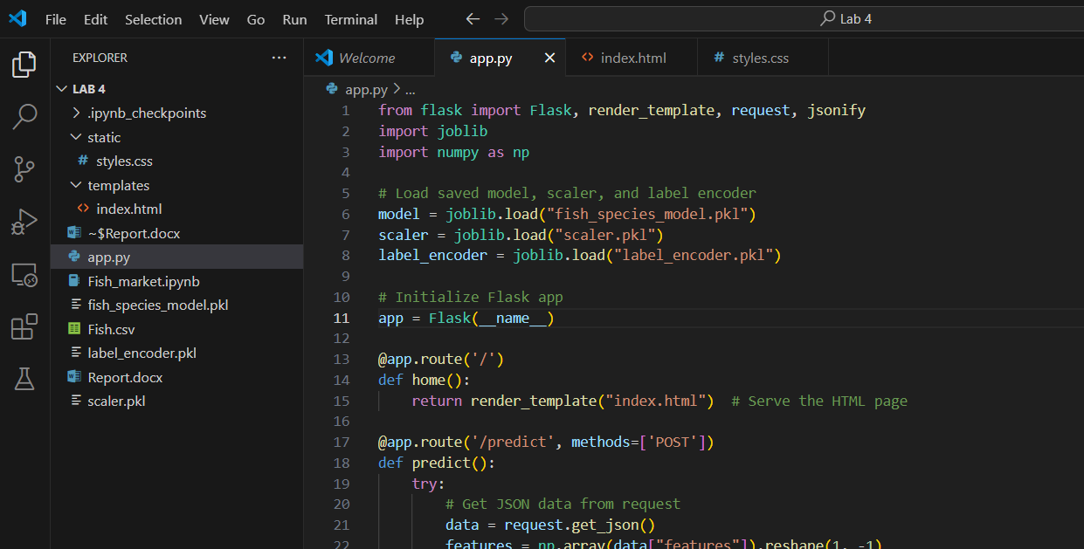

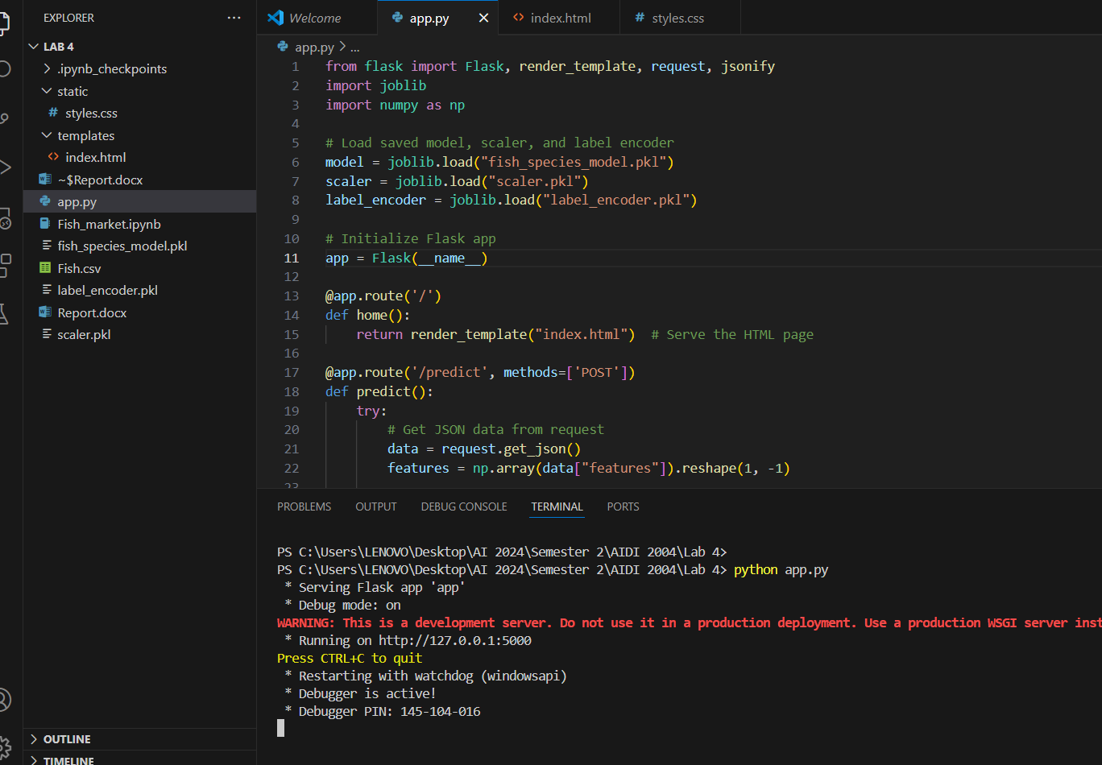

**Final output on the local machine and get a prediction**

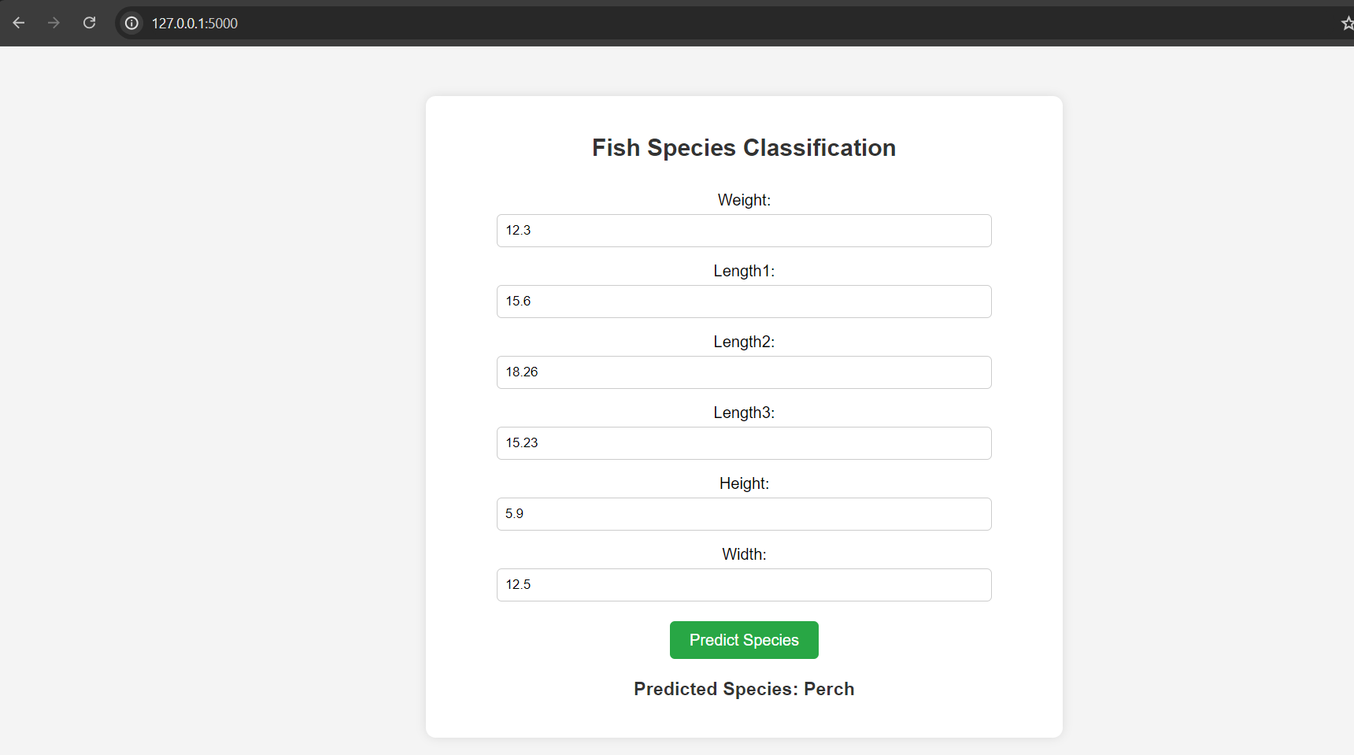

**Step3: Push all the files on GitHub**

**Create a New repository on GitHub:**

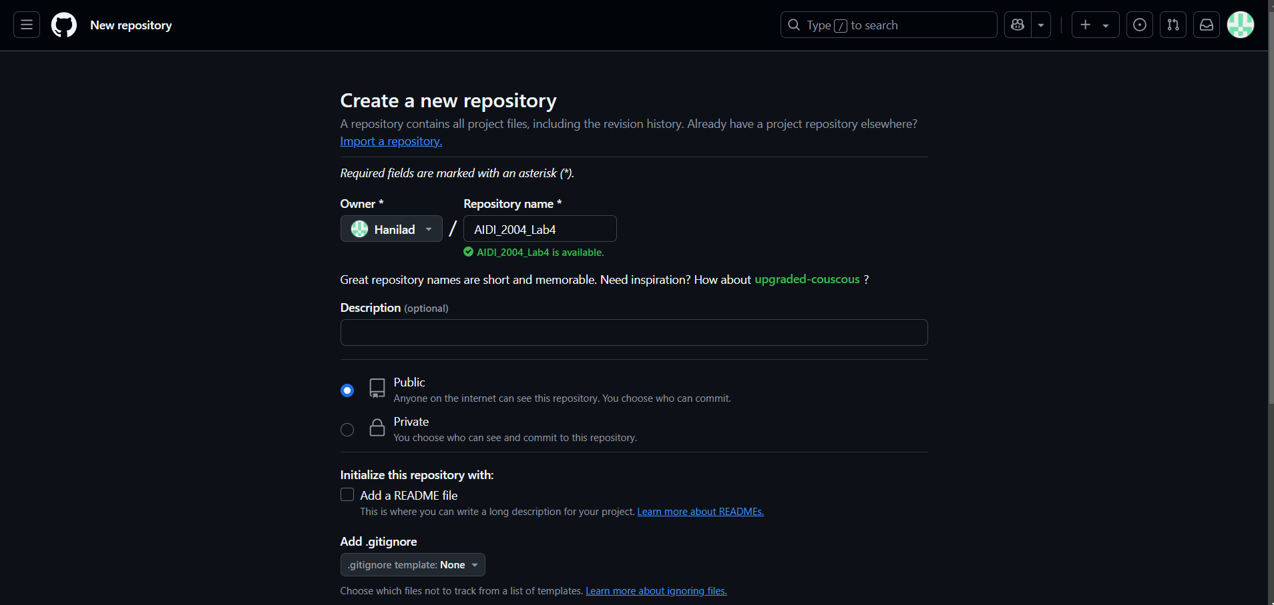

**Run the bash command to push the files on GitHub:**

**File uploaded successfully:**