PearlMart Inventory Management System
Member 1 - DFD Deliverables
Prepared by: Rana Al Dosari | GitHub: Rana-ra1903017
Role: Member 1 / Scrum Master | Milestone 1

1. Scope and responsibility
This document packages the Member 1 data-flow deliverables for PearlMart. It covers DFD Level 0, DFD Level 1, the Level 2 decomposition of Process 4.0 (Process Sales Transactions), boundary-flow balancing, and GitHub Issue #13 / Pull Request #25 evidence.

2. DFD Level 0 - Context Diagram
The context diagram treats PearlMart Inventory Management System as one process and shows only external entities and system-boundary flows. No data stores appear at Level 0.
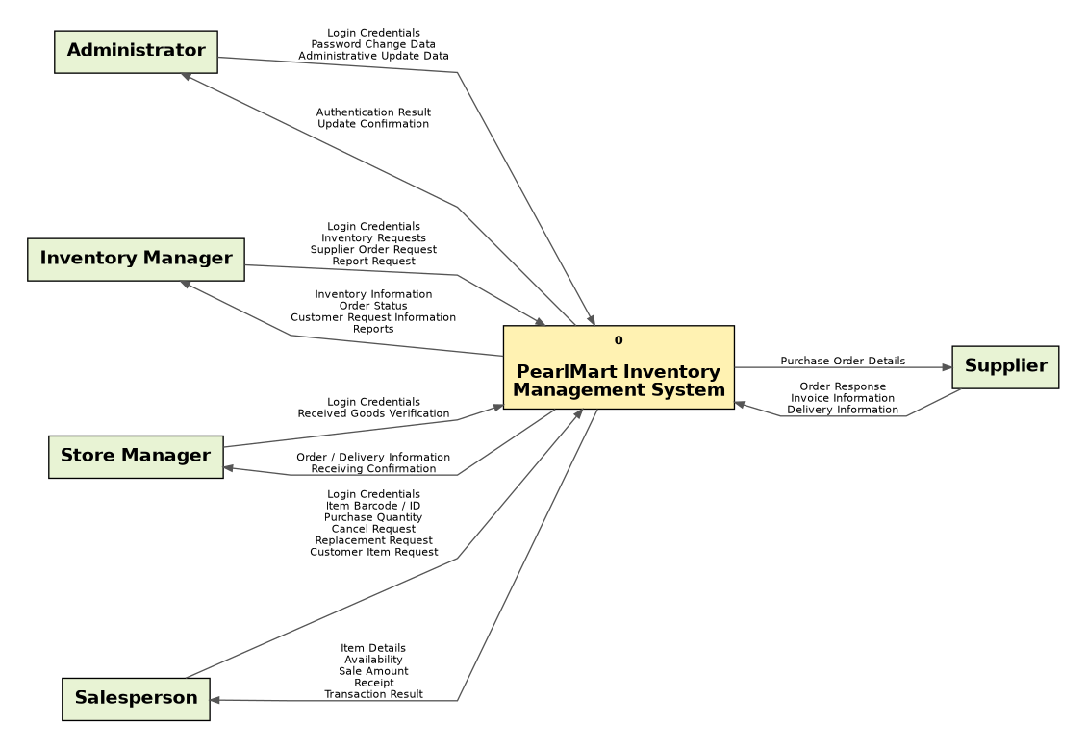
Figure 1. PearlMart DFD Level 0 (clean export, no evaluation watermark).

3. DFD Level 1 - System Decomposition
Level 1 decomposes the system into six major processes and six logical data stores while preserving the external flows from Level 0.
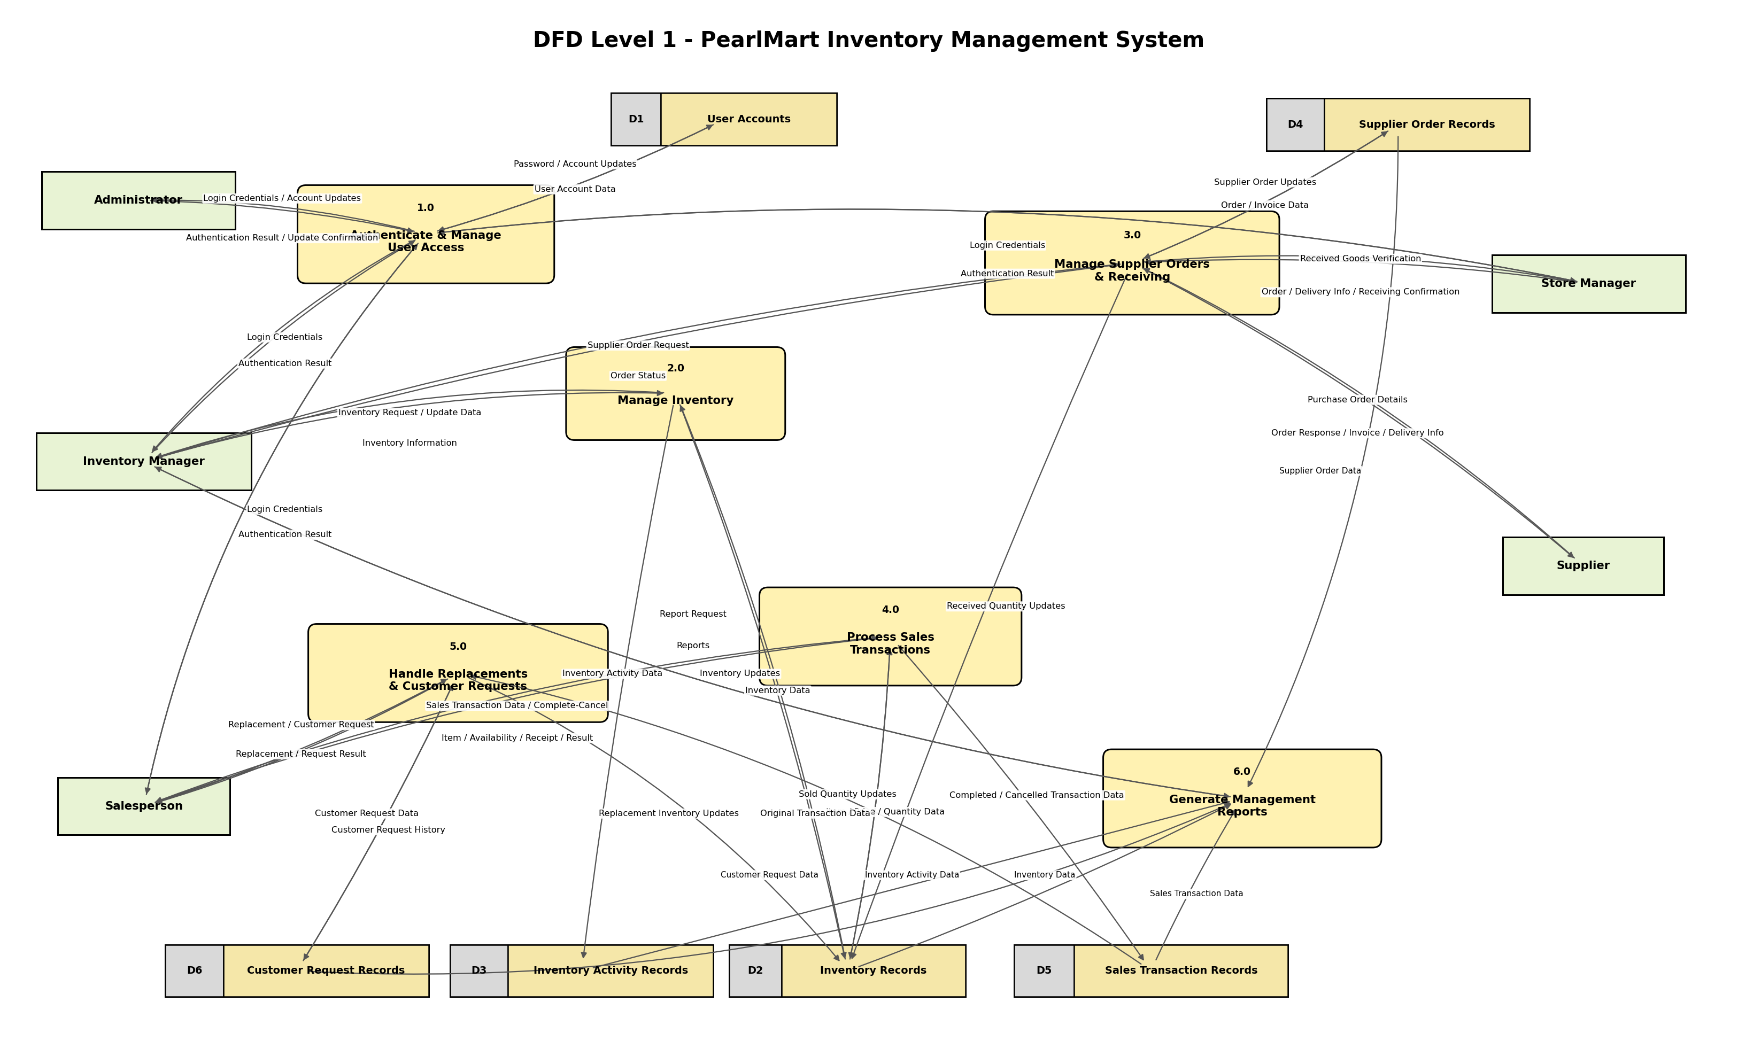
Figure 2. PearlMart DFD Level 1.
Processes: 1.0 Authenticate & Manage User Access; 2.0 Manage Inventory; 3.0 Manage Supplier Orders & Receiving; 4.0 Process Sales Transactions; 5.0 Handle Replacements & Customer Requests; 6.0 Generate Management Reports.
Data stores: D1 User Accounts; D2 Inventory Records; D3 Inventory Activity Records; D4 Supplier Order Records; D5 Sales Transaction Records; D6 Customer Request Records.

4. DFD Level 2 - Process 4.0
Process 4.0 is decomposed into five subprocesses. The Level 2 boundary remains balanced with the Level 1 Process 4.0 inputs, outputs, and data-store interactions.
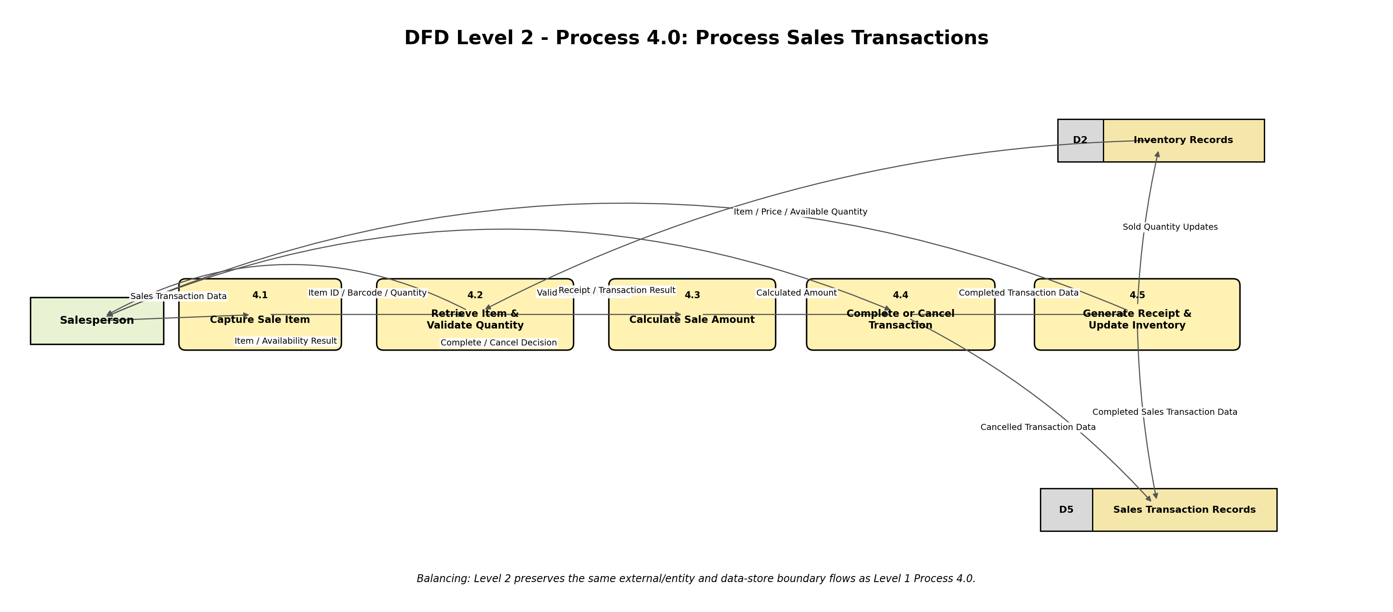
Figure 3. DFD Level 2 for Process 4.0 - Process Sales Transactions.
Subprocess | Name
4.1 | Capture Sale Item
4.2 | Retrieve Item & Validate Quantity
4.3 | Calculate Sale Amount
4.4 | Complete or Cancel Transaction
4.5 | Generate Receipt & Update Inventory

5. Boundary-flow balancing checklist
Boundary | Check | Result
Level 0 -> Level 1 | Administrator flows preserved | PASS
Level 0 -> Level 1 | Inventory Manager flows preserved | PASS
Level 0 -> Level 1 | Store Manager flows preserved | PASS
Level 0 -> Level 1 | Salesperson flows preserved | PASS
Level 0 -> Level 1 | Supplier flows preserved | PASS
Level 1 4.0 -> Level 2 | Sales Transaction Data preserved (Salesperson -> 4.1) | PASS
Level 1 4.0 -> Level 2 | Complete / Cancel Decision preserved (Salesperson -> 4.4) | PASS
Level 1 4.0 -> Level 2 | Inventory read preserved (D2 -> 4.2) | PASS
Level 1 4.0 -> Level 2 | Item / Availability Result preserved (4.2 -> Salesperson) | PASS
Level 1 4.0 -> Level 2 | Receipt / Transaction Result preserved (4.5 -> Salesperson) | PASS
Level 1 4.0 -> Level 2 | Sold Quantity Updates preserved (4.5 -> D2) | PASS
Level 1 4.0 -> Level 2 | Completed / Cancelled transaction writes preserved (4.4 / 4.5 -> D5) | PASS
Overall balancing result: PASS. Level 2 introduces no new external entity and no new boundary flow outside the logical boundary of Process 4.0.

6. GitHub traceability
Issue #13: Create DFD Level 0, Level 1, Level 2 and Boundary-Flow Checklist.
Pull Request #25: Add PearlMart DFD deliverables.
PR close keyword: Closes #13

7. Issue #13 acceptance criteria
☑ DFD Level 0 completed using Gane-Sarson notation.
☑ DFD Level 1 includes major processes and logical data stores.
☑ Process 4.0 is decomposed into Level 2.
☑ Process numbering is consistent.
☑ Boundary-flow checklist confirms balancing.
☑ Diagrams are saved in the Visual Paradigm .vpp file.
☑ Final diagrams are inserted into the Word report.

8. Submission note
The diagrams embedded in this document are clean exports without the Visual Paradigm Evaluation Copy watermark. The real editable PearlMart_Milestone1.vpp file must be saved from the existing Visual Paradigm project and uploaded with these deliverables. If G4.docx is the official team report, replace its watermarked DFD images with the clean images in this package before merging Pull Request #25.

