PearlMart Inventory Management System
Milestone 1 — Data Flow Diagrams
  - Corrected Member 1 DFD package | Issue #13 scope
This report covers the DFD contribution included in the supplied archive. It is not the complete team Milestone 1 report.
Deliverable | Contents
Level 0 | PearlMart context, five external entities and balanced composite boundary flows
Level 1 | Processes 1.0–6.0 and data stores D1–D6, including inventory, ordering, sales, replacements and reporting
Level 2 | Decomposition of Process 4.0 with availability validation, completion/cancellation, audit logging and inventory update
Source | Editable Visual Paradigm project, exported PNG/SVG diagrams and flow specification

Modeling decisions
- The DFD uses Gane–Sarson process and data-store symbols. Level 0 contains one process and no data stores.
- Level 0 combines the detailed Level 1 inputs and outputs for each external entity. Password-change data is handled by Process 1.0 and stored in D1.
- Customer item requests are stored in D6 and passed to Process 3.0 for supplier-order review. Replacement transactions are also written to D5.
- Process 4.2 checks requested quantity against available stock and returns an availability result. A cancelled transaction is recorded but does not change inventory; a completed transaction is recorded and deducts the sold quantity.

Scope limitation
The supplied G4.docx was empty (0 bytes). The archive also did not include the team’s use-case diagram/specifications, OO design class diagram, Scrum sprint evidence, member SIDs/effort declarations or team declaration. Those group-level items are not represented as completed in this DFD report.
DFD images below are the corrected exports. The matching editable project is PearlMart_Milestone1.vpp.

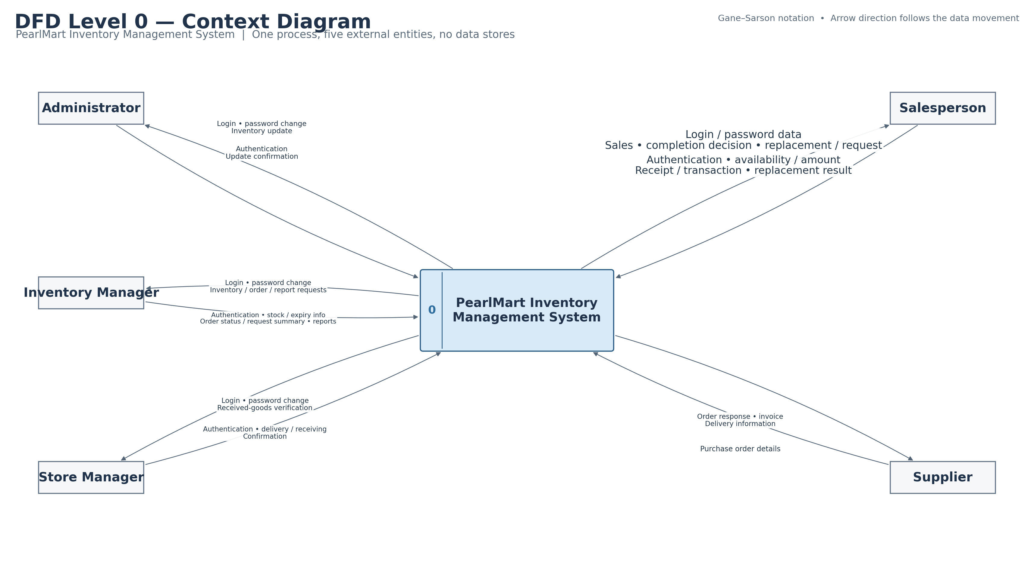

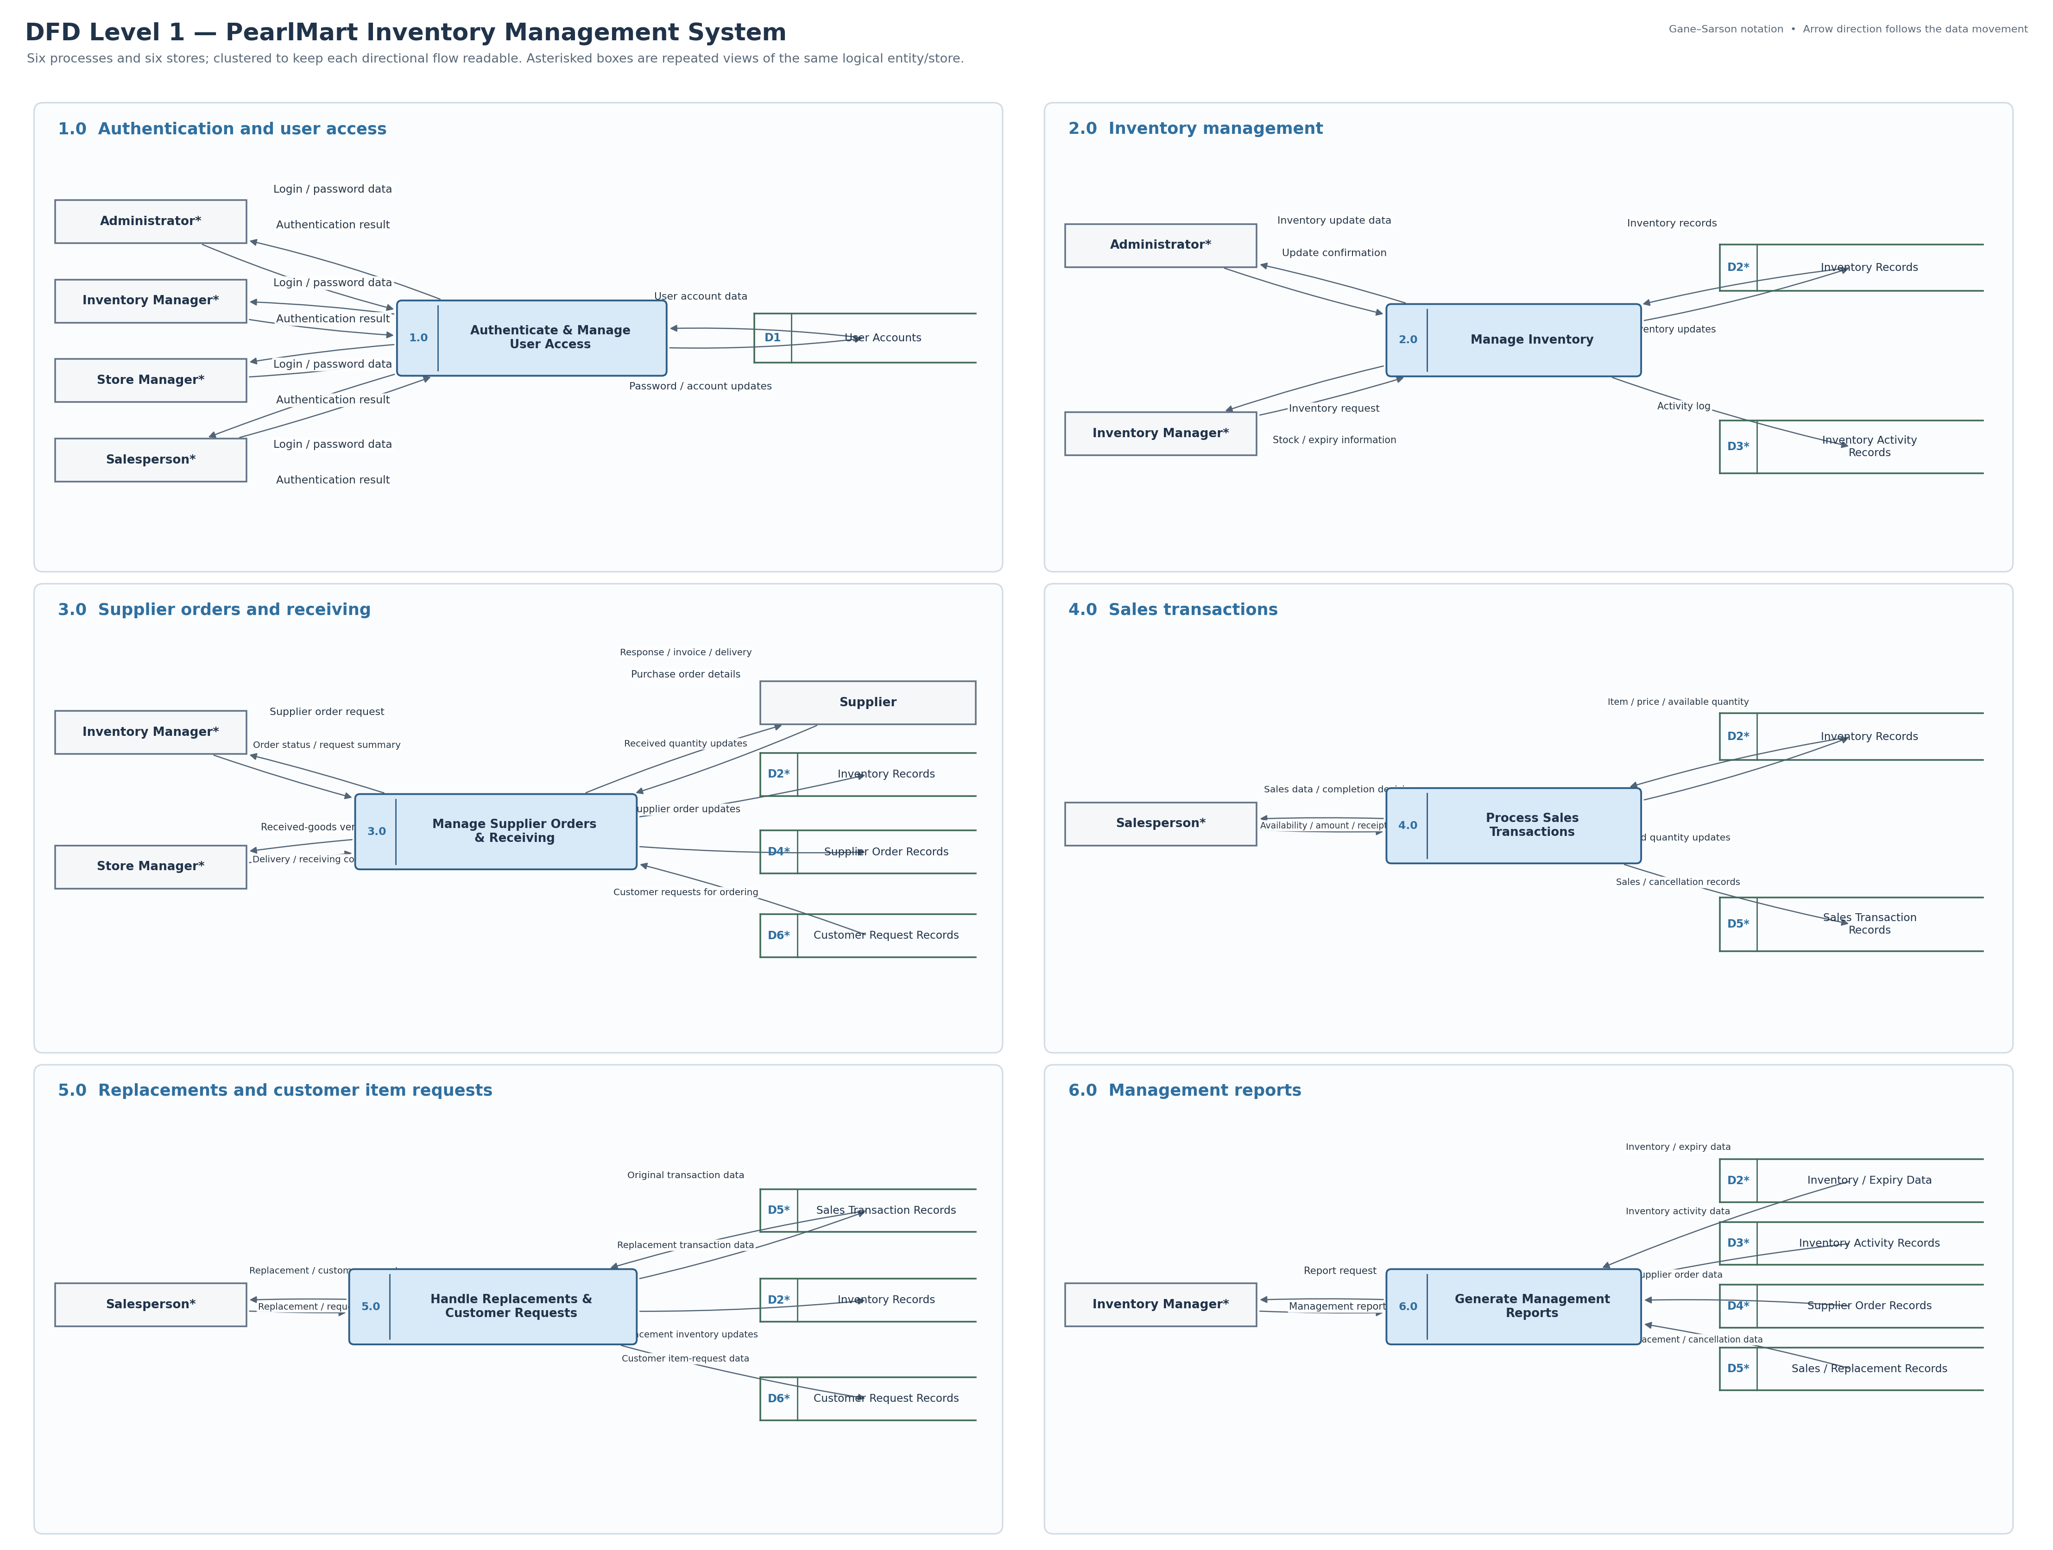

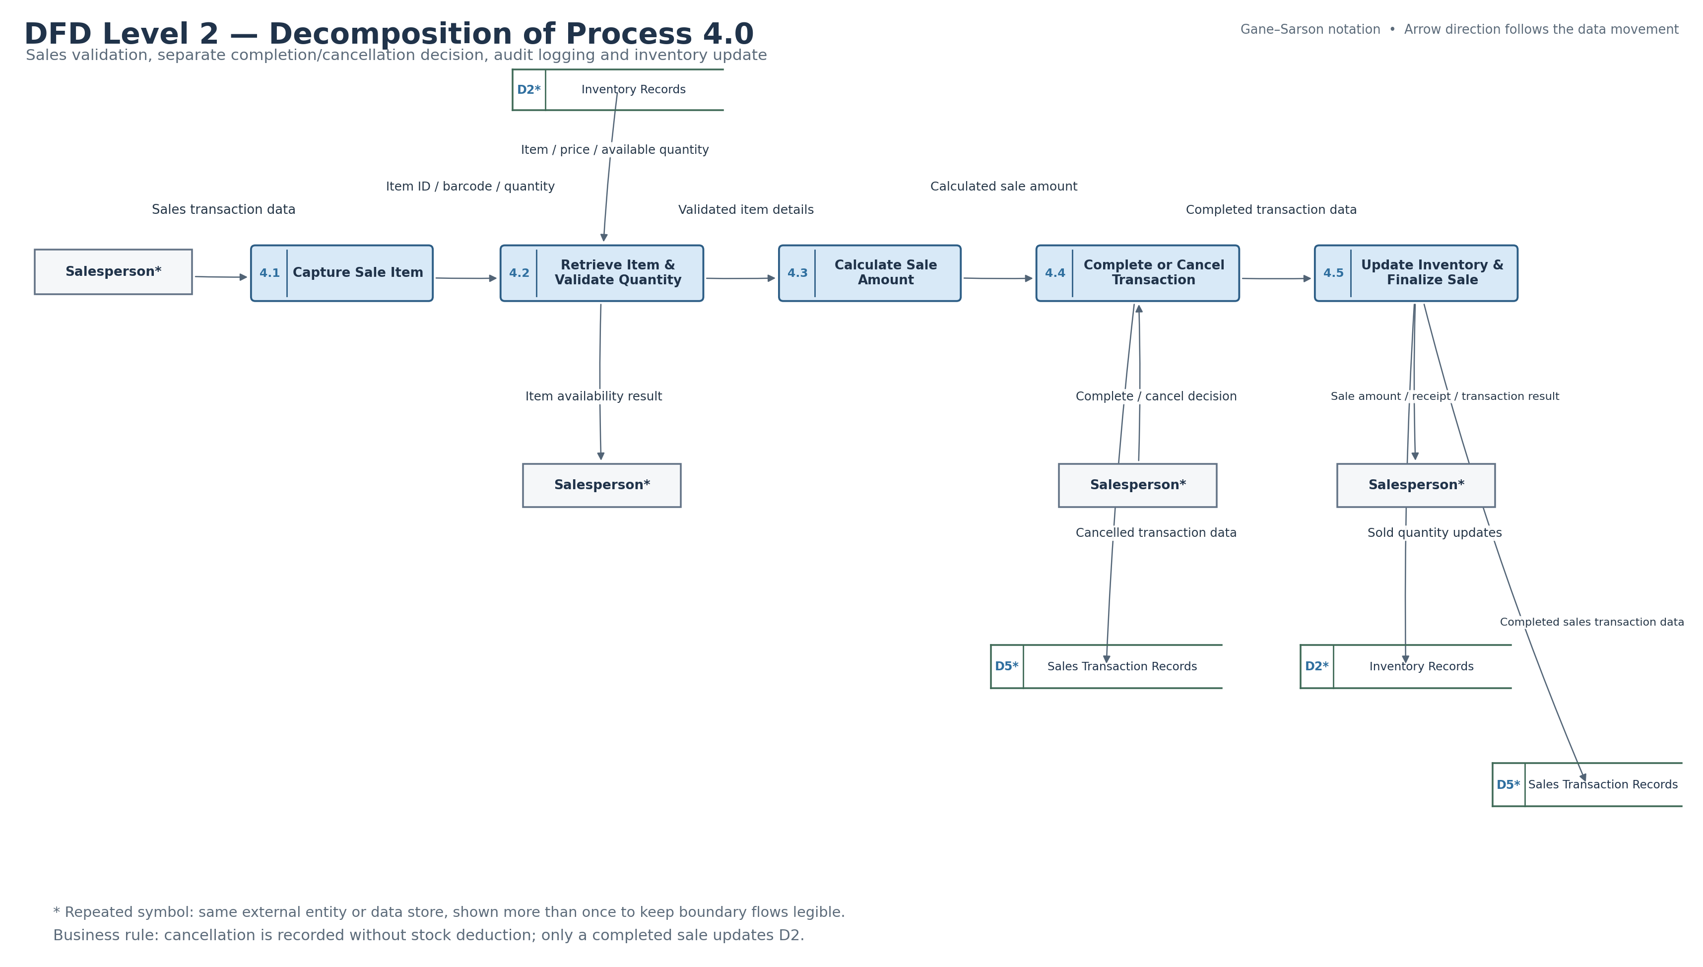

Boundary-flow validation
Each Level 0 input/output is realized by one or more Level 1 flows to the same external entity. Process 4.0’s parent inputs and outputs are accounted for in the Level 2 decomposition.
Boundary / parent flow | Level 1 / Level 2 realization | Result
Administrator: login, password change, inventory update | P1 authentication; P2 inventory update | Balanced
Inventory Manager: inventory, order and report requests | P2, P3, P6 | Balanced
Store Manager: receiving verification | P3; delivery/receiving confirmation returns | Balanced
Salesperson: sales, completion/cancel decision, replacement and customer requests | P4 input decomposes into 4.1 and 4.4; P5 handles replacement/request; all results return | Balanced
Supplier: order response, invoice, delivery; purchase order | P3 receives and sends the same logical flows | Balanced
P4 input: sales transaction data / completion decision | Salesperson → 4.1 and Salesperson → 4.4 | Balanced
P4 input: item / price / available quantity | D2 → 4.2 | Balanced
P4 output: availability result | 4.2 → Salesperson | Balanced
P4 output: sale amount / receipt / transaction result | 4.5 → Salesperson | Balanced
P4 output: completed / cancelled transaction records | 4.4 → D5 for cancellation; 4.5 → D5 for completed sale | Balanced
P4 output: sold quantity updates | 4.5 → D2 | Balanced

Validation status
Verified in the corrected files: process numbering, Level 0 has no stores, Level 1 includes D1–D6, Process 4.0 decomposes into 4.1–4.5, required flow directions, customer-request ordering path, replacement audit flow, and no stock deduction on cancellation.
The Visual Paradigm database passed SQLite integrity checks and its process/data-flow endpoints were cross-checked against the exported diagrams. The Visual Paradigm desktop application was unavailable in this environment, so its rendered canvas could not be opened here.

