CMPS310 SOFTWARE ENGINEERING
PearlMart Inventory Management System
Milestone 1 — Member 1 / Scrum Master Deliverable
DFD Level 0 / Level 1 / Level 2 + Boundary-Flow Checklist + GitHub Issues (Task 4a)

Repository | Team-B51-G04
Role | — Scrum Master
Milestone | Milestone-1
Submission deadline | 18 October 2026, 23:59
Student / GitHub username | Rana-ra1903017

1. DFD Scope and Modeling Decisions
PearlMart is modeled as one integrated inventory system used from the warehouse and billing counters. The system supports authorized access, inventory maintenance, supplier ordering and receiving, sales, cancellation, replacement, unavailable-item requests, and management reporting. The Supplier is external to the system and only its interactions with PearlMart are modeled.
DFD convention used: Gane–Sarson. Level 0 contains one system process and no internal stores; Level 1 introduces major logical processes and stores; Level 2 decomposes the substantial sales process (4.0).

2. DFD Level 0 — Context Diagram
Purpose: show PearlMart as a single process and identify only the external entities and data crossing the system boundary.
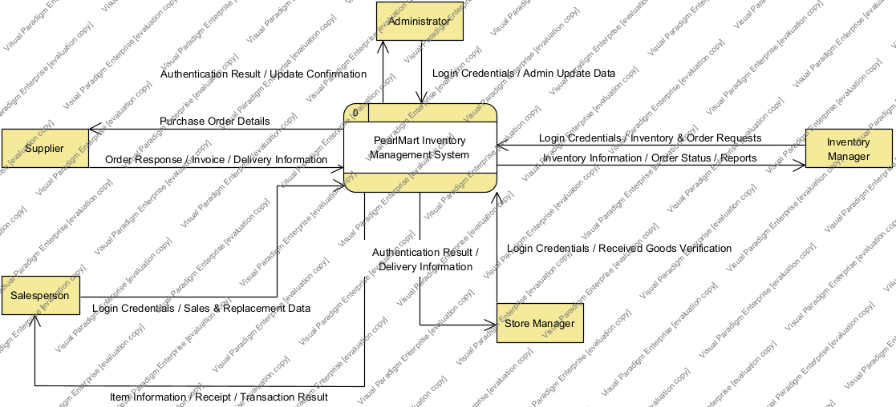
Figure 1. Level 0 context DFD.

3. DFD Level 1 — Major Processes and Logical Data Stores
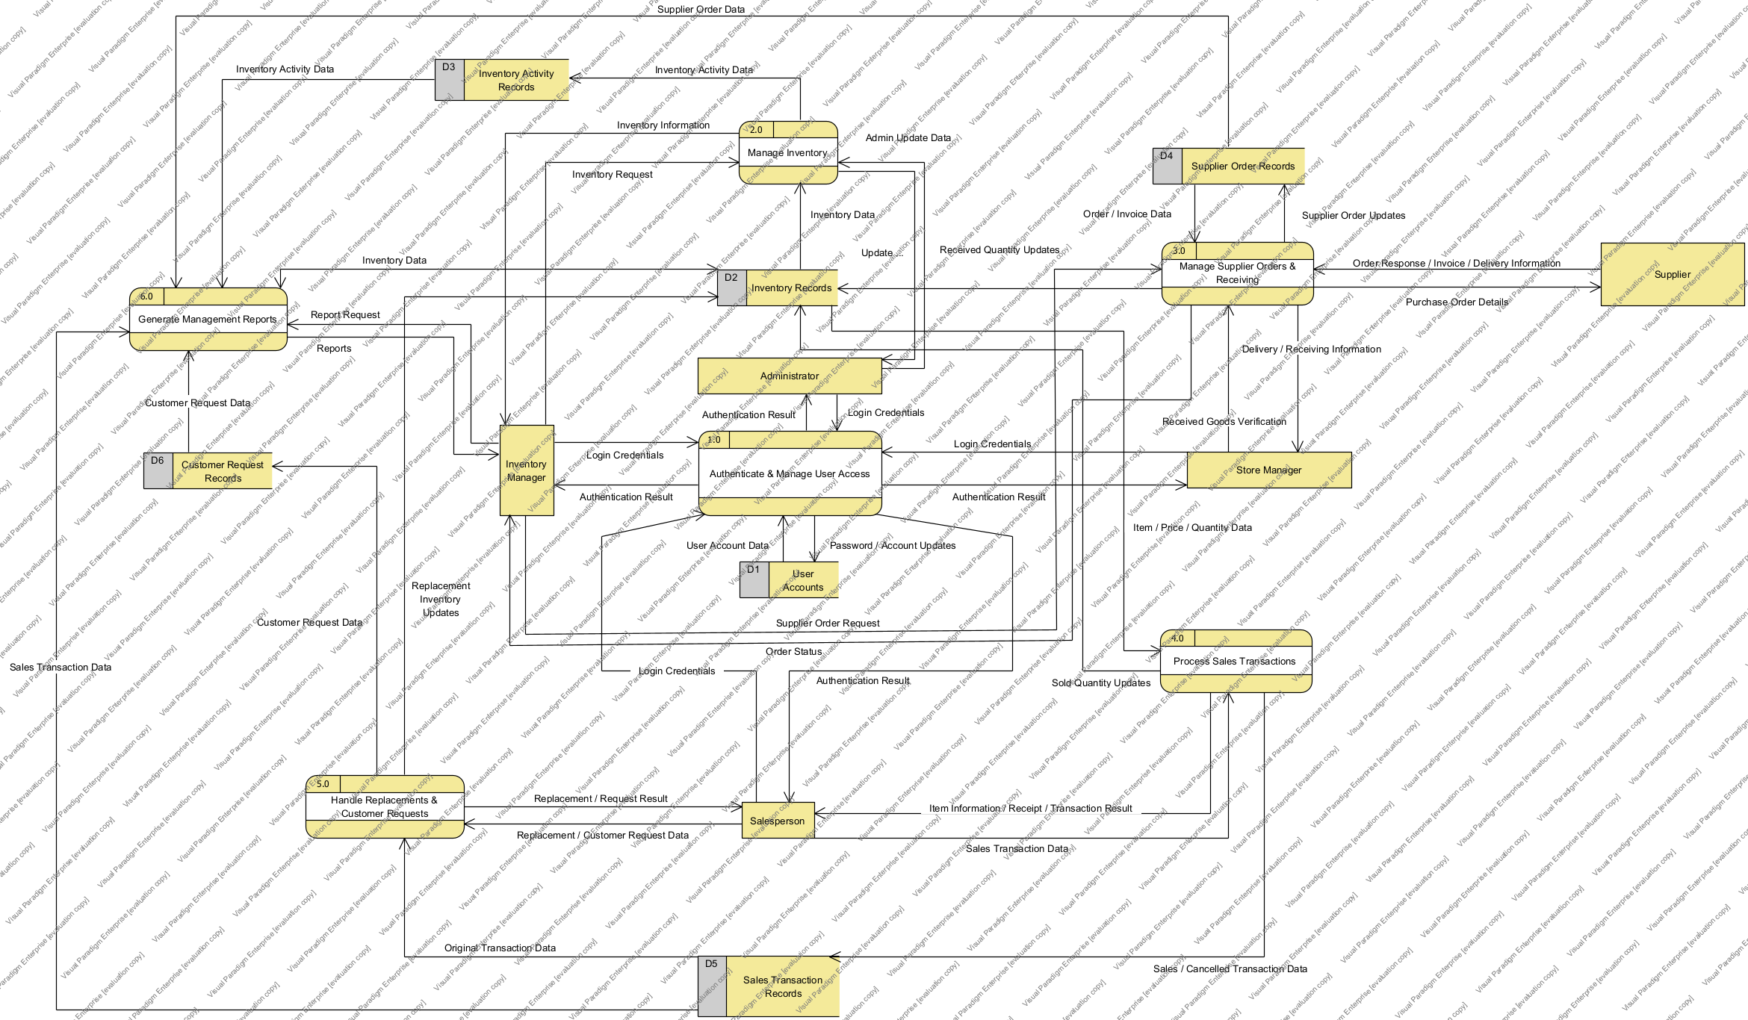
Figure 2. Level 1 DFD.

3.1 Level 1 Process Responsibilities
Process | Name | Responsibility
1.0 | Authenticate & Manage User Access | Verifies credentials, role-based access and password/account changes.
2.0 | Manage Inventory | Adds items, increases/removes quantity, searches items, updates prices and identifies expired goods.
3.0 | Manage Supplier Orders & Receiving | Records supplier orders, sends order data, receives invoice/delivery data and updates received quantities.
4.0 | Process Sales Transactions | Validates sale items and quantities, calculates amounts, completes/cancels sales, generates receipts and updates inventory.
5.0 | Handle Replacements & Customer Requests | Validates replacements and records requests for unavailable items.
6.0 | Generate Management Reports | Retrieves relevant operational records and produces summary reports.

4. DFD Level 2 — Process 4.0 Sales Transactions
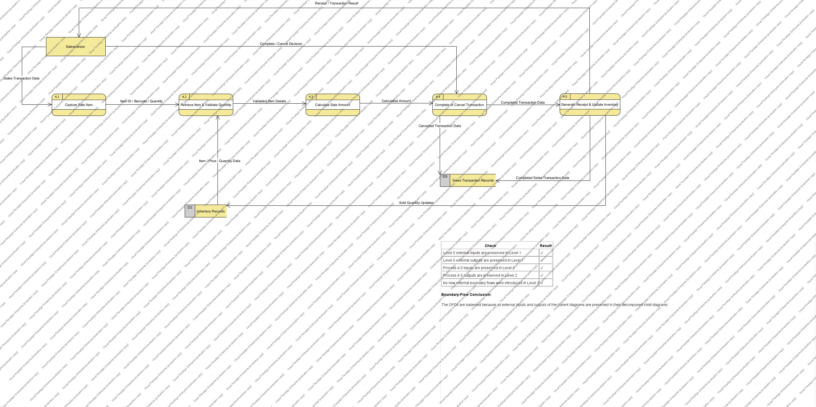
Figure 3. Level 2 decomposition of 4.0 Process Sales Transactions.

4.1 Level 2 Subprocess Responsibilities
Subprocess | Purpose
4.1 Capture Sale Item | Accept barcode/item identifier and requested quantity from the Salesperson.
4.2 Retrieve Item & Validate Quantity | Retrieve current item information and verify that the requested quantity is available.
4.3 Calculate Sale Amount | Calculate selling amount and applicable discounts/taxes; produce final amount.
4.4 Complete or Cancel Transaction | Accept completion/cancellation decision and preserve inventory if cancelled.
4.5 Generate Receipt & Update Inventory | Record completed sale, deduct purchased quantities and generate the receipt.

5. Boundary-Flow Checklist and Balancing
Balancing means that data crossing a parent process boundary must still cross the corresponding child-diagram boundary after decomposition. Internal child flows may be added, but external boundary data must not disappear or be invented.

5.1 Level 0 ↔ Level 1 Boundary Check
External Entity | Parent Input | Level 1 Process(es) | Parent Output | Balanced?
Administrator | Login credentials; administrative update data | 1.0 / 2.0 | Authentication / update result | Yes
Inventory Manager | Login; inventory, supplier-order and report requests | 1.0 / 2.0 / 3.0 / 6.0 | Inventory, order and report information | Yes
Store Manager | Login; received-goods verification | 1.0 / 3.0 | Delivery information; receiving confirmation | Yes
Salesperson | Login; sale/cancel/replacement/customer-request data | 1.0 / 4.0 / 5.0 | Item, receipt, transaction and request results | Yes
Supplier | Order response; invoice; delivery information | 3.0 | Purchase order details | Yes

5.2 Process 4.0 ↔ Level 2 Boundary Check
Parent Boundary Flow | Data | Level 2 Location | Balanced?
Salesperson → 4.0 | Barcode/item ID + quantity | 4.1 | Yes
D2 Inventory → 4.0 | Item details + available quantity | 4.2 | Yes
4.0 → Salesperson | Availability/validation result | 4.2 | Yes
Salesperson → 4.0 | Complete/cancel request | 4.4 | Yes
4.0 → D5 | Completed/cancelled transaction record | 4.4 / 4.5 | Yes
4.0 → D2 | Purchased-quantity deduction | 4.5 | Yes
4.0 → Salesperson | Receipt / transaction result | 4.5 | Yes
Balancing conclusion: Level 0 is balanced with Level 1, and Level 1 process 4.0 is balanced with its Level 2 decomposition.

6. Assumptions Used by the DFDs
ID | Assumption | Justification | Affected Models
A1 | Customers do not directly access the system; Salespersons/authorized employees enter customer transactions. | The requirements describe employee interaction with the inventory system. | DFD L0/L1/L2
A2 | Physical goods are not data flows; only information about goods, quantities, invoices and delivery is modeled. | A logical DFD models data movement, not physical movement. | DFD L0/L1
A3 | “Authorized managers” are represented through the appropriate PearlMart management roles when reports are requested. | The exact report-role split is not fully specified. | DFD L0/L1
A4 | Applicable discount and tax rules are available to the sales process; rule maintenance is outside this milestone’s stated detail. | The requirements require calculation but do not specify rule administration. | DFD L2

7. GitHub Issues — Task 4a
Create the Milestone-1 GitHub milestone with due date 18 October 2026. Every issue below should be linked to the Project and milestone and should have exactly one assignee, plus type, priority, and phase labels. Replace Member 1/2/3/4 with the actual GitHub usernames before final evidence screenshots.
Setting | Recommended Value
Milestone | Milestone-1 — due 2026-10-18
Status field | Todo / In Progress / In Review / Done
Iteration field | Sprint 1 / Sprint 2
Sprint 1 | 2026-09-26 to 2026-10-05
Sprint 2 | 2026-10-06 to 2026-10-16
Other Project fields | Estimate, Start date, Target date
Priority labels | priority:P0, priority:P1, priority:P2
Type labels | type:modeling, type:documentation, type:project-management, type:integration
Phase labels | phase:sprint-1, phase:sprint-2, phase:final

7.1 Prioritized Issue Backlog
# | Issue | Assignee | Priority | Phase | Est.
1 | Create Level 0, Level 1, and Level 2 DFDs with balancing checklist | Member 1 (Scrum Master) | P0 | sprint-1 | 5
2 | Create complete use case diagram for PearlMart | Member 2 | P0 | sprint-1 | 5
3 | Write DFD vs use case comparison and analysis question justification | Member 2 | P1 | sprint-1 | 2
4 | Write four substantial use case specifications | Member 3 | P0 | sprint-1 | 8
5 | Create design class diagram for the entire system | Member 4 | P0 | sprint-2 | 13
6 | Explain OO responsibilities, encapsulation, abstraction, and modularity | Member 4 | P1 | sprint-2 | 3
7 | Set up Milestone-1 GitHub milestone, labels, prioritized issues, and Project fields | Member 1 (Scrum Master) | P0 | sprint-1 | 3
8 | Update README and .gitignore for Milestone 1 | Member 1 (Scrum Master) | P1 | sprint-1 | 2
9 | Plan and maintain Sprint 1 and Sprint 2 in GitHub Projects | Member 1 (Scrum Master) | P0 | sprint-1 | 3
10 | Capture Sprint evidence, reviews, retrospectives, and issue-to-PR traceability | Member 1 (Scrum Master) | P0 | sprint-2 | 5
11 | Create assumptions table and requirements traceability table | Member 3 | P1 | sprint-2 | 3
12 | Integrate, review, and finalize Milestone-1 submission package | Member 1 (Scrum Master) | P0 | final | 5

7.2 Acceptance Criteria Ready for GitHub

#1 Create Level 0, Level 1, and Level 2 DFDs with balancing checklist
Assignee: Member 1 (Scrum Master) | Labels: type:modeling, priority:P0, phase:sprint-1 | Estimate: 5 | Dates: 2026-09-26 → 2026-10-01
☐ Level 0 contains one PearlMart system process and no internal data stores.
☐ Level 1 shows major processes, logical data stores, external entities, and meaningful directional flows.
☐ One substantial Level 1 process is decomposed to Level 2 with consistent numbering.
☐ Boundary-flow checklist demonstrates parent/child balancing.
☐ Final diagrams are reviewed and saved in the shared .vpp model and report.

#2 Create complete use case diagram for PearlMart
Assignee: Member 2 | Labels: type:modeling, priority:P0, phase:sprint-1 | Estimate: 5 | Dates: 2026-09-26 → 2026-10-02
☐ All required actors are represented.
☐ Use cases cover inventory, supplier orders/receiving, sales, cancellation, replacement, customer requests, reports, login and password change.
☐ Relationships are meaningful and consistent with requirements.
☐ Diagram is reviewed and saved in the shared .vpp model and report.

#3 Write DFD vs use case comparison and analysis question justification
Assignee: Member 2 | Labels: type:documentation, priority:P1, phase:sprint-1 | Estimate: 2 | Dates: 2026-10-02 → 2026-10-04
☐ Explains what each model reveals about PearlMart.
☐ States complementary strengths and limitations.
☐ Uses one specific analysis question and justifies which model is more useful for that question.
☐ Terminology matches the final DFD and use case diagram.

#4 Write four substantial use case specifications
Assignee: Member 3 | Labels: type:documentation, priority:P0, phase:sprint-1 | Estimate: 8 | Dates: 2026-09-27 → 2026-10-05
☐ Exactly four substantial business use cases are selected; routine login/search/password change are excluded.
☐ Each specification includes description, actors, trigger, preconditions, postconditions, normal scenario, and alternatives.
☐ Each selected use case includes validation, state change, and meaningful alternative flows.
☐ Specifications use the Blackboard template and match the final use case diagram.

#5 Create design class diagram for the entire system
Assignee: Member 4 | Labels: type:modeling, priority:P0, phase:sprint-2 | Estimate: 13 | Dates: 2026-10-06 → 2026-10-13
☐ Diagram includes required domain and application classes.
☐ Attributes include types and visibility.
☐ Operations include parameter and return types and visibility.
☐ Associations, aggregation/generalization where justified, and multiplicities are shown.
☐ Responsibilities are consistent with requirements and use cases.
☐ Diagram is readable and saved in the shared .vpp model and report.

#6 Explain OO responsibilities, encapsulation, abstraction, and modularity
Assignee: Member 4 | Labels: type:documentation, priority:P1, phase:sprint-2 | Estimate: 3 | Dates: 2026-10-13 → 2026-10-15
☐ Explanation uses concrete examples from the final class diagram.
☐ Responsibility allocation is justified.
☐ Encapsulation, abstraction, and modularity are explained.
☐ Inheritance/aggregation/composition/patterns are discussed only when actually justified.

#7 Set up Milestone-1 GitHub milestone, labels, prioritized issues, and Project fields
Assignee: Member 1 (Scrum Master) | Labels: type:project-management, priority:P0, phase:sprint-1 | Estimate: 3 | Dates: 2026-09-26 → 2026-09-27
☐ Milestone “Milestone-1” exists with due date 2026-10-18.
☐ Every backlog issue has exactly one assignee.
☐ Every issue has type, priority, and phase labels.
☐ All issues are linked to the GitHub Project and Milestone-1.
☐ Project includes Status, Sprint/Iteration, Estimate, Start date, and Target date fields.

#8 Update README and .gitignore for Milestone 1
Assignee: Member 1 (Scrum Master) | Labels: type:documentation, priority:P1, phase:sprint-1 | Estimate: 2 | Dates: 2026-09-27 → 2026-09-29
☐ README lists all team members and GitHub usernames.
☐ README states Scrum Master, Product Owner, and Developers.
☐ README contains the GitHub Project link.
☐ .gitignore is appropriate for temporary/editor/generated files.
☐ Change is submitted through a branch and reviewed pull request.

#9 Plan and maintain Sprint 1 and Sprint 2 in GitHub Projects
Assignee: Member 1 (Scrum Master) | Labels: type:project-management, priority:P0, phase:sprint-1 | Estimate: 3 | Dates: 2026-09-26 → 2026-10-16
☐ Two sprints are defined and each is no longer than two weeks.
☐ Sprint 1: 2026-09-26 to 2026-10-05; Sprint 2: 2026-10-06 to 2026-10-16.
☐ Each sprint has a written Sprint Goal and selected backlog issues.
☐ Table view shows workload grouped by assignee.
☐ Roadmap view shows start/target dates.
☐ Board statuses are kept current: Todo, In Progress, In Review, Done.

#10 Capture Sprint evidence, reviews, retrospectives, and issue-to-PR traceability
Assignee: Member 1 (Scrum Master) | Labels: type:project-management, priority:P0, phase:sprint-2 | Estimate: 5 | Dates: 2026-10-05 → 2026-10-16
☐ Dated board/activity evidence is captured during both sprints, not only at the end.
☐ Substantive issues are linked to branches and pull requests.
☐ Meaningful teammate review is visible before merge.
☐ Sprint 1 review and retrospective are documented.
☐ Sprint 2 review and retrospective are documented and explain how Sprint 1 improvement was applied.

#11 Create assumptions table and requirements traceability table
Assignee: Member 3 | Labels: type:documentation, priority:P1, phase:sprint-2 | Estimate: 3 | Dates: 2026-10-10 → 2026-10-15
☐ Assumptions are listed with justification and affected models.
☐ Major requirements are linked to use cases, DFD processes, and responsible classes.
☐ Names and business rules are consistent across artifacts.
☐ Table is reviewed against final diagrams/specifications.

#12 Integrate, review, and finalize Milestone-1 submission package
Assignee: Member 1 (Scrum Master) | Labels: type:integration, priority:P0, phase:final | Estimate: 5 | Dates: 2026-10-16 → 2026-10-18
☐ Final Word report contains legible diagrams and required Scrum evidence.
☐ Final .vpp file opens and matches diagrams in the report.
☐ Repository URL, Project URL, and final submission commit link are included.
☐ Final Word and .vpp files are committed to Milestone-1 folder on main.
☐ All group members use matching final files for Blackboard submission.

8. Member 1 Completion Checklist
☐ Recreate/save the three DFDs in the shared Visual Paradigm .vpp file using Gane–Sarson notation.
☐ Insert the final DFDs and boundary-flow checklist into the group Word report.
☐ Create Milestone-1, labels, Project fields, and the GitHub issues from Section 7.
☐ Assign each issue to the actual single team-member GitHub username.
☐ Keep statuses current and capture dated evidence during both sprints.
☐ Link substantive issues to branches, pull requests, and teammate reviews before merge.
☐ Before final submission, verify the report diagrams match the .vpp file and the final files match GitHub and Blackboard.

