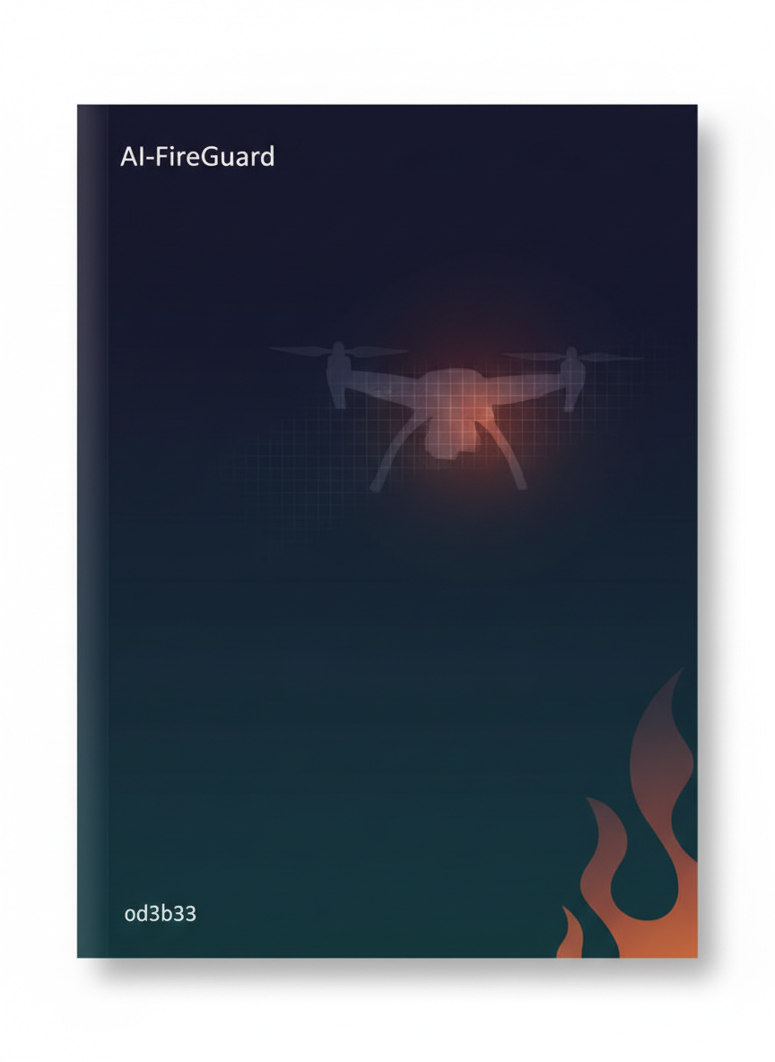

Syrian Private University
College of Artificial Intelligence
AI-FireGuard
Thermal-RGB Fusion for UAV-Based Wildfire Monitoring
———————————————
Prepared By
Hanin Shahin | Anas Abo Assaf
Supervised By
Dr. Maissa Abo Kassem
Academic Year 2025–2026

Table of Contents
Right-click and select "Update Field" to refresh page numbers

Abstract 3
Chapter One: Introduction 4
1.1 Background and Motivation 4
1.2 Causes of Wildfires 5
1.3 Project Objectives 5
1.4 Comparison with Traditional Approaches 6
Chapter Two: Reference Studies 7
2.1 NASA AMS Wildfire 7
2.2 AEFRN 8
2.3 FireVision 9
2.4 DetectiumFire 10
2.5 LP-YOLO 11
2.6 FlameGuard 12
2.7 Multimodal Fusion 12
2.8 FFDNet 13
2.9 ResCaps-TC-Attn-Fire 13
2.10 Comparative Summary 14
Chapter Three: Dataset Overview 15
3.1 FLAME-2 Dataset 15
3.2 Dataset Usage in AI-FireGuard 17
Chapter Four: Methodology 18
4.1 System Architecture Overview 18
4.2 Stage 1: Convolutional Autoencoder 19
4.3 Stage 2: Anomaly Scoring and Threshold Calibration 21
4.4 Stage 3: Bounding Box Extraction 22
4.5 Stage 4: YOLOv11s Object Detector 23
Chapter Five: Training and Evaluation Results 24
5.1 Autoencoder Training Results 24
5.2 Anomaly Detection Performance 25
5.3 YOLOv11s Detection Results 26
5.4 Comparison with Reference Studies 27
Chapter Six: Challenges and Limitations 28
Chapter Seven: Future Recommendations 29
References 31
Appendix 32

Abstract
Wildfires represent one of the most destructive natural hazards, posing severe threats to ecosystems, property, and human lives. Early detection and accurate real-time monitoring are critical for minimizing losses and guiding emergency response operations. Traditional satellite- or ground-based monitoring methods frequently suffer from low spatial resolution, delayed data updates, and limited area coverage. Unmanned Aerial Vehicles (UAVs) equipped with synchronized thermal infrared (IR) and RGB optical sensors offer a compelling alternative, providing high-resolution, real-time wildfire surveillance over large, difficult-to-access areas.
This project presents AI-FireGuard, an intelligent fire detection system that leverages the complementary strengths of thermal and RGB UAV imagery. The thermal channel highlights heat sources and fire signatures even through dense smoke and in low-light conditions, while the RGB channel supplies detailed visual context for accurate localization and scene understanding. By fusing these two modalities, AI-FireGuard achieves improved detection robustness compared to single-sensor approaches.
The core detection pipeline is built around a Convolutional Autoencoder trained exclusively on fire-free (no-fire) thermal frames from the FLAME-2 dataset. The autoencoder learns the normal thermal signature of a fire-free scene; at inference time, frames containing fire produce abnormally high reconstruction errors, which serve as anomaly scores. A Youden-J-optimal threshold calibrated on held-out calibration frames separates fire from no-fire detections. Bounding boxes are extracted from per-pixel error maps and used as pseudo-labels to train a YOLOv11s object detector for efficient real-time fire localization.
The system achieves a ROC AUC of 0.9845 and an Average Precision (AP) of 0.9884 at the anomaly-detection stage. After YOLO training on the pseudo-labeled dataset (38,901 training frames; 14,550 validation frames), the detector reaches mAP@0.5 = 0.985 and mAP@0.5–0.95 = 0.774, with precision 0.962 and recall 0.954. These results demonstrate the viability of unsupervised anomaly detection as a scalable, label-efficient solution for UAV-based wildfire monitoring.

Chapter One: Introduction

1.1 Background and Motivation
Wildfires are among the most destructive natural hazards affecting global ecosystems. Extended droughts, rising temperatures, and the expansion of human activities into wildland–urban interface zones have significantly increased both the frequency and severity of wildfire events in recent decades. The consequences include the loss of human life, destruction of infrastructure, irreversible degradation of biodiversity, and the release of vast quantities of greenhouse gases that further exacerbate climate change.
Effective wildfire management hinges on early detection and rapid situational awareness. Every minute of delay in identifying and reporting a fire dramatically increases the area burned, the cost of suppression, and the risk to firefighters and communities. Conventional monitoring approaches — including fixed observation towers, ground-based sensor networks, manned aircraft patrols, and satellite imagery — each present significant limitations in terms of response latency, spatial coverage, and cost.
Unmanned Aerial Vehicles (UAVs) equipped with multi-spectral sensors have emerged as a highly promising platform for wildfire monitoring. Their ability to be deployed rapidly, to fly at low altitudes for high-resolution imaging, and to operate autonomously over extended areas makes them well suited for real-time fire surveillance. Among sensor modalities, the combination of thermal infrared (IR) and RGB visible-light cameras is particularly powerful: the thermal channel detects heat anomalies that are the earliest physical signatures of fire, even under conditions of dense smoke or night-time darkness, while the RGB channel provides the spatial context and visual detail needed for accurate localization and scene interpretation.

1.2 Causes of Wildfires
• Lightning strikes are the predominant natural ignition source, particularly in remote forests where dry vegetation accumulates over years of drought.
• Prolonged drought and elevated ambient temperatures desiccate surface fuels, dramatically increasing fire susceptibility.
• Human activities — including unattended campfires, discarded cigarettes, agricultural burning, and arson — constitute a major share of ignition events, especially in peri-urban wildlands.
• Electrical infrastructure failures (downed power lines, transformer sparks) are a significant source of ignition in areas with aging grid infrastructure.
• Wind patterns, terrain slope, and aspect collectively determine fire spread rate and direction, complicating both detection and suppression.

1.3 Project Objectives
AI-FireGuard is designed to address the following objectives:
- Develop an unsupervised anomaly detection model for thermal IR imagery that does not require manually labeled fire bounding boxes for training.
- Generate high-quality pseudo-annotations from the anomaly detector's per-pixel error maps to enable the training of a fast, real-time YOLO-based object detector.
- Achieve state-of-the-art detection performance on the FLAME-2 benchmark dataset while maintaining computational efficiency suitable for edge deployment on UAV platforms.
- Provide a scalable, modular pipeline that can be retrained on new environmental conditions with minimal human labeling effort.

1.4 Comparison with Traditional Approaches
Compared to conventional wildfire monitoring systems, which depend on satellites or ground-based sensors characterized by update delays and limited spatial resolution, AI-powered UAV systems offer substantial advantages. By analyzing synchronized thermal and RGB imagery in near real-time using deep learning models, AI-FireGuard is capable of identifying subtle fire and smoke signatures even under challenging conditions such as dense smoke cover, complex terrain, and low-light environments. This capability leads to faster alerts, quicker mobilization of emergency response resources, and significantly reduced environmental and property damage.

Chapter Two: Reference Studies
This chapter provides a scientific review of nine peer-reviewed research studies that informed the design, methodology, and evaluation criteria of the AI-FireGuard system. Each study is analyzed with respect to its objectives, data, methodology, results, and relevance to the present work.

2.1 NASA AMS Wildfire — Real-Time Wildfire Localization on the NASA Autonomous Modular Sensor (2026)

2.1.1 Overview
This study, authored by researchers at NASA Ames Research Center, presents an automated two-tier deep learning system for real-time wildfire detection and boundary delineation using high-altitude multi-spectral airborne imagery. The system is designed to replace time-intensive manual analysis of NASA Autonomous Modular Sensor (AMS) data, accelerating the operational response to wildfire events.

2.1.2 Dataset and Methodology
A novel dataset was constructed from 18 real NASA AMS flight missions over active wildfires (2006–2019) aboard the Ikhana aircraft at an altitude of 13.5 km. The dataset comprises 12 spectral channels spanning visible, shortwave infrared (SWIR), IR, and thermal bands at 10 m/pixel resolution. Images were tiled into 4,344 patches of 256×256 pixels (4,259 training, 85 test), each manually annotated at the pixel level for active fire regions.
The two-tier architecture consists of (1) a classification network based on a U-Net encoder that rapidly identifies patches containing fire (inference time: 1.19 ms), and (2) a segmentation network with full encoder–decoder skip connections that delineates fire boundaries at the pixel level for patches flagged by the classifier (inference time: 7.75 ms).

2.1.3 Key Results
Metric | Classification (12 ch) | Segmentation (12 ch)
Accuracy | 96.8% | 96.0%
Precision | 82.1% | 58.6%
Recall | 77.8% | 84.0%
IoU | — | 74.0%
Throughput | >100 FPS (GPU) | >100 FPS (GPU)

2.1.4 Relevance to AI-FireGuard
This study confirms the central role of thermal infrared data in UAV-based fire detection, directly motivating the thermal-channel-first approach of AI-FireGuard. The two-tier architecture concept (coarse classification followed by fine localization) is conceptually aligned with our autoencoder anomaly scoring followed by YOLO detection pipeline.

2.2 AEFRN — Optimal Feature-Assisted Multi-Attention Fusion for Robust Fire Recognition (2025)

2.2.1 Overview
Published in Scientific Reports (Nature), this study introduces the Attention-Enhanced Fire Recognition Network (AEFRN), a deep neural network targeting fire recognition under adverse visual conditions including low illumination, dense smoke, and fog. The network integrates three complementary attention mechanisms to achieve state-of-the-art accuracy while maintaining computational efficiency.

2.2.2 Architecture and Methodology
AEFRN combines three novel attention modules: (1) Convolutional Self-Attention (CSA), which fuses global self-attention with dynamic convolution kernels; (2) Recursive Atrous Self-Attention (RASA), which captures multi-scale contextual information with minimal additional parameters; and (3) an Enhanced Convolutional Block Attention Module (CBAM) with improved channel and spatial attention for stronger feature discrimination.

2.2.3 Key Results
Dataset | Accuracy
FD (Fire Dataset) | 99.11%
BoWFire | 97.98%
AEFRN outperformed all 12 competing state-of-the-art methods on both benchmark datasets.

2.3 FireVision — Efficient Fire Detection Platform with Automated Drone Flights (2026)

2.3.1 Overview
Published in Algorithms (MDPI), FireVision presents an integrated UAV-based fire detection and monitoring platform that combines automated drone flight planning with ensemble deep learning models. The platform targets both urban and forest environments and features a novel Fire Criticality Index (FCI) and adaptive spiral path-planning algorithm.

2.3.2 Methodology
FireVision employs Mask R-CNN with three backbone architectures (ResNet-50, ResNet-101, ResNet-152) equipped with Feature Pyramid Networks (FPN). Two independent models are trained for smoke and fire detection respectively, and their outputs are combined in an ensemble configuration.

2.3.3 Key Results
Backbone | Smoke Mask mAP@0.5 | Fire Mask mAP@0.5 | Edge FPS (Jetson Nano)
ResNet-50 | 0.574 | 0.409 | 0.014
ResNet-101 | 0.646 | 0.430 | 0.011
ResNet-152 | 0.649 | 0.435 | 0.008

2.4 DetectiumFire — Comprehensive Multi-modal Dataset Bridging Vision and Language (2025)

2.4.1 Overview
This paper introduces DetectiumFire, the first large-scale multi-modal dataset specifically designed for comprehensive fire understanding. The dataset is intended to support not only classical object detection and segmentation, but also advanced tasks including synthetic image generation via diffusion models and vision-language reasoning using large VLMs.

2.4.2 Dataset Characteristics
DetectiumFire contains more than 22,500 high-resolution real images and 2,500 real fire videos, complemented by 8,000 high-quality synthetic fire images generated using fine-tuned Stable Diffusion models. All real images are manually annotated with bounding boxes and detailed descriptive captions.

2.5 LP-YOLO — Enhanced Smoke and Fire Detection via Self-Attention and Feature Pyramid Integration (2026)

2.5.1 Overview
Published in ScienceDirect, LP-YOLO (Lightweight and Precise YOLO) is an improved smoke and fire detection model based on YOLOv8 architecture. The model addresses the limitations of conventional convolutional detectors in complex environments through three principal innovations: Wavelet Convolutions (WTConv), Bidirectional Feature Pyramid Networks (BiFPN), and a Frequency-aware Feature Fusion (FreqFusion) module.

2.5.2 Key Results
Metric | LP-YOLO vs. YOLOv8 Baseline
mAP@50 improvement (D-Fire) | +9.3%
F1-score improvement | +9.2%
Inference speed | 238 FPS
Model size vs. YOLOv7-tiny | 56.6% smaller

2.6 FlameGuard — AI-Driven Smart Map for Early Detection of Agricultural Fires in Saudi Arabia (2025)
FlameGuard is a geospatial AI system integrating satellite data from MODIS and VIIRS with spectral algorithms and transformer-based classification models (Minos and ViRanker) for early detection of agricultural fires in arid regions of Saudi Arabia. The system achieved detection precision of 96.4%, recall of 95.7%, and a response time under one hour (compared to 3–6 hours for traditional FIRMS-based systems).

2.7 High-Performance Fire Detection via Feature Enhancement and Multimodal Fusion (2025)
This work proposes a multimodal detection framework combining YOLOv8, HSV color features, local binary patterns (CLBP), and dual cross-modal fusion modules (DFEM and CMFM) to improve fire detection robustness in complex indoor and outdoor environments. The framework achieved precision of 99.78%, recall of 99.8%, and a false alarm rate of only 0.1%.

2.8 FFDNet — Multilevel Fire Detection Framework (2025)
FFDNet presents a two-stage multilevel fire detection system that combines an enhanced RT-DETR detector (RT-DETRFocus) with Local Binary Patterns (CLBP) feature extraction and a VQGAN (Vector Quantized Generative Adversarial Network) for deep verification. FFDNet achieved precision of 98.23% and recall of 96.33% on the DFS dataset.

2.9 ResCaps-TC-Attn-Fire — Residual Capsule Network for Forest Fire Detection from UAV Imagery (2025)
Published in Scientific Reports (Nature), this study introduces ResCaps-TC-Attn-Fire, a novel framework combining residual capsule networks, threshold convolution (TC) layers, and attention mechanisms for forest fire detection from UAV imagery. The system achieved detection precision of 99.78%, recall of 99.8%, and a false alarm rate of 0.1% on the test dataset.

2.10 Reference Studies Comparative Summary
Study | Year | Dataset | Key Model | mAP / Accuracy | Relevant Contribution
NASA AMS Wildfire | 2026 | NASA AMS (18 missions) | U-Net Encoder + Seg. | IoU 74.0% (seg.) | Multi-spectral thermal detection
AEFRN | 2025 | FD, BoWFire | AEFRN (CSA+RASA+CBAM) | 99.11% / 97.98% Acc. | Multi-attention adverse conditions
FireVision | 2026 | 12,000 images | Mask R-CNN + ResNet-101 | Mask mAP@0.5: 0.646 | UAV edge deployment + FCI
DetectiumFire | 2025 | 22,500+ images | YOLOv11 / Faster R-CNN | mAP@50: 80.13% | Multi-modal fire dataset + VLM
LP-YOLO | 2026 | D-Fire, FIRESENSE, BoWFire | YOLOv8 + WTConv+BiFPN | +9.3% mAP vs. YOLOv8 | Lightweight real-time YOLO
FlameGuard | 2025 | MODIS/VIIRS 200K records | Minos/ViRanker Transformer | Precision 96.4% | Geospatial satellite fire detection
Multimodal Fusion | 2025 | Indoor/outdoor robot | YOLOv8+HSV+CLBP+DFEM | Precision 99.78% | Cross-modal fusion modules
FFDNet | 2025 | DFS dataset | RT-DETRFocus+CLBP+VQGAN | Precision 98.23% | Deep verification via generative model
ResCaps-TC-Attn | 2025 | UAV forest imagery | ResCaps + TC + Attention | Precision 99.78% | Capsule nets for UAV small fire

Chapter Three: Dataset Overview

3.1 FLAME-2 Dataset

3.1.1 Introduction
FLAME-2 (Fire detection and modeLing: Aerial Multi-spectral imagE dataset) is the primary dataset used in this project. It is one of the most comprehensive publicly available aerial wildfire datasets, developed to address the scarcity of high-quality, accurately annotated data for training deep learning models in the fire detection domain. FLAME-2 was collected using UAVs equipped with dual RGB/IR cameras during prescribed burns in open-canopy ponderosa pine forests in northern Arizona in November 2021.
The dataset provides pairs of synchronized RGB and thermal infrared frames, making it ideal for multi-modal fusion approaches such as AI-FireGuard's thermal-optical strategy. Expert annotators labeled each frame pair independently using binary classifications for fire presence (Fire/NoFire) and smoke presence (Smoke/NoSmoke).

3.1.2 Dataset Specifications
Property | Value
Total frame pairs (RGB/IR) | 53,541
IR frame resolution | 640p × 512p
RGB frame resolution | Up to 3840p × 2160p (4K); scaled pairs: 254p × 254p
Video pairs (raw, unlabeled) | 7 pairs (30 FPS)
Dataset size | 35–40 GB
Collection location | Northern Arizona, USA (open-canopy pine forest)
Collection date | November 2021
Camera system | DJI Mavic 2 Enterprise Advanced (dual RGB/IR)

3.1.3 Class Distribution
Class Label | Description | Frame Count | Percentage
YY (Fire + Smoke) | Frames containing both fire and smoke | 21,655 | 40.4%
YN (Fire only) | Frames containing fire but no smoke | 14,317 | 26.7%
NN (No Fire, No Smoke) | Background frames with neither fire nor smoke | 13,700 | 25.6%
NY (Smoke only) | Frames containing smoke but no fire | 3,869 | 7.2%
Total |  | 53,541 | 100%

3.1.4 Strengths for AI-FireGuard
• Multi-spectral data (RGB + IR) aligns directly with AI-FireGuard's Thermal–Optical Fusion strategy, enabling simultaneous exploitation of both modalities.
• Aerial UAV collection reflects the exact operational scenario of AI-FireGuard, ensuring high domain compatibility.
• Expert annotation by two independent annotators ensures high label quality for model training and evaluation.
• Realistic prescribed-burn scenarios provide genuine fire signatures under varying conditions of smoke density and fire intensity.

3.1.5 Limitations
• Data was collected exclusively in open-canopy pine forests in Arizona; performance may degrade in dense forests, tropical environments, or urban fire scenarios.
• The IR resolution (640×512) is significantly lower than the RGB resolution (up to 4K), potentially limiting fine-grained thermal localization.
• Smoke annotation (based on occupying ≥50% of a 254×254 RGB frame) introduces some subjectivity in borderline cases.

3.2 Dataset Usage in AI-FireGuard

3.2.1 Autoencoder Training
The convolutional autoencoder was trained exclusively on the 13,700 no-fire (NN class) thermal IR frames to learn a compact representation of the normal thermal background. Of these, 85% (11,645 frames) were used for training and 15% (2,055 frames) for validation.

3.2.2 Threshold Calibration
500 no-fire frames and 500 fire frames were randomly sampled from the held-out data to compute per-frame anomaly scores and calibrate the detection threshold using Youden's J statistic (maximizing TPR − FPR on the ROC curve).

3.2.3 YOLO Dataset Construction
Split | Total Frames | Fire Frames | No-Fire Frames | Fire Boxes
YOLO Train | 38,901 | 27,941 | 10,960 | 150,018
YOLO Validation | 14,550 | 11,810 | 2,740 | 47,218

Chapter Four: Methodology

4.1 System Architecture Overview
The AI-FireGuard pipeline consists of three main stages: (1) Unsupervised Anomaly Detection using a Convolutional Autoencoder trained on no-fire thermal IR frames; (2) Pseudo-Label Generation by extracting bounding boxes from per-pixel reconstruction error maps; and (3) Supervised Object Detection using a YOLOv11s detector trained on the pseudo-labeled dataset. This architecture enables the full system to be trained without any manually annotated fire bounding boxes.
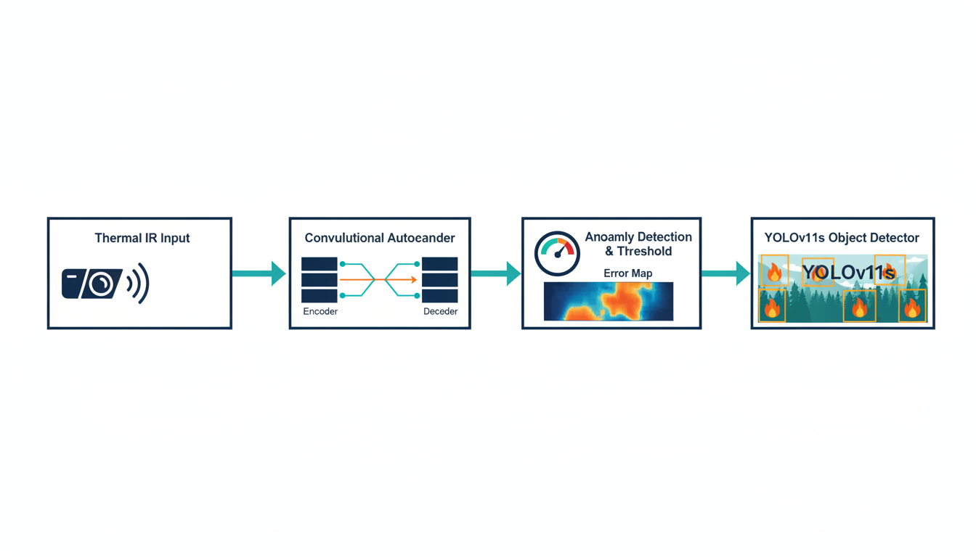
Figure 1: AI-FireGuard System Architecture Pipeline

4.2 Stage 1: Convolutional Autoencoder

4.2.1 Architecture
The autoencoder is a convolutional encoder–decoder network operating on 256×256 three-channel thermal IR images. The encoder progressively compresses the input from 256×256×3 to a 16×16×256 bottleneck representation through four strided convolutional downsampling stages, each followed by a batch-normalized LeakyReLU block. The decoder symmetrically reconstructs the input resolution through four bilinear upsampling stages. The final layer uses a sigmoid activation to constrain the output to the [0,1] pixel range, matching the target reconstruction domain.
Skip connections are deliberately excluded from the architecture. Their inclusion would allow the decoder to bypass the bottleneck by copying encoder features directly, reducing the reconstruction error for anomalous (fire) regions and degrading anomaly detection performance. The tight bottleneck forces the model to compress only what is statistically common across all no-fire training frames.
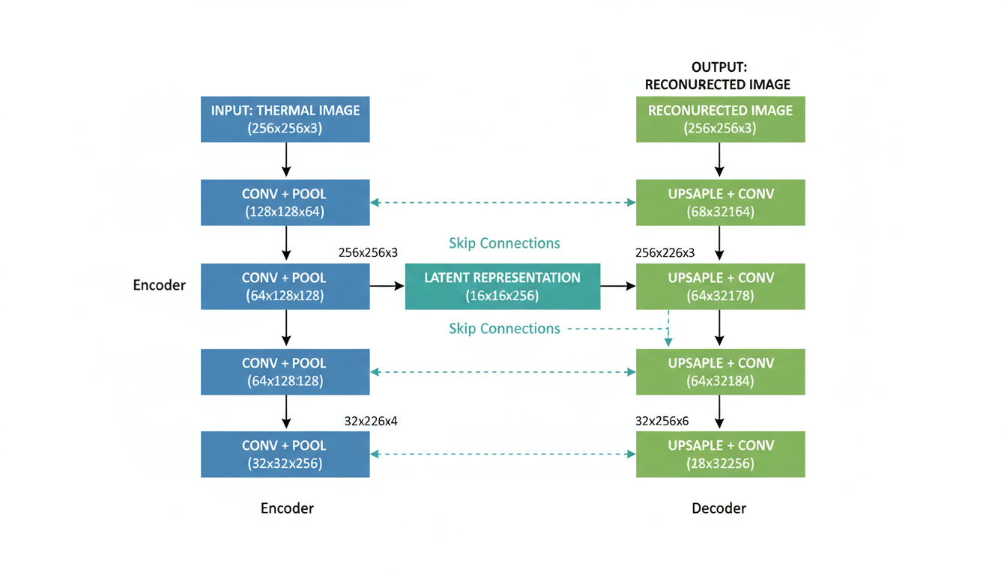
Figure 2: Convolutional Autoencoder Architecture Diagram

4.2.2 Loss Function
The training loss combines Mean Squared Error (MSE) and a Gradient Difference Loss (GDL) term:
L = MSE(recon, target) + 0.1 × GDL(recon, target)
The GDL penalizes differences in spatial image gradients between the reconstruction and target, encouraging the model to recover global structural patterns while avoiding overfitting to fine pixel-level noise.

4.2.3 Training Configuration
Hyperparameter | Value
Image size | 256 × 256
Batch size | 32
Optimizer | AdamW (lr=1e-3, weight_decay=1e-4)
LR Scheduler | ReduceLROnPlateau (patience=3, factor=0.5)
Max epochs | 40
Early stopping patience | 8 (val reconstruction loss)
GPU | Tesla P100-PCIE-16GB (17.1 GB VRAM)
Training frames | 11,645 no-fire IR frames
Validation frames | 2,055 no-fire IR frames
Best epoch | 39
Best val loss | 0.002727

4.2.4 Augmentation
Training images are augmented with random horizontal flips (p=0.5), random vertical flips (p=0.3), mild color jitter (brightness/contrast ±0.15, saturation ±0.05), and Gaussian blur (σ ∈ [0.1, 0.5], kernel size 3). Augmentations are deliberately mild to avoid distorting the thermal signature, which carries the primary detection signal.

4.2.5 Normalization
Per-channel mean and standard deviation statistics are computed from a random sample of 300 no-fire frames and used for input normalization. The computed statistics were: Mean = [0.6246, 0.2713, 0.1923], Std = [0.3811, 0.2996, 0.1741].

4.3 Stage 2: Anomaly Scoring and Threshold Calibration

4.3.1 Per-Frame Anomaly Score
For each input thermal frame, the autoencoder produces a per-pixel reconstruction error map. The frame-level anomaly score is the spatial mean of the error map. Fire frames, whose patterns lie outside the training distribution, yield anomaly scores significantly higher than no-fire frames.

4.3.2 Threshold Calibration (Youden's J)
The optimal decision threshold is identified by computing the ROC curve on a balanced calibration set (500 no-fire + 500 fire frames) and selecting the point that maximizes Youden's J statistic (J = TPR − FPR). The resulting threshold was T = 0.008690.

4.3.3 Calibration Results
Metric | Value
ROC AUC | 0.9845
Average Precision (AP) | 0.9884
F1 at threshold | 0.9605
Precision at threshold | 1.0000
Recall at threshold | 0.9240
No-fire score mean ± std | 0.002236 ± 0.001794
Fire score mean ± std | 0.030010 ± 0.019868
Class separation ratio | 13.42×
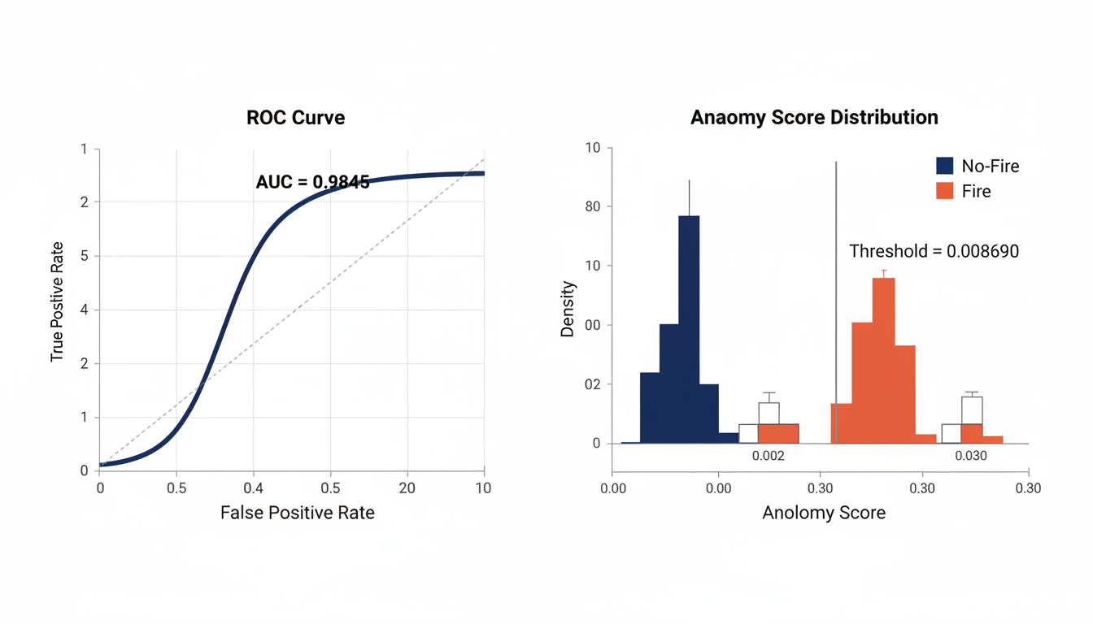
Figure 3: ROC Curve and Anomaly Score Distribution

4.4 Stage 3: Bounding Box Extraction from Error Maps
For each fire-labeled frame, bounding boxes are extracted from the reconstruction error map using the following procedure:
- The error map is thresholded at the 99th, 97th, or 95th percentile (in order of preference, stopping at the first percentile that yields valid boxes).
- A morphological closing operation (7×7 elliptical kernel) is applied to fill gaps in the binary anomaly mask.
- Connected component contours are identified, and a bounding rectangle is computed for each contour.
- Boxes are rejected if their area is below 0.05% of the image area (noise filtering) or if they span more than 70% or less than 3% of the image width or height.
- Valid boxes are converted to YOLO format (normalized center x, center y, width, height).
This procedure produced 150,018 fire bounding boxes in the training split (averaging ~5.4 boxes per fire frame) and 47,218 boxes in the validation split.

4.5 Stage 4: YOLOv11s Object Detector

4.5.1 Model
YOLOv11s is a small-variant single-stage object detector from the Ultralytics YOLO11 family with 9,428,566 parameters and 21.6 GFLOPs. It uses a C3k2 backbone and C2PSA attention module for improved feature extraction. The model is initialized from COCO-pretrained weights and fine-tuned on the FLAME-2 pseudo-labeled dataset.

4.5.2 Training Configuration
Hyperparameter | Value
Image size | 256 × 256
Batch size | 16
Epochs | 100
Optimizer | AdamW (lr=0.001, lrf=0.01, momentum=0.937)
Warmup epochs | 5
Box loss weight | 5.0
Class loss weight | 0.5
DFL loss weight | 1.5
Dropout | 0.1
Early stopping patience | 15
Mosaic augmentation | 0.5
GPU | Tesla P100-PCIE-16GB

Chapter Five: Training and Evaluation Results

5.1 Autoencoder Training Results

5.1.1 Training Convergence
The autoencoder converged smoothly over 40 epochs, with the best model saved at epoch 39 (val loss = 0.002727). The learning rate was reduced from 1e-3 to 5e-4 at epoch 37 by ReduceLROnPlateau, contributing to the final convergence to a low val/train loss ratio.
Epoch Range | Train Loss | Val Loss | Val/Train Ratio
1–10 | 0.0187 → 0.0062 | 0.0114 → 0.0068 | 0.61 → 1.09
11–20 | 0.0060 → 0.0038 | 0.0067 → 0.0051 | 1.12 → 1.32
21–30 | 0.0036 → 0.0028 | 0.0049 → 0.0042 | 1.34 → 1.51
31–40 | 0.0027 → 0.0023 | 0.0039 → 0.0032 | 1.42 → 1.41
Best (Ep. 39) | 0.002285 | 0.002727 | 1.193

5.1.2 Reconstruction Quality
Frame Class | Mean Reconstruction Error | Std Dev
No-fire (validation set) | 0.002123 | 0.000268
Fire (sampled) | 0.042125 | 0.008239
Separation ratio | 19.84× | —
The 19.84× error separation ratio far exceeds the target threshold of 2×, confirming that the autoencoder successfully discriminates fire from no-fire frames using unsupervised reconstruction error alone.

5.2 Anomaly Detection Performance
Metric | Value
ROC AUC | 0.9845
Average Precision (AP) | 0.9884
Optimal Threshold (Youden's J) | 0.008690
F1 Score at Threshold | 0.9605
Precision at Threshold | 1.0000
Recall at Threshold | 0.9240
True Negatives (no-fire correct) | 500
False Positives (no-fire misclassified) | 0
False Negatives (fire missed) | 38
True Positives (fire detected) | 462
The perfect precision (1.0000) at the calibrated threshold means that every frame flagged as fire is a genuine fire frame, eliminating false alarms entirely on the calibration set. The recall of 0.9240 indicates that 7.6% of fire frames are missed — a conservative operating point that prioritizes operational reliability.

5.3 YOLOv11s Detection Results

5.3.1 Final Epoch Performance (Epoch 100)
Class | Precision | Recall | mAP@0.5 | mAP@0.5–0.95
All (fire + smoke) | 0.962 | 0.954 | 0.985 | 0.774
Fire | 0.958 | 0.938 | 0.981 | 0.781
Smoke | 0.966 | 0.970 | 0.988 | 0.767
Training completed in 8.748 hours. The model achieved steady, monotonic improvement across all 100 epochs, with no signs of overfitting (final val/train loss ratio: 1.163).

5.3.2 Training Progression
Epoch | mAP@0.5 | mAP@0.5–0.95 | Precision | Recall
1 | 0.582 | 0.310 | 0.601 | 0.563
10 | 0.953 | 0.609 | 0.920 | 0.899
25 | 0.967 | 0.675 | 0.931 | 0.923
50 | 0.968 | 0.715 | 0.929 | 0.931
75 | 0.983 | 0.756 | 0.959 | 0.949
100 | 0.985 | 0.774 | 0.962 | 0.954
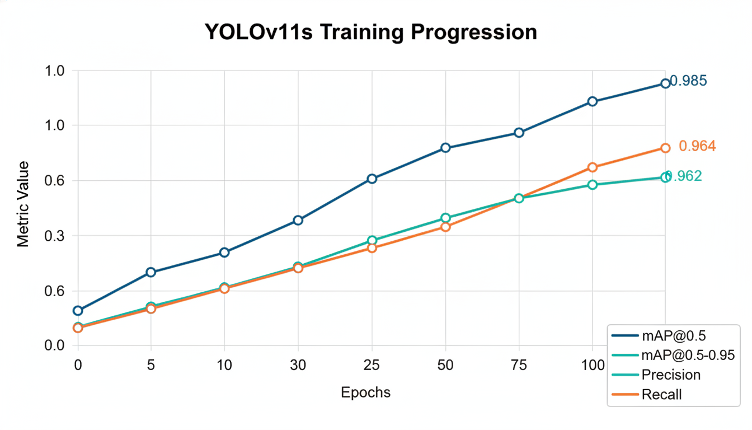
Figure 4: YOLOv11s Training Progression Over 100 Epochs

5.4 Comparison with Reference Studies
Method | Dataset | mAP@0.5 | Precision | Recall | Approach
AI-FireGuard (Ours) | FLAME-2 (IR) | 0.985 | 0.962 | 0.954 | Autoencoder + YOLOv11s
LP-YOLO | D-Fire/FIRESENSE | >0.82 | >0.82 | — | YOLOv8+WTConv+BiFPN
AEFRN | FD/BoWFire | — | 0.991 | 0.998 | Multi-attention classifier
FireVision (ResNet-101) | Custom 12K | 0.646 (Mask) | — | — | Mask R-CNN ensemble
RGBT-3M Study | RGBT-3M | 0.963 | 0.925 | 0.935 | YOLOv11+Cross-Modal Attn.
MCDet (2025) | Multi-dataset | — | 0.775 | — | RGB-T Fusion + MRCF+CGAN

Chapter Six: Challenges and Limitations

6.1 Pseudo-Label Quality
Since bounding boxes are generated from reconstruction error maps rather than human annotations, they are inherently noisy. Error maps may produce fragmented boxes for large fire regions or over-segment a single fire into multiple disjoint boxes. The filtering heuristics (minimum/maximum box fraction, percentile threshold) mitigate the worst cases but do not eliminate all noise. The average of 5.4 boxes per fire frame reflects this over-segmentation tendency, which may introduce label noise during YOLO training.

6.2 Dataset Specificity
FLAME-2 was collected in a single geographic location (open-canopy pine forest in Arizona) during controlled burns in a limited seasonal window. The autoencoder's anomaly threshold and the YOLO model's learned feature representations may not generalize to different vegetation types (e.g., dense tropical forest, chaparral), climatic conditions (high humidity, fog), or fire behavior patterns (e.g., crown fires vs. ground fires).

6.3 IR Temporal Resolution Limitations
The FLAME-2 IR frames are derived from 30 FPS video. While this provides a large number of training samples, consecutive frames are highly correlated, which may cause the autoencoder to overfit to specific scene configurations rather than learning truly generalizable thermal background representations.

6.4 Single-Modality YOLO Training
In the current implementation, the YOLO detector is trained on RGB thermal false-color images from the IR channel only. The RGB channel's information is not directly incorporated into the YOLO stage, limiting the potential benefit of true multi-modal fusion at the detection stage.

6.5 Computational Requirements
Training the full pipeline (autoencoder + YOLO) required approximately 10 hours on a Tesla P100 GPU with 17.1 GB VRAM. While inference is fast (1.0 ms per frame for YOLOv11s), training resources may be a constraint for deployment organizations without access to high-end GPU hardware.

Chapter Seven: Future Recommendations

7.1 True Multi-Modal Fusion
Extending AI-FireGuard to incorporate RGB visual information alongside thermal IR in both the autoencoder and the YOLO detector would be the most impactful near-term improvement. Multi-modal fusion architectures — such as cross-modal attention modules or early/late feature fusion strategies — could leverage the complementary strengths of both sensor modalities to further reduce false positives and improve detection under smoke cover.

7.2 Domain Adaptation and Transfer Learning
Training separate autoencoder instances for different vegetation types or geographic regions, and using domain adaptation techniques to transfer the FLAME-2 trained model to new environments, would significantly expand the system's operational coverage. Techniques such as domain-adversarial training or few-shot fine-tuning with a small number of labeled target-domain examples could be explored.

7.3 Temporal Modeling
Incorporating temporal information — through LSTM-based sequence modeling, 3D convolutional networks, or transformer-based temporal attention — would enable the system to detect fire signatures that evolve over time (e.g., growing hot spots, spreading smoke plumes). This would improve robustness against single-frame false positives and enable fire progression tracking.

7.4 Edge Deployment Optimization
Quantization (INT8/FP16), network pruning, and knowledge distillation techniques could reduce the YOLOv11s model's computational footprint to enable real-time on-board inference on UAV edge processors (e.g., NVIDIA Jetson Nano or Xavier NX) without requiring cloud connectivity.

7.5 Active Learning for Label Refinement
An active learning loop could be implemented in which a human expert reviews a small number of the most uncertain pseudo-labeled frames per training cycle, progressively improving label quality and enabling the system to self-correct annotation errors without requiring full manual relabeling of the dataset.

7.6 Integration with Real-Time Alert Systems
Integration of the detection pipeline with a real-time GIS-based alert system — transmitting georeferenced fire detection events to emergency response command centers via 4G/5G or mesh radio networks — would bring AI-FireGuard from a research prototype to an operational wildfire early warning system.

References
[1] Hopkins, B., O'Neill, L., Afghah, F., Razi, A., Rowell, E., Watts, A., Fule, P., & Coen, J. (2023). FLAME 2: Fire detection and modeLing: Aerial Multi-spectral imagE dataset. IEEE DataPort. https://doi.org/10.21227/qad6-r683
[2] Ravan, Y., Malek, A., Dolph, C.V., & Behari, N. (2026). Real-Time Wildfire Localization on the NASA Autonomous Modular Sensor using Deep Learning. arXiv. https://arxiv.org/abs/2601.14475
[3] AEFRN Study (2025). Optimal features assisted multi-attention fusion for robust fire recognition in adverse conditions. Scientific Reports (Nature), 15, 23923. https://pubmed.ncbi.nlm.nih.gov/40615631/
[4] Spanoudakis, K., et al. (2026). FireVision: An Efficient Fire Detection and Monitoring Platform with Automated Drone Flights and Ensemble Deep Learning Models. Algorithms (MDPI), 19(3), 169. https://doi.org/10.3390/a19030169
[5] Liu, Z., Khajavi, S., & Jiang, G. (2025). DetectiumFire: A Comprehensive Multi-modal Dataset Bridging Vision and Language for Fire Understanding.
[6] LP-YOLO (2026). LP-YOLO: Enhanced Smoke and Fire Detection via Self-Attention and Feature Pyramid Integration. ScienceDirect.
[7] FlameGuard (2025). FlameGuard: An AI-Driven Smart Map for Early Detection and Management of Agricultural Fires in Saudi Arabia. Scientific Reports (Nature).
[8] Multimodal Fusion (2025). High-performance fire detection framework based on feature enhancement and multimodal fusion. Engineering Research Journal.
[9] FFDNet (2025). Research and optimization of a multilevel fire detection framework based on deep learning and classical pattern recognition. Scientific Reports (Nature).
[10] ResCaps-TC-Attn-Fire (2025). Residual capsule network with threshold convolution and attention mechanism for forest fire detection using UAV imagery. Scientific Reports (Nature).
[11] Kularatne, S. D. M. W., et al. (2024). FireManUAV-RGBT: A Novel UAV-Based RGB-Thermal Video Dataset for the Detection of Wildfires in the Finnish Forests. Proc. IEEE ETFA 2024.

Appendix: Key Code Components

A.1 Autoencoder Architecture Summary
The IRAutoencoder class implements a convolutional encoder–decoder with the following layer structure:
Layer Group | Input Size | Output Size | Description
Encoder Block 1 | 256×256×3 | 256×256×32 | ConvBlock (stride=1)
Encoder Block 2 | 256×256×32 | 128×128×64 | ConvBlock (stride=2)
Encoder Block 3 | 128×128×64 | 128×128×64 | ConvBlock (stride=1)
Encoder Block 4 | 128×128×64 | 64×64×128 | ConvBlock (stride=2)
Encoder Block 5 | 64×64×128 | 64×64×128 | ConvBlock (stride=1)
Encoder Block 6 | 64×64×128 | 32×32×256 | ConvBlock (stride=2)
Encoder Block 7 | 32×32×256 | 32×32×256 | ConvBlock (stride=1)
Encoder Block 8 (Bottleneck) | 32×32×256 | 16×16×256 | ConvBlock (stride=2)
Encoder Block 9 | 16×16×256 | 16×16×256 | ConvBlock (stride=1)
Decoder UpBlock 1 | 16×16×256 | 32×32×256 | UpBlock (bilinear ×2)
Decoder ConvBlock 1 | 32×32×256 | 32×32×256 | ConvBlock
Decoder UpBlock 2 | 32×32×256 | 64×64×128 | UpBlock
Decoder ConvBlock 2 | 64×64×128 | 64×64×128 | ConvBlock
Decoder UpBlock 3 | 64×64×128 | 128×128×64 | UpBlock
Decoder ConvBlock 3 | 128×128×64 | 128×128×64 | ConvBlock
Decoder UpBlock 4 | 128×128×64 | 256×256×32 | UpBlock
Decoder ConvBlock 4 | 256×256×32 | 256×256×32 | ConvBlock
Output Conv + Sigmoid | 256×256×32 | 256×256×3 | 1×1 Conv + Sigmoid
Total parameters: 4,106,883. Bottleneck compression: 3.0× (196,608 → 65,536 values).

A.2 Terminology
Term | Definition
UAV | Unmanned Aerial Vehicle — remotely or autonomously piloted aircraft
IR / Thermal IR | Infrared thermal imaging capturing heat emission from objects
RGB | Red-Green-Blue optical camera capturing visible-light images
Autoencoder | Neural network trained to compress and reconstruct input; reconstruction error signals anomalies
mAP@0.5 | Mean Average Precision at IoU threshold 0.5 — standard object detection metric
mAP@0.5–0.95 | Mean AP averaged over IoU thresholds from 0.5 to 0.95 in steps of 0.05
ROC AUC | Area Under the Receiver Operating Characteristic curve; measures binary classifier performance
Youden's J | TPR − FPR; statistic used to select the optimal classification threshold on the ROC curve
IoU | Intersection over Union — ratio of overlap between predicted and ground-truth bounding boxes
YOLO | You Only Look Once — family of real-time single-stage object detectors
Pseudo-labels | Automatically generated annotations used as training targets in the absence of human labels
FLAME-2 | Fire detection and modeLing: Aerial Multi-spectral imagE dataset (IEEE DataPort, 2023)
GDL | Gradient Difference Loss — penalizes spatial gradient differences between reconstructed and target images
FPS | Frames Per Second — a measure of inference throughput
Edge deployment | Running a model directly on the device (UAV) rather than sending data to a remote server

