

Rouibah Hanine

2025-2026
Report on Pneumonia vs. Normal Classification
- Part 1 : Training a CNN Model Directly with Images
  - Data Preparation
Dataset : Images from the two classes (Pneumonia and Normal):
- Training : 3200 images for the Pneumonia class and 708 images for the Normal class
- Validation : 651 images for the Pneumonia and 621 images for the Normal class
Class imbalance issue : The Pneumonia and Normal classes were initially imbalanced.
Data augmentation techniques were applied to artificially generate more examples in both classes to balance them.
Before Data Augmentation (training data only)
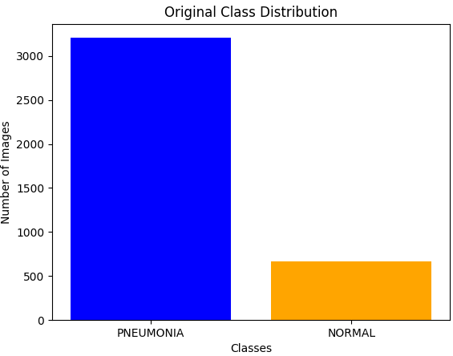
Data Augmentation :
- Rotation ±15°
- Vertical shift 5%
- Horizontal shift 5%
- Zoom 10%
- Horizontal flip
We augmented 20% of the data for the Pneumonia class and 100% for the Normal class.
After Data Augmentation
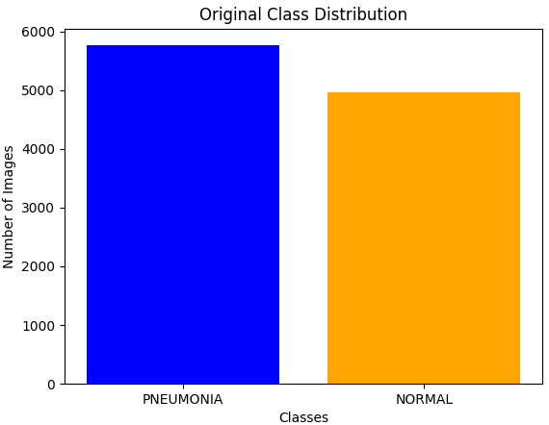
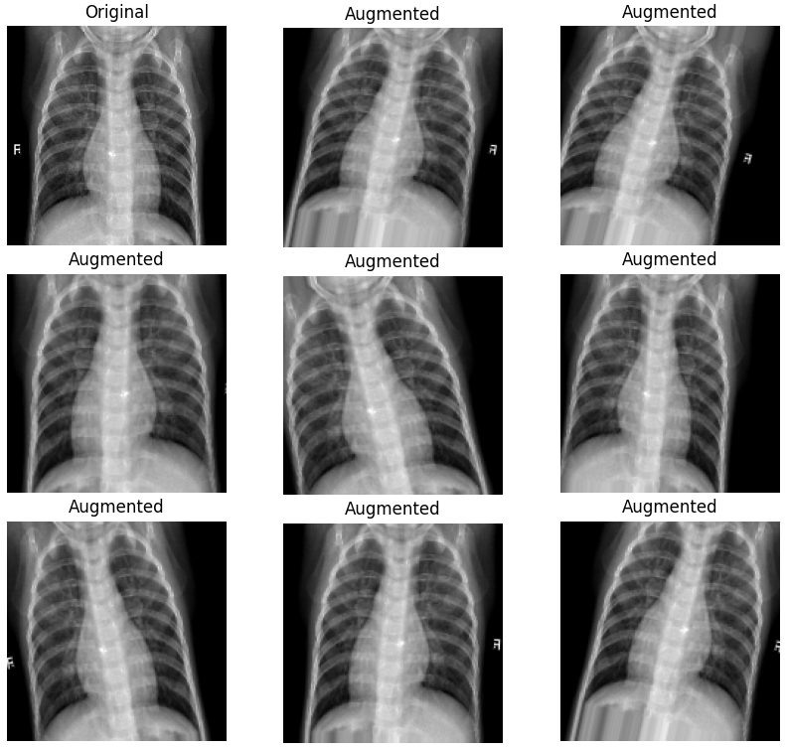
Visualization of augmented data

Image Resizing : All images (original and generated) were resized to 150×150 pixels and saved for future use.
Data Normalization : Pixel values were normalized between [0, 1].
  - CNN Architecture
- Layers :
  - Convolutional Layers (Conv2D) : Apply filters to the input image to extract spatial features such as edges, textures, and patterns.
  - MaxPooling Layers : Reduce the spatial dimensions of the feature maps, retaining the most important information while reducing computational complexity.
  - Batch Normalization : Normalizes activations to stabilize and accelerate training.
  - Dropout : Randomly deactivates a fraction of input units during training to prevent overfitting.
  - Flatten : Converts 2D feature maps into a 1D vector for input into fully connected layers.
  - Fully Connected Dense Layers with Activation Functions : ReLU is used in hidden layers to introduce non-linearity, while Sigmoid is used in the output layer for binary classification.

- Training Parameters :
  - Epochs : 15
  - Optimizer : RMSprop (Root Mean Square Propagation) was used to adjust the network weights, due to its ability to maintain an adaptive and stable learning rate.
  - Learning Rate : 0.001
  - Early Stopping : Monitors validation accuracy and stops training if no improvement is observed after 3 epochs.
  - Reduction of learning rate (ReduceLROnPlateau) : Monitors validation accuracy and reduces the learning rate by a factor of 0.3 if no improvement is seen after 2 epochs.
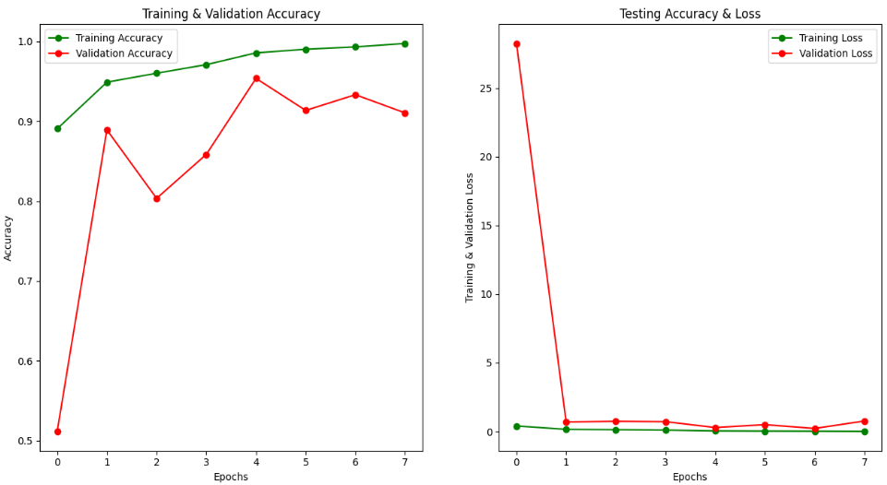
  - Training Results

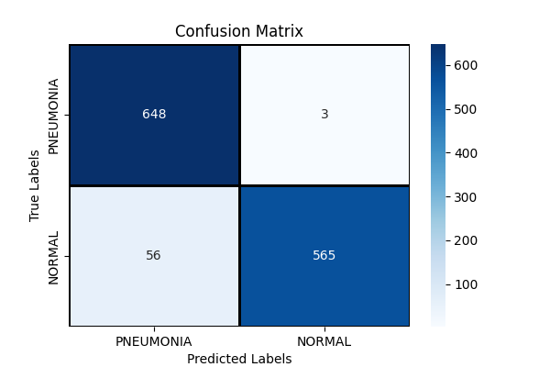
The Confusion Matrix :

Receiver operating characteristic (ROC Curve):
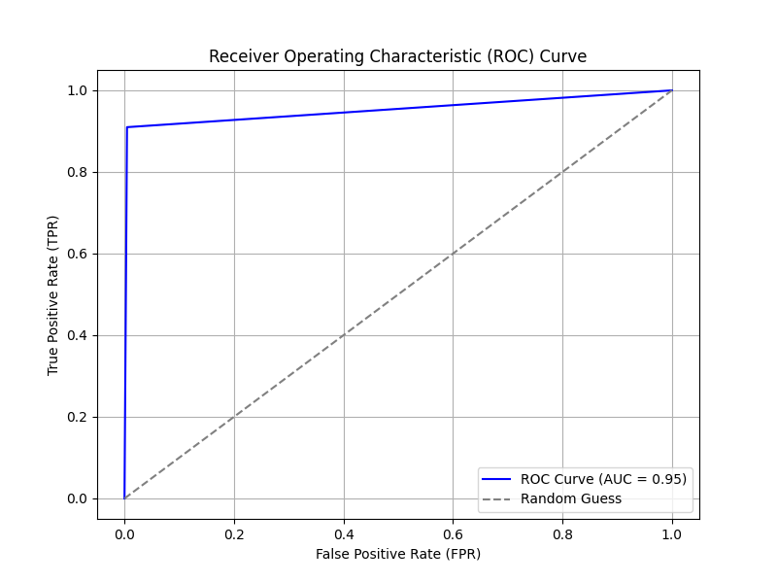
- Accuracy : 95.36 %
- Training Time : 2032.55 seconds

- Part 2 : Training a Machine Learning Model with Feature Extraction
  - Data Preparation
- Dataset : The same images used in training the CNN model were used here and for the next part, to ensure a consistent basis for comparison.
- Extracted Features :
  - Pyramidal Histogram of Oriented Gradients (PHOG) : Encodes spatial and orientation information of gradients, capturing the shape and structure of objects.
  - Gabor Filters : Capture texture features by analyzing frequency and orientation of the image at multiple scales.
  - Discrete Cosine Transform (DCT) : Transforms spatial data into the frequency domain, highlighting low-frequency components often critical for classification.
  - Fourier Transform : Converts spatial information into frequency components, useful for analyzing repetitive patterns or periodic structures.
- Feature Vector
  - Concatenation of the four methods : [PHOG, Gabor, Fourier, DCT]
  - This combination captures complementary features such as texture, frequency, and shape, allowing a comprehensive representation of the images.
- Data Normalization : Feature values were normalized between [0, 1] using the Min-Max method.

  - Model
- Algorithm : SGDClassifier with log_loss loss function (logistic regression).
- Training Parameters :
  - Epochs : 1000
  - Learning Rate : 0.0001 adaptive, which decreases based on model performance.
  - Alpha = 0.0001 : Regularization strength to prevent overfitting.
  - Penalty = 'elasticnet' : Elastic Net regularization combining L1 (lasso) and L2 (ridge) penalties.
  - L1_ratio = 0.5 : 50 % L1 and 50 % L2 to balance the two types of regularization.
  - Shuffle : Shuffles the data at each iteration to improve convergence.
  - Early stopping : Monitors validation accuracy and stops training if no improvement is observed after 20 epochs.

- Why Use SGDClassifier ?
- Performance on large Datasets : SGDClassifier is better suited than LogisticRegression for large datasets, as it uses an incremental approach to adjust weights, making it faster and less memory-intensive.
- Control Over Regularization : SGDClassifier allows direct specification of regularization parameters such as l1 or l2, which is useful for preventing overfitting.
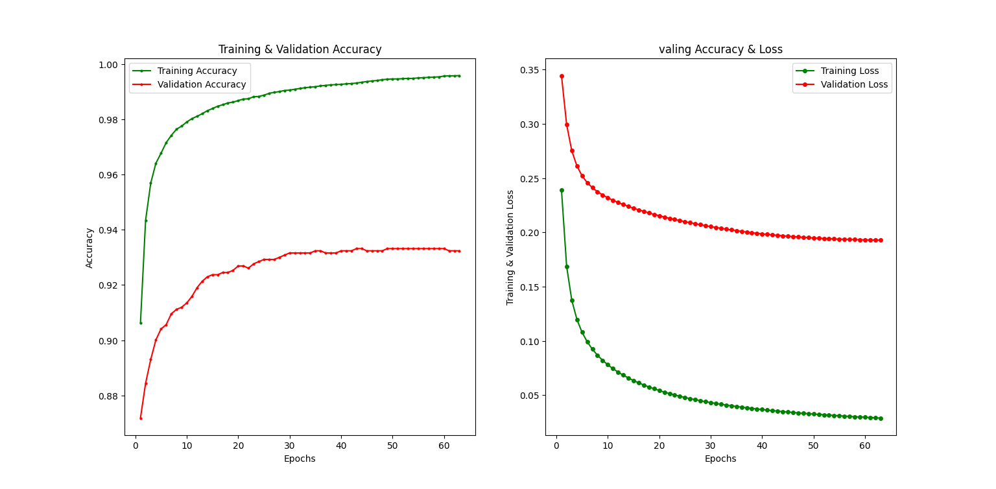
  - Training Results :
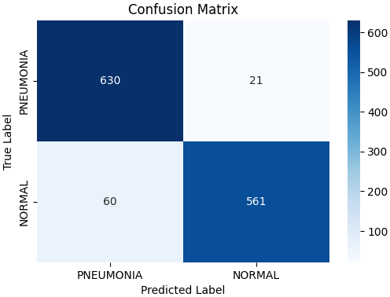
The Confusion Matrix :
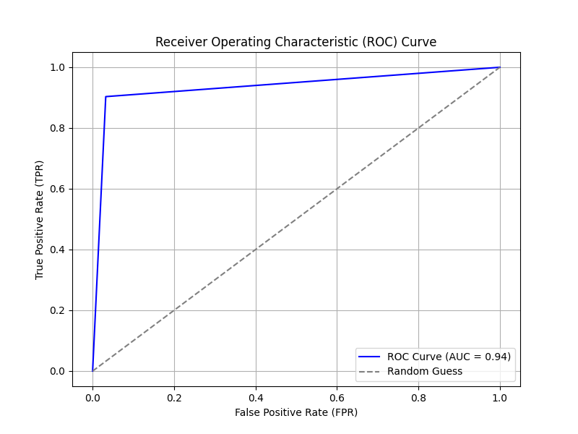
Receiver operating characteristic (ROC Curve):
- Accuracy : 93.63 %
- Training Time : 629.05 seconds

- Part 3 : Sequential Feature Processing for Machine Learning Models
  - Data Preparation
- Feature Extraction Pipeline :
  - Sequence : Gabor → Fourier → DCT → PHOG
    - Reasoning :
      - Gabor Filters : Extract initial texture and orientation features as a base.
      - Fourier Transform : Analyzes periodic structures derived from Gabor features.
      - DCT : Focuses on low-frequency components of the data transformed by Fourier, compressing relevant information.
      - PHOG : Encodes spatial and gradient information from the processed data, providing shape-based features to complete the analysis.
  - Model
- Algorithm : Identical to Part 2 (SGDClassifier with log_loss).
- Model Parameters : The same parameters used in the previous part.
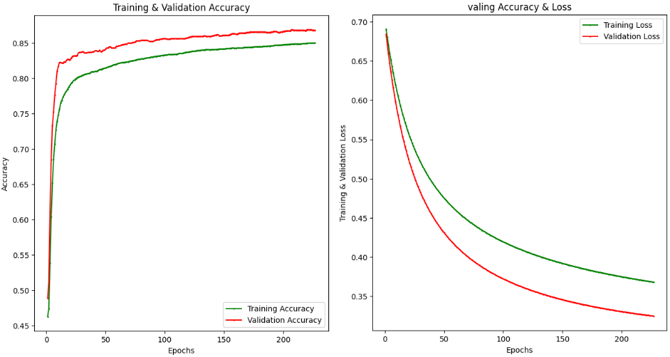
  - Training Results :

The Confusion Matrix :
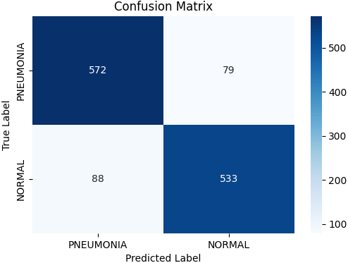
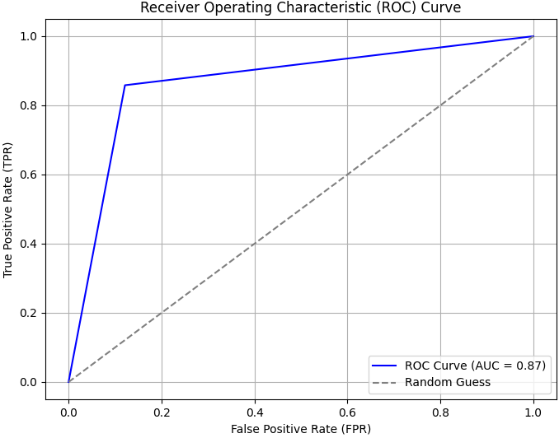
Receiver operating characteristic (ROC Curve):

- Accuracy : 86.87 %
- Training Time : 72.62 seconds

- Comparisons
  - Machine Learning Models
- Concatenation-Based Features
  - Accuarcy : 93.63 %
  - Execution Time : 629.05 seconds
- Sequential Features :
  - Accuracy : 86.87 %
  - Execution Time : 72.62 seconds
Observation : The concatenation-based feature approach outperformed the sequential feature processing in terms of accuracy, at the cost of increased computation time.
  - Machine Learning vs. CNN
- CNN Model
  - Accuracy : 95.36 %
  - Execution Time : 2032.55 seconds
- Best ML Model (Concatenation-Based Features)
  - Accuracy : 93.63 %
  - Execution Time : 629.05 seconds
Observation : The CNN model provided the highest accuracy, demonstrating its superior ability to learn directly from images. However, it required significantly more computation time compared to the machine learning models.

- Presentation of the Prediction Interface
In addition to the developed models, a user interface was implemented to enable real-time prediction.
This interface allows:
- The user to choose the model : CNN or ML.
- Upload an image.
- Directly display the classification result : Sick or Not Sick, accompanied by a confidence percentage.
- Save the analyzed image in dedicated folders, classified according to the prediction result.


- Conclusion
The CNN model is highly effective for binary classification (Pneumonia vs. Normal), achieving the best accuracy (95.36%).
Among the machine learning models, the concatenation-based feature approach (PHOG, Gabor, Fourier, DCT) obtained better results than the sequential approach, with a notable accuracy of 93.63%.
For scenarios where execution time is a critical factor, the sequential feature processing model (86.87% accuracy in 72.62 seconds) can be a viable alternative.

END

