Terraform Flask & Express Deployment Assignment

Overview
This project demonstrates deployment of a Flask backend and Express frontend application on AWS using Terraform in three different architectures:
- Single EC2 Deployment
- Separate EC2 Deployment
- Dockerized Deployment using ECS, ECR, and ALB

Technologies Used
- Terraform
- AWS EC2
- AWS ECS
- AWS ECR
- AWS ALB
- AWS VPC
- Docker
- Flask
- Express.js
- Node.js
- Python

Part 1 — Single EC2 Deployment
Objective
Deploy both frontend and backend applications on a single EC2 instance using Terraform.
Services Used
- AWS EC2
- Security Groups
- Terraform User Data
Steps Performed
- Created EC2 instance using Terraform. 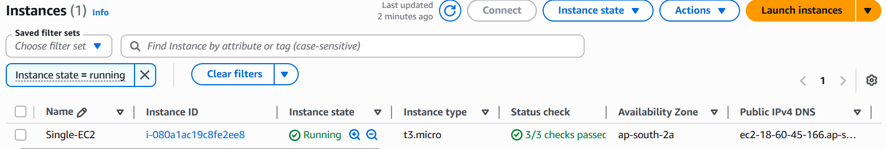
- Configured Security Group.
- Opened ports:
  - 22
  - 3000
  - 5000
- Installed:
  - Python
  - Node.js
  - Git
- Cloned GitHub repository.
- Installed dependencies.
- Started Flask and Express applications using User Data.

Terraform Commands Used
terraform init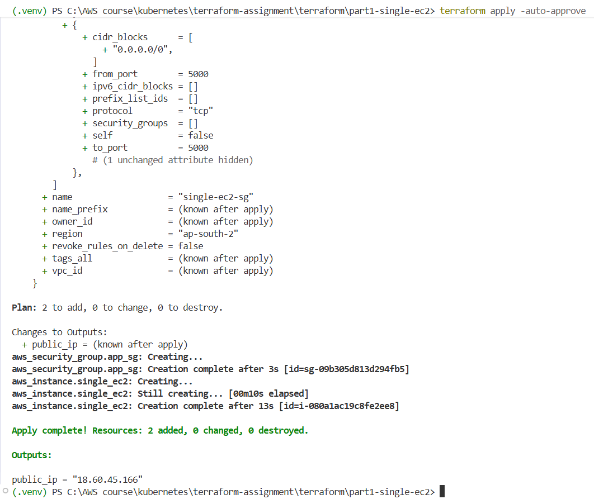

terraform plan
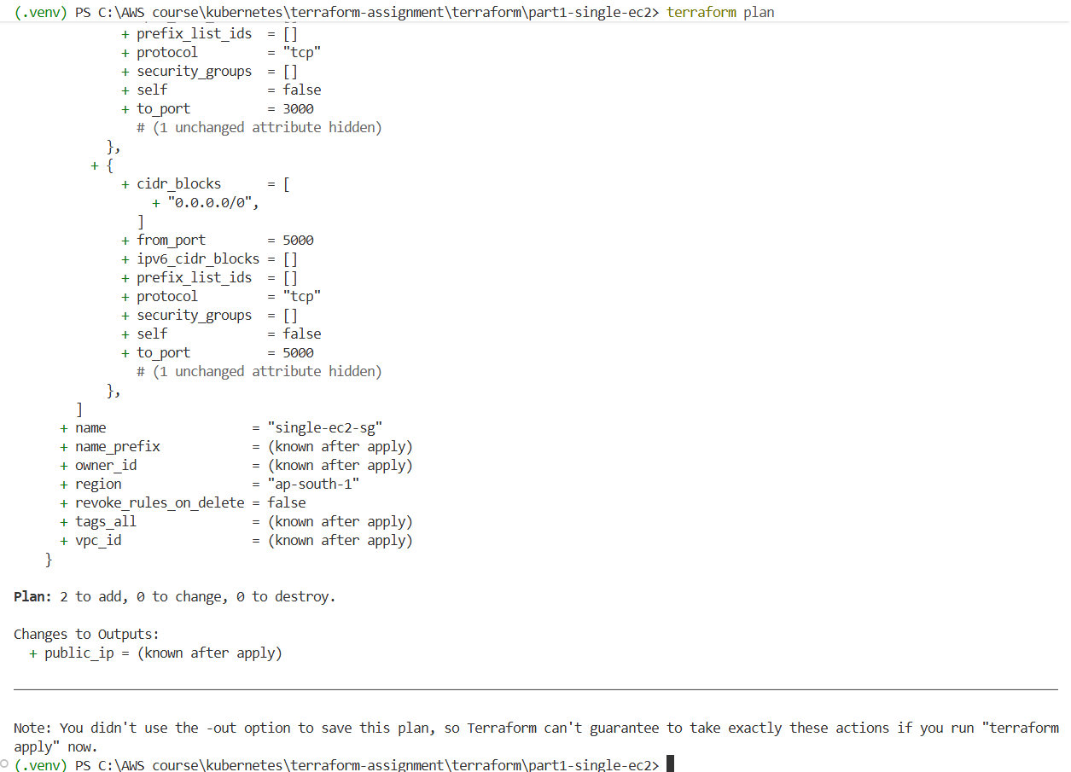
terraform apply
Verification
Frontend:
http:// 40.192.27.109:3000
Backend API was verified through frontend form submission.
Note
The EC2 instance was stopped and restarted after deployment. Therefore, the public IP address changed because an Elastic IP was not attached. Applications were restarted manually using the updated IP address.
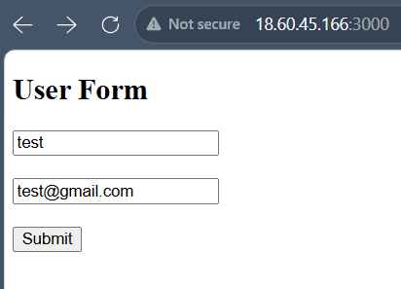
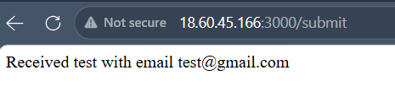

Part 2 — Separate EC2 Deployment
Objective
Deploy frontend and backend on separate EC2 instances using Terraform.
Services Used
- AWS EC2
- AWS VPC
- Security Groups
- Terraform
Steps Performed
- Created:
  - Frontend EC2 instance
  - Backend EC2 instance
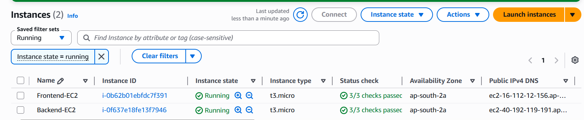

- Configured Security Groups.
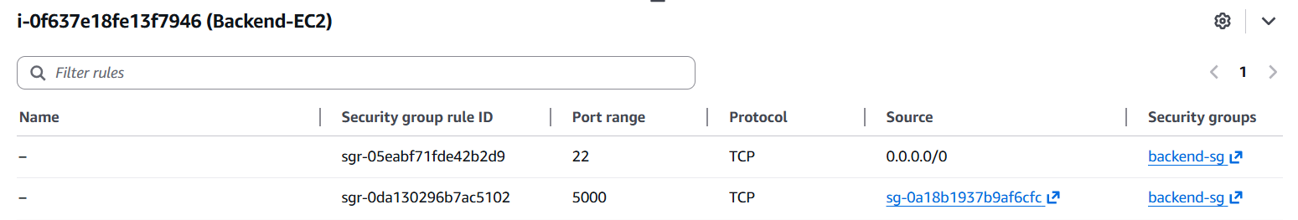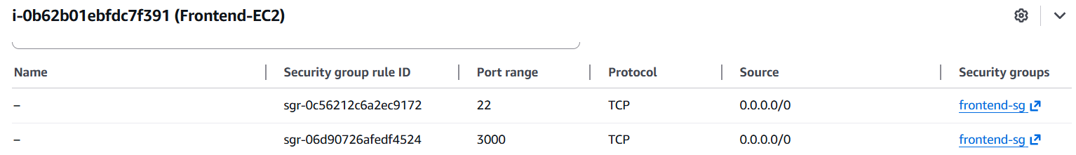
- Allowed communication between frontend and backend.
- Installed required dependencies.
- Started Flask and Express applications using User Data.
Terraform Commands Used
terraform init
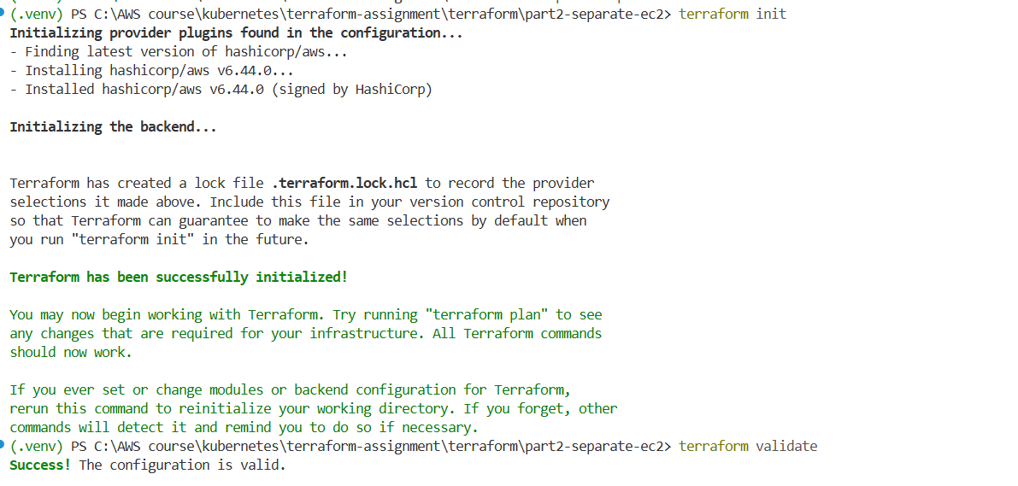

terraform plan
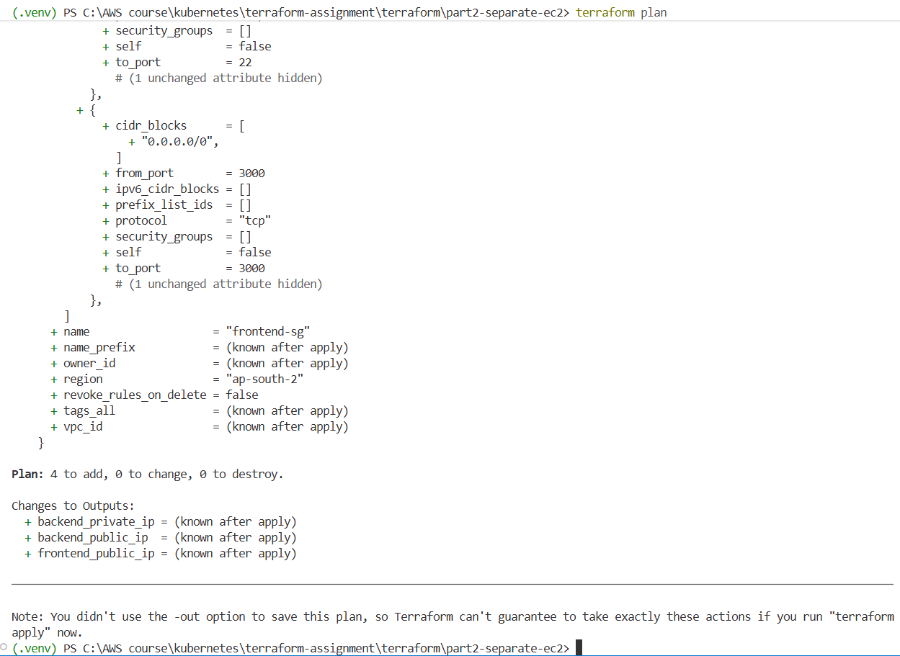
terraform apply
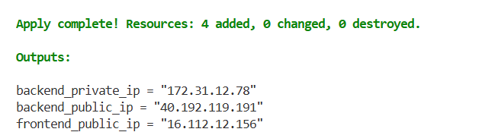

Verification
Frontend:
http:// 16.112.12.156:3000
Backend API was verified through frontend form submission.

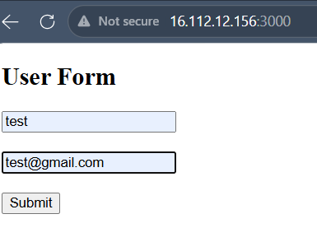
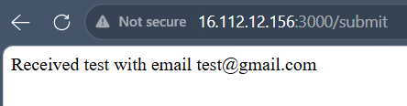

Part 3 — ECS, ECR & Docker Deployment
Objective
Deploy frontend and backend applications as Docker containers using ECS Fargate.
Services Used
- AWS ECS
- AWS ECR
- AWS ALB
- AWS VPC
- Docker
- Terraform

Steps Performed
Step 1 — Dockerized Applications
Created Dockerfiles for:
- frontend
- backend
Built Docker images:
docker build -t hanisha-backend .
docker build -t hanisha-frontend .
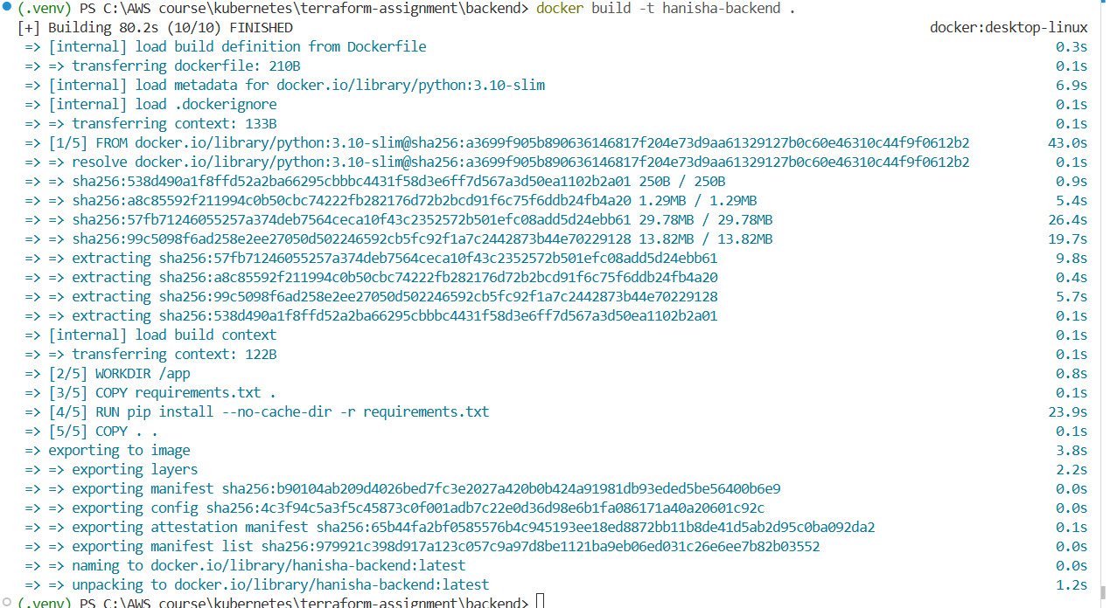
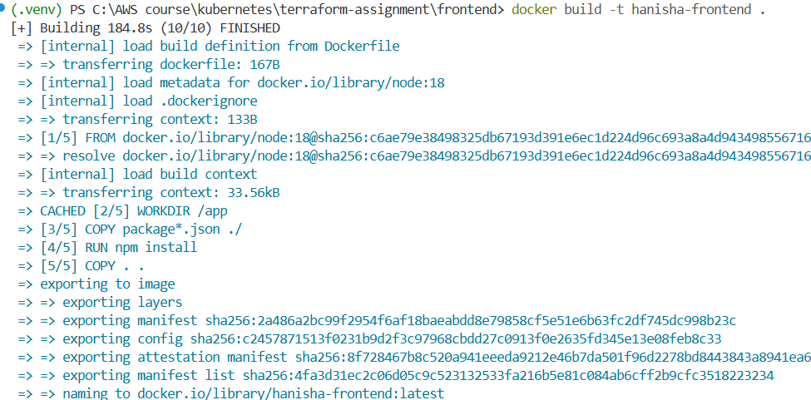

Step 2 — Created ECR Repositories
Created:
- hanisha-backend
- hanisha-frontend
Pushed Docker images to ECR.
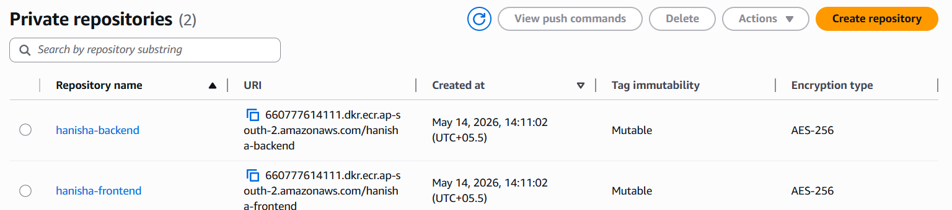
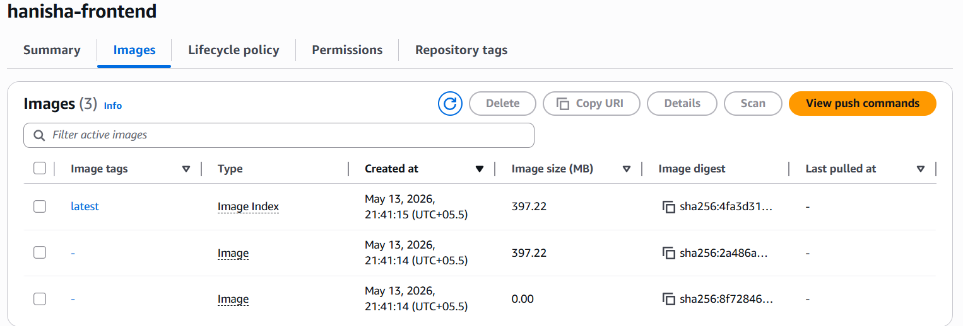
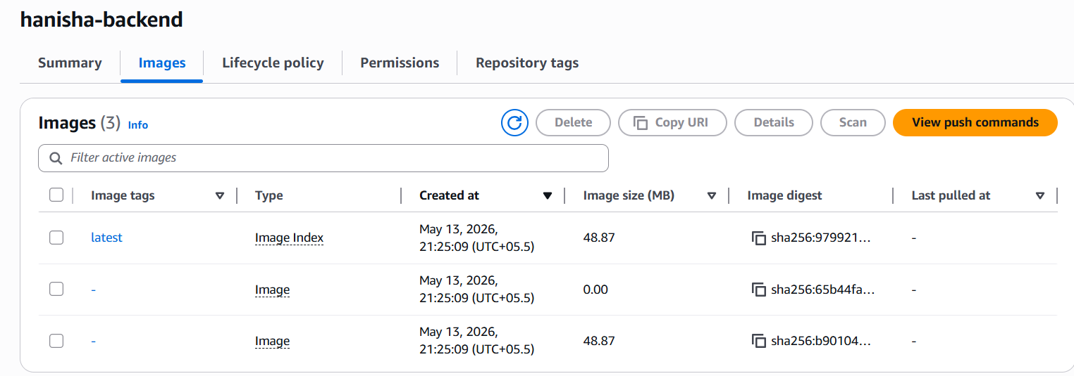

Step 3 — Created Infrastructure Using Terraform
Created:
- VPC
- Subnets
- Internet Gateway
- Route Tables
- Security Groups
- ECS Cluster
- ECS Task Definitions
- ECS Services
- ALB
- Target Groups
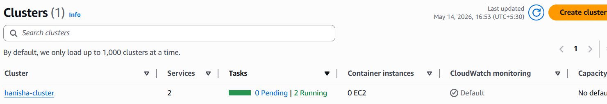
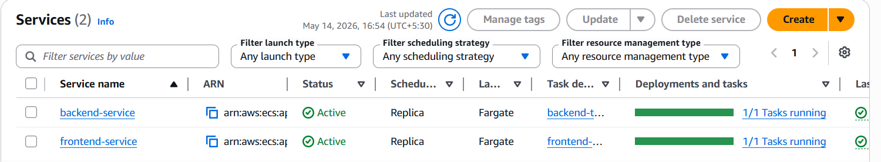
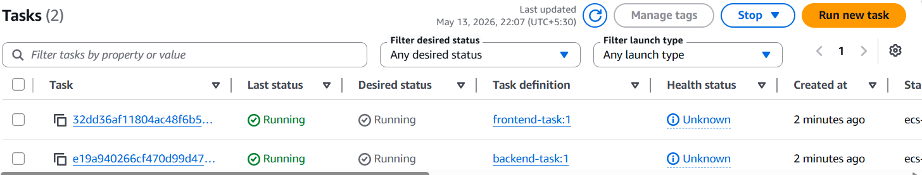
Step 4 — Deployed ECS Services
- Frontend container running on port 3000
- Backend container running on port 5000

Step 5 — Configured ALB
Configured:
- Listener for frontend traffic
- Listener for backend traffic
- Target groups for ECS services
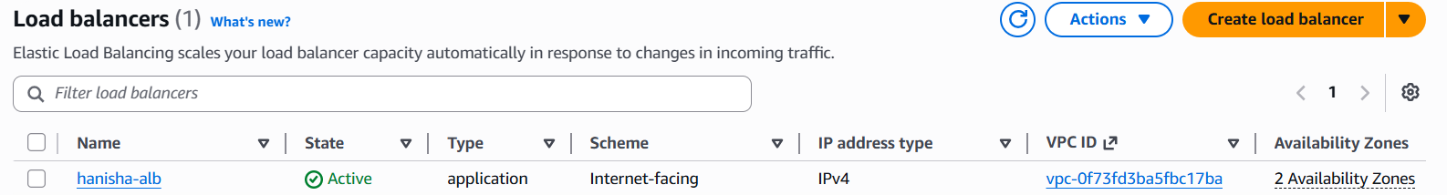

Terraform Commands Used
terraform init
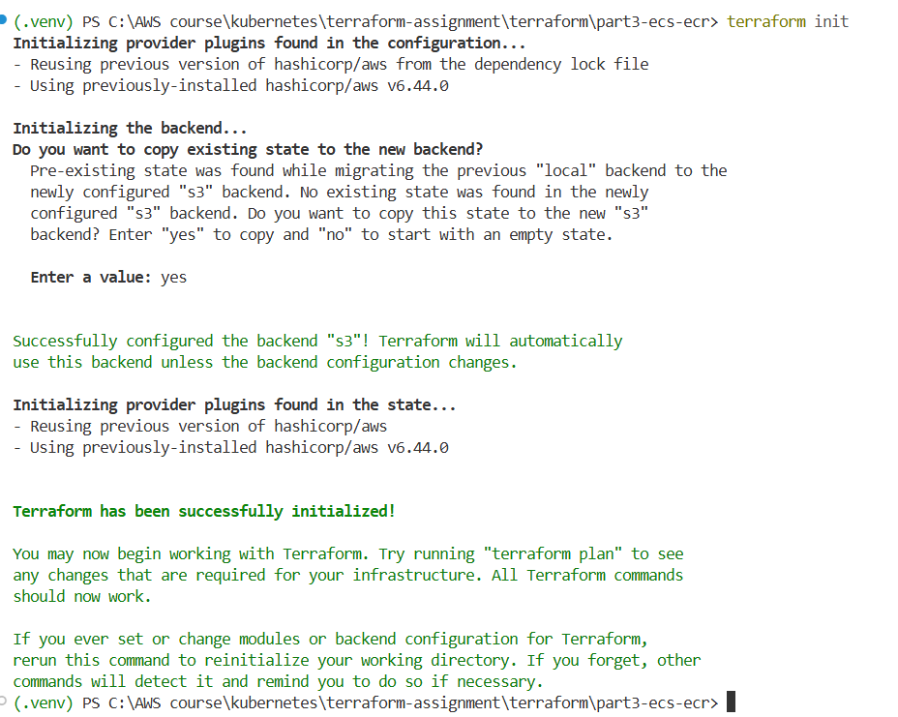
terraform plan
terraform apply
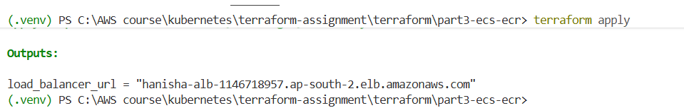

terraform destroy

Verification
Frontend:
http:// MY-ALB-DNS:3000
Backend:
http:// MY-ALB-DNS:5000
The backend / route was added only in Part 3 to support ECS target group health checks.
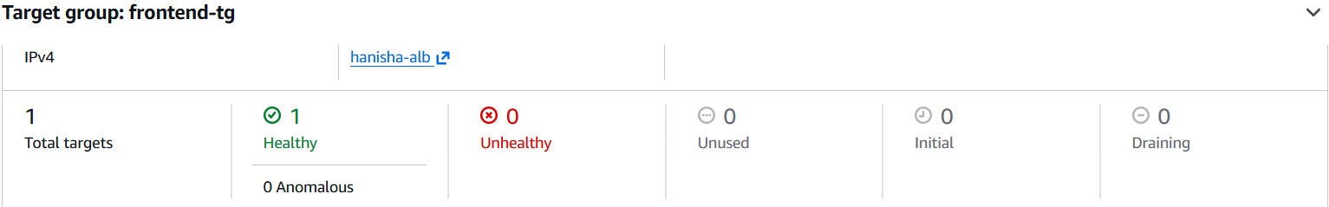
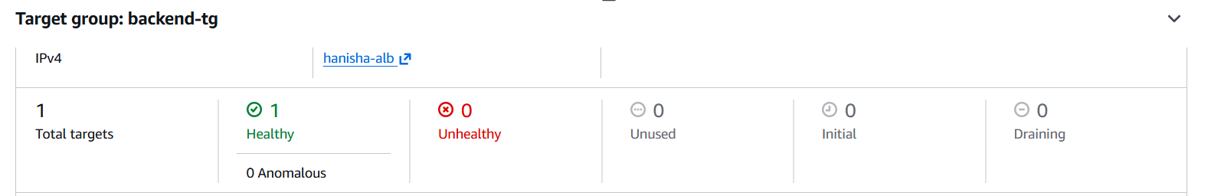
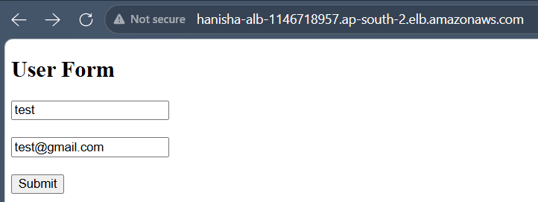
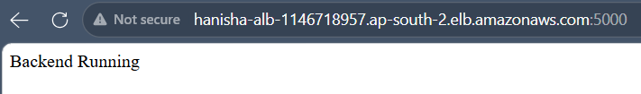
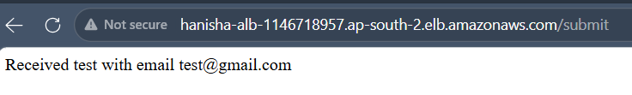
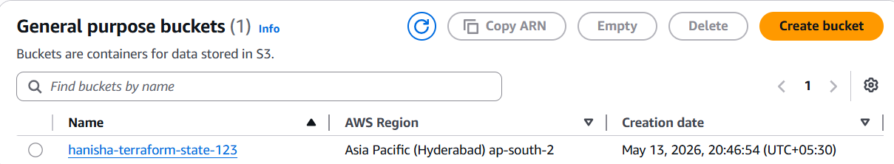

Challenges Faced
- Docker authentication issues with ECR
- ECS target group health check failures
- Frontend-backend communication issues
- Terraform backend state issues
Solutions Implemented
- Configured ECR authentication using AWS CLI
- Added Flask health check route for ECS
- Updated frontend backend URL using ALB DNS
- Forced ECS redeployment after image updates
- Cleaned unused AWS resources to avoid billing
Cleanup
To avoid AWS charges:
terraform destroy
Docker cleanup:
docker system prune -a --volumes
Learning Outcomes
- Terraform Infrastructure as Code
- AWS ECS & ECR deployment
- Docker containerization
- Application Load Balancer configuration
- ECS troubleshooting
- AWS networking basics

