Android Application Development Lab

Name: Hanit Kumar
Roll No. - 25/SCA/MCAN/011

Q1 -> Develop an application that shows names as a list and on selecting a name it should show the details of the candidate on the next screen with a Back button. If the screen is rotated to landscape mode (width greater than height), then the screen should show list on left fragment and details on right fragment instead of second screen with back button. Use Fragment transactions and Rotation event listener.

Ans1 ->

MainActivity.java
package com.example.masterdetail;

import android.content.Intent;
import android.content.res.Configuration;
import android.os.Bundle;
import androidx.appcompat.app.AppCompatActivity;
import androidx.fragment.app.FragmentTransaction;

public class MainActivity extends AppCompatActivity
implements ListFragment.OnNameSelectedListener {

private boolean isLandscape;

@Override
protected void onCreate(Bundle savedInstanceState) {
super.onCreate(savedInstanceState);
setContentView(R.layout.activity_main);

isLandscape = getResources().getConfiguration().orientation
== Configuration.ORIENTATION_LANDSCAPE;

// Load ListFragment if not already added
if (savedInstanceState == null) {
getSupportFragmentManager()
.beginTransaction()
.add(R.id.listContainer, new ListFragment(), "list")
.commit();
}
}

@Override
public void onNameSelected(int index) {
if (isLandscape) {
// Landscape: show DetailFragment on the right panel
DetailFragment detail = DetailFragment.newInstance(index);
FragmentTransaction ft = getSupportFragmentManager().beginTransaction();
ft.replace(R.id.detailContainer, detail, "detail");
ft.addToBackStack(null);
ft.commit();
} else {
// Portrait: launch DetailActivity
Intent intent = new Intent(this, DetailActivity.class);
intent.putExtra("index", index);
startActivity(intent);
}
}
}

DetailActivity.java
package com.example.masterdetail;

import android.os.Bundle;
import androidx.appcompat.app.AppCompatActivity;

public class DetailActivity extends AppCompatActivity {

@Override
protected void onCreate(Bundle savedInstanceState) {
super.onCreate(savedInstanceState);
setContentView(R.layout.activity_detail);

int index = getIntent().getIntExtra("index", 0);

if (savedInstanceState == null) {
DetailFragment fragment = DetailFragment.newInstance(index);
getSupportFragmentManager()
.beginTransaction()
.add(R.id.detailContainer, fragment)
.commit();
}
}
}

ListFragment.java
package com.example.masterdetail;

import android.content.Context;
import android.os.Bundle;
import android.view.*;
import android.widget.*;
import androidx.fragment.app.Fragment;

public class ListFragment extends Fragment {

public interface OnNameSelectedListener {
void onNameSelected(int index);
}

private OnNameSelectedListener listener;

@Override
public void onAttach(Context context) {
super.onAttach(context);
if (context instanceof OnNameSelectedListener)
listener = (OnNameSelectedListener) context;
}

@Override
public View onCreateView(LayoutInflater inflater, ViewGroup container,
Bundle savedInstanceState) {
View view = inflater.inflate(R.layout.fragment_list, container, false);
ListView listView = view.findViewById(R.id.listView);

ArrayAdapter<String> adapter = new ArrayAdapter<>(
getActivity(),
android.R.layout.simple_list_item_1,
Candidates.NAMES
);
listView.setAdapter(adapter);

listView.setOnItemClickListener((parent, v, position, id) -> {
if (listener != null)
listener.onNameSelected(position);
});

return view;
}
}

DetailFragment.java
package com.example.masterdetail;

import android.os.Bundle;
import android.view.*;
import android.widget.TextView;
import androidx.fragment.app.Fragment;

public class DetailFragment extends Fragment {

private static final String ARG_INDEX = "index";

public static DetailFragment newInstance(int index) {
DetailFragment f = new DetailFragment();
Bundle args = new Bundle();
args.putInt(ARG_INDEX, index);
f.setArguments(args);
return f;
}

@Override
public View onCreateView(LayoutInflater inflater, ViewGroup container,
Bundle savedInstanceState) {
View view = inflater.inflate(R.layout.fragment_detail, container, false);
TextView tvDetail = view.findViewById(R.id.tvDetail);

if (getArguments() != null) {
int index = getArguments().getInt(ARG_INDEX, 0);
tvDetail.setText(Candidates.DETAILS[index]);
}
return view;
}
}

Candidates.java
package com.example.masterdetail;

public class Candidates {
public static final String[] NAMES = {
"Alice Johnson", "Bob Smith", "Carol White",
"David Brown", "Eva Green"
};

public static final String[] DETAILS = {
"Alice Johnson\nAge: 28\nRole: Android Developer\nExp: 4 years",
"Bob Smith\nAge: 32\nRole: Backend Engineer\nExp: 7 years",
"Carol White\nAge: 25\nRole: UI/UX Designer\nExp: 2 years",
"David Brown\nAge: 30\nRole: ML Engineer\nExp: 5 years",
"Eva Green\nAge: 27\nRole: DevOps Engineer\nExp: 3 years"
};
}

layout/activity_main.xml
<?xml version="1.0" encoding="utf-8"?>
<FrameLayout xmlns:android="http://schemas.android.com/apk/res/android"
android:id="@+id/listContainer"
android:layout_width="match_parent"
android:layout_height="match_parent" />

land/activity_main.xml
<?xml version="1.0" encoding="utf-8"?>
<LinearLayout xmlns:android="http://schemas.android.com/apk/res/android"
android:orientation="horizontal"
android:layout_width="match_parent"
android:layout_height="match_parent">

<FrameLayout
android:id="@+id/listContainer"
android:layout_width="0dp"
android:layout_height="match_parent"
android:layout_weight="1" />

<FrameLayout
android:id="@+id/detailContainer"
android:layout_width="0dp"
android:layout_height="match_parent"
android:layout_weight="2" />

</LinearLayout>

activity_detail.xml
<?xml version="1.0" encoding="utf-8"?>
<FrameLayout xmlns:android="http://schemas.android.com/apk/res/android"
android:id="@+id/detailContainer"
android:layout_width="match_parent"
android:layout_height="match_parent" />

Fragment_detail.xml
<?xml version="1.0" encoding="utf-8"?>
<LinearLayout xmlns:android="http://schemas.android.com/apk/res/android"
android:orientation="vertical"
android:gravity="center"
android:padding="24dp"
android:layout_width="match_parent"
android:layout_height="match_parent">

<TextView
android:id="@+id/tvDetail"
android:layout_width="wrap_content"
android:layout_height="wrap_content"
android:textSize="18sp"
android:lineSpacingExtra="6dp"
android:text="Select a name from the list" />

</LinearLayout>

Fragment_list.xml
<?xml version="1.0" encoding="utf-8"?>
<LinearLayout xmlns:android="http://schemas.android.com/apk/res/android"
android:orientation="vertical"
android:layout_width="match_parent"
android:layout_height="match_parent">

<ListView
android:id="@+id/listView"
android:layout_width="match_parent"
android:layout_height="match_parent" />

</LinearLayout>

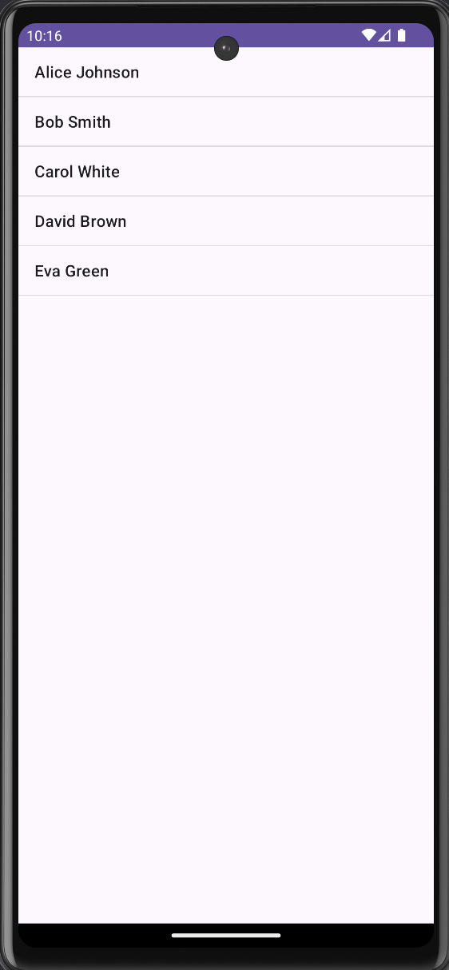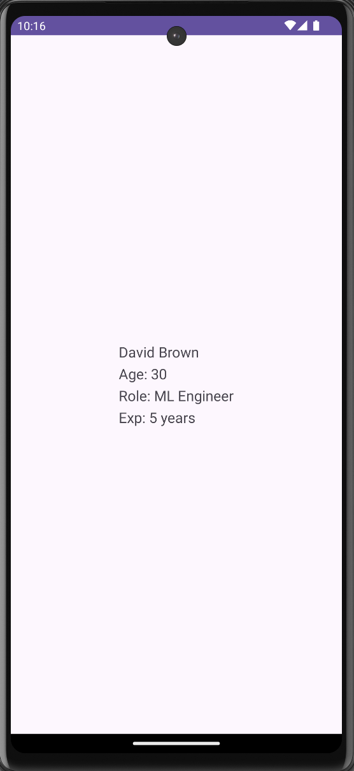

Q2 ->
i. Create a user registration application that stores the user details in a database table.
ii. Create a database and a user table where the details of login names and passwords are stored. Insert some names and passwords initially. Now the login details entered by the user should be verified with the database and an appropriate dialog should be shown to the user.

Ans2 ->

MainActivity.java
package com.example.loginapp;

import android.content.Intent;
import android.os.Bundle;
import android.widget.*;
import androidx.appcompat.app.AlertDialog;
import androidx.appcompat.app.AppCompatActivity;

public class MainActivity extends AppCompatActivity {

EditText etUsername, etPassword;
Button btnLogin, btnGoRegister;
DatabaseHelper db;

@Override
protected void onCreate(Bundle savedInstanceState) {
super.onCreate(savedInstanceState);
setContentView(R.layout.activity_main);

db = new DatabaseHelper(this);

etUsername = findViewById(R.id.etUsername);
etPassword = findViewById(R.id.etPassword);
btnLogin = findViewById(R.id.btnLogin);
btnGoRegister = findViewById(R.id.btnGoRegister);

btnLogin.setOnClickListener(v -> {
String username = etUsername.getText().toString().trim();
String password = etPassword.getText().toString().trim();

if (username.isEmpty() || password.isEmpty()) {
Toast.makeText(this, "Please enter credentials", Toast.LENGTH_SHORT).show();
return;
}

boolean valid = db.checkLogin(username, password);

// Show result as AlertDialog
AlertDialog.Builder builder = new AlertDialog.Builder(this);
if (valid) {
builder.setTitle("Login Successful ✅")
.setMessage("Welcome, " + username + "!")
.setPositiveButton("OK", null);
} else {
builder.setTitle("Login Failed ❌")
.setMessage("Invalid username or password.")
.setPositiveButton("Try Again", null);
}
builder.create().show();
});

btnGoRegister.setOnClickListener(v -> {
startActivity(new Intent(this, RegisterActivity.class));
});
}
}

RegisterActivity.java
package com.example.loginapp;

import android.os.Bundle;
import android.widget.*;
import androidx.appcompat.app.AppCompatActivity;

public class RegisterActivity extends AppCompatActivity {

EditText etUsername, etPassword, etConfirmPassword;
Button btnRegister;
DatabaseHelper db;

@Override
protected void onCreate(Bundle savedInstanceState) {
super.onCreate(savedInstanceState);
setContentView(R.layout.activity_register);

db = new DatabaseHelper(this);

etUsername = findViewById(R.id.etRegUsername);
etPassword = findViewById(R.id.etRegPassword);
etConfirmPassword = findViewById(R.id.etConfirmPassword);
btnRegister = findViewById(R.id.btnRegister);

btnRegister.setOnClickListener(v -> {
String username = etUsername.getText().toString().trim();
String password = etPassword.getText().toString().trim();
String confirm = etConfirmPassword.getText().toString().trim();

if (username.isEmpty() || password.isEmpty()) {
Toast.makeText(this, "Please fill all fields", Toast.LENGTH_SHORT).show();
return;
}
if (!password.equals(confirm)) {
Toast.makeText(this, "Passwords do not match", Toast.LENGTH_SHORT).show();
return;
}

boolean success = db.registerUser(username, password);
if (success) {
Toast.makeText(this, "Registered successfully! Please login.", Toast.LENGTH_SHORT).show();
finish(); // go back to login screen
} else {
Toast.makeText(this, "Username already exists!", Toast.LENGTH_SHORT).show();
}
});
}
}

DatabaseHelper.java
package com.example.loginapp;

import android.content.ContentValues;
import android.content.Context;
import android.database.Cursor;
import android.database.sqlite.SQLiteDatabase;
import android.database.sqlite.SQLiteOpenHelper;

public class DatabaseHelper extends SQLiteOpenHelper {

private static final String DB_NAME = "UserDB";
private static final int DB_VERSION = 1;
private static final String TABLE_USERS = "users";

public DatabaseHelper(Context context) {
super(context, DB_NAME, null, DB_VERSION);
}

@Override
public void onCreate(SQLiteDatabase db) {
String createTable = "CREATE TABLE " + TABLE_USERS + " (" +
"id INTEGER PRIMARY KEY AUTOINCREMENT, " +
"username TEXT UNIQUE, " +
"password TEXT)";
db.execSQL(createTable);

// Insert some initial users
db.execSQL("INSERT INTO " + TABLE_USERS + " (username, password) VALUES ('admin', 'admin123')");
db.execSQL("INSERT INTO " + TABLE_USERS + " (username, password) VALUES ('vansh', 'pass123')");
db.execSQL("INSERT INTO " + TABLE_USERS + " (username, password) VALUES ('test', 'test123')");
}

@Override
public void onUpgrade(SQLiteDatabase db, int oldVersion, int newVersion) {
db.execSQL("DROP TABLE IF EXISTS " + TABLE_USERS);
onCreate(db);
}

// Register a new user
public boolean registerUser(String username, String password) {
SQLiteDatabase db = this.getWritableDatabase();
ContentValues values = new ContentValues();
values.put("username", username);
values.put("password", password);
long result = db.insert(TABLE_USERS, null, values);
return result != -1; // returns false if username already exists
}

// Check login credentials
public boolean checkLogin(String username, String password) {
SQLiteDatabase db = this.getReadableDatabase();
Cursor cursor = db.rawQuery(
"SELECT * FROM " + TABLE_USERS +
" WHERE username=? AND password=?",
new String[]{username, password}
);
boolean exists = cursor.getCount() > 0;
cursor.close();
return exists;
}
}

Activity_main.xml
<?xml version="1.0" encoding="utf-8"?>
<LinearLayout xmlns:android="http://schemas.android.com/apk/res/android"
android:orientation="vertical"
android:gravity="center"
android:padding="32dp"
android:layout_width="match_parent"
android:layout_height="match_parent">

<TextView
android:text="Login"
android:textSize="28sp"
android:textStyle="bold"
android:layout_marginBottom="24dp"
android:layout_width="wrap_content"
android:layout_height="wrap_content"/>

<EditText
android:id="@+id/etUsername"
android:hint="Username"
android:inputType="text"
android:layout_width="match_parent"
android:layout_height="wrap_content"
android:layout_marginBottom="12dp"/>

<EditText
android:id="@+id/etPassword"
android:hint="Password"
android:inputType="textPassword"
android:layout_width="match_parent"
android:layout_height="wrap_content"
android:layout_marginBottom="24dp"/>

<Button
android:id="@+id/btnLogin"
android:text="Login"
android:layout_width="match_parent"
android:layout_height="wrap_content"
android:layout_marginBottom="12dp"/>

<Button
android:id="@+id/btnGoRegister"
android:text="Register New Account"
android:layout_width="match_parent"
android:layout_height="wrap_content"/>

</LinearLayout>

Activity_register.xml
<?xml version="1.0" encoding="utf-8"?>
<LinearLayout xmlns:android="http://schemas.android.com/apk/res/android"
android:orientation="vertical"
android:gravity="center"
android:padding="32dp"
android:layout_width="match_parent"
android:layout_height="match_parent">

<TextView
android:text="Register"
android:textSize="28sp"
android:textStyle="bold"
android:layout_marginBottom="24dp"
android:layout_width="wrap_content"
android:layout_height="wrap_content"/>

<EditText
android:id="@+id/etRegUsername"
android:hint="Choose Username"
android:inputType="text"
android:layout_width="match_parent"
android:layout_height="wrap_content"
android:layout_marginBottom="12dp"/>

<EditText
android:id="@+id/etRegPassword"
android:hint="Choose Password"
android:inputType="textPassword"
android:layout_width="match_parent"
android:layout_height="wrap_content"
android:layout_marginBottom="12dp"/>

<EditText
android:id="@+id/etConfirmPassword"
android:hint="Confirm Password"
android:inputType="textPassword"
android:layout_width="match_parent"
android:layout_height="wrap_content"
android:layout_marginBottom="24dp"/>

<Button
android:id="@+id/btnRegister"
android:text="Register"
android:layout_width="match_parent"
android:layout_height="wrap_content"/>

</LinearLayout>

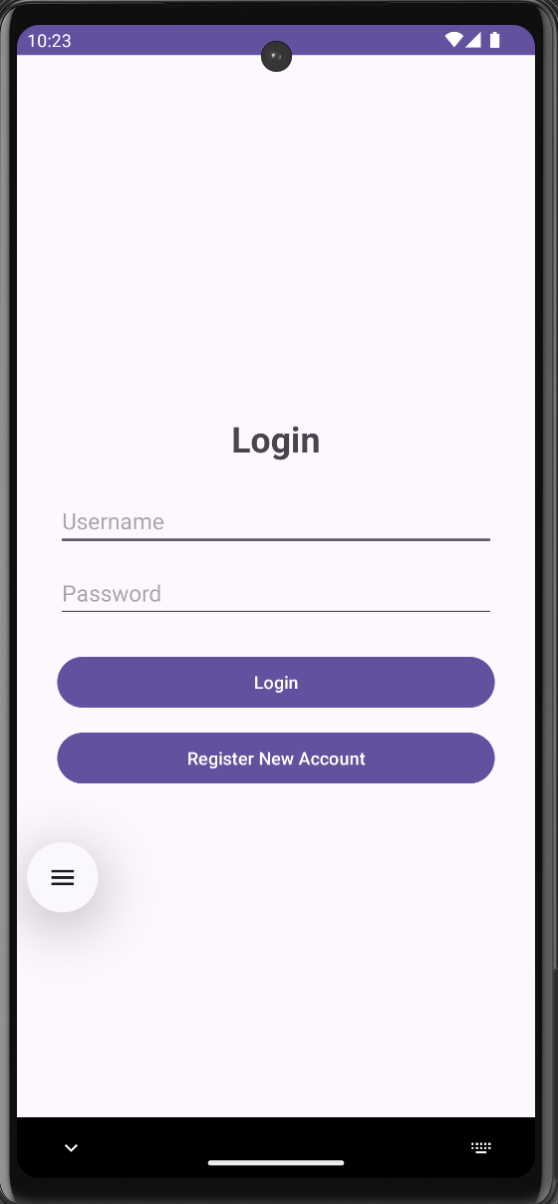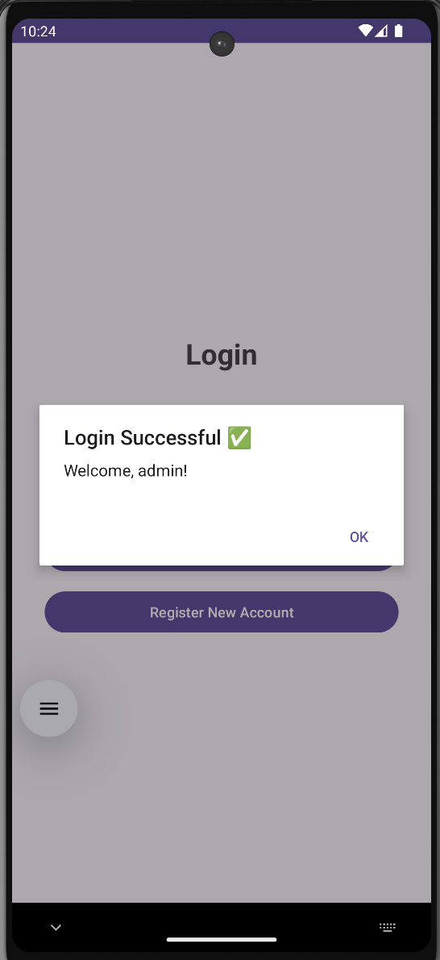

Q3 -> Create an admin application for the user table, which shows all records as a list and the admin can select any record for edit or modify. The results should be reflected in the table.

Ans3 ->

MainActivity.java
package com.example.useradminapp;

import android.app.AlertDialog;
import android.os.Bundle;
import android.view.View;
import android.widget.ArrayAdapter;
import android.widget.EditText;
import android.widget.LinearLayout;
import android.widget.ListView;
import android.widget.Toast;
import androidx.appcompat.app.AppCompatActivity;
import java.util.List;

public class MainActivity extends AppCompatActivity {

DatabaseHelper db;
ArrayAdapter<String> adapter;
List<String> userList;

@Override
protected void onCreate(Bundle savedInstanceState) {
super.onCreate(savedInstanceState);
setContentView(R.layout.activity_main);

db = new DatabaseHelper(this);
ListView listView = findViewById(R.id.listView);

loadUsers(listView);

listView.setOnItemClickListener((parent, view, position, id) -> {
String[] parts = userList.get(position).split(" \\| ");
int userId = Integer.parseInt(parts[0]);

// Build edit dialog
EditText etName = new EditText(this);
EditText etEmail = new EditText(this);
etName.setText(parts[1]);
etEmail.setText(parts[2]);
etName.setHint("Name");
etEmail.setHint("Email");

LinearLayout layout = new LinearLayout(this);
layout.setOrientation(LinearLayout.VERTICAL);
layout.setPadding(40, 20, 40, 10);
layout.addView(etName);
layout.addView(etEmail);

new AlertDialog.Builder(this)
.setTitle("Edit User #" + userId)
.setView(layout)
.setPositiveButton("Save", (dialog, which) -> {
db.updateUser(userId, etName.getText().toString(), etEmail.getText().toString());
Toast.makeText(this, "Updated!", Toast.LENGTH_SHORT).show();
loadUsers(listView); // refresh list
})
.setNegativeButton("Cancel", null)
.show();
});
}

void loadUsers(ListView listView) {
userList = db.getAllUsers();
adapter = new ArrayAdapter<>(this, android.R.layout.simple_list_item_1, userList);
listView.setAdapter(adapter);
}
}

DatabaseHelper.java
package com.example.useradminapp;

import android.content.ContentValues;
import android.content.Context;
import android.database.Cursor;
import android.database.sqlite.SQLiteDatabase;
import android.database.sqlite.SQLiteOpenHelper;
import java.util.ArrayList;
import java.util.List;

public class DatabaseHelper extends SQLiteOpenHelper {

public DatabaseHelper(Context context) {
super(context, "users.db", null, 1);
}

@Override
public void onCreate(SQLiteDatabase db) {
db.execSQL("CREATE TABLE users (id INTEGER PRIMARY KEY AUTOINCREMENT, name TEXT, email TEXT)");
db.execSQL("INSERT INTO users (name, email) VALUES ('Alice', 'alice@example.com')");
db.execSQL("INSERT INTO users (name, email) VALUES ('Bob', 'bob@example.com')");
db.execSQL("INSERT INTO users (name, email) VALUES ('Carol', 'carol@example.com')");
}

@Override
public void onUpgrade(SQLiteDatabase db, int o, int n) {
db.execSQL("DROP TABLE IF EXISTS users");
onCreate(db);
}

public List<String> getAllUsers() {
List<String> list = new ArrayList<>();
Cursor c = getReadableDatabase().rawQuery("SELECT * FROM users", null);
while (c.moveToNext())
list.add(c.getInt(0) + " | " + c.getString(1) + " | " + c.getString(2));
c.close();
return list;
}

public void updateUser(int id, String name, String email) {
ContentValues cv = new ContentValues();
cv.put("name", name);
cv.put("email", email);
getWritableDatabase().update("users", cv, "id=?", new String[]{String.valueOf(id)});
}
}

Activity_main.xml
<?xml version="1.0" encoding="utf-8"?>
<LinearLayout xmlns:android="http://schemas.android.com/apk/res/android"
android:layout_width="match_parent"
android:layout_height="match_parent"
android:orientation="vertical"
android:padding="16dp">

<TextView
android:layout_width="wrap_content"
android:layout_height="wrap_content"
android:text="User Admin Panel"
android:textSize="20sp"
android:textStyle="bold"
android:layout_marginBottom="12dp"/>

<ListView
android:id="@+id/listView"
android:layout_width="match_parent"
android:layout_height="match_parent"/>

</LinearLayout>

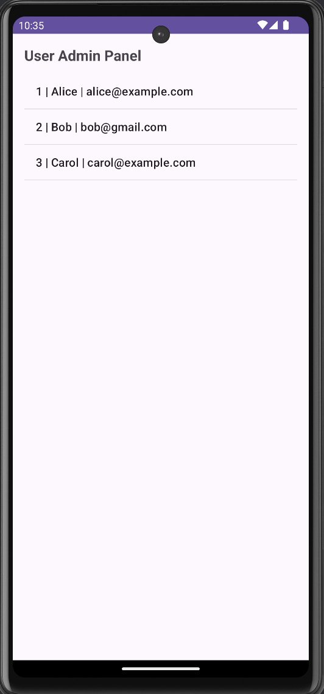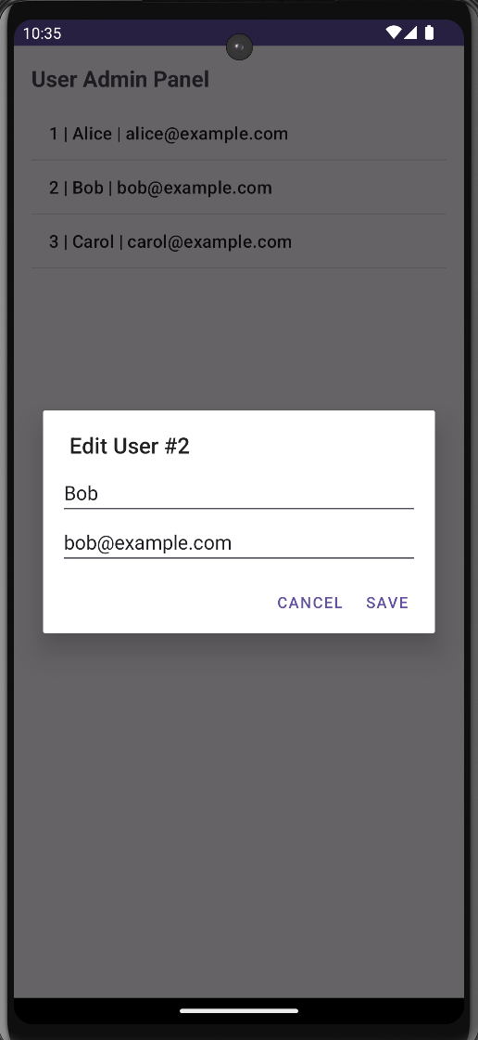

Q4 -> Create an alarm that rings every Sunday at 8:00 AM. Modify it to use a time picker to set alarm time.

Ans4 ->

MainActivity.java
package com.example.alarmapp;

import android.app.AlarmManager;
import android.app.PendingIntent;
import android.app.TimePickerDialog;
import android.content.Context;
import android.content.Intent;
import android.os.Bundle;
import android.widget.*;
import androidx.appcompat.app.AppCompatActivity;
import java.util.Calendar;

public class MainActivity extends AppCompatActivity {

Button btnSetSundayAlarm, btnSetCustomAlarm, btnCancelAlarm;
TextView tvStatus;
AlarmManager alarmManager;
PendingIntent pendingIntent;

@Override
protected void onCreate(Bundle savedInstanceState) {
super.onCreate(savedInstanceState);
setContentView(R.layout.activity_main);

btnSetSundayAlarm = findViewById(R.id.btnSundayAlarm);
btnSetCustomAlarm = findViewById(R.id.btnCustomAlarm);
btnCancelAlarm = findViewById(R.id.btnCancelAlarm);
tvStatus = findViewById(R.id.tvStatus);

alarmManager = (AlarmManager) getSystemService(Context.ALARM_SERVICE);

// Button 1: Set alarm every Sunday at 8:00 AM
btnSetSundayAlarm.setOnClickListener(v -> {
Calendar calendar = Calendar.getInstance();
calendar.set(Calendar.DAY_OF_WEEK, Calendar.SUNDAY);
calendar.set(Calendar.HOUR_OF_DAY, 8);
calendar.set(Calendar.MINUTE, 0);
calendar.set(Calendar.SECOND, 0);

// If this Sunday has passed, move to next Sunday
if (calendar.getTimeInMillis() < System.currentTimeMillis()) {
calendar.add(Calendar.WEEK_OF_YEAR, 1);
}

setAlarm(calendar, true);
tvStatus.setText("✅ Alarm set every Sunday at 8:00 AM");
});

// Button 2: Pick custom time using TimePicker
btnSetCustomAlarm.setOnClickListener(v -> {
Calendar current = Calendar.getInstance();
TimePickerDialog timePicker = new TimePickerDialog(
this,
(view, hourOfDay, minute) -> {
Calendar calendar = Calendar.getInstance();
calendar.set(Calendar.HOUR_OF_DAY, hourOfDay);
calendar.set(Calendar.MINUTE, minute);
calendar.set(Calendar.SECOND, 0);

// If time has already passed today, set for tomorrow
if (calendar.getTimeInMillis() < System.currentTimeMillis()) {
calendar.add(Calendar.DAY_OF_MONTH, 1);
}

setAlarm(calendar, false);
tvStatus.setText("✅ Alarm set for "
+ String.format("%02d:%02d", hourOfDay, minute));
},
current.get(Calendar.HOUR_OF_DAY),
current.get(Calendar.MINUTE),
true // 24-hour format
);
timePicker.show();
});

// Button 3: Cancel alarm
btnCancelAlarm.setOnClickListener(v -> {
Intent intent = new Intent(this, AlarmReceiver.class);
pendingIntent = PendingIntent.getBroadcast(this, 0, intent,
PendingIntent.FLAG_IMMUTABLE);
alarmManager.cancel(pendingIntent);
tvStatus.setText("❌ Alarm cancelled");
});
}

private void setAlarm(Calendar calendar, boolean repeating) {
Intent intent = new Intent(this, AlarmReceiver.class);
pendingIntent = PendingIntent.getBroadcast(this, 0, intent,
PendingIntent.FLAG_IMMUTABLE);

if (repeating) {
// Repeat every week (7 days in milliseconds)
alarmManager.setRepeating(
AlarmManager.RTC_WAKEUP,
calendar.getTimeInMillis(),
AlarmManager.INTERVAL_DAY * 7,
pendingIntent
);
} else {
alarmManager.setExact(
AlarmManager.RTC_WAKEUP,
calendar.getTimeInMillis(),
pendingIntent
);
}
}
}

AlarmReceiver.java
package com.example.alarmapp;

import android.content.BroadcastReceiver;
import android.content.Context;
import android.content.Intent;
import android.media.RingtoneManager;
import android.net.Uri;
import android.media.Ringtone;
import android.widget.Toast;

public class AlarmReceiver extends BroadcastReceiver {

@Override
public void onReceive(Context context, Intent intent) {
// Play default ringtone
Uri alarmUri = RingtoneManager.getDefaultUri(RingtoneManager.TYPE_ALARM);
if (alarmUri == null)
alarmUri = RingtoneManager.getDefaultUri(RingtoneManager.TYPE_NOTIFICATION);

Ringtone ringtone = RingtoneManager.getRingtone(context, alarmUri);
ringtone.play();

Toast.makeText(context, "⏰ Alarm Ringing!", Toast.LENGTH_LONG).show();
}
}

Activity_main.xml
<?xml version="1.0" encoding="utf-8"?>
<LinearLayout xmlns:android="http://schemas.android.com/apk/res/android"
android:orientation="vertical"
android:gravity="center"
android:padding="32dp"
android:layout_width="match_parent"
android:layout_height="match_parent">

<TextView
android:text="⏰ Alarm App"
android:textSize="28sp"
android:textStyle="bold"
android:layout_marginBottom="40dp"
android:layout_width="wrap_content"
android:layout_height="wrap_content"/>

<Button
android:id="@+id/btnSundayAlarm"
android:text="Set Sunday 8:00 AM Alarm"
android:layout_width="match_parent"
android:layout_height="wrap_content"
android:layout_marginBottom="16dp"/>

<Button
android:id="@+id/btnCustomAlarm"
android:text="Pick Custom Time"
android:layout_width="match_parent"
android:layout_height="wrap_content"
android:layout_marginBottom="16dp"/>

<Button
android:id="@+id/btnCancelAlarm"
android:text="Cancel Alarm"
android:backgroundTint="#F44336"
android:layout_width="match_parent"
android:layout_height="wrap_content"
android:layout_marginBottom="32dp"/>

<TextView
android:id="@+id/tvStatus"
android:text="No alarm set"
android:textSize="16sp"
android:gravity="center"
android:layout_width="wrap_content"
android:layout_height="wrap_content"/>

</LinearLayout>

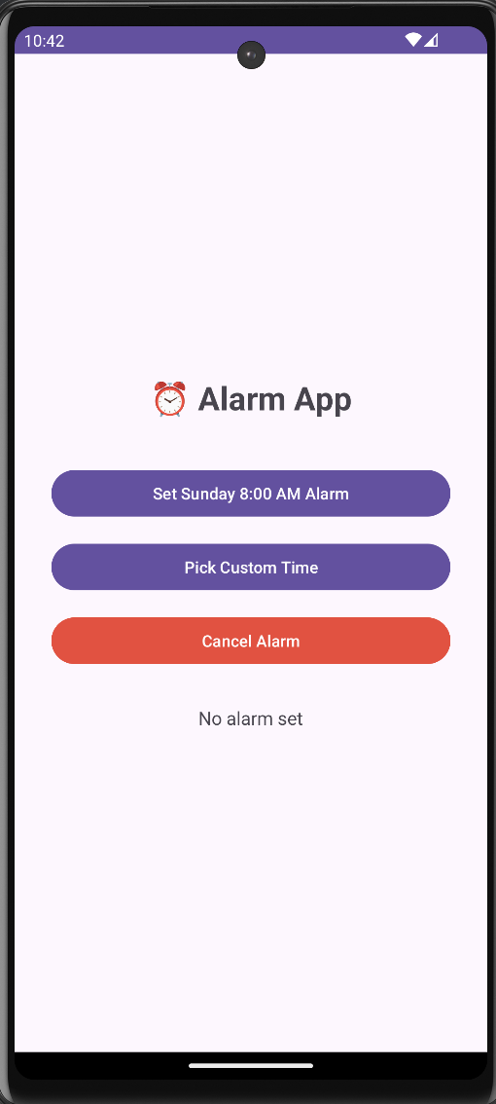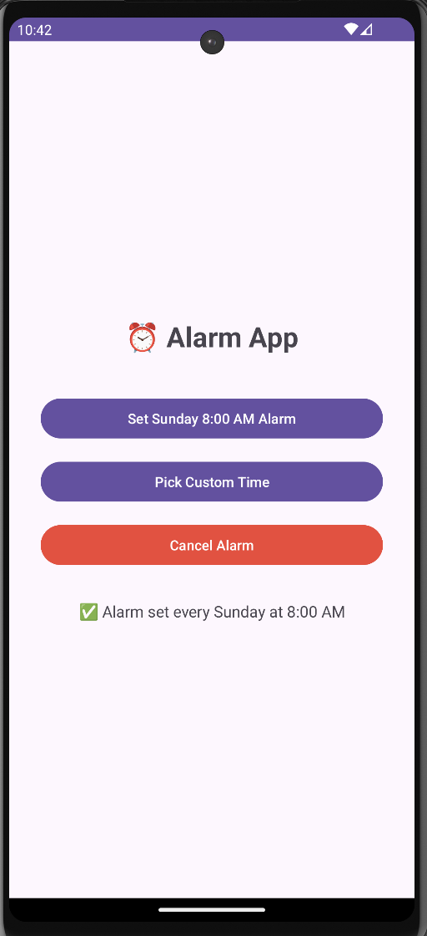

Q5 -> Create an activity that uses a menu with 3 options for dialing a number, opening a website and to send an SMS.

Ans5 ->

MainActivity.java
package com.example.menuapp;

import android.content.Intent;
import android.net.Uri;
import android.os.Bundle;
import android.view.Menu;
import android.view.MenuItem;
import android.widget.Toast;
import androidx.appcompat.app.AppCompatActivity;

public class MainActivity extends AppCompatActivity {

@Override
protected void onCreate(Bundle savedInstanceState) {
super.onCreate(savedInstanceState);
setContentView(R.layout.activity_main);
}

// Inflate the menu
@Override
public boolean onCreateOptionsMenu(Menu menu) {
menu.add(0, 1, 0, "📞 Dial a Number");
menu.add(0, 2, 0, "🌐 Open Website");
menu.add(0, 3, 0, "💬 Send SMS");
return true;
}

// Handle menu item clicks
@Override
public boolean onOptionsItemSelected(MenuItem item) {
switch (item.getItemId()) {

case 1: // Dial a number
Intent dialIntent = new Intent(Intent.ACTION_DIAL);
dialIntent.setData(Uri.parse("tel:+911234567890"));
startActivity(dialIntent);
return true;

case 2: // Open a website
Intent webIntent = new Intent(Intent.ACTION_VIEW);
webIntent.setData(Uri.parse("https://www.google.com"));
startActivity(webIntent);
return true;

case 3: // Send SMS
Intent smsIntent = new Intent(Intent.ACTION_SENDTO);
smsIntent.setData(Uri.parse("smsto:+911234567890"));
smsIntent.putExtra("sms_body", "Hello from the Menu App!");
startActivity(smsIntent);
return true;

default:
return super.onOptionsItemSelected(item);
}
}
}

Activity_main.xml
<?xml version="1.0" encoding="utf-8"?>
<LinearLayout xmlns:android="http://schemas.android.com/apk/res/android"
android:orientation="vertical"
android:gravity="center"
android:padding="32dp"
android:layout_width="match_parent"
android:layout_height="match_parent">

<TextView
android:text="Tap the ⋮ menu (top right)"
android:textSize="20sp"
android:gravity="center"
android:layout_width="wrap_content"
android:layout_height="wrap_content"/>

</LinearLayout>

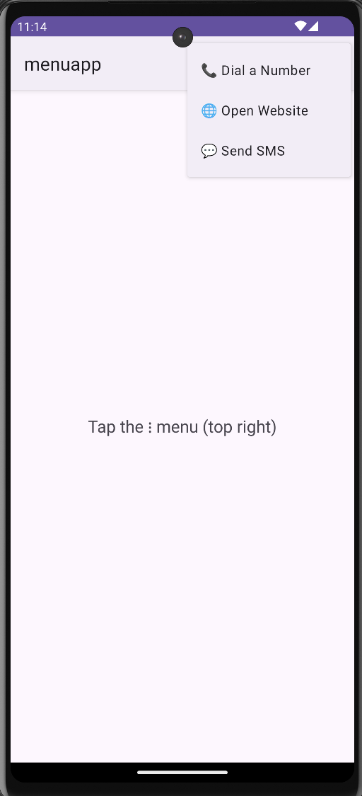

Q6 -> Basic Music Player App

Ans6 ->

MainActivity.java
package com.example.musicplayer;

import android.media.MediaPlayer;
import android.os.Bundle;
import android.view.View;
import android.widget.Button;
import androidx.appcompat.app.AppCompatActivity;

public class MainActivity extends AppCompatActivity {

MediaPlayer mediaPlayer;

@Override
protected void onCreate(Bundle savedInstanceState) {
super.onCreate(savedInstanceState);
setContentView(R.layout.activity_main);

mediaPlayer = MediaPlayer.create(this, R.raw.music_file);

Button btnPlay = findViewById(R.id.btnPlay);
Button btnPause = findViewById(R.id.btnPause);

btnPlay.setOnClickListener(new View.OnClickListener() {
@Override
public void onClick(View v) {
mediaPlayer.start();
}
});

btnPause.setOnClickListener(new View.OnClickListener() {
@Override
public void onClick(View v) {
mediaPlayer.pause();
}
});
}

@Override
protected void onStop() {
super.onStop();
if (mediaPlayer != null) {
mediaPlayer.release();
mediaPlayer = null;
}
}
}

Activity_main.xml

<?xml version="1.0" encoding="utf-8"?>
<LinearLayout xmlns:android="http://schemas.android.com/apk/res/android"
android:layout_width="match_parent"
android:layout_height="match_parent"
android:orientation="vertical"
android:gravity="center"
android:padding="20dp">

<TextView
android:layout_width="wrap_content"
android:layout_height="wrap_content"
android:text="Music Player"
android:textSize="24sp"
android:layout_marginBottom="30dp"/>

<Button
android:id="@+id/btnPlay"
android:layout_width="200dp"
android:layout_height="wrap_content"
android:text="Play" />

<Button
android:id="@+id/btnPause"
android:layout_width="200dp"
android:layout_height="wrap_content"
android:text="Pause"
android:layout_marginTop="10dp"/>

</LinearLayout>

