Haniya Ubaid

SP24-BSE-038

Lab assignment 3

Code

package com.example.demo3;  
  
import javafx.application.Application;  
import javafx.geometry.Insets;  
import javafx.scene.Scene;  
import javafx.scene.control.\*;  
import javafx.scene.layout.HBox;  
import javafx.scene.layout.VBox;  
import javafx.stage.Stage;  
import java.io.BufferedWriter;  
import java.io.FileWriter;  
import java.io.IOException;  
  
public class HelloApplication extends Application {  
  
 @Override  
 public void start(Stage stage) {  
 VBox layout = new VBox(15);  
 layout.setPadding(new Insets(20));  
  
 Label nameLabel = new Label("FullName:");  
 TextField fullNameField = new TextField();  
 HBox nameBox = new HBox(10, nameLabel, fullNameField);  
  
 Label idLabel = new Label("ID:");  
 TextField idField = new TextField();  
 HBox idBox = new HBox(10, idLabel, idField);  
  
 Label genderLabel = new Label("Gender:");  
 RadioButton maleRadio = new RadioButton("Male");  
 RadioButton femaleRadio = new RadioButton("Female");  
 ToggleGroup genderGroup = new ToggleGroup();  
 maleRadio.setToggleGroup(genderGroup);  
 femaleRadio.setToggleGroup(genderGroup);  
 HBox genderBox = new HBox(10, genderLabel, maleRadio, femaleRadio);  
  
 Label provinceLabel = new Label("HomeProvince:");  
 TextField provinceField = new TextField();  
 HBox provinceBox = new HBox(10, provinceLabel, provinceField);  
  
 Label dobLabel = new Label("DOB:");  
 DatePicker dobPicker = new DatePicker();  
 HBox dobBox = new HBox(10, dobLabel, dobPicker);  
  
 Button newButton = new Button("New");  
 Button deleteButton = new Button("Delete");  
 Button restoreButton = new Button("Restore");  
 Button criteriaButton = new Button("Criteria");  
 Button closeButton = new Button("Close");  
 Button findButton = new Button("Find Next");  
  
 closeButton.setOnAction(event -> stage.close());  
  
  
 restoreButton.setOnAction(event -> {  
 fullNameField.clear();  
 idField.clear();  
 genderGroup.selectToggle(null);  
 provinceField.clear();  
 dobPicker.setValue(null);  
  
  
  
  
 });  
 newButton.setOnAction(event -> {  
 String fullName = fullNameField.getText();  
 String homeProvince = provinceField.getText();  
 String id = idField.getText();  
 String gender = genderGroup.getSelectedToggle() != null ?  
 ((RadioButton) genderGroup.getSelectedToggle()).getText() : "";  
 String dob = dobPicker.getValue() != null ? dobPicker.getValue().toString() : "";  
  
 if (!fullName.isEmpty() && !id.isEmpty() && !gender.isEmpty() && !homeProvince.isEmpty() && !dob.isEmpty()) {  
 String record = fullName + "-" + id + "-" + gender + "-" + homeProvince + "-" + dob;  
  
 *AddToFile*(record);  
  
  
 }});  
  
 VBox buttonLayout = new VBox(10, newButton, findButton, closeButton, criteriaButton, deleteButton, restoreButton);  
 VBox leftLayout = new VBox(10, nameBox, idBox, genderBox, provinceBox, dobBox);  
 HBox mainLayout = new HBox(20, leftLayout, buttonLayout);  
  
 Scene scene = new Scene(mainLayout, 500, 300);  
 stage.setTitle("Data Entry Form");  
 stage.setScene(scene);  
 stage.show();  
 }  
  
 public static void AddToFile(String record) {  
 try (BufferedWriter writer = new BufferedWriter(new FileWriter("target/info.txt", true))) {  
 writer.write(record);  
 writer.newLine();  
 } catch (IOException e) {  
 System.*out*.println(e.getMessage());  
 }  
 }

Output: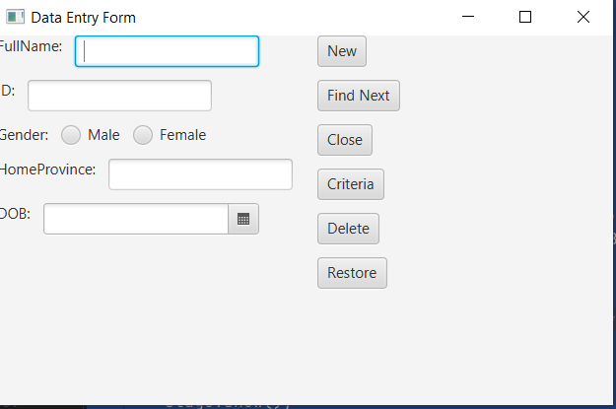

StorageFile:

Hassan-334r-Male-punjab-2024-11-13  
Haniya-223e-Female-punjab-2024-11-13  
lisa-4455-Female-punjab-2024-11-13  
Haniya-2233-Female-punjab-2024-11-20