💚 Front page

ØkoJitsu 4Lyfe

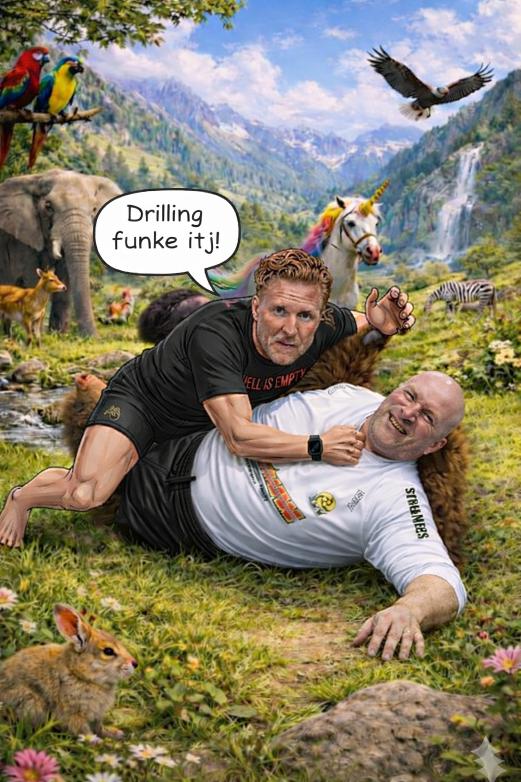

💊 Before we begin

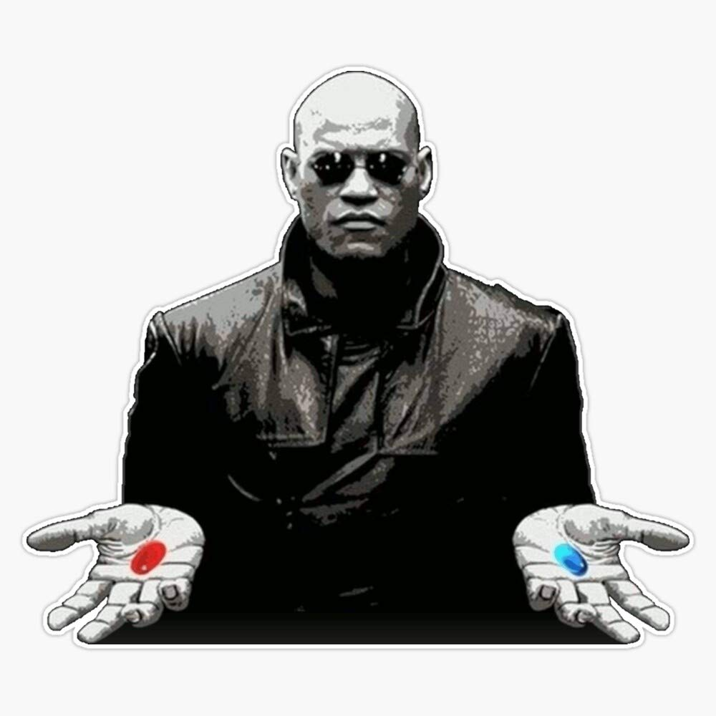
💊 Enter the real game
(Ragebait alert😂)*
Morpheus sits down in front of you.
Before we begin, I need to ask you something.
Are you willing to consider that everything you think you know about training is wrong?
Not some of it. Everything.
You've felt it, haven't you. It's there — like a splinter in your mind. Something you can't quite name. You drill the movement perfectly, and then the moment someone actually resists, it dissolves. You memorize the system, and then the match arrives and the system is nowhere to be found. You watch the footage, absorb the details, take the notes — and still, something doesn't add up.
You've been telling yourself it's you. That you just need more repetitions. More footage. A better instructional.
But the splinter remains.
He walks to the window.
What if skill was never something you store. Never something you retrieve. What if it was always something that emerges — alive, relational, inseparable from the body in front of you and the chaotic struggle.
What if the map was never the territory. And what if every instructional ever sold to you was just someone else's map.
He turns.
There is another way to look at this. A way that begins not with technique but with cause and effect. Not with memory but with perception. Not with what you've been told to do — but with what two bodies, in genuine unscripted struggle, inevitably discover together.
It is not new. It is not comfortable. And it cannot be packaged in ten hours of footage.
He opens his hands.
Take the blue pill — and the drilling continues.
Or take the red pill.
And I will show you how deep the rabbit hole goes.

📖 Theory

📖 Does Theory Matter in Jiu-Jitsu?

For the coach: theory is non-negotiable

Beliefs inform action. If you think the brain is a computer that stores information, you'll coach one way. If you think it's a modeling system that builds behavior through interaction with the environment, you'll coach in a completely different way. You can't avoid having a theory — every coach has one in their head, whether they admit it or not. The question is whether it's a clear, examined theory or a vague set of habits inherited from your old coach.

A coach has to be able to define the concepts they're working with. If you don't have a clear definition of what an affordance or an attractor is, you can't manipulate those things in practice. Without theory, you can't design practice — you can only copy what was done to you. The whole job of a coach is to create new behavior in someone who doesn't have it yet. That's a serious claim. It demands that we actually study what behavior is and how it's built, instead of pulling the wool over everyone's eyes to protect the job.

Theory also gives you a framework to read the room in real time. There is no curriculum, no template — just a way of looking at what's happening and filtering it through principles. Without that lens, you can't adjust on the fly, and you can't tell whether what you're doing is actually working.

Historical knowledge is part of this too. Every coach has to know their field historically because that gives selective power when designing training. Knowing the historical record of what works (for example: legs become passable once we clear the feet and step between the knees) is what lets us identify the invariant relationships we want students to be attracted to.

For the athlete/student: not strictly required

Students do not need to know the framework to practice. Practice is the opportunity for engagement — they need rich opportunities for action, not lectures on direct perception. In the room, the language is human language: push, rotate, turn, stand, squeeze, get behind your partner, get your back off the mat. The science only informs how the coach designs the practice; it doesn't have to be spoken to the student to work.

There are different levels of engagement in any class. Some students just want to sweat. Some just want to learn how to get their training partner off them. The general practice has to appeal to that full room. Forcing theory on everyone misses the point.

When theory does help the student

Some students genuinely benefit from it. They want to go home and think. They want to understand why they're being asked to do what they're doing. For those people — sit down, theorize, share the science, point them at things to read.

There's also a split worth being aware of: when instruction is the only intervention, the more intellectual students get more from it than the more physical, instinctive ones. The "brutes" tend to get more out of just being put in positions with constraints and made to grind. So theory-heavy teaching is not a universal upgrade — it advantages one type of learner. The better move is to learn to whisper the secret in both languages, so each student gets what works for them.

The bottom line

Theory is for the coach. It's the thing that lets you design practice instead of just copying drills. For students, the practice itself is the teacher — they don't need the vocabulary, they need rich problems to solve. Offer the theory to those who want it, but never assume understanding the framework is what produces the skill. The skill comes from interacting with the live environment.

🤼‍♂️ What is BJJ?

🤼The Game of Immobilization
BJJ is fundamentally the game of immobilization as it leads to strangulation and breaking.
To immobilize an opponent, you must first attack the periphery — the head, arms, and legs — in order to gain access to center mass (hips, chest, shoulders, and back). Once you control center mass, you immobilize it, which then allows you to isolate, immobilize, and reattach the periphery to finish.
The foundational skills required to begin this process are:
- Connection — making and maintaining physical contact
- Distance management — controlling space through segmentation
- Destabilization — breaking your opponent's base and structure
- Immobilization — pinning and controlling your opponent's body
- Isolation — separating the target limb from everything that can defend it

🌳 Eco and CLA theory

🌳 The Ecological Approach & Constraints-Led Approach (CLA) Based on Rob Gray – Perception Action Podcast
The Ecological Approach – Core Principles
The ecological approach to skill acquisition is built on the idea that skillful movement is not about storing techniques in the brain, but about developing a relationship between the athlete and their environment. Key principles include:
- Athlete-environment symmetry: Skill emerges from the interaction between the athlete and their surroundings, not from mental models or motor programs stored in the head.
- Information-movement coupling: Athletes learn to attach their movement to powerful, specifying information from the environment (e.g. tau – the optical variable that tells you when an object will arrive).
- Self-organization: Rather than prescribing one correct technique, the approach allows the body to find its own movement solutions within given constraints.
- Repetition without repetition (Bernstein): The goal is to repeat a good outcome without repeating the same movement. Variability in movement is necessary to handle the variability of real performance environments.
- Affordances: Athletes perceive opportunities for action directly from the environment – not abstract physical parameters.

Two Approaches to Skill Acquisition: Key Differences
Rob Gray contrasts the ecological approach with the traditional Information Processing (IP) approach:
 | Information Processing | Ecological Approach
Perception | Indirect – cues must be interpreted | Direct – information specifies what to do
Action control | Predictive, based on internal models | Prospective, online adjustment via control laws
Skill | Stored motor programs with invariant features | Emerges through self-organization and exploration
Coaching | Prescribe correct technique, correct errors | Destabilize ineffective solutions, guide exploration
Variability | Added later, for adjustability | Added early, for adaptability
Expertise | Knowledge about (in your head) | Knowledge of (in the athlete-environment relationship)
Decomposition | Effective – modules can be trained separately | Counterproductive – perception and action are inseparable

The Constraints-Led Approach (CLA) – What It Is
The CLA is the primary coaching methodology within ecological dynamics. A constraint is defined as a feature of the individual, task, or environment that reduces the number of possible movement solutions. All coaching involves constraint manipulation – the difference lies in the purpose.
The CLA uses constraints to encourage guided self-organization: the athlete is not told what to do, but is given problems that make their current (ineffective) solution unworkable, pushing them to explore and find a better one.
Four key goals of the CLA:
- Destabilize the existing non-optimal movement pattern
- Encourage exploration and self-organization
- Amplify information and invite affordances – make the better solution obvious through the environment
- Provide transition feedback – feedback about whether the athlete's search for a new solution is going in the right direction (not just about outcome or technique)

Practical Examples
Baseball – Bat Speed (Lars Nootbaar / Drive Line) A player had low bat speed due to poor hip-shoulder separation. Instead of telling him to "rotate his hips more," coaches gave him a longer bat and asked him to hit to the opposite field – a task nearly impossible with his current swing. The constraint forced him to self-organize a new solution.
Baseball – Forearm Flyout (Connection Ball) Pitchers who "fly out" the arm lose velocity and risk injury. A small rubber ball is placed under the pitching arm. The instruction: "make the ball fall forward when it drops." If the arm separates too early, the ball falls backward – giving immediate transition feedback. The pitcher self-organizes a more connected delivery.
Small-Sided Games (Soccer, Basketball, etc.) Changing field size, player numbers, and rules are classic task constraint manipulations that push players toward better movement decisions and tactical behavior without explicit instruction.

Evidence Supporting the Ecological Approach
1. You don't need to learn fundamentals first through decomposition
A study (Decker et al.) compared 10-year-old soccer players trained via skill-and-drill vs. small-sided games. Even on tests biased toward technical skill, both groups improved equally – with the small-sided game group showing better retention and a higher return on investment per rep (0.006s improvement per pass vs. 0.003s for the drill group).
2. Learning is not slower
Research by Schöllhorn and colleagues found no consistent evidence that ecological/variable practice leads to slower skill acquisition compared to traditional block practice – even on sports tasks.
3. Variability is restructured, not eliminated
Elite athletes are not less variable – their variability is restructured to align with the solution space (e.g. different release angles in basketball shooting that all go in). This adaptability is what allows performance under changing conditions.
4. Unpredictability is critical
A volleyball study showed that athletes who trained blocks (line, diagonal, open) in a random/unpredictable order outperformed those who practiced each type in a blocked fashion. Even a small number of unpredictable options produces significantly better results.
5. Self-organization does not increase injury risk
A study measuring 8 ACL injury risk markers (ground reaction forces, joint angles) found that constraints-led and differential learning groups showed reduced risk factors compared to traditional training groups.
6. More movement solutions available after CLA training
Studies in tennis and baseball show that ecological training leads to more movement options available to the athlete – not fewer. This is what allows them to adapt to changing pitch types, defenders, fatigue, etc.
7. Tactical behavior in team sports
A series of studies by Ramos et al. (volleyball) showed that CLA training through small-sided games with varying task constraints improved team synergy and tactical coordination across a full competitive season.

Key Implications for Practice Design
- Use guided self-organization – manipulate constraints, not technique cues
- Prioritize representative learning design – practice should reflect the information structure of competition
- Add variability early, not after fundamentals are established
- Favor simplification (scaling equipment/speed/distance) over decomposition (breaking skills apart)
- Keep perception and action coupled at all times
- Allow athletes autonomy – constrained choice promotes intrinsic motivation
- Ask: "What can I add to practice that makes their current solution no longer work?"

Sources: Rob Gray, Perception Action Podcast – "The Constraints-Led Approach" (Netherlands Olympic Team Presentation), "Two Approaches to Skill Acquisition," "CLA and Tactical Behavior," and "Evidence Supporting the Ecological Approach."

🍃 The CLA Approach for BJJ

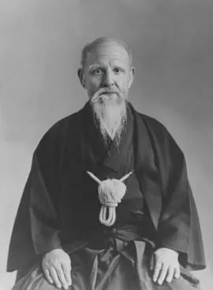
🍃The CLA Approach for BJJ
As explained by Greg Souders

What is it?
CLA stands for Constraints-Led Approach, rooted in Ecological Dynamics — a framework for understanding how behavior emerges from the interaction between three things:
- The individual (their body, psychology, experience)
- The task (what they're trying to do)
- The environment (who they're with, the space, the rules)
The core idea is that perception and action are constantly feeding each other. You perceive something, you act, that action changes what you perceive, and so on. Skill emerges from this loop — not from memorizing steps.

What are "constraints"?
Constraints are simply things that limit options. Greg's example: tie one hand behind your back and you can only reach for a cup one way. Constraints aren't special tricks — they're always present (your height, experience, strength are all constraints). The CLA just uses them deliberately to shape behavior.
A BJJ example he gives: instead of teaching guard passing as a technique, you set up a live drill where the bottom player tries to put their feet on the top player, and the top player tries to keep the feet off. Both players are now solving a real, live problem that is embedded inside guard passing — without being told "here's the technique."

How is this different from traditional BJJ teaching?
Traditional approach:
Show technique → drill it statically → maybe some situational sparring → a few rounds at the end
CLA approach:
Live work almost exclusively → constraints designed around invariant features of the skill → student finds their own solution within that space
Greg's gym does no drilling, no explicit technique instruction as the primary method. All work is live and unscripted from day one.

What are "invariant features" and why do they matter?
This is the key practical concept. An invariant feature is something that never changes, no matter who performs the skill or how.
His armlock example: no matter how you get an armlock from mount, you always have to move the opponent's elbow to transition from parallel (on their hips) to perpendicular (on their shoulders). The elbow is the invariant. So instead of teaching "the armlock technique," you design a drill where the top player's job is simply: get your partner's elbow to touch their head. The student discovers solutions within that space on their own.
This matters because:
- A specific technique detail (like "walk your fingers up") works for some body types and not others
- The invariant works for everyone, because it's the physical reality of what must happen
- Students develop their own movement solutions, which fit their own body

What does a session actually look like?
- Mostly or entirely live rolling/sparring
- Coach sets up a scenario with a task (e.g. "top player: keep feet off you, bottom player: get feet on top player")
- Coach observes and gives feedback in real time — not a script, but guided by what's happening
- No curriculum, no template — just a way of looking at what's happening and adjusting
Greg describes his role as a guide and facilitator, not an information deliverer.

What about showing techniques at all?
Greg isn't saying never show anything. His points are:
- Showing a technique is fine as context — students need to know what they're working toward
- The problem is using showing + drilling as a substitute for live development of skill
- Conversations, watching grappling, discussing what you see — all healthy and part of the process
- The issue is the ratio: most gyms do 80% drilling, 20% rolling. He argues it should be the opposite or more extreme

The "invariance" practical takeaway for coaches
If you want to build a game or drill:
- Pick a skill (e.g. passing guard, armlocking from mount)
- Ask: what is the one thing that ALWAYS has to happen for this skill to work, regardless of body type or technique variation?
- Build a live task around that invariant — give both players a job
- Let them figure it out, observe, then adjust the constraint if needed

Why do people resist this?
Greg gives a few reasons:
- It's not sellable — you can't package "go roll more" into a $400 instructional
- Drilling feels productive — the intellect loves being told answers because it feels like learning
- Coaches built identities around technique instruction and would have to reinvent themselves
- It takes deep knowledge to do well — you need to truly understand grappling to design good constraints, which is harder than just showing a move
His bottom line: the shortcuts being sold (instructionals, drilling systems) are a lie. The people selling them actually got good through live mat time and trial and error — then packaged that up differently.

Source:
BJJ Instructional Shortcuts Are A Lie, All You Need Is Live Work - Greg Souders | #54

🦉 Addressing Arguments Against CLA

🦉Addressing Common Arguments Against CLA

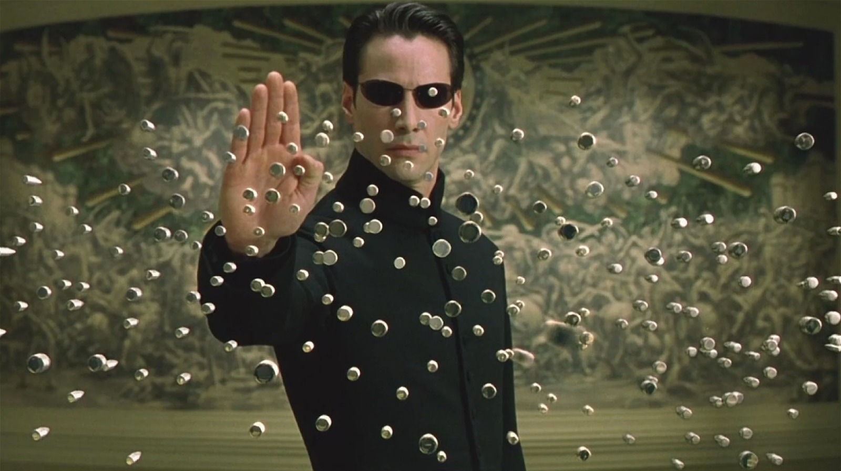

"Students need to be shown techniques first — they need knowledge to start learning"
The concern: Without showing someone what to do, how will they know what they're working towards? You can't just throw a white belt into live rolling and expect anything useful to happen.
The response:
This assumes knowledge must be delivered before experience, but the opposite is true — experience makes knowledge meaningful. When you tell someone what to do before they've felt the problem, the information has no context to attach to. After they've struggled with the problem, the same information lands completely differently.
The deeper issue: if knowledge were required to start learning, who learned the first thing? The first person to ever grab two legs and take someone down had no instructor. They learned through interaction with the live environment. Everything we now call "technique" is just the historical record of what worked.
What Greg does: Show the student what the outcome is (e.g. what an arm lock looks like), then immediately put them in a situation where they have to start working towards it. The outcome provides context. The live struggle provides learning.
"A person needs knowledge to start learning? That's the craziest thing I've ever heard in my life."

"But what about technical details — things like specific grips, foot position, angles?"
The concern: Some moves are genuinely complex. Without being shown the exact grip or the specific angle, students will waste time doing it wrong or never find it at all.
The response:
Two things are worth separating here:
1. Specific details are only useful when the student has context for them. If you show someone a specific C-grip before they understand why the arm needs to be isolated in the first place, the grip is meaningless. They'll remember it as a shape, not as a solution to a problem.
2. Specific solutions don't transfer universally. A 145 lb person and a 200 lb person will not solve the same problem the same way. If you give the small person a specific grip to "walk their fingers up," it won't work against someone stronger. But if you give both players the general task — get your partner's elbow to move away from their body — each person will find a solution scaled to their own capacity. That solution will actually work for them.
What Greg does: Start with the invariant (the thing that must happen), not the specific method. Let the student find a solution. Then refine from there.
"We don't start with the specifics. We start with the general. Any way that you can — this gives you the freedom to experience it for you."

"Live rolling all the time isn't structured enough — students won't develop systematically"
The concern: Without a curriculum, students are just flailing. Drilling gives you a repeatable, teachable structure that ensures everyone covers the same material.
The response:
CLA is not the absence of structure — it requires more structure from the coach, not less. The difference is where the structure lives. In traditional drilling, the structure is in the choreography (do this, then this, then this). In CLA, the structure is in the game design — the starting position, the win conditions, the constraints, and the progression of complexity.
The coach must understand the invariants of jiu-jitsu deeply enough to design situations that expose students to the right problems at the right time. That's a much harder job than running a technique class.
Drilling feels systematic because it's visible and countable. But performing a technique correctly in a cooperative drill does not mean you can perform it in a live, resisted situation — because the problems you face in live rolling are completely different from the problems you practice in drilling.
"This method requires a deep understanding of what you're doing. It's not a plug-and-play. It is not just press start and go."

"What about beginners? Surely they need more guidance, not just live rolling"
The concern: Throwing a complete beginner into live work is overwhelming and discouraging. They need foundational building blocks first.
The response:
Beginners do need guidance — but the guidance should come through game design, not technique explanation. The mistake is thinking that guidance = instruction. You can guide someone by choosing the right starting position, the right opponent, and the right task without ever saying "put your hand here."
What actually happens with beginners in traditional classes: they watch a technique for 20 minutes, try to replicate it with a cooperative partner, and then do two rounds of live rolling at the end where none of the technique appears. The technique felt like learning. The live rolling was the learning.
With CLA, beginners start with simple, achievable tasks in live situations immediately. The first game might be: "keep your partner's feet off you while staying in front of them." Any human being can engage with that on day one — no prior knowledge required.
"We're not teaching techniques — we're teaching the competitive struggle. This is what it feels like to perform this game."

"Elite grapplers use drilling — Gordon Ryan, John Danaher. If it works for them, why change it?"
The concern: The best competitors in the world come from systems that use drilling and explicit instruction. That's proof it works.
The response:
Look at how they describe acquiring their skills, not what they sell. Gordon Ryan has described his training as: start in a position, find where you struggle, go back to that spot, struggle there until you figure it out, move on. That's trial and error in a live environment — not drilling a choreographed sequence.
John Danaher's instructionals follow the same pattern: the first 5–20 minutes contain the entire framework as principles. The remaining hours are just variations of those same principles applied in different situations. If you understood the principles, you wouldn't need the eight hours.
Elite athletes get good because they accumulate massive amounts of live mat time and genuinely care about solving the problems they encounter. The drilling and instructionals exist around that core, not as the cause of it.
"He's admitting that the way he acquired the skill he's now selling you on his DVD was done through trial and error and interaction with the live environment. And nobody flinches."

"I tried just rolling with my students and nothing improved"
The concern: We already do a lot of live rolling and it doesn't seem to work any better. People just keep doing the same things.
The response:
Unstructured rolling is not the same as CLA. Telling students to "just roll" and hoping skill emerges is not the approach — that's the absence of coaching, not an alternative to it.
CLA requires the coach to:
- Identify the invariant of what they're trying to develop
- Design a game with a specific starting position and clear win conditions
- Choose constraints that direct attention to the right problem
- Observe what's happening and adjust the game in real time
If students keep doing the same things in rolling, that's feedback about the game design — the constraints aren't redirecting behavior, or the win condition isn't connected to the skill you want to develop. The answer is to redesign the game, not to go back to drilling.
"There is no curriculum. There is no template. There's only a way to look at what's happening and filter it."

"This takes too long. Traditional instruction is more time-efficient"
The concern: Showing a technique and drilling it is faster than waiting for students to discover things on their own through live play.
The response:
What's being measured as "efficient" here? If the measure is how quickly students can reproduce a technique in a cooperative drill — drilling wins. If the measure is how quickly students can apply that skill under pressure against a resisting opponent — live work wins.
The illusion of efficiency in technique instruction comes from how satisfying it feels to be shown something. The intellect loves a clear answer. But feeling like you know something and actually being able to use it under pressure are completely different things.
Students who only drill also often accumulate what they think are skills but are actually choreographed responses — patterns that collapse the moment the other person doesn't cooperate.
"The intellect loves to hear answers because it makes you feel like you know it all. But if you just remember what they said, do you really know anything?"

"Students lose confidence when they can't do the techniques properly"
The concern: When students struggle without explicit guidance, they feel lost and frustrated. That damages retention and enjoyment.
The response:
Two things worth unpacking here:
1. Struggling is the learning. The discomfort of not knowing what to do is not a sign that the method is failing — it's a sign that the student is encountering real problems. That discomfort, when managed well by the coach (appropriate partners, achievable tasks, enough safety), builds resilience and genuine competence.
2. The alternative has its own confidence problem. Students who learn primarily through drilling often feel confident until they hit live rolling — and then discover their technique doesn't work. That collapse of confidence is arguably more damaging than struggling in live work from the start.
The coach's job is to design games that are challenging but winnable, and to pair students appropriately. A new player should be playing with other new players, not the comp team.
"If it's too uncomfortable, you're probably not going to enjoy the learning process."

"I'm a coach who's been teaching techniques for 20 years. I can't just throw that away"
The concern: Switching to CLA means invalidating everything I know and starting from scratch. That's not realistic.
The response:
You don't throw it away — you use it differently. Your technical knowledge is exactly what informs good game design. The question isn't whether to use what you know. It's how to use it.
Instead of: "Here's how to do an arm lock — step 1, step 2, step 3..." Use it as: "I know the arm must move away from the body. So I'll design a game where the student's task is to move the arm, and see what solutions they find."
Your 20 years of experience lets you identify the invariants faster, design better starting positions, and recognize when a student is close to a breakthrough. That knowledge is more valuable in game design than in technique instruction.
What you're giving up: the need to have all the answers in the room. What you're gaining: students who actually solve problems on their own.
"Coach takes knowledge, makes practice, athlete engages in practice, they become better over time."

"I don't have time to understand all this theory"
The concern: Ecological dynamics, invariants, affordances — this is academic language that doesn't translate to a regular gym setting.
The response:
You don't need the academic language. The practical version is simple:
- Pick one thing you want to get better at
- Find the thing that always has to happen for it to work (the invariant)
- Create a live game where both players are fighting over that thing
- Give clear win conditions
- Watch what happens and adjust
That's it. The theory exists to explain why this works. But you don't need the theory to do it. Greg's framework — make and maintain connection, manage distance, destabilize, segment, isolate, immobilize — is a lens, not a rulebook.
"If you understand what problem you're having, you need to expose yourself to the problem. And whatever game you create needs to give you an opportunity to solve it. Exposure and opportunity. That's it."

"What about watching instructionals and studying technique? Is that all useless?"
The concern: If drilling and instructionals don't develop skill, does that mean there's no value in studying technique at all?
The response:
Watching, discussing, and thinking about jiu-jitsu all have real value — they're part of how humans learn from their environment and culture. There's nothing wrong with watching Gordon Ryan or John Danaher. There's nothing wrong with talking about what you saw.
The issue is using talking about technique as a substitute for experiencing it in a live situation. Watching someone cook a Michelin-star meal doesn't make you a better cook. But if it inspires you to go into the kitchen and try something, it's useful.
The same applies to instructionals. If they give you a starting point — a position to explore, a problem to investigate in live work — they're useful. If they're consumed passively and never tested under resistance, they're not.
"You could put him on mute and you'll probably learn more. There's nothing wrong with hearing people's opinions. I think it's all healthy. All I'm saying is that when we train, it should be all live."

Quick Reference: The One-Sentence Answers
Objection | One-sentence response
"They need to see the technique first" | Experience makes instruction meaningful — not the other way around.
"What about specific grips and details?" | Start with what must happen (the invariant), not how it should look.
"This isn't structured" | The structure is in the game design, not the choreography.
"Beginners need more guidance" | Guidance comes through game design, not technique explanation.
"Elite athletes drill, so drilling works" | They got good from live mat time — the drilling came after, or around it.
"We already roll and nothing improves" | Unstructured rolling is not CLA. The game design is the coaching.
"Traditional instruction is more efficient" | Efficient at what? Performing in drills, or applying skill under pressure?
"Students lose confidence without guidance" | Students lose more confidence when their drilled technique fails in live rolling.
"I can't throw away 20 years of knowledge" | You don't — you use it to design better games instead of better explanations.
"The theory is too complicated" | Ignore the theory. Find the invariant, make a live game, give win conditions.
"Are instructionals useless?" | Useful as inspiration for what to explore in live work — not as a substitute for it.

Based on the work of Greg Souders, Standard Jiu-Jitsu. Instagram: @GD_STS

🌞 Invariants explained

🌞The Invariant Framework

Invariant Framework - Standard Jiu-Jitsu's Coach Greg Souders

What is an invariant?
An invariant is something that is always happening in jiu-jitsu, regardless of position, tactic, or move. The framework exists to describe the game at every level — standing, on the ground, in guard, in pins, everywhere.

Part 1: Attack the Periphery to Gain Access to Center Mass
The first invariant concept is: attack the periphery to gain access to center mass.
The periphery is whatever is sticking out from your partner that controls the gap between you — arms, legs, frames. You must interact with these things — remove them, change angle relative to them, or threaten them with pressure — in order to get to center mass: the hips, chest, shoulders, and back.
Once you gain access to center mass, the full sequence is:
Attack the periphery → Gain access to center mass → Immobilize center mass → Isolate and reattack the periphery
This is not a one-time linear process. It is a loop. You can enter it at any point. When passing guard, for example, you may already be at center mass and in the process of isolating a limb, then the legs come back in and you redirect — you are still operating within the same framework.
Pick any technique in jiu-jitsu. This pattern is present.

Part 2: Make and Maintain Connection to Manage Distance
The second part of the framework is: make and maintain connection to manage distance through segmentation, destabilization, isolation, and immobilization.

Make and Maintain Connection
You cannot fight unless you can grip your partner and hold that connection long enough to create an effect. There is a direct relationship between time in condition and time for effect. If the connection breaks before anything can be done with it, everything that depended on that connection is lost.
This is why connection quality matters — not just making contact, but maintaining it.

Managing Distance
Distance is not something you simply close or create. It is a continuous, complex event that is always changing. Sometimes you use your connections to close distance, sometimes to create it, and sometimes distance is being forced on you and you have to manage it indirectly. The word "manage" reflects this — it accounts for all the different ways distance functions in a match.

Segmentation
As you make and maintain connections, you are doing so to your partner's segments. In the legs: knee, ankle, hip are segments. In the arms: hands, elbows, shoulders. Moving through these segments is an invariant pattern of progression. Clearing the feet to reach the knees, the knees to the hips — this happens regardless of the path taken. Segmentation describes how we use connection to navigate toward our objective.

Destabilization
If your partner is stable, they control the distance. If you are destabilizing them — taking their structure away — you take control of the distance. Whether standing, holding a single leg, working from guard, or being pinned: if your partner cannot stabilize, they cannot manage the space between you. Destabilization is not a separate step — it is happening continuously alongside everything else.

Isolation
Isolation means separating one of your partner's limbs from the rest of their body. Once a limb is isolated, your partner must recover it to regain meaningful function. Until they do, you can use that isolated position to manage distance and threaten everything connected to it. This applies to arms in hand-fighting, legs in entanglements, and limbs being set up for submission.
Isolation is what allows the final step — it starts at one point and ends with a submission at another.

Immobilization
Immobilization is the overarching concept that begins the moment engagement starts. Even walking toward your partner takes space away from them — they can no longer occupy that space. That is already a form of immobilization.
It progresses: proximity reduces movement options, connections reduce them further, pins reduce them even more. Full immobilization is when your partner is covered at hips and shoulders, pressed to the floor, connected at all points, with a limb isolated and under threat. All other elements of the framework must be present for immobilization to be expressed maximally.

These Things Happen Simultaneously
These concepts — segmentation, destabilization, isolation, immobilization — are not steps you cycle through one at a time. They are happening at the same time, continuously. When you grip a wrist with the intention of isolating a limb, you are simultaneously segmenting it, immobilizing it, and destabilizing it. The words are separate; the process is not.

The Paradox: Direct vs. Indirect Control
To maximize direct control over your partner, you need them on the floor, covered at hips and shoulders, with your arms and legs involved. Mount and rear mount are the clearest expressions of this.
But here is the paradox: when you go to isolate and attack the periphery — when you go for the submission — you give up that full coverage. You move from full control to partial coverage. Direct control decreases in the transition to submission.
What replaces it is indirect control — threat. The threat of the break, the angle, the feeling of the joint under pressure. These indirect measures take over and increase immobilization at the moment you need it most. You maximized your control in order to minimize it, and then use the threat of submission to try to remaximize it through indirect means.

🤖 Claude explains BJJ

🤖 The Hidden Logic of Jiu-Jitsu

Watch a Brazilian jiu-jitsu match without knowing the sport and it looks like two people slowly tangling on the floor for reasons that never quite surface. Learn the sport and a different confusion sets in: there are thousands of named techniques, each with its own setup, grip, and counter, and it's tempting to conclude that jiu-jitsu simply is that enormous vocabulary of moves.

It isn't. Underneath the moves sit a handful of plain physical facts, and those facts decide everything that happens. The techniques are just the local ways of obeying them. Once you can see the facts, the chaos resolves into something close to logic. Here is that logic, built from the ground up.

Two ways a fight ends
Every submission works through one of two mechanisms, and they are not interchangeable.

The first is the strangle. The chokes that matter in jiu-jitsu don't cut off air — they compress the two arteries on the sides of the neck that carry blood to the brain. Starve the brain of blood and a person loses consciousness within seconds, whether they want to or not. This is the crucial part: a true blood choke does not care how tough you are. Pain tolerance, willpower, a thick neck, a high threshold for discomfort — none of it helps much once the arteries are sealed, because you cannot decide to keep your own blood flowing. That is why the highest-percentage finishes in the entire sport are blood chokes like the rear naked choke. They route around the opponent's grit entirely.

The second mechanism is the joint lock. Here you take a joint — usually an elbow, shoulder, or knee — and load it past the range it was built to travel. Now the opponent has exactly two options: give up, or let the joint break. Joint locks are real and decisive, but notice the difference. A joint lock negotiates with the opponent's toughness in a way a strangle does not; a determined or reckless person can buy themselves time, or eat damage, in a way that's simply unavailable against a clean choke. This single distinction quietly explains a lot about which finishes show up most often at the highest levels.

Why leverage beats muscle — and where it stops
The famous promise of jiu-jitsu is that a smaller, weaker person can defeat a larger, stronger one. This is true, and it is not mystical. It is levers.

Every control and every submission is a lever — a configuration of fulcrums and arms that multiplies force. An armlock places your hips directly beneath the opponent's elbow so that the strength of your whole body, pivoting on that point, is delivered against a joint that can only resist with the small muscles around it. Done with the right geometry, a slight person generates more force at that joint than a powerful person can withstand, because the leverage, not the muscle, is doing the work.

But an honest account has to name the ceiling. Levers have limits. Stack the geometry wrong — put the elbow on the wrong side of the fulcrum — and no amount of strength will finish the lock, because you've voided the mechanism. And run the size difference high enough, and raw power can overwhelm even good leverage. "Technique beats strength" is true within a range, and the fact that it has a boundary is part of why the explanation is trustworthy rather than a slogan.

Balance is really about the floor

People talk about "off-balancing" an opponent as if balance were a vague quality. It isn't. On the ground, both people are pinned in gravity, and the floor is a wall neither can be pushed through. A stable structure is one that channels incoming force *down into the floor* through a posted hand, knee, or foot — the earth absorbs it, and you don't move.

So off-balancing has a precise meaning: it is the act of taking away the opponent's ability to send force into the floor. Remove the post and their own force, or yours, displaces *them* instead of the ground.

This explains something every beginner gets wrong. You cannot sweep someone in a direction where they have a limb posted and carrying their weight into the floor — you'll fail every time against anyone competent. That is why good sweeps are always preceded by killing a base point: lifting the posting hand, blocking the knee, clearing the foot. First you remove the floor; only then does the person tip.

The real skill is the trap, not the move
Against a beginner, a single attack works. Against a skilled opponent, almost no attack works on its own — they simply do the known defense. What actually beats a good grappler is a dilemma: a position arranged so that the opponent has two ways out, and each one walks them into a different finish. Defend the armlock and you feed the choke; defend the choke and you feed the armlock. Whatever they choose, they lose. It's the grappling version of a checkmate, where every legal move is still a loss.

This reframes what "skill" even means. The expert isn't the person with the most moves. It's the person who can build the position where the opponent's remaining options have all been pre-loaded to fail.

And it comes with a built-in warning that separates a real trap from a fake one. If there exists a third response — a single defense that answers both threats at once — then it was never a dilemma. It was one attack with a known escape, and a good opponent will find that third door and walk straight through it. This is exactly why sequences that look "unstoppable" eventually get solved at the elite level: someone locates the move that defuses both horns at once. The traps that endure are the ones with no third door.

The slow leak
The last fact is about time. Holding someone with muscle — gripping hard, bracing, clamping — burns energy fast, and that energy drains on a predictable schedule. Holding someone with structure — bones stacked, alignment doing the work, the floor carrying the load — costs almost nothing by comparison.

This is the real reason the calm, "lazy"-looking veteran beats the explosive newcomer. The newcomer's control is real but expensive; it runs on a fuel tank that empties. As the minutes pass, the muscular grip decays while the structural one doesn't, and control quietly transfers to whoever was spending less to hold it. The classic signature of an inexperienced grappler is to dominate the first two minutes and collapse in the next five.

One idea underneath
Put the five facts together and a single picture emerges. Jiu-jitsu is the steady shrinking of your opponent's available options — fewer places they can move, fewer things they can do — until the only options left are ones that lose, while you spend less of your own limited reserves of structure and energy than they spend on theirs.

That picture also resolves the sport's central paradox. The most complete control you can have — a heavy, pinning top position — is precisely the thing you must give up to actually finish, because the finish requires reaching in and isolating a limb, which hands the opponent room to move again. So the submission is a trade: you surrender coverage in exchange for inserting a lethal threat into the space you just reopened. The trade only pays off if the threat closes faster than the escape route opens. When you leave a dominant pin to chase a submission and it fails, this is almost always why — you gave back more room than your attack could close in time.

That, not a longer list of techniques, is the discipline: take away your opponent's options until none of them are survivable, spend less than they do to get there, and only cash in your control for a finish when the finish closes faster than the door you're opening.

📚 Readme & further reading

📚About this document
The text in this document is generated using Claude to summarise the ideas of Greg Souders, Rob Gray and others from Youtube transcripts. The AI is good at summarizing but often its best to get info straight from the source. Also there might be errors in the document. Please comment if you find any. Also feel free to comment if you think something is missing, can be improved or if you disagree.

Here are some good sources for further research:

Books:

How we learn to move by Rob Gray:

https://www.goodreads.com/book/show/59507312-how-we-learn-to-move

Constraints Led Approach Principles for Sports Based Caching and Practice Design:

https://www.akademika.no/hjem-og-fritid/sport-og-friluft/constraints-led-approach/9781138104075

Podcasts about CLA:

YT playlist:
https://youtube.com/playlist?list=PLEmjNuJJkxDJFpzJqn3E4ZWSpFd02sZyx&si=Uy5ujjXo4OJfF_3c

Spotify playlist with Greg Souders:

https://open.spotify.com/playlist/6wDBsSfC7EINQuzwPhvuC6?si=d3f2ecc0335b420e

Rob Gray Podcast:

https://open.spotify.com/show/6P7OPFNTMnwRYjVsj8OYaM?si=c63b2e04bbd744e9

Videos with CLA games:
https://youtube.com/playlist?list=PLEmjNuJJkxDJDUg-UOFO_SpeKvusKIzmO&si=CiSLo8fCRBX-LMKc

Articles:
https://www.nytimes.com/athletic/6665943/2025/09/29/sports-training-cla-coaching-wembanyana-ohtani/

🫄 Create ur own sesh

🫄 Create your own session

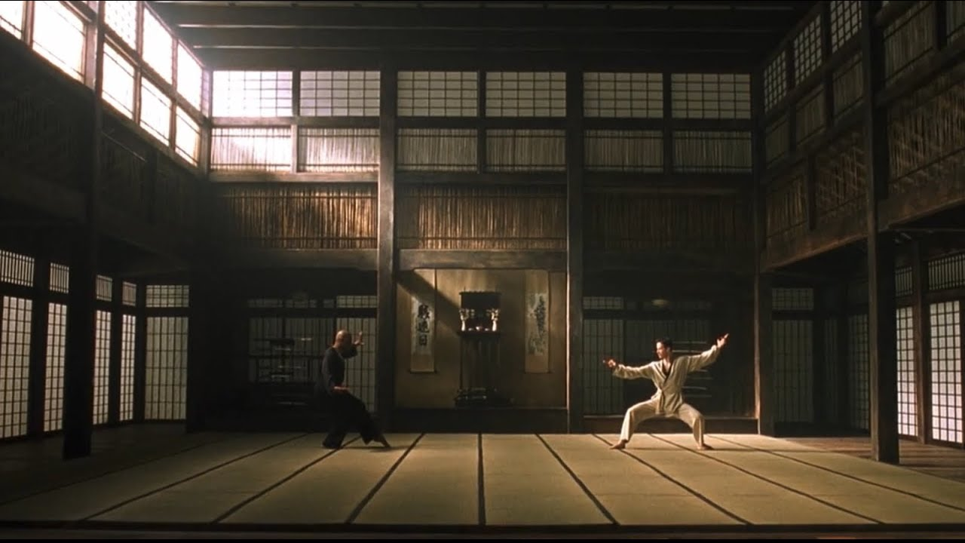

I'm trying to free your mind, Neo. But I can only show you the door. You're the one that has to walk through it. - Morpheus

🦧 How to Design Games

🦧How to Design CLA Games for Jiu-Jitsu
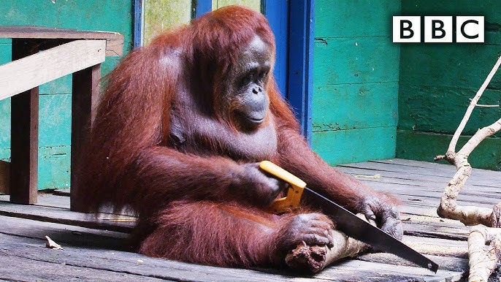

The Core Idea
CLA (Constraints-Led Approach) games are not drills. They are live, resisted situations where both players have a task — and skill emerges from the struggle, not from memorizing steps.
The coach's job is to design the environment. The athlete's job is to solve the problem.
"It's never enough to regurgitate and memorize a bunch of facts or show a bunch of moves. We have to use our knowledge to design good practices so athletes can turn that knowledge into skill."

Step 1: Identify the Invariant
Before you design anything, ask:
What never changes, no matter how this position plays out?
This is called the invariant — the physical constant that underlies all variations of a technique or position. Every effective game is built around one.

Examples of invariants:
Position / Goal | Invariant
Guard passing | The top player must get the bottom player's feet off them
Arm lock from mount | The arm must be separated from the body — elbows must move
Pinning | You must cover hips AND shoulders simultaneously
Leg entanglements | You need inside position OR a cross leg to access the hip
Back control | You must stop rotation AND maintain chest-to-back contact

How to find the invariant:
Ask yourself: "Is there any version of this technique where this thing did NOT happen?"
If the answer is no — that's your invariant. Build your game around it.

Step 2: Define the Problem (Exposure)
Once you know the invariant, you need to expose your student to the problem that invariant solves.
Do not explain the solution first. Put them in the problem.
"Imagine if I told you all the things you'd have to worry about in a round you've never done before. How would you know what a problem actually is?"

Ask yourself:
- What is the defending player trying to do that makes this hard?
- What are the four or five things that go wrong when trying to achieve this outcome?

Example — Pinning:
The four problems a pinner always faces:
- Limb extension — partner pushes you away
- Limb retraction — partner pulls arms back in
- Rotation — partner turns to get off their back
- Basing — partner gets points of contact on the floor to push up
Design a game that forces the student to encounter these problems — don't list them out first.

Step 3: Create the Win Condition (Opportunity)
Every game needs a clear win condition. This gives the student something to aim for and makes feedback immediate.
The win condition should:
- Be achievable through multiple paths (not one specific technique)
- Be directly connected to the invariant you identified
- Be simple enough to explain in one or two sentences
"Exposure and opportunity. You want to expose yourself to the problem. And whatever game you create needs to give you an opportunity to solve it."

Win condition examples:
- Top player: connect both hands under partner's elbows → you win
- Bottom player: get both elbows back to touch your body → you win
- Attacking player: entangle the hip, lock hands around hips, OR put partner's back on the mat → you win
- Defending player: get to your feet and break connections → you win

Step 4: Set the Constraints
Constraints are anything that limits options and directs attention. They shape behavior without telling the student how to move.

Types of constraints:
Task constraints — rules of the game
- "Top player: you cannot put your hooks in"
- "Bottom player: keep both feet to the inside at all times"
Starting position — where the round begins
- Chest to chest, hips covered, double underhooks in
- Double seated, one foot in between partner's knees
- Standing, one player with ankle grip
Partner constraint — who they play with and how
- Resistant vs. cooperative
- Larger vs. smaller partner
- Experienced vs. inexperienced
Remove a win condition — if a player is too successful in one area, take away that option and force them to find another
"If somebody is too successful and we need them to explore more, we constrain it and don't let them do it."

Step 5: Keep It Live
All games should be:
- Live — both players are resisting, not cooperating
- Unscripted — no predetermined sequences
- Uncooperative — the defending player is actually trying to win
Static drilling and cooperative technique practice are not the main event. They may have a place, but skill is acquired through live interaction with a resisting partner.
"All I'm saying is that when we train, it should be all live. It should be unscripted. It should be uncooperative."

Step 6: Progress the Game (Complexity)
Start simple. Add complexity by giving players more conditions to fulfil — not more techniques to remember.

Example progression (pinning):
Game 1 — One focus: Stay chest-to-chest or chest-to-back, and stay under both partner's elbows. Continuous for top player. Bottom player wins if they free both elbows.
Game 2 — Add a second condition: Same as above, but now top player must also keep hips covered. Bottom player can also win by pushing top player over.
Game 3 — Add a third condition: Same, but top player starts without elbow position and must earn it. Bottom player can now also wrestle up to standing.
Game 4 — The whole pin: Start with one hand around partner's waist, partner on their side. Top player must achieve chest contact + elbow connection + hip coverage in any order. Bottom player can stand up, roll top player, or recover guard.
"We start simply first. Then as each game progresses, we make it more complex — meaning you had more to face."

Step 7: Coach in Real Time
Your job during the game is not to stop and explain — it's to observe, then adjust.

What to look for:
- Is the student encountering the problem you designed for?
- Are they finding solutions, or are they stuck?
- Is the task too easy (not enough resistance) or too constrained (no room to solve)?

When to intervene:
- Give a minimal cue connected to the invariant: "What's stopping you from covering the hip?"
- Change the starting position to put them closer to the problem
- Change the win condition to redirect attention
- Change the partner
"There is no curriculum. There is no template. There's only a way to look at what's happening and filter things through it."

Quick Reference: Game Design Checklist
Before running any game, confirm:
- I know the invariant (the thing that never changes)
- The game exposes the student to the real problem
- There is a clear win condition for both players
- The game is live and resisted
- The starting position makes sense relative to the skill I'm developing
- I can progress this game by adding conditions (not techniques)
- I'm not explaining the solution before they've felt the problem

Framework: The Five Skills (Souders' Model)
All of jiu-jitsu can be understood through this framework. Every game you design should connect to one of these:
- Make and maintain connection — connecting to a body to do something to it
- Manage distance — gap closing or denying gap closure
- Destabilize — making the partner fall, break structure, lose base
- Segmentation — moving limbs out of the way to access the body
- Isolation — separating a limb from everything else to make it vulnerable
- Immobilization — holding a body or body part still
Games can target one skill or chain multiple together as the student develops.

Example: Full Game Design — Guard Passing (Beginner)
Invariant: The top player cannot pass while the bottom player's feet are on them.
Problem: Bottom player will always try to reconnect their feet. Top player doesn't know how to manage this.
Exposure: Start the top player in front of a seated bottom player. Let the bottom player immediately try to hook.
Win conditions:
- Bottom player: get both feet connected inside the knees and use hands to put top player on their butt
- Top player: keep feet off, step inside or outside the knees — continuous, no win required yet
Constraint: Top player must keep at least one leg in between partner's knees at all times (or outside).
Progression: Add a win condition for the top player — connect hands around the hips or shoulders.

Based on the work of Greg Souders, Standard Jiu-Jitsu. Instagram: @GD_STS

🐇 How to Structure Session

🐇Session Plan

Core Philosophy
Everything is live resistance. No static drilling. The foundation of every session is: expose the student to the problem, then give them the opportunity to solve it.

Session Structure
1. Warm-Up — Low Variability Start with a simple, live task. Not jogging or shrimping up and down the mat. Something like hand fighting standing up. Intensity is controlled through task design, time intervals, and partner selection — not by telling people to "go at 50%."
2. Define the Concept Briefly show or explain what you're working on. Not step-by-step technique, but what are we trying to achieve and why? Give students just enough context so the games mean something. Example: "Today we're working on pinning. To hold someone down you must cover hips and shoulders simultaneously."
3. Games — Simple to Complex Build games in layers through the session. Each game adds one more problem to solve:
- Game 1 — One task, low chaos. Example: top player stays under both elbows, bottom player tries to get elbows back to body. That's it.
- Game 2 — Add a win condition. Now top player must also cover hips. Bottom player can push, rotate, base.
- Game 3 — Full integration. Multiple ways to win, all connected to the same concept. Closer to the full game.
The key principle: each game builds on the last, but students are never given more information than they need to engage with the current problem.
4. Coach's Role During Games You are a facilitator, not a lecturer. You're reading the room, adjusting tasks on the fly, answering questions that arise from what students are actually experiencing. If a problem keeps coming up, you design the next game around it. There is no fixed curriculum — only a framework and real-time adjustment.
5. Q&A / Debrief After games, open the floor. Students now have shared experience, so concepts actually land. This is when language and explanation become useful — not before.

What to Avoid
- Showing a technique and then drilling it cooperatively
- Spending more time talking than playing
- Giving students more information than they can act on right now
- Solving problems students haven't experienced yet

The Underlying Framework
Every game should connect to one of these fundamental skills:
- Making and maintaining connection
- Managing distance
- Destabilizing the partner
- Segmentation (moving limbs out of the way)
- Isolation (making a limb vulnerable)
- Immobilization (holding the body or part of it still)
Focus games around invariant features — the things that never change regardless of who's doing the technique or how. For guard passing, feet always have to come off the top player. For arm locks, the elbow always has to move. Build your tasks around those constants, not around specific step-by-step sequences.

🐒 Beginner Session Guide

🐒 Beginner Session Guide

Core Philosophy Before You Start
Every game needs three things:
- Definition – where are we, what is this?
- Objective – what are we trying to accomplish here?
- Task – what specifically will they do in the game?
Keep talking to under 90 seconds. Get them working fast.

Session Structure (60 minutes)
Warm-up game: 6 min Low variability, low intensity. Both players moving, but nothing explosive or dangerous.
Guard games: ~24 min (2–3 games × 6 min each)
Pinning games: ~24 min (2–3 games × 6 min each)
Buffer time for transitions/brief explanations: ~6 min

Game Design Rules
Continuous vs. Terminal games
- One player always has a continuous job (keep doing X as long as you can)
- The other player always has a terminal job (reach a specific outcome = win)
- This creates natural pauses so beginners don't gas out, and gives them a goal to chase

Zero-sum design
- If the top player's job is to stay on top and hold their partner down, the bottom player's job must be the opposite: get up or put top player on their butt
- What's good for one player must be bad for the other – this prevents "gaming the game"
Switch top to bottom every time someone wins. Don't let one person stay on top for the whole 6 minutes.

Guarded Work – Example Games

Game 1 – Feet Off (Warm-up/opener)
Setup: Bottom player lies on back, feet pointed at top player. Top player stands in front.
Top player (continuous): Stay on your feet, keep at least one hand connected to your partner at all times, and keep their feet off of you. No chest-to-chest, no double knees down.
Bottom player (terminal): Use hands and feet to connect to top player and make them fall on their butt. Butt touches the mat = bottom player wins.
Switch top to bottom every time bottom player wins.

Game 2 – Inside Position
Same rules as Game 1, but now add:
Top player: Try to get one leg between your partner's knees and keep it there. If it comes out, fight to get it back.
Bottom player: Try to get both feet to the inside of your partner's knees, then use that to make them hit their butt.

Game 3 – Cover the Hips (progression)
Same rules, but now:
Top player: Clear the feet, advance to the knees, then cover/surround your partner's hips with any two parts of your body (hands, knees, elbows – doesn't matter). That's the win.
Bottom player: Same as before – make top player hit their butt.

Pinning Work – Example Games

Game 1 – Stay on Top, Hold Them Down
Setup: Start chest-to-chest, past the legs.
Top player (continuous): Stay on top and hold your partner down. Move around their body however you like, but don't let them up.
Bottom player (terminal): Push top player off and get your legs back in front of them.
Switch when bottom player gets their legs back in front.

Game 2 – Get Under the Elbows
Same setup, but now give the top player a win condition:
Top player: Stay on top, hold them down AND get one arm underneath your partner's elbows with hands connected = win.
Bottom player: Push on top player's hips and knees to create space and get legs back in front.

Game 3 – Scalable Version (for mixed-level groups)
Tell the room: "Choose your difficulty."
- Easy: Get one arm under your partner's elbows, connect hands = win
- Medium: Get both arms under your partner's elbows, connect hands = win
- Hard: Get both arms under elbows, connect hands, AND cover the hips = win
Bottom player's job stays the same across all three: create space, get legs back in front or reverse top player.

Scaling for Mixed Levels
When you have beginners and more experienced players in the same session:
- Keep the win condition the same for everyone
- Change the starting position or constraints for the more advanced player
- Pair people at similar levels where possible – a huge skill gap is bad for both players
- If the gap is unavoidable, give the stronger player a harder task focus

Key Coaching Principles
Don't solve problems they're not having yet. Let mistakes happen. Let them get reversed, let them fail. That failure is information.
Demonstrate sloppily on purpose. If you show a perfect technique, they'll copy it rigidly. Show the position loosely so they understand the situation, not a fixed movement.
Ask questions, don't give answers. If a student is stuck, ask "what happened when you tried that?" not "here's what you should do."
Words are a tool, use them sparingly. A simple task focus beats a five-minute explanation every time.
There are no bad reps. Movement that emerges from live resistance is always more valuable than a perfect-looking drill with no resistance.

What to Avoid
Avoid | Why
Long technique explanations before any contact | They won't remember it and it means nothing without context
Static drilling | Decouples the skill from the environment it needs to work in
Telling them how to solve problems | They need to discover solutions themselves
Keeping the same partner every day | Forces them to adapt to only one body type
Free rolling Monday–Thursday (especially for beginners) | Constrained games develop skill faster and reduce injury risk

One-Line Summary
Define where you are → give them a task → let them struggle → let the resistance teach them.

🕵️ How to give effective clues to students

🕵️ How to give effective clues to students
Practice design comes first. Your first intervention is the task you set up, not your words. Verbal cues come second and used in a limited fashion. Greg is largely quiet in the room and only speaks when he needs to.
Words are a constraint. Whatever you say has an effect on the student's attention and focus — but not always the effect you wanted. More instruction is not better. Constant talking ("puppeteering") makes athletes worse.
Build shared experience before talking. Let the student struggle first. When they ask for help, ask questions before giving answers: What was your intention? Did it work? Did it fail? Why? If they can't tell you why they failed, don't suggest anything — they aren't paying attention to the result of their own actions yet, so any answer is just copying.
Use external focus. Talk about the effect on the opponent, not how the student's body feels. The opponent is the feedback. External focus enhances performance; internal focus costs performance.
Use condition + effect format. Greg's actual cues: Clear the feet. Staple him to the floor. Keep the feet off of you. Make them turn away. Extend the elbow. Get behind the elbow. Hip focus. Build height. Straighten the limb. Short, concrete, aimed at the opponent.
Anchor cues around invariants — the things that don't change person to person. Cue around something specific to your own game and it won't survive different body types.
Be repetitive and consistent. Use the same cues every day, and the same ones in the corner during competition. Don't introduce new language when it matters — it pulls attention off the task.
Different students need different words. If one cue doesn't land, try another way of saying the same thing. Some athletes also need your voice in the corner more than others — read the individual.
Competition exception: if one piece of advice will help your athlete win right now, give it. But know that in-the-moment fixes are not the same as teaching that persists.
Talk to students like humans. The technical vocabulary (invariance, constraints, focus of attention) is for you as a coach. In the room: push, rotate, squeeze, get your chest on theirs.

🧑‍🍼 Iterative Practice

🧑‍🍼Iterative Practice
One of the most important principles in applying CLA is that no game is final. Every game you give a student is diagnostic — it tells you something about where they currently are. What you do next should come directly from what you observed, not from what you planned.
This is what Greg calls iterative practice. The loop is simple:
Give a game → watch what happens → adjust the next game based on what you saw.
The adjustment might mean narrowing the task if the student looks lost, widening it if things are too easy, changing the starting position, or adding a new constraint that addresses a specific breakdown you noticed. The key is that the game responds to the student, not the other way around.

Example
A student is belly-up trying to keep feet and hands connected to a standing partner. They immediately lose connection — feet go everywhere, no clear focus. Rather than explaining technique, the coach starts the next game with the student already connected, feet inside the partner's knees. Now there's a reference point. Connection time improves. The coach then notices the partner is moving too fast laterally and the student can't track it, so he adds a task of grabbing both ankles to reduce that mobility. Each game builds directly on what the previous one revealed.

Why It Matters
A game that works perfectly for one student may be completely wrong for another. Even the same student needs different games as they develop. This is why pre-written curricula and plug-and-play game libraries have a ceiling — they can give you a starting point, but they can't account for what is actually happening in front of you. The coach's job is to stay present, read what the student is showing them, and design the next constraint from that.

⚖️ Training beginners vs advanced students

⚖️ Training beginners vs advanced students
Beginners
- They need direction and clear tasks: "What's my intention here? Where should I look?" That's your job to provide.
- Drills should have a defined endpoint (terminal) rather than being continuous — it gives pauses and concrete goals, which matters because they're tired, nervous, and have no idea where they are.
- Tasks are kept general and simple — e.g. "hold the person down" or "get under one elbow."
- Tasks are loaded toward one side — one player gets a general goal, the other gets a more specific task that creates the problem you want them to solve.
- Don't correct mistakes they haven't experienced yet. Let the mistake happen, let the consequence occur (safely), and use that as the basis for the next task.
Advanced students
- Verbal instructions stop working. The environment is everything — you need to put them in the right situations.
- Drills can be continuous and open, since they can handle the physical and cognitive load.
- Tasks become more specific and complex — e.g. "lower the hips by interacting with your partner's feet, from different grips and starting positions."
- Putting advanced students against each other increases complexity on its own.
- The better the athlete, the more individual the work has to become. What's happening for one athlete isn't happening for anyone else, and you have to figure out exactly which situations create the change you're looking for.
- This is the genuinely hard part of coaching. Getting a small change in someone who has trained for 10 years is brutal.
Short version: With beginners you give general opportunities for action to train general behaviors. With advanced students you give specific opportunities to train specific behaviors — and that requires individual work with each person.

🐯 Scaling CLA Practice

🐯Scaling CLA Practice

Why scale
In a mixed room, everyone needs a focus regardless of level. The weakest player needs a clear goal they can pursue even if they never hit it. The strongest player needs somewhere to progress to. Scaling isn't beginner games vs. advanced games — it's setting tasks that create enough stress to produce a change in that specific person.

Two ways to scale
Choose your own difficulty. Give three win conditions of increasing difficulty. Each student picks which one to go after.
Win, move on; lose, stay. Each person tracks their own progress. Win and you advance to the harder version. Lose and you repeat the same one.

How a progression looks
Standing — handfight to closed hands
- Close hands anywhere from shoulders to ankles wins.
- Close hands AND put partner down wins.
- Close hands → put down → close hands again → put down wins.
Pin completion — top vs. side-lying bottom
- Chest-to-chest contact AND hands connected under one elbow.
- Same start, but get to the shoulders AND cover the hips.
- Start in half guard, open hands. Connect, free the leg, cover the hips.
Each step adds a condition or removes a starting advantage.

Defender win conditions
For pin escapes, three ways out: guard recovery (knee must be in front to count), closed guard, or reversal. Without clear escapes, rounds go one-sided.

Practical rules
- Class structure: standing, guarded, and pinning work in every all-levels class, each scaled.
- Time: ~10-minute rounds when there are multiple ways to win in sequence. Gives time to actually work through it.
- Size: keep partners within 10–15 kg. Big mismatches are a safety issue and the smaller player can't perform much.
- Make wins obvious: big clear outcomes (get on top, get behind) beat abstract concepts. Concepts are for advanced players.

No plug-and-play games
You can run any of these, but you have to know what to do next based on what just happened. "Next" might be: same game, new partner. Same game, different time. Same game, one changed constraint. The only question that matters: is this challenging enough to create a change?

Iterative reality
The first one to three years of designing practice this way will be bumping around in the dark. Start with an idea, run it, watch what emerges, constrain further. That's the work.

🌈 Wraslin'

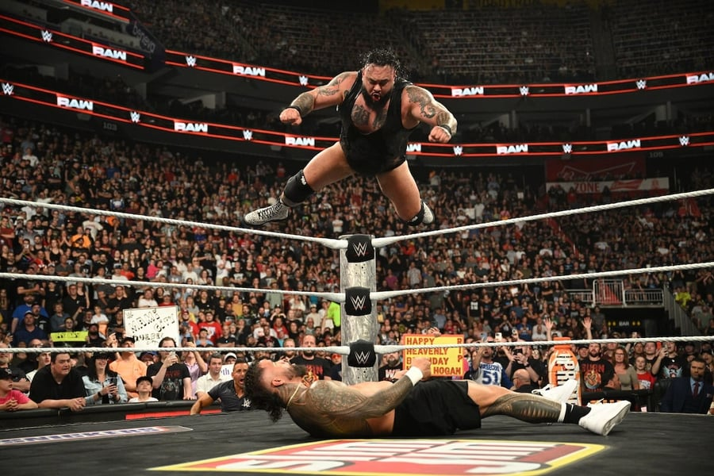
🌈Wraslin’

The standing situation is one of three core parts of the game, alongside guard work and pinning. The goal is the same as everything else in grappling: immobilize your opponent so you can strangle or break them. From standing, this means getting them to the floor.

What are we actually doing?

The job is simple to describe: attack the periphery (head, arms, legs) to gain access to center mass (hips, chest, shoulders, back), then use your connections to take their feet off the floor. Every takedown ever done — whether a double leg, a trip, or anything else — follows this pattern.

The hips are the most important target. Greg calls them "the seat of balance and power." If you affect the hips, you affect the whole system.

Hand fighting comes first

Before you can get to the hips, you have to get past the hands. The hand fight has two simple rules:
- More connections is better than fewer (two hands on them beats one)
- Getting in between, under, or behind their elbows creates structural unevenness in your favor

Once you win the hand fight, access to the legs and hips opens up.

How to develop this skill

Not through drilling technique, but through live games with clear tasks.

👹 Wraslin’ with Greg Games

👹 Wraslin’ with Greg Games

Standing Grappling CLA @ Game Theory/Hilti BJJ Seminar with Greg Souders

Game 1: Hands Down / Knee Touch Snapdown entry — head height dictates leg availability
Starting position: Both players standing, hand fighting.
Farm as many points as possible:
- Make your partner's hands touch the mat
- Touch behind your partner's knees
- Connect your hands around partner’s body
Design rationale: "There's a relationship between his ability to defend his legs and his ability to defend his head. When his head is low, legs are unavailable. When the head is high, the legs are available." Combining knee touches with hands-down forces the partner to defend the legs by dropping their head and hands into position for a snapdown.

Game 2: Closed Hands Snapdown + clinch entry — two ways to win
Starting position: Both players standing, hand fighting.
Objective — two ways to win:
- Collect 3 points (hands to mat or grip behind the knees, same as Game 1), or
- Achieve any closed-hand connection around the partner's head, body, or leg
Note: Either win condition counts. Mix and match focus as you see fit.

Game 3: Foot Sweeps Foot-to-foot contact as entry for sweeps — roles assigned
Starting position: One player with an underhook, one with an overhook.
Overhooking player objective (continuous):
- Keep the overhook at all times
- Move the partner around using both hands
- Make foot-to-foot contact on either leg, inside or outside — stick and follow it
Win condition (terminal): Partner falls.
Underhooking player objective (terminal):
- Achieve a closed-hand connection anywhere below the armpits down to the ankles
- Grabbing the hand does not count
On a fall/win: Switch roles, reset.

6. Standing — Connection Cycling (Knee / Hip / Ankle)
Starting position: Single leg connected around the knee pit.
Attacker (continuous):
- Stay connected at all times
- Destabilize partner (move them toward hands or hips)
- Continuously cycle connection between knee → ankle → hip on either leg, as often as possible
Defender:
- Keep hands on partner (off the mat)
- Keep partner in front
- Win by freeing all connections and getting both feet on the floor

7. Single leg finish
Starting position: Single leg connected around the knee pit.
Attacker (continuous):
- Takedown (hip or knee touching the mat for 3 seconds)
- Focus on lifting the ankle as high as possible or double leg control
Defender:
- Free yourself of all connections while standing

Finishing the shot
Have You Ever Seen A Wrestling Drill Like This? | Standard Jiu-Jitsu Wrestles With CLA

Dynamic Starts Alternating dynamic starts: round 1 attacker has hands behind back, round 2 attacker is turned around.
Starting Position: Both players moving freely. Attacker begins either with hands behind back or turned around (alternating each round).
Attacker objectives (terminal, in order):
- Finish the back take
- Finish the back down pin (chest-to-chest, hips covered)
- Finish the submission
Defender objectives (terminal):
- Counter: get on top, go behind, or submit
- Negate: break all connections once the attack begins
- Defender may not use hands until the attacker makes first connection — once contact is made, the round is live
Design rationale: "Dynamic starts" lower the barrier to entry — they let the shooter get in deep, which forces the defender to engage once the takedown is imminent rather than before contact is made. "Once that connection starts, that starts the fight."

Greg @ b-team

Standing Game 1 – Hand Fight: Collect & Connect
Starting position: Standing, hand fighting (any grip)
Precursor (must complete before winning):
- Collect 3 touches total: any combination of
  - Partner's hands to the mat
  - Behind the knee touches
Win condition (terminal): After collecting 3 touches → land any closed hand connection
Resets: Start again each time someone wins.

Standing Game 2 – Stay Connected: Put Them Down to Switch
Starting position: Standing, already connected in one of three positions:
- Front headlock
- Tight waist
- Single leg
Attacker objective:
- Stay continuously connected, cycling between the three connection points
- Precursor to switching grips: Must get partner's one or both hands to touch the mat before switching to a new connection point
Defender objective:
- Break the connection and turn to face
- If knocked to hip: must get back up (no staying on the floor)
Win condition: Continuous — defender wins each escape; roles swap on each escape.

🥜 PJ Barch Session

🥜 PJ Barch Session

How To Train Like An ADCC Athlete - PJ Barch Runs Practice

Game 1 — Hand Fighting / Inside Position (Standup)
Starting position: Both players standing, neutral
Both players — same objective:
- Win: Get your elbows inside your partner's elbows and your head on your partner
- Bonus task: Once inside with head connected, do a shuffle step forward to create urgency for the partner to re-establish position
Warm-up game. No terminal win condition — continuous.

Game 2 — Guard Pummeling (Elbows vs. Feet)
Starting position: One player standing, one player on their back in front of them
- Top (standing): Keep elbows inside partner's feet/shins. Work back inside when partner reclaims position
- Bottom: Keep feet inside top's elbows, push on biceps/shoulders
Continuous — no terminal win condition. Positional pummeling game.

Game 3 — Takedown to Back Control
Starting position: Standing, connected (rotate through: single leg, double leg, body lock)
Precursor: Top player takes partner down cooperatively. As soon as hips hit the mat, the game begins.
- Top: Keep bottom player's knees facing the ceiling immediately off the takedown → terminal win. If bottom gets knees to mat, score via hooks in, body triangle, or guard pass
- Bottom: Get knees facing the mat as fast as possible → then get to feet or on top to escape
"That's why I made the win conditions for this guy to either be on top or to be on his feet facing — we're punishing people for bad back takes when we turtle."

Game 4 — ADCC Simulation Round
Format: 4-minute round. First 1 minute = no points (use it to establish position). Final 3 minutes = points active.
- Both players: Score via ADCC rules (takedowns, guard passes, back takes, sweeps). Submission ends the match.
- Focus: Pacing, risk management, staying disciplined with hand fighting when tired
Terminal: submission or most points after 4 minutes.

Game 5 — Down Two Points (Bottom Pressure)
Starting position: One player on bottom (two-feet-in guard), one player on top
Scenario: Bottom player is down by 2 points with 2 minutes left.
- Bottom: Must score at least 2 points (sweep, takedown) or submit — any score likely wins
- Top: Maintain position, stay active to avoid stalling calls, protect the lead
"There's going to be times where you're down and you're on bottom and we need to find a way to get on top... put yourself in the place of like you're in that match and you're down by two points cuz I know you guys have all been there before."

Game 6 — Hand Fighting / Inside Position (Post-Round)
Starting position: Both players standing, after a hard round (tired)
Both players — same objective:
- Win: Get inside elbow position with head connected + shuffle step forward
- Lose: Partner touches behind your knees, or partner is inside you moving forward
"We need to be sharp with our hand fights from that moment. If we go in a little bit lazy... and let the guy get in on our legs, they just scored."

🪝 Overhook / Underhook

🪝BJJ CLA Games – South Bay 10th Planet

10th Planet South Bay Full CLA Practice

Game 1: Overhook/Underhook – Sticking and Connecting
Starting position: Standing, clinch – one player has overhook, one has underhook. Neither can remove their hook.
Overhook player (no win condition – continuous task)
- Stick feet to partner's feet and follow them
- Use the overhook to get partner's hands to touch and stay on the mat
Underhook player (terminal win)
- Get hands connected anywhere from under partner's armpits to their ankles
- Win → roles switch

Game 2: Stick and Pull
Starting position: Same as Game 1 – overhook/underhook, standing.
Overhook player (terminal win – two options)
- Stick and pull in any direction (feet, body, open hands) to put partner on their butt or back
- OR capture partner's head and connect hands around it → instant win
Underhook player (terminal win – two options)
- Precursor: get hands connected first, then:
- Split and twist – step between partner's legs and twist them to their back
- Block and lift – block a leg and lift to make partner hit butt or back
Win → roles switch

Game 3: Upper vs. Lower Body
Starting position: Standing, free movement.
Shooter (terminal win – two paths)
- Get connected to a leg, then either:
  - Get out to the ankle and put it in the armpit
  - Get connected to the hips, then: lift both feet off the ground OR get behind
Upper body player (terminal win)
- Can only connect hips-to-arms or hips-to-shoulders – no touching legs
- Uses overhook/underhook, stick and pull, block and twist/lift from Games 1–2
- Must put partner on their butt or back to win
Win → roles switch

🧑‍🤝‍🧑 Standing with Scott

🧑‍🤝‍🧑 Standing with Scott

Ecopalooza Spring 2024: Standing Practice for Beginners w/ Coach Scott Sievewright

1. Get to the Back
- Both players: Try to get behind your partner
- Win: Secure the back → point, reset
- Continuous

2. Frame Game (1-1-2 format)
- Attacker: Get hands connected around partner's leg or trunk (single leg or body lock)
- Defender: Use frames to prevent attacker's hands from connecting
- Win: Hands connected = attacker wins. Prevented = defender wins
- Format: One side attacks, then the other, then both

3. Over-Under Disconnect
- Attacker: From over-under, reach single leg or body lock
- Defender: Break to neutrality
- Win: Connection to body = attacker. Neutrality = defender
- Flip-flop roles on each point

4. Back → Single → Back (continuous)
- Attacker: Start from back body lock, go to single leg, return to back – repeat as long as possible
- Defender: Escape to neutrality
- Win (defender): Reach neutrality

5. Two-on-One to Single
- Attacker: Establish a two-on-one, convert to single leg
- Defender: Break out / maintain neutrality
- Tip given: The closer the leg is to the arm, the better

6. Catch and Release Wrestling (closing)
- Both: Full standup wrestling, no takedowns to the floor
- Win: 1-2-3 control = point, reset
- Multiple rounds, new partner each time

🙌 Grip fighting
Have more grips than them

Starting Position: Both players standing, handfighting.
Both players continuous:
- Have more grips on your partner than they have on you
- Can only grip from wrist to armpit

🦄 Passing

🦄 Guard Passing

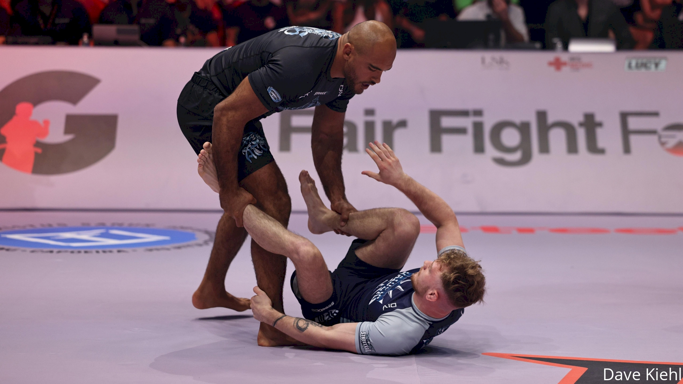
The sequence never changes:
Feet → Knees → Hips
Every pass that has ever worked followed this order in some way, regardless of style, body type, or technique used. You cannot skip a line. You cannot get to the hips without first dealing with the knees, and you cannot deal with the knees without first clearing the feet.

Top player — work through three stages:
- Clear the feet — this is the non-negotiable first step. Nothing else is possible until the feet are off you. It doesn't matter whether you grab them, push them, or move around them — they have to stop being a problem before anything else can happen.
- Hold the line at the knees — once the feet are cleared, step inside or outside the knees and stay there. You need to exist at this line long enough to create an opportunity to advance. This is not passive — the bottom player will constantly try to reset, so holding the line requires continuous work.
- Surround the hips — get any two parts of your body around either side of the opponent's hips. It doesn't need to look a specific way. A hand and a knee, two arms, a chest and a leg — if the hips are surrounded and the opponent is held down, the pass is happening.

Bottom player — two jobs that make passing impossible if done well:
- Keep feet on the inside → inside position denies the top player clean access to the knees, and as long as the feet are in between, entanglements remain available. The top player has to deal with this before they can advance, which is why fighting for inside position is so central to guard play.
- Destabilize the top player toward their hands or butt → the bottom player is always carrying weight, which is fatiguing over time. By using connections to make the top player fall forward onto their hands or back onto their butt, the bottom player relieves that weight, disrupts the top player's structure, and creates space to reset or attack.

How to think about it in practice:
- Start by just learning to keep the feet off you while staying on your feet — this single focus already contains most of what passing requires
- Then add holding the line at the knees — step inside or outside and fight to stay there
- Then add surrounding the hips as the end condition — now you're playing the whole passing game

Why technique doesn't matter as much as you think:
- A pass works because the conditions were met, not because the technique was executed correctly
- When a pass fails, it's almost always because one of the three lines wasn't actually cleared — the feet were still on you, the knees were never held, or the hips were never surrounded
- Different body types, strengths, and styles will produce different looking passes — but they all fulfill the same conditions
- You don't need to memorize specific passes. Learn to fulfill the conditions and the solution will organize itself from there

🐼 Passing Games w bacward progression

🐼 Passing Games Series with Backwards progression
Three conditions to pin: chest-to-chest or chest-to-back contact, be under both elbows and cover hips and shoulders simultaneously
Greg Souders Seminar Session 1: Passing and Pinning (10th Planet South Bay)

Game 4: Completing the Full Pin — Side
Starting position: Partner on their side. Top player hands connected around partner's waist.
Top player (terminal — any order)
- Chest-to-chest or chest-to-back contact
- Get under both elbows with connected hands
- Cover the hips
Bottom player (terminal — three options)
- Get both legs back in front, or roll top player over, or stand up

Game 5: Segmentation to Pin
Starting position: Same as Game 4.
Win conditions: Same as Game 4.
Top player task focus (in sequence)
- Remove partner's hands
- Get under or behind the elbows
- Connect to shoulders and cover hips to win
Bottom player (terminal — same three options as Game 4)
Game 6: Standing to locked hands
Starting position: Top player standing with one leg between partner's knees, hands on partner's stomach. Bottom player supine.

Top player (terminal)
- Stay on top and hold partner down
- Connect hands around partner's hips or shoulders in any closed-hand connection to win
Bottom player (terminal)
- Make top player hit their butt

Game 7: Denying the Feet — Fully Disconnected
Starting position: Top player completely disconnected and standing in front of partner's legs. Bottom player supine (doesn't have to stay there).
Top player (terminal)
- Keep partner's feet off of you
- Step between or outside partner's knees
- Connect hands around hips or shoulders to win
- Hold partner down throughout
Bottom player (terminal)
- Connect with hands and feet on top player, or make top player hit their butt

Game 8: Full Process — Seated Start
Starting position: Partner seated. Top player standing, disconnected.
Top player (terminal — all conditions must be met)
- Put partner on their back or get behind them
- Then: chest-to-chest or chest-to-back contact, connected hands around shoulders, and hips covered
Bottom player (terminal — two options)
- Make top player hit their butt, or stand up and connect around top player's body while standing

🫳 Wrist pin passing

🫴Wrist pin passing
CLA Wrist Pin Guard Passing @ Enso Jiu-Jitsu Seminar

Game 5: Clearing Frames
Half guard — top player fights frames to close distance
Starting position: Half guard. Bottom player on their side, both hands on top player's chest. Top player leaning in. No knees as frames allowed for bottom player.
Top player (terminal)
- Pin one of bottom player's wrists to their own hip
- Get your own other arm across the body and make chest-to-chest contact
- May not pass through the legs
Bottom player (no win condition)
- Keep frames extended to hold top player away
- Must keep half guard closed — no knees as frames

Game 6: Getting Under Elbows
Half guard — top player uses wrist control to sneak under elbows
Starting position: Same as Game 5, but top player starts with one wrist already pinned to hip and your own other arm across the body. Alternate which wrist is controlled each round.
Top player (terminal)
- Maintain wrist pin while getting under at least one elbow and connecting hands
Bottom player (terminal — two options)
- Get both feet back to the middle of partner's knees, or
- Use knees to make top player fall over

Game 7: Clearing the Knee
Half guard / open guard transition — combines wrist control with leg entry
Starting position: Top player has one knee cutting through, bottom player's both knees in front. No hands on each other.
Top player (terminal)
- Control wrists and cover hips, then use any opportunity to get under at least one elbow, get chest-to-chest, and lock hands
- May stand up if wrist control is maintained
Bottom player (terminal — two conditions must both be met)
- Put top player on their butt and get both feet inside holding both ankles (going under or around)

🏕️ Outside camping

🏕️ Outside camping

4. Standing vs. Supine — Knee Line Control (Progression A)
Starting position: Bottom player on back. Top player standing, starting with hands on partner's feet, in front of the feet.
Top player (continuous):
- Move feet out of the way and advance to the line of the knees (inside or outside)
- Hold partner down from that position
- Constraint: Cannot lower chest to chest contact or put both knees on the floor
Bottom player (terminal wins):
- Sit up off the back
- Get both feet inside (between) partner's legs and maintain it
- Make top player's butt hit the floor

5. Standing vs. Supine — Outside Knee Line (Progression B)
Starting position: Top player already at knee line, outside partner's legs. Hands on partner's feet.
Top player (continuous):
- Same as above but must specifically maintain position outside partner's legs
- Same constraint: no chest-to-chest, no knees on floor
- Focus on pulling their head close to you to negate leg pummeling
Bottom player (terminal wins):
- Get both feet back in front of and connected to top player
- Get both feet inside partner's legs
- Make top player's butt/back hit the floor
- Constraint: No leg entanglements — open foot connections only (posts, hooks). Cannot commit all attachments to one leg.
- Sitting up is allowed only to improve connection, not as a win condition

https://www.youtube.com/watch?v=rv7_sUfup9o

Game 2: Line Holding
Starting position: Bottom player supine, top player past the feet (shin on same-side hamstring or outside past feet)
Top player objective (continuous — no win):
- Maintain position past the feet for the whole round
- Cannot put knees down
- Cannot go chest-to-chest (chest-to-back is allowed)
Bottom player wins by:
- Making top player's hip touch the mat (any contact = flip)
- Getting up to feet
Task focus: Keep feet off your body and off the mat. "If the bottom player made your hip touch, that means their feet were on you somehow."

🧑‍🦼 Double under passing

🧑‍🦼Double under passing
CLA Double Under Passing @ Next Level MMA - Coach Greg Souders

Game 1: Staying Behind the Knees Maintaining double under position against an active guard player
Starting position: Top player with both arms under partner's knees, hands open. Bottom player in guard.
Top player (continuous):
- Keep at least one arm behind the partner's knees at all times
- Can play anywhere hip to hip, open or closed hands
- If a leg is lost, fight back to at least one arm under
Bottom player — three ways to win (terminal):
- Get both feet to the inside of the top player's arms or legs
- Make a closed leg connection around the top player's shoulders (or head and arm)
- Sit up and push away, disconnecting completely
Design rationale: Double unders chosen over single because the margin between staying engaged and losing the position is wider — you can transition between double and single while remaining in the task. Gives less experienced players more time to explore.

Game 2: Connecting Hands Past the Hips or Shoulders Working from double unders to a controlling grip past the legs
Starting position: Same as Game 1.
Top player (terminal):
- Maintain at least one arm behind a knee while working
- Connect hands past the partner's legs — around hips or shoulders, any facing
- Flipping the partner over counts as long as hands connect past the legs
Bottom player — same three win conditions as Game 1
Design rationale: Hips and shoulders are strong points of connection that manage rotation. In positions where rotation is possible, connecting there stops the bottom player from moving — regardless of whether you use double under, over under, or single under to get there.

Game 3: Getting to the Knees from Standing Earning the double under position from further away
Starting position: Top player standing behind partner's feet. Bottom player on back.
Top player (terminal):
- Keep the partner's feet in front while working any part of the body behind the partner's knee pits
- Once behind the knees: connect hands past the legs at hips or shoulders to win — same finish as Game 2
Bottom player — two ways to win (terminal):
- Get both feet to the inside
- Trap the top player's shoulders with the legs
- Sit up and away, disconnecting
Note: Feet-to-inside-the-biceps removed as a win condition — at this starting distance it becomes the obvious go-to solution and would shortcut the intended experience of fighting past the feet.

🦚 Outside passing @B-Team

🦚 Outside passing

Guarded Game 1 – Open Guard: Pass the Outsides
Starting position: Bottom player belly up in open guard, top player standing
Precursor (top player):
- Get to the outside of one side of partner's body, making contact with your leg on the side of their body
- Then do the same to the other side
- Then back to the first side
- Must be alternating (left-right-left or right-left-right), but not necessarily consecutive
Top player win condition (terminal): After completing the 3-pass sequence → close hands anywhere from hips to shoulders (chest-to-chest or chest-to-back)
Bottom player win conditions (either):
- Make top player's butt touch the mat
- Get up and wrestle into any close hand connection

Guarded Game 2 – Open Guard: Pass the Insides
Starting position: Same as Guarded Game 1 — belly up open guard, top player standing
Precursor (top player):
- Get between partner's feet and contact either knee pit with one leg
- Repeat with the other leg
- Repeat once more (alternating, 3 total)
Top player win condition (terminal): After completing the 3-pass sequence → close hands from waist to shoulders (chest-to-chest or chest-to-back)
Bottom player win conditions: Same as Guarded Game 1 — put top player on their butt, or get up into a close hand connection.

🐃 Guarded games with forward progression

🐃 Passing games with forward progression

Guarded Work – Example Games

Game 1 – Feet Off (Warm-up/opener)
Setup: Bottom player lies on back, feet pointed at top player. Top player stands in front.
Top player (continuous): Stay on your feet, keep at least one hand connected to your partner at all times, and keep their feet off of you. No chest-to-chest, no double knees down.
Bottom player (terminal): Use hands and feet to connect to top player and make them fall on their butt. Butt touches the mat = bottom player wins.
Switch top to bottom every time bottom player wins.

Game 2 – Inside Position
Same rules as Game 1, but now add:
Top player: Try to get one leg between your partner's knees and keep it there. If it comes out, fight to get it back.
Bottom player: Try to get both feet to the inside of your partner's knees, then use that to make them hit their butt.

Game 3 – Cover the Hips (progression)
Same rules, but now:
Top player: Clear the feet, advance to the knees, then cover/surround your partner's hips with any two parts of your body (hands, knees, elbows – doesn't matter). That's the win.
Bottom player: Same as before – make top player hit their butt.

source: ecopalloza scaling task and design

💂 Guard

💂The Guard

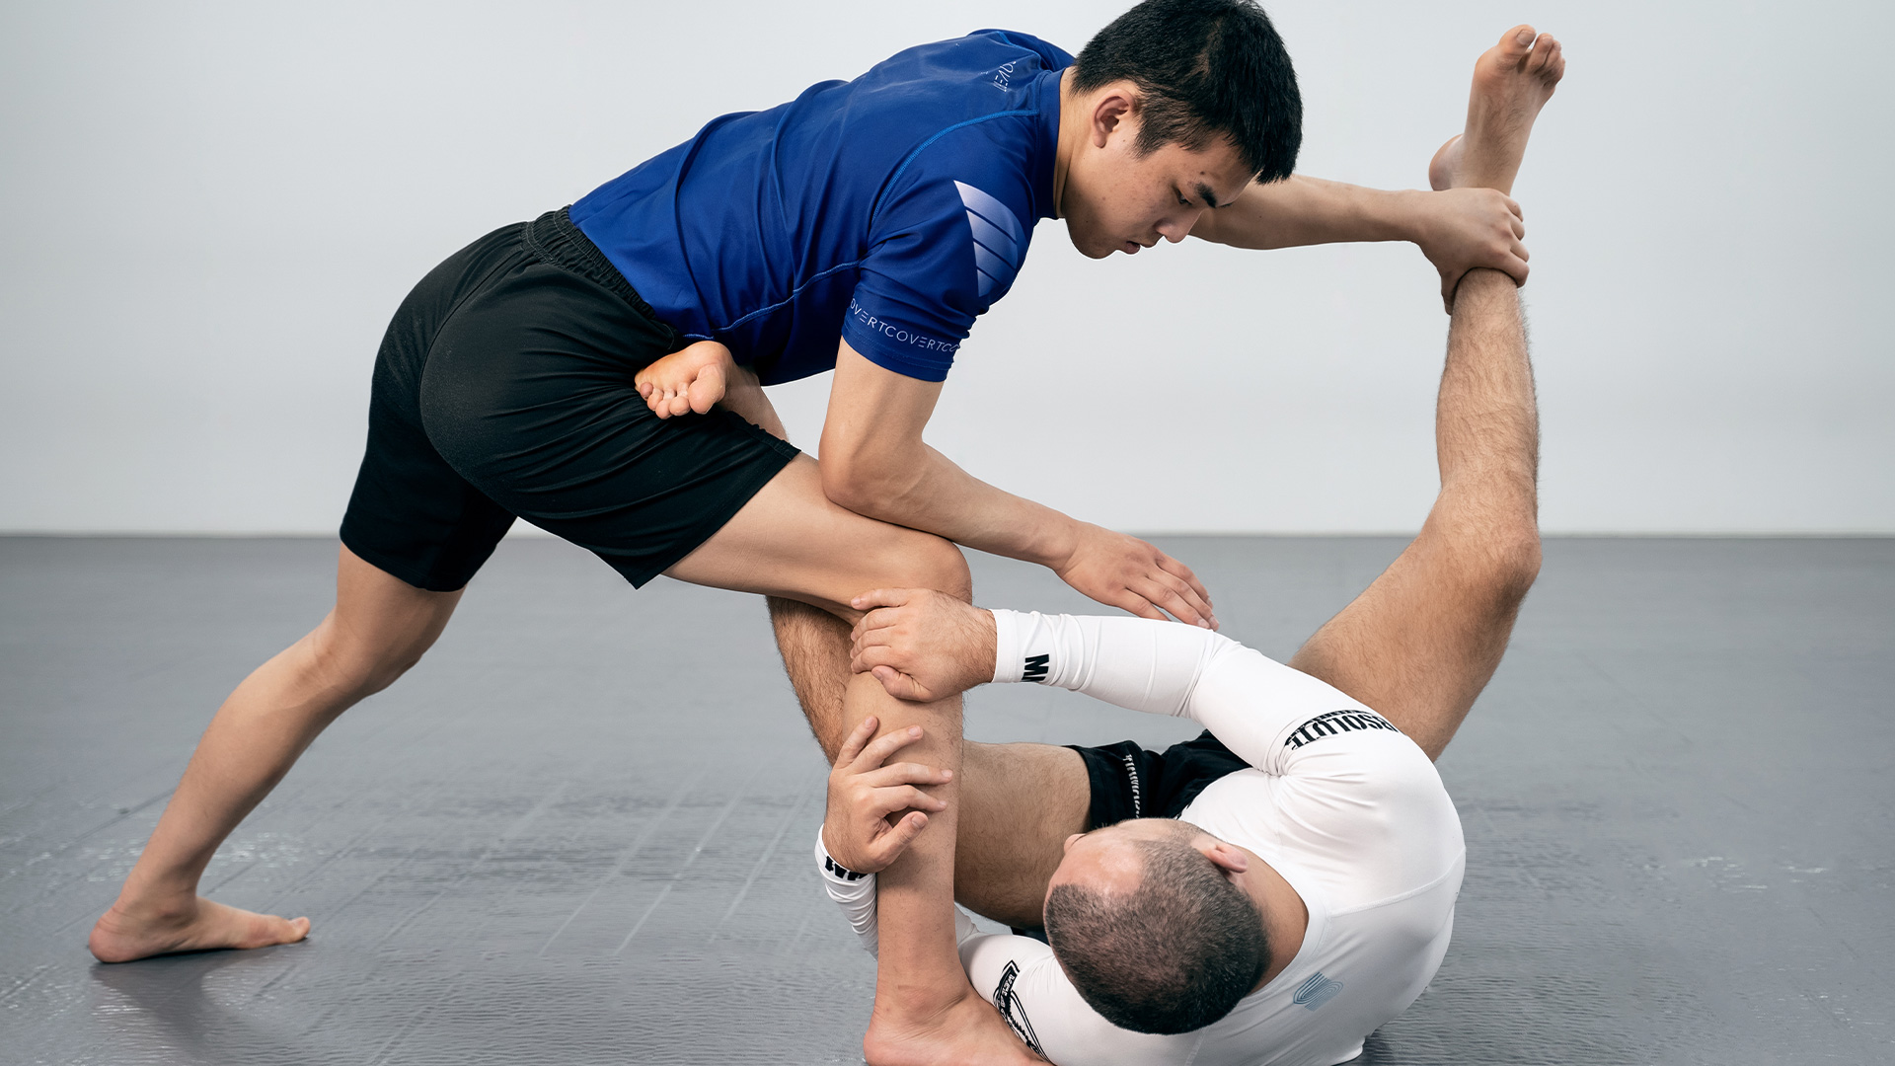
The guard occurs when a bottom player is on the floor with their legs between themselves and the top player. It is not a static position but an active system built around one foundational skill: making and maintaining connection to manage distance.

The Two Orientations
Inside position — feet are in between the partner's knees. This enables direct forward and backward engagement and creates the conditions for entanglements.
Outside position — feet are on the outside of the partner's body. This affords rotation and flanking movement around the partner.
All guards, regardless of their specific shape or name, share the same initial function: making and maintaining connection to manage distance.

Seated vs. Supine
Seated guard is highly mobile, allowing quick movement in all directions, but produces relatively weak connections.
Supine (belly up) guard is less mobile, but allows maximum attachment through both legs and arms simultaneously.
In practice, the seated position is typically used to quickly make an initial connection, after which the player transitions to supine to establish stronger control.

The Primary Job of the Guard Player
The bottom player is carrying weight. On a long enough timeline, this is fatiguing. The guard player's priority is therefore destabilization — using their connections to make the top player fall toward their hands or hips, offsetting that weight and creating opportunities to progress position.

🍑 Buttscooting

🍑 Seated guard
Game 1: Denying supine guard
Starting position: Bottom player seated guard against standing passer.
Bottom player (terminal win conditions):
- Avoid getting put on your back, you lose if you are on your back without an established guard
- Standing up and free yourself from any connection
- Destabilise your partner to their butt or both hands touching the mat
Top player (terminal):
- Stay standing
- Put the guard player on his back without an established guard

Game 2: Destabilising or wrestling up from seated guard
Starting position: Bottom player seated guard against standing passer. Focus and difficulty can be changed by starting with grips in place. Ie. Russian 2on1, arm drag etc.
Bottom player (terminal win conditions):
- Destabilise partner to their butt or both hands touching the mat
- Wrestling up to a strong closed hand connection with both standing
Top player (continuous):
- Stay standing
- Get to the outside of the bottom player's legs and stay there for as long as possible

Wrestling Up from Connection
Starting Position: One player seated, one player standing

Bottom Player (Seated)
Task Focus (in order):
- 1st priority: Keep top player's hands off of you — remove them as soon as they reach in
- 2nd priority: Make leg-to-leg connections (combination of legs and hands)
Precondition before win condition: Must establish connection to a leg or legs first
Win conditions (either):
- Go belly up to destabilize partner → then achieve hip entanglement (standard or otherwise) OR get partner's hands to mat
- Wrestle up from connection all the way to partner's hips
Both destabilization and entanglement must be present — order doesn't matter, but both conditions must be met.

Top Player (Standing)
Objective: Work to the outside of the legs, put bottom player on their back
Win condition:
- Achieve shin-to-body contact anywhere from hips to shoulders

Design note: Starting with just the connection-and-destabilize task can be isolated for a while before adding wrestle ups and entanglements. The idea is to set a specific condition first, then layer in more options once that skill is established.
https://www.youtube.com/watch?v=kmU390aEbFQ

Game 1: Seated Handfight
Starting position: Top player standing/kneeling, bottom player seated
Top player wins by:
- Connecting hands around bottom player's upper body (headlock, body lock — anything connecting at hips or shoulders)
- Making both of bottom player's shoulders touch the mat
Bottom player objective (continuous — no win):
- Prevent top player from connecting
- Stay seated — cannot stand, cannot sweep
- Use all limbs; harass top player's feet with legs as the longest tool
- No closed fists
Constraints: Bottom player cannot stand or sweep. Top player wins = flip roles.
Task focus: Inside position, more connections on him than he has on you.

Siargao Full

🦦 Supine Open guard

🦦 Supine Open Guard Series

Greg Souders Seminar at Black Flag Jiu-Jitsu

Game 3: Guard Retention — Stay Connected
Starting position: Bottom player on back, both hooks between partner's knees, one hand on each ankle. Top player standing.
Bottom player
- Keep tops or bottoms of feet touching partner anywhere on their body
- Keep hands connected to partner's body
- Push/pull partner with feet freely
- No win condition — survival/maintenance only. No resets.
Top player
- Win: Get both legs to the outside of bottom player's legs with all connections broken
Change top/bottom every time top player wins.

Game 4: Competing Destabilizations
Starting position: Same as Game 3.
Bottom player — win by:
- Causing 3 total destabilizations (any combo): partner's hands touch mat (initiated by bottom player) OR partner's butt touches mat
- Same foot-contact focus as Game 3
Top player — win by:
- Getting outside the legs 3 times, alternating sides (left → right → left or right → left → right)
- Each time: get both feet outside and touch partner's body with shin
- Must alternate sides — cannot repeat same side consecutively
Whoever hits 3 conditions first wins. Change top/bottom.

Game 5: Guard to Hip Control
Starting position: Same as Game 3.
Bottom player — win by any of:
- Wrestle up to standing
- Push partner to butt AND get hands connected around their hips (entanglement)
Continuous: if partner stands after being pushed down, return to guard and keep playing.
Top player
- Win: Clear the feet (inside or outside) and lock hands around partner's hips/waist
Change top/bottom every time someone wins.

Game 6: Inside Position vs. Leg Entanglement
Starting position: Bottom player on back with feet between partner's legs and hands on partner's ankles. Top player standing.
Bottom player — win by:
- Entangle one leg (any entanglement: both feet outside, both feet inside, or foot-and-knee)
- Stay connected, disentangle, then entangle the other leg
Top player
- Win: Get both feet to the inside of bottom player's legs at any time
Change top/bottom every time someone wins.

5. Butterfly Guard — Inside/Outside Position
If the conditions for a technique are not present, the effect cannot happen. This game trains the conditions that make butterfly sweeps possible.
Bottom player sweeps; top player clears to outside
- Start (alternating each turn):
  - Both feet inside
  - One foot inside, one outside with a hand on the ankle
- Bottom: Use feet and hands in any orientation to get partner's butt to hit the mat
  - Win: Partner's butt touches mat in any orientation
- Top: Get both legs to the outside of partner's feet and touch shin to their body
  - Win: Shin touches partner's body with both legs outside their feet

🧓 Halfguard

🧓 Halvguard

Ecopalooza Spring 2024: Front Headlocks & Leg Entanglements w/ Coach Greg Souders

Game 4 — Knee Shield Half Guard: Destabilize
Starting position: Knee shield half guard — bottom player's knee between them and the top player. Two legs interacting with one at all times.
Bottom player:
- Use connections (hands, knees, feet) to make top player's hands or hips touch the mat
- Must stay in half guard — two legs interacting with one
- No win condition — continuous task
Top player:
- Make chest-to-chest or chest-to-back contact
- Win = chest contact → reset, switch roles
"If your head is high your legs are available, if your head is low you are easier to snap down" — same principle applies: getting close immobilizes the bottom player, so they must prevent it.

Game 5 — Knee Shield Half Guard: Feet to the Inside
Starting position: Same as Game 4.
Bottom player:
- Destabilize (hands or hips to mat)
- Precursor: During destabilization, get both feet to the inside of top player's knees
- Win = both feet inside
Top player:
- Chest-to-chest or chest-to-back contact
- Win = chest contact → switch roles

Game 6 — Knee Shield Half Guard: Full Entanglement
Starting position: Same as Game 4.
Bottom player:
- Destabilize (hands or hips)
- Get feet to the inside
- Connect both legs to opponent's hips (inside, outside, or mixed — any connection)
- Win = attached to hips with both legs
Top player:
- Chest-to-chest or chest-to-back contact
- Win = chest contact → switch roles
"All entanglements rely on inside positioning — inside position gives me access to your hips, there's nothing in between your hips and me."
Sonnet 4.6

Game 3: Segmenting to Pin
Siargao Full
Starting position: Half guard / top player already past the knees, bottom player framing
Top player wins by:
- Close connection at the shoulders (under one or both arms) AND past the legs — mount, side body, back mount all count
Bottom player wins by:
- Top player's hip touches the mat
- Getting up to feet
- Re-establishing closed guard
Constraints: Top player must stay ahead of each line — feet → knees → hips → hands/elbows → shoulders. "Stay ahead of your lines."
Task focus: Segment the periphery sequentially. Don't think side control or mount — think about what's directly in front of you and remove it.

🐊 K-Guard & DLR
🐊K-Guard & DLR
Hentet fra: CLA Guard Games @ Team Laurien and Alex - Standard Jiu-Jitsu

Game 1: K-Guard Getting inside position and putting the partner down before entangling
Starting position: Bottom player supine, both feet outside partner's hips, one hand gripping partner's knee. Top player standing. (K-Guard mot stående)
Bottom player (terminal win conditions, any order):
- Get feet inside and grip both ankles — either front-facing or rear-facing
- Put partner on the ground
- Only then: finish any entanglement
Top player (continuous):
- Stay standing at all times — if you fall to your knees, stand back up
- Keep hands on partner
- Stay on the outside of the bottom player's legs, foot to foot
Design rationale: Destabilisation is required before entanglement for two reasons. First, more time in position = more opportunity to recognise what's available. Second, safety — hooks and posts produce force through push/pull/lift; entanglements produce force through rotation. Rotation against a standing player is where beginners get hurt. Taking away entanglement against a standing player reduces that risk. The order of inside position and putting the partner down does not matter.

Game 2: DLR (vs. Standing) Same objectives as Game 1 but from a more constrained start
Starting position: Bottom player supine with one cross hook (foot crosses partner's centerline) and same-side grip on the ankle. Top player standing. (DLR mot stående)
Bottom player (terminal win conditions, any order):
- Get feet inside and grip both ankles — front-facing or rear-facing
- Put partner on the ground
- Only then: finish any entanglement
Top player (continuous):
- Stay standing
- Stay on the outside of the bottom player's legs for as long as possible

Game 3: Putting It All Together (from Closed Guard) Multiple win conditions reflecting the full range of connections explored
Starting position: Closed guard.
Bottom player — three ways to win (any order, no strict sequence):
- Any grip under the elbow + closed-hand connection to shoulder, head, or both shoulders
- Shoulder connection with head covered, or arm pulled out (head-and-arm trap between legs — doesn't have to be a triangle)
- Any entanglement — but partner must be grounded first (either grounded then entangle, or entangle as they're being grounded)
Top player (terminal):
- Get to feet, open the guard, and reach the outside of the bottom player's legs
- Win by touching the bottom player's body anywhere with the shin
Note: Players choose their own focus — shoulder connections, leg connections, or entanglements — based on what they want to develop.

🫂 Seated w upper body connection

🫂Seated w upper body connection
https://www.youtube.com/watch?v=EQ6GNe2tmXM&list=PLEmjNuJJkxDJDUg-UOFO_SpeKvusKIzmO&index=9

1. Stay Connected (Bottom Player Exploration)
Starting position: Bottom player on back/seated, top player in front
Bottom player:
- Keep hands connected at all times
- Hold partner as close as possible
- No win condition (exploration only)
Top player:
- Put both hands on partner's chest and push away
- Win by achieving separation (head to chest, grips broken open)

2. Connected Clinch – Put Partner on Back
Starting position: Same as above, alternating between three connections:
- Head and arm connection
- Both hands around shoulder
Both players:
- Win by putting partner on their back or getting on top / behind partner
Note: Highly constrained — only the given connections are allowed. Designed as discovery: "Trial to trial until you start to get a better understanding of the things that are present that let you either be successful or fail."

3. Arm/Wrist Control – Cause Posting
Starting position: Bottom player on back, top player above
Bottom player:
- Grip focus: partner's wrists, elbows, and hands (any combination)
- Goal: cause posting → get hands connected → get behind, on top, or put partner on back
Top player:
- Connect hands around partner
- Win by putting bottom player on their back or going around the legs to put them on back
- Constraint: Cannot stand up on both feet — one foot only

4. Head & Arm Trap – Ankle Cross
Starting position: Bottom player on back with partner's head and arm trapped between crossed ankles
Bottom player:
- Keep feet crossed (ankles only — no locking into the bend of the knee)
- Use hands to keep partner close
- Win condition: keep feet crossed AND arm trapped
Top player:
- Win by pulling arm out or separating partner's feet

5. Overhook Escape
Starting position: Bottom player with overhook connection, top player trapped
Bottom player:
- Keep body down, arms separated
- Win by getting head and arm fastened together (completing the overhook trap)
Top player:
- Put both hands on partner's chest and free the arm from the overhook
- Both conditions must be met to win

🦀 Crab ride

🦀Game 5: Hips to Shoulders (Crab Ride Progression)
Starting position: Crab ride (top player feet inside behind knees, partner facing away)
Top player wins by:
- First destabilizing to hands or hips touching mat, then advancing to hips
- From hips: destabilize again (hands or hips), then advance to shoulders (close connection past the legs)
Defending player wins by:
- Returning to seated guard
- Getting to standing neutral
Task focus: Two-stage destabilization — must make hands or hips touch before progressing to next line. "You must make the hands touch or hips touch before you try to go to the hips. Then once you get to the hips, you must make the hands touch or hips touch again before you get to the shoulders."

🐻 Pinning & Subs

🐻 Pinning and Submission: The Key Factors
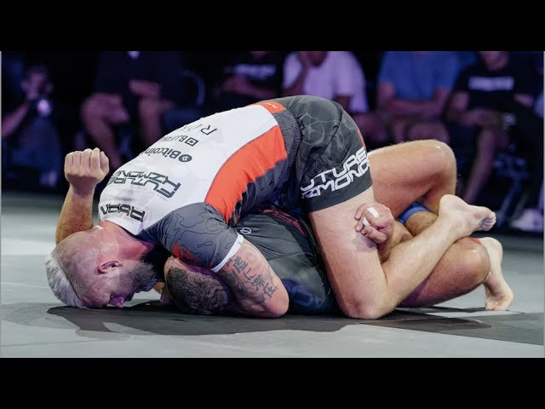
To pin someone, three things must always be present:
- Chest-to-chest or chest-to-back contact
- Hips covered
- Shoulders covered
The bottom player will always try to escape through four things:
- Limb extension — pushing you away
- Limb retraction — pulling limbs back to create space
- Rotation — turning to relieve pressure and face you
- Basing — pressing off the floor to get up
Understanding these four problems means you don't need a counter for every escape — you just need to stop what allows a body to get up.

To attack submissions, you must clear what's in the way:
- Arms and elbows protect the neck and shoulders
- Legs and knees protect the hips
- Work from the outside in — hands before elbows, feet before knees
The underlying principle: Immobilization leads to submission. You can't reliably finish someone you can't hold down, and you can't hold someone down without first understanding the physical conditions that make pinning possible.
Specific techniques are just expressions of these principles. The principles never change — the techniques always will.
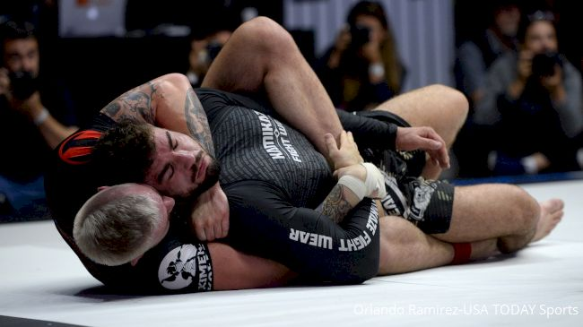

🐢 Turtle

🐢Turtle

1. Stay Behind / Back Control Entry
Starting position: Defender on hands and knees. Attacker chest-to-back, hands connected around defender's shoulders (under one elbow, over the other).
Attacker (continuous):
- Stay behind both of defender's elbows at all times
- Keep defender between your limbs
- One hook allowed at a time — both hooks simultaneously is prohibited
- Task focus: continuously drive defender's hands to the mat to prevent them from fighting your connections
Defender (terminal wins):
- Stand up and get both hands off the mat
- Turn to face the attacker (get attacker in front of either elbow)

🐖 Pinning

🐖 Pinning Games
Greg Souders Seminar Session 1: Passing and Pinning (10th Planet South Bay)
Three conditions to pin: chest-to-chest or chest-to-back contact, cover hips and shoulders simultaneously

Game 1: Holding Under the Elbows — Mount
Starting position: Mount. Top player with double underhooks (arms under both partner's elbows), hands connected.
Top player (continuous)
- Stay on top, keep hips and shoulders covered, maintain arms under both partner's elbows
Bottom player (terminal)
- Get both elbows back to touch their own body, or make top player fall off

Game 2: Getting Under the Elbows — Mount
Starting position: Mount. Hips and shoulders covered, but no underhooks.
Top player (terminal)
- Keep hips and shoulders covered and chest-to-chest or chest-to-back contact throughout
- Get both arms under partner's elbows and connect hands to win
Bottom player (terminal)
- Push on partner's hips and knees to get own knees back in front, or make top player fall off

Game 3: Stopping Rotation — Back Mount
Starting position: Chest-to-back. One arm over, one arm under partner's shoulder. No hooks allowed — legs can go anywhere on the back side of the body only.
Top player (continuous)
- Keep chest-to-back contact no matter where partner goes
- May switch grips freely — only constraint is no hooks
Bottom player (terminal)
- Remove partner's connections and turn to face

From Standard goes to b-team day 1

Pinning Game 1 – Get Under the Elbow
Starting position: Top player past the legs, hands locked around partner's hips, chest-to-chest, same side
Top player objective:
- Get at least one arm underneath one of partner's elbows
- Lock hands around partner's shoulders (chest-to-chest or chest-to-back)
Win condition (terminal): One arm under elbow + hands locked around shoulders = win
Bottom player win condition: Get back off the mat — sit up, stand up, or reverse the position. Top player keeps playing as long as bottom player's back remains on the mat.

Pinning Game 2 – Stay Under the Elbows, Submit
Starting position: Top player with double underhooks under partner's elbows, hips covered
Top player task focus: Stay under at least one elbow at all times — even a head counts
Loss condition (top player): Both of partner's elbows touch their own body simultaneously = top player loses, regardless of position or submission attempt
Top player win condition (terminal): Submit partner — but only while under at least one elbow. All submissions must be executed from underneath the elbow.
Bottom player objective: Bring both elbows to body to make top player lose.

10th Planet South Bay Full CLA Practice

Game 4: Hips to Shoulders
"The defending players' win conditions force the top player to hold them down the entire time. When we let go of the hips to go to the shoulders, we become vulnerable to movement and space."
Starting position: Floor – top player hands locked under partner's hips. Three alternating setups:
- Both feet in the middle, hands locked under hips
- One foot in the middle, partner on their side, hands locked around hips
- Both feet outside, facing partner, hands locked around hips
Top player (terminal win)
- Move from hips connection → shoulders connection
- Must get under at least one elbow and lock hands, either chest-to-chest or chest-to-back
Bottom player (terminal win – three options)
- Separate top player's hands, then:
  - Sit up and recover to seated
  - Reverse top player onto their back
  - Stand up

Game 5: Submitting While Under Elbows
"By forcing you to stay under at least one elbow, we're always forcing you to interact with the arm and neck together, giving more options for potential submission. If the elbows get to the body, all you can manipulate is the neck itself."
Starting position: Floor – chest-to-chest or chest-to-back, under at least one elbow. Alternate starting position every turn (any change in angle counts).
Top player (terminal win)
- Must submit partner
- Must maintain something under at least one elbow at all times (hands, head, leg, figure-four grips all count)
- Lose position under both elbows → instant loss
Bottom player (terminal win)
- Get both elbows touching their own body with nothing underneath → instant win

Pinning games 4 n00bs

Pinning Work – Example Games

Game 1 – Stay on Top, Hold Them Down
Setup: Start chest-to-chest, past the legs.
Top player (continuous): Stay on top and hold your partner down. Move around their body however you like, but don't let them up.
Bottom player (terminal): Push top player off and get your legs back in front of them.
Switch when bottom player gets their legs back in front.

Game 2 – Get Under the Elbows
Same setup, but now give the top player a win condition:
Top player: Stay on top, hold them down AND get one arm underneath your partner's elbows with hands connected = win.
Bottom player: Push on top player's hips and knees to create space and get legs back in front.

Game 3 – Scalable Version (for mixed-level groups)
Tell the room: "Choose your difficulty."
- Easy: Get one arm under your partner's elbows, connect hands = win
- Medium: Get both arms under your partner's elbows, connect hands = win
- Hard: Get both arms under elbows, connect hands, AND cover the hips = win
Bottom player's job stays the same across all three: create space, get legs back in front or reverse top player.

🤑 Pin to submission

🤑Pin to submission

1. Mount — Under Elbow Control to Submission
Starting position: Mount. Top player starts with underhooks (under at least one elbow). Bottom player actively resisting (not already bound).
Top player (terminal win — submission):
- Stay on top, hold down
- Playable condition: Must remain under or behind at least one elbow with any body part at all times
- Precursor: Head and arm must be bound (arms or legs) before submitting — break or strangle both allowed
- Losing both elbows = automatic loss if not back control
- ** Back control with hooks/body triangle counts as under elbows
Bottom player (terminal win):
- Free your elbows or/and escape back control
- Focus on causing posting from top player to gain space to retract elbows

2. Mount — No grips to Submission
Starting position: Mount. Bottom player starts with forearm across the hip frame.
Top player (terminal win — submission):
- Stay on top, hold bottom player down
- Precursor: Must have head and arm bound together (arms or legs) before any submission attempt
- Submission type doesn't matter (break or strangle)
Bottom player (terminal wins):
- Get feet in front (to guard)
- Reverse the position

💪 Armbar

💪 Armbar Games — Immobilization & Isolation
Six games progressing from low to high variability (finish position → mount)

Games 1–3: Immobilization
Top player's sole job is to stay close to the shoulder and hold partner down

Game 1: Holding the Breaking Position
Starting position: Armbar breaking position — one leg over head, one under armpit. Any connection (elbow-to-elbow recommended).
Top player (continuous)
- Stay as close to partner's shoulder as possible and hold them to the floor
Bottom player (terminal)
- Pull arm free from top player's legs, or get back off the mat

Game 2: Holding from Above the Shoulder
Starting position: From armbar position, uncover head, tuck shin behind partner's head (knee touching head), transition body on top and base on the other side.
Top player (continuous)
- Stay on top, stay close to shoulder, hold partner to the floor
Bottom player (terminal)
- Pull arm free, or make top player hit their back

Game 3: Holding from Mount
Starting position: Mount with double underhooks (arms under partner's elbows), hands connected.
Top player (continuous)
- Stay on top, hold partner down, keep arms under partner's elbows
Bottom player (terminal — two options)
- Pull elbows in to touch their own body, or make top player fall off

Games 4–6: Immobilization + Isolation
Top player now also works to separate the attacked arm from everything else

Game 4: Isolating the Arm — Breaking Position
Starting position: Armbar breaking position. Any connection.
Top player (continuous)
- Stay on top, hold partner down, and separate partner's hands — keep them separated
Bottom player (terminal)
- Pull arm free, or make top player fall over
- Continuously try to reconnect hands to anything (body, leg, other arm)

Game 5: Isolating the Arm — From Above the Shoulder
Starting position: Same transition as Game 2 — body on top, basing on other side.
Top player (continuous)
- Stay on top, hold partner down
- Cover partner's head and transition to armbar breaking position
- Once there: separate and isolate the arm from everything else
Bottom player (terminal)
- Pull arm free, get back off mat, or get on top
- Continuously try to reconnect hands once separated

Game 6: Full Process from Mount
Starting position: Mount with double underhooks, hands connected.
Top player (terminal)
- Stay on top using underhooks
- Choose one arm, get your whole body behind both partner's elbows
- Trap both arms between your connections (arms and legs)
- Cover head and reach the armbar breaking position to win
Bottom player (terminal)
- Free both arms so both elbows touch their own body, or make top player fall off

‘

1. Arm Retention Hold-Down
Bottom player escapes; top player controls arm and pins
- Start: Top player has elbow-to-elbow grip on bottom player's nearest arm. Bottom player is on their back.
- Top (attacker): Stay attached to the arm any way possible. Use legs to hold partner to the floor.
  - Win: Maintain arm control AND keep bottom player from reaching knees
  - Lose: Lose the arm OR bottom player gets to their knees
- Bottom (defender): Pull arm free OR get up to knees
  - Win: Get to knees (even if top still has the arm)
- Continuous: Switch roles each time bottom player wins

2. Arm Lock Finish
Progression from Game 1 — same hold-down, now with submission
- Start: Same elbow-to-elbow grip, bottom player on back
- Top: Stay attached to arm, hold partner down with legs. Once disconnection occurs, straighten the arm to tap
  - Win: Partner taps
  - Lose: Lose the arm OR bottom player gets to knees
- Bottom: Pull arm free at any time OR get to knees

3. Mount Elbow Control — Armbar Setup
Getting under the elbows is the precondition for the armbar breaking position.
Top player hunts armbar from mount; bottom player defends with elbows
- Start: Top player mounted, both arms under bottom player's elbows
- Top: Keep at least one arm/body part under an elbow at all times. Move one arm out of the way, get entire body behind it, clamp legs onto shoulder (one leg over head, one over body — the breaking position)
  - Win: Reach full armbar breaking position (leg covering head, leg covering body)
  - Constraint: Cannot lose position under the elbows
- Bottom: Bring both elbows to the mat AND to the body simultaneously
  - Win: Back of arms touching mat + inside of arms touching body

🐍 Back Control

🐍Back Control — Arm Trap Series
Greg Souders Seminar at Black Flag Jiu-Jitsu

Game 1: Arm Trap Survival
Starting position: Attacker has chest glued to defender's back. Overarm grips defender's wrist, underarm grips defender's wrist. The underarm-side leg traps the arm. Feet crossed.
Attacker
- Keep chest glued to partner's back
- Keep the arm trapped between the feet
- No win condition — survival/maintenance only
Defender
- Win: Free the trapped arm OR put back on the mat (breaking chest contact)
Change top/bottom every time defender wins.

Game 2: Arm Trap — Finish It
Starting position: Same as Game 1.
Attacker — win by either:
- Cross feet into partner's knee pit (head-and-arm or just knee pit, either side)
- Lock up the rear strangle grip (overarm around neck, locked into bend of arm — grip only, no finish required)
Defender — same as Game 1:
- Win: Free the arm OR put back on the mat
Change top/bottom every time someone wins.
"Part of the reason why trapping arms is critical is because when we're on somebody's back, our arms have to do two things. I have to use my arms to stay attached to my partner, but I also have to use my arms to threaten my partner or get to a place where I can submit them. So by getting our legs involved and trapping the arms, we can use our arms in different ways."

Back control, no submissions
Starting position: Back control, seated with defensive grips seatbelt and hooks
Attacker:
- Keep chest glued to partner's back
- No win condition — survival/maintenance only
Defender:
- Win: Break chest-to-chest contact

Back control with submissions
Starting position: Back control, seated with defensive grips seatbelt and hooks
Attacker:
- Win by submission
- Must be on the back or have a submission threat ongoing
Defender:
- Win: Break chest-to-chest contact and be free of submission threat

🤕 Front headlock strangles

🤕Front headlock strangles

Game 8: Front Headlock — Back to Mat
Attacker keeps head and arm connected while putting partner on their back
Starting position: Front headlock — attacker has hands locked around partner's head and arm. Defender on all fours.
Attacker (terminal)
- Keep hands connected and partner's hands on the mat
- Get partner's back to touch the mat in any way while maintaining the head and arm connection
Defender (terminal)
- Separate the connection and free your head by any means

Game 9: Front Headlock — Finishing Grip + Hip Cover
Attacker builds toward strangulation through three progressive conditions
Starting position: Same as Game 8.
Attacker (terminal — tap)
- Put partner on their back
- Achieve one of two grips: hands connected behind partner's far shoulder, or wrist locked into elbow crease
- Cover partner's hips with your legs
- All three can be achieved in any order — win by tap
Defender (terminal)
- Separate the connection and free your head at any point in the exchange
Design rationale: Putting the partner on their back limits their mobility and removes their base points. Getting the arm toward the centerline brings the shoulder closer to the neck, which is what creates compression in head and arm strangles. Covering the hips immobilizes the body and adds squeeze.

Front Headlock Progression

Play Along Series | 3 Front Headlock Games w/ Coach Greg Souders #bjj #submissiongrappling

Game 1 — Open Hands / Hands on Mat
Starting position: Front headlock — top player has one hand under the bottom player's chin, other hand anywhere on the opposite side of the body.
Top player (attacker)
- Keep hands open at all times
- Keep opponent's hands on the mat
- Stay in front — cannot go behind
Bottom player (defender)
- Get to feet
- Take hands off the mat
- Pull head free
Win condition: Bottom player wins by clearing head and getting to feet. No terminal win condition for top player — continuous task only. Switch roles on bottom player win.

Game 2 — Close Hands / Head & Arm Trap / Back to Mat
Builds on Game 1. Same starting position.
Top player — three layered tasks:
- Task 1 (foundational): Keep opponent's hands on the mat (still open hands initially)
- Task 2 (precursor): Close hands and trap head and arm together — any grip, anywhere around them
- Task 3 (win condition): Once hands are connected, make opponent's back touch the mat
Bottom player
- Same as Game 1 — stand up and disconnect
Win condition: Top player wins when back touches mat with hands connected. Terminal.

Game 3 — Get Behind the Elbow / Arm-In Strangle
Builds on Game 2. Everything stays the same, one task added.
Top player — full task stack:
- Hold hands down → connect hands around head and arm → put opponent on back → get something behind the trapped arm's elbow → squeeze until tap or escape
Win condition: Tap. Terminal. (Or opponent escapes.)
Bottom player: Same — stand up, disconnect.

Coach note on arm-in vs. naked: "Naked" strangles have nothing between the strangle mechanism and the neck (e.g. guillotine). "Arm-in" includes the arm in the compression. Game 3 guides toward arm-in variations.

🥇 Kimura

🥇 Kimura

Game 1: Keeping the arm bent
Starting position: Defending player laying on his side with hands locked. Attacking player sitting on defenders head holding the kimura grip.

Attacker objective (Continuous):
- Keep the arm bent using the kimura grip.

Defender objective (Terminal) :
- Straighten and free the arm.

Task focus attacking player:
- Separate the bent arm from the rest of the body.

Game 2: Attack from Kimura grip
Starting position: Defending player laying on his side with hands locked. Attacking player sitting on defenders head holding the kimura grip.

Safety note: People have different levels of shoulder flexibility, don't rip the kimura.

Attacker objective (Terminal):
- Submit while arm is exposed (can go for kimura, armbar, triangle,etc) or take the back

Defender objective (Terminal) :
- Free the arm

Task focus for attacking player:
- Separate the arm from the rest of the body
- For the kimura lock: get the hand behind the back and twist the arm.

🦂 Leg lock or Backtake

🦂Game 4: Finish or Backtake
Starting position: Leg drag (top player has leg across, no chest-to-chest)
Top player wins by:
- Finishing on the leg (inside heel hook emphasis)
- Taking the back
Bottom player wins by:
- Breaking free / disconnecting
- Getting to guard, standing, or getting on top
Constraints: No chest-to-chest. "If the back's not there, go right back to the legs."
Task focus: Chase hips and hands — alternate between back and legs fluidly. "Play the whole space."

🏔️ Triangle
⛰️ Triangle

6. Triangle — Threat (Lock Setup)
Ryan Hall broke triangles into four conditions: threat, lock, angle, finish. Submissions are low-variability — we can be explicit about what makes them work.
Top player locks foot to knee pit; bottom player clears the arm
- Start: Top player double knees down, legs around partner, one arm in/one arm out
- Top: Lock foot into the bend of either knee pit, as close as possible. Doesn't matter which knee pit or the angle
  - Win: Foot locked into knee pit
  - Constraint: Cannot stand up — must stay double knees down
- Bottom: Pull the trapped arm out OR push the free arm back in

7. Triangle — Full Finish
Progression from Game 6 — threat → lock → angle → finish
- Start: Same as Game 6 (one arm in, one arm out, top player double knees down)
- Top (precursor sequence):
  - Keep partner close
  - Lock foot to bend of either knee pit
  - Hook under one of the limbs outside the lock (arm or leg — either works)
  - Only then: squeeze to finish
  - Win: Partner taps
- Bottom: Pull arm out or put both arms back in

🦶 Fotfetisj

🦶Leg Locks

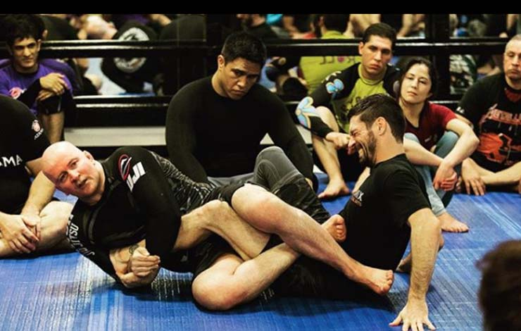Leg Locks

Leg locks attack the knee and ankle through straightening or twisting. To make them work you need three things: attachment to the hip, the leg isolated from everything else, and the hip held to the floor.

Getting there: Inside Position

Everything starts with inside position — feet between your opponent's knees. This gives you access to the hip, which is where all entanglements begin. If neither player has both feet inside, entanglements can't happen.

You can also create hip access with a cross leg — moving your opponent's leg across your centerline. Same goal, slightly different path.

Finishing

For heel hooks: face the side of the knee and control the toes. For straight ankle locks: keep the leg extended and press the toes down.

Simple cue to remember: weigh the toes.

🧑‍🦽 Beginner Games From DVD

🧑‍🦽 Beginner Games From DVD

Game 1: Straight Ashi — Inside or Outside to Inside Heel Hook
Starting Position: Straight ashi garami with an ankle grip.
Attacker Objective (terminal):
- Get your feet to inside or outside position first.
- Once inside or outside position is established, transition to an inside heel hook grip.
- Then get an outside heel hook grip to win.

Game 2: Inside Position to Inside Heel Hook — No Releasing the Ankles
Starting Position: Seated with both feet on the inside hooking behind the partner's knees, and an ankle grip on both legs.
Attacker Objective (terminal):
- Entangle to outside ashi or SLX — without releasing the ankle grips.
- From there, get to an outside heel grip.
- Then transition to an inside heel hook grip to win.

Game 3: Outside Heel Grip vs. 2-on-1
Starting Position: Attacker has outside position with a heel grip. Defender has a 2-on-1 grip on the attacker's arm.
Attacker Objective (terminal):
- Submit the partner.
Defending Player Objective (terminal):
- Free yourself of all connections.

Game 4: Ankle Lock and Heel Hook Dilemma
Starting Position: Attacker in SLX with an ankle grip.
Attacker Objective (terminal):
- Point and drive the partner's knee down into the mat regardless of their leg configuration.
- Submit with an ankle lock, or transition to a heel grip and submit from there.
Defending Player Objective (terminal):
- Separate the attacker's connection and free yourself.

Game 5: Supine Inside Position — Entry to Outside or SLX (vs. Standing)
Starting Position: Bottom player supine with both feet on the inside hooking behind the partner's knees, and one ankle grip. Top player starts standing outside the bottom player's legs.
Bottom Player Objective (terminal):
- Destabilise the top player and entangle to outside ashi or SLX with a heel hook grip.
- If inside position is lost at any point, regain it before continuing.
Top Player Objective (continuous):
- Stay standing and stay on the outside of the partner's legs for as long as possible.

Game 6: Supine Inside Position — Entry vs. Seated Outside Recovery
Starting Position: Bottom player supine with both feet on the inside hooking behind the partner's knees, and one ankle grip. Top player starts standing outside the bottom player's legs.
Bottom Player Objective (terminal):
- Destabilise and entangle to outside ashi or SLX with a heel hook grip to win.
Top Player Objective (terminal):
- Win by getting one leg to the outside with the other in a kneebar position, or both legs to the outside.
- If put on your butt, you must remain seated and work to regain inside position from there. [Note: unclear whether regaining inside from seated is a loss or just a reset — please clarify.]

🙉 Beginner friendly

🙉 Suitable for beginners

Leg Entanglements for Beginners - Greg Souders CLA Seminar

Game 1: Inside Position — Learning Entanglements
Bottom player explores foot positions while staying attached to one leg
Starting position: Straight ashi double seated
Bottom player (terminal — in order)
- Get both feet to the outside of partner's leg
- Move partner's leg to the other side of your body
- Get both feet back to the inside
Top player (terminal)
- Separate partner's feet and get both feet between partner's knees
Safety constraint: Defender may not rotate to free the leg — must separate feet first then pull straight back. No standing up (for new players).

Game 2: Switching Legs — Chaining Entanglements
Bottom player must entangle both legs consecutively
Starting position: Bottom player on inside with both feet inside, holding both ankles.
Bottom player (terminal)
- Entangle one leg (foot and knee, feet outside, or feet inside), then entangle the other
Top player (terminal)
- Get both feet to the inside at any point before bottom player wins

Game 3: Destabilising to Entangle (vs. Standing)
Bottom player uses feet to bring partner down before entangling
Starting position: Bottom player supine, both feet between partner's knees, one hand on an ankle. Top player standing.
Bottom player (terminal)
- Keep at least one foot inside partner's legs at all times
- Use tops and bottoms of feet only to destabilise and bring partner down — no entangling while standing
- Once partner is down, entangle any leg to win
Top player (terminal)
- Get both legs to the outside of bottom player's feet
- Touch shin anywhere from partner's hips to shoulders to win
- If you fall, you may not stand back up — must regain inside position from the ground
Safety constraint: Defender may not rotate to pull the leg out — must separate feet first then pull straight back.

🐦‍🔥 How to Defeat Diego Pato

🐦‍🔥 How to Defeat Diego Pato

Breakdown of Deandre Corbe's Training - Standard Jiu-Jitsu

Game 1: Inside Position vs. Standing Passer
Starting position: Bottom player supine, top player standing.
Bottom player objective (terminal):
- Get both feet hooked inside the top player's knees (ankle to hip)
- Maintain two-hand connection to both legs
- Put the top player on their butt to win
Top player objective (continuous):
- Keep one leg between the bottom player's knees at all times
- Keep the outside leg from crossing to the inside — step inside or outside, stay right in front
- Never let both feet reach the inside simultaneously — one is fine, two is bad

Game 2: Inside Position + Cross Leg + Path to Top
Starting position: Double seated leg drag
Bottom player objective (continuous):
- Keep both feet inside the partner's legs at all times
- Maintain two-hand connection to both legs
- Continuously toggle between cross leg and straight leg, keeping feet hidden inside
- Keep partner grounded — may play the full space (seated to standing)
Top player objective (terminal):
- Get to their feet and get one leg to the inside (order doesn't matter)
- Both conditions must be met to win

Game 3: Inside Position + Cross Leg + Hip Access
Starting position: Double seated leg drag
Bottom player objective (terminal):
- Win by either:
  - Entangling — connect legs to partner's hips, keeping them grounded
  - Coming up — gain access to partner's hips by closing the hands, keeping them grounded
Top player objective (terminal):
- Same as Game 2 — get to feet and get one leg to the inside

Design rationale: Gaining access to the partner's center — whether by clearing hands/elbows to reach the shoulders, or clearing feet/knees to reach the hips — is central to almost all things. Both legs and arms need a path to the partner's center. Game 3 adds a win both by closing hands to the hips and by entangling because both represent achieving that central access. The progression across the three games builds the same core condition (inside position → cross leg → hip access) while expanding the space and the number of available outcomes.

☠️ Greg @B-team day 2

☠️ Greg goes to B-team day 2
Standard Goes to B-Team: Day 2

Game 1 — Entanglement Flow (Single Leg X ↔ Outside Entanglement)
Starting position: Both seated, attacker in Single Leg X
Attacker
- Switch from Single Leg X → Outside Entanglement → back to Single Leg X
- Then switch to the other leg and repeat the same sequence
- Must maintain connection throughout
Defender
- Break all connections and free the leg — nothing else
Win condition: First to complete their objective wins. Swap roles each round.

Game 2 — Three-Condition Leg Control
Starting position: Both seated, attacker in Single Leg X
"By asking to do things that are not tactically optimized... helps you start to get used to novel things."
Attacker — must fulfill all three conditions (any order) on both legs:
- Cross the leg to the opposite side of the body
- Feet to the inside (between partner's knees)
- Capture the second leg
Must then repeat all three on the other leg before losing connection.
Defender
- Disconnect and free the leg at any time

Game 3 — Toe Capture + Hand Connection
Starting position: Both seated, attacker in Single Leg X
Attacker
- Catch partner's toes in armpit, scoop under the heel, connect hands
- Do this on the straight side first, then transition to the cross side
- Repeat on both legs without losing connection
- Feet positioning is free — use whatever works
Defender
- Free the leg or break all connections

Game 4 — Progressive Finishing (Earn Your Starting Position)
Teaches that every failed finish pushes you further from the finishing point — you must earn your way back.
Starting position: Inside entanglement, both legs controlled
Attacker
- Separate partner's feet → capture toes → connect hands → finish (tap)
- If successful: next round starts from single leg — must get to cross leg position (feet inside) before finishing
- If successful again: next round starts from just inside position — must entangle, get feet inside, cross leg, then finish
Defender
- Pull the leg free at any time
Progression: Each successful finish backs the attacker further out. Each failure resets to that failure point.

Game 5 — Keep Them Down
"The most frustrating thing attacking legs — people getting up and coming off the mat."
Starting position: Attacker with double feet inside, entanglement of choice
Attacker
- Entangle (any entanglement), catch toes, connect hands with heel hook finishing grip
- Partner must be on the ground when conditions are met
- Can use the full space — stand if needed to keep hips down
- No finish required — just fulfill the grip conditions with partner grounded
Defender — wins by reaching any of:
- Standing + full disconnect
- Standing + one leg in between
- Standing + both legs on the outside

☃️ Rob Cole Games

☃️ Leg Lock CLA Games

Ecopalooza Spring 2024: Task-focused Games for Leg Entanglements w/ Coach Rob Cole #bjj #jiujitsu

Game 1 — Control the Entanglement (Inside Ashi)
Starting position: Inside Ashi / Saddle / 411 / Cross Ashi — attacker has both feet on the inside, hooked to the hip.
Attacker:
- Stay connected to the hip
- Control the secondary leg
- Collect the second leg if it escapes
Defender:
- Free the knee line by hand fighting and pushing out
- Use ballerina toes (toes pointed away) or karate/sidekick foot (toes curled in hard) — no floppy feet
- Win condition: escape the knee line
Continuous — switch roles if nobody escapes.

Game 2 — False Grip Hunt (Inside Ashi, One Hand)
Starting position: Same as Game 1.
Attacker:
- Same hip connection and secondary leg control
- Can only use one arm to capture the heel
- Win condition: establish a false grip on the heel
Defender:
- Same ballerina toe / karate foot options
- Hand fight to prevent the grip
- Win condition: deny the false grip
Stop when the false grip is established — no submissions.

Game 3 — Upgrade the Position (9010 / Outside Base Guard)
Starting position: Outside base / 9010 — one foot outside, more rotation available but less control.
Attacker:
- Same rules — connect to hip, control secondary leg
- Can now rotate around the knee and attempt to expose the heel
- Win condition: false grip on the heel
Defender:
- Same foot positions
- Win condition: clear the knee line and escape

Game 4 — Upgrade Race (50/50)
Starting position: 50/50 — open legs, no crossing/locking feet down.
Both players have the same goals:
- Win condition (either player): upgrade position by getting closer to the opponent's hip / coming across the body
- Win condition (either player): false grip on the heel if it is given
Defend the heel first, then work the upgrade.

Game 5 — Hip Control Battle (Double Butt Scoot)
Starting position: Double butt scoot — both seated, one in / one out, hands free.
Both players:
- Hand fight and pummel to attach to a hip-to-hip leg entanglement
- Win condition: achieve and hold hip control
Wrapping the knee doesn't count — must be hip.

Game 6 — Get Up (Double Butt Scoot + Stand)
Starting position: Same as Game 5.
Both players:
- Same hip control battle
- Added win condition: stand up and retrieve — if you can get to your feet and out, you win
- Attacker trying to stand must control the bottom leg or the other person gets up freely
Entries to leg entanglements begin to emerge organically.

Game 7 — Three-Way (Hip / Stand / Back)
Starting position: Same as Game 6.
Three win conditions (either player):
- Hip control
- Stand up and out
- Get to the opponent's back
No demo — let it emerge.

Leg Lock CLA Games — Rob Cole

USA Camp 2023: Leglock Games: Play to win [and lose] with Rob Cole

Game 1: Saddle Heel Hide
Defender survives the worst-case leg lock position by protecting the heel
Starting position: Attacker has defender in the saddle (cross ashi) with secondary leg controlled
Attacker
- Maintain saddle control with secondary leg grip
- Dig for a false grip on the heel
- No ripping — false grip catch = win condition (continuous)
Defender
- Ballerina toe (internal rotation) to hide the heel
- Boot foot on attacker's hip
- Free the trapped leg and re-hide heel if recaptured
- Spin/extract to escape
Coaching note: "Start in the worst spot. Once you're able to be comfortable in the worst spot, the other spots are not as scary."

Game 2: Saddle → 90/10 Upgrade
Attacker transitions from saddle to outside position for better heel exposure
Starting position: Saddle with secondary leg control
Attacker
- Foot to center/stomach, wrap around the hip
- Back heel to lock the hip
- Rotate around the knee to reach 90/10 (outside Ashi)
- Dig for heel — bypass 50/50, go straight to 90/10
Defender
- Same as Game 1: hide heel, ballerina toe, extract secondary leg
- Harder to spin out than from saddle

Game 3: 50/50 Shootout → 90/10
Both players fight to upgrade position and hide their own heel
Starting position: Open 50/50 — feet not crossed
- Both players hide their heel immediately
- Battle to reach 80/20 → 90/10
- Whoever gets the positional upgrade first can dig for the heel
- Win condition: false grip on opponent's heel (continuous)
Constraint: Do not lock/cross your feet — stay open and active
Coaching note: "Don't just lock up a triangle and stall. The person who is more aggressive and not worried wins this."

Game 4: Double Butt Scoot — Leg Entanglement / Get Up
Neutral entry game to reach any leg entanglement, or simply stand up
Starting position: Both seated, one inside, one outside
Option A — Leg Entanglement
- Get to any leg entanglement (saddle, 50/50, 90/10)
- Inside pummeling, no running away
Option B — Get Up (bonus)
- First player to stand wins the exchange
- Opponent can shoot for leg entries to prevent the standup
- Win condition: reach feet without being leg-locked (terminal per exchange)

🪄 Our own Woj lock Games

🪄Woj Lock Games

Game 1: Woj Control Without Submitting
- Try to establish and hold the Woj lock position without finishing the submission. Focus on control only. [Underdeveloped — add rules and win conditions as needed.]

Game 2: Woj with One Arm Controlled
- Same as above but with one of the partner's arms already controlled. [Underdeveloped — add rules and win conditions as needed.]

🦍 Playing the whole space

🦍Playing The Whole Space
Playing the Whole Space with CLA - Greg Souders Queretaro Seminar

Playing the Whole Space
How do you keep control of your partner as you move through the entire space — from your back, to seated, to standing?

Game 1: Playing the Whole Space
Starting position: Bottom player supine, both feet between partner's knees, both hands on partner's ankles. Top player on the ground.
Attacker (bottom) — any of the following to win:
- Reach any entanglement
- Get to feet and make partner's back touch the mat without an established guard
- Lock hands around partner's hips
Defender (top) — terminal win condition:
- Get to feet and break all connections

Game 2: Out to the Ankle
Starting position: Both players standing. Attacker gripping partner's leg at the knee.
Precursor: Attacker must slide grip from knee to ankle before any win condition counts.
Attacker — any of the following to win (partner must be down first):
- Entangle any leg
- Get hips (lock hands around hips)
- Make partner's back touch the mat without an established guard

Defender — terminal win condition:
- Free the leg. If defender falls, must get up with no connections to win.
Note: With new players, require the hip to touch the mat before entangling to avoid knee injuries.

Game 3: Even Start
Starting position: Both players on the ground, each with one foot on the inside.
Both players attack simultaneously — first to any of the following wins:
- Separate and stand up (break all connections)
- Entangle and put partner down
- Lock hands around partner's hips
- Put partner's back on the mat

Design rationale: "No matter where we're going — entanglement, body lock, on top — as long as we're able to get access to our partner's ankle or ankles and keep it off the mat, no matter what our starting position is, we have access to the whole space and an opportunity to reach the outcomes that we're searching for."

🧍 Just stand up bro

🧍Just stand up bro

Ecopalooza Spring 2024: Constraints-Led Approach to "Just Stand Up" w/ Coach Rob Cole

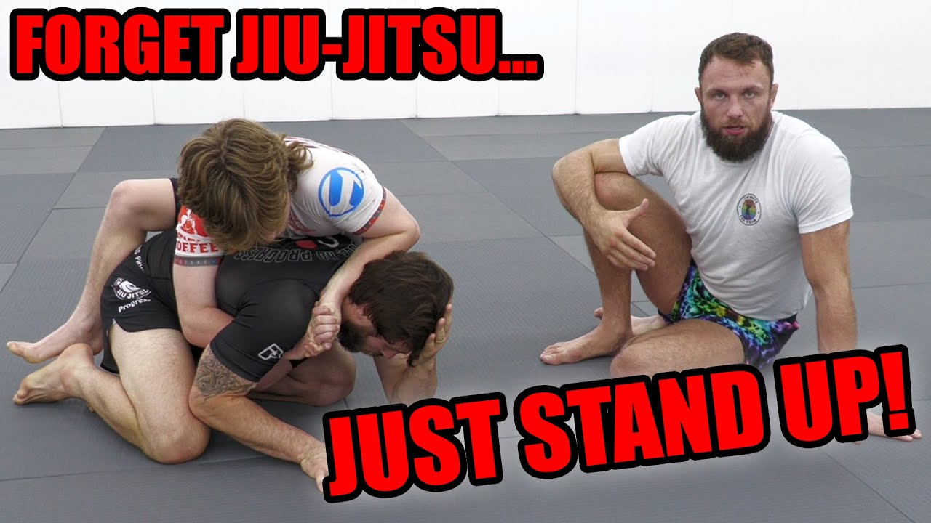
Game 1: Hand Connection Denial — Standing (Behind) Don't let them lock their hands around your waist
- Start: Attacker behind defender, covering the knuckles (not wrist, not fingers)
- Attacker: Connect hands around the waist, a leg, or anywhere from shoulders to ankles
- Defender: Get hips away and face the attacker — any way you want
- Win condition (terminal): Attacker wins by connecting hands; Defender wins by disengaging and facing

Game 1b: Add-on — Re-attack on the Break
- Same as Game 1, but on the break both players battle for hip control or a single leg
- Win condition (continuous): Same hand connection / hip escape logic, but with re-attack built in

Game 2: One Hand, One Knee Get back to your feet from a compromised base
- Start: Defender in quadruped — one hand, one knee on the mat
- Attacker: Get defender's hip to the mat OR both hands to the mat. Cannot connect hands
- Defender: Maintain the one-hand/one-knee base and get to both feet
- Win condition (terminal): Defender wins by reaching two feet; continuous pressure from attacker

Game 3: Referee Position / Turtle — Hip Breakdown Don't let your hips get broken down; keep getting back to turtle
- Start: Defender in referee position (turtle). Attacker has any unconnected grip
- Attacker: Break defender to a hip, keep hips on the mat. Cannot connect hands
- Defender: Keep getting back to turtle. Keep wrists clean (don't let them get tied up)
- Win condition (continuous): No terminal win — both players are working continuously. Switch after a set time

Game 4: Chest-to-Chest Get-Up (No Hands) Use your body weight to keep someone down — or escape it
- Start: Defender on back, one shoulder off mat. Attacker chest-to-chest, no hands (no connected grip)
- Attacker: Stay chest-to-chest or chest-to-back using only body weight and legs
- Defender: Get to both feet any way possible
- Win condition (terminal): Defender wins by standing
The design logic: it forces the attacker to use toes, chest pressure, and gravity — not arms. It makes him honest. If he's controlling the upper body, the legs are free. If he's on the lower body, the head can come up. Hard to control both at once.

Game 4b: Chest-to-Chest — With Free Grip
- Same as Game 4 but defender gets a free grip (attacker covers the top-hand knuckles)
- Defender: Use the grip to break attachments and get up. Keep elbows to body
- Attacker: Connect hands and hold down using chest, legs, arms
- Focus of attention: Grip fighting — deny attachments while escaping

Game 5: Quarter Guard Pass → Pin Finish the pass AND hold them down
- Start: Attacker has crossface, underhook, and one knee trapped in quarter guard
- Attacker: Free the trapped knee, then pin shoulders to the mat (3-second count)
- Defender: Hold the knee, then if the knee is freed — try to get to turtle/feet
- Win condition (terminal): Attacker wins by freeing knee + 3-second shoulder pin
Can be backed up one step to half guard to increase difficulty.

Game 6: Guard Connections + Stand-Up Option Make an honest guard player and an honest top player
- Start: Guard vs. passer — passer tries to break connections and reach the knee line
- Attacker (top): Break guard connections, cross the knee line
- Defender (bottom): Maintain connections AND has the option to stand up at any time
- Win condition (continuous/dual): Top wins by passing; bottom wins by maintaining connections OR standing up
This emerged live during the session. The design forces the top player to also monitor and prevent the stand-up, not just focus on passing. Naturally surfaces concepts like controlling the bottom leg.

🤸 Games with scaling

Games with scaling
Overall intent (scaling, stated by coach): "If you have a bunch of different levels in the room, everybody needs something to work on... me and Ivonne were playing this and he was better than me and I might never make a close hand connection. At least I know exactly what my goal is. So the whole time I have something to be working on." Each player tracks their own progression. Win = move on to next level. Lose = stay and repeat the same level.

Game 1: Handfight to Closed Hands
Starting position: Standing, hand fighting.
Both players race to complete their current level:
- Level 1: Close your hands anywhere on partner's body, from shoulders down to ankles.
- Level 2: Close hands + put partner on the ground (hands down or butt down wins).
- Level 3: Close hands → get a second close-hand connection somewhere else on the body → then put partner down.

Game 2: Seated vs Standing
Starting position: One player standing, one player seated.
Top player (constant goal across all levels):
- Get past the feet to the outside of the legs and make shin touch the body. Counts whether bottom is down or has turned.
Bottom player progression:
- Level 1: Make any connection + destabilize (partner falls to butt or hands).
- Level 2: Make a connection to the hips — legs only OR hands only (entangle or wrestle up).
- Level 3: Either connection (legs or hands) + make them fall.

Game 3: Completing Pins
Starting position: Lying next to partner. Bottom on side facing top. Top's hands connected around bottom's waist. Bottom's frames/hands on top.
Top player progression:
- Level 1: Make chest-to-chest or chest-to-back contact + connect hands under at least one elbow.
- Level 2: Same start — get shoulders AND cover hips.
- Level 3: Start in half guard, open hands — connect, free the leg, cover hips.
Bottom player (3 ways to win, same all levels):
- Guard recovery — knee must be in front (e.g. half guard only counts if top knee is in front; legs in front without a knee = keep fighting).
- Closed guard.
- Reversal / get up.

Game 4: Finishing
Level 1 — Armlock
- Start: armlock breaking position.
- Top wins: hold partner down, separate the hands, finish the armlock.
- Bottom wins: pull the arm free.
Level 2 — Figure Four
- Start: facing partner's legs, figure-four grip with hand on body.
- Top wins: finish the kimura, OR take figure four to any other submission.
- Bottom wins: pull arm free / break the connection.
Level 3 — Under Both Elbows
- Start: under both of partner's elbows. Top chooses position — side, mount, or north-south.
- Top wins: any submission. Any body part (incl. legs) can be used under the elbows to stop them coming in.
- Bottom wins: pull both elbows in (losing one is fine, losing both = over).
- Special rule: if top leaves the submission and gets chest-to-back, it counts as a win.
Coach's progression note (from Q&A) — combining submission types: "We give the top player a role of collecting the head first before you finish. So once I collect the head, I could finish on the arm... or I could strangle with my legs." Same idea with figure four: "our job is to keep the figure four grip and use our legs to collect our partner's head and arm."

🤹 Øktplaner

🐑 Fundamentals CLA Class

🐑Standard Jiu Jitsu – CLA Class Games (White/Blue Belt)

Foundations at Standard Jiu-Jitsu

Game 1 – Make Inside Connection
Starting position: Standing passer vs. Belly Up guard player
Intention: The foundational function of the guard is to manage distance, and we can't do that unless we first make connections with our hands and feet.
- Bottom player: Get both feet to inside position (between partner's knees) and both hands on partner's legs. Hold this position as long as possible.
- Top player: Use hands and movement to prevent feet from reaching inside position. Stay close – don't run away.
Win condition: Continuous – maintain/deny inside position.

Game 2 – Make Inside Connection (One Leg at a Time)
Starting position: Same as Game 1
Intention: The way we structure our body will ultimately affect how we accomplish our tasks. Students were reaching out with both legs simultaneously, losing structure.
- Bottom player: Same goal as Game 1, but use one leg at a time. Reach out, hook, pull yourself closer, then orient to inside position.
- Top player: Same as Game 1.
Task focus added: Treat feet like hands – probe with one leg, retract, use it to close distance.

Game 3 – Destabilize to Hands / Advance to Knee Line
Starting position: Standing passer vs. Belly Up guard player
Intention: Once connection is established, the next layer is destabilization. Students were shown three movement patterns from open guard, all sharing inside control, hand/foot connection, and destabilization as common foundations.
- Bottom player: Make and maintain inside connection, then destabilize top player onto their hands or their butt.
  - If top player hits butt → let them stand, restart
  - If top player hits hands → keep them there, continue pressure
- Top player: Clear the line of feet, advance to the knee line, and hold it. Deny inside position by going outside or through the center.
Win condition: Continuous – maintain destabilization / hold the knee line.

Game 4 – Side Control: Figure Four / Arm Extension / Exposed Back
Starting position: Side control (top vs. bottom)
Context switch from guard work to pinning.
- Top player (experienced): Win by achieving one of three:
  - Any figure four grip (Kimura, Americana)
  - At least one arm extended
  - Chest-to-back contact secured with over-under grip
- Top player (beginner): Simply maintain pins and move between them.
- Bottom player: Guard recovery (legs back in front) or reversal to top position.
Win condition: Terminal – flip-flop and restart on success.

Game 5 – Rear Mount: Maintain Back / Clear Defenders
Starting position: Chest-to-back, hooks in, over-under grip
- Top player (beginner): Maintain chest-to-back contact and over-under grip. If they escape, transition to chest-to-chest (side control).
- Top player (experienced): Use hands to clear the defender's arms, then work toward strangulation. Can also involve legs for arm trapping (recalled from prior training).
- Bottom player: Guard recovery or reversal.
Win condition: Terminal – flip-flop and restart on success.

Game 6 – Whole Game
Starting position: Belly Up guard vs. standing passer
Intention: Students have now played every component in isolation. This ties it together.
- All players: Play full Jiu Jitsu, but execute the tasks learned throughout class as situations arise:
  - Clear the line of feet → advance to knee line
  - Create chest-to-chest contact
  - Work toward figure four / arm extension / back exposure
  - From back: clear defenders → strangulation
Win condition: Submission → flip-flop and restart.

🐏 All Levels CLA Class

🐏 Breaking & Back Taking — Leg Entanglements - All Levels Class
All Levels Class at Standard Jiu-Jitsu
Starting position: Any leg entanglement of choice
Attacker (bottom/leg player)
- Win: Finish a leg submission OR come up to take the back
- Task focus (scaled):
  - Stay as close to partner as possible, maintain hip attachment
  - Search for access to both legs as a precursor to heel exposure
  - Capture the partner's toes with arm/body
Defender (top player)
- Win: Free the leg, counter submission, or pass the legs
Continuous — flip-flop on win

Breaking & Back Taking — Arm (Figure-Four)
Starting position: Bottom player on their side; top player with a figure-four grip on the arm
Attacker (top player)
- Win: Submit OR take the back
- Task focus (scaled):
  - Keep hips as close to partner's shoulder as possible at all times
  - Separate the arm from everything it can touch (body, other arm, leg)
  - Once separated: chain threats continuously (twisting lock → straight lock → strangle) — no lag time between threats
Defender (bottom player)
- Win: Get free of threat and hide the back
Continuous — flip-flop on win

Side Control — Hip Connection
Starting position: Bottom player on their side; top player wrapping arm around partner's hip, lined up on the same line
Attacker (top player)
- Win: Submit
- Task focus:
  - Remove the bottom player's hands (beat the push, stay chest to chest)
  - Search for underhooks — prioritize the bottom arm underhook above all else
Defender (bottom player)
- Win: Seated open guard recovery, standing recovery, or reversal
Continuous — flip-flop on win

All-Fours — Rear Hip Connection
Starting position: Bottom player on all fours; top player connected around the waist from behind
Attacker (top player)
- Win: Submit from any pin (chest to chest or chest to back)
- Task focus:
  - Always stay taller/higher than partner's back — never fall below their hip height
  - Break partner off their base points progressively: feet → knees → hips / hands → elbows → shoulders
Defender (bottom player)
- Win: Seated open guard, stand and turn to face, or reversal
Continuous — flip-flop on win

🤖 Wraslin handfighting, seated guard og back control
Have more grips than them
Starting Position: Both players standing, handfighting.
Both players continuous:
- Have more grips on your partner than they have on you
- Can only grip from wrist to armpit

Hand Fight: Collect & Connect
Starting position: Standing, hand fighting (any grip)
Precursor (must complete before winning):
- Collect 3 touches total: any combination of
  - Partner's hands to the mat
  - Behind the knee touches
Win condition (terminal): After collecting 3 touches → land any closed hand connection

Finishing the shot
Have You Ever Seen A Wrestling Drill Like This? | Standard Jiu-Jitsu Wrestles With CLA

Dynamic Starts Alternating dynamic starts: round 1 attacker has hands behind back, round 2 attacker is turned around.
Starting Position: Both players moving freely. Attacker begins either with hands behind back or turned around (alternating each round).
Attacker objectives (terminal, in order):
- Finish the back take
- Finish the back down pin (chest-to-chest)
- Finish the submission
Defender objectives (terminal):
- Counter: get on top, go behind, or submit
- Negate: break all connections once the attack begins
- Defender may not use hands until the attacker makes first connection — once contact is made, the round is live
Design rationale: "Dynamic starts" lower the barrier to entry — they let the shooter get in deep, which forces the defender to engage once the takedown is imminent rather than before contact is made. "Once that connection starts, that starts the fight."

🍑 Seated guard
Game 1: Denying supine guard
Starting position: Bottom player seated guard against standing passer.
Bottom player (terminal win conditions):
- Avoid getting put on your back, you lose if you are on your back without an established guard
- Standing up and free yourself from any connection
- Destabilise your partner to their butt or both hands touching the mat
Top player (terminal):
- Stay standing
- Put the guard player on his back without an established guard

Game 2: Destabilising or wrestling up from seated guard
Starting position: Bottom player seated guard against standing passer. Focus and difficulty can be changed by starting with grips in place. Ie. Russian 2on1, arm drag etc.
Bottom player (terminal win conditions):
- Destabilise partner to their butt or both hands touching the mat
- Wrestling up to a strong closed hand connection with both standing
Top player (continuous):
- Stay standing
- Get to the outside of the bottom player's legs and stay there for as long as possible

Back control, no submissions
Starting position: Back control, seated with defensive grips seatbelt and hooks
Attacker:
- Keep chest glued to partner's back
- No win condition — survival/maintenance only
Defender:
- Win: Break chest-to-chest contact

Back control with submissions
Starting position: Back control, seated with defensive grips seatbelt and hooks
Attacker:
- Win by submission
- Must be on the back or have a submission threat ongoing
Defender:
- Win: Break chest-to-chest contact and be free of submission threat

☀️ Wraslin, guard og poeng-pinning
Have more grips than them
Starting Position: Both players standing, handfighting.
Both players continuous:
- Have more grips on your partner than they have on you
- Can only grip from wrist to armpit

Hand Fight: Collect & Connect
Starting position: Standing, hand fighting (any grip)
Precursor (must complete before winning):
- Collect 3 touches total: any combination of
  - Partner's hands to the mat
  - Behind the knee touches
Win condition (terminal): After collecting 3 touches → land any closed hand connection

Finishing the shot
Have You Ever Seen A Wrestling Drill Like This? | Standard Jiu-Jitsu Wrestles With CLA

Dynamic Starts Alternating dynamic starts: round 1 attacker has hands behind back, round 2 attacker is turned around.
Starting Position: Both players moving freely. Attacker begins either with hands behind back or turned around (alternating each round).
Attacker objectives (terminal, in order):
- Finish the back take
- Finish the back down pin (chest-to-chest)
- Finish the submission

Defender objectives (terminal):
- Counter: get on top, go behind, or submit
- Negate: break all connections once the attack begins
- Defender may not use hands until the attacker makes first connection — once contact is made, the round is live
Design rationale: "Dynamic starts" lower the barrier to entry — they let the shooter get in deep, which forces the defender to engage once the takedown is imminent rather than before contact is made. "Once that connection starts, that starts the fight."

Game 1: Seated Handfight
Starting position: Top player standing/kneeling, bottom player seated
Top player wins by:
- Connecting hands around bottom player's upper body (headlock, body lock — anything connecting at hips or shoulders)
- Making both of bottom player's shoulders touch the mat
Bottom player objective (continuous — no win):
- Prevent top player from connecting
- Stay seated — cannot stand, cannot sweep
- Use all limbs; harass top player's feet with legs as the longest tool
- No closed fists
Constraints: Bottom player cannot stand or sweep. Top player wins = flip roles.
Task focus: Inside position, more connections on him than he has on you.

Game 2: Line Holding
Starting position: Bottom player supine, top player past the feet (shin on same-side hamstring or outside past feet)
Top player objective (continuous — no win):
- Maintain position past the feet for the whole round
- Cannot put knees down
- Cannot go chest-to-chest (chest-to-back is allowed)
Bottom player wins by:
- Making top player's hip touch the mat (any contact = flip)
- Getting up to feet
Task focus: Keep feet off your body and off the mat. "If the bottom player made your hip touch, that means their feet were on you somehow."

Tournament pinning

Starting position: sidecontrol
Top player objective (continuous — no win):
- Get mount twice
- Get back control (seatbelt and hooks)
Bottom player wins by:
- Seated guard
- Standingg
- sweep

Tournament pinning

Starting position: sidecontrol
Top player objective (continuous — no win):
- Get mount twice
- Get back control (seatbelt and hooks)
- Submission
Bottom player wins by:
- Seated guard
- Standingg
- sweep

🗽 Wraslin, guard, arm trap back control
We’ll do a different kind of session today where we split the whole game of jiu jitsu into smaller parts and play these so-called task based games. This is not drilling and you should both strive to win the game.
I will not give you specific techniques, but sometimes things to focus on to help accomplish the win condition. Eight(!) games and then free rounds at the end.
Partner up 3 and 3, ideally with someone of similar skill and size. Switch every time someone wins.
Greg @ b-team

Standing Game 1 – Hand Fight: Collect & Connect
Starting position: Standing, hand fighting (any grip)
Precursor (must complete before winning):
- Collect 3 touches total: any combination of
  - Partner's hands to the mat
  - Behind the knee touches
Win condition (terminal): After collecting 3 touches → land any closed hand connection
Resets: Start again each time someone wins.

Safety note : dont fall to make partner fall, don't wrap knee around partner knee

Standing Game 2 – Stay Connected: Put Them Down to Switch
Starting position: Standing, already connected in one of three positions:
- Front headlock
- Tight waist
- Single leg

Attacker objective:
- Stay continuously connected, cycling between the three connection points
- Precursor to switching grips: Must get partner's one or both hands to touch the mat before switching to a new connection point
Defender objective:
- Break the connection and turn to face
- If knocked to hip: must get back up (no staying on the floor)
Win condition: Continuous — defender wins each escape; roles swap on each escape.

Game 1 — Entanglement Flow (Single Leg X ↔ Outside Entanglement)
Starting position: Both seated, attacker in Single Leg X
Attacker
- Switch from Single Leg X → Outside Entanglement → back to Single Leg X
- Then switch to the other leg and repeat the same sequence
- Must maintain connection throughout
Defender
- Break all connections and free the leg — nothing else
Win condition: First to complete their objective wins. Swap roles each round.

Game 2: Inside Position to ankle lock — No Releasing the Ankles
Starting Position: Seated with both feet on the inside hooking behind the partner's knees, and an ankle grip on both legs.
Attacker Objective (terminal):
- Entangle to outside ashi or SLX — without releasing the ankle grips.
- From there, get an ankle lock
Defender objective (terminal)
- Free the foot and get inside posistion

Game 3: Guard Retention — Stay Connected
Starting position: Bottom player on back, both hooks between partner's knees, one hand on each ankle. Top player standing.
Bottom player
- Keep tops or bottoms of feet touching partner anywhere on their body
- Keep hands connected to partner's body
- Push/pull partner with feet freely
- No win condition — survival/maintenance only. No resets.
Top player
- Win: Get both legs to the outside of bottom player's legs with all connections broken
Change top/bottom every time top player wins.

Game 4: Competing Destabilizations
Starting position: Same as Game 3.
Bottom player — win by:
- Causing 3 total destabilizations (any combo): partner's hands touch mat (initiated by bottom player) OR partner's butt touches mat
- Same foot-contact focus as Game 3

Top player — win by:
- Getting outside the legs 3 times, alternating sides (left → right → left or right → left → right)
- Each time: get both feet outside and touch partner's body with shin
- Must alternate sides — cannot repeat same side consecutively
Whoever hits 3 conditions first wins. Change top/bottom.

Game 1: Arm Trap Survival
Starting position: Straight jacket system grips med fanget arm. (cross grip with armtrap)
Attacker
- Keep chest glued to partner's back
- Keep the arm trapped between the feet
- No win condition — survival/maintenance only
Defender
- Win: Free the trapped arm OR put back on the mat (breaking chest contact)
Change top/bottom every time defender wins.

Game 2: Arm Trap — Finish It
Starting position: Same as Game 1.
Attacker — win by either:
- Cross feet into partner's knee pit (head-and-arm or just knee pit, either side)
- Lock up the rear strangle grip (overarm around neck, locked into bend of arm — grip only, no finish required)
Defender — same as Game 1:
- Win: Free the arm OR put back on the mat

Change top/bottom every time someone wins.
"Part of the reason why trapping arms is critical is because when we're on somebody's back, our arms have to do two things. I have to use my arms to stay attached to my partner, but I also have to use my arms to threaten my partner or get to a place where I can submit them. So by getting our legs involved and trapping the arms, we can use our arms in different ways."

🧙 Wraslin overunder, K/X og kimura

🧙 Økt 26.04.26

10th Planet South Bay Full CLA Practice

Game 1: Overhook/Underhook – Sticking and Connecting
Starting position: Standing, clinch – one player has overhook, one has underhook. Neither can remove their hook.
Overhook player (no win condition – continuous task)
- Stick feet to partner's feet and follow them
- Use the overhook to get partner's hands to touch and stay on the mat
Underhook player (terminal win)
- Get hands connected anywhere from under partner's armpits to their ankles
- Win → roles switch

Game 2: Stick and Pull
Starting position: Same as Game 1 – overhook/underhook, standing.
Overhook player (terminal win – two options)
- Stick and pull in any direction (feet, body, open hands) to put partner on their butt or back
- OR capture partner's head and connect hands around it → instant win
Underhook player (terminal win – two options)
- Precursor: get hands connected first, then:
- Split and twist – step between partner's legs and twist them to their back
- Block and lift – block a leg and lift to make partner hit butt or back

Game 1: K-Guard Getting inside position and putting the partner down before entangling
Starting position: Bottom player supine, both feet outside partner's hips, one hand gripping partner's knee. Top player standing. (K-Guard mot stående)
Bottom player (terminal win conditions, any order):
- Get feet inside and grip both ankles — either front-facing or rear-facing
- Put partner on the ground
- Only then: finish any entanglement
Top player (continuous):
- Stay standing at all times — if you fall to your knees, stand back up
- Keep hands on partner
- Stay on the outside of the bottom player's legs, foot to foot
Design rationale: Destabilisation is required before entanglement for two reasons. First, more time in position = more opportunity to recognise what's available. Second, safety — hooks and posts produce force through push/pull/lift; entanglements produce force through rotation. Rotation against a standing player is where beginners get hurt. Taking away entanglement against a standing player reduces that risk. The order of inside position and putting the partner down does not matter.

Game 2: DLR (vs. Standing) Same objectives as Game 1 but from a more constrained start
Starting position: Bottom player supine with one cross hook (foot crosses partner's centerline) and same-side grip on the ankle. Top player standing. (DLR mot stående)
Bottom player (terminal win conditions, any order):
- Get feet inside and grip both ankles — front-facing or rear-facing
- Put partner on the ground
- Only then: finish any entanglement
Top player (continuous):
- Stay standing
- Stay on the outside of the bottom player's legs for as long as possible

Game 1: Keeping the arm bent
Starting position: Defending player laying on his side with hands locked. Attacking player sitting on defenders head holding the kimura grip.

Attacker objective (Continuous):
- Keep the arm bent using the kimura grip.

Defender objective (Terminal) :
- Straighten and free the arm.

Task focus attacking player:
- Separate the bent arm from the rest of the body.

Game 2: Attack from Kimura grip
Starting position: Defending player laying on his side with hands locked. Attacking player sitting on defenders head holding the kimura grip.

Safety note: People have different levels of shoulder flexibility, don't rip the kimura.

Attacker objective (Terminal):
- Submit while arm is exposed (can go for kimura, armbar, triangle,etc or take the back)

Defender objective (Terminal) :
- Free the arm

Task focus for attacking player:
- Separate the arm from the rest of the body
- For the kimura lock: get the hand behind the back and twist the arm.

Game 4: Isolating the Arm — Breaking Position
Starting position: Armbar breaking position. Any connection.
Top player (continuous)
- Stay on top, hold partner down, and separate partner's hands — keep them separated
Bottom player (terminal)
- Pull arm free, or make top player fall over
- Continuously try to reconnect hands to anything (body, leg, other arm)

Wraslin, K/DLR og leglocks

Game 1: Hands Down / Knee Touch Snapdown entry — head height dictates leg availability
Starting position: Both players standing, hand fighting.
Farm as many points as possible:
- Make your partner's hands touch the mat
- Touch behind your partner's knees
- Connect your hands around partner’s body
Design rationale: "There's a relationship between his ability to defend his legs and his ability to defend his head. When his head is low, legs are unavailable. When the head is high, the legs are available." Combining knee touches with hands-down forces the partner to defend the legs by dropping their head and hands into position for a snapdown.

10th Planet South Bay Full CLA Practice

Game 1: Overhook/Underhook – Sticking and Connecting
Starting position: Standing, clinch – one player has overhook, one has underhook. Neither can remove their hook.
Overhook player (no win condition – continuous task)
- Stick feet to partner's feet and follow them
- Use the overhook to get partner's hands to touch and stay on the mat
Underhook player (terminal win)
- Get hands connected anywhere from under partner's armpits to their ankles
- Win → roles switch

Game 2: Stick and Pull
Starting position: Same as Game 1 – overhook/underhook, standing.
Overhook player (terminal win – two options)
- Stick and pull in any direction (feet, body, open hands) to put partner on their butt or back
- OR capture partner's head and connect hands around it → instant win
Underhook player (terminal win – two options)
- Precursor: get hands connected first, then:
- Split and twist – step between partner's legs and twist them to their back
- Block and lift – block a leg and lift to make partner hit butt or back

Game 1: K-Guard Getting inside position and putting the partner down before entangling
Starting position: Bottom player supine, both feet outside partner's hips, one hand gripping partner's knee. Top player standing. (K-Guard mot stående)
Bottom player (terminal win conditions, any order):
- Get feet inside and grip both ankles — either front-facing or rear-facing
- Put partner on the ground
- Only then: finish any entanglement
Top player (continuous):
- Stay standing at all times — if you fall to your knees, stand back up
- Keep hands on partner
- Stay on the outside of the bottom player's legs, foot to foot
Design rationale: Destabilisation is required before entanglement for two reasons. First, more time in position = more opportunity to recognise what's available. Second, safety — hooks and posts produce force through push/pull/lift; entanglements produce force through rotation. Rotation against a standing player is where beginners get hurt. Taking away entanglement against a standing player reduces that risk. The order of inside position and putting the partner down does not matter.

Game 2: DLR (vs. Standing) Same objectives as Game 1 but from a more constrained start
Starting position: Bottom player supine with one cross hook (foot crosses partner's centerline) and same-side grip on the ankle. Top player standing. (DLR mot stående)
Bottom player (terminal win conditions, any order):
- Get feet inside and grip both ankles — front-facing or rear-facing
- Put partner on the ground
- Only then: finish any entanglement
Top player (continuous):
- Stay standing
- Stay on the outside of the bottom player's legs for as long as possible

Game 3: Outside Heel Grip vs. 2-on-1
Starting Position: Attacker has outside position with a heel grip. Defender has a 2-on-1 grip on the attacker's arm.
Attacker Objective (terminal):
- Submit the partner.
Defending Player Objective (terminal):
- Free yourself of all connections.

Game 4: Ankle Lock and Heel Hook Dilemma
Starting Position: Attacker in SLX with an ankle grip.
Attacker Objective (terminal):
- Point and drive the partner's knee down into the mat regardless of their leg configuration.
- Submit with an ankle lock, or transition to a heel grip and submit from there.
Defending Player Objective (terminal):
- Separate the attacker's connection and free yourself.

🥳 Wraslin, Føtter, K og pin sub
We’ll do a different kind of session today where we split the whole game of jiu jitsu into smaller parts and play these so-called task based games. This is not drilling and you should both strive to win the game.
I will not give you specific techniques, but sometimes things to focus on to help accomplish the win condition. Six games and then some free rounds at the end.
Partner up 3 and 3, ideally with someone of similar skill and size. Switch every time someone wins.

Game 1: Hands Down / Knee Touch Snapdown entry — head height dictates leg availability
Starting position: Both players standing, hand fighting.
Three ways to get points:
- Touch behind their kneepits
- Connect your hands around their upper body (under at least one arm)
- Make their hands touch their mat
Design rationale: "There's a relationship between his ability to defend his legs and his ability to defend his head. When his head is low, legs are unavailable. When the head is high, the legs are available."

Game 2. Single leg finish
Starting position: Single leg connected around the knee pit.
Attacker (continuous):
- Takedown (hip or knee touching the mat for 3 seconds)
- Focus on lifting the ankle as high as possible or connecting hands around their hips/legs
Defender:
- Free yourself of all connections while standing

Game 3: Inside Position — Learning Entanglements
Bottom player explores foot positions while staying attached to one leg
Starting position: Single leg X with control of both ankles.
Bottom player (terminal — in order)
- Get both feet to the outside of partner's leg
- Move partner's leg to the other side of your body
- Get both feet back to the inside
Top player (terminal)
- Separate partner's feet and get both feet between partner's knees
(Sjekk hvor mange bots som er med): Safety constraint: Defender may not rotate to free the leg — must separate feet first then pull straight back. No standing up (for new players).

Game 4: Destabilising to Entangle (vs. Standing)
Bottom player uses feet to bring partner down before entangling
Starting position: Bottom player supine, both feet between partner's knees, one hand on an ankle. Top player standing.
Bottom player (terminal)
- Keep at least one foot inside partner's legs at all times
- Use tops and bottoms of feet only to destabilise and bring partner down — no entangling while standing
- Once partner is down, entangle any leg to win
Top player (terminal)
- Get both legs to the outside of bottom player's feet
- Touch shin anywhere from partner's hips to shoulders to win
- ** If you fall, you may not stand back up — must regain inside position from the ground
Safety constraint: Defender may not rotate to pull the leg out — must separate feet first then pull straight back.

Game 5: K-Guard Getting inside position and putting the partner down before entangling
Starting position: Bottom player supine, both feet outside partner's hips, one hand gripping partner's knee. Top player standing. (K-Guard mot stående)
Bottom player (terminal win conditions, any order):
- Get feet inside and grip both ankles — either front-facing or rear-facing
- Put partner on the ground
- Only then: finish any entanglement
Top player (continuous):
- Stay standing at all times — if you fall to your knees, stand back up
- Keep hands on partner
- Stay on the outside of the bottom player's legs, foot to foot
Design rationale: Destabilisation is required before entanglement for two reasons. First, more time in position = more opportunity to recognise what's available. Second, safety — hooks and posts produce force through push/pull/lift; entanglements produce force through rotation. Rotation against a standing player is where beginners get hurt. Taking away entanglement against a standing player reduces that risk. The order of inside position and putting the partner down does not matter.

1. Mount — Under Elbow Control to Submission
Starting position: Mount. Top player starts with underhooks (under at least one elbow). Bottom player actively resisting (not already bound).
Top player (terminal win — submission):
- Stay on top, hold down
- Playable condition: Must remain under or behind at least one elbow with any body part at all times
- Precursor: Head and arm must be bound (arms or legs) before submitting — break or strangle both allowed
- Losing both elbows = automatic loss if not back control
- ** Back control with hooks/body triangle counts as under elbows
Bottom player (terminal win):
- Free your elbows or/and escape back control
- Focus on causing posting from top player to gain space to retract elbows

📜 meme_folder
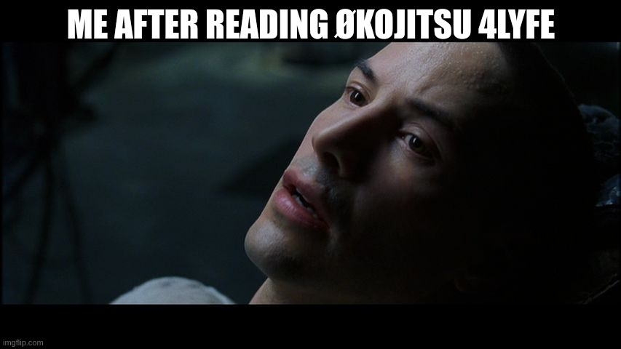
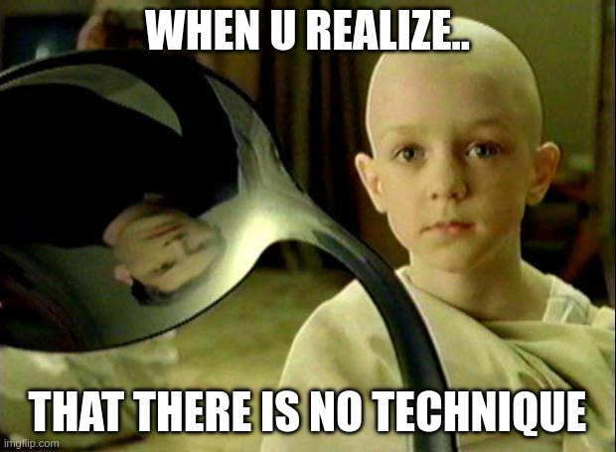
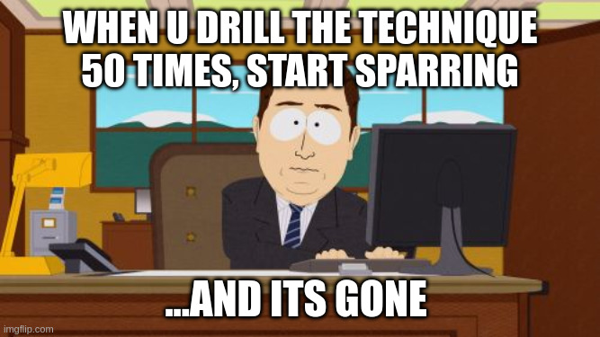
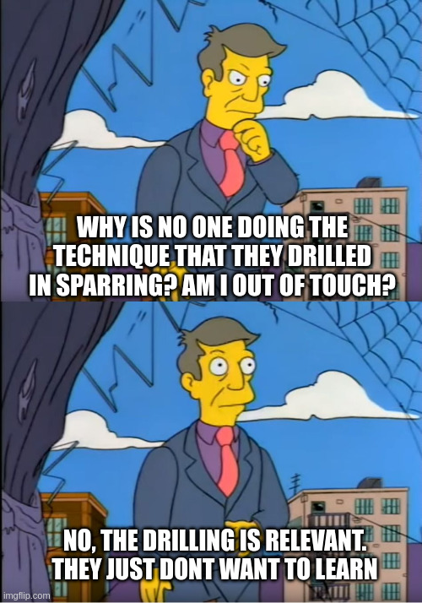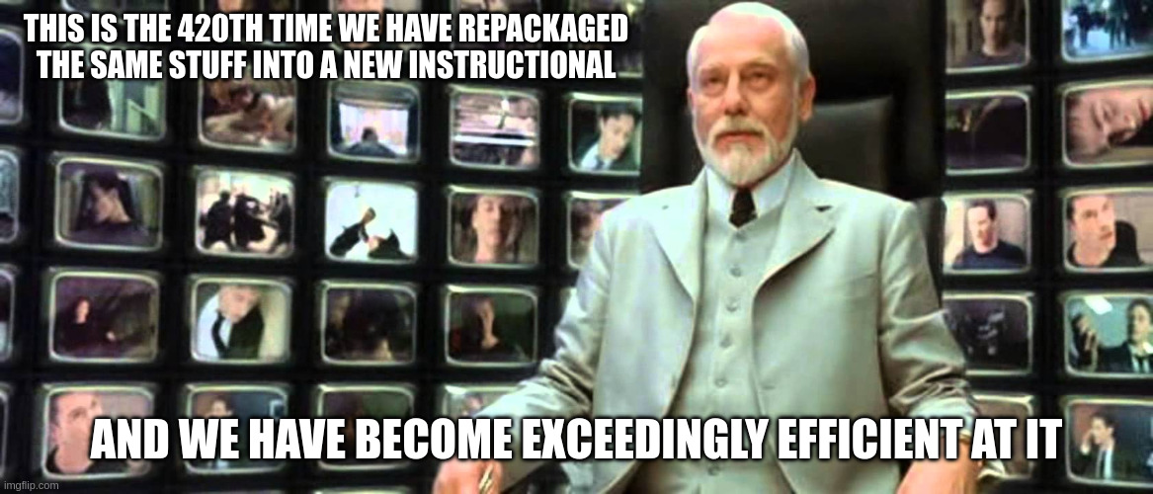

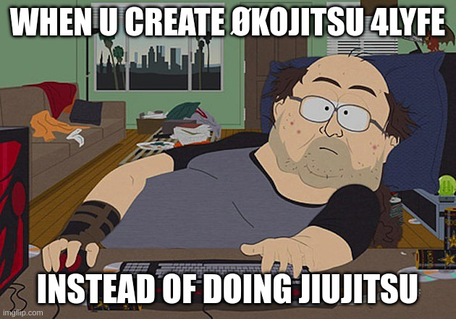

Tab 62

BJJ CLA Games — Seminar Transcript

1. Arm Retention Hold-Down
Bottom player escapes; top player controls arm and pins
- Start: Top player has elbow-to-elbow grip on bottom player's nearest arm. Bottom player is on their back.
- Top (attacker): Stay attached to the arm any way possible. Use legs to hold partner to the floor.
  - Win: Maintain arm control AND keep bottom player from reaching knees
  - Lose: Lose the arm OR bottom player gets to their knees
- Bottom (defender): Pull arm free OR get up to knees
  - Win: Get to knees (even if top still has the arm)
- Continuous: Switch roles each time bottom player wins

2. Arm Lock Finish
Progression from Game 1 — same hold-down, now with submission
- Start: Same elbow-to-elbow grip, bottom player on back
- Top: Stay attached to arm, hold partner down with legs. Once disconnection occurs, straighten the arm to tap
  - Win: Partner taps
  - Lose: Lose the arm OR bottom player gets to knees
- Bottom: Pull arm free at any time OR get to knees

3. Mount Elbow Control — Armbar Setup
Getting under the elbows is the precondition for the armbar breaking position.
Top player hunts armbar from mount; bottom player defends with elbows
- Start: Top player mounted, both arms under bottom player's elbows
- Top: Keep at least one arm/body part under an elbow at all times. Move one arm out of the way, get entire body behind it, clamp legs onto shoulder (one leg over head, one over body — the breaking position)
  - Win: Reach full armbar breaking position (leg covering head, leg covering body)
  - Constraint: Cannot lose position under the elbows
- Bottom: Bring both elbows to the mat AND to the body simultaneously
  - Win: Back of arms touching mat + inside of arms touching body

4. Guard Passing — Hips to Shoulders
Wrestlers come into grappling unable to hold people down because their whole life they trained not to be on the floor. This game builds that. Scaled by distance: start at hips, then knees, then feet — each line makes it harder.
Top player passes; bottom player stands up
- Start: Top player's hands locked around bottom player's hips
- Top: Change connection from hips → shoulders (chest-to-chest or chest-to-back). Must secure hips first, then move to shoulders — in that order
  - Win: Achieve chest-to-chest or chest-to-back connection at shoulders
  - Constraint: Must pass through hips first
- Bottom: Get both feet on the floor with hands off the floor
  - Win: Both feet on floor, no hands on mat

5. Butterfly Guard — Inside/Outside Position
If the conditions for a technique are not present, the effect cannot happen. This game trains the conditions that make butterfly sweeps possible.
Bottom player sweeps; top player clears to outside
- Start (alternating each turn):
  - Both feet inside
  - One foot inside, one outside with a hand on the ankle
- Bottom: Use feet and hands in any orientation to get partner's butt to hit the mat
  - Win: Partner's butt touches mat in any orientation
- Top: Get both legs to the outside of partner's feet and touch shin to their body
  - Win: Shin touches partner's body with both legs outside their feet

6. Triangle — Threat (Lock Setup)
Ryan Hall broke triangles into four conditions: threat, lock, angle, finish. Submissions are low-variability — we can be explicit about what makes them work.
Top player locks foot to knee pit; bottom player clears the arm
- Start: Top player double knees down, legs around partner, one arm in/one arm out
- Top: Lock foot into the bend of either knee pit, as close as possible. Doesn't matter which knee pit or the angle
  - Win: Foot locked into knee pit
  - Constraint: Cannot stand up — must stay double knees down
- Bottom: Pull the trapped arm out OR push the free arm back in

7. Triangle — Full Finish
Progression from Game 6 — threat → lock → angle → finish
- Start: Same as Game 6 (one arm in, one arm out, top player double knees down)
- Top (precursor sequence):
  - Keep partner close
  - Lock foot to bend of either knee pit
  - Hook under one of the limbs outside the lock (arm or leg — either works)
  - Only then: squeeze to finish
  - Win: Partner taps
- Bottom: Pull arm out or put both arms back in

8. Back Take from Hip Control
Top player takes back; bottom player stands up
- Start: Top player on bottom player's hips
- Top (task sequence): Take elbow off the floor → get under elbow → chest-to-chest or chest-to-back → lock hands → cover hips with legs
  - Win: Achieve back control with legs covering hips
- Bottom: Get to feet
  - Win: Both feet on the floor

Fane 74

BJJ CLA Games – Philippines Seminar

Game 1: Seated Handfight
Starting position: Top player standing/kneeling, bottom player seated
Top player wins by:
- Connecting hands around bottom player's upper body (headlock, body lock — anything connecting at hips or shoulders)
- Making both of bottom player's shoulders touch the mat
Bottom player objective (continuous — no win):
- Prevent top player from connecting
- Stay seated — cannot stand, cannot sweep
- Use all limbs; harass top player's feet with legs as the longest tool
- No closed fists
Constraints: Bottom player cannot stand or sweep. Top player wins = flip roles.
Task focus: Inside position, more connections on him than he has on you.

Game 2: Line Holding
Starting position: Bottom player supine, top player past the feet (shin on same-side hamstring or outside past feet)
Top player objective (continuous — no win):
- Maintain position past the feet for the whole round
- Cannot put knees down
- Cannot go chest-to-chest (chest-to-back is allowed)
Bottom player wins by:
- Making top player's hip touch the mat (any contact = flip)
- Getting up to feet
Task focus: Keep feet off your body and off the mat. "If the bottom player made your hip touch, that means their feet were on you somehow."

Game 3: Segmenting to Pin
Starting position: Half guard / top player already past the knees, bottom player framing
Top player wins by:
- Close connection at the shoulders (under one or both arms) AND past the legs — mount, side body, back mount all count
Bottom player wins by:
- Top player's hip touches the mat
- Getting up to feet
- Re-establishing closed guard
Constraints: Top player must stay ahead of each line — feet → knees → hips → hands/elbows → shoulders. "Stay ahead of your lines."
Task focus: Segment the periphery sequentially. Don't think side control or mount — think about what's directly in front of you and remove it.

Game 4: Finish or Backtake
Starting position: Leg drag (top player has leg across, no chest-to-chest)
Top player wins by:
- Finishing on the leg (inside heel hook emphasis)
- Taking the back
Bottom player wins by:
- Breaking free / disconnecting
- Getting to guard, standing, or getting on top
Constraints: No chest-to-chest. "If the back's not there, go right back to the legs."
Task focus: Chase hips and hands — alternate between back and legs fluidly. "Play the whole space."

Game 5: Hips to Shoulders (Crab Ride Progression)
Starting position: Crab ride (top player feet inside behind knees, partner facing away)
Top player wins by:
- First destabilizing to hands or hips touching mat, then advancing to hips
- From hips: destabilize again (hands or hips), then advance to shoulders (close connection past the legs)
Defending player wins by:
- Returning to seated guard
- Getting to standing neutral
Task focus: Two-stage destabilization — must make hands or hips touch before progressing to next line. "You must make the hands touch or hips touch before you try to go to the hips. Then once you get to the hips, you must make the hands touch or hips touch again before you get to the shoulders."

