**Portfolio Optimization using MPT & CAPM**

Liang An, Jhao-Han Chen, Xuanzhu Luo, Jiamei Wang, Ming Wei

Stevens Institute of Technology

BIA-650-Optimization & Porc. Analysis

Instructor: Professor Alkiviadis Vazacopoulos

**Portfolio Optimization using MPT & CAPM**

A variety of methods can be used to optimize the choice of stocks. In our report, we mainly use MPT & CAPM to predict three indicators to determine the merits of a portfolio: Sharpe Ratio, return, and risk.

*Keywords*: Modern Portfolio Theory (MPT), Capital Asset Pricing Model (CAPM)，

**Project Overview**

Our project objective is to select the best asset distribution, out of the set of all portfolios being considered so as to compare the expected portfolio return, expected volatility, and the Sharpe Ratio when minimizing the variance (risk) and when maximizing the Sharpe Ratio. We compare the expected portfolio return, expected volatility, and the Sharpe Ratio when using different approaches: Modern Portfolio Theory (MPT) Vs. Capital Asset Pricing Model (CAPM). For MPT, we used Python, and for CAPM we used.

In the following sections, we will show the data and methodologies we used. We will also explain our detailed analysis upon each step in Excel and Python. After that, we will conclude the whole thing we did in the end.

**Data and Methodologies**

**Data**

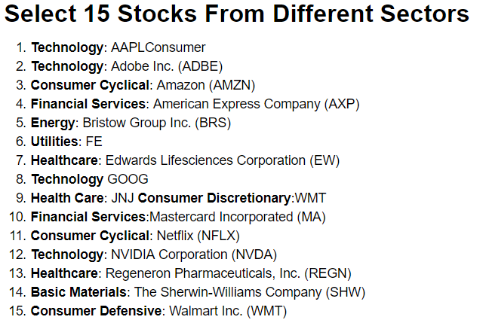

To diversify our portfolio, we chose 15 stocks from different sectors. Historical adjusted prices were collected from Yahoo Finance, ranging from 12/29/2016 - 10/26/2018.

**Methodologies**

1.Modern Portfolio Theory (MPT)

We use this method in python, which is introduced by Harry Markowitz. It assumes investors are only concerned about efficient portfolios. Its key insight is that an asset's risk and return should not be assessed by itself, but by how it contributes to a portfolio's overall risk and return. It uses

the variance of asset prices as a proxy for risk.[1]

2.Sharpe Ratio

It an indicator uses standard deviation to measure a fund's risk-adjusted returns. The detailed way to calculate it is that the average return minus the risk-free return, then divided by the standard deviation of return on investment.

3.Monte Carlo Simulation

We implemented Monte Carlo simulation in python. Monte carlo simulation is used to model the probability of different outcomes in a process that cannot easily be predicted due to the intervention of random variables. It is a technique used to understand the impact of risk and uncertainty in prediction and forecasting models.[2] We use it to generate 1000,000 times of possible portfolios.

4.Efficient Frontier  
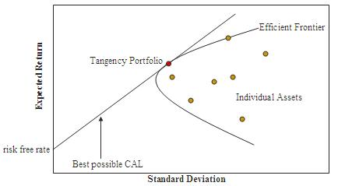

We use this method in Python. As shown in the graph above, all the dots are portfolios generated by Monte Carlo simulation, but only the portfolios that lie on the curve are the most efficient ones, given a certain risk. This method focuses on the risk and return relationship for efficient portfolios. The straight line is called Capital Market Line, where it intersect with the efficient frontier is the Tangency Portfolio (with max sharpe ratio). By efficient frontier, we could also find the Min Variance Portfolio

5.Capital Asset Pricing Model (CAPM)

As an extension of Modern Portfolio Theory (MPT), it considers the relationship between expected return and risk for individual assets or securities. In Excel, we use CAPM to calculate the expected return of each stock with function presented below:

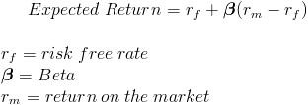

The Beta in the function measures the volatility (systematic risk) of a portfolio in comparison to the entire market.

6.Solver

The Solver is a tool included in excel for doing optimizations. Our target is to found optimizations for three indicators:(1) Max Return, (2) Min Risk, (3) Max Sharpe Ratio.

7.Matplotlib & Tableau

We use Matplotlib & Tableau to do data visualizations.

**Model-Python**

**Variables for the Excel Solver**

There are five input variables in the Capital Asset Pricing Model. The market return and risk-free rate is generated by calculating the daily return of S&P500 Index and Treasury Bill, respectively. We have three objectives to optimize, and the common constraint for those three optimizations is that total weight equals to one. There are still specific constraints for each optimization. We

should make the standard deviation of the portfolio less than or equal to the standard deviation of each stock when maximizing the return of the portfolio, and the return of the portfolio larger than or equal to the return of each stock when minimizing the risk of the portfolio.

**Input Variables:** Expected return, Standard Deviation and Beta of each stock, Market

Return (S&P500), and Risk-free rate (Treasury Bill).

**Decision Variables:** Stock weights.

**Objectives:** (1) Maximum return (2) Minimum risk (3) Maximum Sharpe Ratio.

**Constraints:** Total weight = 1

**Other constraints for different objectives:** (1) Maximum return: Std <= Std of each stock (2) Minimum risk: Return >= Return of each stock.

**E(r), STDEV and Sharpe Ratio of each stock**

For a given stock and a benchmark, the beta of the stock can be acquired by find this approximate formula , where is the return of stock, is the active return and is the return of the benchmark. The benchmark here is the market return.

|  |  |  |  |  |  |  |  |  |
| --- | --- | --- | --- | --- | --- | --- | --- | --- |
|  | AAPL | ADBE | AMZN | AXP | BRS | FE | EW | GOOG |
| Beta | 0.96974 | 1.14382 | 1.12396 | 1.44410 | 1.28212 | 0.69237 | 0.66123 | 0.95099 |

|  |  |  |  |  |  |  |  |
| --- | --- | --- | --- | --- | --- | --- | --- |
|  | JNJ | MA | NFLX | NVDA | REGN | SHW | WMT |
| Beta | 0.56236 | 1.12910 | 0.95834 | 1.38815 | 1.14775 | 0.81311 | 0.53159 |

For the given beta, market return and risk-free rate, the expected return of each stock can be acquired by applying the formula . We calculate the standard deviation of each stock using the Function “= STDEV()” in Excel. The Sharpe Ratio can be obtained by applying the formula .

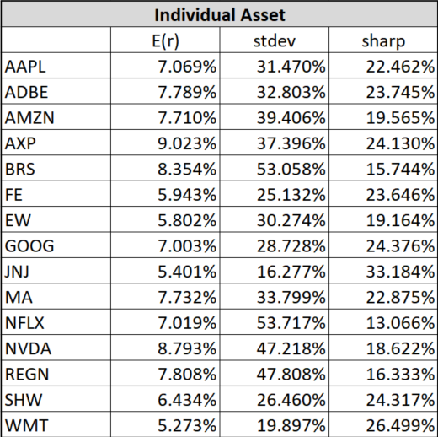

**Covariance Matrix**

The covariance method is a risk management technique for calculating the value at risk of a portfolio of assets. The value at risk is a statistical risk management technique measuring the maximum loss that a portfolio is likely to face.

Our portfolio has multiple assets, so its volatility is calculated using a matrix, which is computed for all assets. The vector of the weights of the assets in the portfolio is multiplied by the transpose of the vector of the weights of the assets multiplied by the covariance matrix of all of the assets.

The covariance of a pair of stocks can be acquired by using the formula, where is the weight of each stock, is the variance of each stock, is the standard deviation of each stock, and is the correlation between two stocks. We use the Function “=MMULT()” and “=TRANSPOSE()” to acquire the covariance matrix of the portfolio with fifteen stocks.

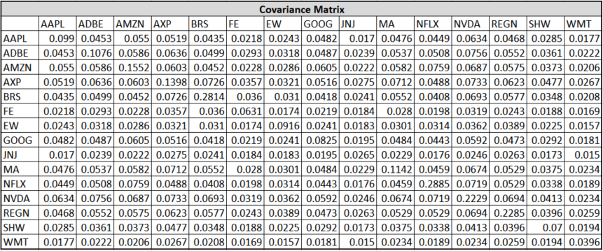

**Results from Solver**

The rate of return on our portfolio is calculated as the weighted average rate of return on the multiple stocks within this portfolio. The variance of the portfolio is calculated as , where w is a column vector containing the weights of different stocks on this portfolio, is the covariance matrix, and is the transpose of the matrix .

The results indicate that portfolio with highest expected return is the most volatile, and portfolio with lowest expected return has the lowest volatility. If an investor is risk-averse, he might prefer the portfolio with 5.878% annual return and 0.1521 volatility. If an investor is a risk-tolerant, he might prefer the portfolio with 9.030% annual return and 0.3739 volatility.

**Model-Python**

With the same dataset, we analyzed the risks and return of different stocks.

**Time-series Plot of the Data**

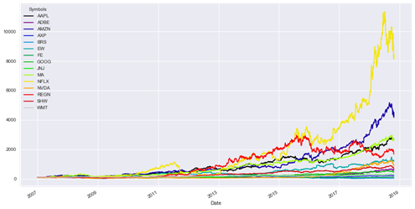

This time-series plot of shows the volatility of the different stocks. The yellow one is Netflix, and the blue one is AMAZON. They are increasing these years, which means that their risks are increasing these years. Also, the red line, Negeneron, is decreasing after 2015. Although the volatility is decreasing, its return is increasing. After adding it into the portfolio, the sharper ratio of the portfolio is higher, which is good for our result.

**Daily log Return**

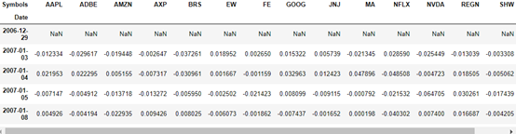

We use the daily log return to calculate the annual return

**Individual Stocks’ Volatility**

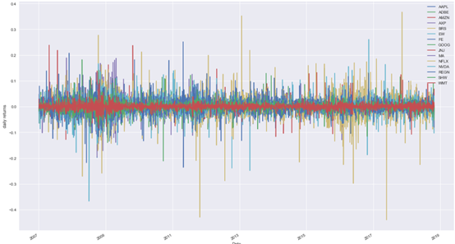

This is the volatility of the individual stock. Some are higher, some are low, which diffuse the risk, good for our optimization.

**Annualized Return**

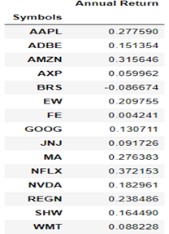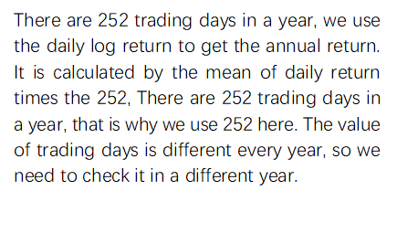

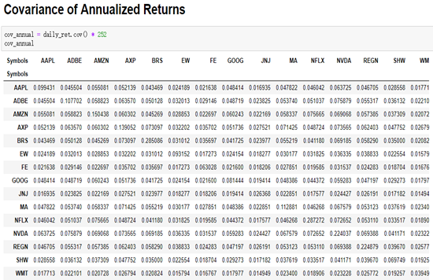

We used this covariance to calculate the stand deviation.

**Portfolio Optimization using Efficient Frontier**

We use Monte Carlo Simulation to run 1000,000 different randomly generated weights for the individual stocks and then calculate the expected return, expected volatility and Sharpe Ratio for each of the randomly generated portfolios.

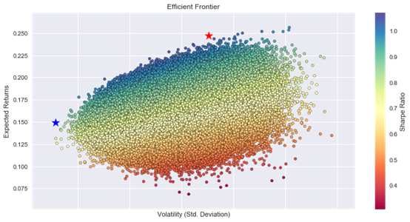

The red star is the point which the sharper ratio of this portfolio is the biggest one among all that of the portfolios. Any Sharpe ratio greater than 1 is considered acceptable to good by investors. A ratio higher than 2 is rated as very good, and a ratio of 3 or higher is considered excellent. Although the biggest sharper ratio in our portfolios is almost 1, no so high, it is the best one in our portfolios.

The blue star is the point whose risk is the smallest one in our portfolios, we prefer the risk of our investment not too high, in order to ensure that we will not suffer too much lost.

**Python Result**

**Min Variance Portfolio Weights/ Tangency Portfolio Weights**

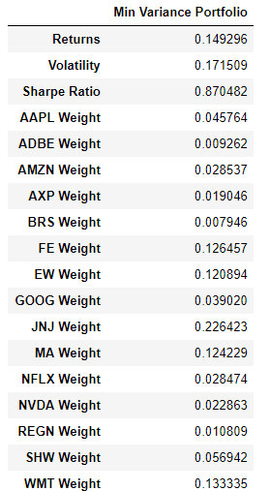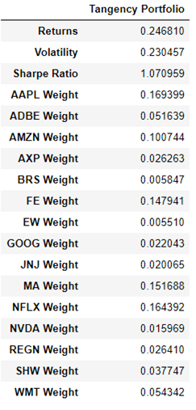

**Optimization Results**

The volatility of the two results are almost the same, but the sharper ratio and return of the Yellow one are much higher (the yellow one is the stock with maximize sharpe ratio). We prefer sharper ratio bigger than 1, which make the investment sense. So we choose the portfolio with maximized shaper ratio as the optimization result.

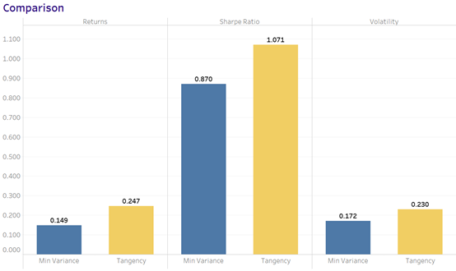

**Total Conclusion**

We processed both MPT and CAPM so that we could do some comparisons between these two methods. By comparing the expected return, standard deviation and Sharpe Ratio for each portfolio based on Max Sharpe Ratio and Min Risk respectively, which lists below, We found w

|  |  |  |  |
| --- | --- | --- | --- |
| **Max Sharpe Ratio** | **Expected Return** | **Standard Deviation** | **Sharpe Ratio** |
| MPT | 24.7% | 0.230 | 1.071 |
| CAPM | 5.9% | 0.152 | 0.386 |

|  |  |  |  |
| --- | --- | --- | --- |
| **Min Risk** | **Expected Return** | **Standard Deviation** | **Sharpe Ratio** |
| MPT | 14.9% | 0.172 | 0.870 |
| CAPM | 9.030% | 0.3739 | 0.2415 |

1. Wigglesworth, Robin (11 April 2018). ["How a volatility virus infected Wall Street"](https://www.ft.com/content/be68aac6-3d13-11e8-b9f9-de94fa33a81e). *The Financial Times*.
2. https://www.investopedia.com/terms/m/montecarlosimulation.asp