[Circle of the Grassland](https://roll20.net/compendium/dnd5e/Druid#h-Circle%20of%20the%20Land)

**Grassland Forms**

When you choose this circle at 2nd level, you gain access to fallowing forms at 2nd, 4th, and 8th level, you do not have to fallow any of the restriction for these forms.

2nd Warhorse, Pronghorn

6th Cheetah, Lion.

12th Giant Elk

16th Rhinoceros

**Circle Spells**

At 2nd level, you learn the thunderclap cantrip, you already know this cantrip you may one additional druid cantrip of your choice instead. At 3rd, 5th, 7th, and 9th level you gain access to the spells listed for that level in the Circle of Planes Spellstable.

Once you gain access to one of these spells, you always have it prepared, and it doesn’t count against the number of spells you can prepare each day. If you gain access to a spell that doesn’t appear on the druid spell list, the spell is nonetheless a druid spell for you.

Druid Level Circle Spells

3rd Warding Wind, Pass Without Trace

5th Haste, Thunder Step

7th Freedom of Movement, Aura of Life

9th Control Winds, Dawn

**Plan Runner**

Your speed increases by 10 feet while you aren't wearing Heavy Armor or wielding a shield.

**Grace Of Planes**

At 6th level, As a action, you can use your action to enter a state as sweeping winds of the planes around you until the end of your turn, while in this state, when you move within 5 feet of a another creature, you may choose to heal the creature for 1d6 + your spellcasting ability modifier or deal 1d6 + your spellcasting ability modifier thunder damage to the creature, You may use combination of either abilities up to six times this turn and only once on a creature.

Once you have used this action, you can’t use it again until you finish a long rest or until you expend a spell slot of 3th level or higher to use it again.

**-Avatart of the Planes**

At 10th level You can expend two uses of Wild Shape at the same time to transform into Elephant, Zephyr Horn, or Bronzehide Lion. In addition, if you have magic weapon merge into any of your wild shapes, your attacks in wild shape form count as magical for the purpose of overcoming resistance and immunity to nonmagical attacks and damage.

**Soinic Charge**

At 14th level, You go at supersonic Speeds in a straight Line Cutting down anything that stands in your way, as a bonus action, you may choose to move up to a 120 feet in a line along the ground in front of you, this movement does not provoke attacks of opportunity and you have advantage on dexterity saving throws while moving this way, each creature that comes into contact with while moving this way must make a strength saving throw vs your spell save. On a failed save, a creature takes 5d10 thunder damage and push to side of you and is knocked prone, or half as much damage on a successful save and you are stopped in your path.

Once you have used this action, you can’t use it again until you finish a long rest or until you expend a spell slot of 5th level or higher to use it again.

|  |  |  |  |  |  |
| --- | --- | --- | --- | --- | --- |
| Bronzehide Lion  ***Large Celestial*** | | | | | |
| **Armor Class** 16  **Hit Points**  68  **Speed** 50ft. | | | | | |
| **STR**  19 (+4) | **DEX**  15 (+2) | **CON**  16 (+3) | **INT**  6 (-2) | **WIS**  16 (+3) | **CHA**  14 (+2) | |
| **Damage Resistance** Bludgeoning, Piercing, and Slashing.  **Saving** Throws Str +6, Con +4  **Skills** intimidation + 4 Perception +5, Stealth +5  **Senses**. Darkvision 90 Ft. passive Perception 15  **Challenge** 5 (200 XP)  **Ambusher** - The Lion has advantage on attack rolls against any creature it has surprised.  **Keen senses.** The Lion has advantage on Wisdom (Perception) checks.  **Running Leap**. With a 10-foot running start, the lion can long jump up to 40 ft. | | | | | | | |
| **­** | | | | | | | |
| ACTIONS | | | | | | | |
| **Multiattack. The lion makes two attacks: one with its bite and one with its claw.**  **Bite.** Melee Weapon Attack: +6 to hit, reach 5 ft., one target. Hit: 8 (2d8 + 4) piercing damage.  **Claw.** Melee Weapon Attack: +6 to hit, reach 5 ft., one target. Hit: 7 (2d6 + 4) slashing damage. | | | | | | | |
|  | | | | | | | |

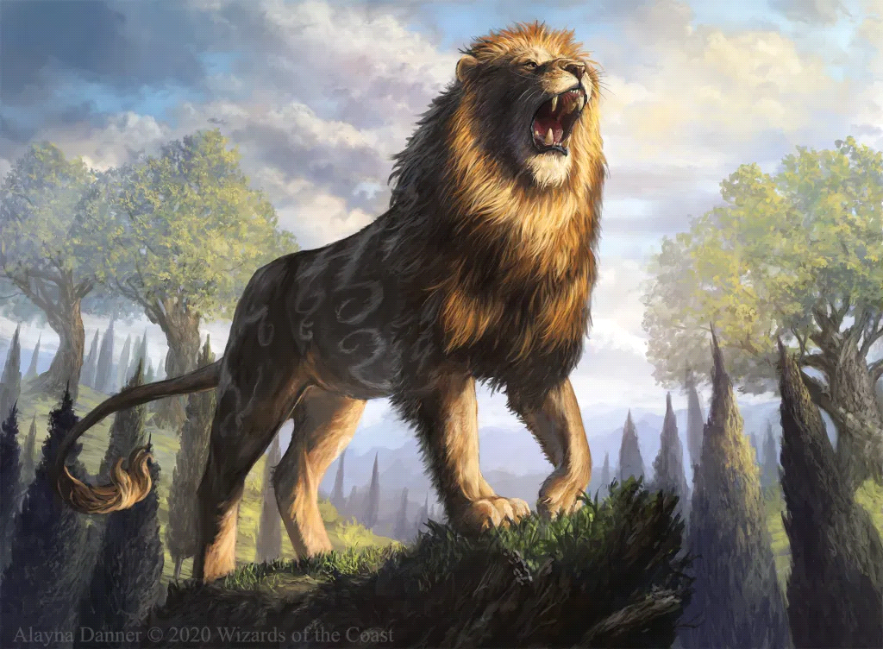

|  |  |  |  |  |  |
| --- | --- | --- | --- | --- | --- |
| Zephyr Horn  ***Medium Elemental*** | | | | | |
| **Armor Class** 16  **Hit Points**  32 (7d8)  **Speed** 70ft. | | | | | |
| **STR**  12 (+1) | **DEX**  22 (+6) | **CON**  10 (+0) | **INT**  8 (-1) | **WIS**  16 (+3) | **CHA**  12 (+1) | |
| **Damage Resistance** Thunder  **Saving** Throws Dex +8  **Skills** Perception +5, Stealth +8  **Senses** passive Perception 14  **Challenge** 5 (200 XP)  **Ambusher** - The Zephyr Horn has advantage on attack rolls against any creature it has surprised.  **Keen Sight and Hearing.** The Cheetah has advantage on Wisdom (Perception) checks that rely on sight or hearing.  **Sprinter**. The first time the Zephyr Horn uses the action to Dash on its turn, its speed is quadrupled instead of doubled. Zephyr Horn can also make one Ram attack as a bonus action on that turn  **Blurred Movement**. Attack rolls against the Zephyr Horn have disadvantage unless the Zephyr Horn is incapacitated or restrained.  **Sonic Ram.** If the Zephyr Horn moves at least 40 feet straight toward a target and then hits it with a ram attack on the same turn, the target takes an extra 16 (3d10) Thunder damage. If the target is a creature, it must succeed on a DC 14 Constitution saving throw or be stunned until the end of it's next turn. | | | | | | | |
| **­** | | | | | | | |
| ACTIONS | | | | | | | |
| |  | | --- | | **Multiattack.** The Zephyr Horn makes three attacks: one with its bite and one with its claws and one with its horns.  **Bite**. Melee Weapon Attack: +8 to hit, reach 5 ft., one target. Hit: 9 (1d6 + 5) piercing damage.  **Claw**. Melee Weapon Attack: +8 to hit, reach 5 ft., one target. Hit: 7 (1d4 + 5) slashing damage. If the target is a creature  **Ram.** Melee Weapon Attack: +8 to hit, reach 10 ft., one target. Hit: 7 (1d4 + 5) bludgeoning damage. | | | | | | | | |
|  | | | | | | | |

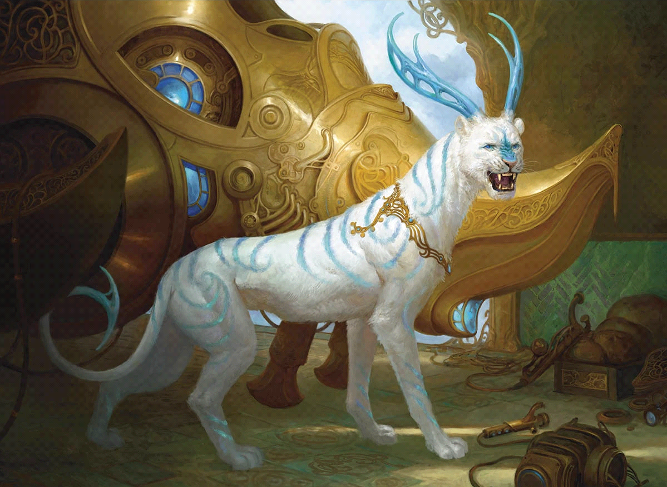

|  |  |  |  |  |  |  |
| --- | --- | --- | --- | --- | --- | --- |
| Elephant  ***Huge beast*** | | | | | | |
| **Armor Class** 14  **Hit Points**  114 (12d12+36)  Speed 50 ft, | | | | | | |
| **STR**  23 (+6) | **DEX**  9 (-1) | **CON**  17 (+3) | **INT**  6 (-2) | **WIS**  16 (+3) | **CHA**  10 (0) | | |
| **Skills** intimidation + 4 Perception +6  **Senses**. passive Perception 11  **Challenge** 5  **Keen Hearing and Smell** **-** The Elephant has advantage on Wisdom (Perception) checks that rely on hearing or smell.  **Trunk -** The Elephant can grasp things with its trunk, it can use it as a snorkel. It has a reach of 10 feet, and it can lift a 800 pounds. it can use it to do the following simple tasks: lift, drop, hold, push, or pull an object or a creature; open or close a door or container. it can't wield weapons or shields or do anything that requires manual precision, such as using tools or magic items or performing the somatic components of a spell.  **Trampling Charge.** If the elephant moves at least 20 ft. straight toward a creature and then hits it with a gore attack on the same turn, that target must succeed on a DC 16 Strength saving throw or be knocked prone. If the target is prone, the elephant can make one stomp attack against it as a bonus action. | | | | | |
| **­** | | | | | |
| ACTIONS | | | | | |
| **Multiattack.** The Elephant makes two attacks: one with its Gore and one with its Trunk Smack or Throw.  Gore. Melee Weapon Attack: +9 to hit, reach 5 ft., one target. Hit: 16 (3d8 + 6) piercing damage.  **Trunk Smack** Melee Weapon Attack**:** +9 to hit, reach 10 ft., one target. Hit: 8 (1d4 + 6) bludgeoning damage. If the elephant's Trunk is not holding anything and If the target is a Medium or smaller creature, The target is grappled (escape dc 16) Until this grapple ends, the creature is restrained, and the Elephant can't grapple another creature with its Trunk  **Throw,** The Elephant makes a ranged a attack with whatever it is holding in it's trunk. Ranged Weapon Attack: +2 to hit, reach 20/40 ft., one target. Hit: 9 (1d6 + 6) bludgeoning damage. if a creature the elephant is Grappling is thrown this way, it lands prone 5 feet away from the target and takes (1d6 + 6) damage, hit or miss  **Stomp.** Melee Weapon Attack: +8 to hit, reach 5 ft., one prone creature. Hit: 22 (3d10 + 6) bludgeoning damage. | | | | | |
|  | | | | | |

|  |  |  |  |  |  |  |
| --- | --- | --- | --- | --- | --- | --- |
| Rhinoceros  ***Large beast*** | | | | | | |
| **Armor Class** 14  **Hit Points**  68 (9d10+18)  Speed 40 ft | | | | | | |
| **STR**  21 (+5) | **DEX**  8 (-1) | **CON**  16 (+2) | **INT**  4 (-3) | **WIS**  10 (0) | **CHA**  8 (-1) | | |
| **Skills** intimidation + 4  **Senses**. passive Perception 11  **Challenge** 3  **Poor Sight.** The rhinoceros has disadvantage on Wisdom (Perception) checks that rely on sight.  **Charge.** If the rhinoceros moves at least 20 ft. straight toward a target and then hits it with a gore attack on the same turn, the target takes an extra 13 (3d8) piercing damage. If the target is a creature, it must succeed on a DC 15 Strength saving throw or be knocked prone. | | | | | |
| **­** | | | | | |
| ACTIONS | | | | | |
| **Gore. Melee Weapon Attack: +7 to hit,** reach 5 ft., one target. Hit: 14 (2d8 + 5) piercing damage. | | | | | |
|  | | | | | |

|  |  |  |  |  |  |  |
| --- | --- | --- | --- | --- | --- | --- |
| Cheetah  ***Medium beast*** | | | | | | |
| **Armor Class** 13  **Hit Points**  Hit Points 13 (3d8)  Speed 50 ft | | | | | | |
| **STR**  12 (+1) | **DEX**  18 (+3) | **CON**  10 (+0) | **INT**  4 (-3) | **WIS**  14 (+2) | **CHA**  8 (-1) | | |
| **Skills** Perception +4 Stealth +5  **Senses**. passive Perception 14  **Challenge** 1  **Ambusher** - The Cheetah has advantage on attack rolls against any creature it has surprised.  **Keen Sight and Hearing.** The Cheetah has advantage on Wisdom (Perception) checks that rely on sight or hearing.  **Sprinter**. The first time the Cheetah uses the Dash action on its turn, its speed is quadrupled instead of doubled. Cheetah can also make one claw attack as a bonus action on that turn | | | | | |
| **­** | | | | | |
| ACTIONS | | | | | |
| **Multiattack.** The Cheetah makes two attacks: one with its bite and one with its claws.  **Bite**. Melee Weapon Attack: +5 to hit, reach 5 ft., one target. Hit: 4 (1d6 + 1) piercing damage.  **Claw**. Melee Weapon Attack: +5 to hit, reach 5 ft., one target. Hit: 3 (1d4 + 1) slashing damage. If the target is a creature, it must succeed on a DC 11 Strength saving throw or be knocked prone | | | | | |
|  | | | | | |
|  | | | | | |

|  |  |  |  |  |  |  |
| --- | --- | --- | --- | --- | --- | --- |
| Lion  ***Large beast*** | | | | | | |
| **Armor Class** 14  **Hit Points**  45 (6d10+12)  Speed 40 ft 25 climb | | | | | | |
| **STR**  17 (+3) | **DEX**  15 (+2) | **CON**  13 (+1) | **INT**  4 (-3) | **WIS**  14 (2) | **CHA**  12 (+1) | | |
| **Skills** intimidation + 3, Perception +4, Stealth +4  **Senses**. Darkvision 60 Ft. passive Perception 14  **Challenge** 1  **Keen senses.** The Lion has advantage on Wisdom (Perception) checks.  **Ambusher** - The Lion has advantage on attack rolls against any creature it has surprised.  **Pack Tactics.** The lion has advantage on an attack roll against a creature if at least one of the lion's allies is within 5 ft. of the creature and the ally isn't incapacitated.  **Running Leap.** With a 10-foot running start, the lion can long jump up to 30 ft. | | | | | |
| **­** | | | | | |
| ACTIONS | | | | | |
| **Multiattack.** The Jaguar makes two attacks: one with its bite and one with its claws.  **Bite.** Melee Weapon Attack: +5 to hit, reach 5 ft., one target. Hit: 7 (1d8 + 3) piercing damage.  **Claw**. Melee Weapon Attack: +5 to hit, reach 5 ft., one target. Hit: 6 (1d6 + 3) slashing damage. | | | | | |
|  | | | | | |
|  | | | | | |

|  |  |  |  |  |  |  |
| --- | --- | --- | --- | --- | --- | --- |
| Pronghorn  ***Medium Beast*** | | | | | | |
| **Armor Class** 12  **Hit Points**  6 (1d8+1)  Speed 70 ft | | | | | | |
| **STR**  14 (+2) | **DEX**  14 (+2) | **CON**  12 (+1) | **INT**  3 (-2) | **WIS**  14 (+2) | **CHA**  8 (-1) | | |
| **Skills** Perception +4  **Senses**.. passive Perception 14  **Challenge** 1/2  **Keen Sight**. The Pronghorn has advantage on Wisdom (Perception) checks that rely on sight.  **Lose Fur** Creatures get disadvantage on grapple checks to grapple the Pronghorn or natural weapons attacks that deal pricing damage.  **Charge.** If the Pronghorn moves at least 20 ft. straight toward a target and then hits it with a ram attack on the same turn, the target takes an extra 2 (1d4) damage. | | | | | |
|  | | | | | |
| ACTIONS | | | | | |
| **Ram.** Melee Weapon Attack: +4 to hit, reach 5 ft., one target. Hit: 5 (1d4+ 2) bludgeoning damage. | | | | | |
|  | | | | | |
|  | | | | | |
|  | | | | | |