**Object-Oriented Analysis and Design**

**Course Assignment3**

Note : 多彩筆記

|  |  |  |
| --- | --- | --- |
| Name | ID | E-mail |
| 張明翔 | 106598023 | lakesd6531@gmail.com |
| 鍾承翰 | 106598024 | cmf15bsw@gmail.com |
| 李柏霖 | 106598038 | morris12345678987654321@gmail.com |
| 吳彥銘 | 106598060 | 40143109wu@gmail.com |

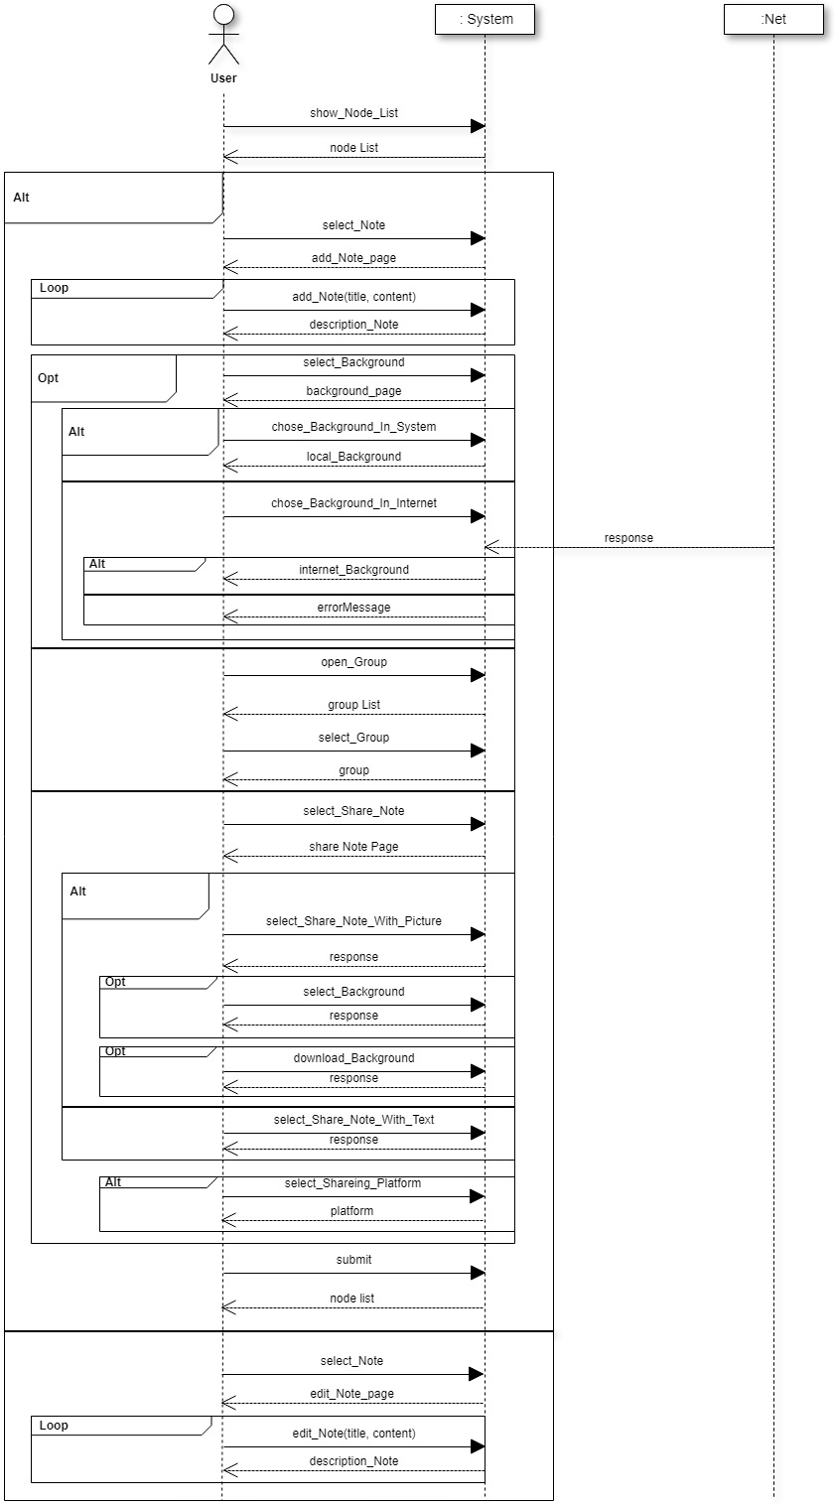

SSD

show_Note_List_SD

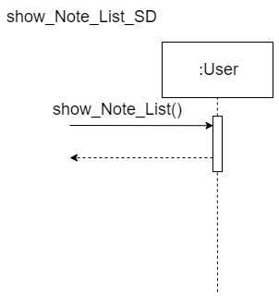

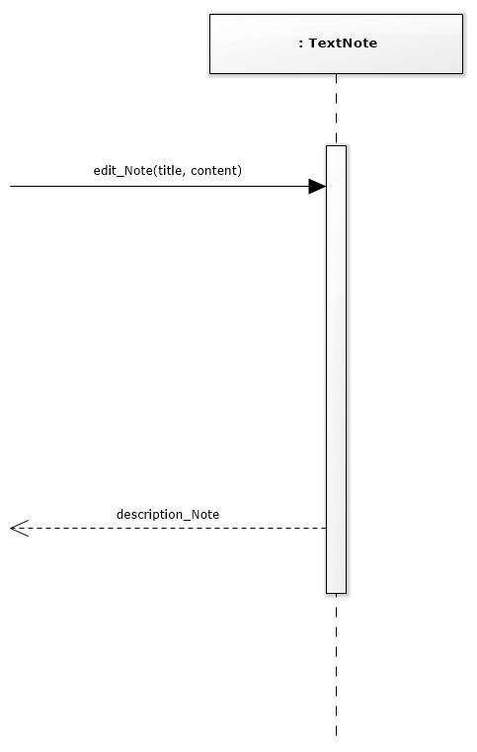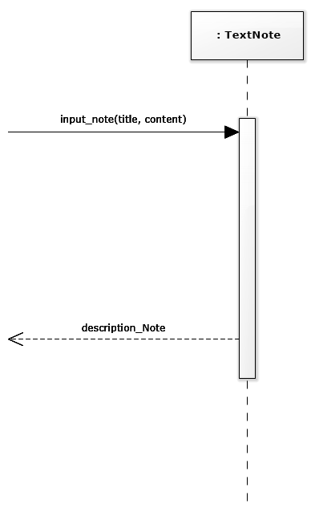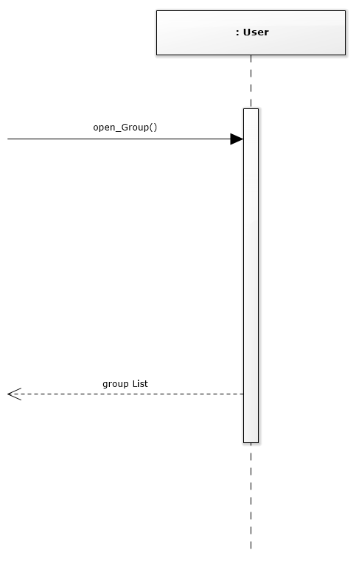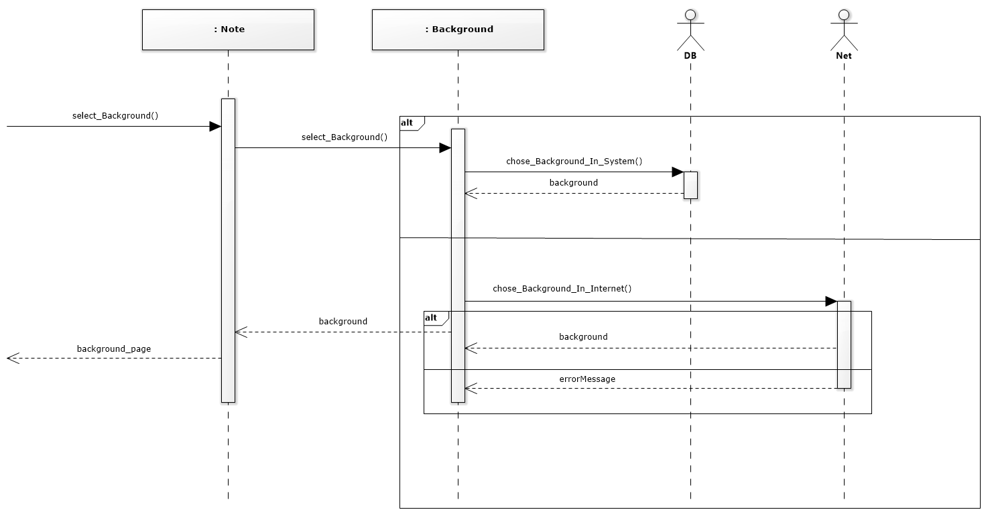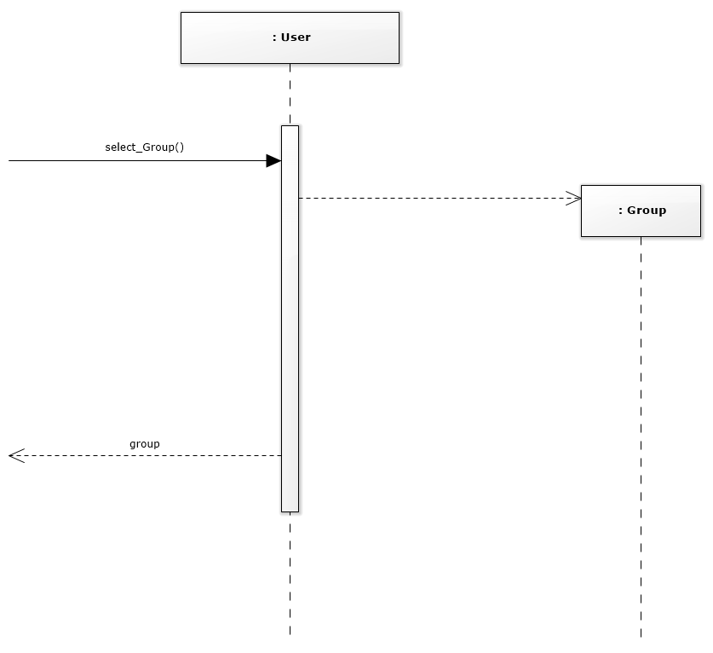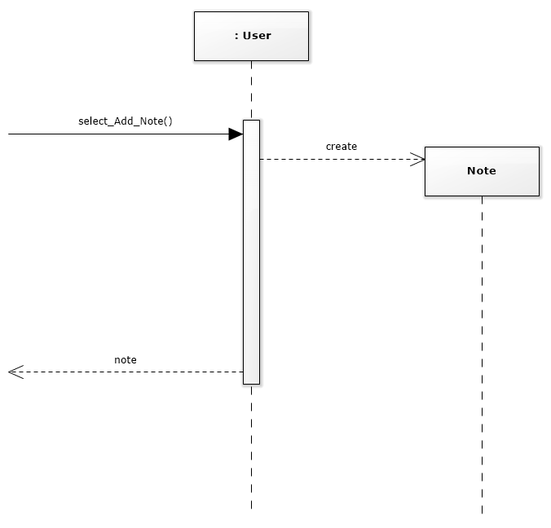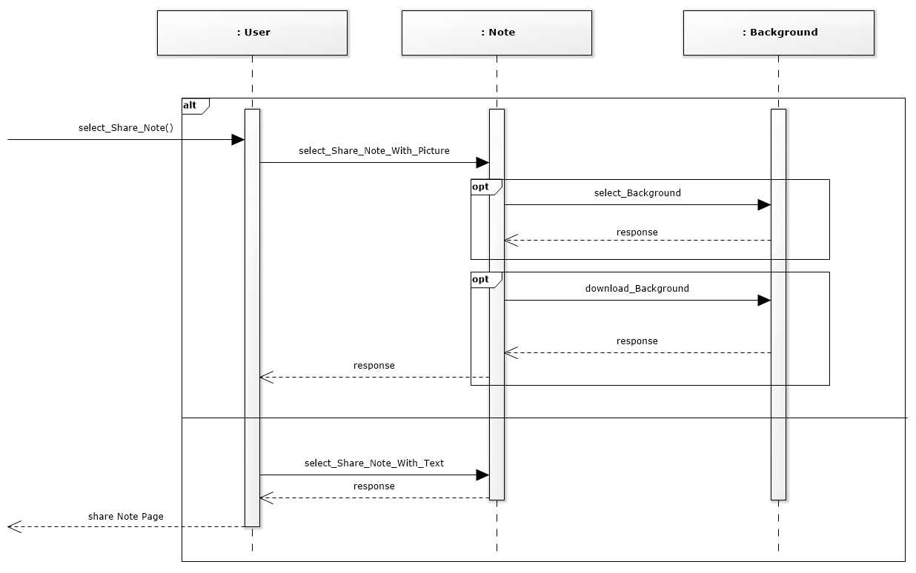

edit_Note_SD

Input_Note _SD

open_Group_SD

select_Background_SD

select_Group_SD

select_Add_Note_SD

select_Share_Note_SD

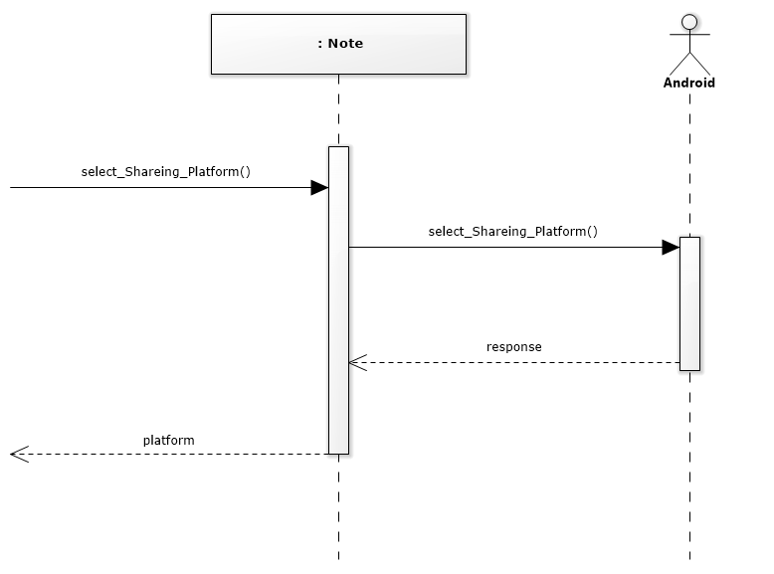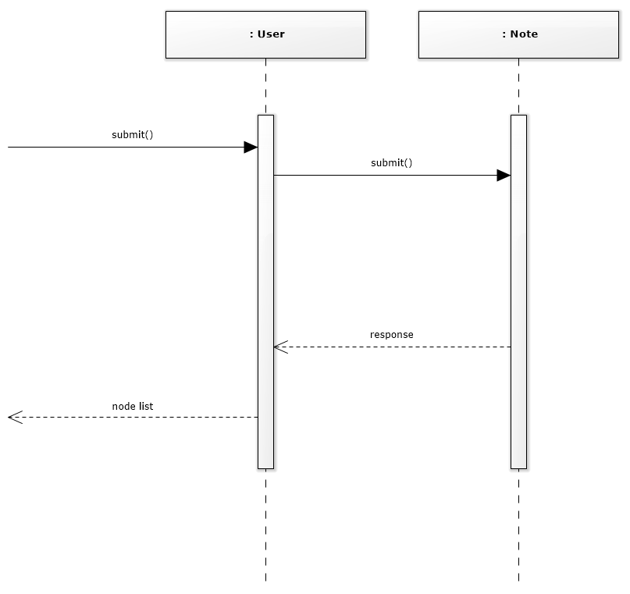

select_Sharing_Platform_SD

submit _SD

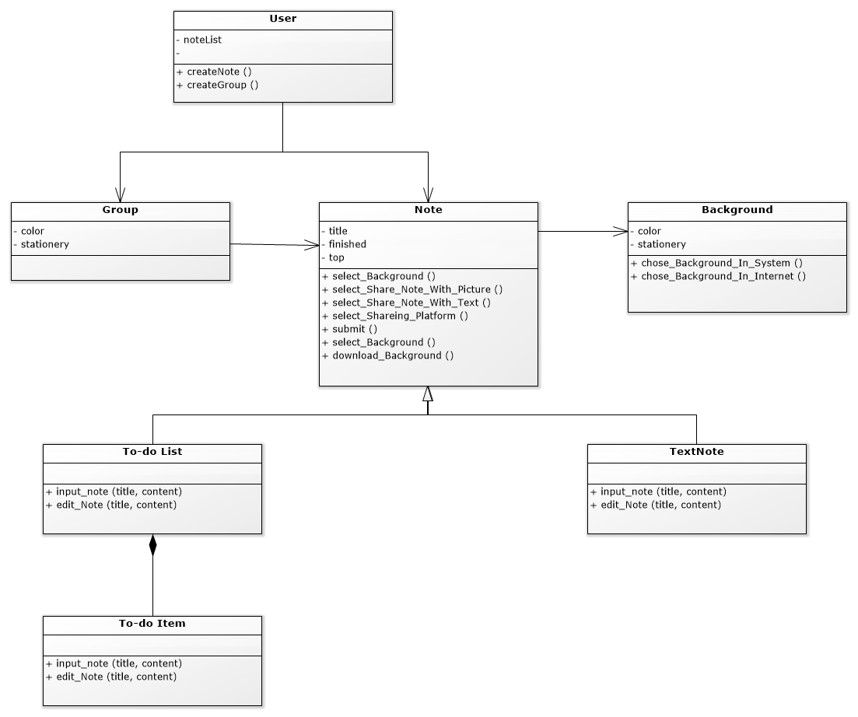

Class Diagram