Led Cube Concept

The Led cube is a display unit that can be utilized to visualize different effects in 3D environment. In this prototype we utilize the led cube to visualize the surrounding sound environment. The cube can be programmed to show other visual effects such as letters, messages, 2D and 3D pictures.

Our led cube is size of 4x4x4 (leds) and it consist of three main elements: the led cube, electronic circuit and controlling computer unit (Arduino). To visualize the sound a microfone is connected to the arduino, which controls the electronic circuit and the led cube. You can see a sketch of the led cube in the picture 1 below. We are using mirrors on two sides of the cube to amplify the visual effect.

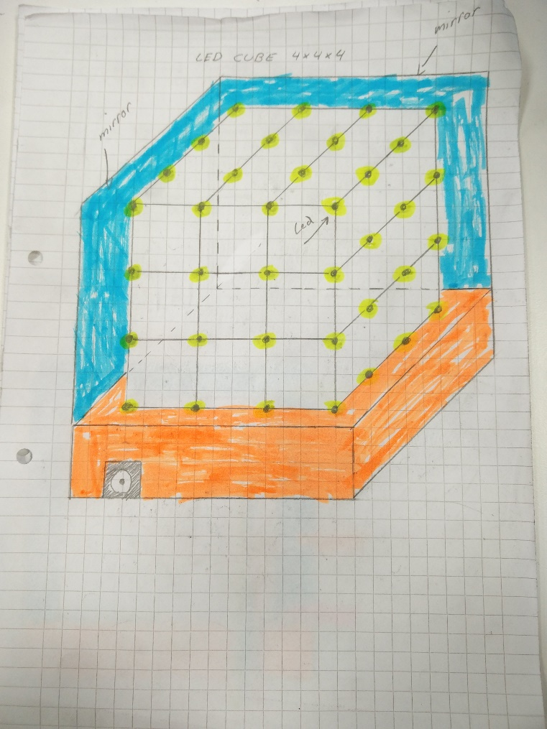

Picture 1. 4x4x4 Led Cube sketch.

Individual leds are controlled by using layers and columns, which are connected to the electronic circuit. In this prototype there will be 4 layers and 16 columns (4x4=16) which are controlled. In picture 2 below are two sketches of the layers and columns.

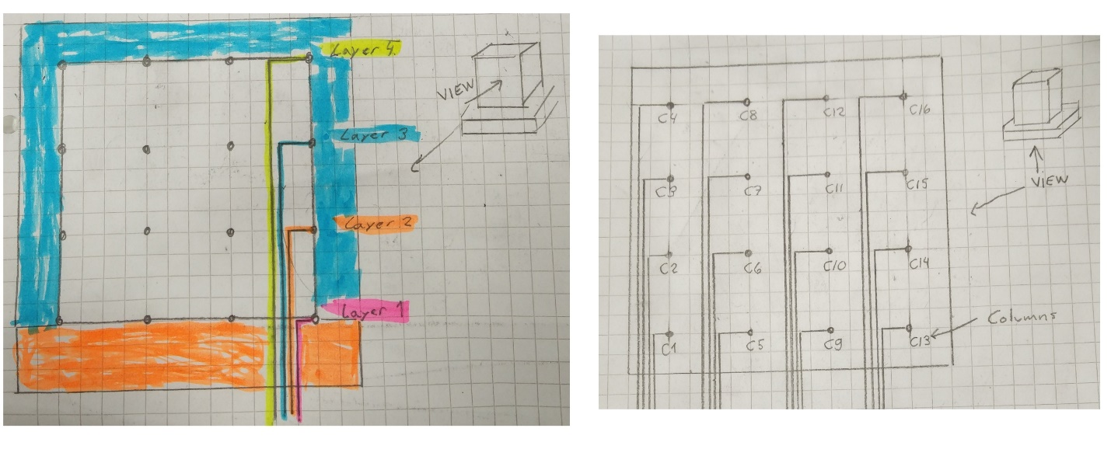

Picture 2. Layers (left) and columns (right) to control individual leds sktech.

How we arrived to this design

When we first started this course, we didn’t have any idea what kind of project we are going to do during this course. Despite this, we were sure that we wanted to do a project which lets us to learn as much as possible about FabLab equipments and which lets us to learn more about electronics, coding, computing and designing.

After some brainstorming, one of us remembered led cube which someone had made by themselves with simple electronics and computer unit. After researching subject more, we found out that this project connect our previously needs and could give good basic understanding about how to create versatile product. Because of this, we choosed led cube to be our project during this course.

To qualify our concept little bit more, we researched different kind of ways how the led cube could be implemented. On the basic of our research, we choosed to create this cube by using electronics which are connected to computer unit, Arduino. We could do this project without Arduino or with RasperyPi, but we want to learn to use Arduino so we choosed to go with this consept version. Addition to this, we choosed to do cube in size 4x4x4 because our orginal consept cube was 8x8x8. We choosed 4x4x4 because its easier and faster to do so if we broke something, it will not take so much time to get back to the situation before braking. Finaly, we brainstormed some extra ideas like mirros which would give cube more stylish look.

Other options we considered while we were deciding our design

We had multiple small brainstorm ideas for design but Led Cube was by far most well considered. Other ideas were thinked only on surface level and they were.

* Robot which uses lego Mindstorm units to do something great
* Alarm clock robot (course standard consept)
* Robot which react to the voice

Bill of materials, reference as link

**RGB LEDs Common Anode:** [http://rover.ebay.com/rover/1/711-53200-19255-0/1?...](http://rover.ebay.com/rover/1/711-53200-19255-0/1?icep_ff3=2&pub=5575101368&toolid=10001&campid=5337582279&customid=&icep_item=400498019125&ipn=psmain&icep_vectorid=229466&kwid=902099&mtid=824&kw=lg)

**Silvered Copper Wire (Bridge Wire):**[http://rover.ebay.com/rover/1/711-53200-19255-0/1?...](http://rover.ebay.com/rover/1/711-53200-19255-0/1?icep_ff3=2&pub=5575101368&toolid=10001&campid=5337582279&customid=&icep_item=371022540194&ipn=psmain&icep_vectorid=229466&kwid=902099&mtid=824&kw=lg)

**Solder**: [http://rover.ebay.com/rover/1/711-53200-19255-0/1?...](http://rover.ebay.com/rover/1/711-53200-19255-0/1?icep_ff3=2&pub=5575101368&toolid=10001&campid=5337582279&customid=&icep_item=170850630222&ipn=psmain&icep_vectorid=229466&kwid=902099&mtid=824&kw=lg)

**Ribbon Cable:**[http://rover.ebay.com/rover/1/711-53200-19255-0/1?...](http://rover.ebay.com/rover/1/711-53200-19255-0/1?icep_ff3=2&pub=5575101368&toolid=10001&campid=5337582279&customid=&icep_item=300922605797&ipn=psmain&icep_vectorid=229466&kwid=902099&mtid=824&kw=lg)

**DC Jack:**[http://rover.ebay.com/rover/1/711-53200-19255-0/1?...](http://rover.ebay.com/rover/1/711-53200-19255-0/1?icep_ff3=2&pub=5575101368&toolid=10001&campid=5337582279&customid=&icep_item=281160525209&ipn=psmain&icep_vectorid=229466&kwid=902099&mtid=824&kw=lg)

**Switch:**[http://rover.ebay.com/rover/1/711-53200-19255-0/1?...](http://rover.ebay.com/rover/1/711-53200-19255-0/1?icep_ff3=2&pub=5575101368&toolid=10001&campid=5337582279&customid=&icep_item=280613367489&ipn=psmain&icep_vectorid=229466&kwid=902099&mtid=824&kw=lg)

**Potentiometer (10k):**[http://rover.ebay.com/rover/1/711-53200-19255-0/1?...](http://rover.ebay.com/rover/1/711-53200-19255-0/1?icep_ff3=2&pub=5575101368&toolid=10001&campid=5337582279&customid=&icep_item=260807134429&ipn=psmain&icep_vectorid=229466&kwid=902099&mtid=824&kw=lg)

**Arduino Nano:**[http://rover.ebay.com/rover/1/711-53200-19255-0/1?...](http://rover.ebay.com/rover/1/711-53200-19255-0/1?icep_ff3=2&pub=5575101368&toolid=10001&campid=5337582279&customid=&icep_item=161282080431&ipn=psmain&icep_vectorid=229466&kwid=902099&mtid=824&kw=lg)

**TLC5940:**[http://rover.ebay.com/rover/1/711-53200-19255-0/1?...](http://rover.ebay.com/rover/1/711-53200-19255-0/1?icep_ff3=2&pub=5575101368&toolid=10001&campid=5337582279&customid=&icep_item=290742857279&ipn=psmain&icep_vectorid=229466&kwid=902099&mtid=824&kw=lg)

**Resistor Kit**:[http://rover.ebay.com/rover/1/711-53200-19255-0/1?...](http://rover.ebay.com/rover/1/711-53200-19255-0/1?icep_ff3=2&pub=5575101368&toolid=10001&campid=5337582279&customid=&icep_item=360823786398&ipn=psmain&icep_vectorid=229466&kwid=902099&mtid=824&kw=lg)

**Power Supply (5V, 2A):**[http://rover.ebay.com/rover/1/711-53200-19255-0/1?...](http://rover.ebay.com/rover/1/711-53200-19255-0/1?icep_ff3=2&pub=5575101368&toolid=10001&campid=5337582279&customid=&icep_item=370733801995&ipn=psmain&icep_vectorid=229466&kwid=902099&mtid=824&kw=lg)

**IRF9540N P-Channel MOSFET:**[http://rover.ebay.com/rover/1/711-53200-19255-0/1?...](http://rover.ebay.com/rover/1/711-53200-19255-0/1?icep_ff3=2&pub=5575101368&toolid=10001&campid=5337582279&customid=&icep_item=161143520782&ipn=psmain&icep_vectorid=229466&kwid=902099&mtid=824&kw=lg)

**Capacitor Kit:**[http://rover.ebay.com/rover/1/711-53200-19255-0/1?...](http://rover.ebay.com/rover/1/711-53200-19255-0/1?icep_ff3=2&pub=5575101368&toolid=10001&campid=5337582279&customid=&icep_item=251320053385&ipn=psmain&icep_vectorid=229466&kwid=902099&mtid=824&kw=lg)

**Prototyping PCB:** [http://rover.ebay.com/rover/1/711-53200-19255-0/1?...](http://rover.ebay.com/rover/1/711-53200-19255-0/1?icep_ff3=2&pub=5575101368&toolid=10001&campid=5337582279&customid=&icep_item=121389559333&ipn=psmain&icep_vectorid=229466&kwid=902099&mtid=824&kw=lg)