Government Rumor Correction and Belief Updating under Group Cocooning
Completed factorial simulation comparing two definitions of belief updating time
Guang Yang¹ Xiangyu Xu² Pengyuan Xu²
¹ China University of Mining and Technology
² Hong Kong University of Science and Technology (Guangzhou)

Abstract
Government corrections compete with rumor sources in uneven information networks. We compare response timing (RT), targeting capacity (TC) and government credibility (GC), and test moderation by degree of group cocooning (DGC), in 54 completed SocioVerse V7 scenarios with 300 LLM users and ten rounds each. Two TBU clocks are retained: government publication to first qualifying rejection (POST), and first belief to that same rejection (FB). Both use 757 observed transitions at or after publication and yield 54 scenario means. Mean POST and FB TBU are 1.51 and 4.56 steps. HC3-robust level tests with Holm correction across both endpoints support TC and GC differences. RT strongly differs under FB (p<.001); its POST result is borderline after joint correction (p=.051). DGC level effects and all three moderation terms are unsupported under either clock. FB includes time spent awaiting official publication, so a positive RT association concerns total belief duration, not slower processing after correction. Unresolved episodes are censored, and observed-converter means do not represent all believers. A common follow-up check and a fixed initial-believer cohort support interpretation. Single runs per cell, synthetic profiles, an uncalibrated case and no no-response control limit causal and population claims.
Keywords Government rumor correction; belief updating; group cocooning; government credibility; LLM agents

1 Research background and objectives
Social-media rumors can circulate within selective follower networks, while users assign different weights to familiar bloggers and official corrections. Prior research motivates studying exposure, trust and resistance to correction [1,2], but does not establish the behavioral validity of any particular LLM population. Our objective is to compare the TBU associated with different RT, TC and GC settings and to test whether their slopes change with DGC. This addresses Track B on counterfactual intervention and impact assessment through controlled scenario comparisons, rather than a claim of verified effects among real users.
The wider proposal resource base comprises 125 public rumor events, 21,833 comments, 22,359 reposts, 873 rumor posts in seven categories and 265 questionnaire responses [5]. The present experiment nevertheless uses one scripted case and synthetic demographic/personality assignments. These resources are contextual foundations, not evidence that V7 parameters or simulated belief rates are empirically calibrated.

2 Model setting and experimental design
SOURCE publishes a fixed allegation that safety-renovation funds for old residential neighborhoods were redirected to commercial-street improvements, delaying safety work. A separate GOVERNMENT account denies the redirection after a claimed records review, explains possible scheduling differences and promises disclosure. Its text supplies no independently inspectable budget documents; the case is experimental, not a verified real-world incident. Both texts remain identical across scenarios.
All 300 audience users are LLM agents: 48 inside and 252 outside the cocoon. Each follows eight same-group and two cross-group peers, giving 3,000 user-to-user ties plus 48 SOURCE-following ties. Only inside users initially read the original post. Others first encounter it through a followee’s repost. A directly delivered official post does not automatically reveal the original; either encountered root can subsequently be revisited (Figure 1). No algorithmic recommendation engine is implemented.
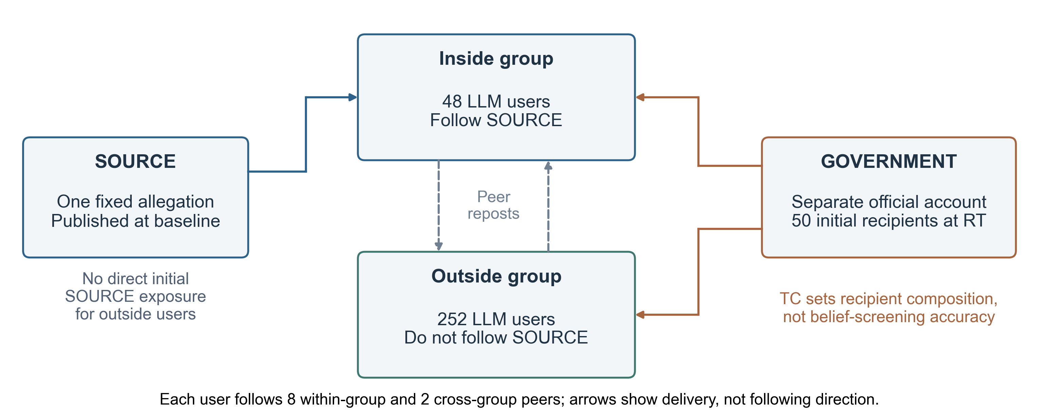
Figure 1 Implemented actors and information access. Blue denotes the original source, orange official delivery, and dashed gray arrows possible peer reposts. Audience sizes and network rules are fixed across the factorial design.
Table 1 Factor levels and intervention allocation
Factor | Symbol | Levels | Operational definition
Response timing | RT | 2, 4, 7 | Official publication and one-time direct delivery round.
Targeting capacity | TC | .20, .80 | Inside share of 50 recipients: 10/40 or 40/10 inside/outside.
Government credibility | GC | .25, .50, .75 | Population mean of assigned individual government source trust.
Degree of group cocooning | DGC | 0, .20, .40 | Inside-minus-outside mean trust in SOURCE; network topology unchanged.
RT×TC×GC×DGC gives 3×2×3×3=54 conditions. TC=.20 reaches 20.83% of inside and 15.87% of outside users; TC=.80 reaches 83.33% and 3.97%. Sampling is without replacement and does not screen current belief.
Source trust and government trust are fixed 0–1 priors, distinct from the changing 0–100 belief score. Source means are 0.5+DGC/2 inside and 0.5−DGC/2 outside. Symmetric truncated-normal quantiles with scale .10 and seeded permutations assign individual values. Because group sizes differ, increasing DGC also lowers overall mean source trust (.500, .432, .364); it is not a pure network-cocooning manipulation.

3 Integrated research framework
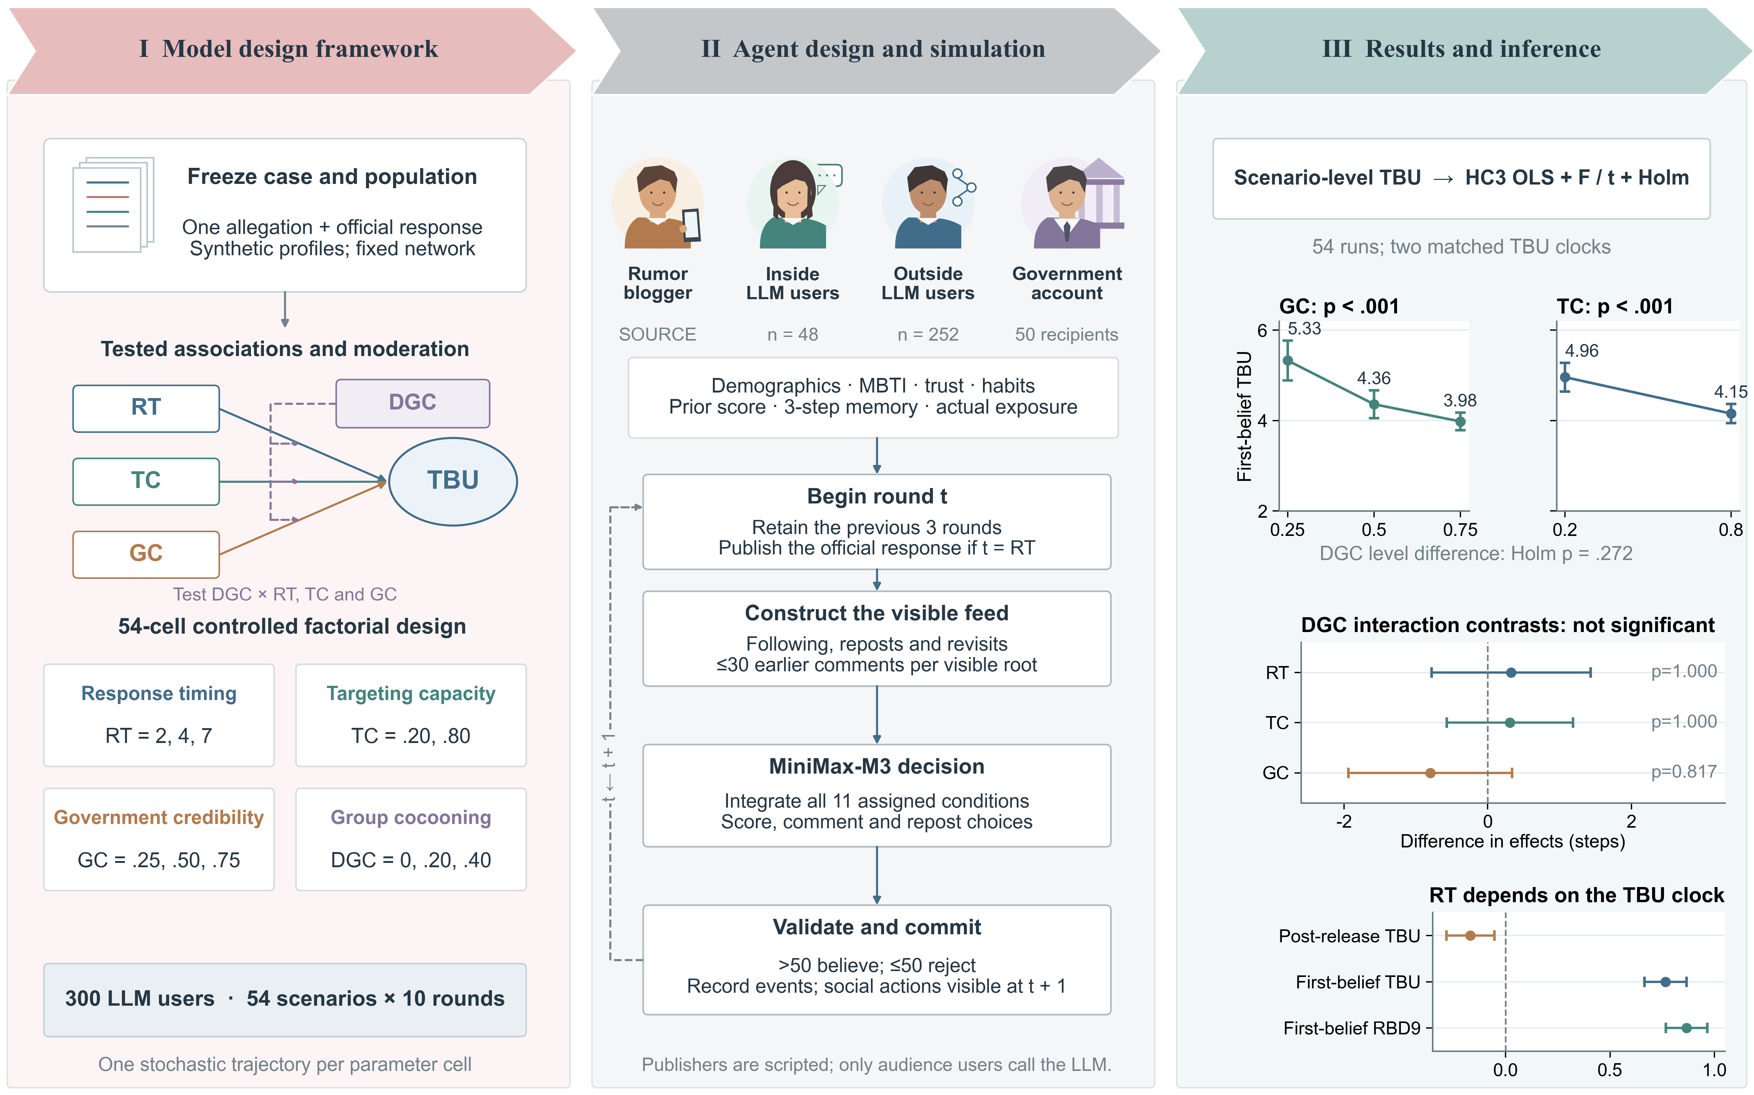
Figure 2 Integrated framework with two TBU clocks. Right: FB level means, FB interaction contrasts, and RT coefficients under POST, FB and initial-cohort RBD9. Interaction contrasts compare high-minus-low effects between DGC=.4 and 0 (RT 7−2, TC .8−.2, GC .75−.25). Whiskers are pointwise HC3 95% intervals. Level p values use Holm8 and interaction p values Holm6 across the two main endpoints. SOURCE and GOVERNMENT are scripted publishers.

4 Belief updating measurement and analysis
Synthetic personas vary in age (18–74), region, occupation, community experience, all 16 MBTI types, verification preference, sharing propensity and repetition sensitivity. The prompt requires all 11 assigned conditions, prior score, current evidence and actual exposure history. MiniMax-M3 returns an overall credibility score, three component scores (fund redirection, safety delay and their causal link), and separate comment/repost choices. Only the overall score determines belief: >50 is believe; ≤50 is reject. Unjudged is a null, not-yet-assessed baseline, not a third attitude.
Higher SOURCE trust is prompted to increase source persuasiveness. Government trust is prompted to lower acceptance of the allegation only after the official response has actually been read. Role descriptions use individual government trust below 1/3, from 1/3 to below 2/3, or at least 2/3 to express cautious, conditional or more favorable official-source attitudes. These are modeling assumptions; no fixed trust-weighted score or mandatory score increment is imposed.
For repeat readings beyond the first, n, the prompt uses a saturating familiarity signal. With repetition sensitivity ρ, verification preference v and baseline sharing propensity p, the retained cue definitions are:
$$\text{h = 1 − exp(−n/3).}$$
$$\text{Δf = 0.35ρ(1 − 0.5v)h;}{\text{p}}^{\text{∗}}\text{= min(0.95, p + 0.25ρh).}$$
These coefficients are study settings, not fitted probabilities. Memory retains experiences from the previous three rounds, without replaying old public-comment transcripts. Scores, exposure counts and repost flags persist. Each visible root displays at most 30 earlier comments; commenting is voluntary, and at most one visible root may be commented on or reposted per user-round. Each root may be reposted only once per user. New actions become visible at the next round.

Outcome definitions
Let b denote a user’s first observed belief round, RT the government publication round, and r the first observed belief-to-rejection transition at or after RT. Publication precedes decisions within its round, so same-round transitions qualify. We retain two clocks on the identical eligible users:
$${TBU}_{is}^{POST} = r_{is} − {RT}_{s}; {TBU}_{is}^{FB} = r_{is} − b_{is} (r_{is} ≥ {RT}_{s}).$$
Each scenario averages the two intervals over the same eligible users. Never-believers have no TBU. Unresolved first episodes are right-censored at round 10; a user who resolved before publication is excluded from the matched endpoints.
Table 2 Two TBU clocks and supplementary endpoints
Endpoint | Population and scenario N | Clock and incomplete updates
POST TBU | 757 matched updates; 54 means | Mean r−RT among users with first qualifying transition r≥RT.
FB TBU | Same 757 updates; 54 means | Mean r−b using first belief as the origin and the identical endpoint.
Strict legacy pair | 475 updates; 52 means | Require r>RT under both clocks; two empty means stay undefined.
Initial-cohort  RBD9 | 911 step-1 believers; 54 means | Nine-step restricted first-episode duration; unresolved episodes contribute 9.
POST and FB use the same 757 transitions. The strict legacy analysis excludes 282 publication-round updates; its two undefined scenario means remain missing. No result is interpolated.
Scenario means are equally weighted. M1 includes numeric RT, TC and GC; M2 adds DGC; M3 adds DGC interactions with RT, TC and GC. Variables are centered at RT=13/3, TC=GC=.5 and DGC=.2. HC3 t/F inference is exploratory. Categorical level F tests and numeric linear-slope t tests have different null hypotheses. Joint Holm families cover eight level tests, twenty pairwise contrasts, eight numeric main slopes and six interactions across the two main clocks; within-clock corrections are also supplied. All 95% intervals are pointwise. Supplementary restricted durations address unresolved outcomes [6].

5 Results for factor-level differences
All 54 scenarios completed ten rounds (540/540). Among 16,200 user-scenario instances, 980 ever believed: 757 first updates occurred at or after publication, 222 first episodes remained unresolved, and one resolved earlier. Of the 757 qualifying updates, 282 occurred in the publication round and 475 later. Equal-scenario mean TBU is 1.512 steps for POST and 4.557 for FB; event-weighted means are 1.472 and 4.428. The former means are used for scenario-level inference.
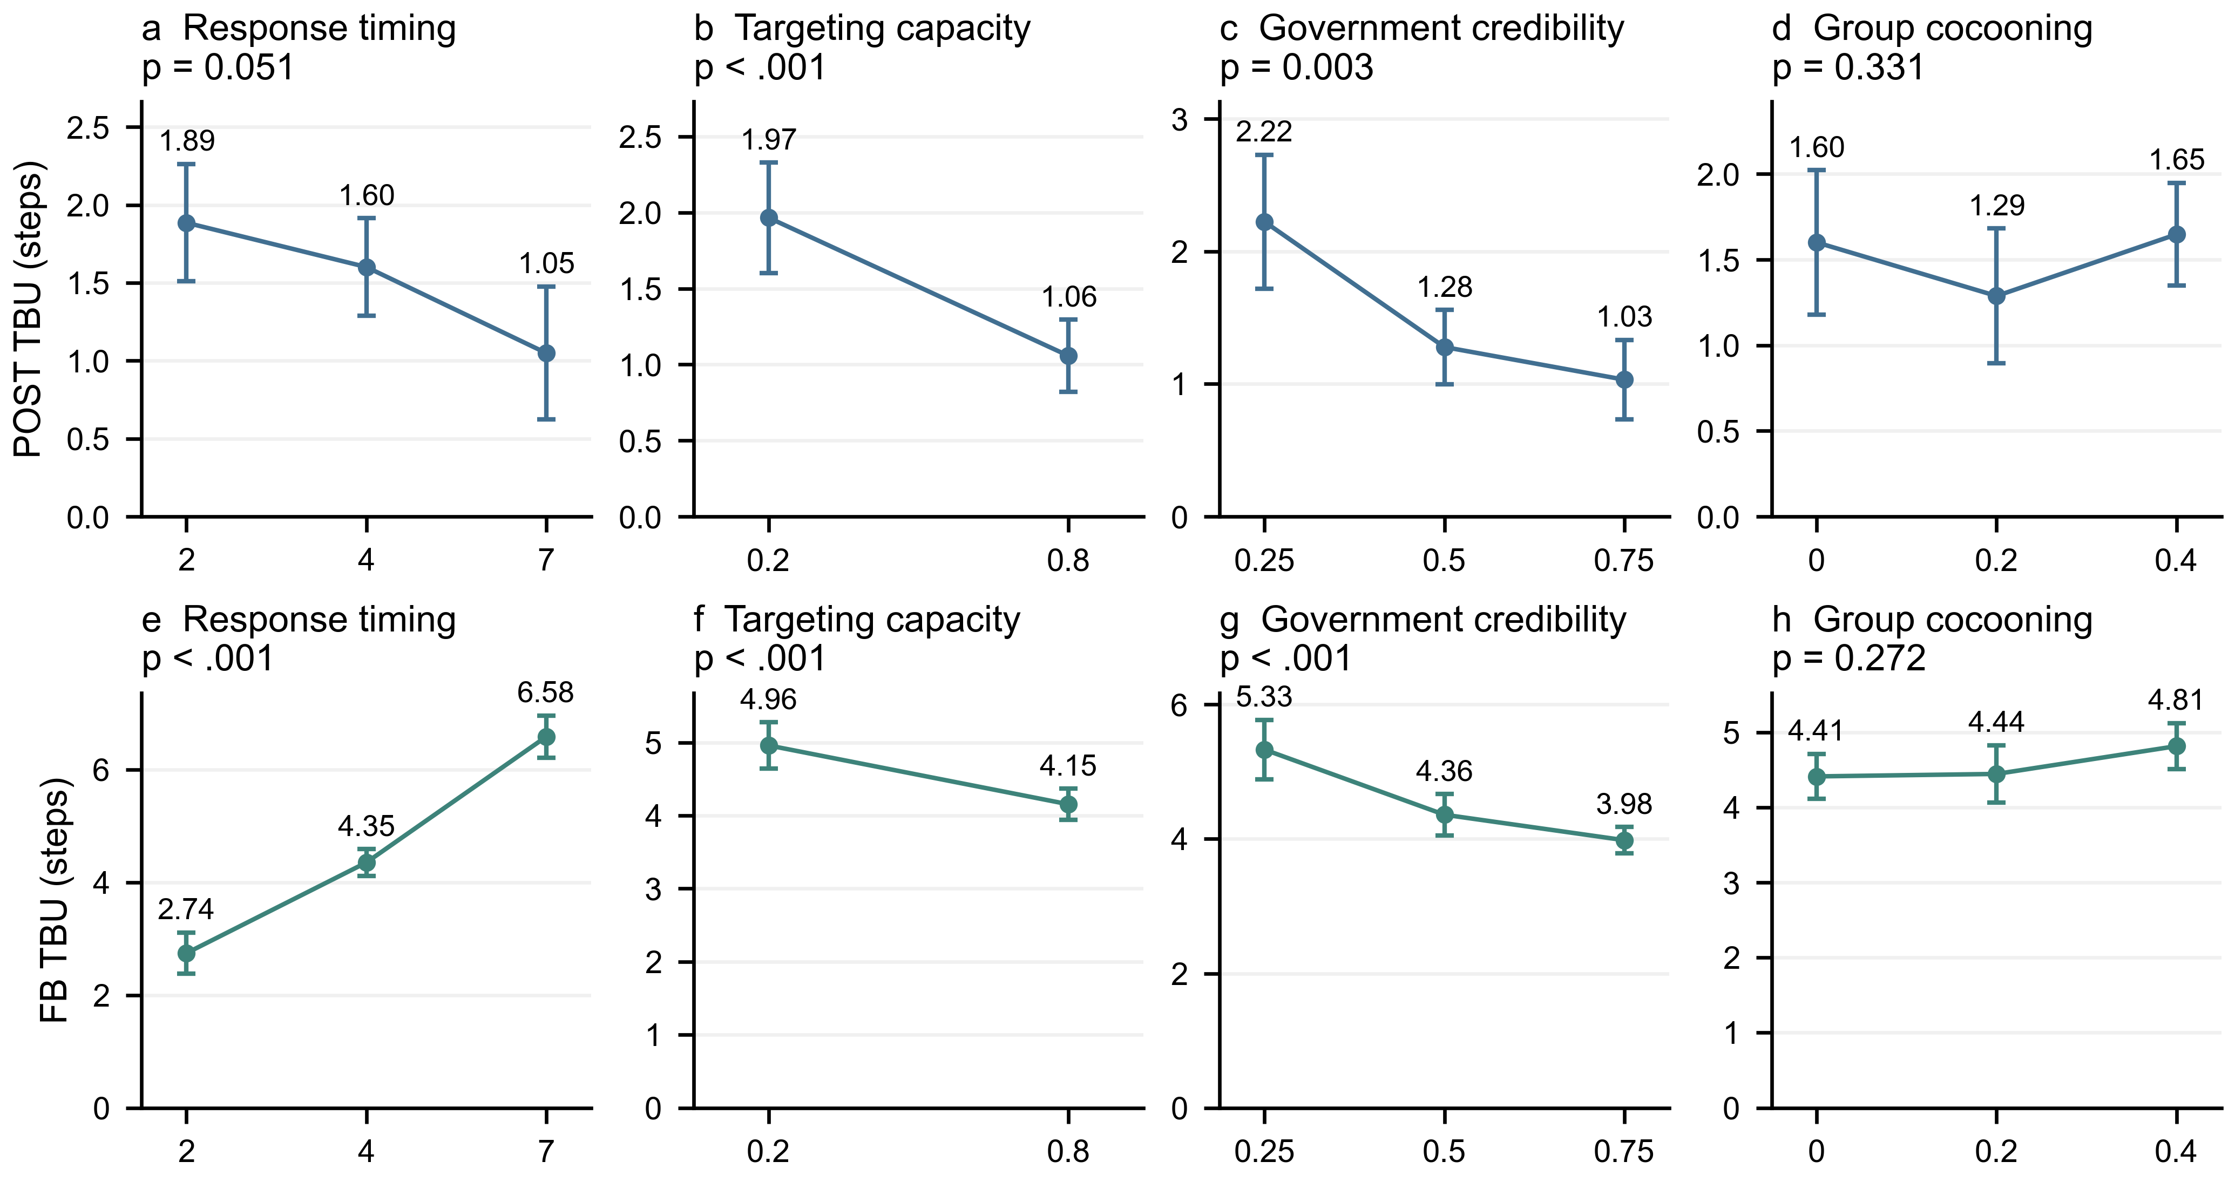
Figure 3 Adjusted TBU under the two clocks. Top: POST; bottom: FB. Means are standardized equally over the complete factorial grid using separate categorical additive models (54 observations each). Error bars are pointwise HC3 95% intervals. Panel p values use Holm correction across eight omnibus tests for both endpoints.
Table 3 Factor-level tests and high-minus-low contrasts under both clocks
Factor | POST F  Holm p | POST contrast  95% CI | FB F  Holm p | FB contrast  95% CI | Pair p  POST / FB
RT | 4.447  0.051 | -0.836  [-1.405, -0.267] | 111.198  <.001 | 3.838  [3.317, 4.358] | 0.054 /  <.001
TC | 17.803  <.001 | -0.908  [-1.342, -0.475] | 18.050  <.001 | -0.806  [-1.187, -0.424] | 0.002 /  0.002
GC | 8.421  0.003 | -1.192  [-1.778, -0.605] | 16.170  <.001 | -1.348  [-1.831, -0.865] | 0.002 /  <.001
DGC | 1.132  0.331 | 0.047  [-0.470, 0.564] | 2.086  0.272 | 0.403  [-0.023, 0.829] | 1.000 /  0.505
F tests use df=(2,46), except TC=(1,46); p in the F columns is joint Holm8. Contrasts are RT 7−2, TC .8−.2, GC .75−.25 and DGC .4−0; the last column gives joint Holm20 p. Confidence intervals are pointwise. Models adjust for all other categorical factors.
RT=7 versus 2 changes adjusted POST TBU by -0.836 steps but FB TBU by +3.838. Under FB, higher TC corresponds to -0.806 steps and higher GC to -1.348 steps. TC and GC level differences survive correction across both clocks. DGC does not. The opposite RT directions follow from the clocks’ different starting points and cannot be described as contradictory estimates of one outcome.

6 Results for cocooning moderation
Adding the three DGC interactions to M2 gives a joint HC3 F(3,46)=1.765, p=0.167 for POST and F(3,46)=1.100, p=0.359 for FB. None of the separate interaction tests survives the joint six-test Holm correction. Improved fit or different-looking within-DGC slopes does not itself establish moderation.
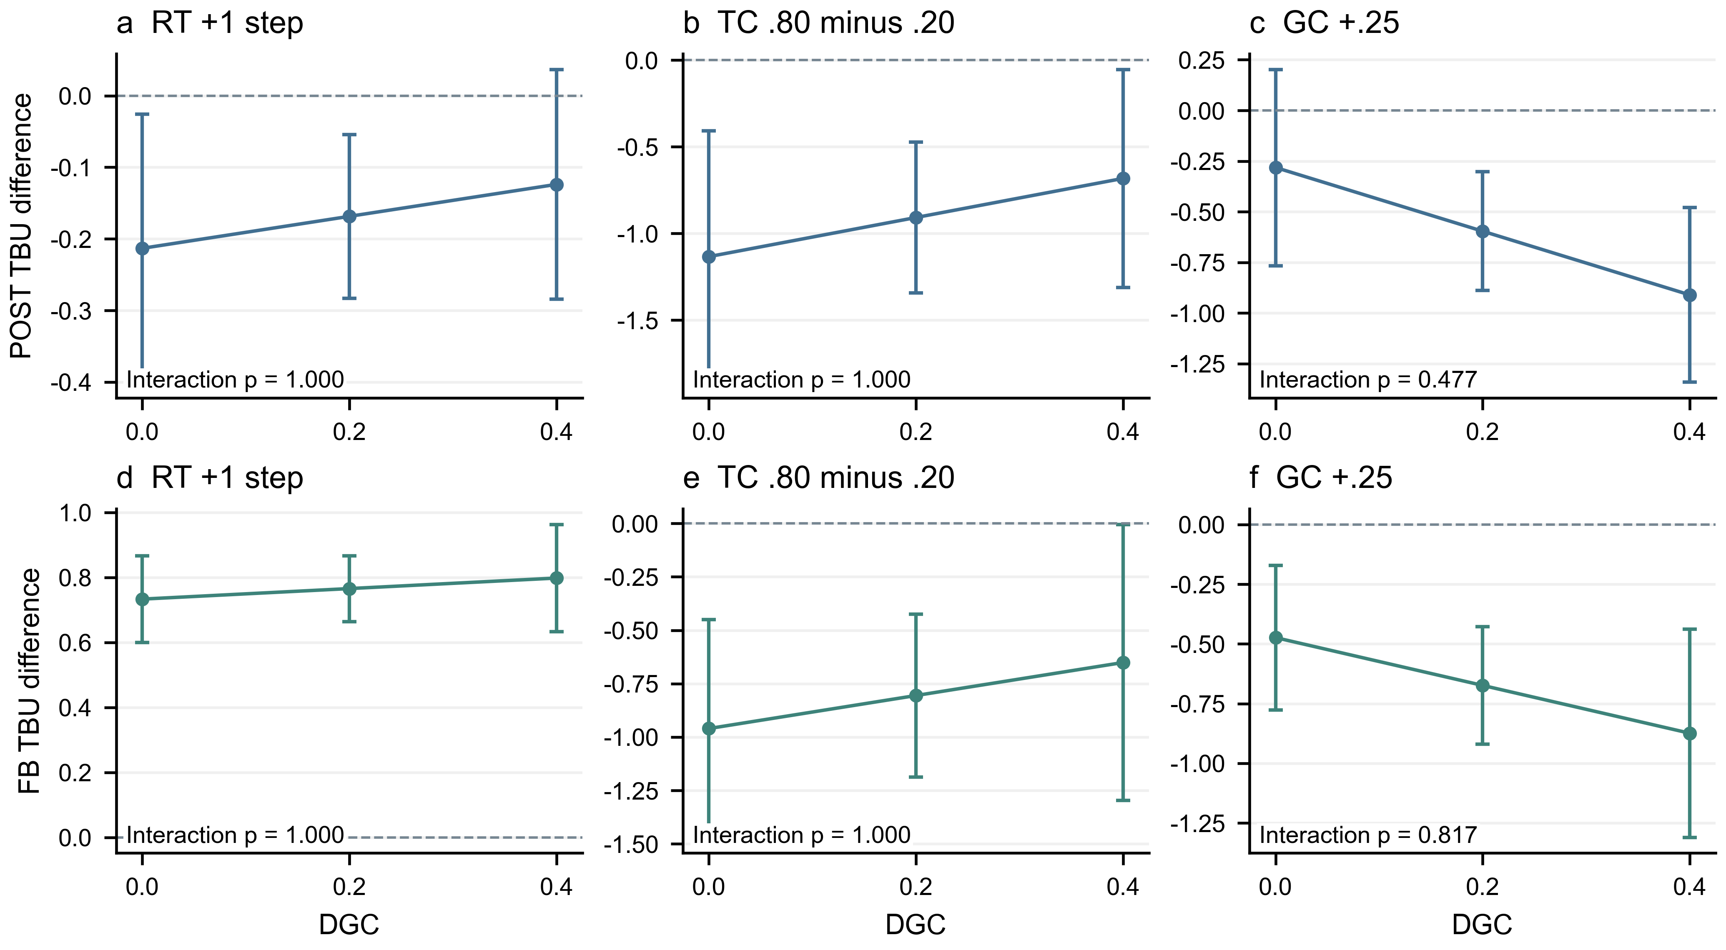
Figure 4 Conditional effects under POST (top) and FB (bottom). Columns show RT+1 step, TC .80−.20 and GC+.25 at DGC=0, .2 and .4. Error bars are pointwise HC3 95% intervals. Interaction p values are adjusted across the six terms under both clocks. Within-stratum significance is distinct from an interaction test.
Table 4 Numeric M3 coefficients under both clocks
Term | POST b | POST 95% CI | FB b | FB 95% CI | Holm p  POST / FB
RT | -0.169 | [-0.283, -0.054] | 0.766 | [0.664, 0.867] | 0.014 /  <.001
TC | -1.514 | [-2.238, -0.790] | -1.343 | [-1.979, -0.707] | <.001 /  <.001
GC | -2.384 | [-3.556, -1.212] | -2.695 | [-3.678, -1.713] | <.001 /  <.001
DGC | 0.117 | [-1.186, 1.421] | 1.007 | [-0.090, 2.105] | 0.857 /  0.142
RT × DGC | 0.223 | [-0.435, 0.881] | 0.162 | [-0.391, 0.715] | 1.000 /  1.000
TC × DGC | 1.880 | [-2.466, 6.226] | 1.288 | [-2.371, 4.946] | 1.000 /  1.000
GC × DGC | -6.284 | [-13.337, 0.768] | -4.004 | [-9.694, 1.686] | 0.477 /  0.817
N=54; residual df=46. Main slopes are conditional on DGC=.20 and other centered variables; TC, GC and DGC coefficients are per 1.0-unit change. Last-column p values use joint Holm8 for the four main slopes across clocks and Holm6 for interactions. All intervals are pointwise.
For the GC .75−.25 contrast, the estimated change in its effect between DGC=.4 and 0 is -1.257 steps under POST ([-2.667, 0.154]) and -0.801 under FB ([-1.939, 0.337]). Both intervals include zero. The corresponding RT and TC differences also remain uncertain. Fully categorical interaction tests provide no corrected evidence of moderation under either clock.

7 Timing definitions follow-up and interpretation
The two clocks satisfy an exact identity for each included user: FB−POST=RT−b. Thus FB includes the interval spent believing before government publication, while POST starts at publication. Changing the starting point changes the policy quantity being measured. Among matched converters, the mean difference between clocks is 3.045 steps. Neither mean includes the 222 unresolved first episodes, so neither is an unrestricted all-believer mean.
Table 5 Clock and inclusion sensitivity using the same numeric M3 specification
Outcome | N | RT b and 95% CI | RT  Holm p | TC  Holm p | GC  Holm p
POST matched | 54 | -0.169  [-0.283, -0.054] | 0.014 | <.001 | <.001
FB matched | 54 | 0.766  [0.664, 0.867] | <.001 | <.001 | <.001
POST strict legacy | 52 | -0.151  [-0.238, -0.064] | 0.003 | 0.006 | <.001
FB strict legacy | 52 | 0.787  [0.689, 0.886] | <.001 | 0.038 | <.001
Initial-cohort RBD9 | 54 | 0.867  [0.767, 0.967] | <.001 | <.001 | <.001
Post-release PRUD3 | 54 | 0.031  [-0.015, 0.077] | 0.356 | <.001 | <.001
Rows1–2 are the paired main endpoints; rows3–4 preserve the strict legacy inclusion rule. RBD9 uses 911 step-1 believer instances and a nine-step cap. PRUD3 uses believers immediately before release and a three-step post-release cap. Supplementary rows use within-endpoint Holm4, while the paired main rows use joint Holm8. Different cohorts are explicitly distinguished.

What a common three-step window means
RT=2, 4 and 7 leave eight, six and three post-release steps before round 10. The optional common-window check observes only the first three steps after each release: rounds3–5, 5–7 and 8–10. It does not redefine either TBU. A publication-round update has zero POST waiting; an update by the third later round contributes its waiting time, and no update within that interval contributes the three-step cap.

Why the RT result changes
Most observed believers first believe early. Delaying publication therefore adds time to FB before a qualifying post-release update can occur. This is a meaningful component of total belief duration, but it does not show that late corrections take longer to process after receipt. POST can instead shorten with later release because only fast, observed converters remain within the shorter follow-up horizon.
The fixed initial-believer check, RBD9, retains unfinished episodes through the nine-step restriction. It avoids dropping them from the mean but concerns 47 distinct inside-user IDs across scenarios. It cannot establish outside-user effects. PRUD3 concerns a different pre-release cohort; it is a sensitivity check rather than a competing primary definition.

Endpoint choice and policy interpretation
Use FB when the question is total duration from initial acceptance to the observed update; use POST when it is elapsed time after government publication among observed converters. Retain both with these labels. Government credibility and more inside-directed targeting are consistently associated with shorter intervals in this simulation. DGC moderation remains unsupported. The endpoint should follow the research question, with all analyses retained rather than selected by their smallest p value.

8 Reproducibility limitations and conclusions

Reproducible implementation
The model uses SocioVerse2 [3] and runtime v7-government-trust-persona-20261027-2 [4]. The client requests MiniMax-M3 with temperature=1.0, top_p=.95 and max output=1,536 tokens; no generation seed is sent. Local seeds fix network (20261018), targets (20261019), behavioral ordering (20261020), government trust (20261022), SOURCE trust (20261023) and population selection (20261024). Frozen personas, prompts, trust assignments, edges, target lists, raw responses and checkpoints permit audit and replay, but re-querying the LLM may change outputs.
All users observe their own fixed pre-update feed before current actions are applied. Valid response caches survive pauses. JSON, scores, visible targets/evidence and short application summaries for all 11 conditions are validated; these summaries are an output audit, not proof of internal causal reasoning. Unresolved failures pause rather than inject synthetic fallback decisions. Each complete 300-user round is checkpointed; the batch exports one workbook per parameter combination with counts by group, MBTI, age, occupation and region, plus scores, coverage, participation and actual transition events.

Scope and next validation steps
One stochastic trajectory per cell cannot identify within-cell Monte Carlo variation. The 757 matched transitions produce 54 scenario means, not 757 independent experimental replications. HC3 inference depends on the response surface and error assumptions; shared users and networks remain dependent. Low simulated belief, synthetic personas, one scripted case and no no-response control limit external and causal interpretation. MBTI is a role-diversity convention. DGC also changes population mean SOURCE trust, so it is not a pure structural-network contrast.
Priority extensions are prespecified independent replications, a no-response arm, alternative networks/cases, equal follow-up and sensitivity to wording, memory, comments and the belief threshold. The prompt explicitly embeds directional trust assumptions; finding an association in the simulation does not independently validate that mechanism among human users. LLM-generated agent decisions are part of the research method and should be disclosed in any AI-use statement.

Conclusion
Both TBU clocks associate greater government credibility and more inside-directed targeting with shorter observed updating intervals. First-belief TBU also shows longer total duration under later publication, which includes the wait for the response itself. No corrected DGC moderation is established. Further validation should retain unresolved episodes, use independent replications and distinguish response publication, actual exposure and subsequent updating.

References
[1] Del Vicario, M., et al. (2016). The spreading of misinformation online. Proceedings of the National Academy of Sciences, 113(3), 554–559. https://doi.org/10.1073/pnas.1517441113
[2] Ecker, U. K. H., et al. (2022). The psychological drivers of misinformation belief and its resistance to correction. Nature Reviews Psychology, 1, 13–29. https://doi.org/10.1038/s44159-021-00006-y
[3] Zhang, X., et al. (2026). SocioVerse2: A longitudinal dynamic social simulation framework under a human-AI co-evolutionary paradigm. arXiv:2609.24911. https://doi.org/10.48550/arXiv.2609.24911
[4] SocioVerse V7 project materials (2026). Model design, parameter settings and interaction mechanisms (24 October), with belief update and government trust persona revisions (27 October). Technical documentation and source code.
[5] Yang, G., Xu, X., & Xu, P. (2026). Government rumor correction and the time of belief updating under group cocooning. SocioVerse Challenge 2026 research proposal.
[6] Royston, P., & Parmar, M. K. B. (2013). Restricted mean survival time: an alternative to the hazard ratio for the design and analysis of randomized trials with a time-to-event outcome. BMC Medical Research Methodology, 13, 152. https://doi.org/10.1186/1471-2288-13-152

