**COMP9331-21T2-Lab2**

Haojin Guo

(z5216214)

**Exercise 3: Using Wireshark to understand basic HTTP request/response messages.**

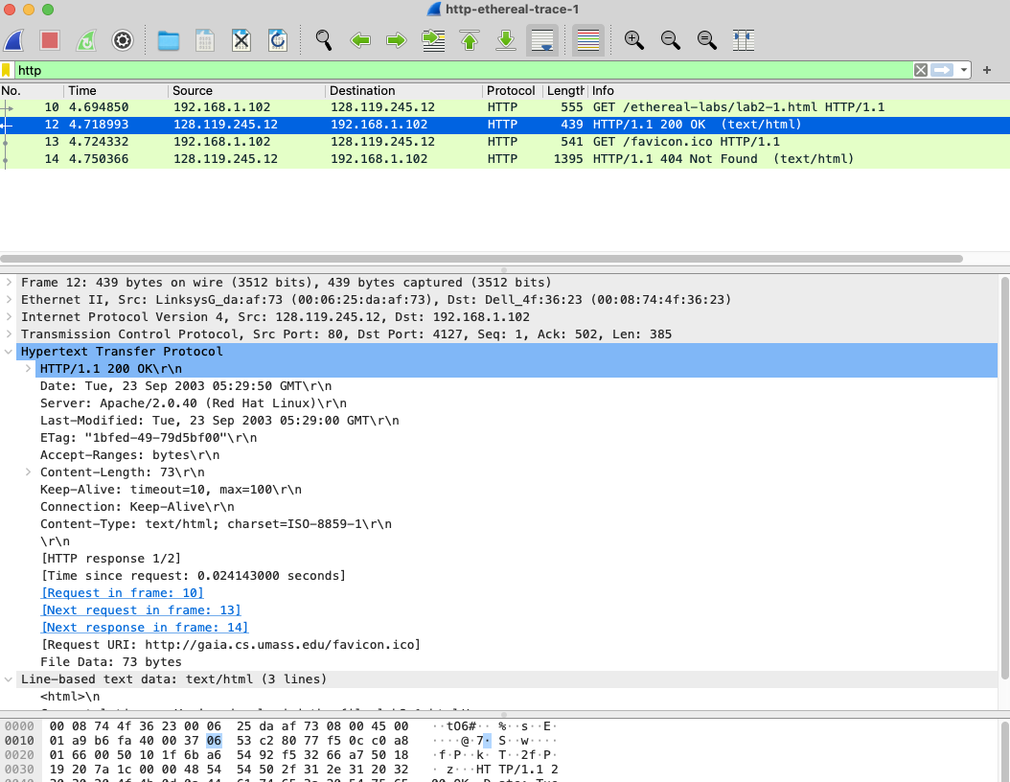

**Question 1.**

a) Status Code: 200

b) Returned Phrase: OK

**Question 2.**

1. Last modified at the server:

Last-Modified: Tue, 23 Sep 2003 05:29:00 GMT

1. The response contains a DATE header.

Date: Tue, 23 Sep 2003 05:29:50 GMT

1. Date represents that the time when the Web was created.

However, the last-Modified shows the last modification time of the page.

**Question 3.**

1. The connection established is persistent between the browser and the sever.
2. The reason is showed by,

Connection: Keep-Alive

Also, HTTP 1.1 can show the connection is persistent.

**Question 4.**

There are 73 bytes of content are being returned to the browser, according to the fact that Content-Length: 73\r\n .

**Question 5.**

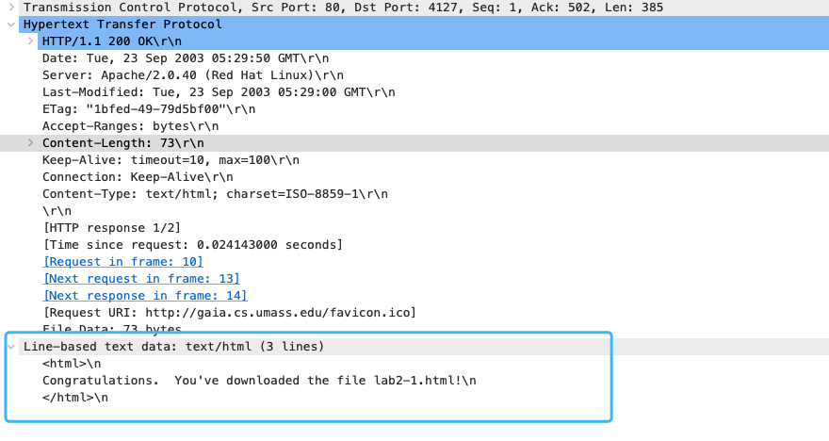

By the part of “Line-based text data: text/html (3 lines)”, the response packet is “Congratulations. You've downloaded the file lab2-1.html!”

**Exercise 4: Using Wireshark to understand the HTTP CONDITIONAL GET/response interaction.**

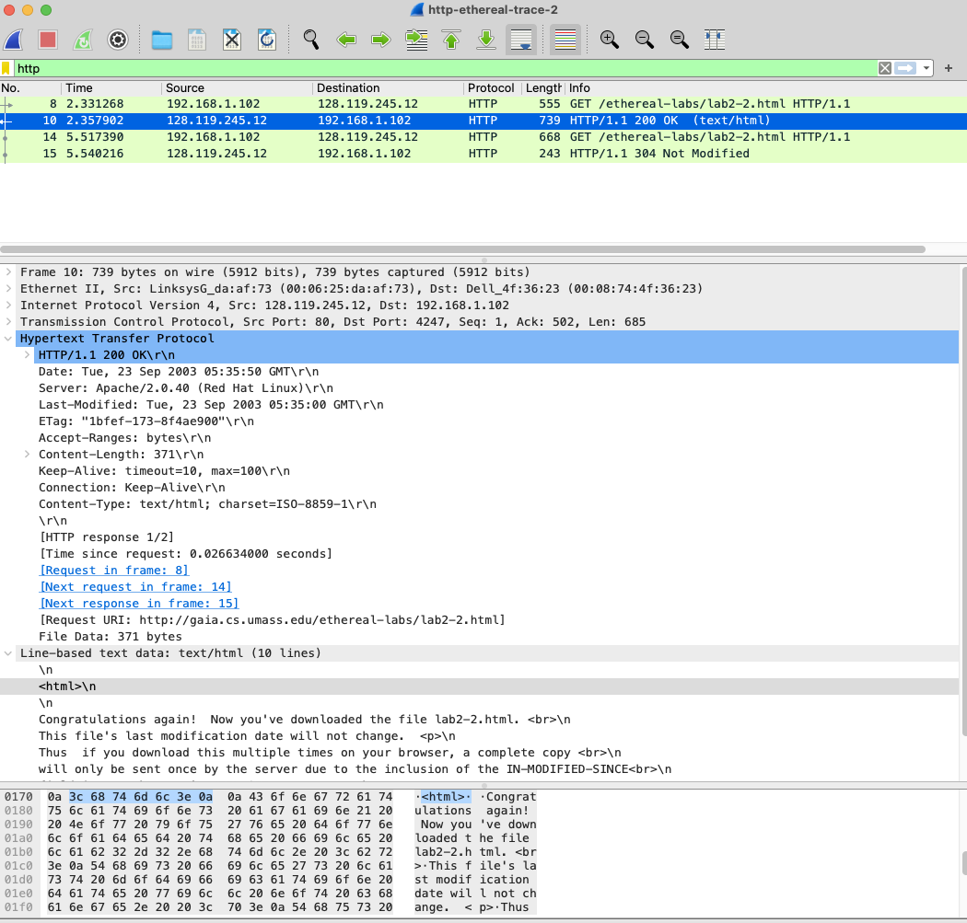

**Question 1.**

No, the header “IF-MODIFIED-SINCE” is not present in the first HTTP GET request. This is because this Header exists after the Cache and is used for cache detection together with Etag.

**Question 2.**

Yes. The response does indicates that the file was last modified on Tue, 23 Sep 2003 05:35:00 GMT.

**Question 3.**

The detail of second HTTP GET request is as follows.

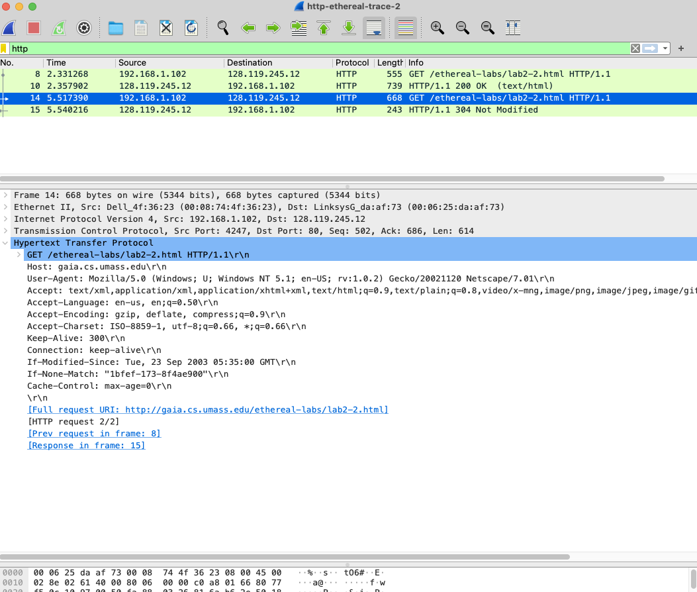

The second GET request does contain the part of "If-Modified-Since" and "IF-None-Match" . a) If-Modified-Since: Tue, 23 Sep 2003 05:35:00 GMT

b) If-None-Match: "1bfef-173-8f4ae900"

**Question 4.**

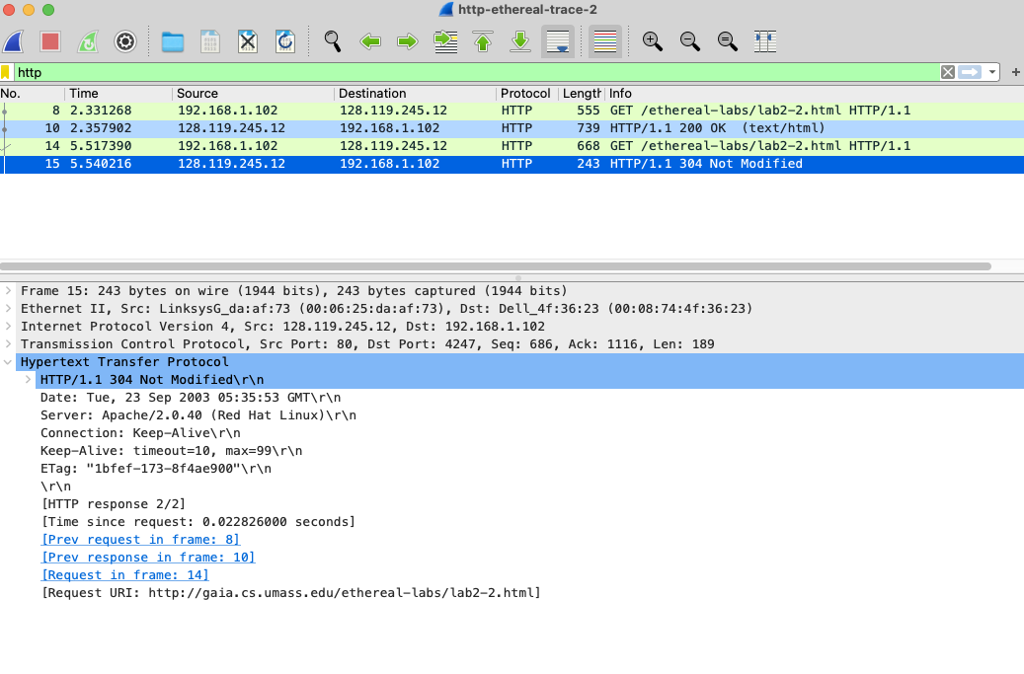

1. Status code: 304
2. Phrase returned form the server: Not Modified
3. No, the server does not respond back with the requested file. Because, the server has not modified the page, and the browser can simply show the locally cached version of this file.

**Question 5.**

1. The entity tag (Tag) value is "1bfef-173-8f4ae900".
2. ETag is used in conjunction with "If-None-Match" header field.

**Exercise 5: Ping Client.**

Server message:

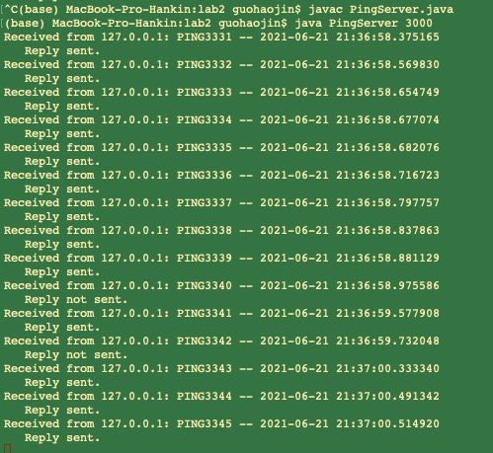

Client message:

