**Exercise 3: Digging into DNS (marked, include in the lab report)**

**Question 1**. What is the IP address of [www.eecs.berkeley.edu](https://eecs.berkeley.edu/). What type of DNS query is sent to get this answer?

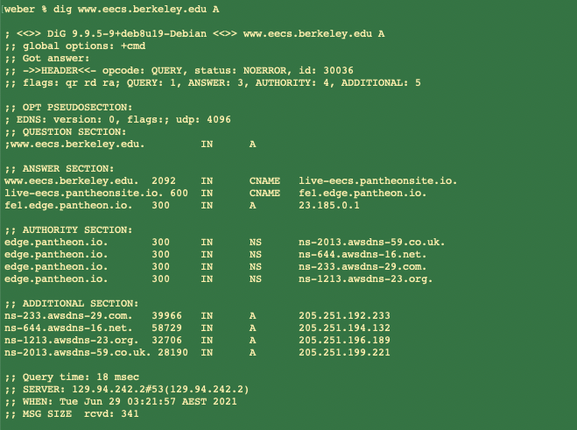

The IP address is: 23.185.0.1

The type of DNS query is A. (Name: host domain name; Value: IP address)

**Question 2.** What is the canonical name for the eecs.berkeley webserver (i.e. [www.eecs.berkeley.edu](http://www.eecs.berkeley.edu/))? Suggest a reason for having an alias for this server.

1. The canonical name for the eecs.berkeley webserver is live-eecs.pantheonsite.io.
2. An alias for this server is more easier to remember.

**Question 3**. What can you make of the rest of the response (i.e. the details available in the Authority and Additional sections)?

1. The part of Authority Section presents the corresponding authoritative domain name resolution server.

NS: records for the edge.pantheon.io domain name.

1. Additional Section includes some potentially useful information that is cached. For example, the IP address of the corresponding authoritative domain name resolution server.

The A records are for IPv4 addresses. (The AAAA records are for IPv6 addresses.

)

**Question 4**. What is the IP address of the local nameserver for your machine?

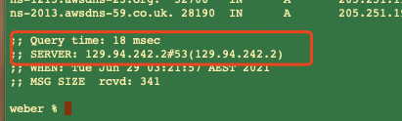

The IP address of local nameserver for CSE is 129.94.242.2

**Question 5.** What are the DNS nameservers for the “eecs.berkeley.edu.” domain (note: the domain name is eecs.berkeley.edu and not [www.eecs.berkeley.edu](https://eecs.berkeley.edu/). This is an example of what is referred to as the apex/naked domain)? Find out their IP addresses? What type of DNS query is sent to obtain this information?

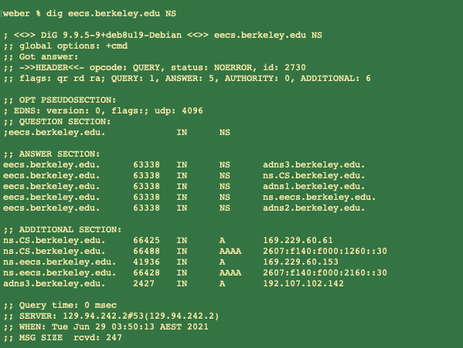

1. The name servers are:

adns3.berkeley.edu.

ns.CS.berkeley.edu.

adns1.berkeley.edu.

ns.eecs.berkeley.edu.

adns2.berkeley.edu.

1. The IP addresses are:

169.229.60.61 (IPv4)

2607:f140:f000:1260::30 (IPv6)

169.229.60.153 (IPv4)

2607:f140:f000:2160::30 (IPv6)

192.107.102.142 (IPv4)

**Question** **6**. What is the DNS name associated with the IP address 111.68.101.54? What type of DNS query is sent to obtain this information?

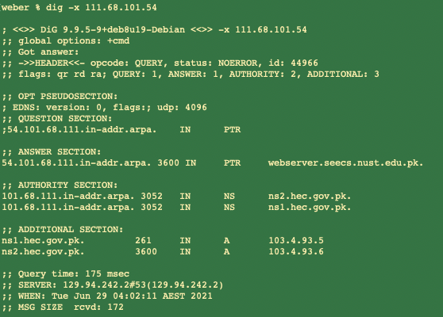

(a) The DNS corresponding to 111.68.101.54 is webserver.seecs.nust.edu.pk.

(b) The type of DNS query is PTR.

**Question** **7**. Run dig and query the CSE nameserver (129.94.242.33) for the mail servers for Yahoo! Mail (again the domain name is yahoo.com, not [www.yahoo.com](http://www.yahoo.com/)). Did you get an authoritative answer? Why?

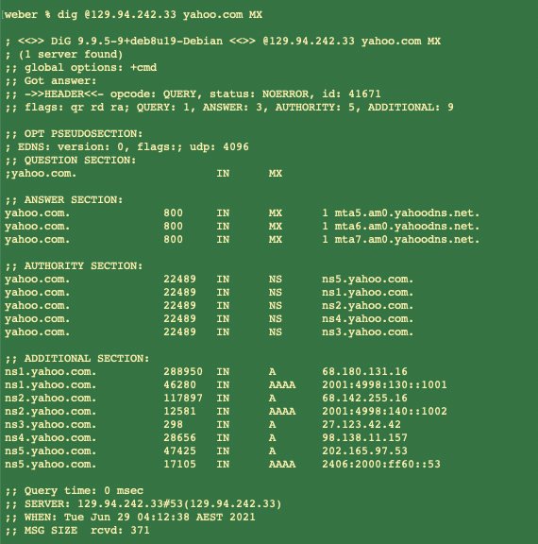

We cannot get authoritative answer. Because the flags do not contain the keyword “aa”, specifically it has authority for only the cse.unsw.edu.au domain and not for the Yahoo domain. And hence, if we want to get aa, we need to query with the authority name server of Yahoo.

**Question** **8**. Repeat the above (i.e. Question 7) but use one of the nameservers obtained in Question 5. What is the result?

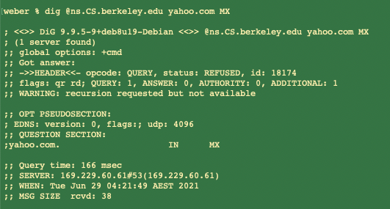

There is not a response when we try with ns.CS.berkeley.edu.

**Question** **9**. Obtain the authoritative answer for the mail servers for Yahoo! Mail. What type of DNS query is sent to obtain this information?

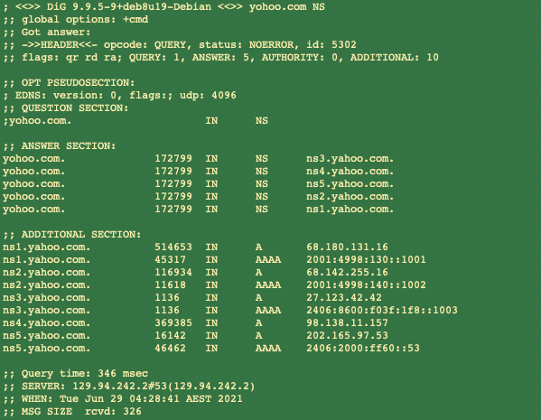

Through the commend dig yahoo.com NS, we can one of its IP addresses is 68.180.131.16.

Then,

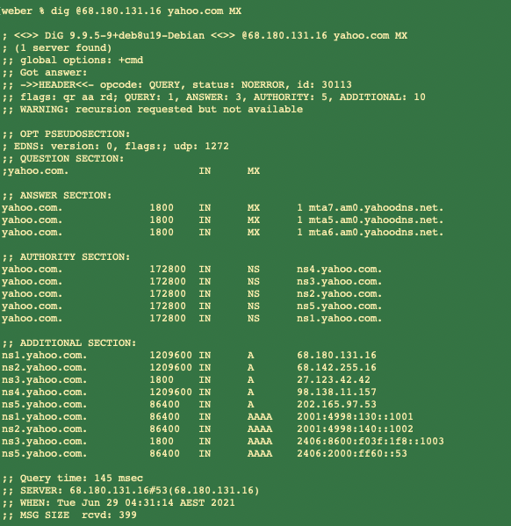

By this query we can get the authoritative answer for the mail servers. And the type of DNS is MX.

**Question** **10**. In this exercise, you simulate the iterative DNS query process to find the IP address of your machine (e.g. lyre00.cse.unsw.edu.au).

Step (1): First query for the IP address of the root nameservers.

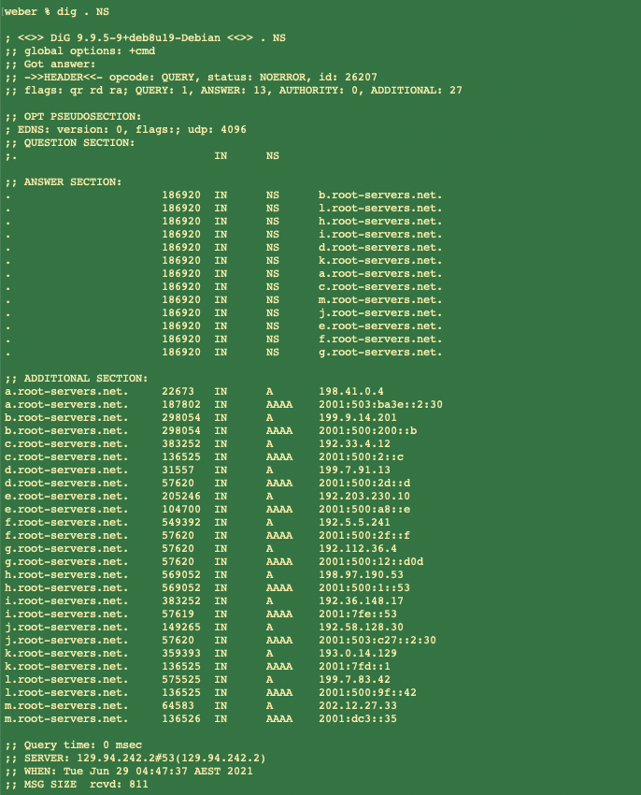

Step (2): Next query one of the roots nameservers as follows:

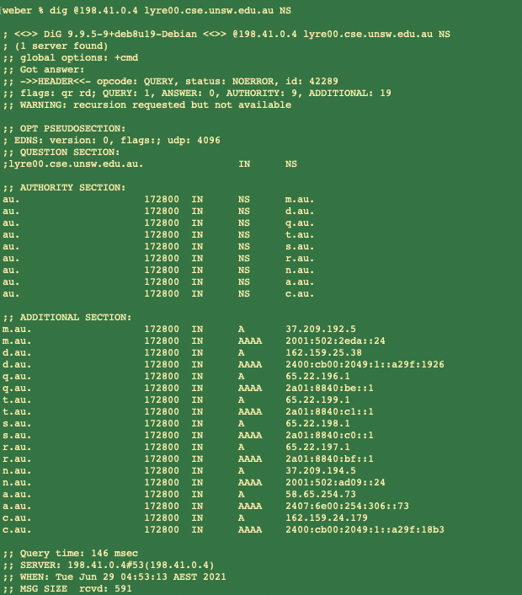

Step (3): Query the a.au nameserver as follows.

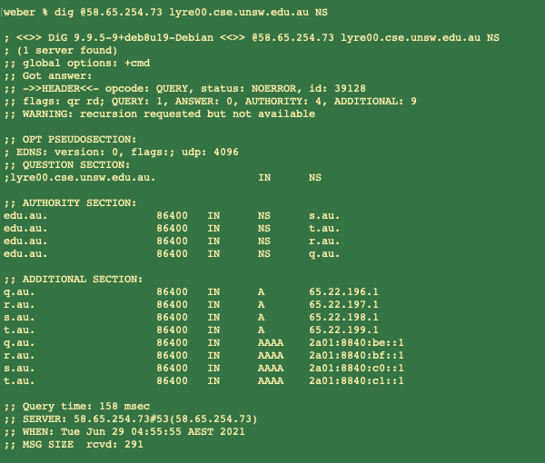

Step (4): Now we get the edu.au. nameservers above, so query one of them below:

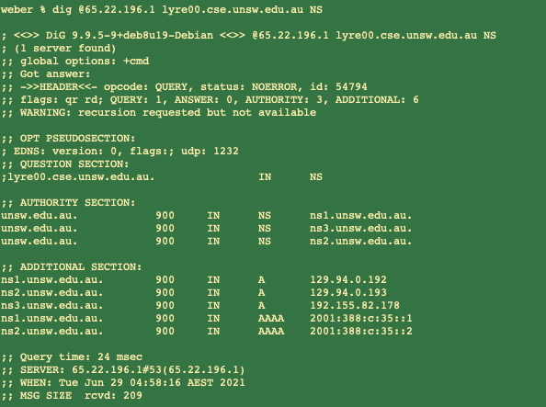

Step (5): We get the UNSW nameservers above, the query one of them below.

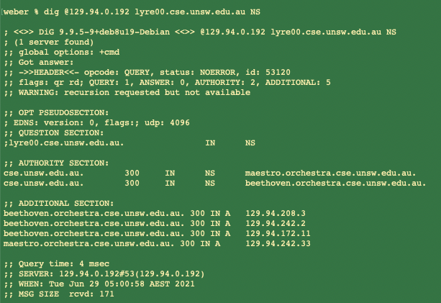

Step (6): Now we are now being referred to the CSE nameservers. Then query one of them by a type A address as follows.

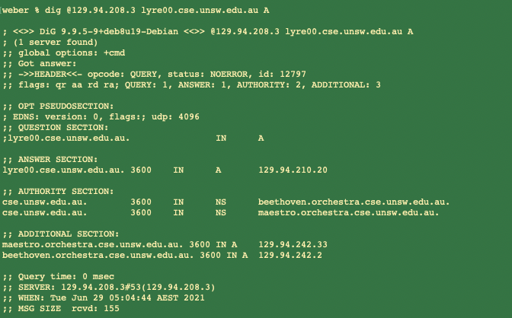

According to the results above, the IP address for lyre00.cse.unsw.edu.au is 129.94.210.20. And we did 5 DNS query in this process.

**Question 11**. Can one physical machine have several names and/or IP addresses associated with it?

Yes. There may be more than one network interface in a physical machine. As a result, a physical machine can have multiple IP addresses, and each IP address can have multiple "aliases", which are host names. Therefore, a physical machine has multiple names and IP addresses associated with it.

**Exercise 4: A Simple Web Server (Marked, submit your code )**

The following results are based on the local environment：

1. http://127.0.0.1:4001/index.html



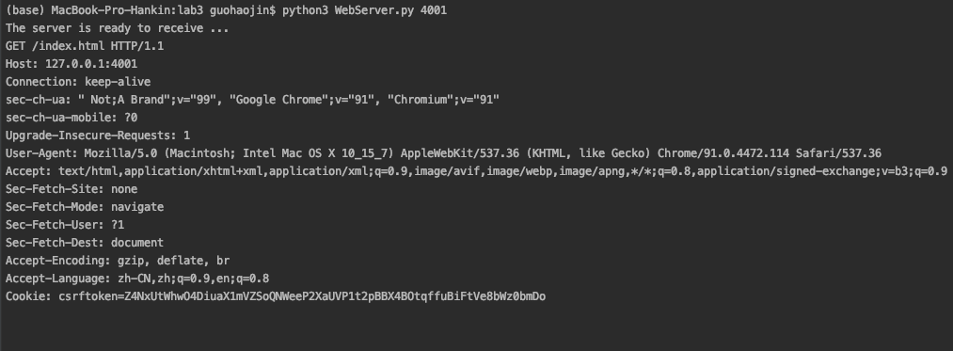

1. http://127.0.0.1:4001/myimage.png



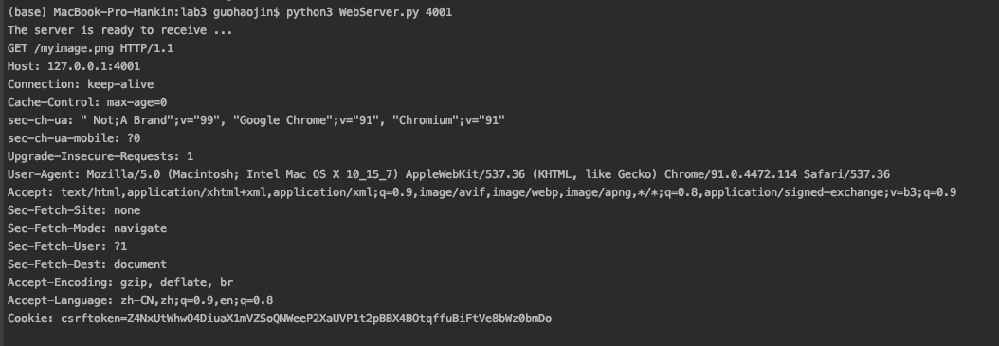

1. http://127.0.0.1:4001/bio.html

