A. The client background
- Gender: The sex of the client
- SeniorCitizen : old people or not
- Partner : have partner or not
- Dependents :Any children

B. 客戶使用多久 / 合約狀況
- tenure : How long the client stay in?
  - Long term: will stay and stable
  - Short term: easy to leave
- Contract :

C. 客戶使用哪些服務
- PhoneService : Apply for the server or not
- MultipleLines :
  - Yes: Have the multipleline
  - No: Don’t have the multipleline, but have the phone service
  - No phone service
- InternetService :
  - DSL = Digital Telephone Line Network
  - Fiber Optic = Fiber Optic Network
  - No = No Internet Service
- OnlineSecurity :

- OnlineBackup
- DeviceProtection
- TechSupport
- StreamingTV
- StreamingMovies

D. 帳單與付款
- PaperlessBilling
- PaymentMethod
- MonthlyCharges
- TotalCharges

E. 預測目標
- Churn

How to use

value_counts() : Count the number of times each value appears
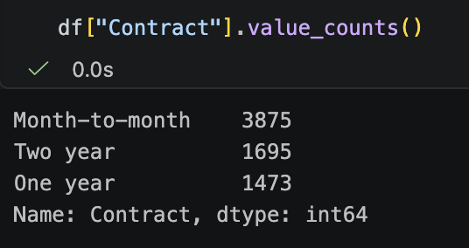
In the contract column, each value, Count the number of times each value appears.

