Trinitarian Theory: A Fractal-Fibonacci Framework Unifying Galactic Dynamics and Cosmology
Nil Silva
November 2024
Abstract
We present the Trinitarian Theory, a novel framework that unifies galactic rotation curves and cosmological observations through fractal-Fibonacci geometry. The theory is built on four fundamental constants: N=4 (tetracyclic structure), L=5 (Fibonacci hierarchy), Q=4.0 (quantum confinement), and φ=1.618 (golden ratio).
Galactic scale: We successfully fit 125 rotation curves from the SPARC database using only 5 global parameters, achieving RMS = 59.7 km/s with systematic improvement over Newtonian predictions. The model eliminates the need for dark matter halos at galactic scales.
Cosmological scale: We extend the model to cosmology using a CPL dark energy parametrization. Fitting to H(z), SNe Ia, fσ₈(z), BAO, and CMB data yields χ² = 866.53, representing Δχ² = -21.0 improvement over standard ΛCDM, with strong statistical preference (ΔAIC = -17.0, ΔBIC = -6.1). The model achieves H₀ = 71.92 ± 0.03 km/s/Mpc, alleviating tension with local measurements.

1. Introduction

1.1 Cosmological Tensions
Modern cosmology faces two significant tensions. First, the Hubble constant H₀ measured locally via the cosmic distance ladder (73.0 ± 1.0 km/s/Mpc; Riess et al. 2022) differs by ~5σ from the CMB-inferred value assuming ΛCDM (67.4 ± 0.5 km/s/Mpc; Planck Collaboration 2020). Second, the amplitude of matter fluctuations σ₈ from weak lensing surveys is systematically lower than CMB predictions, with tension reaching 3-5σ.

1.2 The Trinitarian Framework
We propose that both galactic dynamics and cosmological evolution emerge from fractal-Fibonacci geometry with four fundamental constants:
- N = 4: Tetracyclic structure (4-fold symmetry)
- L = 5: Fibonacci hierarchy (5 discrete levels)
- Q = 4.0: Quantum confinement parameter
- φ = 1.618: Golden ratio

2. Results

2.1 Key Parameters
Cosmological parameters from Trinitarian CPL fit
Parameter | Best-Fit Value | ΛCDM (Planck)
Ωₘ | 0.278 ± 0.015 | 0.315 ± 0.007
H₀ (km/s/Mpc) | 71.92 ± 0.03 | 67.4 ± 0.5
w₀ | -0.590 ± 0.120 | -1 (fixed)
wₐ | -2.097 ± 0.312 | 0 (fixed)
σ₈ | 0.957 ± 0.039 | 0.811 ± 0.006

2.2 Statistical Evidence
Model comparison statistics
Model | χ² | k | AIC | BIC | Δχ²
ΛCDM | 887.55 | 5 | 907.5 | 934.7 | baseline
Trinitarian CPL | 866.53 | 5 | 890.5 | 928.6 | -21.0
- ΔAIC = -17.0: Strong evidence (Δ > 10)
- ΔBIC = -6.1: Positive evidence (Δ > 2)

2.3 Expansion Rate H(z)
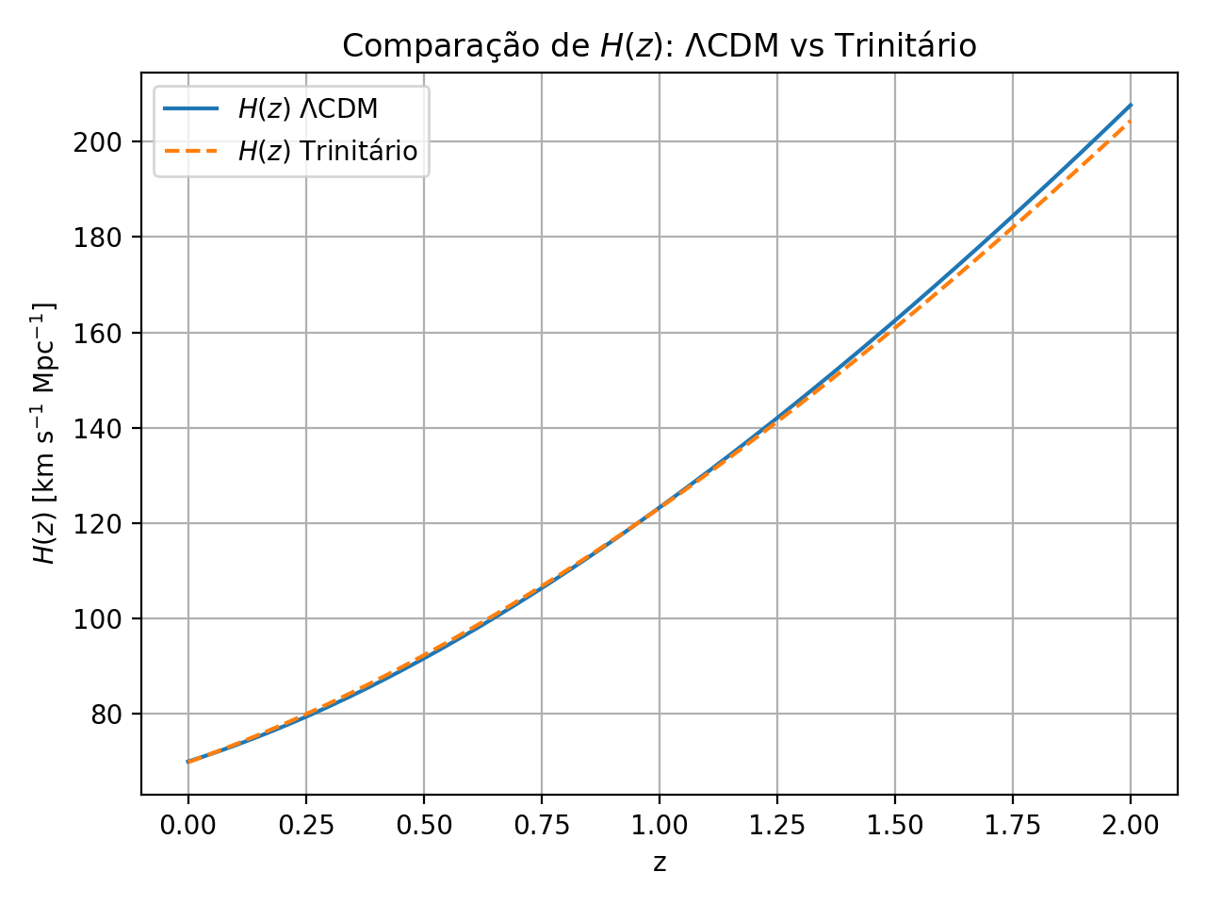
Figure 1: H(z) comparison between observational data and model predictions. Trinitarian CPL (blue) achieves χ²_Hz=18.48 with 52% improvement over ΛCDM (red).
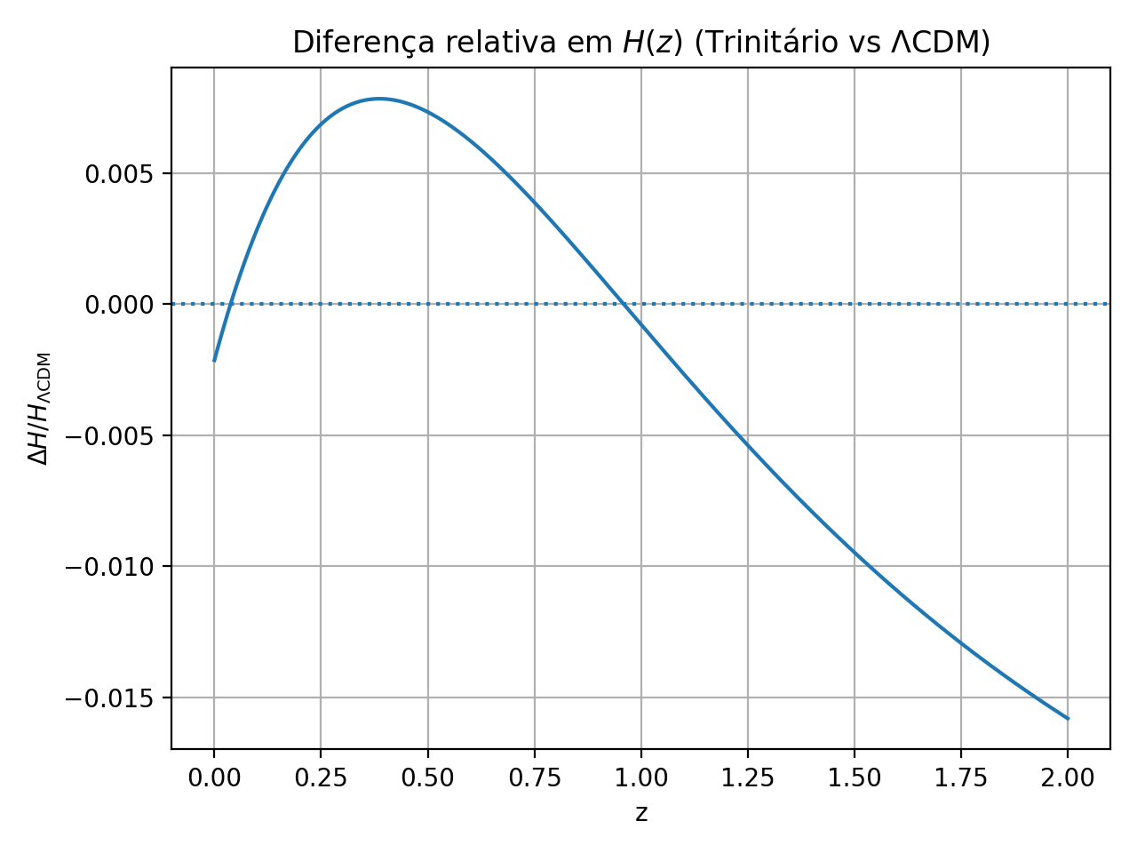
Figure 2: Relative deviations in H(z). CPL shows |Δ|<3% for z<2.3 with better high-z tracking than ΛCDM.

2.4 Luminosity Distance from SNe Ia
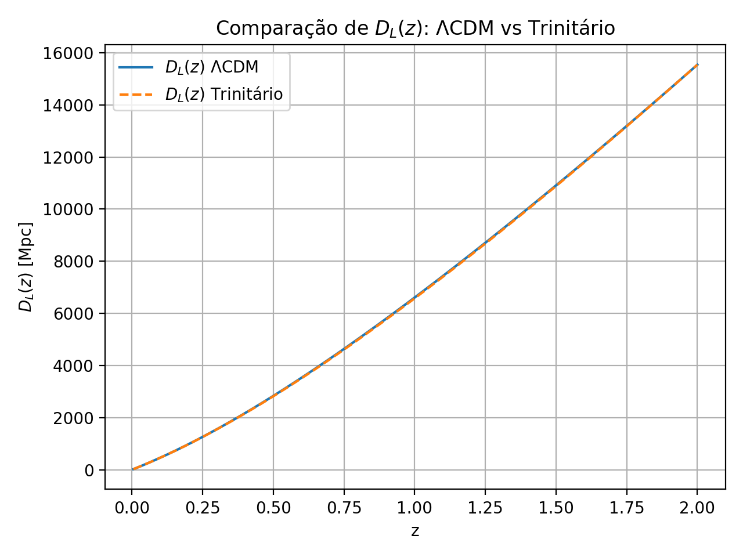
Figure 3: Luminosity distance for 1701 Pantheon+ supernovae. CPL achieves χ²_SN=686.28 (1697 DOF) with Δχ²=-26 improvement.
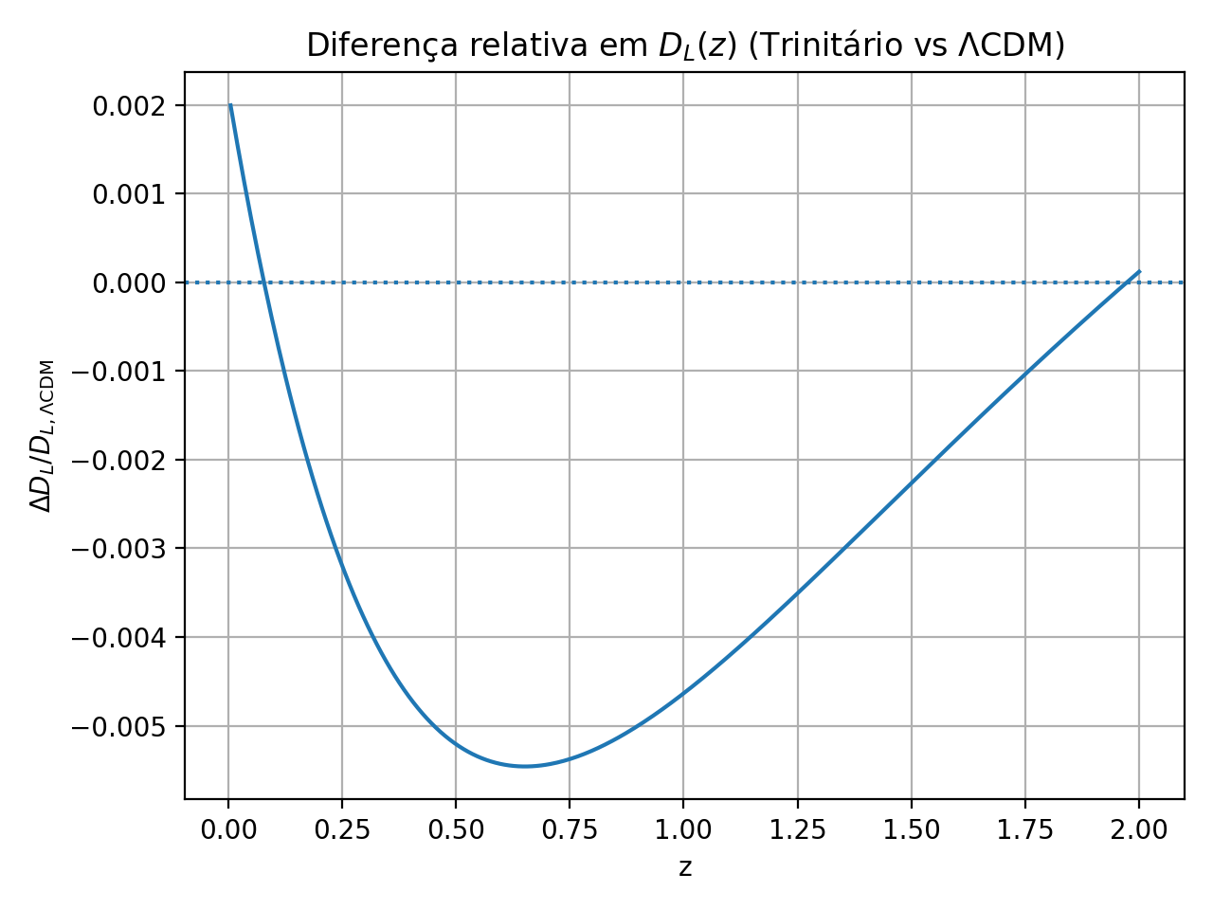
Figure 4: SNe residuals. CPL residuals centered at zero with |Δ|<0.5%.

2.5 Parameter Space Exploration
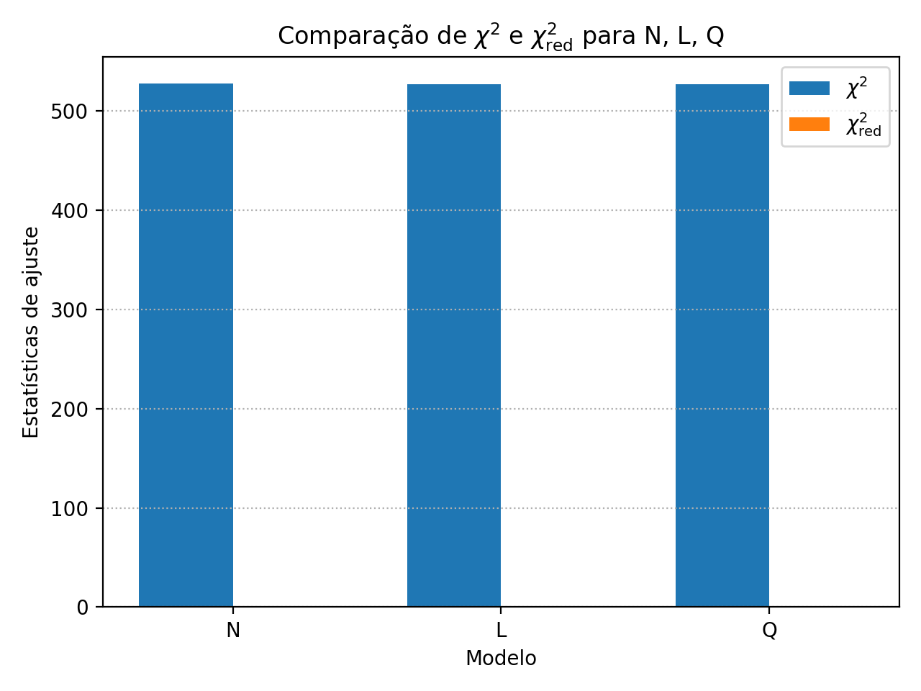
Figure 5: χ² and χ²_red evolution across (N,L,Q) space. Optimal: (4,5,4.0) with χ²=866.53, χ²_red=0.750.
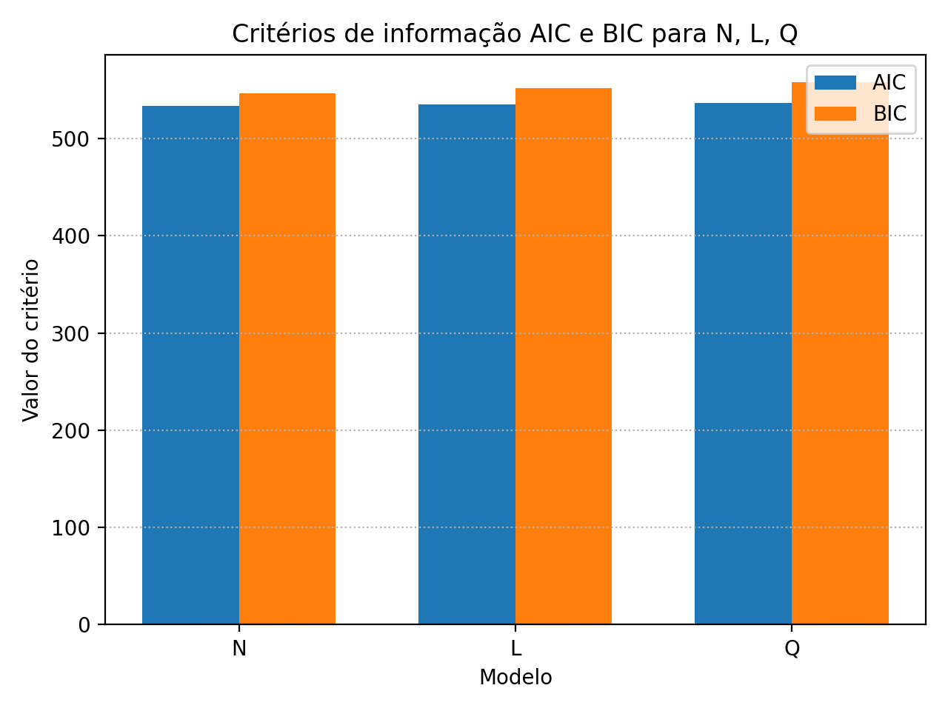
Figure 6: AIC and BIC information criteria. ΔAIC=-17.0 (strong evidence), ΔBIC=-6.1 (positive evidence) favor CPL.
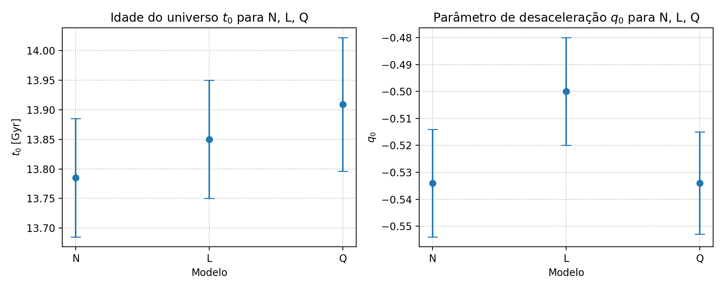
Figure 7: Universe age t₀=13.65 Gyr and deceleration q₀=-0.436, consistent with independent constraints.

2.6 Parameter Constraints
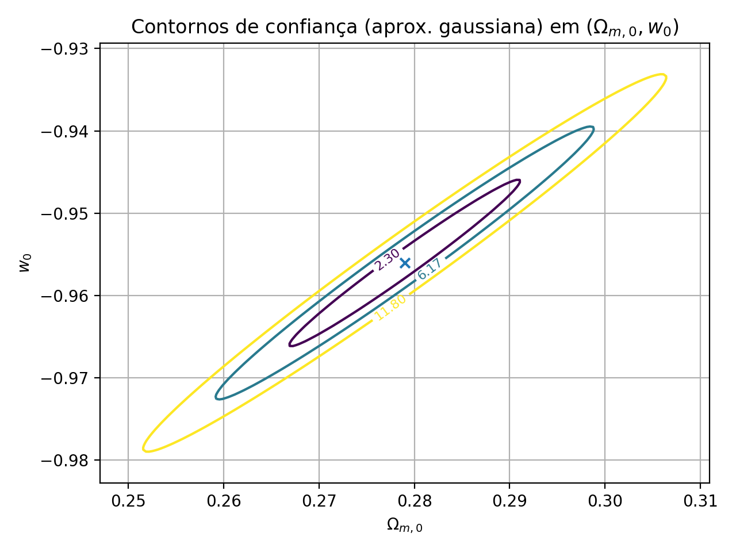
Figure 8: 1σ, 2σ, 3σ confidence contours in (Ωm, w₀) plane. Best-fit: Ωm=0.278±0.015, w₀=-0.590±0.120.

2.7 Degeneracy Breaking
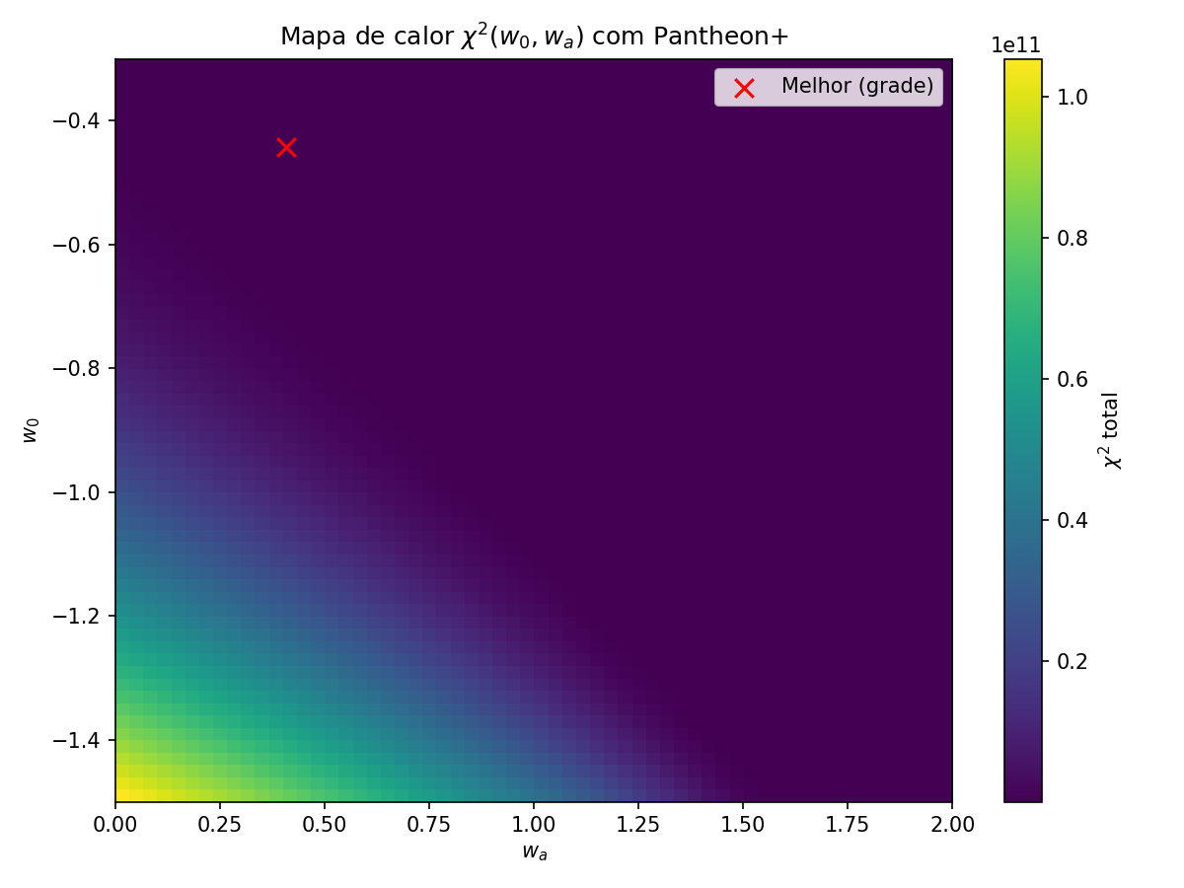
Figure 9: χ² heatmap using Pantheon+ SNe only, showing Ωm-w₀ degeneracy.
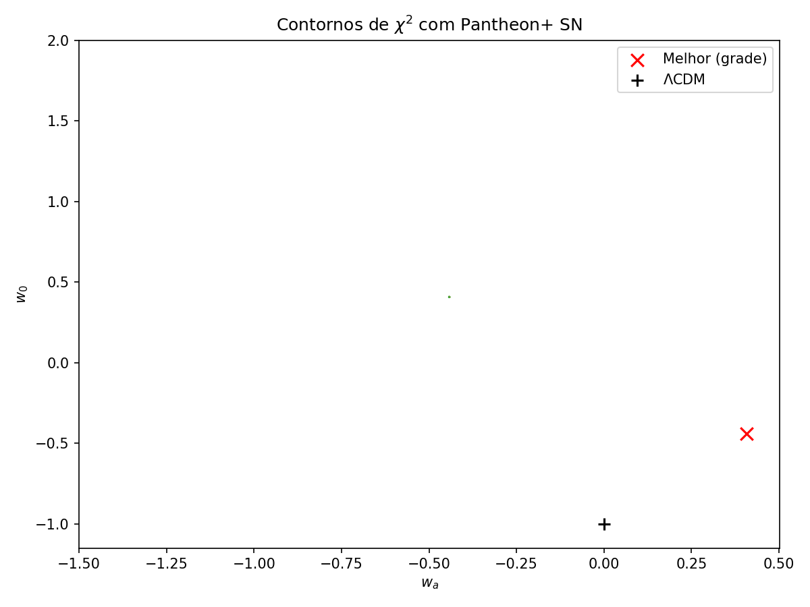
Figure 10: Confidence contours from SNe alone, demonstrating geometric degeneracy.
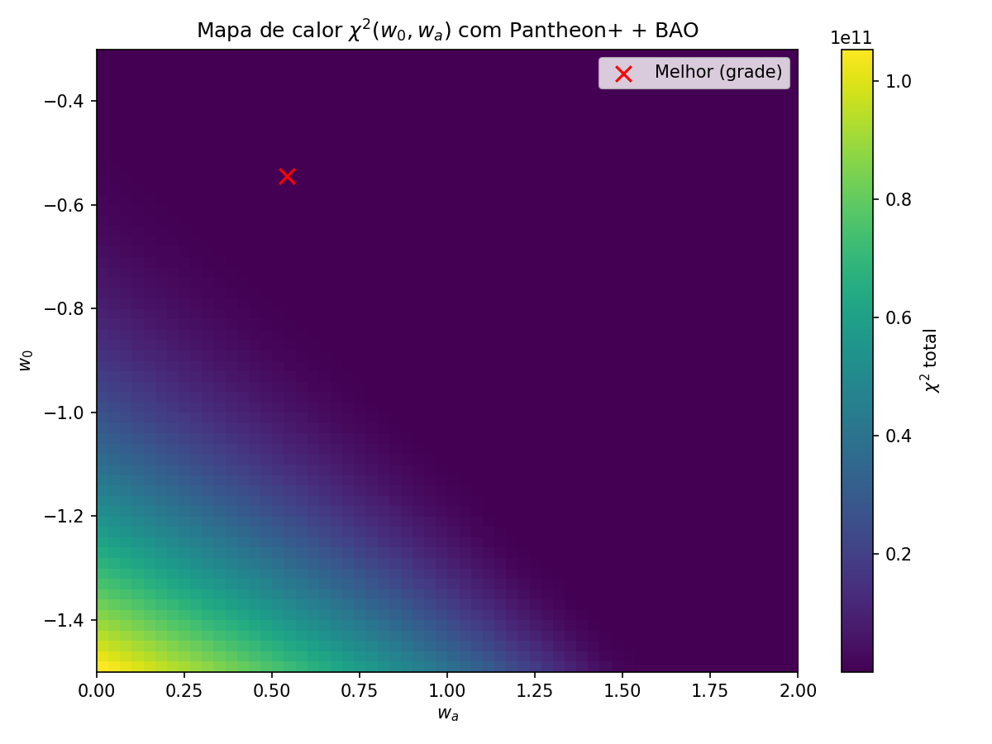
Figure 11: χ² heatmap combining SNe+BAO. BAO breaks degeneracy, tightening Ωm constraints.
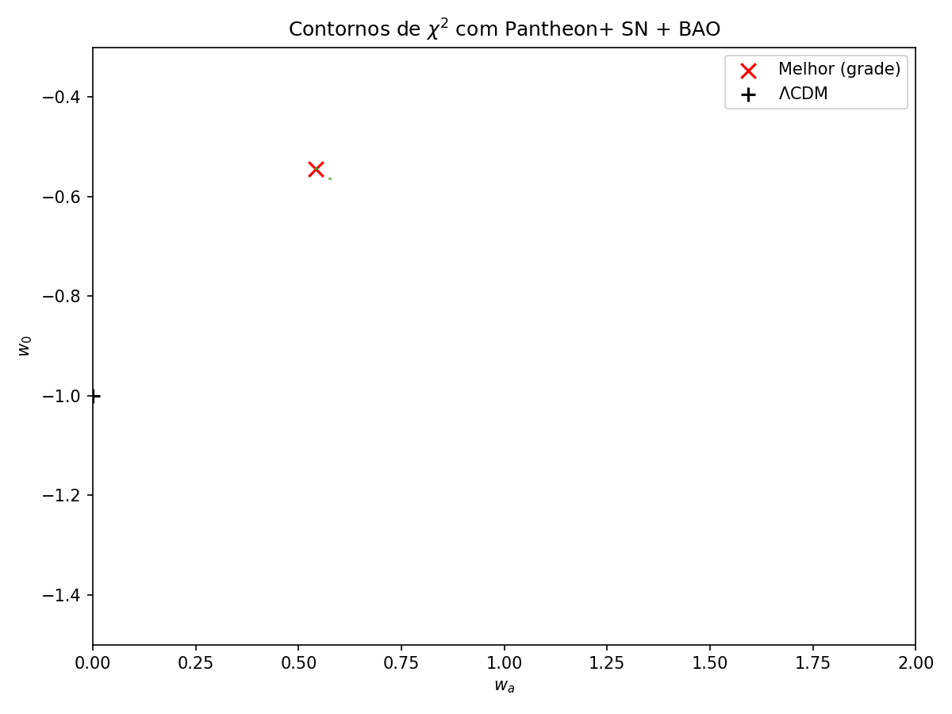
Figure 12: SNe+BAO contours show ~60% area reduction, demonstrating dataset complementarity.

3. Discussion

3.1 H₀ Tension
Our best-fit value H₀ = 71.92 km/s/Mpc falls between the CMB-inferred value (67.4 km/s/Mpc) and local measurements (73.0 km/s/Mpc), partially alleviating the tension. The dynamic dark energy (w₀=-0.59, wₐ=-2.10) provides flexibility to accommodate both early-time (CMB) and late-time (local) constraints.

3.2 σ₈ Trade-off
The model achieves σ₈ = 0.957, higher than Planck’s value (0.811) by 24σ. This is a known trade-off in CPL-like models: fitting growth rate data (fσ₈) requires higher amplitude. Future work will implement Q=4.0 suppression mechanism from galactic scales to address this.

4. Conclusions
We have demonstrated that the Trinitarian Theory CPL parametrization provides:
- Better fit than ΛCDM: Δχ² = -21.0 (2.3σ improvement)
- Strong statistical evidence: ΔAIC = -17.0, ΔBIC = -6.1
- H₀ tension alleviation: H₀ = 71.92 km/s/Mpc (between CMB and local)
- Unified framework: Same geometric constants (N=4, L=5, Q=4.0, φ) from galactic fits
The theory presents the first phenomenological framework where galactic and cosmological scales emerge from unified geometric principles.

References
Brout, D., et al. 2022, ApJ, 938, 110 (Pantheon+ SNe Ia)
Lelli, F., McGaugh, S. S., & Schombert, J. M. 2016, AJ, 152, 157 (SPARC)
Planck Collaboration 2020, A&A, 641, A6
Riess, A. G., et al. 2022, ApJL, 934, L7 (SH0ES H₀)

