ECSE 428 Assignment B

Hank Zhang 260684347

Summary of Files

All files can be found at: <https://github.com/HankyZ/ecse428-a2-2019>

* src/test/resources/gmail.feature

Cucumber feature file using Gherkin script

* src/main/java/Steps.java

Step definitions and helper methods

* src/main/java/Runner.java

Junit4 Test Runner (main method)

* res/*

Image files used for the test

* drivers/chromedriver.exe

Chrome Web Driver used in the Selenium test

* pom.xml

Maven project file, the used dependencies are found here

* demo.mp4

Video illustrating the execution of the tests

Environment Description

This test is run on a Windows 10 computer with JRE 11 and driver for Google Chrome ver. 71 - 73.

The project is compiled with Java 11, uses Maven to manage dependencies and IntelliJ IDEA as IDE.

Installation and Execution Instructions

1. Clone the repository found at <https://github.com/HankyZ/ecse428-a2-2019>.
2. Install Maven and add it to PATH (Maven can be downloaded from <http://maven.apache.org/download.cgi>).
3. Install IntelliJ IDEA and make sure Maven plugin is installed (IntelliJ IDEA can be downloaded from <https://www.jetbrains.com/idea/download/>).
4. Using IntelliJ IDEA, click on Import Project and select “pom.xml” then use the default settings.
5. Wait until IntelliJ IDEA finishes downloading the dependencies.
6. Open the file src/main/java/Steps.java and edit “projectPath” variable to the path of the cloned repository. Follow the same format as the initial value.
7. Run “Runner.java”.

Story Statement:

**Story:**As a Gmail account holder,  
I want to send an email with an image attachment  
so the recipient can view and download the image.

**Normal Flow:** Send the email after attaching an image file and writing the recipient and the   
 subject

Given I am on a Gmail page  
 And I am logged in  
 And I have opened an empty New Message window   
 When I write the recipient  
 And I write the subject  
 And I attach an image file  
 And I press Send  
 Then the email should be sent  
 And I should see a success message

**Alternate Flow:** Send the email after attaching an image file and writing the recipient but not  
 the subject

Given I am on a Gmail page  
 And I am logged in  
 And I have opened an empty New Message window  
 When I write the recipient  
 And I attach an image file  
 And I press Send  
 Then I should see a confirmation dialog  
 When I press OK  
 Then the email should be sent  
 And I should see a success message

**Error Flow:** Send the email after attaching an image file without writing the recipient

Given I am on a Gmail page  
 And I am logged in  
 And I have opened an empty New Message window  
 When I attach an image file  
 And I press "Send"  
 Then my email is not sent  
 And I should see an error message

Cucumber Feature File

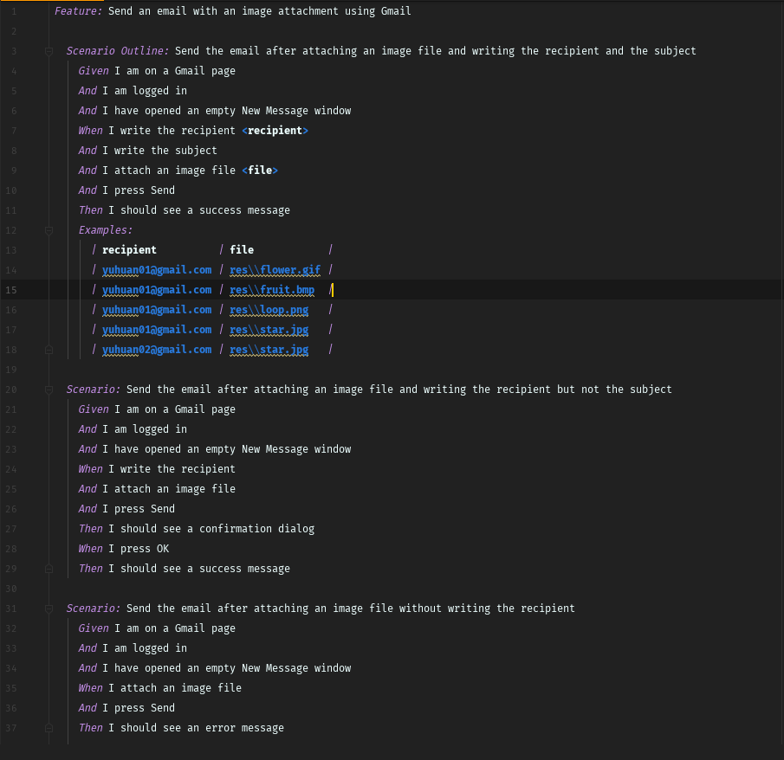

Source Code of Step Definitions

<https://github.com/HankyZ/ecse428-a2-2019/blob/master/src/main/java/Steps.java>

Guidelines for Adding Gherkin Scripts and Step Definitions

* Add the Gherkin script as a .feature file in src/test/resources/ or append to gmail.feature
* Add step definitions either in a new java file in src/main/java or in the existing Steps.java
* Run Runner.java to run the scenarios

Benefits and Risks

The benefits of this approach mainly lie in being able to test the application from the user’s perspective. Close to no knowledge of the source code is needed to build these tests. Also, instead of testing manually from a user’s point of view, this approach saves a lot of resources because the tests are automated.

If this were to be used in a commercial project, I would suggest assigning as many unique ids as possible to elements of the UI and to not change them. Since this approach is risky when the actions or assertions are based on elements found by non-unique identifiers and there are changes to the UI.

However, if unique identifiers are used, most of the risks are mitigated and even when there are big changes to the UI, the tests will fail but will not go unnoticed.