# 虚拟机mqtt：

## 【16运行的时候依赖这个—视频对应的都是16版本】

16：/home/edu/mqtt_transplant/pc/openssl_install/lib

【libmosquitto的头文件路径】

/home/edu/mqtt_transplant/pc/mqtt_install/home/xh/share/debug/mqtt/pc/mqtt_install/include

12 ： /home/edu/mqtt_pc/mqtt_install/home/edu/share/mqtt_pc/mqtt_install/include

## 【16C语言的库】

16

：/home/edu/mqtt_transplant/pc/mqtt_install/home/xh/share/debug/mqtt/pc/mqtt_install/lib

Libmosquit

12：/home/edu/mqtt_pc/mqtt_install/home/edu/share/mqtt_pc/mqtt_install/lib

## ps -A | grep mosq* 【mqtt服务器程序运行查看】

## 进入到家目录：vim .bashrc 【属性路径设置】

## GG，到最底部

## cd mqtt参考例子

## 【12版本】库+头文件mqtt_pc：

### 虚拟机：

/home/edu/mqtt_pc/ssl_install/lib

/home/edu/mqtt_pc/mqtt_install/home/edu/share/mqtt_pc/mqtt_install/lib

/home/edu/mqtt_pc/mqtt_install/home/edu/share/mqtt_pc/mqtt_install/include

### 开发板：

/usr/mqtt_arm/uuid_install/lib

/usr/mqtt_arm/ssl_install/lib

/usr/mqtt_arm/mqtt_install/home/edu/share/mqtt_arm/mqtt_install/lib

/usr/mqtt_arm/mqtt_install/home/edu/share/mqtt_arm/mqtt_install/include

## 【✳12版本下的makefile也需要注明依赖路径】：

cflags = -lmosquitto -lpthread -ldl -lrt

cflags += -I/home/edu/mqtt_pc/mqtt_install/home/edu/share/mqtt_pc/mqtt_install/include

cflags += -L/home/edu/mqtt_pc/mqtt_install/home/edu/share/mqtt_pc/mqtt_install/lib

cflags += -L/home/edu/mqtt_pc/ssl_install/lib

## 【12版本的环境变量配置文件’.bashrc’中的mqtt程序路径依赖：】

export LD_LIBRARY_PATH=$LD_LIBRARY_PATH:/home/edu/mqtt_transplant/pc/openssl_install/lib

export LD_LIBRARY_PATH=$LD_LIBRARY_PATH:/home/edu/mqtt_pc/mqtt_install/home/edu/share/mqtt_pc/mqtt_install/lib

#/home/edu/mqtt_transplant/pc/mqtt_install/home/xh/share/debug/mqtt/pc/mqtt_install/lib

export LD_LIBRARY_PATH=$LD_LIBRARY_PATH:/home/edu/mqtt_transplant/pc/mqtt_install/home/xh/share/debug/mqtt/pc/mqtt_install/include

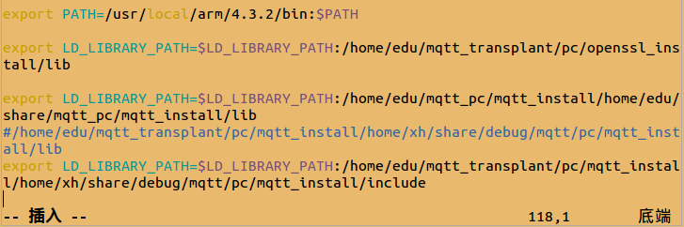

## 虚拟机运行现象：

gcc publisher.c -o publisher -lmosquitto -lpthread -ldl -lrt

-I/home/edu/mqtt_pc/mqtt_install/home/edu/share/mqtt_pc/mqtt_install/include

-L/home/edu/mqtt_pc/mqtt_install/home/edu/share/mqtt_pc/mqtt_install/lib

-L/home/edu/mqtt_pc/ssl_install/lib

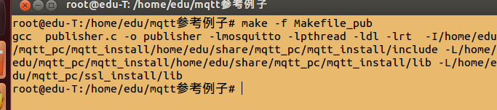

# 开发板下的：

## 最后效果：

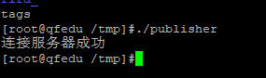

## mqtt_arm拷贝到挂载目录下：

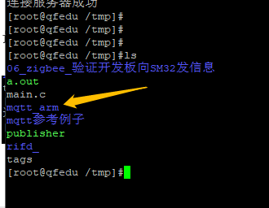

## 开发板上的依赖路径/etc/profile

/usr/mqtt_arm/mqtt_install/home/edu/share/mqtt_arm/mqtt_install/include

export LD_LIBRARY_PATH=$LD_LIBRARY_PATH:/usr/mqtt_arm/uuid_install/lib

export LD_LIBRARY_PATH=$LD_LIBRARY_PATH:/usr/mqtt_arm/ssl_install/lib

export LD_LIBRARY_PATH=$LD_LIBRARY_PATH:/usr/mqtt_arm/mqtt_install/home/edu/share/mqtt_arm/mqtt_install/lib

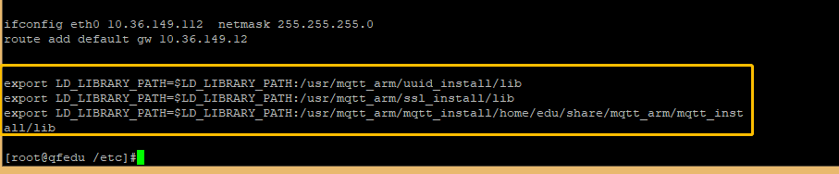

## 开发板，解压后拷贝到这里

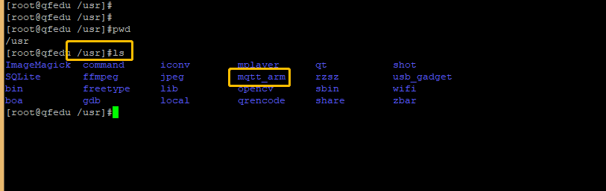

# 虚拟机手动执行服务器路径

/home/edu/mqtt_pc/mqtt_install/home/edu/share/mqtt_pc/mqtt_install/sbin

# 使用云端IP，ping一下，看对应IP：

ping test.mosquitto.org

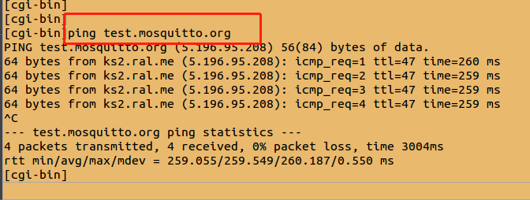

# 问题1-接收端收不到消息：

正常反应：

27: data

28: mid=1

29: qos_count=1

31: granted_qos[0]=1

2021.9.29 10:50:18 17:topic(temp)->hello

双方需要用到云端IP ：5.196.95.208

# 问题2：开发板运行无法发给虚拟机-订阅、发布主题不一致

## 可执行命令实验是否正常发布、订阅

## 订阅者 topc2

mosquitto_pub -t topc2 -m "nihaosdf" -h 5.196.95.208

## 发布者 topc1

mosquitto_sub -t topc1 -h 5.196.95.208