GitHub Link: https://github.com/HanluMaa/dsci560/tree/main/lab1

Commits on 1/14:

Commit 1: Lab 1 File Structure Building: Set up the files and folders to store the solutions of the lab 1

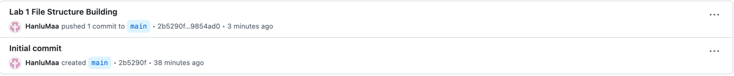

Commits on 1/15:

Commit 1: Update commit history for lab 1: I updated commit history table for the commits and the corresponding descriptions made yesterday.

Commit 2: Update report for lab 1: I updated report for lab 1, where I include my lab results (i.e., screenshots and descriptions) for installation and setup.

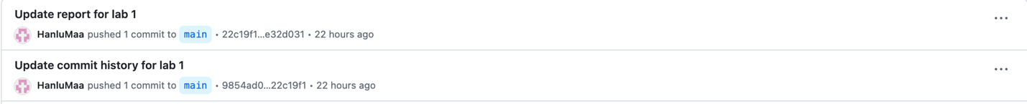

Commits on 1/16:

Commit 1: