

**DX-30 efficient microcrack hard chromium plating intermediate**

**DX-30 efficient microcrack hard chromium plating intermediate is a solid powder intermediate that can significantly improve current efficiency and reduce corrosion of the plating solution on the anode plate. It makes the surface of the finished product smoother and brighter, increases the hardness of the coating, generates more microcracks, and has higher corrosion resistance. When used for decorative chrome plating, it can accelerate the deposition and dispersion ability of the plating solution and is often used as the main component of liquid chrome plating additives. It can be used directly in solid form..**

**materials**

**DX-30 efficient microcrack hard chromium plating intermediate Technology**

1. More efficient cathode current (up to 25% -27%), fast deposition speed, twice that of traditional technology. Under the following conditions, the cathode current density is 70A/dm2, the temperature is 55-65 ° C, and the current efficiency is as high as 60% μ M/h.

2. The chromium layer has high hardness and meets the GB9790-88 standard, with a voltage range of 860-1200 HV. Durability increased by 20% -30%.

3. The chromium layer has many microcracks, which range from 200 to 1000/cm2 and are more corrosion-resistant than traditional processes.

4. The chromium layer is more firmly bonded to the substrate, and the pre-treatment operation is simpler.

5. Chromium solution has better dispersibility, more uniform layer thickness, and a smoother surface with almost no rolling.

6. Chromium solution does not contain fluoride, which can prevent corrosion of the workpiece due to low current during the electroplating process.

7. The anode solution has good conductivity and less corrosion to the anode.

Reducing labor costs and fuel consumption by two times significantly shortens metal processing time.

**Process parameters:**

**Status: White powder**

**Molecular formula: NaSO3CH2SO3Na**

**Molecular weight 220.12**

**Purity: above 99.99%**

**1 , Usage**

The new solution is prepared as follows: CrO3 250g/L, DX-30 4g/L

Then add some H2SO4 to make the ratio of CrO3: H2SO4 between 1.05-1:1 / 100.

Steps:

1. Add 2/3 volume of deionized water to a clean plating solution. The deionized water should not cont ain any chloride or sulfate ions and should be heated to 45-50 ℃.

2. Continuously stir the liquid while adding CrO3.

3. Continuously stir and add the required DX-30 and sulfuric acid

4. Stir the solution evenly and add deionized water to the full volume. Test the density of the solution and adjust the components if necessary.

5. Heat the solution to 55-65 ℃ and add an appropriate amount of anti fog chemicals approved .

6. After electrolysis for 0.5-1 hour, test the electroplating effect.

**2, Additional dosage (reference):**

Consume 100 kilograms of chromic anhydride, supplement 500g DX-30

**Reference value**

|  |  |
| --- | --- |
| density of cathode current (A/dm²) | Deposition speed (um/h) |
| 30 | 30 |
| 45 | 40---45 |
| 60 | 50---60 |
| 70 | 60---70 |

1,Deposition speed

2,current efficiency Comparing 3, Deposition speed Comparing

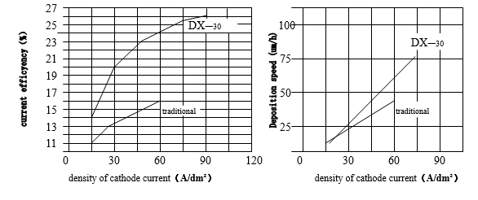

**Company address of China:**

**Changsheng Industrial Park, No. 64 Keji Middle Road, Shijie Town, Dongguan City, Guangdong Province China**

**Contact phone number: +8613790181730**

**US office address: 3054knollwood ave la verne ca 91750**

**Contact phone number:+16268636126**

**Contact email: jingjinggddg@gmail.com**