Name: Hann Manich

Date: 01. Jan. 2018

Submit to: Ms. Sheryl

Title: Best photo of 2017-2018 and caption

* 2017

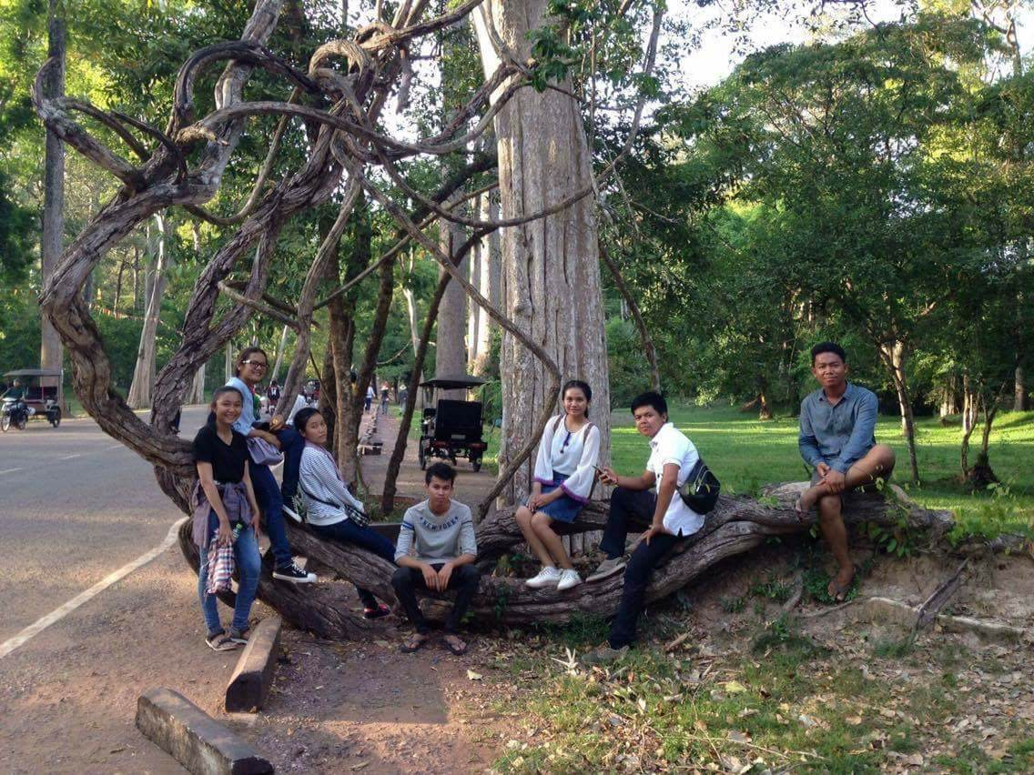

This picture was toke at Angkor Wat in Khmer New Year Ceremony. It's such a wonderful moment for me. It's so exhausted but I really enjoy this trip. I hope to have a chance like this next time. It's a special time for me to have a trip with them. They make me feel comfortable all the time. I'm so lucky to have friends like them.

* 2018



I have a lot of things to do in 2018 but the most important thing I want to do first is to study hard and try to improve my English as well as I can, especially grammar and vocabulary. One more thing, I have to learn more about program and explore everything that related to the computer.