- Nataly- She usually buys clothes at Old Market because the quality is good, it has latest styles. Yes, I am.
- Wan- No, I don't. My mom helps me to choose clothes.
- Lynan- The money I spend on clothes are maximum 25$.
- Thou-No, I don't. It is too fashionable for her.
- Hak- No because I don't like to buy it. Pros is cheap and Cons is old and baggy.
- Nyratt- Jacket. No I don't.
- Dane- I think wearing high heels is difficult for me in walking. Yes, I do. Because I have to join the party.
- Channy- For about 10 minutes.
- Chayrith- Shoes.
- Jenny- No, I don't. Because my school is free in wearing. Going to the party by wearing dress.
- Sokheng-No I don't. I usually wear clothes only a year.
- Ly chan dara- Yes, I do. Hi-so fashion is my favorite.
- Lya- See through. It depends on a person who wear it.
- Somnang- They wear traditional clothes.
- Thavin- No I don't. I think They look like gangster but if they are superstar I think It is simple because sometimes It has the meaning for them.
- Taing- No I don't. I think it is so cool.
- Sokmeng- I think a man who wear make-up is not good. A person who wear too much make-up when they join the party.
- Seavpor- Av pak. I don't know. No I don't.
Part II. 5 Quotations relate to fashion:
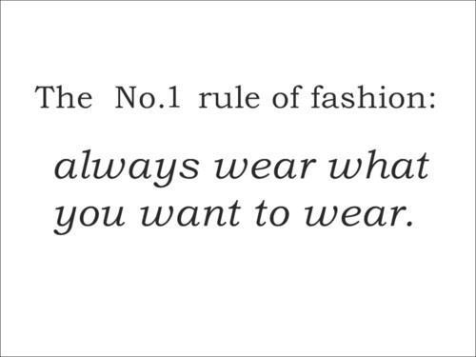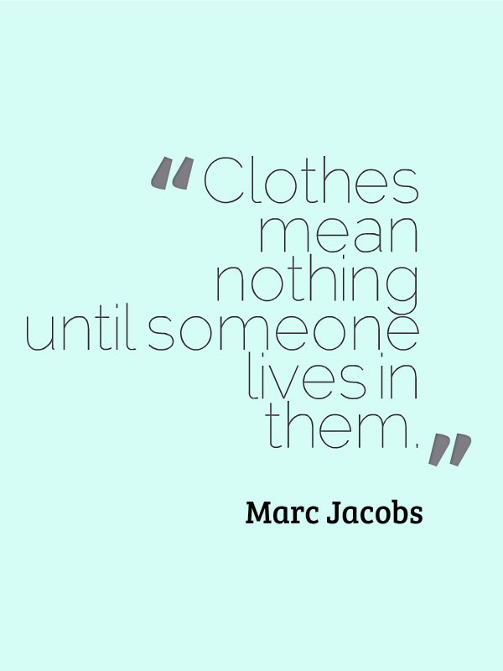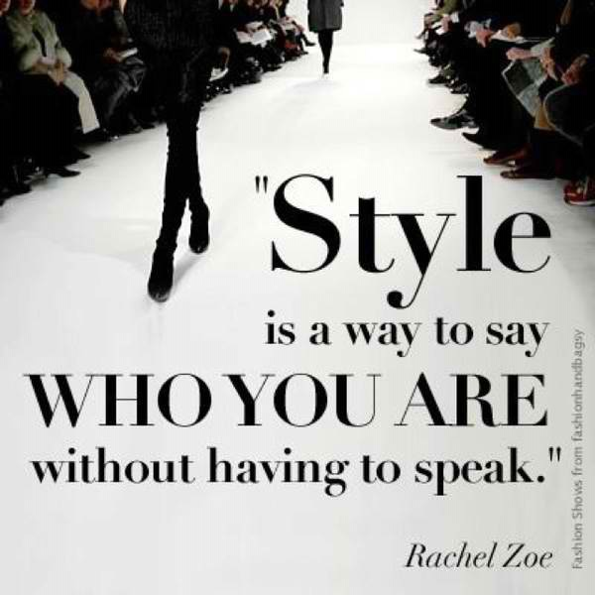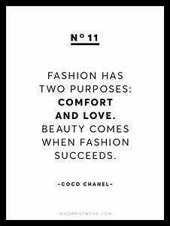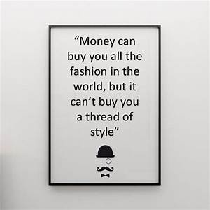

My favorite quote:

This quote is really meaningful for me and it is the reality thing in my life. Every time I wear the clothes depend on my feel and my thought or sometime the situation I'm in. I just don't care too much about the fashion. Be free in wearing and it will make my life be fulfill.

