User studies - prototype testing

Link to testable prototype:
https://www.figma.com/proto/MTHrWEQydJJj8uJHAJQibK/u10?node-id=23%3A0&scaling=min-zoom

First test on one user
Feedback and insights:
- Directly at login, you should see all cases instead of the “Create new case” page. From there you can go to “Create new case” instead.

- Generate the case ID after the case has been created instead of before creating the new case. “The information about the case ID is not interesting if the case has not been created yet.”

- Combine “Search cases” and “History” - simply into “Cases” for example, where you can search for cases and see history and also filter on open/close cases.

- The left navigation might not be needed as it could be the same page for “Search cases” and “History” for the first line agent user.

- On the “History” page, you should be able to click a case to see it. You will then get to kind of the same page as “Create new case”, but the fields are disabled.
On this page there could be a button for “Assign myself” to the case to start working on it if the user is a technician. Or the technician can assign another user ID of another technician.

- The dark mode/light mode setting could be saved for the user, so when next time the same user logs in, the system will change to the mode that he/she had last time.

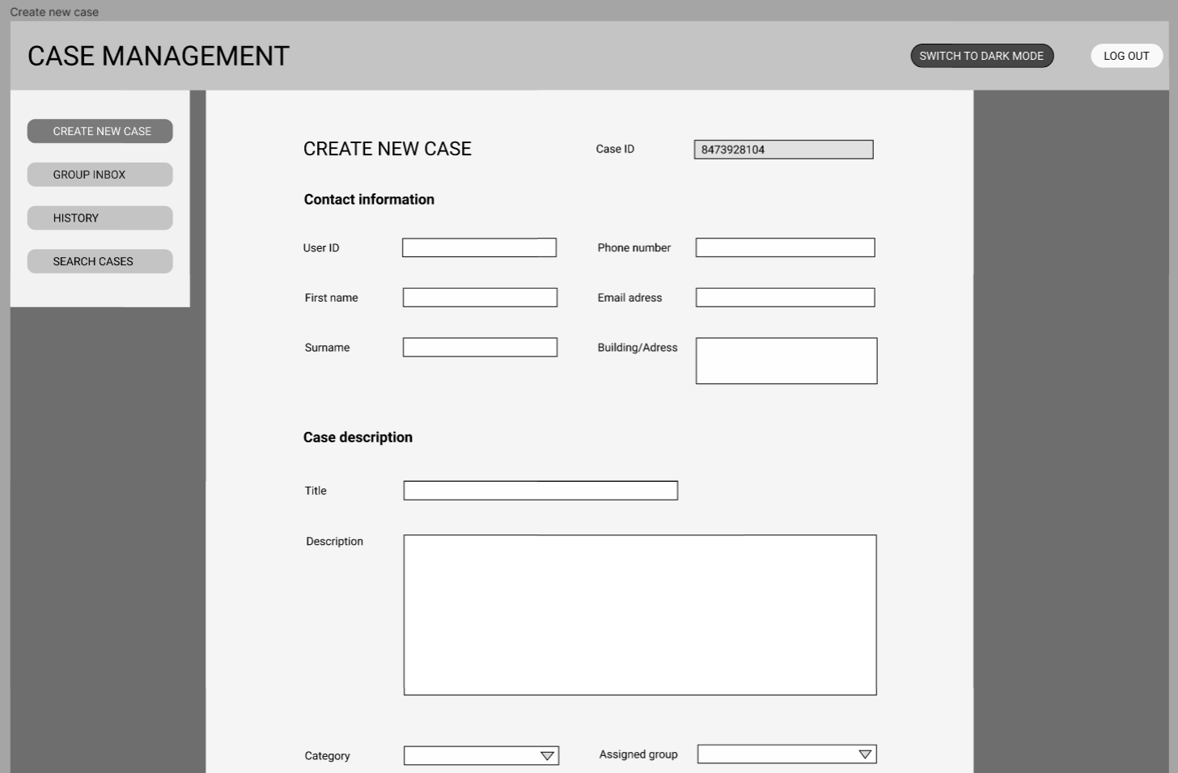
This is how the prototype for “Create new page” is looking at first draft in light mode.

