1. Created S3 policy
2. Created S3 role with full access: S3, DynamoDB, Lambda, CloudWatchLogs

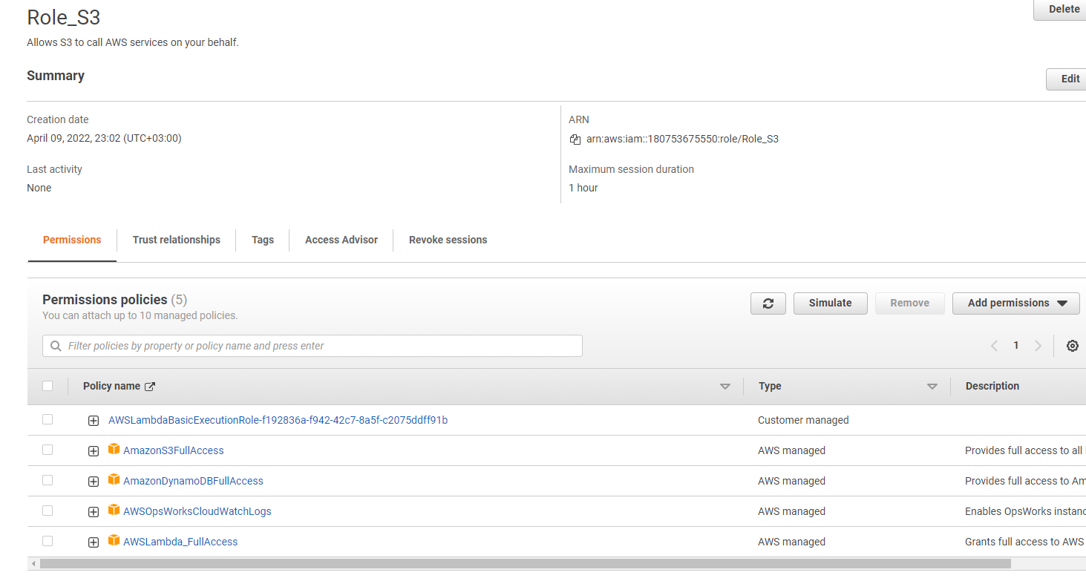

1. Created user
2. Added group

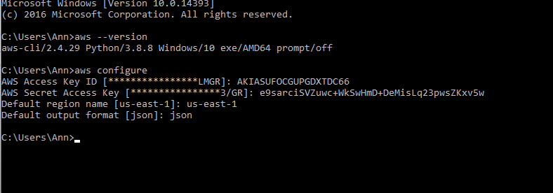

1. Created S3 bucket

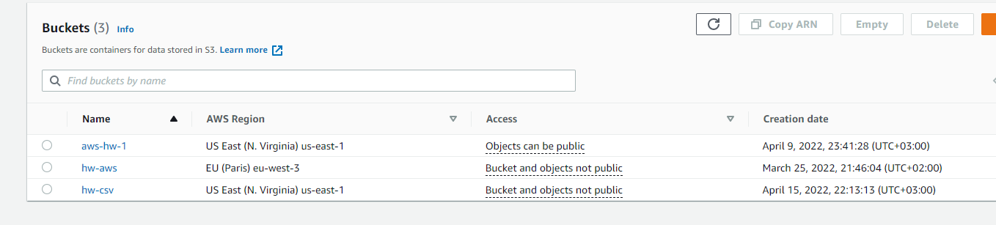

1. Uploaded csv file into S3 bucket using CLI



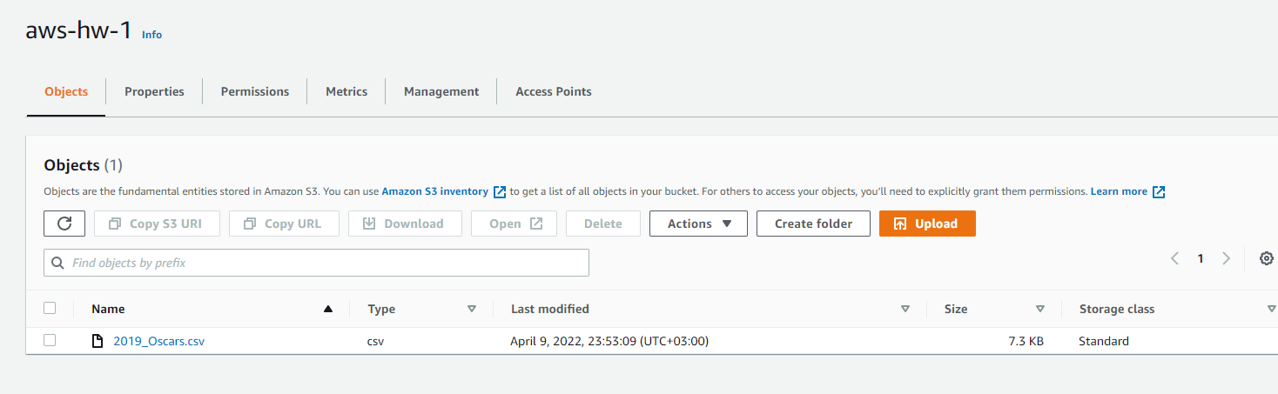

1. Created Lambda function

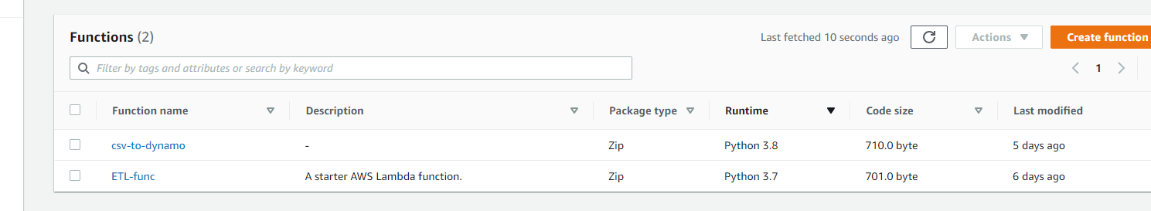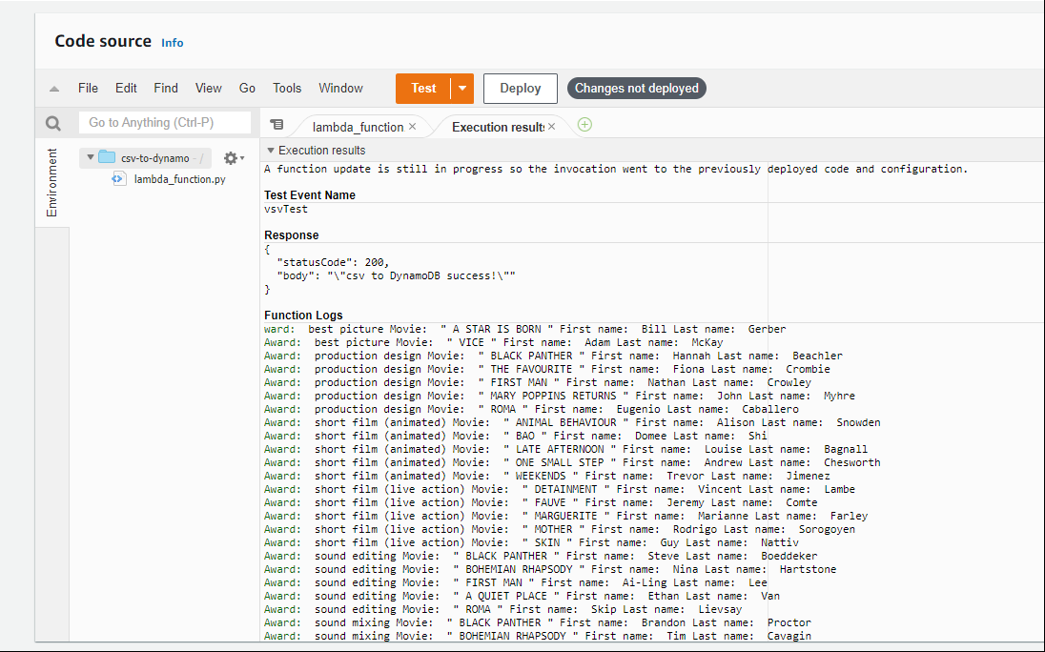

1. Python code for Lambda function

import json

import csv

import boto3

import string

dynamodb = boto3.resource('dynamodb')

table = dynamodb.Table('Oscar_2019')

 def lambda_handler(event, context):

region = 'eu-east-1'

record_list = []

try:

s3 = boto3.client('s3')

dynamodb = boto3.client('dynamodb', region_name = region)

bucket = event['Records'][0]['s3']['bucket']['name']

key = event['Records'][0]['s3']['object']['key']

print('Bucket: ', bucket, 'Key: ', key)

csv_file = s3.get_object(Bucket = bucket, Key = key)

record_list = csv_file['Body'].read().decode('utf-8').split('\n')

csv_reader = csv.reader(record_list, delimiter=',', quotechar='"')

sign = '"'

for row in csv_reader:

award = row[0].lower()

movie = row[1]

nominee = row[2].split(' ')

print('Award: ', award, 'Movie: ', sign, movie, sign, 'First name: ', nominee[0], 'Last name: ', nominee[-1])

except Exception as e:

print(str(e))

return {

'statusCode': 200,

'body': json.dumps('csv to DynamoDB success!')

}

1. Created event: 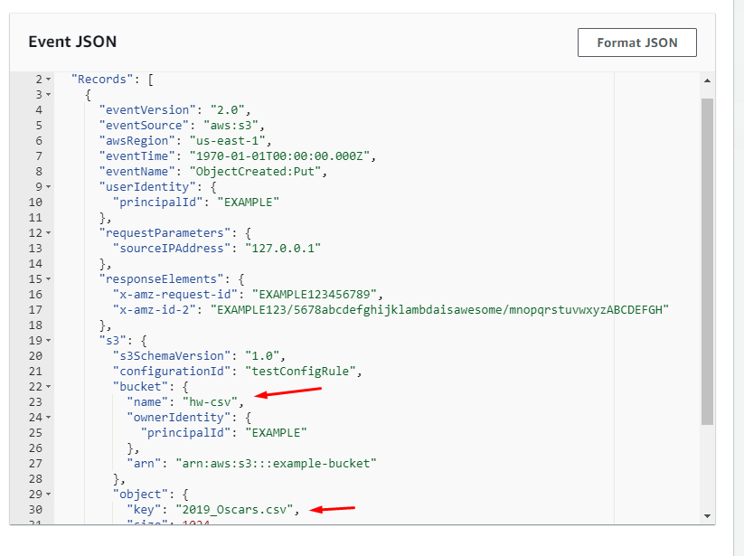
2. Created DynamoDB table:

