Answer on Question #76991- Math – Calculus

Find the dimensions of the rectangle of largest area that has its base on the  
x-axis and its other two vertices above the x-axis and lying on the parabola

**Solution**

See the figure 1 below:

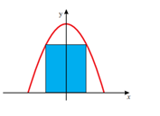

Figura 1

The area of the inscribed rectangle equals

Calculate the derivative of the area function, and set it equal to zero.

As for , and for

then maximum point and the rectangle have largest area for it (32).

Length of the rectangle is ; the height of the rectangle is .

**Answer:** The base of the rectangle has length 4 and the height of the rectangle is 8.

It was using example in [1].

References:

1. http://www.math.tamu.edu/~stecher/151/Sp00/final.pdf