**Let and for problems 1. - 4.**

**1.** Find .

Solution

Answer:

**2. Find**

Solution

Answer:

**3. Find the distance between and** .

Solution

Answer:

**4.** **Find the angle 𝜃 between and** .

Solution

Answer:

**5.** **Calculate the angle of rotation of the conic described by .**

Solution

then

Find angle of rotation:

Answer:

**6.** **Sketch the graph of the conic described in problem 5. (You may use software to generate the graph.) Your graph must show the rotated axes, 𝑥′ and 𝑦′. Identify the conic section and any parameters from the graph. (For example, ℎ, 𝑘, 𝛼, 𝛽, or focus, depending on the conic section in question).**

Solution

then we have a hyperbola.

The coordinates of the center point are found by rotating back about angle :

Substitute these in (1) for *x* and *y*:

where axes 0f the hyperbola:

Then graph is:

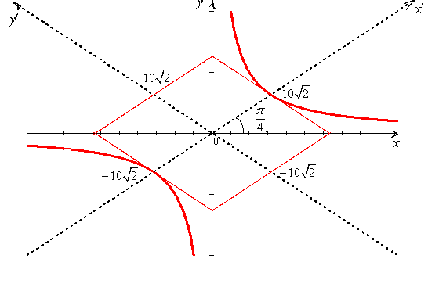

Graph 1

**Use the matrix for problems 7. – 10.**

**7.** **Find a basis for the row space of the matrix 𝐴**.

Solution

Find the row echelon form of the matrix A using elementary row operations.

We see that the row space of the matrix 𝐴 is spanned by and .

Answer: .

**8**. **Find the rank of the matrix 𝐴.**

Solution

The row space has basis with two vectors, which means that the rank of the matrix 𝐴 is 2.

Answer: rank𝐴=2

**9**. **Find the null space of the matrix 𝐴.**

Solution

using the row echelon form of the matrix A:

then have the set of equations

General solution:

In a matrix form:

then

Answer: Basis of null space is .

**10.** **Find the nullity of the matrix 𝐴**.

Solution

The null space has basis with two vectors, then nullity(*A*)=2.

Answer: nullity(*A*)=2.

**11. Find the volume of a parallelepiped with a vertex at the origin and edges , , and .**

Solution

Answer: 1 cubic units.

**12. Compute for and**

Solution

Answer:

**13. Find the coordinate matrix of 𝑥 = (2, −1,2) in 𝑅3 relative to the basis 𝐵′ = {(1, −1,0), (0,1,0), (1,0,2)}.**

Solution

Find () coordinate in 𝑅3 relative to the basis 𝐵′.

or

then

Answer: ().

**14. Find the area of a parallelogram with adjacent sides and .**

Solution

Answer: square units.

**15. Using matrix methods, find the least squares regression line for the points {(25,100), (38,73), (78,38)}.**

Solution

Find the least squares regression line in form:

Use matrix methods for finding coefficients: , .

Use the x-coordinates of the data to build the matrix X and the y-coordinates to build the vector y:

Form matrix

For the least-squares solution of , obtain the normal equation(with the new notation):

,

That is, compute

The normal equations are:

Hence

Thus the least-squares line has the equation:

Answer:

**16. Using graph paper or a computer generated plot, graph the points and regression line from problem 15.**

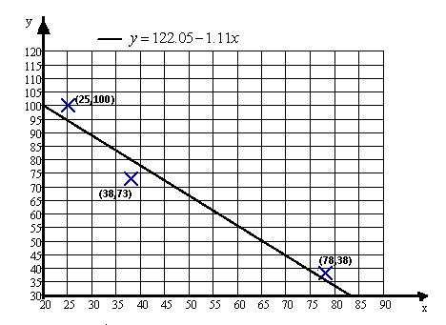

Graph 2

**Use the vectors and for problems 17. - 20.**

**17. Find .**

Solution

Answer:

**18. Find** .

Solution

Answer:

**19. Find**

Solution

Answer:

**20. Find .**

Solution

Answer:

**21. Let and . Find .**

Solution

Answer:

**22. Using graph paper or a computer generated plot, graph , , and from problem 21. on the same set of coordinate axes.**

Solution

let's choose the set of coordinate so that the beginning of coordinates coincided with the beginning of vectors:

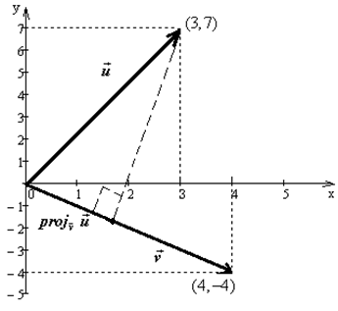

Graph 3

**Use the set for problems 23. – 25.**

**23. Apply the Gram-Schmidt orthonormalization process to transform the set of vectors 𝑆 into an orthonormal basis for 𝑅3.**

Solution

let's designate

thus

The Gram-Schmidt Algorithm:

Step1

Step2

Step3

You can verify that – forms an orthogonal basis for R3. Normalizing the vectors in the orthogonal basis, we obtain the orthonormal basis:

Answer:

**24. Use the orthonormal basis in problem 23. to find a QR factorization of 𝑆.**

Solution

so

As and , then

Answer: .

**25. Multiply 𝑄𝑅 to verify that you return to the vectors in *S***.

Solution