VCC MAC 2311

Multiple Choice

Identify the choice that best completes the statement or answers the question.

**1.** Find the area of the region bounded by the curves.

Select the correct answer.

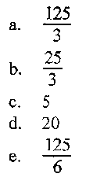

**Solution**

Find the points of intersection of the lines.

Draw the graph (graph1).

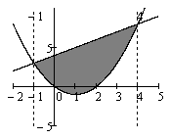

Graph1

The line is showed a higher than the curve so find the area of the region as the difference between the two integrals

**Answer: e**

**2.** Sketch the region enclosed by the curves and . Decide whether to integrate with respect to *x* or *y.* Draw a typical approximating rectangle and label its height and width. Then find the area of the region.

Select the correct answer.

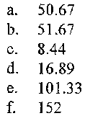

**Solution**

Draw the approximating rectangle (graph2).

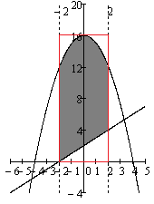

Graph2

Its height is 16 and width is 4.

The curve is showed a higher than the line so find the area of the region as the difference between the two integrals

**Answer: a**

**3.** Find the area of the region bounded by the curves.

Select the correct answer.

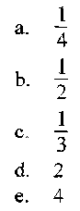

**Solution**

Draw the graph (graph3).

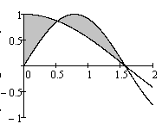

Graph3

Find the points of intersection of the curves.

,

In our case are points ,than get 2 integral:

**Answer: b**

4. Find the volume of the solid obtained by rotating the region in the first quadrant bounded by and about the y-axis.

Select the correct answer.

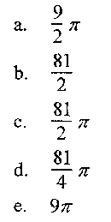

**Solution**

Draw the graph (graph4).

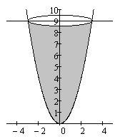

Graph4

Use the formula to find the volume of the solid

**Answer:** c.

5. Use calculus to find the area of the triangle with the given vertices.

(0, 0), (2,1), (-1,6)

Select the correct answer.

a. 4.5

b. 4

c. 6

d. 6.5

e. 1/2

**Solution**

Draw the graph (graph5).

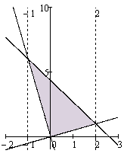

Graph5

Use the formula to find the equation sides of the triangle:

Consider the interval (-1;0). The line is showed a higher than the line .

Consider the interval (0;2). The line is showed a higher than the line .

So get 2 integral:

**Answer** d. 6.5

**6**. Find the volume of the solid obtained by rotating the region bounded by and about the x-axis. Select the correct answer.

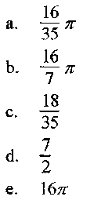

**Solution**

Find the points of intersection of the curves.

Draw the graph (graph6).

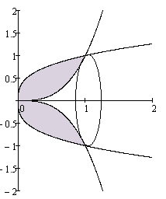

Graph6

The curve is showed a higher than so use the formula to find the volume of the solid obtained as the difference between the two integrals:

**Answer** a.

**7**. Find the volume of the solid obtained by rotating the region bounded by and about the y-axis. Select the correct answer.

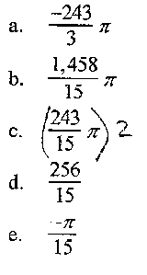

**Solution**

Find the points of intersection of the curves.

Draw the graph (graph7).

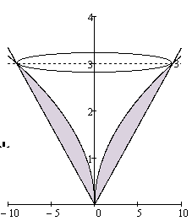

Graph7

The curve is showed a higher than so use the formula to find the volume of the solid obtained as the difference between the two integrals:

**Answer** c

**8.** Find the number b such that the line divides the region bounded by the curves and into two regions with equal area.

Select die correct answer.

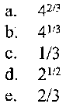

**Solution**

Draw the graph (graph8).

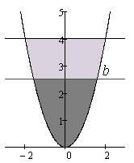

Graph8

Function is symmetric with respect to axis y than the area of the region bounded by the curves is

And the area of the region bounded by the curves is

By condition

**Answer a.**

9. Find the volume of the solid obtained by rotating the region bounded by the given curves about the specified axis. ; x-axis

Select the correct answer.

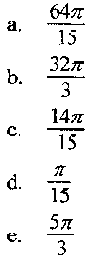

**Solution**

Find the points of intersection of the curves.

Draw the graph (graph9).

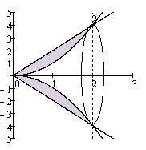

Graph9

The curve is showed a higher than so use the formula to find the volume of the solid obtained as the difference between the two integrals:

**Answer** a.

**10**. Use the method of cylindrical shells to find the volume generated by rotating the region bounded by the given curves about the specified axis.

; about Select the correct answer.

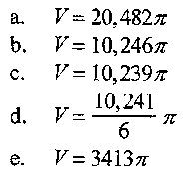

**Solution**

Draw the graph (graph10).

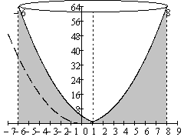

Graph10

Use the formula , where find the volume generated

**Answer d.**

**11**. The region bounded by the given curves is rotated about the specified axis. Find the volume of the resulting solid by any method.

; about the x-axis

Select the correct answer.

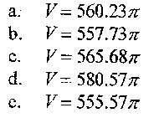

**Solution**

Find the points of intersection of the x-axis.

For this

Draw the graph (graph11).

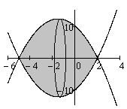

Graph11

Use the formula to find the volume of the solid obtained:

**Answer a.**

12. The height of a monument is 20 m. A horizontal cross-section at a distance x meters from the top is an equilateral triangle with side meters. Find the volume of the monument.

Select the correct answer.

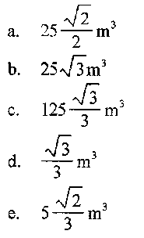

**Solution**

Draw the graph (graph12).

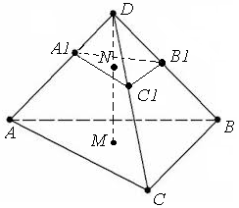

Graph12

By condition .

Use the formula to find the volume of the monument

**Answer c.**

**13.** The region bounded by the given curves is rotated about the specified axis. Find the volume of the resulting solid by any method. ; about the y-axis

Select the correct answer.

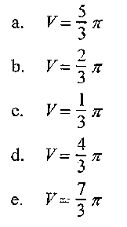

**Solution**

Draw the graph (graph13).

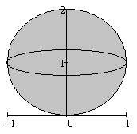

Graph13

We can see from the graph 13 than get ball of radius 1.

Use the formula to find the volume of the resulting solid:

**Answer d.**

**14**. If 132 J of work are needed to stretch a spring from 9 cm to 12 cm and another 588 J are needed to stretch it from 12 cm to 19 cm, what is the natural length of the spring?

Select the correct answer.

a.6 cm

b. 5 cm

c. 3 cm

d. 4 cm

e. 1 cm

**Solution**

The work is the integral of force F=kx ( force of stretching a spring).

let a is natural length of the spring in cm then

**Answer** b.5

**15**. A heavy rope, 40 ft long, weighs 0.8 lb/ft and hangs over the edge of a building 110ft high. How much work is done in pulling the rope to the top of the building?

Select the correct answer.

640 ft-lb

590 ft-lb

641 ft-lb

489 ft-lb

740 ft-lb

**Solution**

when the force is constant, but it this case, it's changing.

In our case, we go with an integral, from 0 to 40

640 ft-lb

**Answer a.** 640 ft-lb.

**16.** A tank is full of water. Find the work required to pump the water out of the outlet.

Round the answer to the nearest thousand

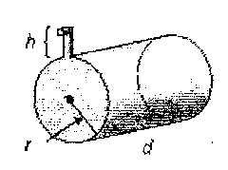

h = 2m,r = 2m,d = 5m Select the correct answer.

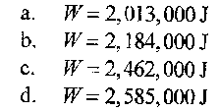

**Solution**

Consider the Graph 14

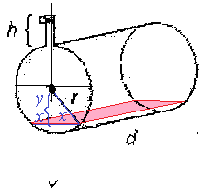

Graph14

Then the work required to pump the upper half of the tank outlet:

,

the work required to pump the lower half of the tank outlet:

the work required to pump the all water out of the outlet

Then

=

**Answer**

**17**. Find the average value of the function on the interval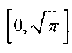 Select the correct answer.

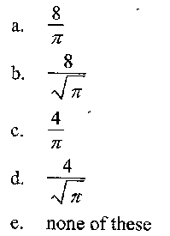

**Solution**

Use the formula find the average value of our function

**Answer d.**

**18**. The temperature of a metal rod, 4 m long, is 3x (in degrees Celsius) at a distance x meters from one end of the rod. What is the average temperature of the rod?

Select the correct answer.

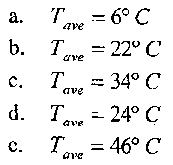

**Solution**

Use the formula find the average temperature of the rod.

**Answer a.** 6.

**19**. Find the area of the region bounded by the parabola , the tangent line to this parabola at (5, 25), and the x-axis.

Select the correct answer.

a. 44 2/3

b. 42 2/3

c. 41 1/3

d. 47 2/3

e. none of these

**Solution**

Use the formula find the equation of the tangent line to this parabola at (5, 25)

Draw the graph (graph15).

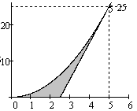

Graph15

Find the area as the difference between the two integrals:

**Answer**

**20**. True or False?

The volume of the frustum of a right circular cone with height h = 9, lower base radius R=10 and top radius r=2 is 327

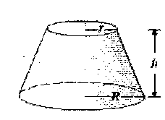

**Solution**

Use the formula the volume of the frustum of a right circular cone

**Answer** True.

**21.** Find the area of the region bounded by the given curves.

Select the correct answer.

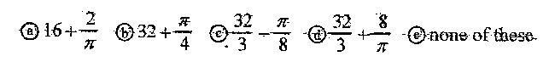

**Solution**

Draw the graph (graph16).

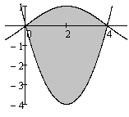

Graph16

The curve is showed a higher than the curve so find the area of the region as the sum between the two integrals. Take the second integral with a minus sign.

**Answer d.**

22. Find the volume of the solid obtained by rotating the region bounded by the given curves about the specified axis.

Select the correct answer.



**Solution**

Find the points of intersection of the lines.

Draw the graph (graph17).

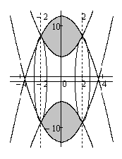

Graph17

The curve is showed a higher than the curve . Volume of the solid then add 1 to each function.

So use the formula to find the volume of the solid obtained as the difference between the two integrals:

**Answer a.** .

**23**. A heavy rope, 90 ft long weighs 0.8 Ib/ft and hangs over the edge of a building 110 ft high. How much work is done in pulling the rope to the top of the building?

Select the correct answer.



**Solution**

when the force is constant, but it this case, it's changing.

In our case, we go with an integral, from 0 to 90

ft-lb

**Answer**  ft-lb

**24**. The average value of a function is

Select the correct answer a) True b) False

**Solution**

Correct formula

**Answer** b) False

**25.**Use the method of cylindrical shells to find the volume generated by rotating the region bounded by the given. Curves about the specified-axis.

y=f(x), y=0, x=a, x=b about x=0

Select the correct answer.

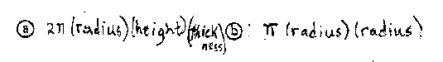

**Answer a.**

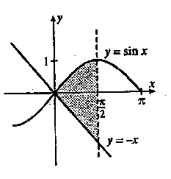**26**. A definite integral for the area shaded at the right is:

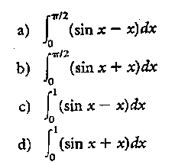

**Solution**

Consider the graph. The curve is showed a higher than the curve so find the area of the region as the sum between the two integrals. Take the second integral with a minus sign.

**Answer b.**

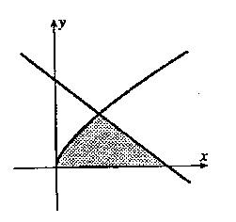**27**. For the area of the shaded region, which integral form, or should be

used?

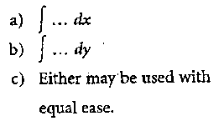

**Solution**

If integrate with respect to x we obtain the two integrals, with respect to y – the one integral.

**Answer b.**

**28.** A definite integral for the area of the region bounded by and is:

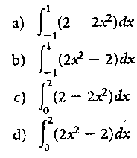

**Solution**

Find the points of intersection of the curves.

Draw the graph (graph18).

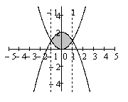

Graph18

The curve is showed a higher than the curve . So find the area as the difference between the two integrals:

**Answer a.**

**29**. The region bounded by the given curves is rotated about the specified axis. Find the volume of the resulting solid by any method.

about the line

Select the correct answer.

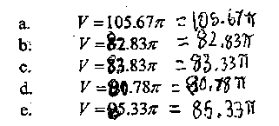

**Solution**

Find the points of intersection of the curves.

Draw the graph (graph19).

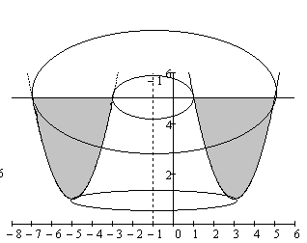

Graph19

Use the formula , where find the volume generated

**Answer e**

**30**. An integral for the solid

obtained by rotating the region at the right about the x-axis is:

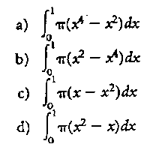

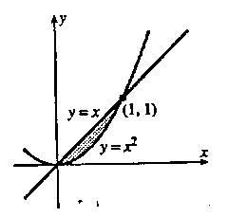

**Solution**

Consider the graph

The line is showed a higher than the curve so use the formula find integral for the solid obtained as the difference between the two integrals

**Answer b.**

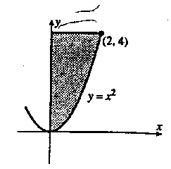**31.** An integral for the solid obtained by rotating the region at the right about the y-axis is:

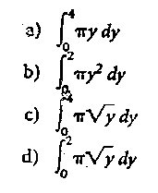

**Solution**

Use the formula to find an integral of the solid obtained

**Answer a.**

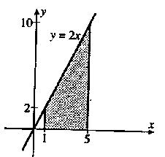**32**. Which definite integral is the volume of the solid obtained by revolving the region at the right about the y-axis using cylindrical shells?

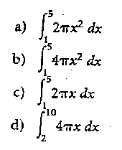

**Solution**

Use the formula , where

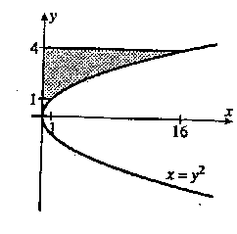**Answer b.**

**33**. Which definite integral is the volume of the solid obtained by revolving the region at the right about the x-axis using cylindrical shells?

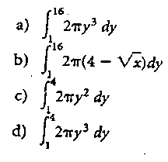

**Solution**

Use the formula , where

**Answer d.**

**34**. How much work is done in lifting a 60-pound child 3 feet in the air?

a) 20 ft-lbs

b) 20g ft-lbs

c) 180 ft-lbs

d) 180g ft-lbs

**Solution**

*foot-pounds*

**Answer c.**

**35** A particle moves along an x-axis from 2 m to 3 m pushed by a force of newtons. The integral that determines the amount of work done is :

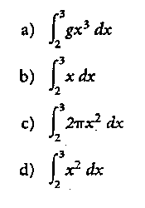

**Solution**

**Answer d.**

**36.** The average value of on the interval [2,4] is:

a) 29 b) 66 c) 58 d) . 36

**Solution**

**Answer a.**

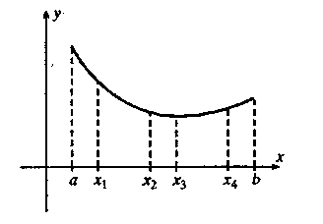**37**. Which point x1, x2, x3 or x4, on the graph is the best choice to serve as the point guaranteed by the Mean Value Theorem for Integrals?

a) x1 b) x2 c) x3 d) x4

**Solution**

Consider the graph20

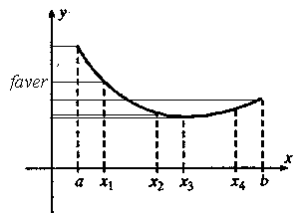

graph20

The graph shows that the average value is closest to the point x1

**Answer a.**

**38**. Find a point c for the Mean Value Theorem for Integrals for on [2,5].



**Solution**

**Answer c.**

39. The region bounded by about the x axis. Find the volume of the resulting solid by washers when is

a) True

b) False

**Solution**

Correct formula

**Answer b.**

**40**. If 132 J of work are needed to stretch a spring from 9 cm to 12 cm and another 888 J are needed to stretch it from 12 cm to 19 cm, what is the natural length of die spring?

Select the correct answer.

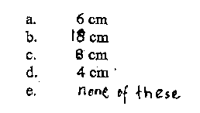

**Solution**

The work is the integral of force F=kx ( force of stretching a spring).

let a is natural length of the spring in cm then

**Answer e**

41. Estimate to the hundredth the area from 1 to 5 under the graph of using four approximating

rectangles and right endpoints.

Select the correct answer.

a. 5.13

b. 6.65

c. 5.83

d. 3.65

e. 4.23

**Solution**

Draw the graph (graph21).

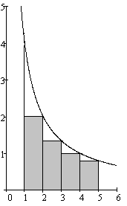

graph21

**Answer a**

42. Evaluate the Riemann sum for , with four sub intervals, taking the sample points to be right endpoints.

Select the correct answer.

a. 0.25

b. 1.5

c. 2.5

d. 0.36 .

e. 0.2

**Solution**

Draw the graph (graph22).

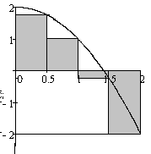

graph22

**Answer a**

43. Use Part 1 of the Fundamental Theorem of Calculus to find the derivative of the function.

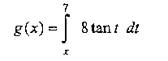

Select the correct answer.

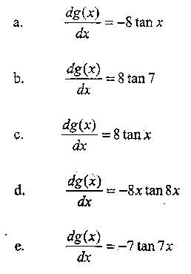

**Solution**

Part 1 of the Fundamental Theorem of Calculus:

Then

**Answer a**

44. Use the Midpoint Rule with n = 5 to approximate the integral.

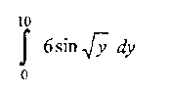

Select the correct answer.

a. 14.344

b. 38.786

c. 26.995

d. 10.344

e. 12.374

**Solution**

The interval [0,10] is divided into 5 equal subintervals

[0,2], [2,4], [4,6], [6,8],[8,10]

The midpoints of the above subintervals are

1, 3, 5, 7, 9

Using the above midpoints to determine the heights of the approximating rectangles we have

**Answer b.**

45. Evaluate the integral. Use calculator write down the steps.

Select the correct answer.

a.-1.000

b. 0.250

c. 1.000

d.-0.500

e. 0.500

**Solution**

**Answer e.**

46. Find the area of the region that lies beneath the given curve.

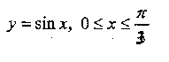

Select the correct answer.

a. 1.500

b.- 1.500

c. 0.500

d- 0.500

e.1.450

**Solution**

**Answer c.**

47. Find the general indefinite integral.

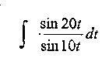

Select the correct answer.

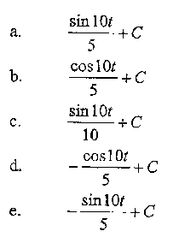

**Solution**

**Answer a**

48. Evaluate the integral. Show your work by hand.

Select the correct answer.

a. 215

b. 92.4

c. 430

d. 150

e. 25

**Solution**

**Answer b**

49. An annual population is increasing at a rate of per year ( where t is measured in years). By how much does the animal population increase between the fourth and tenth years?

Select the correct answer.

a.2,220

b.4,362

c.2,155

d.2,064

e. 2,100

**Solution**

**Answer a**

50. Evaluated the integral. Show your work by hand.

Select the correct answer.

a.-18

b.45

c.54

d.36

e.-12

**Solution**

**Answer d**