**TMA 06 Cut-off date** 11 April 2018

Question 1

The temperature T of a point with coordinates (x, y) lying in a region of the (x, y)-plane is given by the function

T (x, y) = 3x2 — 3xy + 5x — 2y2 + 5y.

1. Determine grad T and evaluate it at the point (—1,1).

**Solution**

Use the formula

where

then

**Answer:**

1. What is the value of the derivative of *T* at the point (—1,1) in the direction of the vector d = i + j?

**Solution**

Use the formula the derivative of function f in the direction of the unit vector u=(a,b)

In this case let’s first check to see if the direction vector d is a unit vector or not and if it isn’t convert it into one. To do this all we need to compute its magnitude.

So, it’s not a unit vector. We can convert any vector into a unit vector that point in the same direction by diving the vector by its magnitude. The unit vector that we need is,

Use values of derivatives:

then the value of the derivative of *T* at the point (—1,1) in the direction of the vector d **=** i **+** j is

**Answer:** The value of the derivative of *T* at the point (—1,1) in the direction of the vector d = i + j is

1. Find the maximum rate of change in temperature at the point (—1,1). What is its direction?

**Solution**

Use theorem:

The maximum rate of change of is given by and will occur in the direction given by

Consider the vector which is the direction of the maximum rate of change in temperature.

The maximum rate of change in temperature at this point is

**Answer:** The maximum rate of change in temperature at the point (—1,1) is . Its direction is occur in the direction of the vector .

1. Show that the temperature is 4 at the point (—1,1). At this point, determine the equation of the tangent to the T = 4 contour of temperature, in the form y = mx + c, where m and c are constants that you should determine.

**Solution**

Find the value

For case when T=4 the equation of contour of temperature has an appearance:

or

Designate

Use the formula of tangent equation to a graph of function F at the point (x0,y0):

where

Substitute

Reduce on 4

Is the equation of the tangent to the T=4 contour of temperature.

**Answer**: The equation of the tangent to the T=4 contour of temperature is .

Question 2

Consider the three-dimensional scalar field

1. Find an expression for the scalar field h in cylindrical coordinates.

**Solution**

Use the next conversion between cartesian and cylindrical coordinates:

Let’s substitute in the condition:

Use the main trigonometrical identity:

then

**Answer**:

1. Determine the gradient grad h in cylindrical coordinates.

**Solution**

Use the formula:

where

then

**Answer:** .

1. Find an expression for the scalar field h in spherical coordinates.

**Solution**

Use the next conversion between cartesian and spherical coordinates:

Let’s substitute in the condition:

Use the main trigonometrical identity twice:

then

**Answer:** .

1. Determine the gradient grad h and the value of |grad h| in spherical coordinates.

**Solution**

Use the formula:

where

then

**Answer:**

Question 3

Evaluate the scalar line integral of the vector field

around the closed circular path C of radius 1 centred at the point (2,0,1) defined by the parametric equations

Is the vector field F conservative?

**Solution**

At first we need the vector field along the curve C

Next we need the derivative of the parameterization

Use the formula

The line integral is then

Use the main trigonometrical identity:

then

Using property of the conservative field we can draw a conclusion:

This line integral of vector field F around closed circular path C is not zero then the vector field is non-conservative.

**Answer:** The scalar line integral is This vector field is non-conservative.

Question 4

Consider the vector field

*.*

1. Calculate curl F and state whether or not F is conservative.

**Solution**

Use the formula

where

then substituting in the formula, we obtain

Using property of the conservative field we can draw a conclusion: , then this field F is conservative.

**Answer:**  and this field F is conservative.

1. Follow Procedure 1 on page 94 of Unit 16 to calculate a potential function U such that F = — grad U.

**Solution**

Using the Procedure 1 we perform the following steps:

1. Take C to be the direct path from (0, 0, 0) to a general point (a, b, c) parametrised by
2. With this choice of parametrisation, calculate the scalar line integral

where

,

Then

Write

**Answer:**

1. Using the expression for U(x,y,z) that you found in part (b), calculate — grad U and confirm that F = — grad U.

**Solution**

Use the formula

where

then

And on a condition

That is .

**Answer:**

Question 5

A vector field F is expressed in cylindrical coordinates as

Determine div F.

**Solution**

Use the formula the divergence of a vector field in cylindrical coordinates:

where

then

**Answer:**

Question 6

A velocity field v is expressed in spherical coordinates as

By calculating ∇ × v, show that v is everywhere conservative.

**Solution**

Use the formula for finding the curl of a vector field in spherical coordinates:

where

then

Thus , then using property of the conservative field, this field v is everywhere conservative.

**Answer:**

Question 7

A region in the (x, y)-plane is bounded by the curves 1 2x2

These curves meet only at .

1. Sketch a diagram showing the region. Indicate a thin vertical strip within the region, and mark the values of y at its endpoints.

**Solution**

Sketch a diagram showing the region.

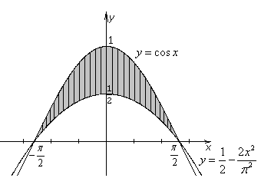

Graph1

**Answer:** Graph1.

1. Use an area integral to find the area of the region.

**Solution**

Find an area integral for the region on the graph1

**Answer:**

Question 8

A bullet-shaped object is formed from a cylinder with a curved top. The cylinder has radius a and is situated with its base on the (x, y)-plane, with the origin located at the centre of the base. The curved top of the bullet is given by the formula z = 4a2 — x2 — y2, and the density is given by the constant D.

Calculate the mass of the object in terms of D and a.

**Solution**

Sketch a graph showing the bullet-shaped object

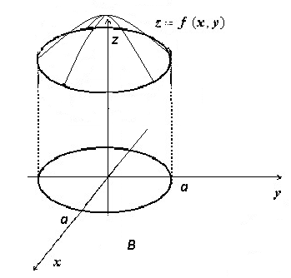

Graph 2

The integral for calculate the mass of the object on the graph 2:

Calculate the integral in the cylindrical coordinates, then

Use the next conversion between cartecian and cylindrical coordinates:

then

Let's substitute in the integral:

**Answer:**

Question 9

A thick spherical shell occupies the region between two spheres of radii *a* and 2*a*, both centred on the origin. The shell is made of a material with density where A is a constant.

1. Show that the density expressed in spherical coordinates is

**Solution**

Use the next conversion between cartesian and spherical coordinates:

Let’s substitute in the condition:

Use the main trigonometrical identity:

then

**Answer:**

1. Hence, or otherwise, find the mass M of the shell by evaluating a suitable volume integral.

(Hint: To evaluate the integral

use the substitution .)

**Solution**

We use spherical coordinates, and the shell is as shown in the figure below.

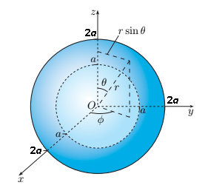

Use the next formula:

The function to be integrated does not depend on the azimuthal angle , so the -integral yields a factor 2*π*. This leaves the area integral

We can write , then

Use the substitution , so the θ-integral yields

Return to the initial integral

**Answer:**