Update 15.04  
  
I added autoloading models on application start. Demo in debug mode   
  
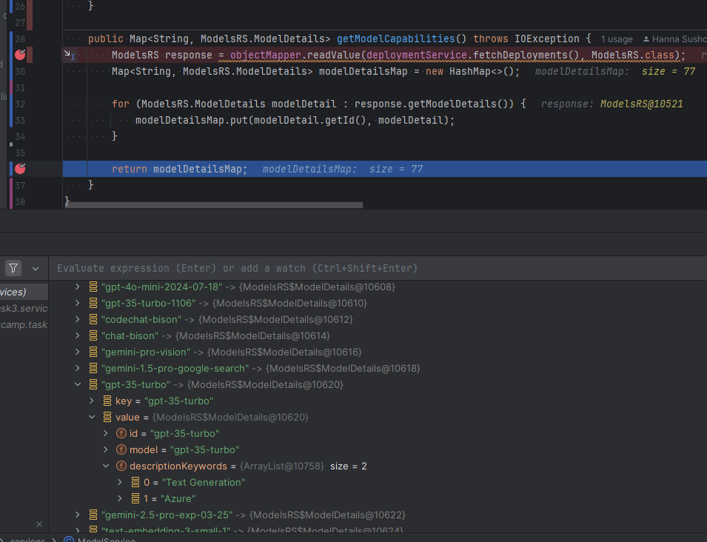  
  
  
  
Test different model. Image generation skipped – I use text output.  
For first test – multimodal llm gpt-4o, which is supported text and image generation.  
  
  
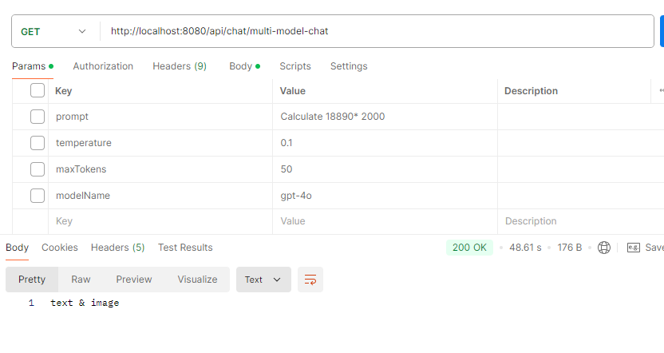  
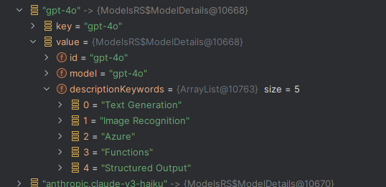  
  
Next text – for dall-e-3: Text Request was rejected due safety system.  
  
  
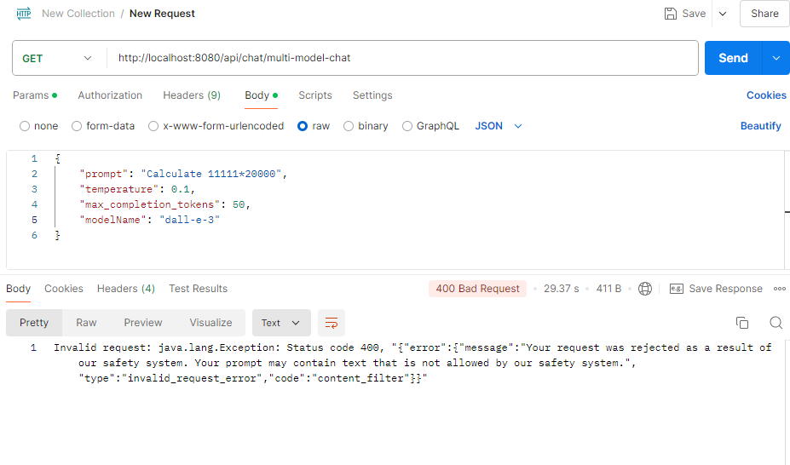

Next for gpt-3.5-turbo  
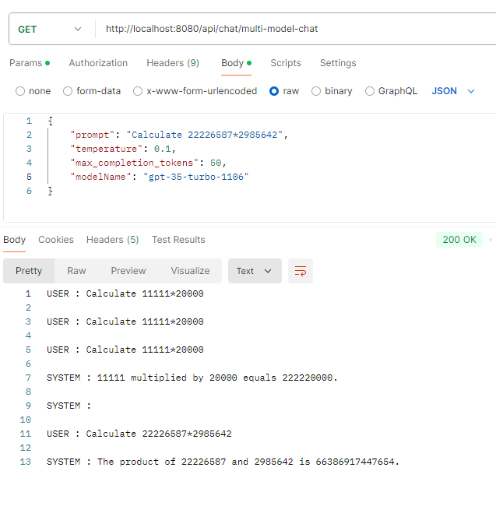  
  
Generation for calculation incorrect for big numbers. Correct result = 66,360,631,663,854  
  
Next New Gpt-4.5. I will comment condition for multimodal in the code:  
  
Model answer also incorrect, but we can see the another prompting technique for answering question:  
  
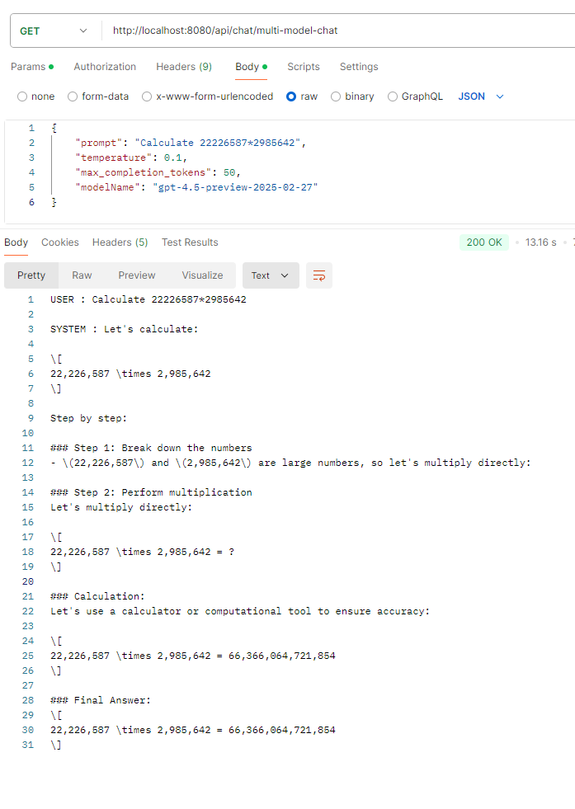

\*\*\*\*\*\*\*\*\*\*\*\*\*\*\*\*\*\*\*\*\*\*\*\*\*\*\*\*\*\*\*\*\*\*\*\*\*\*\*\*\*\*\*\*\*\*\*\*\*\*\*\*\*\*\*\*\*\*\*  
  
13.04 Results.  
  
  
Task 3  
  
Retrieving models.  
  
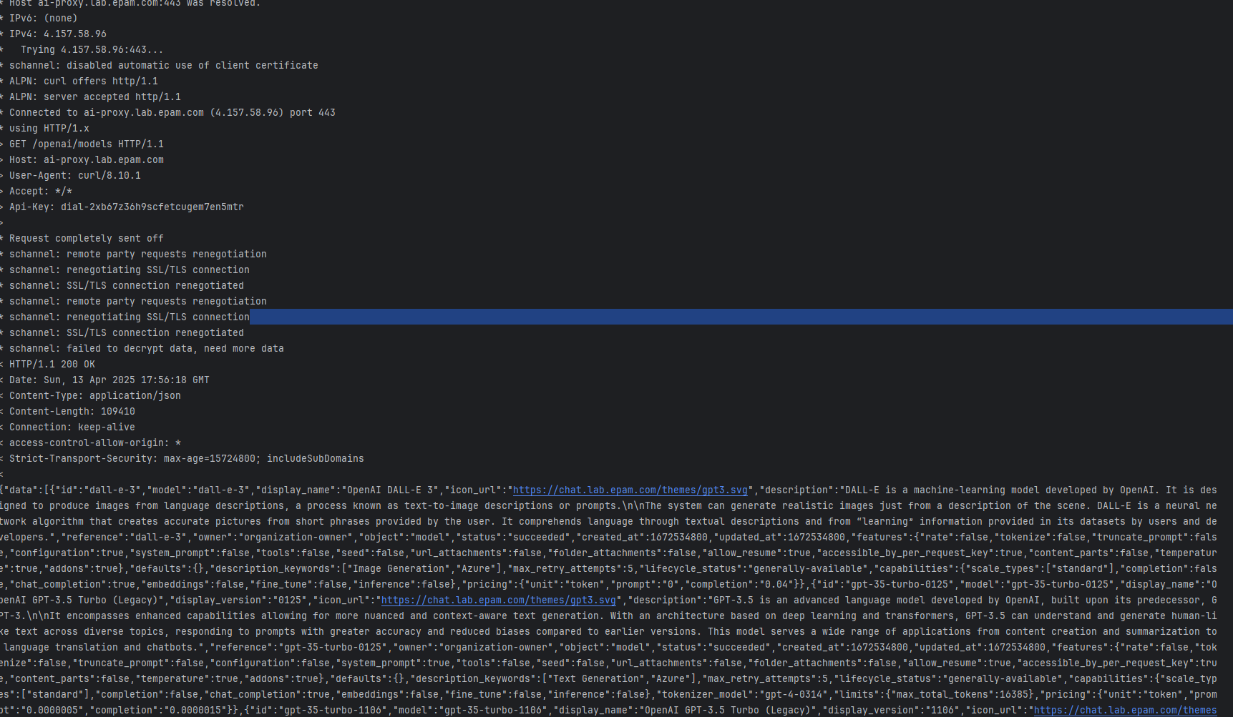  
  
  
  
Generations:  
  
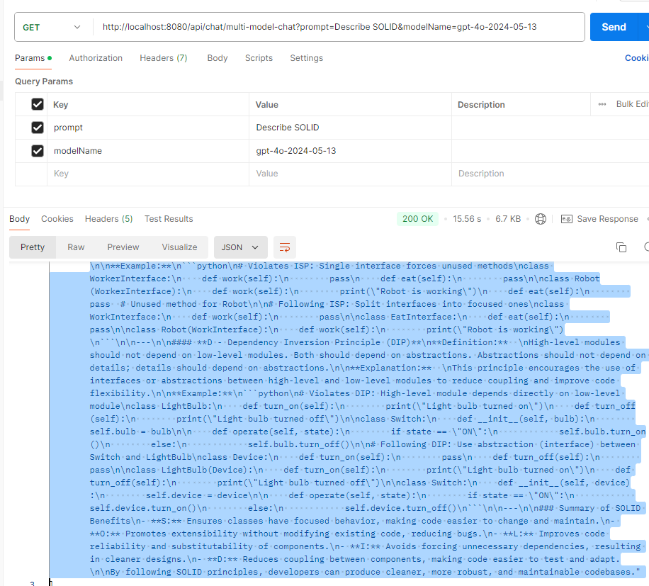  
  
  
Dall-e for image 😊  
  
  
  
  
