1. Goal.

Create custom popup listbox with checkboxes.

1. Result.

By clicking any ‘Press me’ button, you will call a popup checkbox which will have marks for preselected values. You can change them and after clicking Submit button changes will be saved into QV variable.

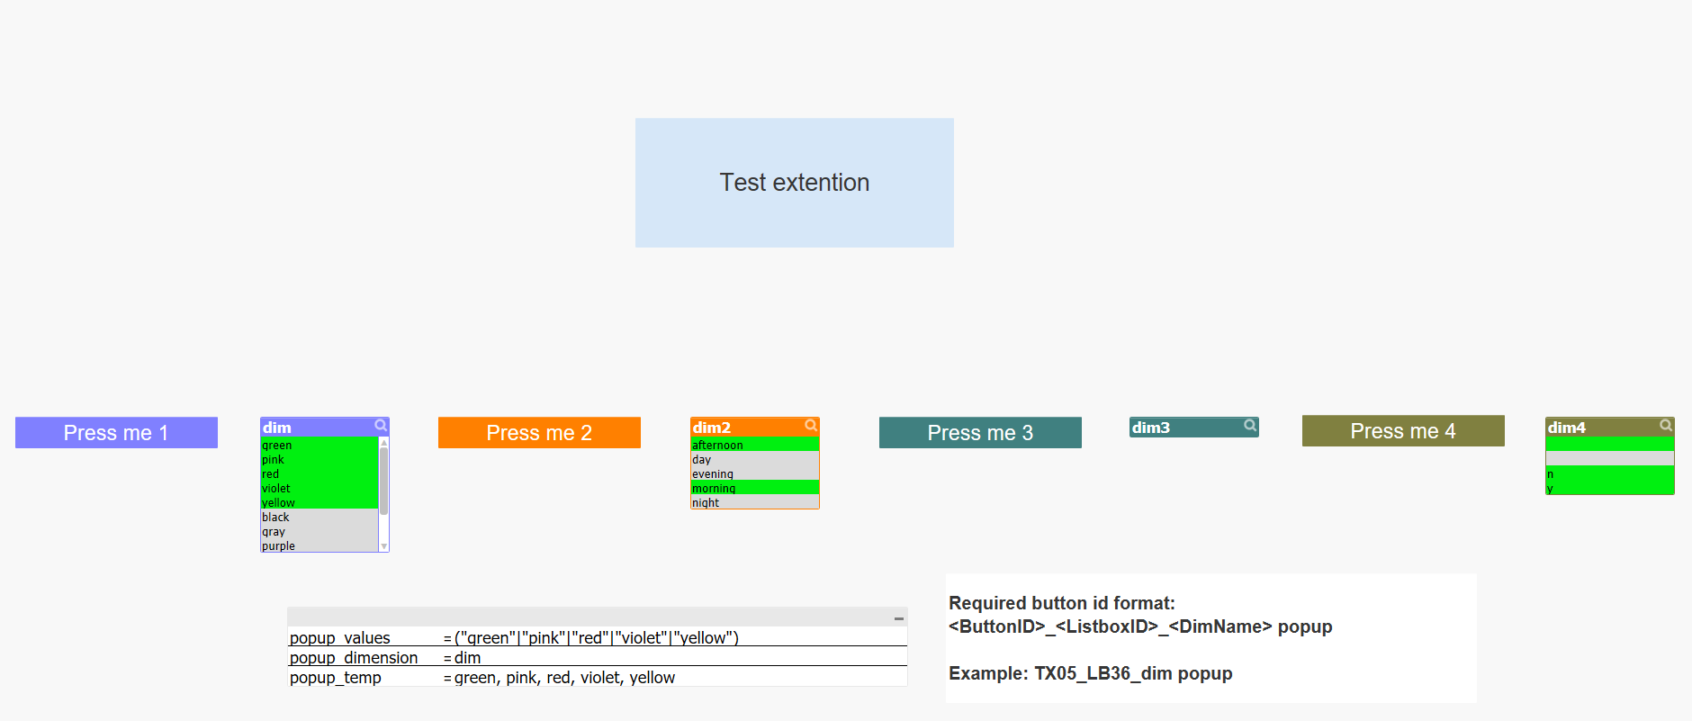

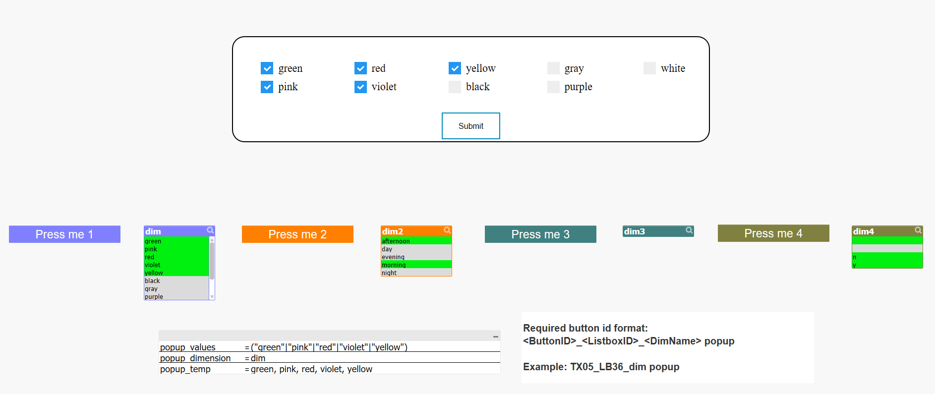

To apply selections from QV variable you can create a document trigger:  
