1. **BUG REPORT: Low**

**TITLE**:

Unable to delete the profile picture

**DESCRIPTION:**

Profile picture is not deleted after asking to delete it

**STTEPS:**

1. Click on the hamburger

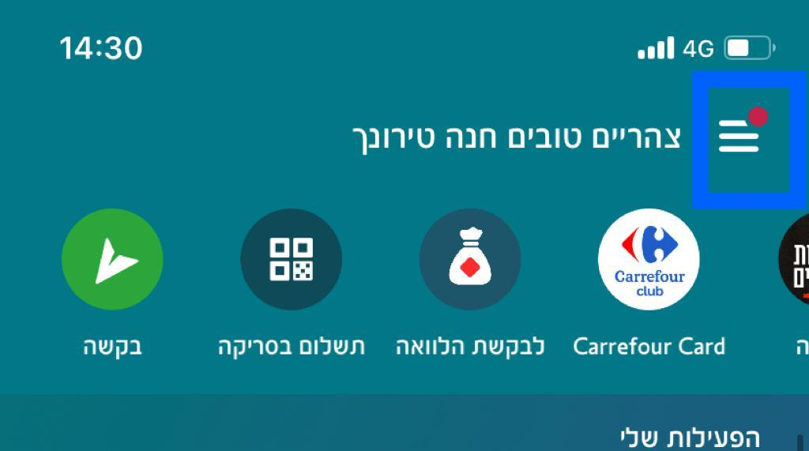

1. Click on the profile picture

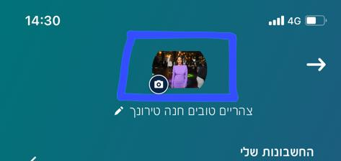

1. Click on 'מחק'

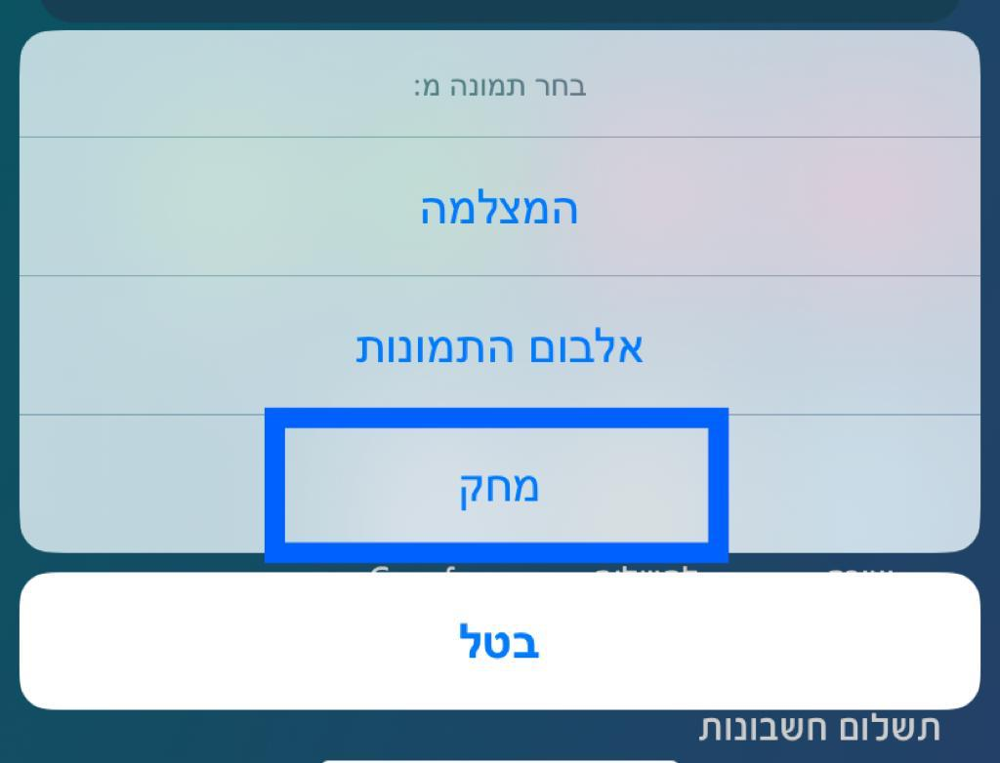

**EXPECTED RESULTS**

The profile picture will be deleted

**ACTUAL RESULTS**

Profile picture is not deleted and current profile sill appear



1. **BUG REPORT: Low**

**TITLE**: The profile picture does not appear for other users

**DESCRIPTION**: The user set a profile picture, the user sees the set picture but it's does not appear for the user's contact list.

**STTEPS:**

1. Click on the hamburger
2. Click on the camera icon
3. Click on 'אלבום התמונות'
4. Choose a photo
5. Click on "keep current selection"
6. Click on 'use photo'
7. Open the app on a different user's phone and verify the profile picture appears

**EXPECTED RESULTS:**

Profile picture will appear

**ACTUAL RESULTS:**

Profile picture does not appear

A recheck was also carried out the next day, the profile picture still does not appear.

1. **BUG REPORT: Low**

**TITLE**: Request does not appear on the transactions page

**DESCRIPTION:** When user sent a request for money, he cannot see the request on the transactions page, its able to see only after the other user approve/decline the request**.**

**STTEPS:**

1. Click on 'בקשה'
2. Type in 'יונתן'
3. Choose the contact 'יונתן'
4. Type in 1 NIS
5. Type in the reason text box: 'בדיקה'
6. Click on 'המשך'
7. Go to the 'הפעילות שלי' page to verify the request has been sent

**EXPECTED RESULTS:**

The request from 'יונתן' in the amount of 1 NIS appears at the top of the transactions list in a pending status**.**

**ACTUAL RESULTS:**

The request doesn't appear

The user does not know if the request was sent

The user may continue to send requests because he does not see the request