Test Description: “bit” company's application in a production environment.

Smoke test: download, sign-up, add a bank account, add a credit card, transfer

Sanity testing- functional test: export the transections as
a file, questions and answers, groups
Interface testing: accessibility statement, payment for "buyme"
Usability test: Request for receiving money
Compatibility test: download, sign-up, add a bank account, add a credit
card, transfer
Error handing: transfer (input password, input amount)
transfer to a mobile number, my bank account, my credit cards
Security test: password input
GUI: questions and answers

Test Purpose: Ensure the functionality, usability, and compatibility of the “bit” Company's application in a production environment.
Test Run Instructions:
Test Run Information:  Tester Name: Hanna Tiruneh  Date of Test: 21/11/2023 | Prerequisites for this test: Mobile
Software Versions: 5.12.1
Application:
Browser:
Operating System: IOS, Android
 | Required Configuration: 3 mobiles, 3 credit cards and 3 bank accounts
NOTES and RESULTS:

TEST SCRIPT STEPS/RESULTS
STEP | TEST STEP/INPUT | EXPECTED RESULTS | ACTUAL RESULTS | Requirements Validated | PASS/FAIL
Smoke test- download, sign up, add a bank account, add a credit card, transfer
Download
 | Go to the App store | App store opens | App store opened |  | pass
 | Click on the search button | Search page opens | Search page opened |  | pass
 | Type 'bit' | Bit app shows | Bit app shows |  | pass
 | Click on install | Bit app will be installed | The app has been installed |  | pass
Sign up
 | Open the bit app | Welcome page will appear | Welcome page appeared |  | pass
 | Click on ‘המשך’ | Terms of use and privacy policy page will open | Terms of use and privacy policy page opened |  | pass
 | Click on ‘לצפייה בתנאי השימוש המלאים' | Terms of use page opens | Terms of use page opens |  | pass
 | Click on X to exit terms of use page | Terms of use and privacy policy page appears again | Terms of use and privacy policy page appeared again |  | pass
 | Click on ‘הסכמה לאימות ואישור תנאי השימוש' | A text box opens for entering a phone number | A text box opened for entering a phone number |  | pass
 | Enter the phone number: 050-2551514 | The phone number will appear | The phone number will appeared |  | pass
 | Click on ‘המשך’ | OTP will be sent to the mobile number | OTP has been sent to the mobile number |  | pass
 | Type the received OTP | ‘?מה השם המלא שלך’ page opens | ‘?מה השם המלא שלך’ page opened |  | pass
 | Type ‘חנה’ in the first name and ‘טירונך’ in the last name | The first name and last name will appear | The first name and last name appeared |  | pass
 | Click on ‘המשך’ | A page for filling in an ID number will open | A page for filling in an ID number opened |  | pass
 | Enter the ID number: 305711111 | The entered ID number will appear | The entered ID number appeared |  | pass
 | Click on ‘המשך’ | Create password page opens | Create password page opened |  | pass
 | Enter password: 2023 | The entered password appears in asterisks (the digits are invisible) | The entered password appeared in asterisks (the digits are invisible) |  | pass
 | Enter the password again | The entered password appears in asterisks (the digits are invisible) | The entered password appeared in asterisks (the digits are invisible) |  | pass
 | Click on ‘המשך’ | A page for filling personal details will be open | A page for filling personal details has been open |  | pass
 | Click on ‘להשלמת הפרטים’ | A page to filling birth day will appear | A page to filling birth day appeared |  | pass
 | Enter the date: 21/11/1991 | The entered date will appear | The entered date appeared |  | pass
 | Click on ‘המשך’ | A page to enter an address will be open | A page to enter an address has been open |  | pass
 | Type ‘ישראל 2, נתניה’ | The entered address will appear | The entered address appeared |  | pass
 | Click on ‘המשך’ | A gender selection page will open | A gender selection page opened |  | pass
 | Choose ‘נקבה’ | A purpose of use page will open | A purpose of use page opened |  | pass
 | Choose ‘פרטית’ | A page for entering an email will open | A page for entering an email opened |  | pass
 | Enter the e-mail: hana@gmail.com and then click on ‘אישור וסיום’ | A page for entering the set password will open | A page for entering the set password opened |  | pass
 | Enter the password: 2023 | Confirmation to get notifications page will open | Confirmation to get notifications page opened |  | pass
 | Click on ‘לא עכשיו’ | A page for confirming access to the contact list will open | A page for confirming access to the contact list opened |  | pass
 | Click on ‘אישור’ | Registration process is done and bit’s main page will open | Registration process is done and bit’s main page opened |  | pass
Add a bank account
 | Click on the hamburger | Main menu opens | Main menu opened |  | pass
 | Click '+' on 'הוסף חשבון בנק' | A page for entering a password will open | A page for entering a password opened |  | pass
 | Enter the password: 2023 | A list of banks opens | A list of banks opened |  | pass
 | Type 'בנק לאומי' in to the search box | Only 'בנק לאומי' will appear in the results | Only 'בנק לאומי' will appeared in the results |  | pass
 | Choose 'בנק לאומי' | - Two text boxes appears to enter the branch and the bank account  - A note will appear: '*ייתכן שתיגבה עמלה בכל העברה לחשבון בכפוף להסכם מול הבנק שלך,' | - Two text boxes appeared to enter the branch and the bank account  - The note appeared |  | pass
 | Type '943' into the branch text box and '12345678' into the bank account text box | - The branch number and the bank account number will appear in the text boxes  - Pop-up message: "לפני שממשיכים, חשוב לוודא שהפרטים נכונים והחשבון רשום על שמך" | The branch number and the bank account number appeared in the text boxes |  | pass
 | Click on 'אישור הוספת חשבון' | The bank account will be added | The bank account has been added |  | pass
Add a credit card
 | Click on the hamburger | Main menu opens | Main menu opened |  | pass
 | Click on 'הכרטיסים שלי' | 'My credit cards' page opens | My credit cards page opened |  | pass
 | Click on 'להוספת כרטיס+' | A page for entering a password will open | A page for entering a password opened |  | pass
 | Enter the password 2023 | A page will open to fill in credit card details | A page opened to fill in credit card details |  | pass
 | Enter the credit card details:  Number: 1234-5678-91011-1213  Expiry: 12/24  CVV: 123 | The credit card details will appear:  - Last 4 digits  - Expiry date  - CVV | The credit card details appeared |  | pass
 | Click on 'שמירת פרטים' | The credit card will be added to 'הכרטיסים שלי' and will be set as the main credit card | The credit card has been added to 'הכרטיסים שלי" and set been set as main credit card |  | pass
Transfer
 | Click on 'העברה' | Transfer page opens, contact list and favorites transfers shows | Transfer page opened, contact list and favorites transfers shows |  | pass
 | Type 'כריסטינה' in the search box | The contact details of 'כריסטינה' appears | The contact details of 'כריסטינה' appeared |  | pass
 | Choose the contact 'כריסטינה' | A text box appears to enter a transfer amount | A text box appears to enter a transfer amount |  | pass
 | Type in 1 NIS | The amount of 1 NIS will appear in the text box | The amount 1 NIS appeared in the text box |  | pass
 | Click on 'המשך' | A text box appears to enter the reason for the transfer | A text box appeared to enter the reason for the transfer |  | pass
 | Type in the reason text box: 'בדיקה' | 'בדיקה' will typed in to the text box | 'בדיקה' typed in to the text box |  | pass
 | Click on 'העברה לכריסטינה' | A text box appears to enter the password | A text box appeared to enter the password |  | pass
 | Enter the password 2023 | Password enters and a notification will receive that the transfer is pending to the beneficiary's approval | Password entered and a notification received that the transfer is pending to the beneficiary |  | pass
 | Click on x to verify that the transfer appears in the activities page | The activities page appears and the transfer to 'כריסטינה' in the amount of 1 NIS appears pending as of today | The activities page appeared and the transfer to 'כריסטינה' in the amount of 1 NIS appeared pending as of today |  | pass
 | Open the beneficiary's bit application | Beneficiary will see the pending transfer in the activities page | Pending transfer appeared in the activities page |  | pass
 | Click on 'קבל את הכסף" | A notification will receive that the transfer is done | A notification received that the transfer is done |  | pass
 | Verify the amount of 1 NIS is received in to beneficiary's bank account | 1 NIS receives in to the beneficiary's bank account | 1 NIS received in to the beneficiary's bank account |  | pass
 | Go back to the transfer's bit application | Activities page appears | Activities page appeared |  | pass
 | Verify the transfer status has been changed to 'העברה בוצעה היום' | The transfer status will appear as a 'העברה 'בוצעה היום | Transfer status: 'העברה בוצעה' |  | pass
 | Verify the credit card was charged for 1 NIS | Credit card will charged for 1 NIS by bit | Credit card charged for 1 NIS by bit |  | pass
Compatibility test – smoke test to Android
 | Repeat steps 1-59 on Android device | As steps 1-59 | As steps 1-59 |  | pass
Sanity testing – Request feature
Usability test – Request for receiving money
 | Click on 'בקשה' | Search box appears and a list of contacts will open | Search box appeared and a list of contacts opened |  | pass
 | Type in 'יונתן' | 'יונתן' name and his phone number will be selected | 'יונתן' name and his phone number were selected |  | pass
 | Choose the contact 'יונתן' | A text box appears to enter a request amount | A text box appeared to enter a request amount |  | pass
 | Type in 1 NIS | The amount of 1 NIS will appear in the text box | The amount 1 NIS appeared in the text box |  | pass
 | Click on 'המשך' | A text box appears to enter the reason for the transfer | A text box appeared to enter the reason for the request |  | pass
 | Type in the reason text box: 'בדיקה' | 'בדיקה' will typed in to the text box | 'בדיקה' typed in to the text box |  | pass
 | Click on 'המשך' | Notification will received that the request in the amount of 1 NIS is pending | Notification received that the request in the amount of 1 NIS is pending |  | pass
 | Go to the 'הפעילות שלי' page to verify the request has been sent | The request from 'יונתן' in the amount of 1 NIS appears at the top of the transactions list in a pending status | The request doesn't appear |  | fail
 | Open the bit application on 'יונתן' phone | The request will appear, included the request amount (1 NIS) and the name (חנה) | The request appeared, included the request amount (1 NIS) and the name (חנה) |  | pass
 | Click on 'העבר את הכסף' | A text box appears to enter the password | A text box appeared to enter the password |  | pass
 | Enter the password '4321' | Password enters and a notification will receive that the transfer is pending to the beneficiary | Password entered and a notification received that the transfer is pending to the beneficiary |  | pass
 | Verify that the transfer appears in the activities page | The activities page appears and the transfer to 'חנה' in the amount of 1 NIS appears in pending status as of today | The activities page appeared and the transfer to 'יונתן' in the amount of 1 NIS appeared pending as of today |  | pass
 | Go back to the beneficiary's bit application | Beneficiary will see the pending transfer in the activities page | Pending transfer appeared in the activities page |  | pass
 | Click on 'קבל את הכסף' | A notification will receive that the transfer is done | A notification received that the transfer is done |  | pass
 | Verify the amount of 1 NIS is received in to beneficiary's bank account | 1 NIS receives in to the beneficiary's bank account | 1 NIS received in to the beneficiary's bank account |  | pass
 | Go back to the transfer's bit application | Activities page appears | Activities page appeared |  | pass
 | Verify the transfer status has been changed to 'העברה בוצעה היום' | The transfer status will appear as a 'העברה בוצעה היום | Transfer status: 'העברה בוצעה' |  | pass
 | Verify the credit card has been charged for 1 NIS | Credit card will charged for 1 NIS by bit | Credit card charged for 1 NIS by bit |  | pass
Functionality test (boundary testing) - amount input
 | Click on ‘בקשה’ | Search box appears and a list of contacts will open | Search box appeared and a list of contacts has been open |  | pass
 | Type in 'יונתן' | 'יונתן' name and his phone number will be selected | 'יונתן' name and his phone number has been selected |  | pass
 | Choose the contact 'יונתן' | A text box appears to enter a request amount | A text box appeared to enter a request amount |  | pass
 | Type in 0.5 NIS | 0 (zero) cannot be entered before another digit | 0 (zero) cannot be entered before another digit |  | pass
 | Type in 1 NIS | 1 NIS will appear into the amount box | 1 NIS appeared into the amount box |  | pass
 | Type in 100 NIS | 100 NIS will appear into the amount box | 100 NIS appeared into the amount box |  | pass
 | Type in 1,000 NIS | 1,000 NIS will appear into the amount box | 1,000 NIS appeared into the amount box |  | pass
 | Type in 2,000 NIS | 2,000 NIS will appear into the amount box | 2,000 NIS appeared into the amount box |  | pass
 | Type in 3,600 NIS | 3,600 NIS will appear into the amount box | 3,600 NIS appeared into the amount box |  | pass
 | Type in 3,600.01 NIS | 3,600.01 NIS can't be typed and pop-up message:  'הבקשה בסכום זה תחרוג מהסכום המקסימאלי השנתי. עד סוף השנה תוכל לבקש עד 3,600 ₪' | 3,600.01 NIS can't be typed and pop-up message:  'הבקשה בסכום זה תחרוג מהסכום המקסימאלי השנתי. עד סוף השנה תוכל לבקש עד 3,600 ₪' |  | pass
 | Type in 3,601 NIS | 3,601 NIS can't be typed and pop-up message:  'הבקשה בסכום זה תחרוג מהסכום המקסימאלי השנתי. עד סוף השנה תוכל לבקש עד 3,600 ₪' | 3,601 NIS can't be typed and pop-up message:  'הבקשה בסכום זה תחרוג מהסכום המקסימאלי השנתי. עד סוף השנה תוכל לבקש עד 3,600 ₪' |  | pass
Sanity test –Transfer feature
Security test – password input
 | Click on 'העברה' | Transfer page will open | Transfer page opened |  | pass
 | Choose the contact 'כריסטינה' | A text box appears to enter a transfer amount | A text box appeared to enter a transfer amount |  | pass
 | Type 1 NIS | The amount of 1 NIS will appear in the text box | The amount of 1 NIS appeared in the text box |  | pass
 | Click on 'המשך' | A text box appears to enter the reason for the transfer | A text box appeared to enter the reason for the transfer |  | pass
 | Click on 'העברה לכריסטינה' | A text box appears to enter the password | A text box appeared to enter the password |  | pass
 | Type an incorrect password '8520' | A pop-up message will appear: 'הסיסמא שגויה, ניתן לנסות שנית בעוד 1 דקה' | A pop-up message appeared: 'הסיסמא שגויה, ניתן לנסות שנית בעוד 1 דקה' |  | pass
 | Verify that the password input appears in asterisks and the numbers are invisible | Password input appears in asterisks and the numbers are invisible | Password input appears in asterisks and the numbers are invisible |  | pass
 | Click on 'שכחתי סיסמא' | A pop-up message will appear that says the user have to register again.  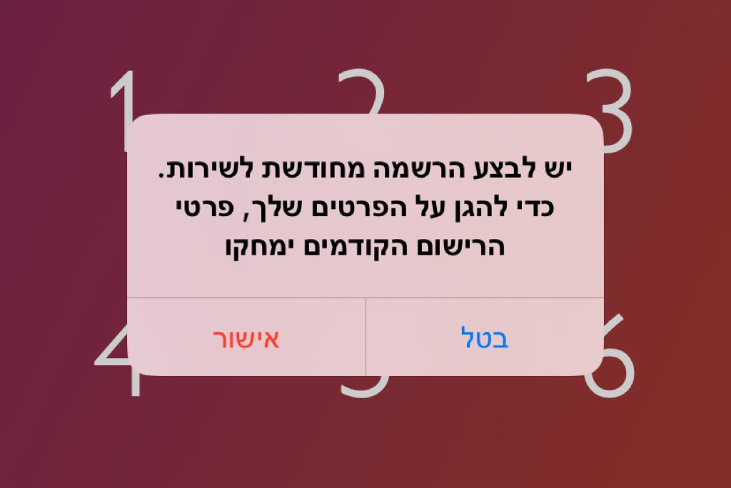 | The pop-up message appeared |  | pass
 | Click on 'בטל' | The pop-up message will disappear | Pop-up message disappeared |  | pass
 | Click on the face ID icon and scanning someone else's face | A pop-up message will appear:  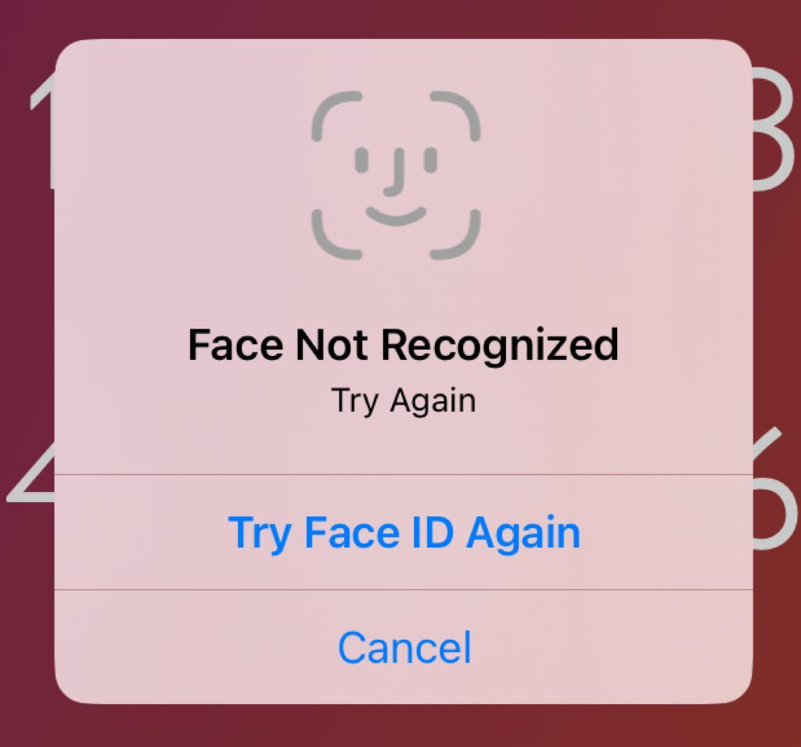 | Pop-up message appeared |  | pass
 | Click on the face ID icon | Face ID enters and a notification will receive that the transfer is pending to the beneficiary's approval | Face ID enters and a notification received that the transfer is pending to the beneficiary's approval |  | pass
Error handling- transfer to my phone number (the user's phone number)
 | Click on 'העברה' | Transfer page opens | Transfer page opened |  | pass
 | Click on 'העברה למספר נייד' | Numeric keypad opens for entering a phone number | Numeric keypad opened for entering a phone number |  | pass
 | Enter the number 054-7141245 (user's phone number) | The typed phone number will appear | The phone number appeared |  | pass
 | Click on 'העברה ל-054-7141245' | A pop-up message: 'איזה קטע – זה בול המספר שלך' | A pop-up message appeared |  | pass
Error handling – transfer to invalid phone number
 | Click on 'העברה' | Transfer page opens | Transfer page opened |  | pass
 | Click on 'העברה למספר נייד' | Numeric keypad opens for entering a phone number | Numeric keypad opened for entering a phone number |  | pass
 | Enter the number '051-1111111' | A pop-up message: 'היי, אין מספר טלפון כזה' | A pop-up message appeared: 'היי, אין מספר טלפון כזה' |  | pass
 | Enter the number '050-0000000' | A pop-up message: 'היי, אין מספר טלפון כזה' | A pop-up message appeared: 'היי, אין מספר טלפון כזה' |  | pass
 | Delete the number from the previous step | The number will be deleted and the pop-up message will change to: 'מומלץ לוודא שהמספר נכון לפני השליחה' | The number has been deleted and the pop-up message changed to: 'מומלץ לוודא שהמספר נכון לפני השליחה' |  | pass
Error handling – transfer more then 3,600
 | Click on 'העברה' | Transfer page opens, contact list and favorites transfers shows | Transfer page opened, contact list and favorites transfers shows |  | pass
 | Type 'כריסטינה' in the search box | The contact details of 'כריסטינה' appears | The contact details of 'כריסטינה' appeared |  | pass
 | Choose the contact 'כריסטינה' | A text box appears to enter a transfer amount | A text box appears to enter a transfer amount |  | pass
 | Type in 3,600.01 NIS | 3,600.01 NIS can't be typed and pop-up message:  'נשארו לך רק עוד 3,600 ₪ כדי להגיע למגבלה המקסימלית' | 3,600.01 NIS can't be typed and pop-up message appeared |  | pass
Sanity test - My bank accounts feature
Functionality - Add another bank account
 | Click on the hamburger | Main menu opens | Main menu opened |  | pass
 | Click '+' on 'הוסף חשבון בנק' | A page for entering a password will open | A page for entering a password opened |  | pass
 | Enter the password: 2023 | A list of banks opens | A list of banks opened |  | pass
 | Type 'בנק אוצר החייל בע"מ' in to the search box | Only 'בנק אוצר החייל בע"מ' will appear in the results | Only 'בנק אוצר החייל בע"מ' appeared in the results
 | Type '346' into the branch text box and '12345678' into the bank account text box | - The branch number and the bank account number will appear in the text boxes  - Pop-up message: "לפני שממשיכים, חשוב לוודא שהפרטים נכונים והחשבון רשום על שמך" | - The branch number and the bank account number appeared in the text boxes  - Pop-up message: "לפני שממשיכים, חשוב לוודא שהפרטים נכונים והחשבון רשום על שמך" |  | pass
 | Click on 'אישור הוספת חשבון' | The bank account will be added | The bank account has been added |  | pass
Functionality – Set a bank account as main account
 | Click on the hamburger | Main menu opens | Main menu opened |  | pass
 | Choose the bank account that ends with 602 by clicking the 3 dots | A menu with 3 options will appear  - הגדרת חשבון כראשי  - עריכת כינוי לחשבון  - הסרת החשבון מ-bit | The menu appeared |  | pass
 | Click on 'הגדרת חשבון כראשי' | A page for entering a password will open | A page for entering password opened |  | pass
 | Enter the password: 2023 | The bank account that ends with 602 will be set as the main bank account | The bank account that ends with 602 has been set as the main bank account |  | pass
Functionality (negative) - delete a bank account
 | Click on the hamburger | Menu opens | Menu opened |  | pass
 | Click on 'החשבונות שלי' | All the user's bank accounts will appear | All the user's bank accounts appeared |  | pass
 | Choose 'בנק לאומי' by clicking the 3 dots | Menu opens | Menu opened |  | pass
 | Choose ' הסרת החשבון מ-bit' | A text box appears to enter the password | A text box appeared to enter the password |  | pass
 | Enter the password 2023 | Password enters and the bank account will be deleted | Password entered and the bank account has been deleted |  | pass
Error handling – Add an existing bank account
 | Click on the hamburger | Main menu opens | Main menu opened |  | pass
 | Click '+' on 'הוסף חשבון בנק' | A page for entering a password will open | A page for entering a password opened |  | pass
 | Enter the password: 2023 | A list of banks opens | A list of banks opened |  | pass
 | Type 'בנק לאומי' in to the search box | Only 'בנק לאומי' will appear in the results | Only 'בנק לאומי' appeared in the results |  | pass
 | Choose 'בנק לאומי' | - Two text boxes appears to enter the branch and the bank account  - A note will appear: '*ייתכן שתיגבה עמלה בכל העברה לחשבון בכפוף להסכם מול הבנק שלך,' | - Text box appeared  - Note appeared |  | pass
 | Type '943' into the branch text box and '12345678' into the bank account text box | - The branch number and the bank account number will appear in the text boxes  - Pop-up message: "לפני שממשיכים, חשוב לוודא שהפרטים נכונים והחשבון רשום על שמך" | - The branch number and the bank account number appeared in the text boxes  - Pop-up message: "לפני שממשיכים, חשוב לוודא שהפרטים נכונים והחשבון רשום על שמך" |  | pass
 | Click on 'אישור הוספת חשבון' | A pop-up message will appear: מצטערים, לא ניתן להתקדם  לא ניתן להוסיף - חשבון כבר קיים4 | Pop-up message appeared |  | pass
Error handling – Add invalid bank account details
 | Click on the hamburger | Main menu opens | Main menu opened |  | pass
 | Click '+' on 'הוסף חשבון בנק' | A page for entering a password will open | A page for entering a password opened |  | pass
 | Enter the password: 2023 | A list of banks opens | A list of banks opened |  | pass
 | Choose 'בנק הפועלים' | Two text boxes appears to enter the branch and the bank account | Two text boxes appeared to enter the branch and the bank account |  | pass
 | Type '111' into the branch text box | A pop-up message will appear: מספר סניף שגוי | A pop-up appeared: מספר סניף שגוי |  | pass
 | Type '633' into the branch text box | The branch number will appear in the branch text box and | The branch number appeared in the branch text box |  | pass
 | Type ‘1111111' into the bank account text box and click on 'אישור הוספת חשבון’ | A pop-up message will appear: 'חשבון לא תקין' | Pop-up message appeared |  | pass
 | Type '0000000' into the bank account text box | A pop-up message will appear: חשבון לא תקין | Pop-up message appeared |  | pass
 | Type '4523685' into the bank account text box | A pop-up message will appear: חשבון לא קיים | Pop-up message appeared |  | pass
Error handling - Adding another owner's account
 | Click on the hamburger | Main menu opens | Main menu opened |  | pass
 | Click '+' on 'הוסף חשבון בנק' | A page for entering a password will open | A page for entering a password has been opened |  | pass
 | Enter the password: 2023 | A list of banks opens | A list of banks opened |  | pass
 | Type 'בנק דיסקונט' in the search box | Only 'בנק דיסקונט' will appear in the results | Only 'בנק דיסקונט' appeared in the results |  | pass
 | Choose 'בנק דיסקונט' | - Two text boxes appears to enter the branch and the bank account  - A note will appear: '*ייתכן שתיגבה עמלה בכל העברה לחשבון בכפוף להסכם מול הבנק שלך,' | - Two text boxes appeared to enter the branch and the bank account  - A note appeared: '*ייתכן שתיגבה עמלה בכל העברה לחשבון בכפוף להסכם מול הבנק שלך,' |  | pass
 | Type '027' into the branch text box and '21298569' into the bank account text box | The branch number and the bank account number will appear in the text boxes  Pop-up message: "לפני שממשיכים, חשוב לוודא שהפרטים נכונים והחשבון רשום על שמך" | - The branch number and the bank account number appeared in the text boxes  - Pop-up message: "לפני שממשיכים, חשוב לוודא שהפרטים נכונים והחשבון רשום על שמך" |  | pass
 | Click on 'אישור הוספת חשבון' | The bank account will be added, but have to be verify by adding a credit card of the same owner | The bank account has been added, but have to be verify by adding a credit card of the same owner |  | passs
 | Click on the hamburger | Main page opens | Main page opened |  | pass
 | Click on ‘הכרטיסים שלי’ | 'My credit cards' page opens | 'My credit cards' page opened |  | pass
 | Click on 'להוספת כרטיס+' | A page for entering a password will open | A page for entering a password opened |  | pass
 | Enter the password 2023 | A page will open to fill in credit card details | A page opened to fill in credit card details |  | pass
 | Enter the credit card details:  Number: 5521-5678-91011-1617  Expiry: 12/24  CVV: 789 | A pop-up message will appear:  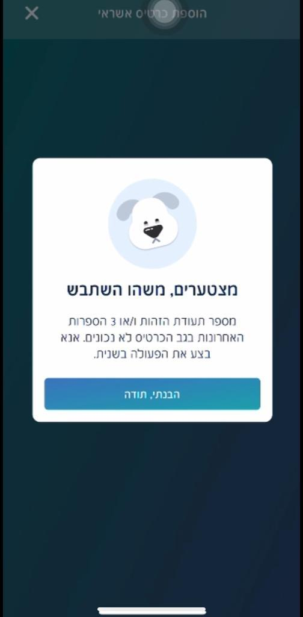 | The pop-up message appeared |  | pass
Sanity test - My credit cards feature
Functionality test - Add another credit card
 | Click on the hamburger | Main menu opens | Main menu opened |  | pass
 | Click on 'הכרטיסים שלי' | My credit cards page opens | My credit cards page opened |  | pass
 | Click on 'להוספת כרטיס+' | A page for entering a password will open | A page for entering a password opened |  | pass
 | Enter the password 2023 | A page will open to fill in credit card details | A page opened to fill in credit card details |  | pass
 | Enter the credit card details:  Number: 1234-5678-91011-1415  Expiry: 12/25  CVV: 456 | The credit card details will appear:  - Last 4 digits  - Expiry date  - CVV | The credit card details appeared |  | pass
 | Click on 'שמירת פרטים' | The credit card will be added to 'הכרטיסים שלי' | The credit card has been added to 'הכרטיסים שלי' |  | pass
Functionality test – Set a credit card as main card
 | Click on the hamburger | Main menu opens | Main menu opened |  | pass
 | Go to 'הכרטיסים שלי' | A list of the credit cards opens | A list of the credit cards opened |  | pass
 | Choose the credit card that ends with 1415 and click on the 3 dots | A menu with two options will appear  - הגדרת כרטיס כראשי  - הסרת הכרטיס מ- bit | A menu appeared |  | pass
 | Click on 'הגדרת כרטיס כראשי' | A text box appears to enter the password | A text box appeared to enter the password |  | pass
 | Enter the password 2023 | The chosen card will be set as the main card | The chosen card has been set as the main card |  | pass
Functionality (negative) - Delete a credit card
 | Click on the hamburger | Main page opens | Main menu opened |  | pass
 | Click on 'הכרטיסים שלי" | A list of the credit cards opens | A list of the credit cards opened |  | pass
 | Choose the credit card that ends with 1122 by clicking the 3 dots | A menu with two options will appear  - הגדרת כרטיס כראשי  - הסרת הכרטיס מ- bit | A menu appeared |  | pass
 | Click on 'הסרת כרטיס מ-bit' | A page for entering a password will open | A page for entering a password opened |  | pass
 | Enter password: 2023 | Credit card will be deleted | Credit card has been deleted  card |  | pass
Error handling - Add an existing credit card
 | Click on the hamburger | Main menu opens | Main menu opened |  | paas
 | Click on 'הכרטיסים שלי' | My credit cards page opens | My credit cards page opened |  | pass
 | Click on 'להוספת כרטיס+' | A page for entering a password will open | A page for entering a password has been opened |  | pas
 | Enter the password: 2023 | A page will open to fill in credit card details | A page opened to fill in credit card details |  | pass
 | Enter the credit card details:  Number: 1234-5678-91011-1213  Expiry: 12/24  CVV: 123 | The credit card details will appear:  Last 4 digits  Expiry date  CVV | The credit card details appeared |  | pass
 | Click on 'שמירת פרטים' | The entered card will not be added to the cards list and a pop-up message will appear:  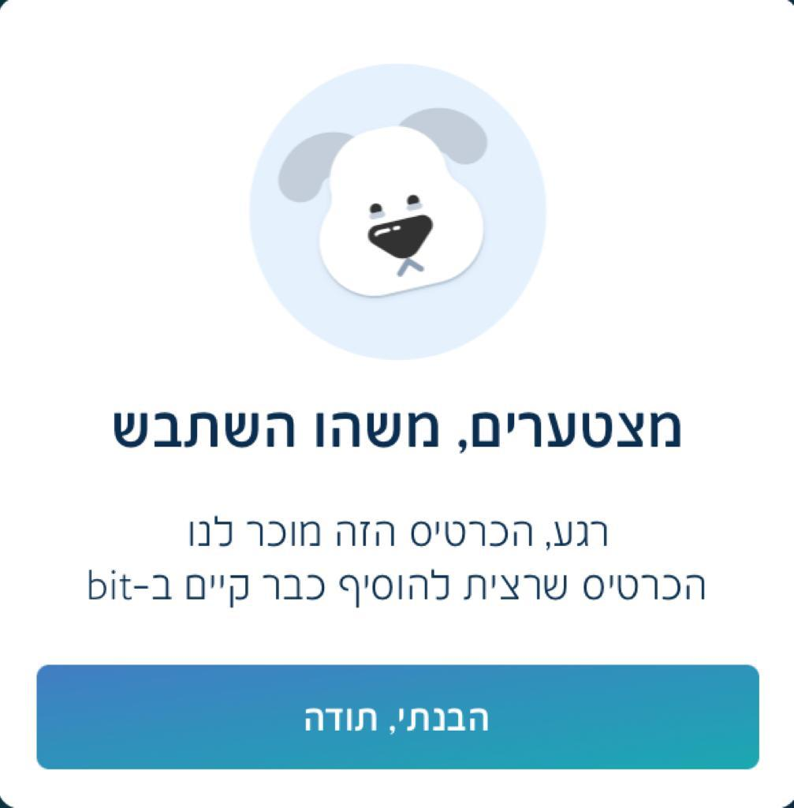 | The entered card has not been added to the cards list and pop-up message appeared |  | pass
Error handling - Add invalid credit card details
 | Click on the hamburger | Main menu opens | Main menu opened |  | pass
 | Click on 'הכרטיסים שלי' | ‘My credit cards’ page opens | ‘My credit cards’ page opened |  | pass
 | Click on 'להוספת כרטיס+' | A page for entering a password will open | A page for entering a password opened |  | pass
 | Enter the password: 2023 | A page will open to fill in credit card details | A page opened to fill in credit card details |  | pass
 | Enter the credit card details:  Number: 1111-1111-1111-1111 | A pop-up message will appear: ‘מספר אשראי זה לא תקין’ | The pop-up message appeared: ‘מספר אשראי זה לא תקין’ |  | pass
 | Type in the text box of the account number:  4580-1111-1111-4580 | A pop-up message will appear: 'מספר אשראי זה לא תקין' | The pop-up message appeared: ‘מספר אשראי זה לא תקין’ |  | pass
Error handling - Adding another owner's credit card
 | Click on the hamburger | Main page opens | Main page opened
 | Click on ‘הכרטיסים שלי’ | 'My credit cards' page opens | 'My credit cards' page opened
 | Click on 'להוספת כרטיס+' | A page for entering a password will open | A page for entering a password opened
 | Enter the password 2023 | A page will open to fill in credit card details | A page opened to fill in credit card details
 | Enter the credit card details:  Number: 5521-5678-91011-1617  Expiry: 12/24  CVV: 789 | A pop-up message will appear: | The pop-up message appeared
Profile picture – functionality testing (positive) – set a profile picture
 | Click on the hamburger | Menu opens | Menu opened |  | pass
 | Click on the camera icon | An image selection menu will open | An image selection menu opened |  | pass
 | Click on 'אלבום התמונות' | The photo album will open | The photo album opened |  | pass
 | Choose a photo | A pop-up message "bit would like to access your photos" | Pop-up message appeared |  | pass
 | Click on "keep current selection" | The selected photo appears as the profile picture | The selected photo appeared as the profile picture |  | pass
 | Click on the camera icon | A image selection menu will open | A image selection menu opened |  | pass
 | Click on 'המצלמה' | The camera opens | The camera opened |  | pass
 | Take a picture | A picture is taken | A picture was taken |  | pass
 | Click on 'retake' | The camera opens again | The camera opened again |  | pass
 | Take a picture | A picture is taken | A picture was taken |  | pass
 | Click on 'use photo' | The photo taken will be set as a profile picture | The photo taken was set as a profile picture |  | pass
 | Open the app on a different user's phone and verify the profile picture appears | Profile picture will appear | Profile picture does not appear |  | fail
Sanity test - Groups feature
Functionality test – create a group
 | Click on the hamburger | Main menu opens | Main menu opens |  | pass
 | Click on 'יצירת קבוצה' | A page opens to choose an image and reason for the transfer | A page opened to choose an image and reason for the transfer |  | pass
 | Choose 'מתנה' | The chosen reason and image will appear in the text box | The chosen reason and image appeared in the text box |  | pass
 | Click on 'המשך' | A page will appear to enter the amount we are asking from every participant | A page appeared to enter the amount we are asking from every participant |  | pass
 | Type 1 NIS | The amount of 1 NIS will appear in the text box, included the amount in words | The amount of 1 NIS appeared in the text box, included the amount in words. |  | pass
 | Click on 'המשך' | A page will open to choose until when the participants can transfer the money | A page opened to choose until when the participants can transfer the money |  | pass
 | Choose 2 days | The current date for transfer will appear | The current date for transfer appeared |  | pass
 | Click on 'המשך' | A page for selecting participants will open | A page for selecting participants opened |  | pass
 | Click on 'אנשי קשר' | A contact list opens | A contact list opened |  | pass
 | Choose 2 contacts:  Eden and Elior | The two contact name will appeared at the participants list | The two contact name appeared |  | pass
 | Click on 'שלח בקשה' | The request will be sent and the following page appears:  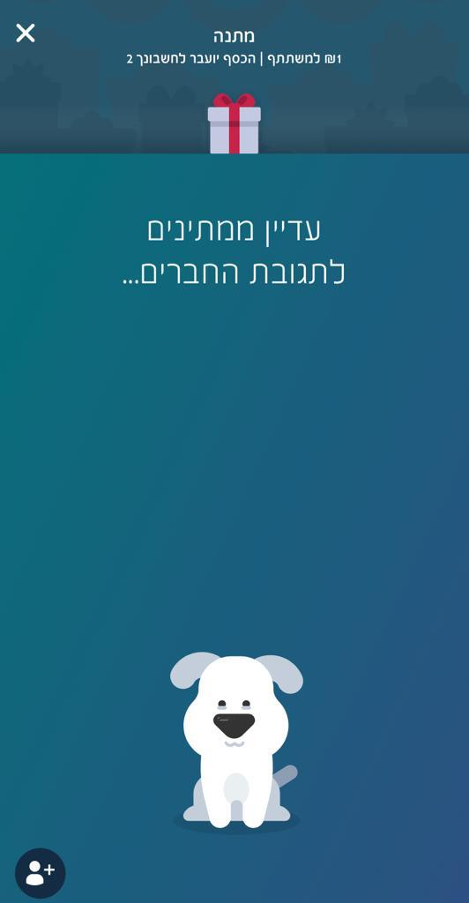 | The request has been sent and the page appeared |  | pass
 | Open the app on the participants phone | The request to join the group will appear | The request to join the group appeared |  | pass
 | Click on 'כן, צרפו אותי' | The transfer request will appear | The transfer request appeared |  | pass
 | Click on 'העבר כסף' | A page for entering a password will open | A page for entering a password opened |  | pass
 | Enter the password 2023 | A notification will receive that the transfer is done | A notification received that the transfer is done |  | pass
 | Go back to the beneficiary's bit application | Beneficiary will see the participants transferred 1 NIS (apiece) | Beneficiary saw the participants transferred 1 NIS (apiece) |  | pass
 | Verify the amount of 2 NIS is received in to beneficiary's bank account | 2 NIS receives in to the beneficiary's bank account | 1 NIS received in to the beneficiary's bank account |  | pass
 | Go back to the transfer's bit application | Activities page appears | Activities page appeared |  | pass
 | Verify the transfer status: 'העברה בוצעה היום' | The transfer status will appear as a 'העברה בוצעה היום | Transfer status: 'העברה בוצעה' |  | pass
 | Verify the credit card has been charged for 1 NIS | Credit card will charged for 1 NIS by bit | Credit card charged for 1 NIS by bit |  | pass
Profile picture – functionality testing (negative) – delete a profile picture
 | Click on the hamburger | Menu opens | Menu opened |  | pass
 | Click on the camera icon | An image selection menu will open | An image selection menu opened |  | pass
 | Click on 'מחק' | The profile picture will be deleted | The profile picture has not been deleted |  | fail
Sanity test – Payment for 'buyme'
Interface testing
 | Click on the hamburger | Main page opens | Main page opens |  | pass
 | Click on ' לתשלום ל-buyme' | A pop-up message:  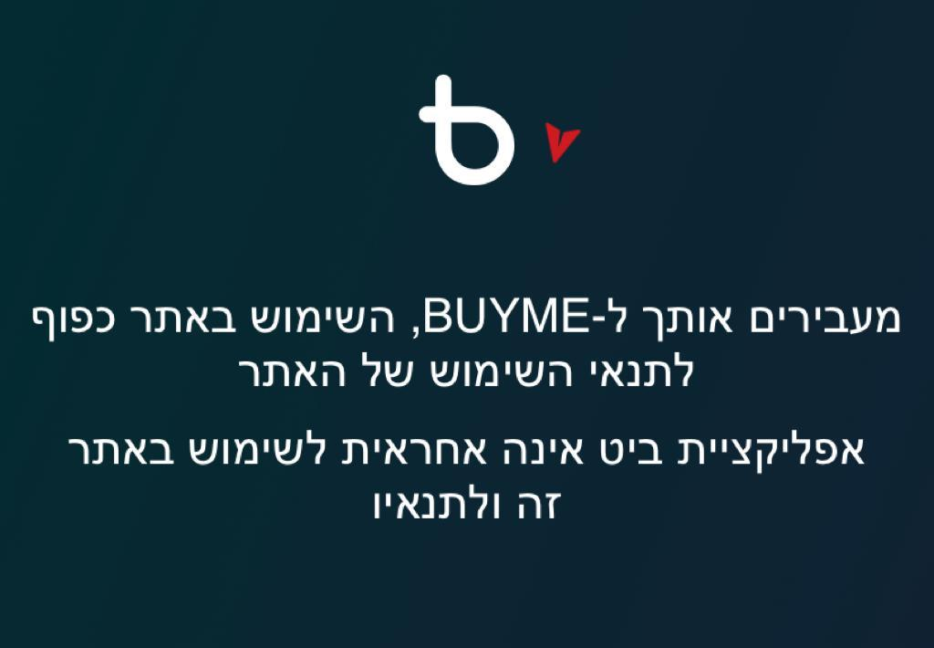  Buyme's site will open | Buyme's site opened and the pop-up message appeared |  | pass
 | Exit Buyme's site by clicking the X | Pop-up message will appear to verify the user does want to leave the site  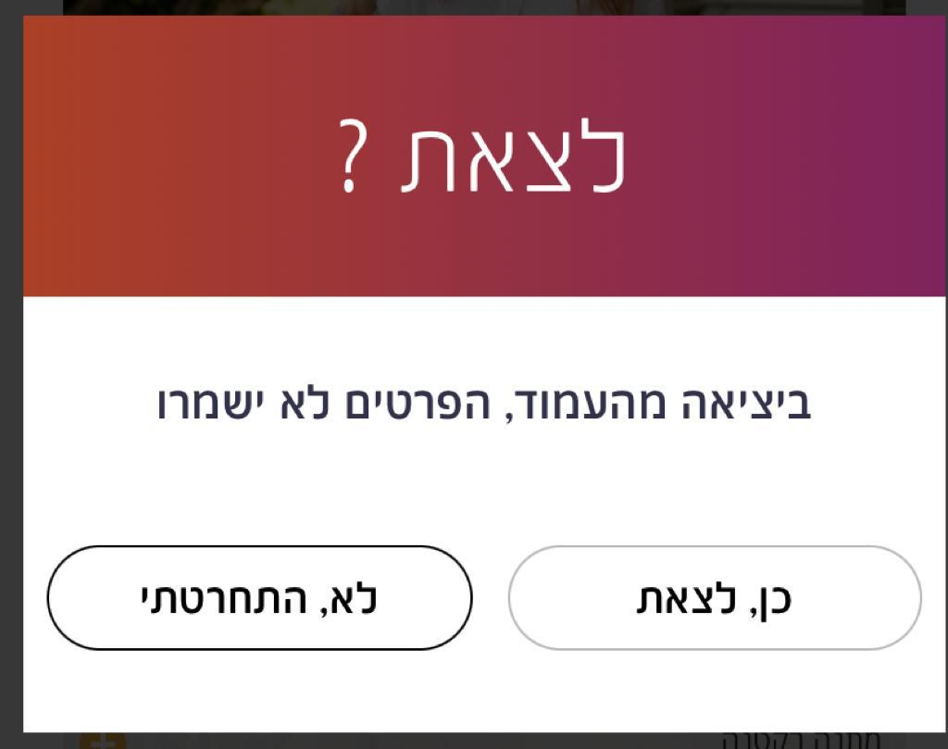 | Pop-up message appeared |  | pass
 | Click on 'כן, לצאת' | Bit's main menu will appear | Bit's main menu has been appear |  | pass
Sanity test - Accessibility statement
Interface testing
 | Click on the hamburger | Main menu opens | Main menu opens |  | pass
 | Click on 'הצהרת נגישות' | The website of Bank Hapoalim will open and shows the accessibility statement | The website of Bank Hapoalim has been open and shows the accessibility statement |  | pass
Sanity test - Export the transections as a file
Functionality test
 | Click on the hamburger | Main menu opens | Main menu opens |  | pass
 | Click on 'ייצוא הפעולות כקובץ' | A pop-up message will appear:  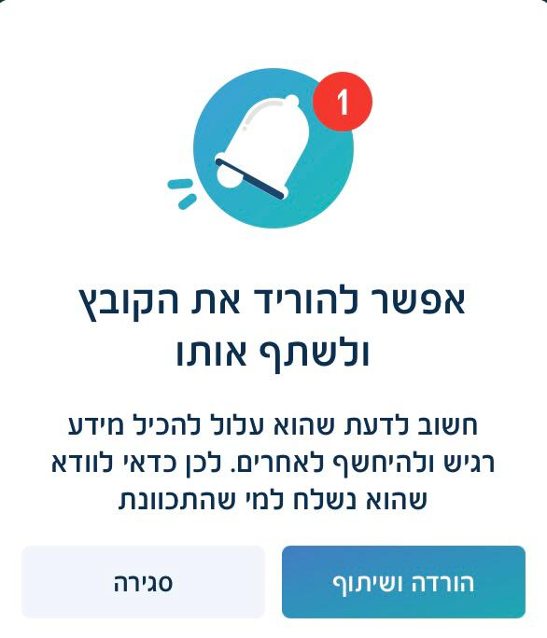 | Pop-up message appeared |  | pass
 | Click on 'הורדה ושיתוף' | A page for entering a password will open | A page for entering a password opened |  | pass
 | Enter the password 2023 | A menu for selecting a year will open  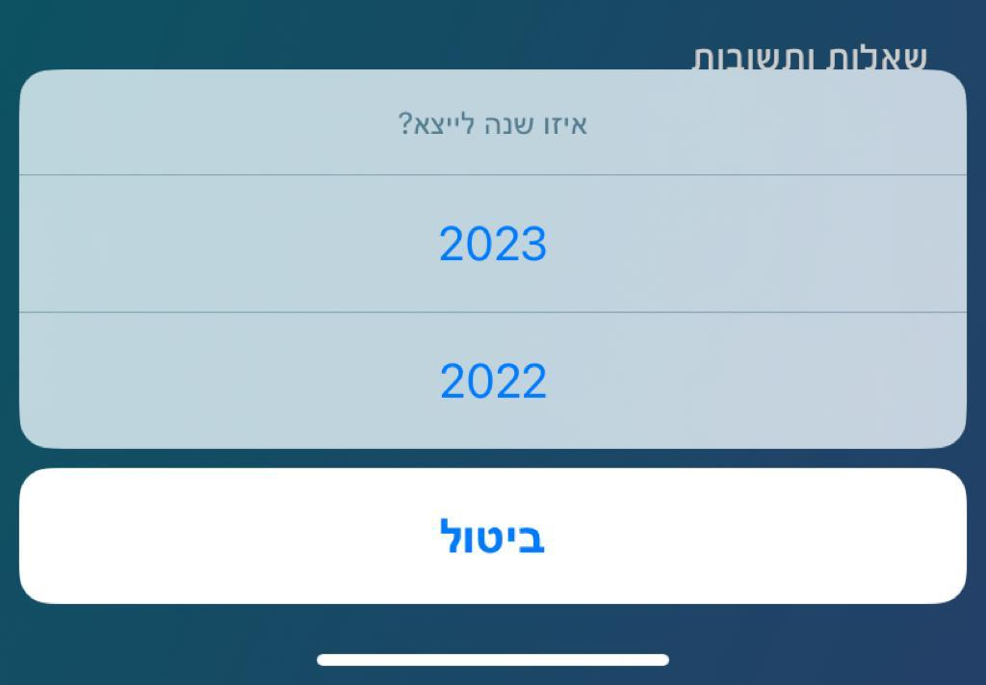 | A menu for selecting a year has been open |  | pass
 | Choose 2023 | The transections file will be ready to be sent/save on mobile | The transections file ready to save on mobile |  | pass
 | Click on 'Save to Files' | The file will be save on the mobile | The file has been save on the mobile |  | pass
 | Go to the files folder on the mobile to verify the file exists | The file exists | The file exists |  | pass
 | Verify that the transactions in the file match the transactions in the application | Transactions match | Transactions match |  | pass
Sanity test - Questions and answers
GUI testing
 | Colors |  |  |  | pass
 | Font |  |  |  | pass
 | Spelling |  |  |  | pass
 | Verify 10 questions have answers | 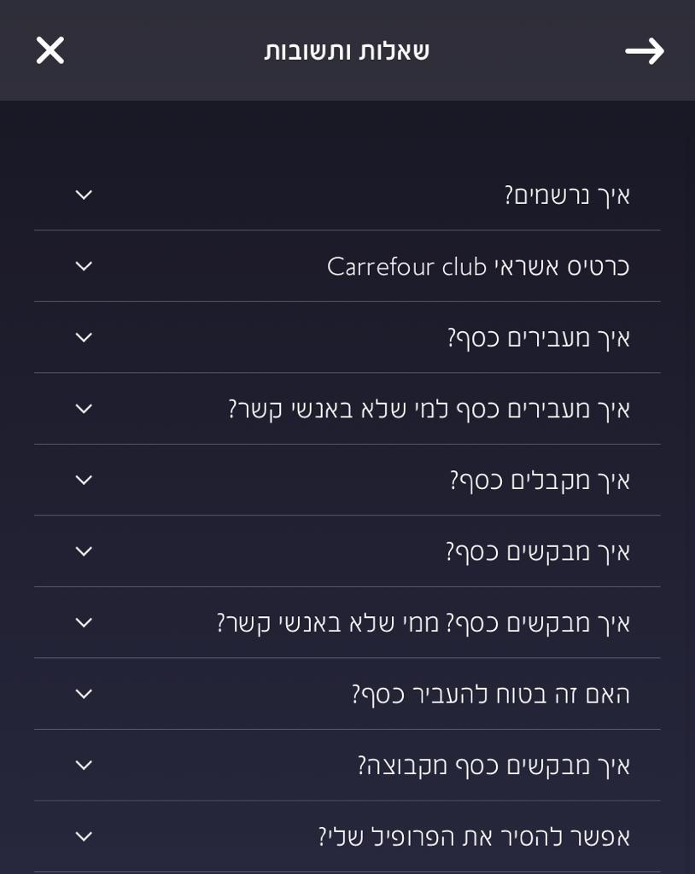 |  |  | pass
 | Verify that the contact information appear and the details are up to date | 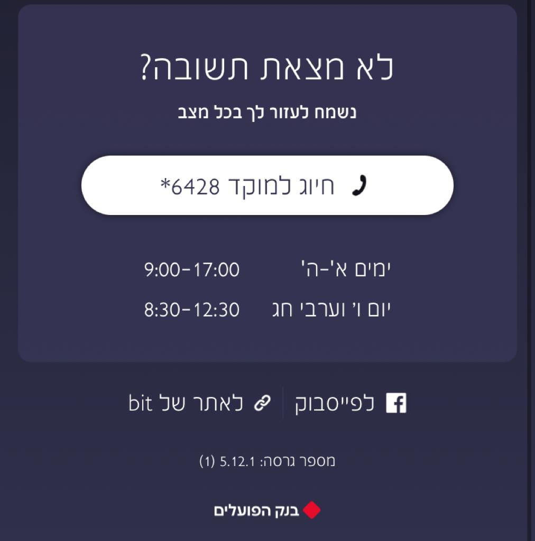 |  |  | pass
Sanity test - Settings
Functionality test – Delete profile
 | Click on the hamburger | Main menu opens | Main menu opens |  | pass
 | Click on 'הגדרות' | Setting menu opens  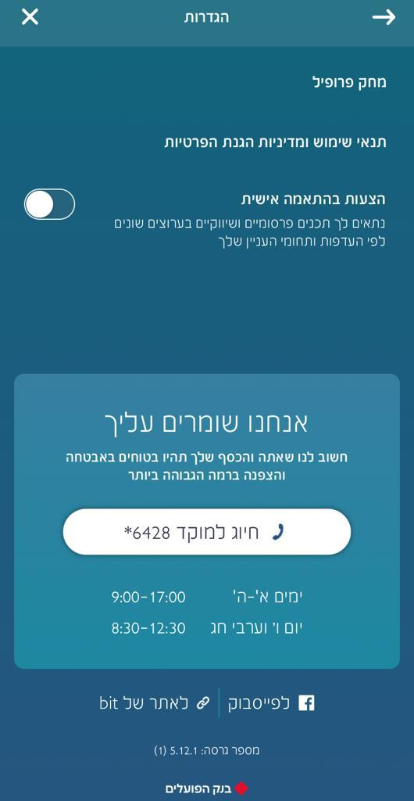 | Setting menu opens |  | pass
 | Click on 'מחק פרופיל' | A pop-up message will appeared  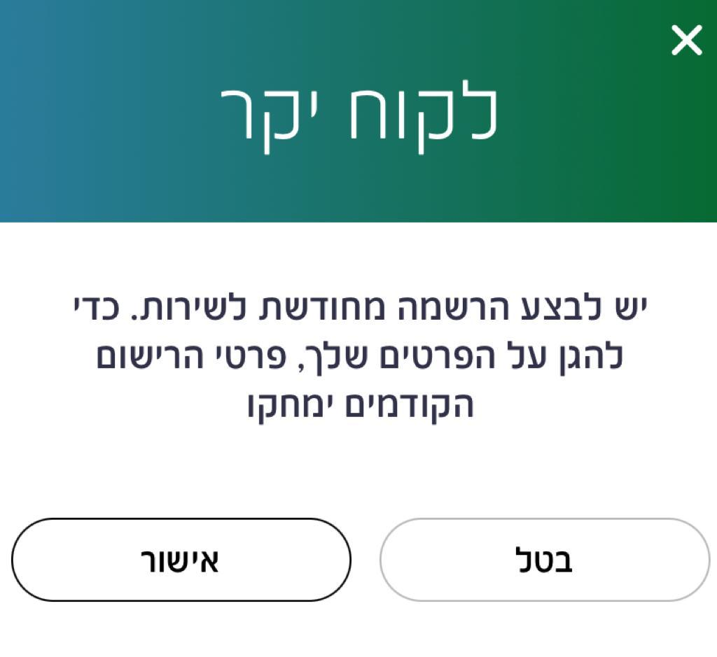 | Pop-up message appeared |  | pass
 | Click on 'אישור' | A page for entering a password will open | A page for entering a password opened |  | pass
 | Enter the password 2023 | The profile will be deleted and register page will appear | The profile has been deleted and register page appeared |  | pass

