**Readme**

* **A list of all the files in the system**

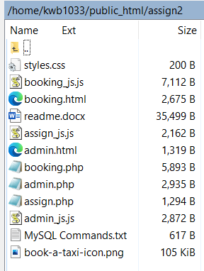

* **brief instructions on how to use the system**

1. **Go to booking.html page**
2. **Enter the booking information**
3. Notice: the contact phone just only number, and pick-up time have format. Please follow the time format.
4. When you click the “Book a taxi” button, the input details will be sent after all the information is valid, except unit number.
5. After you click the “Book a taxi” button and all the information is valid, the sever side will sent back to you booking reference number automatically. It will show: “Thank you! Your booking reference number is xxxxxx. You will be picked up in front of your provided address at xx:xx on xxxx-xx-xx .”
6. **Go to Administration page to enter admin.html for showing your booking information and assigning**
7. Click the show booking button

**Notice**: Only show all the booking with a pick-up time within 2 hours from now

1. The table of booking information will be displayed.
2. Enter the booking reference number, and then click the assign a taxi button to assign a taxi
3. The booking reference number you enter is number;
4. The booking reference number you enter is unassigned. If it is valid input, the sever side will display the confirmation information: “The booking request xxxxxx has been properly assigned”; if not, the sever side will display “the booking request xxx is invalid.”